InternAtional
Journal

of

Instructional Technology
and
Distance Learning

November 2014
Volume 11 Number 11

Editorial Board
Donald G. Perrin Ph.D.
Executive Editor
Elizabeth Perrin Ph.D.
Editor-in-Chief
Brent Muirhead Ph.D.
Senior Editor
Muhammad Betz, Ph.D.
Editor

ISSN 1550-6908

PUBLISHER'S DECLARATION
Research and innovation in teaching and learning are prime topics for the Journal of Instructional Technology and Distance Learning (ISSN 1550-6908). The Journal was initiated in January 2004 to facilitate communication and collaboration among researchers, innovators, practitioners, and administrators of education and training involving innovative technologies and/or distance learning.
The Journal is monthly, refereed, and global. Intellectual property rights are retained by the author(s) and a Creative Commons Copyright permits replication of articles and eBooks for education related purposes. Publication is managed by DonEl Learning Inc. supported by a host of volunteer editors, referees and production staff that cross national boundaries.
IJITDL is committed to publish significant writings of high academic stature for worldwide distribution to stakeholders in distance learning and technology.
In its first decade, the Journal published more than 600 articles; 7,500 pages of research and theory by over 1,000 authors. It logged over ten million page views and more than a million downloads of Acrobat files of monthly journals and eBooks. Many authors benefited from refereed publication for retention, promotion, tenure, and advancement in their profession
Donald G. Perrin, Executive Editor
Elizabeth Perrin, Editor in Chief
Brent Muirhead, Senior Editor
Muhammad Betz, Editor

Vol. 11. No. 11.
ISSN 1550-6908

Table of Contents – November 2014
 | Page
Editorial: Legacy | 1
Donald G. Perrin
Game Design for Second and Foreign Language Learning | 3
Niamboue Bado
SWOT analysis of the use of ICT in Jordanian schools | 15
Muhannad Al-Shboul

Return to Table of Contents

Editorial

Legacy

Donald G. Perrin
Innovation is essential for progress. It may be a new or original discovery, idea, device or process that provides a better solution for some present or future need. It may be a process that brings together novel ideas to solve problems or improve results. The innovation is potentially more useful, more practical, more powerful, or more efficient than the present way of doing things.
Innovation differs from invention in that innovation refers to the use of a better and, as a result, novel idea or method, whereas invention refers more directly to the creation of the idea or method itself. Innovation differs from improvement in that innovation refers to the notion of doing something different rather than doing the same thing better. (Wikipedia: Innovation)
Innovations can be the product of individuals or groups. As innovators, we would like our contributions to be recognized as the first, best, most productive, unique, or …. these are natural human desires. But only history can tell us, “how significant was our contribution?” The innovation may be just a stepping-stone or part of a larger enterprise? It might be significant or insignificant, a step forward, or a step backward.
Some contributions are ahead of their time, like daVinci’s conceptualization of machines and applications like airplanes and submarines. Others are immediately recognized and widely adopted, like the CD for recorded music, and the iPhone to integrate popular communication experiences with networks and computers. Apple Inc. has a business model that stimulates development of creative and innovative products and services that anticipate consumer needs and interests.
Some innovations become obsolete while others become an integral part of future developments. The best products do not always win in the marketplace because of timing, cost, marketing, support services, and perception of their quality or usefulness. There are excellent examples of all of these in education. The lantern slide projector developed in the 1600s as the “Magic Lantern” was replaced early in the twentieth century by filmstrip and slide projectors. The opaque projector was replaced by the overhead transparency projector where the teacher could face the students in a brightly lit room. The language laboratory failed initially because it lacked training, materials, and technical support for effective use. Costly 16mm films and projectors were replaced by inexpensive videotapes and DVDs. TVs were replaced by digital projectors and displays. Computers, networks, digital cameras, scanners, and powerful software integrated legacy media into one communication system. Ubiquitous man-machine interfaces and networks enable instant communication on a variety of fixed and mobile devices. Computers facilitate fast-low-cost production of audiovisual, multimedia, hypermedia and web materials by teachers and students.
Over the past 50 years, the 1962 vision of Finn and Hoban, updated by the Commission on Instructional Technology in 1970, became a reality. Now called Information Communication and Technology, it provides infrastructure to support learning and teaching in the 21st century:
Instructional technology is a systematic way of designing, carrying out, and evaluating the total process of teaching and learning in terms of specific objectives, based on human learning and communication, and employing a combination of human and nonhuman resources to bring about more effective instruction.
Sidney G. Tickton, Ed. (1970). To Improve Learning:
An Evaluation of Instructional Technology. Bowker.
Return to Table of Contents

Return to Table of Contents
Editor’s Note: Games and simulation s provide attractive learning options for today’s students. They are widely used for entertainment, but slow to be adopted in education because of high production costs and a relatively small number of educators with the necessary design and production skills. Also, very few schools have adequate budgets to create or buy interactive multimedia learning materials.

Game design for
second and foreign language learning

Niamboue Bado

USA

Abstract
Video games are playing an increasingly important role in the second and foreign language classroom. However, no empirically validated model exist to date to guide the design and development of educational video games for language learning. The present study sought to understand high school students’ perceptions of the design of an educational video game for English as a Foreign Language (EFL) acquisition. The participants were 113 high school students from Burkina Faso. The participants interacted with a video game for about four weeks and participated in focus group interviews to discuss their experiences. The Attention, Relevance, Confidence, and Satisfaction framework (Keller, 2010) was used to guide data analysis. The findings indicated that the attention, relevance, confidence and satisfaction constitute important motivational factors in the design of the game. It was also found that the participants value the inclusion of local content in the game. The implications of the study are discussed.
Keywords: game design, educational games, EFL, ARCS, Burkina Faso

Introduction
The use of technology in second and foreign language education is not a new phenomenon. Tapes, films, and television have all been used in second and foreign language education. However, the development of computer technology and the Internet have brought an unprecedented revolution in the field. Second and foreign language education has seen the emergence of Computer Assisted Language Learning (CALL) as an autonomous and fast growing area of specialization devoted to practice and research on the use of computer technology in teaching and learning. The field claims a wealth of researchers and practitioners creating knowledge on the use of social media, web 2.0 tools and video games to improve language learning.
As far as video games are concerned, the findings of several studies suggest that they have the potential to improve second and foreign language learning outcomes (Rankin, Morrison, McNeal, Gooch & Shute, 2009; Struppert, 2010; Sykes, 2008) and motivation (Connolly, Stansfield, & Heiney, 2011; deHaan, 2011; Oldaker, 2010; Yang & Zapata-Rivera, 2010).
While those findings on the impact of games on second and foreign language learning are well established, much remains to be learned on the design of games for language learning. The scholastic community is still in search of an empirically validated model to guide the design of educational games for language learning. It is still unclear what design features of games contribute to improving language learning.
The present study aimed to gain insights into high school students’ perceptions of the design of an educational video game for EFL learning. The educational video game Trace Effects (United States Department of State, 2012) was used in the study. By studying that particular game, we hoped to gain insights into game design elements that learners find useful for language learning and use that knowledge to inform the design of other games.
The following research questions guided the study:
- What are students’ perceptions of the design of Trace Effects?
- How can Trace Effects be improved to meet students’ EFL learning needs?
In this section, we have introduced the research topic, aims and research questions. The second section of the study is devoted to the review of the literature on the major game design models; the third sections describes the research methodology; the fourth section reports the findings of the study, the fifth section is a discussion of the findings and the last section reports the conclusions and limitations of the study.

Literature review
Video games are a fast growing industry in the United States. The development of new computer technology has made it possible to produce more sophisticated games with better graphics. The consumer market is expanding. It includes adults, adolescents and children. People spend hours every day hooked up to their game consoles or computer screens playing games alone or with friends.
This recent development of games and the growing interest in them has led many researchers to suggest that the motivational power of games can be harnessed to improve education (Gee, 2007, Squire, 2006). Commercial off-the-shelf games (COTS) have been widely used in the classroom to support learning (Charsky & Mims, 2008; Charsky & Ressler, 2011; Eck, 2006; Ritzhaupt, Gunter, & Jones, 2010). However, their use has poses several challenges to educators including non-alignment with curriculum and instructional objectives (Ritzhaupt et al., 2010). This is not surprising considering that those games were not primarily developed for teaching. For that reason, many scholars have advocated for the development of games whose primary purpose is learning. Even though the idea is noble, the development of educational games has posed several challenges. One major challenge is the necessity to strike a balance between fun and learning (Eck, 2006).
Educational video game design should be informed by instructional design and motivational theories. Game design is motivational design after all. This section reviews the major motivational design theories and models and their relation to games.

Motivational design models
One of the major motivational design models that have influenced the field of game design and motivational studies is Malone and Lepper (1987)’s intrinsic motivation model. Malone (1981) and Malone and Lepper (1987) identified four main elements that contribute to intrinsic motivation in games. There elements are: challenge, fantasy, curiosity and control. According to the authors, game developers should strive for an optimal level of challenge in their games in order for them to be motivating. In other words, the game should neither be too difficult nor too easy. Furthermore, the game environment should provide an opportunity to players to perform certain actions that they would not be able to perform in the real world, giving them a sense of fantasy. Game designers should elicit players’ curiosity by creating gaps in their knowledge, which prompts them to seek information. The fourth major element in Malone and Lepper (1987)’s model is control. Games designers should design their games in a way to give players some degree of control over the outcomes of the game. Players should feel that the outcome of the game depends on their actions rather than pure luck.
Malone and Lepper (1987)’s model has been influential in the field of game and motivational design. However, the model falls short of providing clear guidance on how to weave educational content into games. In other words, the model can be effective for designing games that are fun to play, but not necessarily games that are fun and result in learning. As a result, the model may not be the best choice when one is designing a game for learning.
Another model that has received wide attention in motivational and game design is the Input-process-output model (Garris, Ahler, & Driskell, 2002). Unlike the first model which was a game design model in general, this one is specifically intended for guiding the design of educational games. As its name suggests, the input-process-output model has three main components that are input, process and output. Input, in the model refers to game characteristics and instructional content. By ‘characteristics’ Garris et al. (2002) refers to all the features that make a game fun such as goals, challenge, fantasy, control, mystery and sensual stimuli. As on can notice, most of the game characteristics were also referred to by Malone and Lepper (1987). After input, comes the second component of the model which is process. Process deals with the game cycle, which includes user behavior, judgment and system feedback. Output is the last component of the model. It refers to learning outcomes as a result of interacting with the game. Garris et al. (2002) identified three types of learning outcomes which are skill-based learning outcomes, cognitive learning outcomes and affective learning outcomes. Even though debriefing does not appear in the name of the model, the authors consider debriefing as an important component of the model since it is the process through which gameplay is translated into actual learning outcomes.
The input-process-output model appears to be a comprehensive educational game design model because it integrates almost everything from the design of the game to its implementation in an actual learning context and assessment of learning outcomes. However, the model does not discuss instructional content. It does not give any insights on the choice of instructional content, or appropriate ways to structure it.
Keller (2010)’s Attention, Relevance, Confidence, and Satisfaction (ARCS) model is probably one of the few models that discusses both game features and instructional content. The model draws from expectancy-value theory (Atkinson, 1957; Eccles et al.,1983; Wigfield, 1994; Wigfield & Eccles, 1992), which postulates that people’s drive and persistence to complete a task can be explained by their expectation for success and their perceived value of the task. In the ARCS model, attention refers to the need for game designers to include features that capture and maintain learners’ attention. Relevance deals with the instructional content of the game. Selecting a game content that is relevant to learners’ needs, goals and personal interest can go a long way in making the game motivating. Game designers needs to attend to learners’ confidence by designing games that improves learners’ expectation for success. Games should be at an optimal level of difficulty in order to improve learners’ confidence. The last component of the model is satisfaction which deals with ways to reward learners for their performance. Rewards, whether external or internal are important motivational factors in games, according to Keller (2010).
The major game and motivational design models such as Malone and Lepper (1987) and Garris et al. (2002) have identified important design features to include in games in order to improve their motivational appeal. However, when it comes to integrating educational content into games, the models fail to provide any useful guidance. Keller (2010)’s ARCS appears to be one of the most useful models for guiding the design of educational games because provides guidelines on incorporating motivational features as well educational content into games. Therefore, the ARCS model is used as a framework for investigating students’ perceptions of game design for language learning.

Methodology
The present study sought to understand students’ perceptions of the design of an educational video game for English as a Foreign Language learning (EFL). The study adopted a multiple-case study design (Stake, 2006; Yin, 2003) and took place in four publish high schools in Ouagadougou the capital of Burkina Faso. The advantage of using multiple-case study is that it replicates the study, thereby yielding findings that are robust (Baxter, & Jack, 2008; Yin, 2003).

Participants
The participants in the study were 113 12th grade students from four public high schools in Burkina Faso, West Africa. The schools are named A, B, C and D. The breakdown of the participants by school is presented in Table 1. There were 46.9% female and 53.1% male participants. The average age of the participants was 19.02 (SD=1.09). Their mean computer technology experience was 23.90 months (SD=25.08).

Table 1

Participants
Schools | Participants
A | 15
B | 47
C | 23
D | 28
Total | 113

Instruments
The instruments used in the study were: an interview guide, a biographical questionnaire, and the Trace Effects game. The interview questions were adapted from Keller (2010)’s Attention, Relevance, Confidence, Satisfaction Model. The questions aimed to elicit information from the participants on their perceptions of the design of Trace Effects in the following areas: game features that caught their attention, the relevance of the game to EFL learning, their confidence in their ability to complete the game, their satisfaction with gameplay. The last question on the interview guide asks participants for suggestions on how to improve the game. The biographical questionnaire was used to collect background information from the participants on their age, gender, technology experience, gaming experience and technology ownership.
The Trace Effect game was the main material used in the study. It is a single player adventure game developed by The Super Group and a team of English to Speakers of Other Languages (ESOL) professionals. Funding for the development of the game was provided by the United States Department of State. In terms of content, Trace Effects has seven chapters tackling different themes ranging from gender empowerment, community activism, science, innovation and American culture to Environmental protection (American English, 2012). The game is played using a computer mouse and keyboard to select pre-made phrases and sentences. The students earn points for selecting phrases and sentences that are grammatically correct and pragmatically appropriate but lose points for the doing the opposite. The game is intended to teach English vocabulary, listening, speaking and pragmatics to high school students learning EFL in foreign countries (Hanson-Smith, 2013). Figure 1 shows the main interface of Trace Effects.

Figure 1: Trace Effects

Procedure
Purposive sampling technique was used to select four 12th grade EFL classes in four public schools for participation in the study. All the schools were located in Ouagadougou, the capital of Burkina Faso, had the same curriculum and served the same student population. These four schools were selected as cases for study because they had computer labs, which could be used to implement the game.
Data collection for the study lasted approximately a month and was conducted in three main steps. The first step consisted of training participants in order to familiarize them with the game content and technology. The second step consisted of organizing gameplay sessions for participants to interact with Trace Effects. Four gameplay sessions were arranged for participants. During gameplay, the researcher was available to provide technical assistance to participants who needed it. The last step in data collection was interviewing. After gameplay was completed, ten participants were randomly selected from each class to take part in a focus group interview in order to discuss their perceptions of the design of Trace Effects. Four focus group interviews were conducted in the four schools.

Data Analysis
The focus-group interview data was transcribed and coded for the themes and patterns. The ARCS model (Keller, 2010) served as a framework for data coding and analysis. The questionnaire data was analyzed by applying descriptive statistics procedures using SPSS. The qualitative data collected with focus group interviews in the four schools was first analyzed at the school level and then analyzed across schools to identify salient themes.

Findings

Descriptive Statistics
The results of the data collected with the questionnaire indicated that the majority of participants in the study had never played a video game and had never been formally trained on how to use the computer for learning. On the other hand, the majority of the participants indicated that they have used the computer and the Internet to do some school related work. Table 2 provides detailed information on the participants’ technology experience and ownership.

Table 2

Participants’ technology experience and ownership
Items |  | Responses
 | N | Yes (%) | No (%) | Total (%)
Gaming Experience | 113 | 46.90 | 53.10 | 100
Used Internet for School Work | 113 | 75.22 | 24.78 | 100
Used Computer for School Work | 110 | 80.91 | 19.09 | 100
Training on Using Computer for Learning | 112 | 29.46 | 70.54 | 100
Computer Ownership | 113 | 12.39 | 87.61 | 100
Family Computer Ownership | 110 | 27.27 | 72.73 | 100
Internet Connection at Home | 111 | 18.92 | 81.08 | 100
Cellphone Ownership | 113 | 93.81 | 6.19 | 100
Smartphone Ownership | 113 | 27.43 | 72.57 | 100

What are students’ perceptions of the design of trace effects?
The results of the study pertaining to the participants’ perceptions of the design of Trace Effects showed that attention, relevance, confidence and satisfaction constitute important motivational factors in the design of Trace Effects. The participants indicated that the images in the game motivated them to play the game. Furthermore, the participants found Trace Effects to be useful for improving their EFL vocabulary knowledge, pronunciation and spelling. As far as confidence is concerned, the participants found Trace Effects to be difficult at first, which causes some frustrations. On the other aspect of confidence which is personal responsibility, the participants indicated that they felt that their game score was a reflection of the effort they put into gameplay. Some of the participants suggested that they were about to exit the game when they felt that they could not complete the missions assigned to them. As far as satisfaction is concerned, the participants indicated that the scoring system in the game was a major motivator for them to continue playing. According to the participants, a game without points is not a game because the goal of play is to accumulate as many points as possible. The main themes as well as some illustrative excerpts from the focus group discussion are presented in Table 3.

Table 3

ARCS components and illustrative quotations
Themes | Illustrative Quotations
Attention | Student 2 (S2): The images are what got my attention in the game. They make me feel like I am in the real world.  S1: Given that the game has audio and video, even if you don’t want to play the game the images make you want to play.
Relevance | S9: It [Trace Effects] can contribute to vocabulary acquisition. You can easily learn the new vocabulary words that you collect in the game environment.  S6: It [Trace Effects] can help to improve English pronunciation. Just by listening to the conversation helps improve my pronunciation.  S4: It [Trace Effects] can help improve our spelling. Sometimes you know a word; you can pronounce it, but you don’t know how to spell it
Confidence | S6: I was not very confident in my ability to complete the game. When I first played Chapter 3 of the game and was told to look for Andre [one of the characters in the game] I was not confident in my ability to find him. They [the game designers] didn’t give any indications as to where he was. I didn’t know where to go. I was about to quit the game when I couldn’t find Andre.  S4: I found the game a little difficult on the first day. The vocabulary was difficult. The game objectives that I was asked to complete were also difficult. However, I later learned the vocabulary words and improved.  S3: I see the point system as a punishment for those who do not play well. If you don’t play well, you lose points. And that tells you that you should pay attention to what you do and avoid selecting inappropriate options when playing.
Satisfaction | S1: Who speaks of a game speaks of points. It’s a competition and everyone wants to be the best. Everyone wants to get the maximum points. Without the points there is no reason for playing.

How can trace effects be improved to meet students’ EFL learning needs?
The second research question in the study focused on eliciting information from participants on how to improve the design of Trace Effects. Major themes that emerged from the data are multilingualism, violence, action, and local themes. The participants indicated that if they were to redesign Trace Effects they would make the game available in multiple languages such as English, French and German. Others indicated that they would include some combat scenes in it. They also reported that they would give the player a more active role in performing actions. Instead of seeing objects appear in their repertoire and disappearing as they give them to someone else, they would rather be able to perform all actions including riding a bicycle or driving a car. The last but not least major theme was the inclusion of local content. The participants indicated that they appreciated learning about American culture through Trace Effects, but if they were to redesign the game they would include some local themes related to their own country, culture and people. Table 4 summarizes the main themes discussed in this section.

Table 4

Suggestions for improving trace effects?
Themes | Illustrative Quotations
Multilingualism | S8: I would love the game to be available in multiple languages
Violence | S10: I would include some action scenes in the game. Combats or something like that.
Action | S2: I would have preferred to see things like riding a bicycle. For example when Trace took the bicycle to Louis, I didn’t see Trace riding the bicycle and then giving it to Louis. It would be good to include actions like that.
Local Content | S1: We want African themes but also themes related to America. If we learn just what is related to Africa it’s not good. We need to also know what is going on in the rest of the world.

Discussion
The results of the study suggested that the participants perceived Trace Effects to be well designed in terms of attention, relevance, and satisfaction. As far as confidence is concerned a great number of participants indicated that the game was difficult the first time they played; something which negatively affected their confidence in their ability to successfully complete it.
The findings reinforce the relevance of the ARCS model (Keller, 2010) to educational game design.

Attention
The participants found the pictures in Trace Effects to be visually appealing and a great motivation for them to continue playing the game. Keller (2010) considers attention catching and holding to be one of the conditions for successful learning to take place.

Relevance
In terms of relevance, the results of the study showed that the participants found the game useful for their EFL learning needs. This, according to Keller (2010), is an important motivational factor. The researcher indicated that learners are more likely to put efforts into gameplay if they perceive the game to be relevant to their learning needs and personal interests. The participants in this study indicated that Trace Effects was useful for learning vocabulary, pronunciation and spelling. However, the participants indicated that they would aim for more diversity in terms of themes if they were to redesign Trace Effects. By diversity they mean that they would include both themes related to the United States of America as well as themes related to their own country of residence. This finding relates well to the issue of relevance in Keller (2010)’s model. According to the author, the content of the game should be related to participants’ learning needs as well as personal interests and backgrounds. The more people can relate to stories, the more motivated they are likely to be when they interact with those stories. According to expectancy-value theory, the usefulness and importance of the content as well as learners’ interests constitute important motivation factors (Atkinson, 1957; Eccles et al., 1983; Wigfield, 1994; Wigfield & Eccles, 1992).
It is important to note that in addition to motivating students, including educational content that is relevant to the curriculum and students’ learning needs can contribute to improving the adoption of an educational game into the classroom. According to Ritzhaupt, et al. (2010), non-alignment of game content with curriculum is one of the major barriers to the use of video games in the classroom.

Confidence
When it comes to confidence, the results of the study indicated that many participants were not confident in their ability to complete the game. They found the game difficult and considered giving up at some point. Many researchers in the field of game and motivational design have pointed out the need for the game to be at an optimal level of difficult in order for it to be fun (Garris et al., 2002; Keller, 2010; Malone & Lepper, 1987). A game that is too difficult or too easy is likely to be a motivation killer. Bandura (1986) and Schunk (1985) referred to the same idea of confidence in earlier motivational studies by using the term ‘self-efficacy.’ Their idea was that learners are more likely to engage with a task if they expect some degree of success. Clearly, a task that is perceived to be too difficult can be a motivation killer.
Difficulty is not the only facet of confidence in Keller (2010)’s model. The other facet is personal responsibility or control. The results showed that the participants perceived some sense of control in the game. Many of them indicated that their game score depended on how well they played, which suggested that they had control over their scores. It was clear from their responses to the interview questions that they didn’t believe that winning was a matter of good luck, something they did not have control over. Control is a factor that many researchers have also found important in game and motivational design (Garris et al., 2002; Keller, 2010; Malone & Lepper, 1987).

Satisfaction
The results of the study showed that satisfaction is an important factor in game design and development. Many of the participants indicated that they derive great satisfaction from the points they earn during gameplay. Some participants went further to suggest that the points are the essence of a game. Keller (2010) considers rewards to be an important aspect of motivational design. The rewards can be intrinsic or extrinsic. Malone (1983) also pointed out the importance of intrinsic rewards in motivational design.

Implications for game design for language learning
The results of the study have implications for the design and development of educational video games for language learning. Table 5 provides a framework based on the ARCS model, which can be used to guide the design of educational video games for language learning. Prior to using this model the game designer should conduct learner analysis in order to identify language proficiency level, gaming proficiency, cultural background, age, gender, career goals, and personal interests of the learners. That information can be useful in making the game relevant to its intended audience’s needs and interests.

Table 5

ARCS model applied to language game design
Factors | Design Considerations
Attention | - Visually appealing graphics
Relevance | - Themes  -Themes relevant to target and source language cultures  -Themes relevant to students’ personal interests  - Objectives  -Game objectives or missions that are relevant to students’ interests  -Language objectives relevant to students language needs
Confidence | - Difficulty  -Game language should be at optimal level of difficulty  -Gameplay technology should be at optimal level of difficulty  - Control  -Students should be given control over outcomes of game  - Progression  -Sequence game chapters/levels in order of difficulty staring with easiest level and ending with most difficult level
Satisfaction | - Scores as rewards for performance  - Certificates as rewards for completion of game chapters/levels

Conclusions
The present study sought to understand students’ perceptions of the design of an educational video game for language learning. The results of the study indicated that attention, relevance, confidence and satisfaction (Keller, 2010) constitute important factors in the design of an educational video game for language learning. The results of the study further indicated that the participants value the inclusion of content and themes that address their culture and daily realities as well as other cultures. The study concludes by suggesting that the ARCS model (Keller, 2010) can be adapted for use to guide the design of educational games for language learning.

References
Atkinson, J. W. (1957). Motivational determinants of risk taking behavior. Psychological Review, 64,
359–372
Bandura, A. (1986). Social foundations of thought and action: A social cognitive theory. Englewood Cliffs, NJ: Prentice-Hall.
Baxter, P, & Jack, S. (2008). Qualitative case study methodology: Study design and implementation for novice researchers. The Qualitative Report, 13 (4), 544-559. Retrieved on August 3, 2014, from: http://www.nova.edu/ssss/QR/QR13-4/baxter.pdf
Charsky, D., & Mims, C. (2008). Integrating commercial off-the-shelf video games into school curriculums. TechTrends, 52 (5), 38-44.
Charsky, D., & Ressler, W. (2011). Games are made for fun: Lessons on the effects of concept maps in the classroom use of computer games. Computers & Education 56, 604–615.
Connolly, T. M., Stansfield, M., & Hainey, T. (2011). An alternate reality game for language learning: ARGuing for multilingual motivation. Computers & Education 57, 1389–1415.
deHaan, J. (2011). Teaching and learning English through digital game projects. Digital Culture & Education, 3(1), 46-55. Retrieved on August 12, 2012, from: http://www.digitalcultureandeducation.com/cms/wpcontent/uploads/2011/04/dce1046_dehaan_2011.pdf
Eccles J. S., Adler, T. F., Futterman, R., Goff, S. B., Kaczala, C. M., Meece, J. L., & Midgley, C. (1983). Expectancies, values, and academic behaviors. In J. T. Spence (Ed.), Achievement and achievement motivation (pp. 75–146). San Francisco, CA: W. H. Freeman.
Eck, R. V. (2010). Digital game-based learning: It's not just the digital natives who are restless. EDUCAUSE Review, 41(2), 1-16.
Garris, R., Ahlers, R., & Driskell, J. M. (2002). Games, motivation, and learning: A research and practice model. Simulation & Gaming, 33(4), 441-467.
Gee, J. P. (2007). What video games have to teach us about learning and literacy. New York: Palgrave Macmillan.
Hanson-Smith, E. (2013). Trace Effects/Language Effects: Scripting for a language practice adventure game. Presented at the CALL IS Academic Session TESOL Convention, Dallas, TX, 21 March 2013.
Keller, J. M. (2010). Motivational design for learning and performance: The ARCS model approach. New York: Springer
Malone, T. W. (1981). Towards a theory of intrinsically motivating instruction. Cognitive Science, 4, 333-369.
Malone, T. W., & Lepper, M. R. (1987). Making learning fun: A taxonomy of intrinsic motivations for learning. In R. E. S. M. J. Farr (Ed.), Aptitude, learning and instruction: Conative and affective process analyses (pp. 223-253). Hilsdale, NJ: Erlbaum.
Oldaker, A. (2010). Creating video games in a middle school language arts classroom: A narrative account. Voices from the Middle, 17(3), 19-26.
Rankin, Y., Morrison, D., McNeal, M., Gooch, B., & Shute, M. (2009). Time will tell: In-game social interactions that facilitate second language acquisition. In R. M. Young (Ed.), Proceedings of the 4th international conference on foundations of digital games (pp. 161–168). New York: ACM.
Regional English Language Office for the Andean Region. (2012). English through state’s new computer game. Retrieved on August 8, 2012, from: http://reloandes.com/2012/06/24/english-through-states-new-computer-game/
Ritzhaupt, A.D., Gunter, E., & Jones, G. (2010). Survey of commercial-off -the-shelf video games: Benefits and barriers in formal education settings. International Journal of Instructional technology and Distance Learning, 7(5). Retrieved on July 15, 14 from: http://www.itdl.org/Journal/May_10/index.htm
Schunk, D. (1985). Self-efficacy and school learning. Psychology in the Schools, 22, 208-223.
Stake, R. E. (2006). Multiple case study analysis. New York: The Guilford Press.
Struppert, A. (2010). It’s a whole new fun different way to learn. Students’ perceptions of learning with an Electronic simulation: Selected results from three case studies in an Australian, an American and a Swiss middle school. The International Journal of Learning, 17(9), 363-376.
Squire, K. (2006). From content to context: Videogames as designed experience. Educational Researcher 35(8), 19–29.
Sykes, J. M. (2008). A Dynamic Approach to social Interaction: Synthetic immersive environments & Spanish pragmatics [Dissertation] Minnesota: University of Minnesota.
Wigfield, A. (1994). Expectancy-value theory of achievement motivation: A developmental perspective. Educational Psychology Review, 6, 49–78.
Wigfield, A., & Eccles, J. (1992). The development of achievement task values: A theoretical analysis. Developmental Review, 12, 265–310.
Yang, H., & Zapata-Riviera, D. (2010). Interlanguage pragmatics with a pedagogical agent: the request game. Computer Assisted Language Learning, 23(5), 395-412.
Yin, R. K. (2003). Case study research: Design and methods (3rd ed.). Thousand Oaks, CA: Sage.

About the Author
Dr. Niamboue Bado is an Instructional Designer at Florida A&M University. He earned his Ph.D. in Instructional Technology from Ohio University in May 2014. His research interests centered on game-based learning, instructional design, and web 2.0 tools in education.
E-mail: niamboue.bado@famu.edu

Return to Table of Contents
Editor’s Note: This research complements Faculty members’ perceptions of e-learning at the University of Jordan published in this journal in October 2014. This in-depth research is a model that can be replicated for a variety of academic purposes in other regions and cultures.

SWOT analysis of the use of information and communication technology in Jordanian schools

Muhannad Al-Shboul

Jordan

Abstract
E-Learning and (ICT) require changes in the way we teach and the way we learn. Thus, many schools, universities, and institutions of higher education have recognized the value of the Internet in changing the way people learn. Traditional classroom courses can be augmented with interactive materials on the Web and old fashioned distance learning courses can be transformed from correspondence courses or television lectures into e-Learning environments. However, few educational institutions have been able to embrace e-Learning and ICT in a way that enables widespread innovative uses of learning technology throughout the institution. Therefore, this study reviews the literature related to the use of ICT in school education in general, and in Jordan in specific; as well as it presents and discusses the strengths, weaknesses, opportunities, and threats for adopting and utilizing ICT in schools in Jordan. Despite the fact that our schools and universities are distinguished in the quality of teaching and research, their utilization of e-Learning and ICT is still in the middle stages and we may face many challenges in this regard. We have excelled in some areas related to information technology and have many challenges to face as well. In what follows, the researcher will identify the strengths, weaknesses, and threats in ICT in Jordan as well as the many opportunities that will be available. So, the Jordanian Ministry of Education be able to utilize the strengths and build on them, mitigate the weaknesses, avoid the threats, and exploit the opportunities.
Keywords: ICT, e-Learning, information technology, education, Jordan, SWOT, online learning, educational technology, technology integration, ICT barriers.

Introduction
The use of ICT is on the rise with the digital generation growing exponentially. In addition to providing education at the primary, secondary and post-secondary levels, ICT plays an important role in ongoing professional development for adults in the workforce. As the world strives to meet development goals, there is increasing recognition of the potential of ICT and its tools to meet growing educational challenges (Kirkman, Cornelius, Sachs, & Schwab, 2002).
ICT has become an integral and accepted part of everyday life for many people. ICT is increasing in importance in people’s lives and it is expected that this trend will continue, to the extent that ICT literacy will become a functional requirement for people’s work, social, and personal lives. The creative use of ICT in education has the capacity to increase the quality of people’s lives by enhancing teaching and learning. ICT includes the range of hardware and software devices and programs such as personal computers, assistive technology, scanners, digital cameras, multimedia programs, image editing software, and database and spreadsheet programs. It also includes the communications equipment through which people seek and access information including the Internet, email and video conferencing (National Council for Curriculum and Assessment (NCCA), 2004).
The use of ICT in appropriate contexts in education can add value in teaching and learning, by enhancing the effectiveness of learning, or by adding a dimension to learning that was not previously available. ICT may also be a significant motivational factor in students’ learning, and can support students’ engagement with collaborative learning (Daniel, West, D’Antoni, & Uvalić-Trumbić, 2006).
Learning today demands new pedagogical and technological approaches to using ICT. School leaders and teachers have the responsibility to prepare students for the demands of an ever-changing world by facilitating learning in a technology-rich environment where students and teachers do not just learn about technology, they use it to achieve powerful learning and teaching, and improve student learning outcomes (Tondeur, Van Braak, & Valcke, 2007).
ICT have become commonplace entities in all aspects of life (Leask & Pachler, 2013; Tondeur, Van Keer, Van Braak, & Valcke, 2008). Across the past twenty years the use of ICT has fundamentally changed the practices and procedures of nearly all forms of endeavour within business and governance. Education is a very socially oriented activity and quality education has traditionally been associated with strong teachers having high degrees of personal contact with learners. The use of ICT in education lends itself to more student-centered learning settings. But with the world moving rapidly into digital media and information, the role of ICT in education is becoming more and more important and this importance will continue to grow and develop in the 21st century (Noor-Ul-Amin, 2013).
ICT and e-Learning are often described as having the potential to enable learners to learn at any time, anywhere and at their own pace. Learners are predicted as being able to take responsibility for their own learning using online content, learning networks, and communities of practice. However, achieving these results is not simply about access to technology. It is also about being confident and competent users of technology, having e-Learning skills, and being media and information literate. These are not simple achievements (Clarke & Luger, 2007).
Statistics from several studies revealed that there are a number of citizens do not use ICT. This is not simply with regard to access to technology but concerns motivating them to realize the relevance of ICT to their lives and giving them meaningful access. Motivated people will acquire the required ICT skills. Technology is a major change factor and must therefore be considered in all discussions of education and training policy (Cox, Cox, & Preston, 1999).
ICT provides the means for teachers to expand their role as content developers. Many teachers produce materials for their own use and the Internet provides the means for these resources to be made widely available to the learners. Learners have access to a wide range of ICT devices of their own which can play an important part in delivering effective learning. These include portable MP3 Players, Multi functional mobile phones, voice recorders, digital cameras, and digital-video cameras. A range of wireless and physical connections can be used for this but often fear of data loss or viruses prevent this important functionality. Learners and teachers must be enabled and encouraged to connect their devices to the learning network, accessing digital content, and contributing their own digital materials (Yusuf, 2005).
The demands of the modern society represent a unique opportunity for education systems. Schools that traditionally have taught students to store and recall information from specific content areas must now respond to the challenge of preparing young people for integration and success in societies and economies driven by the transformation of knowledge into new ideas and applications. In this regard, classrooms must serve as places of collaboration and discovery where ICT can be integrated into the learning process. Technology can also be used to facilitate the acquisition of more general skills such as critical thinking, communication, and life-long learning. New technologies are tools that can be used to improve most areas of education (Unwin, 2008).
ICT is of paramount importance to the future of education. According to Lai & Pratt (2004), ICT in education initiatives that focus on the following areas are most likely to successfully contribute meeting the needs of all learners:
- Increasing access through distance learning – ICT can provide new and innovative means to bring educational opportunities to greater numbers of people of all ages, especially those who have historically been excluded, such as populations in rural areas, women facing social barriers, and students with disabilities.
- Enabling a knowledge network for students – With knowledge as the crucial input for productive processes within today’s economy, the efficiency by which knowledge is acquired and applied determines economic success. Effective use of ICT can contribute to the timely transmission of information and knowledge, thereby helping education systems meet this challenge.
- Training teachers – Large numbers of school teachers will be needed to meet specific standards and requirements for quality education. The use of ICT can help in meeting teacher training targets. Moreover, ICT provides opportunities to complement on the job training and continuing education for teachers.
- Broadening the availability of quality education materials – Network technologies have the potential to increase the availability of quality educational materials. Their interactivity and global reach allow for customized sharing of knowledge, materials, and databases, quickly and cheaply over long geographic distances. Furthermore, online resources offer teachers access to a vast and diverse collection of educational materials, enabling them to design curricula that best meet the needs of their students.
- Enhancing the efficiency and effectiveness of educational administration and policy – New technologies can help improve the quality of administrative activities and processes, including human resource management, student registration, and monitoring of student enrollment and achievement.
Although ICT and e-Learning are two subjects, there are various factors that connect them. In simple terms, in order to benefit from e-Learning an individual needs to have a reasonable degree of ICT skills and confidence in using technology. Instructors and teachers seeking to use e-Learning tools need both technical and pedagogical skills and understanding to use the tools effectively. Both ICT and e-Learning are dynamic subjects in which change is a normal feature (Clarke & Luger, 2007). However, e-Learning can be defined as the use of ICT to acquire knowledge and improve skills at times and on terms defined by each learner in an interactive and engaging environment. It can cover a spectrum of activities from supported learning, to blended learning (the combination of traditional and e-Learning practices), to learning that is entirely online. Recent advances in ICT have spurred an increasing interest in e-Learning pedagogy to widen access to learning and cultivate lifelong learning among citizens through the use of ICT (Ministry of Higher Education and Scientific Research, 2009).
Moreover, ICT and e-Learning are both global phenomena. New developments are often pioneered in one country and rapidly transfer to others. ICT products and services span the globe so that policies and utilization need to take into account global developments. In addition, ICT and e-Learning have the potential to make education a global commodity with online courses already been offered across the planet (Clarke & Luger, 2007).
ICT sector in Jordan has recently witnessed a great development in terms of its high prevalence and diversity of its services, in addition to the increasing volume of investment and employment in both the public and private sectors. This has resulted in the rapid technological development that has affected the various economic, social, and educational aspects of life.
The Ministry of Higher Education and Scientific Research (MoHESR) in Jordan has formed an e-Learning steering committee to draft a national e-Learning and ICT strategy with a mission to support institutions of higher education in their move towards embedding e-Learning and ICT appropriately using technology to transform education into a learner centric system that is internationally distinguished in its quality and impact, to foster innovation and excellence in teaching and learning, and to support employability of lifelong learning. This strategy presents the strengths, weaknesses, opportunities, and threats for adopting e-Learning and ICT tools in the higher education institutions in Jordan (MoHESR, 2009).
The Jordanian Ministry of Education (MoE) has made extraordinary efforts to implement ICT in schools, where computer labs had been introduced in public schools and simultaneously equipped with computers, Internet lines, and terminals such as printers, scanners and data show. The MoE has created the e-Learning portal (EduWave) which enables all end-users to communicate smoothly through discussion forums, chat, e-exams, e-mail and others ,and enhance better education by activating the various e-content subjects, such as Math, Science, English and Arabic languages, IT, Civic and Health Education. The MoE has also begun teaching computer in 2000 for grades 7-11, MoE was keen on encouraging all teachers to attend the ICDL, Intel Teach to the Future, and Word Links professional development programs, and it has presented scholarships to some teachers to get the ICT Diploma or Master degree in education.
The Jordanian Ministry of Information and Communication Technology (MoICT) has established the National Broadband Network Program (NBN Program) which contributes in developing Jordan educational system by increasing ICT diffusion in universities, community colleges, schools, and learning intuitions throughout the kingdom .This high speed, fiber-optic based network is expected to connect nearly 95% of Jordanian schools by 2015.
The Jordan Education Initiative (JEI) has emerged as the first model that manifests the true partnership between the public and private sectors, by the World Economic Forum and the Jordanian Government, during the extraordinary meeting of the Forum that took place under the patronage of His Majesty King Abdullah II at the Dead Sea in June 2003. It was launched in the presence of more than one hundred local and international participants, with the aim of supporting Jordan’s efforts in improving the level of education, encouraging creativity, developing capabilities and building knowledge economy by using the latest technological tools in one hundred governmental schools that was later named "Discovery Schools".
The Initiative has worked in the Discovery Schools and has influenced 80,000 students, 3000 teachers, provided technological climates and electronic resources, and unprecedented and qualitative achievements. The initiative was registered as a non-profit organization, and had the honor of Her Majesty Queen Rania Al-Abdullah to launch the second phase of the initiative in 2008.
To pursue the efforts made in the field of implementing specialized studies to measure the impact of ICT on education, MoE, MoICT, and the JEI have conducted a comprehensive survey of all local and private Jordanian schools to measure a set of indicators in the use of ICT in education, which in turn will help in taking decisions that are based on reliable and updated data. Furthermore, the study conducted by MoE, the MoICT, and the JEI aimed at examining the readiness and the use of ICT in all schools in the Hashemite Kingdom of Jordan (HKJ). It aimed at assisting in developing plans, strategies and programs that support educational development based on the educational reform for the knowledge economy (MoE, MoICT, & JEI, 2012).
It is important to highlight that the study used SWOT (strengths, weaknesses, opportunities and threats) analysis technique to identify the key issues of the research on ICT diffusion and the use of ICT in school education. This research also aimed to build an approach for the critical success factors influencing ICT adoption in schools. Accordingly, the findings of the study are relevant to educational systems to evaluate the implementation of ICT, the innovation and its acceptance within Jordanian school life. Many factors played a role in the relatively accelerated adoption of ICT in schools. Because of this pioneering study, the policy makers in the Ministry of Education will be more informed in their future endeavours regarding the factors that impede or facilitate the implementation of ICT and its adoption rate throughout the country’s educational system.
Hence, the purpose of this research paper aims to bring together the findings and key points from a review of significant part of the available literature associated with the willingness and the use of ICT in school education in Jordan; as well as to identify and evaluate relevant strategies in national and international research and initiatives related to measuring and demonstrating the effective use of ICT in education and the effective use of ICT for education. Specifically, in this paper, a literature review regarding the use of ICT in school education was provided; effective use of ICT for school education, along with ICT use in the teaching-learning process; ICT and quality and accessibility of education; ICT and learning motivation; ICT and learning environment.; and ICT to enhance the scholastic performance.
Furthermore, this research study presents a strengths, weaknesses, opportunities and threats (SWOT) analysis of the Jordanian National Policy for ICT to evaluate the strengths, weaknesses, opportunities and threats involved in the use of ICT in education in Jordanian schools. Policy implications and suggestions are offered to ensure maximum use of ICT potentials in the Jordanian education system.
Additionally, this article on use of ICT in school education in Jordan provides a study of trends and identifies dominant features of the use of ICT for school education as profiled in different initiatives captured in the country reports. It highlights and reviews the available evidence on the diffusion of ICT in school education within the context of the educational system of Jordan. The research paper also examines the key issues and challenges in the effective implementation of ICT in school education and provides suggestions to address these challenges and aid the implementation of ICT in school education. Furthermore, the study aimed at creating a national database on the readiness of ICT infrastructure and use in the Kingdom’s schools However, it is important to mention that due to space and time constraints; it has been decided to focus the study regarding the readiness and the use of ICT in education in Jordan only on the primary and secondary education.
The research paper is organized as follows: Section Two provides a literature review of ICT in school education. Section Three portrays ICT use and diffusion in Jordanian schools. Section Four discusses the major factors and issues affecting classroom ICT use; specifically, it reviews teachers’ barriers to the use of ICT in school education. Section Five presents a SWOT analysis of ICT integration and utilization within the context of the educational system in Jordan. Section Six provides a discussion related to the factors influencing ICT integration in teaching in schools in Jordan. Finally, conclusions, implications, and recommendations are provided in Section Seven.

Literature review

The role of ICT in education
Technology such as ICT is a potent force in driving economic, social, political, and educational reforms. Countries, particularly developing ones, cannot afford to stay passive to ICT if they are to compete and strive in the global economy. The health of the economy of any country, poor or rich, developed or developing, depends substantially on the level and quality of the education it provides to its workforce. Education reform is occurring throughout the world and one of the tenets of the reform is the introduction and integration of ICT in the education system. The successful integration of any technology, thus ICT, into the classroom warrants careful planning and depends largely on how well policy makers understand and appreciate the dynamics of such integration (Jhurree, 2005).
ICT has become, within a very short time, one of the basic building blocks of modern society. Many countries now regard understanding ICT and mastering the basic skills and concepts of ICT as part of the core of education, alongside reading, writing and numeracy (Daniels, 2002).The field of education has been affected by ICT, which have undoubtedly affected teaching, learning, and research (Yusuf, 2005). A great deal of research has proven the benefits of ICT to the quality of education (Al-Ansari, 2006). ICT have the potential to innovate, accelerate, enrich, and deepen skills, to motivate and engage students, to help relate school experience to work practices, to create economic viability for tomorrow’s workers, as well as to strengthen teaching, and to help schools change (Lemke & Coughlin, 1998).
Technology, such as ICT, in education should not be considered as a replacement for face-to-face instruction but rather as a support to “attain objectives that have not been attained efficiently otherwise: expanding access, promoting equality, improving the internal efficiency of educational systems, enhancing the quality of education, and preparing new and old generations for a technology-driven market place” (Haddad & Jurich, 2002, p. 47).
Jhurree (2005) conducted a study regarding the technology integration in education in developing countries; he offered a set of guidelines to policy makers for the successful integration of ICT into the classroom. According to Jhurree, ICT in education offers the following benefits to the educational community and the society:
- An enhanced learning environment for learners. Technology provides a motivating learning environment whereby learners are given the opportunity to be constructively engaged with instruction. Research has revealed that, if properly implemented, learners can reap the pedagogical benefits of technology in the classroom.
- A powerful tool to supplement teachers’ instruction in classroom. If properly used by teachers, technology can foster more interest in learning on the part of students, and teachers can use it in the instruction of their respective subjects. Technology has the potential to make instruction easier, more challenging and motivating for teachers.
- An administrative tool for teachers and administrators. Apart from classroom instruction, teachers are also involved in class administrative duties such as student record keeping, lesson planning, preparing handouts, tutorials and slides, preparing exams papers, marking papers and recording of results, performing some type of statistical analyses on marks, and so on. Administrators are also involved in a variety of work that requires technology, such as the computation of school performance for a certain year, keeping of records of employees, and preparation of school budget.. Technology can therefore become an extremely useful tool in handling of a number of the administrative tasks for both teachers and administrators.
- Increased access to education and inclusive education in the school. Schools have had at heart the integration of all students regardless of their cultural, racial, and socio-economic backgrounds, as well as their strengths and weaknesses in any area into an integrated school community. Technology has been recognized as providing a means of helping schools achieve this goal of promoting equal access to education. Also, it has the potential to offer increased access to education to students with disabilities.
- A communication platform. In the not so distant past, geographical distance was a major hurdle when it came to communicating with people around the world. Technology has changed that. Through networks and the Internet, it is now possible to communicate with anyone in the world. Technology has also presented schools with an excellent medium to share ideas and experiences. Students, teachers, and administrators can communicate, exchange knowledge and concerns, meet experts and peers, and share work in collaborative projects through the use of technology.
- A passport to employment and to gaining competitive edge in the global economy. Increasingly in developed and developing countries, job markets are demanding a computer literate workforce. In the not too distant future, knowledge and skills of computer use will become a basic requirement for securing a job and for a nation to compete for a share of the global market. Technology in education can prepare students now to integrate the world of work and competition tomorrow.
Noor-Ul-Amin (2013) has reviewed the effective use of ICT for education and learning. According to his study, it was found that ICT increases the flexibility of delivery of education so that learners can access knowledge anytime and from anywhere; it can influence the way students are taught and how they learn. This in turn would better prepare the learners for lifelong learning as well as to improve the quality of learning. In concert with geographical flexibility, students are starting to appreciate the capability to undertake education anywhere, anytime, and anyplace; specially learners with special needs.
One of the most vital contributions of ICT in the field of education is easy access to learning. With the help of ICT, students can now browse e-books, take an online practice test, retrieve archived data, access educational resources from different locations, etc. This flexibility has heightened the availability of just-in-time learning and provided learning opportunities for many more learners who previously were constrained by other commitments (Young, 2002).
Wider availability of best practices and best course material in education, which can be shared by means of ICT, can foster better teaching. In this regard, Young (2002) pointed out that ICT allows the academic institutions to reach disadvantaged groups and new international educational markets. He also stated that mobile technologies and seamless communications technologies support 24x7 teaching and learning. Thus, ICT enabled education will ultimately lead to the democratization of education. Especially in developing countries, effective use of ICT for the purpose of education has the potential to bridge the digital divide.
People access information via ICT have to keep pace with the latest developments (Plomp, Pelgrum & Law, 2007). ICT can be used to remove communication barriers such as that of space and time (Lim & Chai, 2004). ICT also allow for the creation of digital resources like digital libraries where the students, teachers, and professionals can access research material, course material, and scholarly material from any place at any time (Bhattacharya & Sharma, 2007; Cholin, 2005).
Sharma (2003) has investigated the barriers in using technology for education in developing countries; he mentioned that the use of ICT can improve performance, teaching, administration, and develop relevant skills in the disadvantaged communities. Yuen, Law, and Wong (2003) examined the ICT implementation and integration in teaching and learning; they stated that ICT improves the quality of education by facilitating learning by doing, real time conversation, delayed time conversation, directed instruction, self-learning, problem solving, information seeking and analysis, and critical thinking, as well as the ability to communicate, collaborate and learn.
In a study about ICT integration in Singapore schools, Lim and Hang (2003) affirmed that ICT presents an entirely new learning environment for students, thus requiring a different skill set to be successful. They also mentioned that critical thinking, research, and evaluation skills are growing in importance as students have increasing volumes of information from a variety of sources to sort through. Hence, ICT is changing processes of teaching and learning by adding elements of vitality to learning environments including virtual environments. Additionally, ICT is a potentially powerful tool for offering educational opportunities; it is difficult and maybe even impossible to imagine future learning environments that are not supported, in one way or another, by ICT (Mishra, Sharma, & Tripathi, 2010).
ICT provides opportunities to access an abundance of information using multiple information resources and viewing information from multiple perspectives, thus fostering the authenticity of learning environments. ICT may also make complex processes easier to understand through simulations that, again, contribute to authentic learning environments. Thus, ICT may function as a facilitator of active learning and higher-order thinking (Alexander, 1999; Jonassen, 1999; Papanastasiou & Angeli, 2008). The use of ICT may foster co-operative learning and reflection about the content (Susman, 1998). Furthermore, ICT may serve as a tool to curriculum differentiation, providing opportunities for adapting the learning content and tasks to the needs and capabilities of each individual learner and by providing tailored feedback (Mooij, 1999).
Kennewell, Parkinson, and Tanner (2000) pointed out that another aspect which may of course influence the use of ICT is access to technology. This refers not only to the number of computers, but also to the placement of the equipment in the classroom or in a computer room. Kennewell et al. (2000) feel it is essential that computers be placed in the classroom, in order to maximize the opportunities for curriculum activity. ICT environment improves the experience of the students and teachers and to use intensively the learning time for better results. The ICT environment has been developed by using different software and also the extended experience in developing web-based and multimedia materials. ICT has an important role to play in changing and modernizing educational systems and ways of learning.
ICT can enhance the quality of education in several ways, by increasing learner motivation and engagement, by facilitating the acquisition of basic skills, and by enhancing teacher training. ICT is also transformational tool which, when used appropriately, can promote the shift to a learner centered environment. ICT, especially computers and Internet technologies, enable new ways of teaching and learning rather than simply allow teachers and students to do what they have done before in a better way. ICT has an impact not only on what students should learn, but it also plays a major role on how the students should learn. Along with a shift of curricula from “content-centered” to “competence-based”, the mode of curricula delivery has now shifted from “teacher centered” forms of delivery to “student-centered” forms of delivery. ICT provides- Motivation to Learn. ICT such as videos, television and multimedia computer software that combine text, sound, and colourful moving images can be used to provide challenging and authentic content that will engage the student in the learning process (Noor-Ul-Amin, 2013).
ICT changes the characteristics of problems and learning tasks, and hence play an important task as mediator of cognitive development, enhancing the acquisition of generic cognitive competencies as essential for life in our knowledge society. Students using ICT for learning purposes become immersed in the process of learning and as more and more students use computers as information sources and cognitive tools, the influence of the technology on supporting how students learn will continue to increase (Jonassen & Reeves, 1996).
ICT helps in providing a catalyst for rethinking teaching practice (Flecknoe, 2002; McCormick & Scrimshaw, 2001) developing the kind of graduates and citizens required in an information society; improving educational outcomes and enhancing and improving the quality of teaching and learning (Garrison & Anderson, 2003). Furthermore, ICT can help deepen students’ content knowledge, engage them in constructing their own knowledge, and support the development of complex thinking skills (Kozma, 2005; Webb & Cox, 2004). Also, ICT, such as tablet PCs, has the potential for increasing access to and improving the relevance and quality of education; thus, the use of ICT in educational settings, by itself acts as a catalyst for change in teaching (Fister & McCarthy, 2008).
In Summary, extrapolating current activities and practices, the continued use and development of ICT within education will have a strong impact on: What is learned, how it is learned, when and where learning takes place, and who is learning and who is teaching. The continued and increased use of ICT in education in years to come, will serve to increase the temporal and geographical opportunities that are currently experienced. The integration of ICT in schools is inevitable. The very high demand for school has stimulated significant growth in both private and public provision. ICT in the form of Management Information Systems are increasingly universal. The strength of computers in teaching is their power to manipulate words and symbols-which is at the heart of the academic endeavour. The use of ICT creates an open environment which enables the storage and the reuse of information materials as also it enables the interface among the teachers as well as students. Apart from having enabling telecommunications and ICT policies, governments and academic institutions will need to develop strategies for effective ICT and media deployment and sustainability (Moges, 2013).
In conclusion, ICT for education refers to the development of information and communications technology specifically for teaching-learning purposes, while the ICT in education involves the adoption of general components of information and communication technologies in the teaching-learning process. This literature review has sought to explore the role of ICT in education as we progress into the 21st century. In particular ICT has impacted on educational practice in education to date in quite medium ways but that the impact will grow considerably in years to come and that ICT will become a strong agent for change among many educational practices. Extrapolating current activities and practices, the continued use and development of ICT within education will have a strong impact on: ICT and teaching-learning process; quality and accessibility of education; learning motivation, learning environment, and ICT usage and academic performance.
In Short, the adoption and use of ICT in education have a positive impact on teaching, learning, and research. ICT can affect the delivery of education and enable wider access to the online educational resources. In addition, it will increase flexibility so that learners can access the education regardless of time and geographical barriers. It can influence the way students are taught and how they learn. It would provide the rich environment and motivation for teaching learning process which seems to have a profound impact on the process of learning in education by offering new possibilities for learners and teachers. These possibilities can have an impact on student performance and achievement. Similarly wider availability of best practices and best course material in education, which can be shared by means of ICT, can foster better teaching and improved academic achievement of students. The overall literature suggests that successful ICT integration in education. However, in using ICT, the learner or even the teacher should consider about the main difficuties or weaknesses of ICT.

The use of ICT in education
Masino (2013) conducted a study about the use of ICT in teaching and e-Learning in the Caribbean; she captured the perceptions of such use. The findings of Masino’s study revealed that ICT appropriately used can enhance teaching and learning; lack of training was a major barrier to the use of ICT; enhance student learning, appropriateness, and improvement of teaching were the main factors to be considered when deciding to use ICT in teaching; in regard to which factors were considered when deciding “which” technologies to use in teaching, respondents indicated that appropriateness was the deciding factor; and virtual learning environments had the most positive impact on teaching.
ICT is a powerful tool for the development of quality teaching and learning; it is a catalyst for radical change in existing school practices and a veritable vehicle for preparing the students for the future. In this regard, Yusuf (2005) analyzed the Nigerian national policy for information technology; he indicated that success in the implementation of an ICT policy will be dependent on the recognition of the importance of sectoral application to education and sustainable implementation. According to Yusuf’s study, maximizing ICT potentials will involve quality ICT policy, greater involvement of private and public in the funding of the implementation, and proper implementation and monitoring.
"ICT in School Education" (2010) examined the key issues and challenges in the effective implementation of ICT in school education and provides suggestions to address these challenges and aid the implementation of ICT in school education. An observation of international trends in application of ICT in schools indicates that it is directly related to the development of schools and the teaching and learning environment. It is observed that new and emerging technologies are being integrated with the older technologies to make ICT applications in education more effective. Educators are also showing an increasing tendency to use mobile technology to enable access to education.
ICT in schools provide an opportunity to teachers to transform their practices by providing them with improved educational content and more effective teaching and learning methods. ICT improve the learning process through the provision of more interactive educational materials that increase learner motivation and facilitate the easy acquisition of basic skills. The use of various multimedia devices such as television, videos, and computer applications offers more challenging and engaging learning environment for students of all ages. Consequently, the process of teaching as well as learning were directly and positively affected by the use of ICT ("ICT in School Education," 2010).
In the developing world, ICT is used largely to increase access to and improve the relevance and quality of education. ICT has demonstrated potential to increase the options, access, participation, and achievement for all students. The unprecedented speed and general availability of diverse and relevant information due to ICT, extends educational opportunities to the marginalized and vulnerable groups, among the other disadvantaged. Teachers and learners in the developing world are no longer solely dependent on physical media such as printed textbooks which are often times outdated. With today’s technology, one even has the ability to access experts, professionals, and leaders in their fields of interest, around the world at any given time (Haddad & Jurich, 2002).
The Governments the developing countries are now keen and committed on exploring the uses of ICT for school education. Therefore, Government policies lately reflect their realization of the importance of integrating ICT use and the promotion of quality education enabled through ICT. The creation of educational networks offer substantial economies of scale and scope, when attempting to improve the quality of education and seek to standardize quality across the system. Hence, Governments are investing in infrastructure facilities that link schools, educational institutions, and resource centers. However, despite administrators and experts alike recognizing the potential of ICT in improving access to quality education, the utilization of ICT in school education in the developing countries is still not at a very advanced stage (Basu, 2004).
Although ICT does offer many beneficial opportunities for education, they are no substitute for formal schooling. The main goal of using technology in teaching is to support school education and not replace it, though the technology may play an appreciable part in meeting the needs of children who cannot go to a conventional school. Access to ICT ensures enhancement of traditional or formal education systems, enabling them to adapt to the different learning and teaching needs of the societies (Anderson & Dexter, 2005).
In terms of trends in ICT in school education, the following are selected few international experiences that have been observed in ICT applications in primary and secondary education across the globe:
- Integrating new technologies with existing technologies in use. Older technologies such as print, radio, and television are more common in most part of the world, unlike the recent technologies such as Internet, e-mail, and wireless communications. This is largely due to the state of infrastructure development that had not allowed the adoption of newer technologies as extensive as the older technologies. In recent times, however, it has been noticed that these newer technologies are gaining prominence and are being integrated with the older technologies to make ICT applications in education more effective.
- Increased use of mobile technology. In the developing countries given the almost ubiquitous presence of mobile phones in some geographies, there is an increasing interest in the opportunities offered by this technology. Several initiatives using mobile phones for English language learning, for facilitating educational administration tasks, and other support informational and educational services are being widely offered.
- However, as articulated by educationists and experts, the small screen size, limitations on the amount of data exchanged, and so on are problems that limit the usage of mobile phones (the models most commonly available) in actual content delivery in education.
- Content development through learning objects and repositories. Development of content has largely been done on an individual basis, resulting in a scenario where the content software is not compatible with the latest technology. Moreover, there is no established system for cataloging and classifying virtual learning materials, leading to many excellent online learning materials remaining underutilized. This scenario calls for the need for a standardized system for cataloging, storing, and retrieving content in ways that enable users to access and organize resources for their particular purposes as well as sharing it institutionally, nationally, and internationally. Learning objects can be identified, tracked, referenced, used, and reused for a variety of learning purposes. They are developed to function as discrete entities or to be linked in order to relate to explicit concepts or learning outcomes.
- Teachers and online learning activities. ICT is an important source, which teachers may use to keep themselves abreast of emerging issues, share knowledge, and reach out to students. Several portals are being developed where teachers can network and share information including best practices ("ICT in School Education," 2010).

Key issues / concerns in implementing and integrating ICT in education
There are many challenges in implementing ICT effectively in existing schools. Policy-makers need to give ICT adequate priority and attention so as to reap the benefits of deploying ICT in school education. Students from rural locations or impoverished communities often tend to slip under the radar so that they do not have even basic access to ICT. Given that a number of schools still do not even have appropriate classrooms, computers, telecommunication facilities, and Internet services, ICT continues to be a distant dream. The existing shortage of quality teachers further compounds the problem (Seyoum, 2004).
In developing countries, budgetary allocations for deploying ICT in school education are typically limited, and given the high initial costs of setting up ICT systems, the cost factor works as a further deterrent. Shifting the existing focus from traditional educational models to an ICT-based education system is bound to be met with constraints and roadblocks. According to Alemu (2013), the following are some key issues and concerns that need to be addressed in order to create an ICT friendly environment in schools, especially in developing countries:
- Availability of infrastructure to support ICT. A country’s educational technology infrastructure sits on top of the national telecommunications and information technology infrastructure. Availability of adequate infrastructure to support the deployment of ICT in schools is a tremendous challenge that schools in the developing countries currently face. Apart from the high initial cost of purchasing and setting up the requisite infrastructure, the maintenance and upgrade costs, as well as the cost and effort of supporting such infrastructure are also roadblocks to the successful usage of ICT in schools, especially in poor and remote areas. Thus, before any ICT-based program is launched, policy-makers and planners must carefully consider the following:
- In the first place, a basic requirement is whether appropriate rooms or buildings available to house the technology? In countries where there are many old school buildings, extensive retrofitting to ensure proper electrical wiring, heating/cooling and ventilation, and safety and security would be needed.
- Another basic requirement is the availability of electricity and telephony. In some developing countries, large areas are still without a reliable supply of electricity and the nearest telephones are miles away. Power situation in rural and remote-rural areas even in some advanced countries in this region is undependable, and this affects the functioning of any ICT initiative. Power cuts with different power cut schedules each week play havoc with the timetables. Power outages and fluctuations add to the high maintenance costs of computer hardware.
- Policy-makers should also look at the ubiquity of different types of ICT in the country in general, and in the educational system (at all levels) in particular. For instance, a basic requirement for computer-based or online learning is access to computers in schools, communities, and households, as well as affordable Internet service.
- Insufficient access to computers is one of the main obstacles to the spread of ICT usage in school education. This is more so in the case of rural areas where the school is often the only access point for computers. Moreover, system software is expensive and prone to upgrades and requires resources put aside for new versions and upgrades. Operating System itself adds to the cost burden of the hardware. Although this will require massive investments in the infrastructure, it is nevertheless essential in order to guarantee equal access and to overcome the digital divide. Strong, sustainable partnerships between the Government, private sector, and civil society must be built to offset costs and mitigate the complexities of the integration of ICT in education systems.
- Availability of funds to implement ICT. Given the current budgetary and resource constraints of various Governments, a widespread investment in ICT in education is probably not possible in most developing countries. It is, therefore, critically important to better understand the cost-benefit equation of the wide range of ICT options and uses in order to effectively target-spend the scarce resources.
- Capacity Building of Teachers. In most of schools in the subcontinent, the teachers are overloaded, less motivated and inadequately trained, and often deal with inconvenient working conditions. The use of ICT in the classroom or in distance education does not diminish the role of the teacher; neither does it automatically change teaching practices. In such an atmosphere, building the capacity of teachers so that they are equipped to deal with using ICT in classrooms is a challenge. Resistance is commonly witnessed while attempting to introduce ICT into schools, very often from the teachers themselves, since they may be of the opinion that they shall become redundant once technology comes in or due to their perception that it is too late for them to adapt to a new environment. Educators themselves may be skeptical about the effectiveness of using ICT in school education.
- Lack of awareness. There is a general lack of awareness about the utility of ICT in education, as well as about the ICT at our disposal and how they can be accessed and utilized economically and effectively. This lack of awareness and knowledge about ICT and their use in education, even on the part of policy makers, administrators, and educators, makes it particularly difficult to deploy ICT in the field of school education. Another critical issue with the usage of ICT in schools is the implementation of new technologies without having analyzed their appropriateness, applicability and impact on various environments and contexts. In most countries, particularly the least developed ones, they must learn from the experiences of others, but must also use technology to respond to their own needs and not just follow trends.
- Internet usage. While the Internet contains tremendous potential for education, it also has its own pitfalls. For one, providing all the students with Internet access is a very expensive proposition for most Government schools. This is more so in the case of rural centers and remote areas, where Internet connections are bound to be erratic, if available at all. A different challenge altogether when it comes to Internet usage is the effort involved in monitoring the students usage of the Internet to ensure that they do not visit educationally irrelevant and socially undesirable sites, thus detracting from the intended objective.
- Language barriers. English is the dominant language of the Internet. An estimated 80 percent of online content is in English. A large proportion of the educational software produced in the world market is in English. For developing countries where English language proficiency is not high, especially outside metropolitan areas, this represents a serious barrier to maximizing the educational benefits of the World Wide Web.
- Monitoring and evaluation. Many of the issues and challenges associated with ICT in education initiatives are known by policy-makers, donor staff, and educators. However, data on the nature and complexity of these issues remains limited because of the lack of good monitoring and evaluation tools and processes. Where evaluation data is available much of the work is seen to suffer from important biases. Another problem in this area is the lack of a common set of indicators for ICT in education. And, where data has been collected, it is often quantitative data related to infrastructure (number of computers, for example) rather than data that can help policy-makers gauge the impact of ICT interventions on student learning.
If ICT is to become effective and integral tool in education, and if accountability is to be demonstrated to donors and stakeholders, monitoring and evaluation must be a priority area of focus ("ICT in School Education," 2010).

Key factors in the use of ICT in school education
Although there is great opportunity for improvement in school education at many levels through the use of ICT, the road to achieving it is not easy. It will take continued commitment from all stakeholders involved to make any kind of substantial and sustainable change. The following broad-based suggestions may act as a basis for building a long-term roadmap to bringing ICT to schools, and students at large in the developing countries. A key to succeed in this endeavor is to adopt a comprehensive, end-to-end, systematic approach, with a phased and learn-as-you-go strategy for implementation, that can be adjusted to adapt to the specific needs and a changing environment.
- Government support. Government cooperation is necessary for ICT programs to have substantial impact and be sustainable. In the attempt to reevaluate the education delivery system and curriculum of countries to include ICT, Governments have to consider the social context in which they are implementing this new phenomenon. The realities of individual countries and the disparities within and across their geographies, including their limitations say, the language barrier, should be considered and the availability of ICT should be made according to the needs and desires of the countries in order to facilitate appropriate learning and local ownership of knowledge.
- Creating community-based ICT facilities. The concept of community-based ICT facilities may be expanded at the school level to increase school students’ access to ICT-based materials. For example, one ICT center may be created for every five schools in the village or block, and this center may be equipped with computers, television, radio, or other technologies. A timetable may be allocated so that each school has access to the ICT center for one day of the week. Within each school again, different classes may be allocated different periods for accessing the ICT center. The challenges with implementing such a scheme, is that the distance of the centre from the various schools that warrant the need for firming up the mode of students’ mobility and the frequency of such mobility to access the ICT facility and others. Moreover, the cost of renting or buying land and a building for setting up the ICT center is another deterrent. However, this concept of school communities using common ICT facilities is a feasible way in which to introduce students from rural communities to ICT.
- Prioritizing and planning access to remote areas. Special consideration should be given to ICT connectivity and accessibility for educational purposes. Bandwidth and spectrum of radio and television wavelengths should be allocated for education. Planning for connectivity infrastructure and regulations should promote and facilitate educational use of ICT. The trends toward convergence and new mobile platforms for Internet connectivity need to be fully exploited through innovative policies and partnerships that can help lower cost and expand access. Regional networks of collaboration among countries where language and cultural context are similar could serve as a platform to promote educational quality and equality in an effort to bridge the digital divide. Greater exchange and collaboration in the production and management of educational resources would lower expenses in the development of materials as well as increase the amount of educational content available to teachers and students across the region.
- Adopting ICT suited to the context. Given that Internet access is a problem for most schools in developing countries, especially in rural areas, educators and administrators needs to consider the possibility of establishing Local Area Networks (LANs) in schools. Content could be hosted on school LANs, instead of trying to make them available on the Internet. A digital library on a server on the LAN would be a valuable asset, as it can store all types of digital content. Interactive multimedia material can also be hosted on the LAN at a much lower cost than on the Internet. This also has the added advantage of enabling students to access Programs at their convenience, instead of having to adhere to a scheduled telecast.
- Focus on capacity building. The use of ICT in education calls for a fundamental shift in the way content is designed and delivered, as well as for teamwork and collaborative practices. New technologies cannot be imposed without enabling teachers and learners to understand these fundamental shifts. Ongoing training is necessary for the trainers in institutions and organizations who are engaged in the design of curriculum, teaching materials, and delivery of ICT-enabled education. At the same time, middle-level managers need to understand the pedagogy of learning through ICT and the management models that are required. Given that teachers themselves are not comfortable using ICT for teaching purposes, it is critical that there is a focus on capacity building of teachers so that they are equipped adequately to use ICT in the classrooms. A locally-accessible instructor or trainer may be hired to provide training to the teachers on the usage of computers and Internet, and other ICT that are proposed to be used in the school. Further, the contracts of procurement of ICT products could include among other, a short-term handholding feature with respect to familiarization and effective usage of the facilities. It is also suggested that the Teachers Training Institutes shall ensure ICT-based teaching and learning methodologies be integrated into the educational streams and build capabilities to the next-generation teachers with the capacity to handle ICT facilities with ease. Support of school administrators and, in some cases, the community, is critical if ICT is to be used effectively. In addition, teachers must have adequate access to functioning computers (or other technologies) and sufficient technical support. Shifting pedagogies, redesigning curriculum and assessment tools, and providing more autonomy to local schools all contribute to the optimal use of ICT in education.
- Creative solutions to computer shortages. Computer-based ICT interventions require significant investment in hardware. In addition, the expected active life of a computer is about five years, and as the hardware industry develops more sophisticated products, the software adapts to the top-of-the-line products. Computer recycling is an ecologically sound alternative to this problem. A growing number of not-for-profit organizations are dedicated to the tasks of collecting, refurbishing, and finding new homes for old computers.22 In most developing countries, it has been found that computer usage is most cost effective when placed in common areas such as cyber cafes, community resource centers, and so on.
- Alternative power sources. Given the situation of power shortages in rural areas, and the effect of power shortage on the usage of computers and other technologies in schools, the Governments should actively promote the usage of alternate sources of power. This ecologically friendly solution will also ensure a steady power supply to schools in rural areas.
- Financing ICT investments. Financing mechanisms for ICT in education initiatives are quite varied. Due to the high up-front costs and large recurrent costs, countries and communities typically employ varied models of financing and cost recovery mechanisms. Public-private partnerships and user fees are important components of financing ICT in education in many countries, although more research is needed to determine the impact and effectiveness of these mechanisms (Webb, 2007).
Tolani-Brown, McCormac, & Zimmermann (2009) examined the impact that ICT in education has had on student learning in developing country contexts. They indicated that educational interventions that seek to integrate ICT into the classroom or other learning environments will face a different set of challenges in developing country contexts compared to interventions taking place in developed countries. They have reported several challenges facing evaluation of ICT for education in developing country contexts; these challenges are as follows:
- Absence of standardized evaluation framework for educational interventions using ICT. A comprehensive and rigorous body of evidence of the educational impacts of ICT interventions in developing countries does not yet exist and is needed to better understand if and how particular interventions will prove effective, and to guide local and national decision making and spending of scarce donor resources. Program evaluation is an essential component to the implementation of effective educational interventions, especially those that employ innovative technologies.
- Limited local capacity for evaluation. Researchers and evaluators in developed countries have extensive experience in empirical—both quantitative and qualitative—techniques and evaluation design. Often, local researchers within developing countries need to be trained in modern data collection methodologies, monitoring, and analysis.
- Confusing updating with upgrading. Given the dearth of evidence that correlates ICT with improved student learning, why then are so many developing countries headed down this path? Clearly, the research shows that many stakeholders and decision-makers in developing countries are driven by their intuition, that by modernizing learning environments with computers and other ICT; they believe they will be improving the learning and teaching that occurs in classrooms. Social and political pressures may also influence where scarce resources are allocated, hoping to realize the biggest and quickest impact towards reaching goals of improved student learning. However, by simply updating materials, infrastructure and resources, schools and education systems are not likely to accomplish the desired upgrades to classroom instruction and student learning.
Moreover, Tolani-Brown, McCormac, & Zimmermann (2009) provided a summary of the lessons learned and future trends concerning the utilization of ICT in developing countries:
- Extant evaluations using qualitative methodologies often rely on self-reported data, without validation or triangulation across multiple sources. This can lead to an inflation, or positive bias, of the effectiveness of ICT in educational settings.
- Future evaluations of ICT in the educational sector should include a formative evaluation during the intervention’s developmental phase.
- An impact evaluation to assess the overall effects of the intervention on beneficiaries, including cost benefit and effectiveness analyses, and whether intended goals were achieved is also crucial to understanding if and why an educational intervention is effective and relevant.
- ICT and their evaluations must be context-sensitive. A uniform approach to implementation and evaluation cannot be universally applied. For each intervention, researchers must consider national-level educational goals and the fit of ICT solutions within this policy framework.
- The impact of ICT is also dependent upon exogenous factors, such as teacher training and support, classroom management techniques, and support from school leadership. Successful school integration depends heavily on effective and integrated leadership at the school, regional and national levels; support systems across sectors (including professional development, infrastructure maintenance, etc.); and curricular content that is relevant to needs and interests of teachers and students.
- Finally, an important lesson learned is that it is equally important to know about the failures of ICT use in education. Important data can be gleaned from different resources to inform planning and roll out of ICT interventions in other countries within developing regions in the future.
In conclusion of this section of the study, the role of and potential for ICT in the education sector is not an issue separate from educational reform efforts, but rather inextricably intertwined. This research paper has reviewed relevant literature that investigates the impacts of ICT interventions on student learning outcomes and has highlighted the challenges that hinder rigorous evaluation of such interventions. Evaluation is a crucial process to assess how and when to use ICT to achieve desired outcomes and to what degree perception and reality align. However, the number of reliable and methodologically rigorous studies that have been conducted on the impacts of ICT in educational settings within developing countries is small. From this small pool, the review suggests that the impacts of ICT on learner outcomes vary, whether positive, negative, or no impact at all. The perception of ICT impacts however among stakeholders is mostly positive and whether ICT can meet these expectations is dependent upon how such solutions are implemented.

ICT in primary and secondary schools in Jordan
Yet, the rapid technological changes in the last two decades have left no choice for education systems worldwide but to act swiftly to assimilate such development. Therefore, education systems have been struggling to initiate reforms that integrate ICT in order to catch up with the rapid changes. Developed and developing countries alike are racing to initiate large-scale reform projects in order to accelerate educational change towards the adoption of ICT. In 2003, the Jordanian Ministry of Education (MoE) launched a large-scale reform project under the name of Education Reform for the Knowledge Economy (ERfKE), aiming to enhance students learning with the help of ICT-rich environments. MoE is convinced that the launching of such initiative is an important step in improving students’ abilities to cope with the 21st century challenges. The current research study sheds light on ICT integration across the Jordanian education system as part of the ERfKE project (Abuhmaid, 2010).
The MoE became responsible for adequately preparing teachers to integrate ICT into their instruction. Furthermore, in spite of the belief of policymakers in Jordan and elsewhere that integrating ICT in the educational system will lead to improved outcomes for Jordanian students, it cannot be assumed that the placement of ICT in Jordanian classrooms equals effective integration for teaching and learning (Abu Samak, 2006).
Al-Shboul (2012) indicated that the use of EduWave e-Learning system and ICT tools in public schools in Jordan will require a modification of the role of the Jordanian teachers, who in addition to classroom teaching will have other skills and responsibilities. Many will become specialists in the use of distributed learning techniques, the design and development of shared working spaces and resources, and virtual guides for students who use electronic media. Ultimately, the use of EduWave e-Learning system and ICT tools will enhance the learning experiences for students, helping them to think and communicate creatively.
In terms of integrating ICT into education within the Jordanian context, Abuhmaid (2011) stated that "ICT is increasingly having pervasive role and presence in the educational milieu as it continues to shape all aspects of our lives. Numerous reform projects have been in place aiming to infuse ICT across education systems" (P. 195). Teachers are widely believed to be the key agents of any educational change. Accordingly, the Jordanian MoE adopted several ICT training courses aiming to prepare teachers to integrate ICT effectively across the curriculum.
In terms of context for ICT in the primary and secondary schools curriculum in Jordan, ICT offers teachers and students educational tools and resources which extend their learning environment. When used to support the aims, principles and objectives of the primary and secondary schools curriculum, these technology tools have the potential to augment and transform classroom learning and teaching.
Using ICT in teaching and learning in Jordanian schools is approached in three ways: learning about ICT, learning with ICT, and learning through ICT. Learning about ICT: teachers and students develop skills and knowledge in the potential uses of ICT to support learning. Learning with ICT: teachers and students use ICT resources to support the classroom curriculum. Learning through ICT: teachers and students use ICT to transform the process of teaching and learning, learning in new ways.
The use of ICT in teaching and learning in such ways, does not follow a continuum, rather, these functions are inter-related and mutually supportive. Much of students’ learning about ICT will develop as an integral part of learning with ICT. At the same time, it is acknowledged that learning about ICT will be necessary in order to successfully use ICT tools to support the curricular objectives, and to learn in new ways. Learning through ICT, which supports the general aim of ICT use in the primary and secondary schools curriculum, places a greater emphasis on the recognition of individual difference, and the use of varied approaches and methodologies in teaching (National Council for Curriculum and Assessment, 2004).
Specific aims for ICT use in the primary and secondary schools in Jordan include:
- To enable the student to use a range of ICT tools in a relevant curriculum context.
- To enable the student to develop and use ICT skills in the attainment of curriculum learning objectives.
- To foster the student’s confidence in his or her use of ICT, through enjoyable learning experiences.
- To develop the student’s understanding and practice of the safe use of ICT.
- To enable the student to overcome barriers of access to learning resources caused by geographic location, culture, or language.
- To enable the student to use ICT to support his or her learning effectively and creatively.
- To inform the student’s attitudes regarding the role of ICT in society, including the benefits and challenges of ICT use.
- To support the development of the student’s social skills through cooperative learning and problem-solving.
- To facilitate authentic learning by offering opportunities for students to experience the outside world within their own classroom. This experience is facilitated by using the Internet to find information, as well as providing facilities for the students to share their findings with others, using a range of communication tools – e-mail, threaded discussions, chats, and video-conferencing.
The use of ICT in the primary and secondary schools in Jordan is consonant with the principles of learning which underpin the primary and secondary school curriculum. Additionally, the following principles for the use of ICT in the curriculum should be considered:
- The integration of ICT in the primary and secondary schools curriculum should be directed toward enhancing teaching and learning.
- The development of ICT skills should be embedded in learning objectives in the primary and secondary schools curriculum.
- Planning for ICT use should be at school level and should address key issues including the use of ICT for students with special needs, equality of ICT access for all students, and health and safety when using ICT.
- The role of the teacher in planning, supporting, and assessing student’s learning with ICT is central to the effective integration of ICT across the primary school curriculum.
- Co-operation between home and school can facilitate the development of a common understanding about the use of ICT as a tool for lifelong learning.
The teacher assesses the student’s learning, both formally and informally as appropriate, to plan for future learning needs and to make changes to teaching approaches as necessary. ICT can support the teacher in constructing a comprehensive picture of the short and long-term learning needs of each student. The curriculum identifies a varied range of assessment tools to support teachers. ICT tools can also support the teacher in developing a more complete picture of the student’s learning needs and progress. The following are the role of assessment in teaching and learning in schools in Jordan:
- Reinforcement software may provide the teacher with tools for grading and reporting children’s progress in specific curriculum subjects. The instant feedback on progress available to a student using a software program can be motivational, as well as allowing him or her to see instantly if he or she has mastered a task before moving on to the next stage.
- Database and spreadsheet software may enable the teacher to maintain transparent electronic records of a student’s progress, and to communicate this information to the student and his or her parents, teachers, and other partners in the teaching and learning process.
- Personal digital assistant (PDA) is portable device that can exchange information with PC and other PDA. The PDA offers the teacher an additional source of real-time assessment information, such as teacher notes, running records, database entries, which contributes to an effective picture of each student’s learning experiences in the primary and secondary school.
- Electronic or digital portfolios provide durable records of student’s work using a variety of ICT tools that include writing, presentation, multimedia authoring, concept mapping, database and spreadsheet software, which may be easily communicated with partners in the teaching and learning process.
When used to support learning objectives in the primary and secondary schools curriculum, ICT can positively contribute to students’ learning across the curriculum, including their literacy and numeracy skills, higher-order thinking skills (critical thinking, creative thinking, problem solving) and collaborative and interpersonal skills. Perhaps most importantly, ICT facilitates the differentiation of the curriculum to suit the range of learning needs and styles of individual student. In this way, ICT can offer the teacher a powerful teaching and learning resource helping to ensure that all students can enjoy success as learners (National Council for Curriculum and Assessment, 2004).
Additionally, when school planning for curriculum, teachers can plan the learning skills that will be supported by ICT at each level. It will be important to coordinate these areas at school planning level, to provide for continuity of development and to avoid overlap. If students are to use ICT effectively to learn, they need regular opportunities to use ICT tools in the context of their engagement with the curriculum. Based on the learning needs of each student, the learning objectives to be achieved and the ICT tools available, teachers will identify the ICT experiences that students need to enhance their learning in the primary and secondary schools curriculum.
In terms of using ICT to support learning skills, ICT tools afford opportunities for students to develop learning skills that are valued in the primary and secondary schools curriculum – higher-order thinking skills, including problem-solving, investigating, evaluating and analyzing, critical and creative thinking skills, and communication skills. The following examples describe ways in which ICT can be used to develop students’ critical and creative thinking skills in the primary and secondary schools curriculum in Jordan:
- Searching for information on the Internet by entering search terms in a search engine, and refining these search terms to retrieve the information required.
- Evaluating information retrieved from the World Wide Web using a range of criteria, and selecting appropriate information to be used when researching opposing viewpoints on a historical topic.
- Using the Internet and e-mail to access copies of archived records, for example by e-mailing the local library or newspaper office. Accessing documentary evidence online through museum archives, gallery collections and newspaper collections worldwide. Examining and analyzing this evidence.
- Describing and recording information on animals and plants along pre-defined fields using database software, and developing complex queries to retrieve information from the database using a range of criteria.
- Recording and sorting survey data on students’ use of ICT tools in their homes using spreadsheet software, and interpreting the survey results using multiple representation formats (e.g., pie charts, bar graphs, scatter-plots).
- Developing visual representations of line, angle and shape by using programming software to predict and control a screen image.
The following examples describe ways in which ICT can be used to develop students’ communication skills:
- Documenting, editing, and presenting a field trip using a digital camera, or video camera, and multimedia and/or presentation software.
- Recording and editing samples of speech using multimedia software to publish sound files for language learning.
- Articulating and exchanging ideas with students and adults in other schools by sending and receiving e-mail, or participating in a threaded discussion.
- Collaborating with students and adults in other schools, organizations, and agencies to compare rivers in different locations using videoconferencing equipment.
- Selecting examples of students’ work across primary and secondary schools curriculum areas, and publishing these work samples in an electronic portfolio that can be shared with parents using presentation and authoring software.
Broadly speaking, in regard to ITC policy in Jordanian schools, it will be important for the administrators in MoE to develop a policy for ICT use to support the curriculum at school level. The ICT planning resources will support schools in implementing their school’s ICT policy. Among the considerations when drafting the school’s ICT policy are the following:
- How ICT can support and integrate with the Primary School Curriculum.
- Roles and responsibilities for ICT in the school.
- Teacher’s continual professional development in ICT.
- Use of software and hardware.
- Data protection and copyright issues.
- Hardware and software audits and inventory.
- Health and safety in the use of ICT.
- The use of the Internet and electronic communications.
- ICT experiences for students across all classes.
- ICT for learning support.
- ICT and special educational needs.
- Technical support and maintenance.
In terms of using the Internet for teaching and learning in schools in Jordan, Internet use has expanded greatly and is now an accepted part of life for many people. The Internet and World Wide Web (WWW) is also a powerful resource for teaching and learning, opening up a remarkable range of resources. The Internet has three identifiable uses for Jordanian schools:
- To access an information resource: the WWW can be compared to a vast library which can be accessed by teachers and students using information retrieval skills. It can provide resources including curriculum-related content, planning ideas for teachers, and information on education and schooling issues. Additionally, a wide range of material and software can be downloaded from the Internet.
- To facilitate communication both locally and globally, between schools, teachers and students through e-mail, electronic conferencing and video conferencing.
- To provide a facility for publishing school work on the WWW, stimulating communication between schools, students, parents, and others.
In summary, it is believed that ICT enable teachers and students to construct rich multisensory, interactive environments with almost unlimited teaching and learning potential (UNESCO, 2005). From the learning-teaching perspective, ICT should support:
- Access to online resources that use a powerful combination of video, text and graphics, prepared by specialists in a centralized facility and delivered to individuals or groups by technology.
- Provision for the teacher to teach a whole class or part of a class, assisted by technology as appropriate.
- Provision for all students to learn the same way or to choose ways that suit their individual learning styles, assisted by technology as appropriate.
- Access to individualized curriculum pathways, managed by technology.
- Access to individualized diagnostic testing and assessment of progress, managed by technology.
- Allowing students to move independently between learning areas as necessary, managed by technology.
- Large screen video display (projector).
- Individualized access to network resources including wireless networking.
- Continuity of access to network resources away from school.

ICT use and diffusion in Jordanian schools
The adoption of ICT in educational institutions is currently not clearly understood. However, informal reports indicate that in many of the educational institutions, the adoption of ICT has not been satisfactory. This information has not been verified through research findings. Very little research has been done in exploring the utilization and the factors affecting adoption of ICT in primary and secondary schools in Jordan. Therefore, the purpose of this study was to investigate the factors influencing ICT adoption among primary and secondary schools teachers in Jordan.
This study aimed at examining and creating a national database on the readiness and the use of ICT in all schools in Jordan. It also aimed at assisting the planner and policy makers in developing plans, strategies, and programs that support educational development based on the educational reform for the knowledge economy. Conducting a SWOT analysis study will lead to achieve such purposes. Thus, the study main objectives are:
- Provides reference for the ICT indicators diffusion and the use in Jordanian schools, which supports the national initiatives and programs that works on education.
- Provides a reliable data source that meets the requirements of local, regional, and global organizations by providing analytical reports to identify the strengths and weaknesses of the education sector, particularly with regard to the impact of ICT on education.
- It enlightens the decision makers with the actual needs of the educational sector in Jordan.
- Provides in-depth investigation of ICT readiness in Jordanian schools.
- It contributes in identifying the education process stakeholders’ views on various ICT issues.
Accordingly, in the following, the research study will introduce the following issues: (a) what is the extent of ICT infrastructure readiness in the Jordanian schools? (b) What is the extent of ICT diffusion in the Jordanian schools? And (c) what are the purposes of ICT usage in schools, and to what extent they are activated?
The scholarly importance of this study rests on the fact that this study was to provide information to members of the scholastic community regarding a gap in knowledge on why the usage of ICT at a moderate level in primary and secondary schools in Jordan, specifically in the public schools. This is important for helping to ensure that decision making in education means better practices. Overall, this knowledge of what is perceived to contribute to the persistence of lack of ICT usage and what is perceived to reduce lack of ICT usage provides practical and scholarly educational leaders with a better knowledge base to improve their schools in combination with their own local educational strategies.
In terms of the readiness level of ICT infrastructure in the Jordanian schools, the extent of ICT diffusion in the Jordanian schools, and the extent of the use of ICT in the Jordanian schools, MoE, MoICT, & JEI (2012) conducted a study to measure the impact of ICT on education in Jordan. Particularly, MoE, MoICT, & JEI have conducted a comprehensive survey of all local and private Jordanian schools to measure a set of indicators in the use of ICT in education, which in turn will help in taking decisions that are based on reliable and updated data. The following are key findings of the indicated study which is considered the first national survey that investigated ICT readiness in Jordanian schools.
MoE, MoICT, & JEI (2012) reported that 76% of all schools in Jordan own at least one telephone line. Almost all UNRWA schools (98%) have s telephone line while 71% of the public schools have one telephone line as shown in Figure 1.
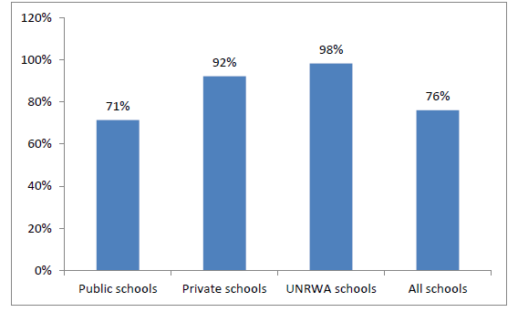

Figure 1. Percentage of schools that own at least one telephone line
Figure 2 shows that of schools that have a mobile phone line dedicated for the school use, 20% of schools in Jordan have such a line. Only 2% of UNRWA schools have a mobile phone line and 76% of private schools have mobile phone line (MoE, MoICT, & JEI (2012).
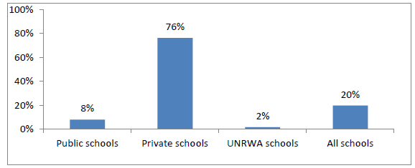

Figure 2. Percentage of schools that own at least one mobile line
The MoE, MoICT, & JEI’s (2012) study found that 98.6% of all schools in Jordan have at least one computer as shown in Figure 3. The total number of computers available in the schools is around 95750, 97% of them are desktop personal computers (PCs) around 92713; the laptops are 3037 around 3% of the total computers.
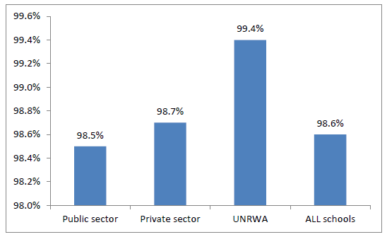

Figure 3. Percentage of schools that own at least one computer by sector
According to MoE, MoICT, & JEI (2012), 85% of the desktop PCs in the schools are used for educational purposes compared with 71% of the laptops that are used for the same purpose as shown in Figure 4.
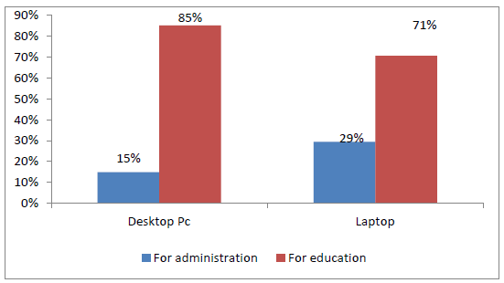

Figure 4. Percentage of computers at schools based on use, purpose and type
Figure 5 shows that students per computer ratio for all schools in Jordan is 14:3 students per computer; the highest ratio was in the UNRWA schools while the lowest was in the private schools 11:9 (MoE, MoICT, & JEI, 2012).
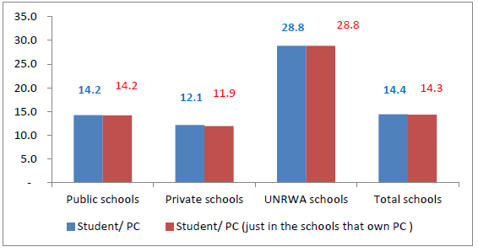

Figure 5. Students per computer ratio in schools that own and do not own PCs
The study of MoE, MoICT, & JEI (2012) found that there are around 8800 computers that are not utilized in the schools in Jordan. As shown in Figure 6, there are several reasons behind this: 40% of the schools indicated that the computers need maintenance, while 16% of the schools reported that the computers are not used because they are damaged. Another reason as stated by 3% of the schools is due to the fact that these computers need to be installed.
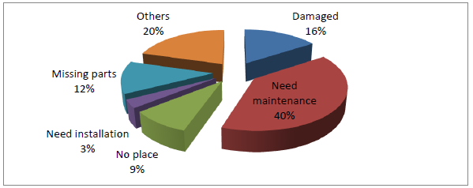

Figure 6. Reasons for not utilizing all available computers in schools
Around 5900 Labs are available in the kingdom’s schools; the majority is in the private sector. Tthe lab per school ratio is 1:3; for the computers average per lab it was around 11 computers per lab. Figure 7, shows at least one lab is available in 85% of the schools in Jordan; 96% of the UNRWA schools are equipped with at least one lab, while 83% of the public schools owns labs.
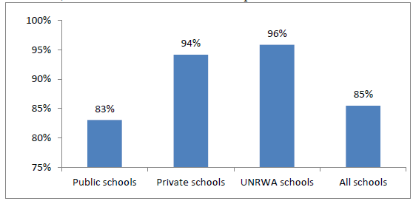

Figure 7. Percentage of schools that owns at least one lab
Figure 8 shows the availability of at least one server in the schools; 47% of the schools owns at least one server.
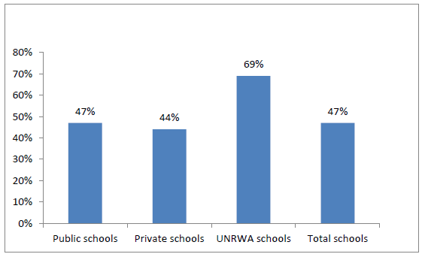

Figure 8. Percentage distribution of schools that owns at least one lab
As shown in Figure 9, most of the schools own printers; while 55% own scanner, and 58% own data show.
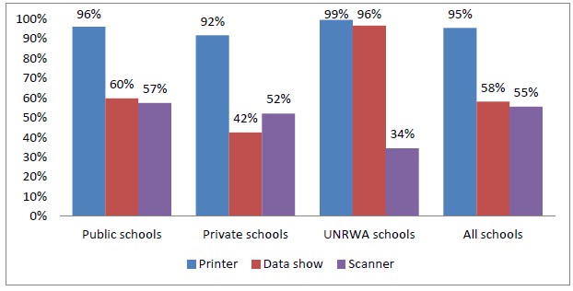

Figure 9. Percentage of schools equipped with computer peripherals

Around 62% of all the schools use additional educational software not available on EduWave e-Learning system. Figure 10 shows that 34% of these schools buy the software; while more than the half stated that the used software are free, 46% of the schools reported that the software are produced by teachers, while 37% said its student’s production.
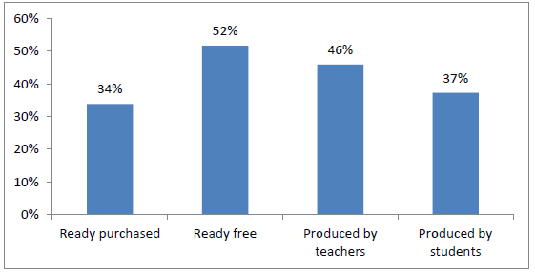

Figure 10. Percentage of schools that use software other than EduWave
Figure 11 shows that 85% of the schools in Jordan are connected to the internet.
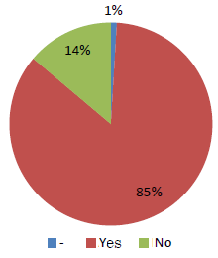

Figure 11. Percentage of schools that are connected to the internet
As shown in Figure 12, 85% of the public schools owns internet while higher percentage at the private sector with 89% and 100% of UNRWA schools.
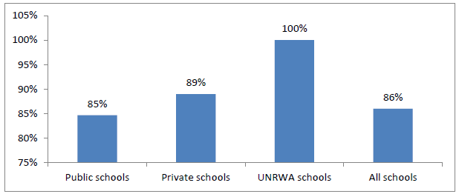

Figure 12. Percentage distribution of schools that owns internet
based on the sector
A significant gap is clear between schools in the city and outside the city; with 95% of schools in the city have internet while 74% of the schools outside the city as shown in Figure 13.
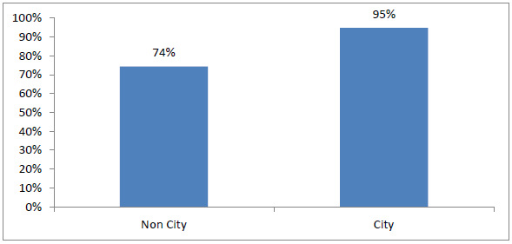

Figure 13. Percentage distribution of schools that own internet
based on the geographic location
As shown in Figure 14, 54% of the schools are connected to internet by Broadband internet, while 26% of them are connected via narrow band, 15% are using the wireless connection.
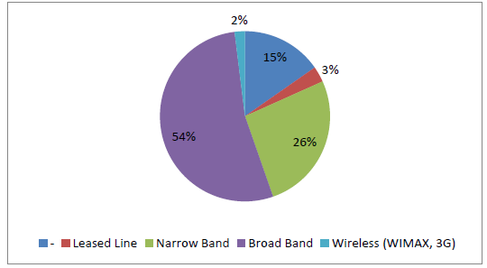

Figure 14. Percentage of the schools connected to the internet
based on the connection type
As shown in Figure 15, 86% of the schools that are connected to internet are using the internet for educational purposes and 74% use it for administrative purposes.
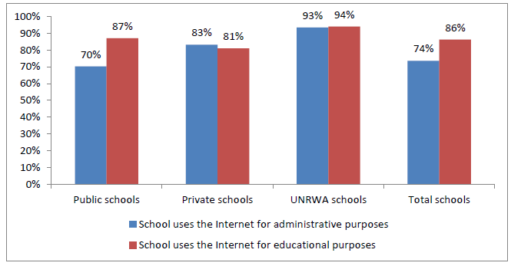

Figure 15. Percentage of schools connected to internet
based on their usage purposes
The most challenge facing schools in using the internet was the slow internet connection and technical issues with 84% of the schools reported this as illustrated in Figure 16; followed by the lack of time available to use the internet at schools with 79%.
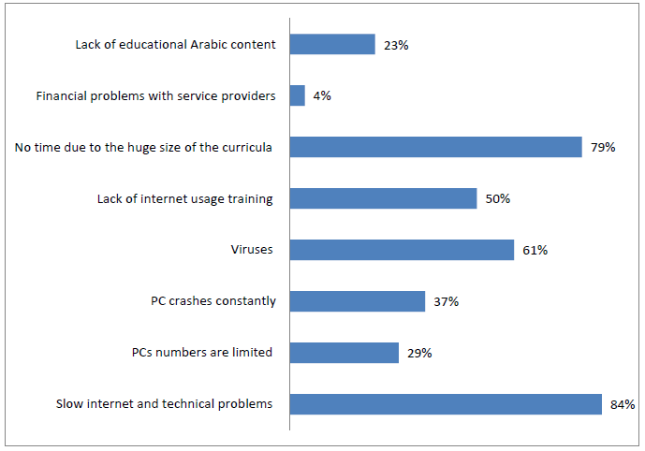

Figure 16. Percentage of schools connected to internet
based on challenges related to internet
As shown in Figure 17, 16% of the schools own a website (605 schools); 16% also own a webpage through the Ministry of Education website; while 9% utilizing the blog.
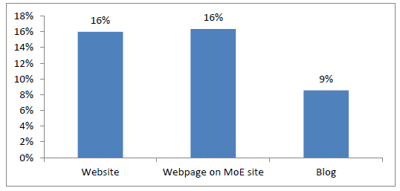

Figure 17. Percentage of schools connected to internet
and own website, webpage and blog
Representing the same percentages for the three sectors as shown in Figure 18, the private sector has the highest percentages, while UNRWA has the least.
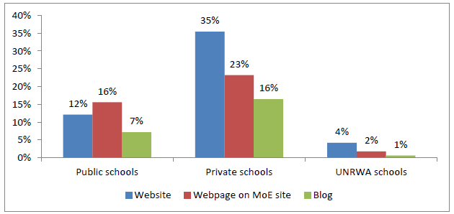

Figure 18. Percentage distribution of schools connected to internet
and own website, webpage and blog, per sector
As shown in Figure 19, 65% of the schools are using their internet presence to introduce and identify the school, 49% for academic purposes, and 39% for communication.
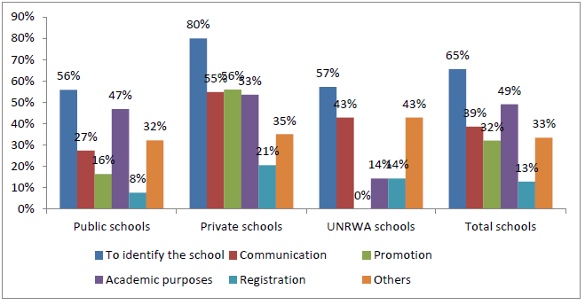

Figure 19. Percentage distribution of schools connected to internet
and own website, webpage and blog, per sector and use purposes
Figure 20 shows that 63% of the schools own e-mail on the government domain (@moe.gov.jo), while 23% own private e-mails at their domain name, and 42% uses the free e-mails. However, 72% of the schools reported that they use their e-mail for working purposes. These numbers were calculated out of the schools which own Internet.

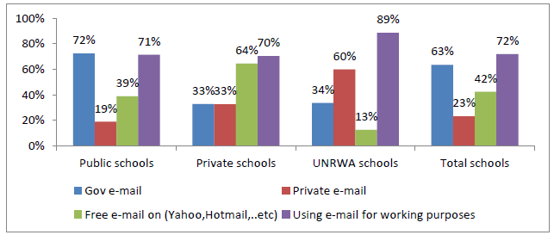

Figure 20. Percentage distribution of schools that own e-mail
and use purposes per sector
Figure 21 shows that 96% of the schools reported that they can access EduWave e-Learning system from the school and use it (4243 schools), 100% of the UNRWA schools, while 95% of the public schools can access EduWave from the school and use it.
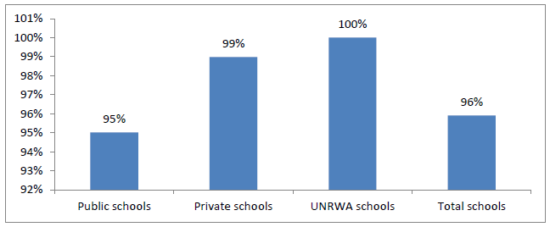

Figure 21. Percentage distribution of schools that can access EduWave e-Learning system from their schools and use it
As for the purpose of using EduWave as shown in Figure 22; the common use is for entering the students’ grades with 97%; followed by the administrative data 95%; then using e-mail at EduWave with 70%, and 69% for using e-contents.
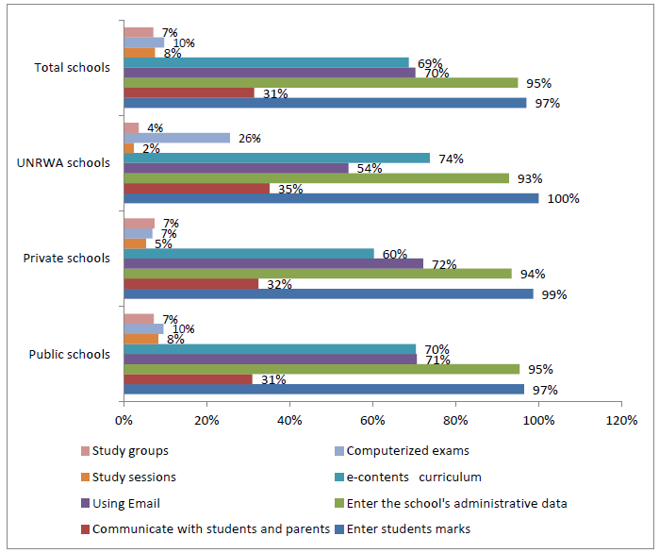

Figure 22. The percentage distribution of the schools where they can access EduWave from their schools and use it based of purposes and sectors
The common challenge facing the school while using EduWave as shown in Figure 23 is the slow internet connection 82% of the schools reported this, followed by 52% reported lack of time available to use the EduWave; 48% said that its due to technical problems in EduWave.
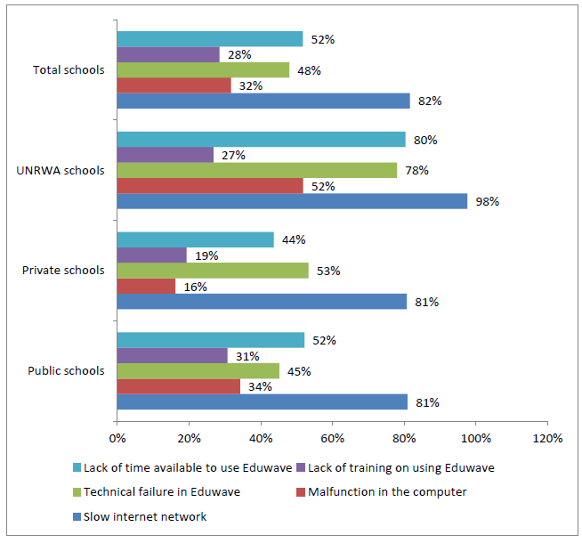

Figure 23. Percentage distribution of schools that use Eduwave
based on the challenges and sector
Figure 24 shows that 78% of the schools reported that they use the e-contents available on EduWave; the higher percentage was for the public schools with 79% and 73% for UNRWA schools.
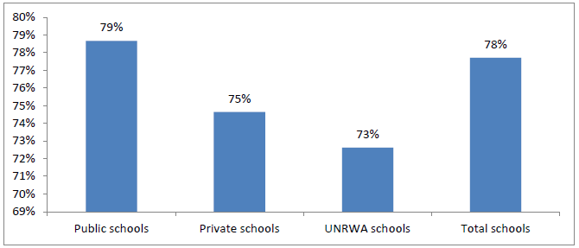

Figure 24. Percentage distribution of schools that use e-contents
In terms of technical support, the average number of technical support visits was around 2.1 per month for all schools, the highest average was for Amman directorates with 13.6 while the lowest was for Aqaba directorate 1.03. Figure 25 shows the time required to provide the technical assistance based on sector; as shown most of the public schools (39%) are waiting more than one week to get the support; while 54% of the private schools received the support during 24 hours.
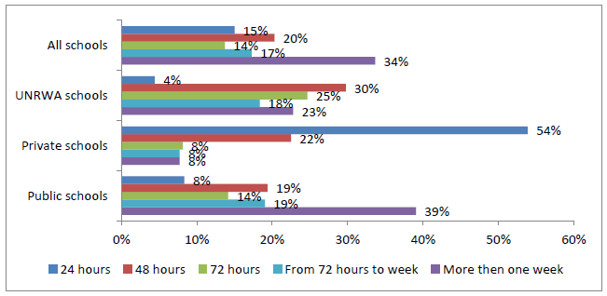

Figure 25. Percentage distribution of time required to provide
technical assistance based on sector
In terms of security and safety software, most of the schools are concerned about the safety and security in using technology and internet; 80% of the schools are using antivirus software; 13% are using firewall while 6% are filtering the content using special tools. Around 240 schools are not using and tool or software for security and safety. As shown in Figure 26, the same trend appears under the three sectors.
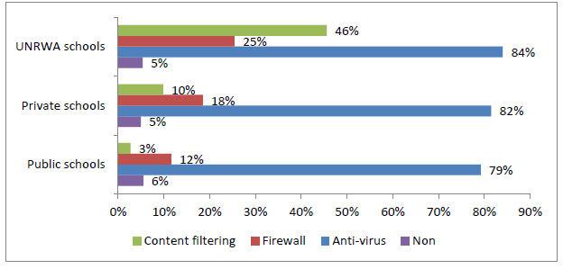

Figure 26. Percentage distribution of schools that use safety and security tools
based on sector
Figure 27 shows that 47% of the schools did not update the ICT hardware so far; 25% update it yearly; and looking at the sectors private schools are the most concerned for updating with 58%; while more than half of the public schools did not update the ICT hardware.
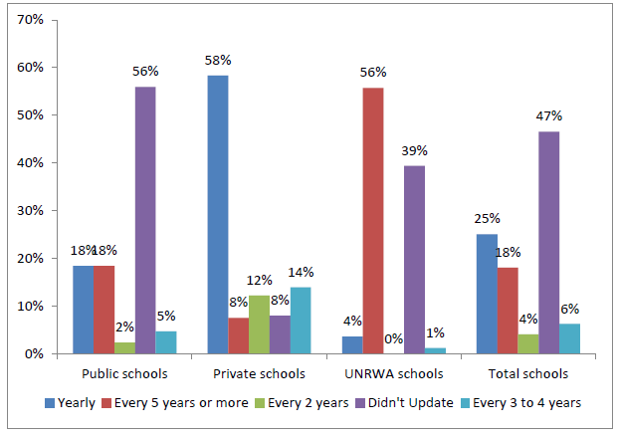

Figure 27. Percentage distribution of schools that update ICT hardware
based on sector
In terms of communicating through social network websites, around 951 schools are using the social networks websites at Internet, as shown in Figure 28; most of those schools are using the Facebook with 53%, while 6% are using twitter, and 41% are using other networks.
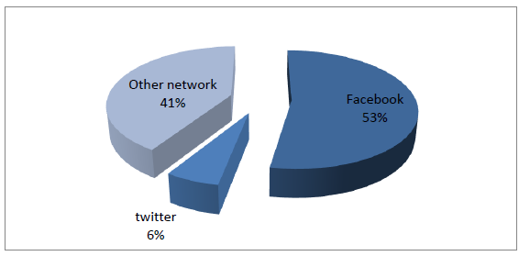

Figure 28. Percentage of social network websites utilization by schools
Looking at the sectors as shown in Figure 29, private schools are more familiar with social networks websites than the public schools. These percentages were calculated out of the schools which communicate through social networks websites.
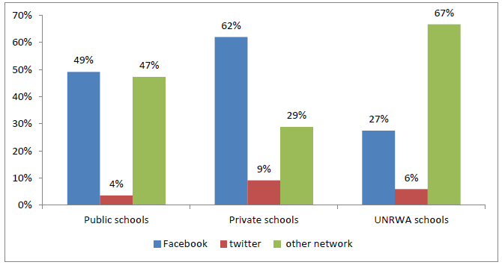Figure 29. Percentage of schools that communicate through social network websites, based on sector
The Internet and EduWave challenges in schools in Jordan are displayed in Figures 30 and 31, respectively.
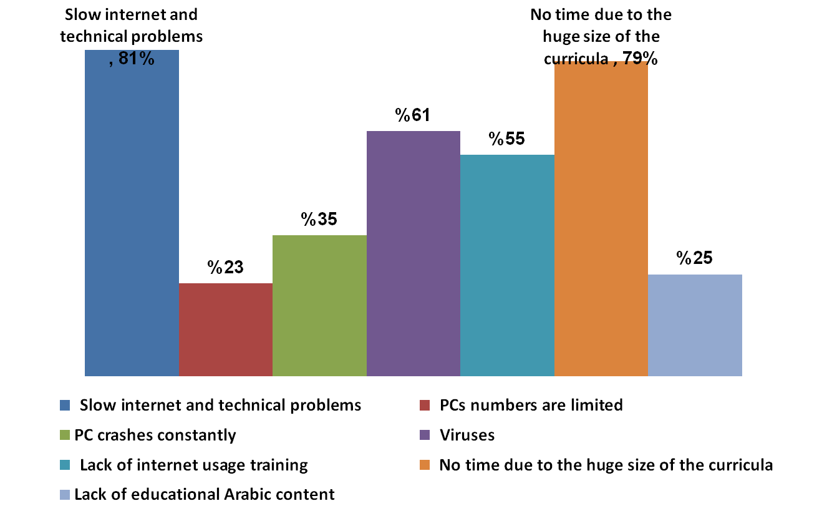

Figure 30. Internet challenges in Jordanian schools
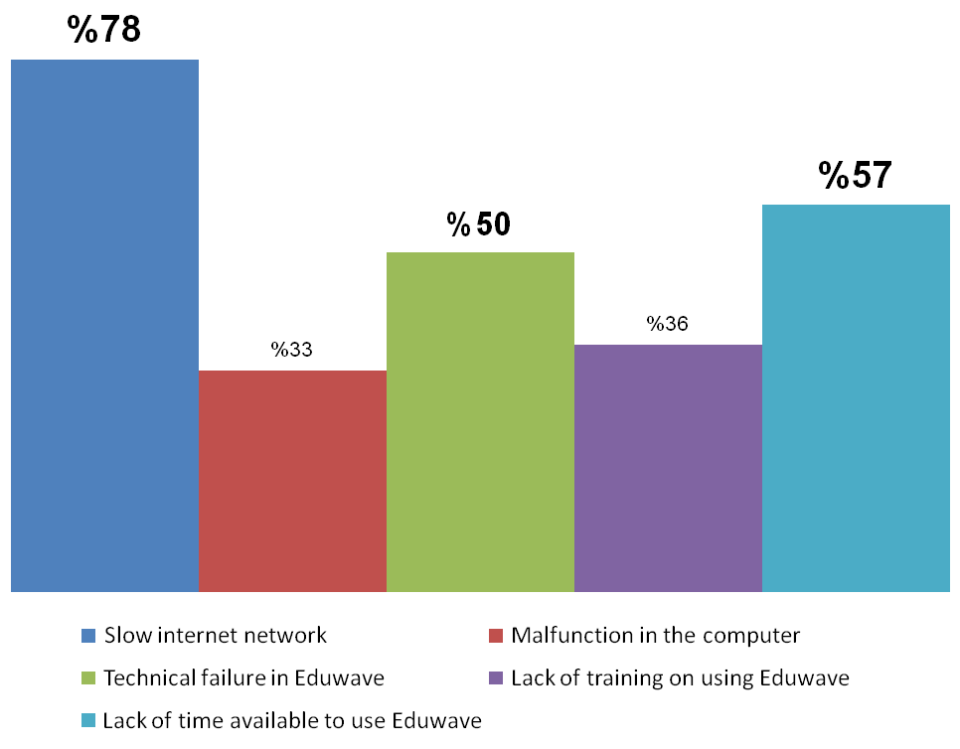

Figure 31. EduWave challenges in Jordanian schools

Jordan education initiative
Developed by the World Economic Forum (WEF) and the Government of Jordan, the Jordan Education Initiative (JEI), incorporates over 17 global corporations, 17 Jordanian entities, and 11 governmental and non-governmental organizations as stakeholders in achieving its goals, thus becoming the first Global-Local, Public Private Partnership program in education, ever launched by the WEF. Launched in June 2003 at the Extraordinary Meeting of the World Economic Forum at the Dead Sea, the JEI was set up to accelerate education reform through public-private partnership models that drive innovation and capability (UNESCO, 2012).
By the end of the its phase one (2003-2007), the JEI has managed to foster and maintain partnerships and had launched multi-million dollar projects that had strong impact on the modernization process of education in Jordan, and had effectively contributed to the development of the local private sector in areas of ICT and Professional Development. Key achievements of this phase were:
- Development of e-Curricula: Six electronic subjects (comprising 3,373 e-learning lessons) were developed from scratch based on the national curriculum, including: e-Math, e-Science, e-English, e-Arabic, e-ICT, and e-Civics. Adopting a blended learning approach, the JEI uses these e-curricula as enrichment tools to support teaching of the national curriculum and to shift the learning process towards a student-centered approach. All e-Contents are deployed on the Ministry of Education national portal (EduWave).
- Teacher Training: For effective deployment of the JEI materials, the JEI, together with the government of Jordan, set out to provide teachers in the participating Discovery Schools with basic ICT literacy programs, as a first step. A general policy was issued by the MoE that required all teachers in Discovery Schools to take the International Computer Driving License (ICDL) Course, as well as other available courses such as Intel Teach and World Links.
- Technical infrastructure: all 100 Discovery Schools were provided with wireless access points, a minimum of 2 computer labs to be used for teaching e-content, and innovative in-classroom technology solutions (laptops, projectors, Interactive white boards. etc). These providing 80,000 students and 3000 teachers with opportunities to research, communicate, and use modern teaching and learning techniques.
Today, the JEI has become one of Her Majesty Queen Rania Al Abdullah’s Not-for-Profit companies working with the Ministry of Education in driving innovation, through leveraging private sector participation. JEI’s work is categorized under three main tracks: (a) Discovery: Piloting new innovative solutions and new partnerships; (b) Expansion: Rolling out through Madrasati (Queen Rania’s companies); and (c) Global: JEI services offered to local/global private sector and governments.

Track 1: Discovery
The quest for innovation and continuous improvement in education never stops and the Discovery Schools, which are fully equipped with the model technology, can serve as test beds and venues for attracting and piloting further innovations. The JEI actively researches in areas of innovation, and seeks to create new international and local partnerships and scope new projects. Each project is based on a partnership and gets implemented using Project Management Institute (PMI) standards in discovery schools. To make sure the projects achieve the desired outcomes, a set of key performance indicators (KPIs) are identified, and the project is monitored and assessed throughout the implementation process. Project results are summarized in a report that is shared with all stakeholders. JEI pilot projects (so far, 31 projects in public schools in Jordan) include various partnerships and a broad range of technologies, aiming at communication, planning, ICT skills, and presentation. These Pilots are well received by schools, and contribute to the overall improvement of each school (UNESCO, 2012).

Track 2: Expansion
The JEI’s experiences with partners and technologies have resulted into a comprehensive JEI model for education using technology (Hardware and Software), training and change management. Through further strategic partnerships, JEI has been able to raise funds to roll out the model in another 100 Schools distributed throughout the kingdom (UNESCO, 2012).

Track 3: Strategic partnerships and global outreach
A strategic goal of the JEI, since its inception, is the creation of a model of reform and partnerships that can be promoted and shared with other countries around the world. Therefore the JEI actively participates in regional and international conferences and forums to promote the JEI model and projects, to generate interest in other countries. The JEI has set up a consultancy arm that can manage and implement projects abroad (UNESCO, 2012). Figure 32 represents the JEI’s educational model. However, for more information about Jordan Education Initiative, visit the JEI’s website at http://www.jei.org.jo/.
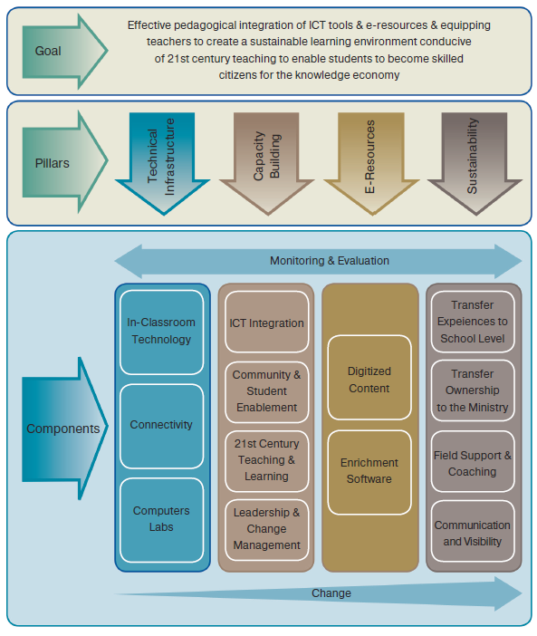

Figure 32. Jordan education initiative’s educational model

Factors affecting teachers’ use of ICT in the classroom
In this section, a number of factors that may affect teachers’ attitudes towards ICT utilization in instruction are presented. Thus, the purpose of this section is to explore factors that might influence the attitudes towards ICT by Jordanian teachers as highlighted by the reviewed literature. Abu Samak (2006) has explored various factors related to teachers’ attitudes towards ICT deployment in school teaching, including computer attributes, cultural perceptions, computer competence, computer access, teacher characteristics and others.
- Computer attributes: the literature indicated that there is a positive relationship between teachers’ attitudes towards ICT and computer attributes. When teachers perceive ICT as a beneficial, compatible with their current activities, easy to use, and have observable outcomes, they will demonstrate positive attitudes towards ICT.
- Cultural perceptions: the literature indicated that cultural perception of ICT might play a role in terms of the teachers’ attitudes towards ICT. Jordanian school teachers may perceive ICT positively in the Arabic cultural context, and thus, they will demonstrate positive attitudes towards ICT. On the other hand, their negative cultural perception of ICT may affect their attitudes towards ICT negatively.
- Computer competence: research has highlighted the importance of teachers’ computer competency in order to utilize ICT educational tools in their classrooms.
- Computer access: the literature indicated that that unless teachers had the necessary computer skills and convenient access to equipment (at schools and/or home), the use of computers as a valuable instructional tool would remain limited.
- Teacher characteristics and ICT: the literature investigated and described some of the major demographic factors associated with teacher attitudes towards ICT such as age, gender, years of teaching, computer experience/use, professional training, and the actual use of ICT by teachers.
However, access to ICT in schools in developing countries, in general, is commonly associated with having computer labs, which are often single rooms with between 1 and 30 networked computers, although some are standalone PCs (Farrell, 2007). Also, the developing countries face several challenges, however, in the attempt to integrate ICT in education. Currently, the curricula across these countries do not prioritize ICT. It is mainly taught in secondary schools and to just a few students as it is offered as an optional subject. In addition, the ICT curriculum focuses on teaching students about technology, not how they can apply that technology to enrich learning. Moreover, students are taught basic computer skills and applications – predominantly word processing, spreadsheets, databases, desktop publishing and Internet – but are not taught how to use ICT as a tool to facilitate learning in other areas. It is difficult to fully determine students’ ICT proficiency from a modest body of published literature but we do know that schools are yet to address the critical question of how ICT can be integrated into other subjects and generally be applied to improve teaching and learning processes (Hennessy et al., 2010).
The reviewed literature have looked at, firstly, the importance of availability and accessibility of ICT resources (hardware, software, infrastructure) in terms of physical and other external factors. Secondly, the significance of context, including national policies on ICT use in a range of contexts (economic, educational, etc), and local level policies (school leadership, curriculum, etc), are discussed in the preceding sections. In so doing, the review has also established that developing countries suffer from typical infrastructure problems including (1) insufficient numbers of computers in schools and other technologies owing to limited funds; (2) absence of properly developed curricula for teaching ICT skills; (3) lack of subject teachers trained to integrate ICT into learning areas (Hennessy et al., 2010).
Qualified teachers are often seen as a catalyst in the introduction and effective use of technology in schools. Unfortunately, in many developing countries, the lack of trained teachers and the low levels of teachers’ ICT knowledge and skills have been identified as major impediments to effectively introducing technology into schools (Mumtaz, 2000).
The real challenge for educationists is, therefore, how to harness the potential of ICT to complement the role of a teacher in the teaching and learning process. Teachers who do not have a chance to develop professionally in the use of emerging technologies and acquire modern computer (ICT) literacy and skills are under threat. The relevance of a teacher in the 21st century is determined by the will to develop professionally and appropriately, while teacher development, according to MacDougall and Squires (1997), should focus on the following aspects in pre-service and in-service training programs: (1) ICT skills with particular applications; (2) integration of ICT into existing curricula; (3) curricular changes related to the use of ICT including changes in instructional design; (4) changes in teacher role in the face of ICT; and (5) underpinning educational theories.
These ICT training programs prepare the teacher to handle the learner-centered processes of education and play the role of facilitator, mentor, and coach. This experience is also a learning experience for the teacher, as it will involve discovering new ideas alongside the learners. The teacher will have to become less authoritative in class and guide the learners on how to ask questions and pose problems, formulate hypotheses, and locate information; and then critically assess the information in relation to the problems posed (Jung, 2005).
The role of the teacher in developing ICT use in schools is utterly critical, yet there are many obstacles to be faced, in addition to those already listed that emerge more generally (such as access to ICT facilities). A primary barrier to teachers’ readiness and confidence in using ICT – despite general enthusiasm and belief in benefits for learners – is their lack of training, either initially or in-service. This results in lack of proficiency in using ICT, and knowledge of all of the potential uses and roles of ICT in teaching and learning. Lack of time is another factor, linked in turn to large classes and teacher shortage rates, lack of funding for salaries and ironically, the admirable goal of universal primary education which requires increasing numbers of trained and qualified teachers. Levels of teacher education and literacy rates are low and ICT training courses in place are inconsistent in quality. Identifying which competencies particular teachers need to acquire is far from simple either, as these are context-dependent and personal teaching styles and school location and other circumstances play a major role (Pohjola, 2003).
Cox, Cox, and Preston (1999) identified a number of factors that contribute to the continuous use of ICT by teachers, such as ICT helps making the lessons more interesting, easier, more diverse, more motivating for the students and more enjoyable. Tella, Tella, Toyobo, Adika, & Adeyinka (2007) found that computer use was predicted by intentions to use it and that perceived usefulness was also strongly linked to these intentions. Generally, if the ICT is available, this will motivate the teachers to access them more than when they are not available or available but not in sufficient quantity and quality.
Mumtaz (2000) investigated factors affecting teachers’ use of ICT in the classroom, her Study revealed a number of factors which influence teachers’ decisions to use ICT in the classroom: access to resources, quality of software and hardware, ease of use, incentives to change, support and collegiality in their school, school and national polices, commitment to professional learning and background in formal computer training. Mumtaz’s study highlights the role of pedagogy and suggests that teachers’ beliefs about teaching and learning with ICT are central to integration. It is suggested that successful implementation of ICT needs to address three interlocking frameworks for change: the teacher, the school, and policy makers.
Papanastasiou and Angeli (2008) examined factors affecting teachers teaching with technology; these factors include knowledge of common software applications, use of common applications, computer confidence, encouragement by colleagues, computer anxiety, beliefs about the computer’s value, the computer as an agent for change, and technology infrastructure. However, the results of this study also show that important factors that do play a role in the successful integration of ICT in schools are those of teachers’ actual knowledge and use of various computer software for professional and personal purposes, teacher confidence and attitudes toward technology, the technology infrastructure and support in the schools, as well as teachers’ beliefs about the use of technology as an agent for change.
Buabeng-Andoh (2012) has reviewed and examined factors that encourage teachers’ use of computer technology in teaching and learning processes. These factors include lack of teacher ICT skills; lack of teacher confidence; lack of pedagogical teacher training; lack of suitable educational software; limited access to ICT; rigid structure of traditional education systems; and restrictive curricula.
It is a fact that teacher training programs play an important role to provide the necessary leadership in training pre-service and in-service teachers to deal with the current demands of society and economy. They should model the new pedagogies and tools for learning with the aim of enhancing the teaching-learning process. Moreover, teacher education institutions and programs must help teachers to understand how the new technologies can best be used in the context of the culture, needs, and economic conditions of their country. Hence, building the capacity of teachers in the utilization of ICT for education requires long-term continuous development of the lead trainers, sharing of knowledge among teachers, partnerships and collaboration among educators and organizations, and support from principals and administrators. These factors must be available in order to create changes in the classroom. Therefore, both teachers and trainers require ongoing support and opportunities to experiment with new skills and strategies concerning ICT use over time (Afshari, Bakar, Luan, Samah, & Fooi, 2009).

Teachers’ barriers to the use of ICT in instruction
Across most developing countries in the Middle East, there are many challenges in bringing ICT into teacher training and the education process in general. Hismanoglu (2012) identified a range of factors that affect ICT use by teachers, including many of those physical and cultural factors identified in the literature. In addition, educational factors including levels of teachers’ own education and literacy rates and access to professional development play an important role.
Albirini’s (2006) study revealed that the most significant barriers identified are linked to staff attitude and training in the use of ICT, access and ICT skill in general. Specifically, attitudes of trainees and teacher trainers indicate a gross lack of independent learning skills and a reluctance to take responsibility for their own learning. There is also a general inadequacy of learning resources, course curriculum and other learning materials that incorporate ICT use. Consequently teachers’ expertise and lack of knowledge to evaluate the use and role of ICT in teaching (or technophobia in teachers and teacher trainers) are prominent factors hindering teacher’s readiness and confidence in using ICT support. Moreover, there is a lack of qualified IT professionals who might work with teachers on ICT-related matters and this is exacerbated by the problem of ‘brain drain,’ leading the experts to opt for better paying jobs elsewhere (Alev, 2003; Alemneh & Hastings, 2006).
Marshall (2002) reported that teachers continue to identify the lack of time as a barrier to the use of ICT. While some interpret this to mean that staff have not have had the time to acquire the necessary skills in the use of such technology in teaching. Surveys of academic staff attitudes to the use of ICT have identified time, an absence of skills and knowledge, and the lack of a national policy on the use of computers in schools as significant barriers to ICT adoption and to the use of computers (Marshall, 2000). Importantly, few of the surveyed schools’ teachers in Marshall's study were concerned about the following barriers: computers did not match instructional goals or methods; the use of computers would have no value for students; and the introduction of computers in schools would affect teachers’ jobs status or stability.
Mumtaz (2000) investigated the barriers to successful implementation of technology integration in educational settings. She examined why teachers do not use computers and ICT tools in their teaching; she found a list of inhibitors (factors that prevent teachers from using ICT): (a) lack of teaching experience with ICT; (b) lack of on-site support for teachers using technology; (c) lack of help supervising students when using computers; (d) lack of ICT specialist teachers to teach students computer skills; (e) lack of computer availability; (f) lack of time required to successfully integrate technology into the curriculum; and (g) lack of financial support.
Despite the efforts expended by the MoE in developing the learning teaching process through the employment of ICT in instruction, teachers still face barriers to the use of ICT in classrooms (Al-Jaraideh, 2009; Abu Samak, 2006; Ihmeideh, 2009). Thus, this justifies the present study’s investigation of the barriers that inhibit Jordanian in-service teachers from using ICT in their instruction through the review of the related and updated literature within Jordanian context. The purpose of finding out the barriers to the use of ICT that teachers encounter in instruction is to assist policy makers and educators in Jordan in their evaluation of ICT initiatives, educational programs, materials, curricula, and teaching procedures.
Rababah, Bani Melhem, Jdaitawi, Rababah, and Rababah (2012) conducted a study to examine English as Foreign Language (EFL) teachers’ barriers to the use of ICT in instruction in Jordan. The study revealed that the integration of ICT in EFL instruction is generally low among the EFL teachers due to a key of barriers that face them. These barriers led to insufficient or no integration of ICT in Jordanian schools. They are as follows: lack of time, lack of training, lack of support and resources, lack of confidence, lack of computer hardware and software, and lack of competence.
Hennessy, Harrison, and Wamakote (2010) have identified a range of physical, cultural, and educational factors that affect ICT use by teachers, including lack of reliable access to electricity, limited technology infrastructure (especially internet access, bandwidth, hardware and software provision), language of instruction and available software, and levels of teachers‟ own education and literacy rates. They also indicated that teachers’ attitudes and expertise, lack of autonomy, and lack of knowledge to evaluate the use and role of ICT in teaching are the prominent factors hindering teachers’ readiness and confidence in using ICT support. Moreover, they indicated that the lack of incentives and support for teachers are other factors hindering their use of ICT.
Bingimlas (2009) explored the barriers to successful integration of ICT in teaching and learning environments; he identified some challenges for implementing ICT in education. The most common challenges are: teachers hesitate to change; some teachers do not have the skills to use ICT tools; and there is an institutional reluctance to provide sufficient personnel and financial assistance to facilitate the use of such technology. Other challenges is that timely teachers development, support, and learning materials are required to integrate ICT tools effectively; moreover, potential users are often reluctant to acquire the skills for using such technology. In addition, he included the following barriers to integration of ICT into education at teacher-level and school level: lack of teacher competence, lack of teacher confidence, resistance to change and negative attitudes, lack of time, lack of effective training, and lack of technical support.
Jabaka and Danbaba (2014) have discussed specific teacher personal characteristics which could have significant influence on learners and learning. These characteristics can be regarded as factors that facilitate or ruin instruction in the classroom. According to Jabaka and Danbaba, some of these teacher-related factors are: teacher’s attitude, teacher’s initial training, teacher technophobia, and teacher ICT competence.
Khan, Hasan, and Clement (2012) examined the barriers encountered when introducing ICT into classrooms and obstacles to the implementation of ICT in education; these barriers and obstacles are: lack of knowledge and skills, lack of time, teachers’ attitudes and beliefs about ICT, insufficient funds, and limited technological resources within educational institutions.
Tedla (2012) explored factors preventing the use of ICT in education; he mentioned that there are several factors that inhibit the application of ICT into classroom instruction. Some factors are school base (internal) while some are community base (external), and teacher’s personal issue. The impact factor could be different, but these factors affect the use of ICT directly or indirectly in a great way. Researches identify these factors as non-manipulative, manipulative and teacher factors. Non-manipulative refers to the factors, such as age, teaching experience, computer experience, government policy and the availability of external support; whereas the manipulative factors refers to teachers’ attitude towards the use of ICT, teachers’ knowledge and skills about ICT, and school commitment for implementation process.
Jones (2004) reported a review of the research literature on barriers to the uptake of ICT by teachers; the key findings of his report are:
- A very significant determinant of teachers’ levels of engagement in ICT is their level of confidence in using the technology. Teachers who have little or no confidence in using computers in their work will try to avoid them altogether.
- There is a close relationship between levels of confidence and many other issues which themselves can be considered as barriers to ICT. For example, levels of confidence and therefore levels of ICT use are directly affected by the amount of personal access to ICT that a teacher has, the amount of technical support available, and the amount and quality of training available.
- Levels of access to ICT are significant in determining levels of use of ICT by teachers. However, it is not necessarily the case that a school with low access does not have enough equipment; it may be that the amount of equipment is adequate but inappropriately organized in the school. Equipment should be organized in such a way to ensure maximum access for all users.
- Inappropriate training styles result in low levels of ICT use by teachers. Courses which lack pedagogical aspects are likely to be unsuccessful, but there also needs to be an element of ICT skills training.
- Teachers are sometimes unable to make full use of technology because they lack the time needed to fully prepare and research materials for lessons, particularly where this involves online or multimedia content. Time is also needed for teachers to become better acquainted with hardware and software.
- Technical faults with ICT equipment are likely to lead to lower levels of ICT use by teachers. Recurring faults, and the expectation of faults occurring during teaching sessions, are likely to reduce teacher confidence and cause teachers to avoid using the technology in future lessons. The lack of available technical support is also likely to lead to teachers avoiding ICT, for fear of a fault occurring that cannot be rectified and lessons being unsuccessful as a result.
- Resistance to change is a factor which prevents the full integration of ICT in the classroom. This resistance can be seen in terms of teachers’ unwillingness to change their teaching practices, and also in terms of schools as institutions finding it difficult or being unable to re-organize in ways which facilitate innovative practices involving ICT.
- Teachers who do not realize the advantages of using technology in their teaching are less likely to make use of ICT. Any training program needs to ensure that teachers are made aware of the benefits of using ICT.
- Little evidence was found in the literature to support the view that age affects levels of teachers’ ICT use. Younger teachers are no more likely to make use of ICT in their work than their more experienced colleagues.
- There is some evidence to suggest that teachers’ gender has an effect on the degree to which they use ICT, with male teachers making more use of ICT than female teachers, and with female teachers reporting greater levels of computer anxiety than male teachers. This may have a significant negative effect on the use of ICT in primary schools, where there are more female teachers than male teachers.
- There are close relationships between many of the identified barriers to ICT use; any factors influencing one barrier are likely also to influence several other barriers. For example, teacher confidence is directly affected by levels of personal access to ICT, levels of available technical support and the amount and type of training available, all of which can be seen as barriers to ICT themselves.
Moreover, Jones (2004) has categorized the barriers into two groups: barriers relate to the individual (teacher level barriers) and barriers relate to the institution (school level barriers). The barriers identified are as follows: (1) School level barriers include: lack of time, lack of access to resources (lack of hardware, inappropriate organization, poor quality software), lack of effective training, and technical problems. (2) Teacher level barriers include: lack of time, lack of confidence, resistance to change & negative attitudes, no perception of benefits, and lack of access to resources (personal/home access).
Goktas, Yildirim, and Yildirim (2009) investigated the main barriers and possible enablers for integrating ICT in Turkey’s pre-service teacher education programs. The findings of their study revealed that lack of in-service training, lack of appropriate software, hardware, and materials, lack of basic knowledge/skills for ICT integration, lack of technical support, lack of appropriate course content and instructional programs, lack of time, and lack of appropriate administrative support are the main barriers for integrating ICT in pre-service teacher education programs. Goktas, Yildirim, & Yildirim have offered the following suggestions to overcome the ICT barriers (possible enablers): having technology plans, offering in-service training, allocating more budgets for ICT equipments, supporting teacher educators (i.e., incentive payment), and reduce the course load of the teacher educators.
Nyambane and Nzuki (2014) examined factors influencing ICT integration in teaching; they found that Teachers’ attitudes, ICT competence, computer self-efficacy, teaching experience, teacher workload, professional development, availability and accessibility of ICT resources, technical support, and leadership support were the major factors that influence ICT integration in teaching.

Barriers to utilizing ICT in education in Jordan
Abuhmaid (2008) conducted a study aimed at analyzing the ICT integration within the Jordanian education system. He investigated the barriers, obstacles, and factors associated with teachers’ adoption and implementation of ICT in schools in Jordan. Theses factors/barriers are: teacher ICT competence, attitudes towards ICT classroom integration, ICT training, ICT skills and pedagogical skills, time and timing of ICT training, teachers’ interaction and collaboration, teachers’ belief in the potential of ICT, school leadership, infrastructure, and the ease of access to computers’ location in schools.
Al-Mobaideen (2009) examined ICT acquisition in Jordanian universities and investigated the critical success factors influencing ICT adoption in universities in Jordan. He stated that many factors played a role in the relatively accelerated adoption of ICT in Jordanian universities. Consequently, the policy makers in the Ministry of Higher Education in Jordan will be more informed in their future endeavours regarding the factors that impede or facilitate the implementation of ICT and its adoption rate throughout the country’s higher educational system. However, Al-Mobaideen’s study has identified some fundamental critical success factors that would act as enablers to build a model for the successful implementation of ICT in Jordanian universities. These factors were: strategies and policies; infrastructure and networks; funding and sustainability; and culture; in addition to the individuals’ factors which imply abilities, skills, attention, behaviour and training.
Accordingly, the most important factors which influence ICT application in this context were: internal and external orientation; assessing the current situation of ICT in Jordanian universities; identifying and indicating many critical success factors that related to ICT adoption, such as culture; infrastructure and networks; policies and strategies; funding and sustainability. This means that effective integration of ICT into the educational system is complex, involving not just technology but also curriculum and pedagogy, university readiness, individuals’ competencies, long-term financing and sustainability, policies and strategies. Also, environmental elements play an important role in ICT adoption (Al-Mobaideen, 2009).
MoE, MoICT, & JEI (2012) identified the barriers that might face ICT usage in schools in Jordan and the reasons behind these obstacles. The followings are the main issues that were raised by the study:
- Insufficient number of computers, computer labs, and lab chairs besides unfair distribution of labs’ equipment, and too old computers with frequent break down. In other words, the computers at most of the schools are not sufficient and not matching the demand and number of students.
- Inefficient maintenance work and the need to follow up on computers when they are out of order, things become more complicated when talking about the routine of reporting technical failures and prolonged maintenance time.
- Shortage of computer labs technicians.
- Inexperienced computer lab technicians besides teachers’ incapability to employ technology in education
- Slow Internet connection and the absence of Internet service at many teachers’ homes. Moreover, despite the fact that most schools have Internet access, they still suffer from certain network disconnection issues.
- Lack of knowledge of EduWave e-Learning system and the e-content by some teachers.
- Teachers’ professional development courses timing is inconvenient. The majority of teachers complain that training courses usually start after 3:00 PM.
Al-Shboul (2012) investigated the factors influencing teachers’ adoption and integration of ICT in their instruction in public schools in Jordan. His study revealed that the following obstacles were facing the use and utilization e-Learning and ICT tools as perceived by Jordanian teachers at public schools: absence of incentives for teachers, heavy teaching load, insufficient teachers’ training programs, insufficient encouragement from school administration, lack of teacher ICT skills, and lack of teacher confidence.
Alassaf (2014) analyzed lecturers’ attitudes towards the use of ICT in teaching at Jordanian public universities. He examined the factors affect ICT use in teaching and learning; these factors include lack of training, lack of technological infrastructure, students’ ICT skills and motivation, teachers’ workload, lack of administrative support, lack of financial resources and incentives, lack of technical support, absence of ICT strategic plan, and lack of clear vision on ICT use. Based on these factors, ICT use is negatively affected and the consequences of this could be chaos and uncertainty, for example, waste of time and efforts, lack of understanding and failure of effective ICT integration in educational institutions in Jordan.
Alkhawaldeh and Menchaca (2014) explored the barriers to utilizing ICT for teaching and learning in Jordan as perceived by students, teachers, and administrators. The identified barriers and ICT utilizations factors within Jordanian context according to the study are: lack of confidence, disbelieving ICT benefits, lack of sharing best practices, lack of Training, government procedures, lack of time, lack of infrastructure, lack of access to technology, lack of technical staff, change resistance, lack of incentives and motivations, lack of institutional supports, integration difficulties, transferring of teachers, and lack of ICT skills.
The results of Alkhawaldeh and Menchaca’s study lead to the argument that the barriers to the uptake of technology in education will be always present. Although the Jordan Education Initiative (JEI) discovery schools are adequately -equipped with ICT infrastructure compared to the rest of public schools in Jordan; barriers to utilizing ICT in the JEI schools are still evident. This means that even if all Jordanian schools were fully equipped with ICT infrastructure, there will always be some teachers who resist the change or disbelieve in ICT benefits.
Furthermore, it can be noticed from the results that significant number of barriers is related to the lack of facilitating conditions. Since the Jordanian Ministry of Education (MoE) is responsible for providing the best means to enhance public education in Jordan, the ministry should take a greater role in allocating more resources and opportunities to facilities the process of integrating technology into education. It is true that ministry cannot do much regarding the barriers are related to financial issues; but the ministry should still be able to facilitate the process by offering occasions for sharing the best practices, providing more training to teachers, and controlling the issue of transferring teachers.
Overall, the following are important implications of Alkhawaldeh and Menchaca’s study: (a) the need to obtain more local and global support of the JEI to replicate its model all over Jordan, (b) the need to provide more technical and pedagogic training for teachers, and (c) the need for more institutional support by the MoE.
Although the Alkhawaldeh and Menchaca’s study concluded those barriers to ICT implementation were common and perhaps to be expected, addressing such barriers continues to be paramount. Thus, to overcome such barriers, the following procedures are recommended:
- The need for more institutional support from the Ministry of Education in Jordan.
- The need to focus more on teachers’ development.
- Since a lack of sufficient training was a common barrier, there is a need for more systematic training for all the involved stakeholders.
- The need for holding forums and occasions for sharing best practices.
- The need for facilitating communication among involved stakeholders using ICT.
- The need for more professional development for the supervisors from the MoE.
- The need for continuous update and assessment of curriculum.
- The need for inviting more local and global partners to support the JEI.

SWOT analysis of the integration and use of ICT in schools in Jordan
Almarabeh and Mohammad (2013) reviewed the status of e-Learning (ICT) at the Jordanian universities in SWOT model showed that Jordan has sufficient awareness of the importance of e-Learning and ICT, the factors that help in the success and the challenges of such project, and explained that the implementation process is gradual and needs patience, encouragement, and continuous technical support. Thus, the increasing availability of effective technology and e-Learning tools at Jordanian universities in general, and in schools in specific, justifies investigating the perceptions and attitudes of teachers towards such tools and the challenges that are associated with using these technologies.
MoHESR (2009) has initiated and launched a national e-Learning and ICT strategy for higher education (2007-2010) developed by e-Learning steering committee. This strategy presents the strengths, weaknesses, opportunities, and threats for adopting e-Learning in the higher education institutions in Jordan, and then sets forth seven strategic goals:
- To enable higher education institutions in Jordan to adopt ICT and e-Learning and facilitate widening access to learning.
- To support higher education institutions in their strategic planning with a holistic approach to embedding ICT and e-Learning including implementation, administration, and change management.
- To create a culture and awareness for ICT and e-Learning.
- To establish a robust integrated virtual learning environment.
- To assure the quality of ICT and e-Learning and their impact on students’ teaching, learning and assessment experience.
- To promote learning and educational technologies research that focuses on student learning rather than on technology and on faculty and teacher development.
- To lead the move towards instilling lifelong learning and enabling connections between academic learning and experiential learning (MoHESR, 2009).
These goals are followed by specific objectives with action plans to achieve the set goals. The strategy is intended to set up the blueprint for policy makers to embed ICT and e-Learning within the higher educational systems in Jordan. The steering committee will continually assess progress toward meeting the goals, provide annual reports and updates, and maintain the flexibility to revise the set goals and plans as external and internal conditions change (Al-Shboul, Rababah, Al-Sayyed, Sweis, & Aldreabi, 2013).
However, the SWOT analysis is a business analysis technique that the organization or institution can perform to each of its products, services, and markets when deciding on the best way to achieve future growth. The process involves identifying the strengths and weaknesses of the organization or institution, and opportunities and threats present in the market that it operate in. The first letter of each of these four factors creates the acronym SWOT (Free Management eBooks, 2013), as illustrated in the Table 1.
Thus, the main reason of conducting a SWOT analysis for the ICT use and diffusion in Jordanian schools is to help educational leaders and strategic planning managers in the Ministry of Education in Jordan to find its strength points and opportunities which will contribute to a successful integration of ICT in Jordanian schools; it also to help the Ministry of Education to realize its weaknesses which should be eliminated to make the utilization of ICT in education in Jordan successful.

Table 1

Illustrative diagram of SWOT analysis
 | Helpful in achieving the objective | Harmful in achieving the objectives
Internal origin | Strengths | Weaknesses
External origin | Opportunities | Threats
Despite the fact that our schools and universities are distinguished in the quality of teaching and research, their utilization of e-Learning and ICT is still in the middle stages and we may face many challenges in this regard. We have excelled in some areas related to information technology and have many challenges to face as well. In what follows, the researcher will identify the strengths, weaknesses, and threats in ICT in Jordan as well as the many opportunities that will be available. So, the Jordanian Ministry of Education be able to utilize the strengths and build on them, mitigate the weaknesses, avoid the threats, and exploit the opportunities.
According to the main points highlighted by the study and the current situation of ICT in education in Jordan, the following is dissection of the strengths, weaknesses, opportunities and threats of the use of ICT in Jordanian schools.
Strengths
- The vision of His Majesty King Abdullah II that “Jordan will become an IT hub for the region” has been a rallying call to all Jordanians to pull together to realize His Majesty’s vision for the future benefit of all citizens.
- In 2003, the Jordanian Ministry of Education (MOE) lead Jordan to become the first country in the Arab world to take clear steps into applying true ICT to all its students by deploying EduWave e-Learning system at the Kingdom’s main Data Center and to serve over 1.3 million students in Jordan.
- Connecting Jordanians Initiative (CJI): A National Broadband Learning and Educational Network (NBN) has been lunched in 2003 and it installed approximately 5,000 km of optical fiber and several thousand IT-network devices to create one of the most advanced educational networks in the world. This network links Jordan’s 3200 public schools, 10 public universities, 23 community colleges, and 75 Knowledge Stations to support the transformation of Jordan’s formal and informal education system. Currently, the Schools Broadband Learning Network has been lunched.
- Knowledge Stations: 114 public centers with computers, internet, and trainers spreading all over kingdom to provide electronic services to the community and to train Jordanians.
- Jordan Education Initiative has produced 5 e-curricula (Math, ICT, English, Arabic, Science) since it started in 2003, and it has been piloted in 100 Discovery Schools.
- Jordan is already well endowed with telecommunications infrastructure. A fixed or mobile telephone service is available almost universally in inhabited areas of the country, and penetration has reached more than 97% of households overall.
- Mobile penetration in Jordan is growing rapidly and reached 140% by the end of 2012; smartphone penetration in Jordan reached 42% by the end of 2012; Internet penetration in Jordan reached 63% by the end of 2012, mainly due to significant drops in mobile charges. 40% of Jordanian households have a PC; 50% of households have at least one main line telephone.
- The kingdom ranks as one of the countries whose fixed Internet network performance is improving at an advanced level.
- The Jordanian Government equipped all Jordanian schools with computers and internet connection and instituted an ICT curriculum into Jordan’s education system.
- ICT faculties were established in Jordanian universities and these campuses have been churning out 15,000 ICT graduates every year.
- Information access centers were established across the Kingdom to allow rural areas access to the Internet.
- The Jordanian Government has overwhelming supported education initiative and heavily invested in Jordan’s ICT sector. The result is the most competitive ICT industry in the region. Moreover, Jordan has one of the highest internet penetration rates in the region. All of these accomplishments have happened in the past few years.
- The quality and reliability of the telecommunications infrastructure is above global standards.
- Jordanian universities and schools have robust, standards-based information technology network infrastructure, including hardware, software, and applications for intra-university connectivity; and global connectivity through the Internet.
- ICT helps students study subjects using a wide range of sources.
- Most students are ready to learn new skills.
- The development of students’ skills to use ICT for their lifelong learning activities.
- The majority of teachers have attended and obtained an International Computer Driving Licence (ICDL); thus have ICT skills.
- The teachers have noticed the main difference between a traditional and computer-based learning (saving time, motivating students).
- ICT helps students with disabilities.
- ICT helps both students and teachers realize that teaching and learning are interactive processes.
- More flexibility of time, pace and place of study, enhanced quality of pedagogic process, and enlarged and enriched offer of various study materials.
- Development of new skills and knowledge (for example - increased knowledge how to use modern ICT).

Weaknesses
- E-Learning and ICT experience is immature in most Jordanian schools.
- There is no common understanding of the benefits of e-Learning/ICT; some see it as a lesser form of education (when compared with traditional classroom-based, teacher or professor-led instruction). Very few people see the potential it can bring to improving the quality of education, and increasing the reach and breadth of educational opportunities.
- There is no holistic or coordinated/collaborative approach to ICT that considers the cost of PCs and Internet access.
- There is no broad adoption of international web-based training development standards.
- There is no large-scale production of courseware or e-Content curricula.
- There is a lack of content developer or little evidence that content developers are trained in instructional design, learning theory, and instructional technologies.
- Despite the skilled human resources of Jordanian people, there is no source for training e-Learning course developers and instructional technologists.
- There is a lack of cooperation/collaboration between schools and private sector in ICT. Also, there is no cooperation/collaboration between subject experts, content developers, and instructional technologists.
- There is a lack of skills for self-paced learning which has been addressed by the JEI.
- There is no Jordanian ICT community.
- There is no ICT “champion” who works at the highest levels of government, with enough clout to obtain inter-ministry cooperation and collaboration, plus inter-school cooperation and collaboration.
- ICT needs commitment and leadership support from the Minister of MoE, top-level administrators at MoE, and schools principals.
- Most of the content being developed does not leverage ICT instructional design.
- Huge investments need to be made to provide the infrastructure and content to address school required courses and to build capacity in ICT.
- Some teachers hesitate to use ICT.
- There is limited resources and computers for each classroom/computer laboratory.
- Inadequate funds, support, and incentives.
- Some students do not have appropriate equipment nor access to Internet at home.
- Some students have no basic skills needed for the use of ICT.
- Substantial workload of teachers and lack of time.
- Introducing ICT as result of individual initiative not always supported systematically by leadership of institution.

Opportunities
- Prepare Students for the knowledge economy which places a premium on innovation, customization, new business models, and new ways of organizing work. ICT will improve students’ skills and teach them new ways of managing knowledge and information; so they can be more productive, find high-quality jobs, be self learners, and have a positive impact on the success of their future employers, their families, and their communities
- There is a strong desire to improve the quality of education in Jordanian schools; ICT is perceived as one of the solutions to improve the quality of instruction and to raise the performance in the University Achievement Exam to the international level.
- Students have a chance to present their work in a way that suits them.
- Integrate ICT with all subjects, so this could replace or be combined with traditional teaching methods.
- Encourage active cooperation of school and businesses, public and private sectors, as well as the local community and government bodies, in computerization.
- Increased opportunity for education for certain target groups (learners with special needs or those with disabilities).
- Opportunity for constant innovation and research in the pedagogic process.
- Professional development of teachers and other technical staff.
- Opportunity to enrich study program supply by offering short-cycle modules.
- Possibility to involve in international ICT projects and in the process of globalization as partner in equal terms.

Threats
- Throughput and width limitations could limit usage of advanced media; i.e., streaming video, large graphical and data files.
- The MoE and private sector need to cooperate rather than direct or indirect competition in content development for students advantage in schools.
- There is no framework or regulations to govern ICT practices and quality assurance procedures in Jordan.
- There are no policies or in place Intellectual Property Right to protect ICT content authors.
- ICT needs strong cooperation and collaboration between MoE, MoHESR, MoICT, and schools.
- There is a lack of ICT culture and there is some fear of ICT, particularly among teachers, who do not have a clear understanding of their role in ICT (will they be replaced? What happens to the course materials t have worked so hard to develop? Who will take care of my students? They need me!). There are concerns that most of Jordanian students lack the ability to be self-learners, soft skills, and personal and time management skills.
- The high up-front costs and large recurrent costs.
- Lack of training or insufficient training.
- Theft of or damage to ICT equipment in schools.
- Distractions of ICT tools and devices.
- Unclear ICT development strategy or lack of institutional ICT policy, which can be important drivers for educational reform.
- Adjustment of financial, staff, and organizational scheme are needed.
- Adaptation of technological infrastructure, both in terms of technical requirements and user behaviour, is needed.

A SWOT matrix summary of ICT in education in Jordan is demonstrated in Table 2.

Table 2

A summary of SWOT analysis of ICT in education in Jordan
Internal Strengths | Internal Weaknesses
- Good leader’s vision and initiative in education reform  - The expansion of ICT infrastructure coverage in the country (rural and urban areas) is boundless, including telephone, ADSL, and internet networks  - ICT is a more flexible way of delivering teachers’ in-service-training  - There is a good backbone ICT system (EduWave) at the school level serving the Kingdom educational system and providing good e-Learning services  - The Jordanian Government has policies and programs to promote the ICT industry and expand ICT into rural areas; which could help schools in terms of distance learning  - There is an increasing pool of people with ICT knowledge and skills. There are more ICT graduates inside and outside the system  - Administrators in both the public and private sectors appreciate the importance of ICT more, thus increasing the use of ICT in education in the country  - Fixed and wireless ICT infrastructure provides full coverage in the big urban service areas. ICT can be used to increase educational opportunities in the provincial areas in terms of using mobile learning  - New operators that receive the permit from the National Telecommunication Commission such as the Metropolitan Electrical Authority and the Provincial Electrical Authority may allow small operators to lease dark fiber and invest in BPL (Broadband over Power Line) technology so they can provide last mile access themselves at low charges  - Jordan has the potential to produce software and digital content (such as animation) for educational purposes; so can have a business with the regional academic institutions  - Mobile penetration in Jordan is 140% and is growing rapidly; Internet penetration in Jordan is 63%; and 40% of Jordanian households have a PC. | - Some teachers and students have limited access to computer services (Digital Divide)  - Technical infrastructure issues i.e. IT equipment not fit for purpose  - IT literacy of some school teachers i.e. some not literate  - Not all teachers within the trust engaged/supportive of ICT  - Lack of quality ICT training material  - The ICT for education budget is insufficient and imbalanced, resulting in differences in educational institutions in the urban and rural areas and imbalanced budgets for the acquisition of equipment, software, and personnel development  - Basic infrastructure of ICT for education in the rural areas is still insufficient for quality development  - There is still a shortage of highly-qualified personnel such as graphic designers, Web-design programmers, e-content developers and other specialized workers as labor is limited and hard to produce  - There is a concern regarding data security (a probability of easy access to data and services)  - The standard formal education system has not been upgraded totally to meet the rapidly changing situation. At the same time, Jordan has not yet supported other forms of education (such as self-learning to obtain certification; e.g. online learning, distance learning, e-Learning)  - Lack of Arabic e-Content and educational software applications on the Internet. This has prevented the application of knowledge and effective cooperation with the academic institutions globally.  - E-Learning experience is immature in all Jordanian schools, with an exception to a number of private schools  - There is no shared vision of e-Learning for Jordan; some decision makers perceive e-Learning as a luxury form of education  - There is no Jordanian e-Learning community
External Opportunities | External Threats
- Use ICT as powerful tool to improve quality of learning system (learner centric model)  - Develop a National Learning Content Management System facilitated by ICT tools  - Increase volumes of those receiving ICT training  - The policy to develop the country as a knowledge-based society will increase the need for e-Learning content. Thus, e-Learning content development  - The trend for more e-content demand opens up opportunities for developing ICT infrastructure services  - The Internet opens up business opportunities. Technological progress enables educational services to become more convenient and speedy, thus facilitating e-content developing and e-services  - Jordan can make use of the convergence of computer technology, telecommunications, video and audio broadcasting in providing educational services and developing ICT infrastructure  - Learning basic ICT at all levels will promote the ICT market, specially for Jordanian IT graduates  - The quality and reliability of ICT is above global standards, and IT industry is growing rapidly; this will open the opportunity to the telecommunication industry to compete regionally (thinking regionally to compete globally)  - Universities in Jordan can collaborate in producing e-Content for shared school’s requirement courses  - The advances in ICT structures led to construct e-Library, this will lead to more investments in e-publishing and e-Content industry at a local level | - No control of Internet materials, making it easy to access insufficient materials in Internet  - Organizational change at the school level e.g. departmental restructuring, cost cuttings etc  - E-Learning and ICT tools being seen as not cost effective  - In some cases, e-Learning and ICT tools seen as second best i.e. “ticking the boxes” but delivering knowledge or skills  - In some occasions, the government’s rules and regulations are obstacles to providing e-Content and e-services, thus making the e-Learning development slower than in neighboring countries  - The important competitor countries (Hong Kong, Singapore, South Korea, Taiwan, and India) have more rapid ICT development than Jordan in many respects. This makes countries investing in ICT more interested in these countries, instead of Jordan  - There are shortages in qualified IT teachers that meet the standards and have teaching experience, making ICT skills development lag behind  - There is still social and income inequality, along with an age gap. This makes access to ICT more difficult structurally  - Knowledge and skills in advanced mathematics and science, which provide the important foundation for developing ICT knowledge among Jordanian youth, are weak  - Some schools principals lack experience in technology so they cannot effectively use ICT  - Jordanian people have low awareness of intellectual property and they do not see the value of their fellow Jordanian’ intellectual property

Discussion
In creating this new teaching and learning environment, ICT offers numerous advantages and provide opportunities for: (a) facilitating learning for students who have different learning styles and abilities, including slow learners, the socially disadvantaged, the mentally and physically handicapped, the talented, and those living in remote rural areas; (b) making learning more effective, involving more senses in a multimedia context and more connections in a hypermedia context; and (c) providing a broader international context for approaching problems as well as being more sensitive response to local needs (UNESCO, 2005).
According to Terzieva, Paunova, Kademova-Katzarova, & Stoimenova (2014), ICT tools can be exploited for enhancing teaching strategies in a relevant curriculum context. Different teaching methods require different ICT tools. For the information method drawings, diagrams, pictures, audio/ visual clips are appropriate to illustrate the learning matter. Using more colours and sounds contributes to ease of assimilation of facts and knowledge acquisition. In the phenomenological approach demonstration is important, but it is not always possible in the classroom.
However experience in the natural sciences can be simulated using modern ICT. In this way the students take part in the experiment, even if only virtually. In vocational training, educational films can be used to obtain better practical application of theoretical knowledge and to obtain information on the developments in the subject. Therefore, the results are significant enhanced learning outcomes and students’ motivation. Good practices of teaching sciences by ICT-based resources are shown in Figure 33, as demonstrated by Terzieva et al. (2014). This justifies the essential role of ICT in education.
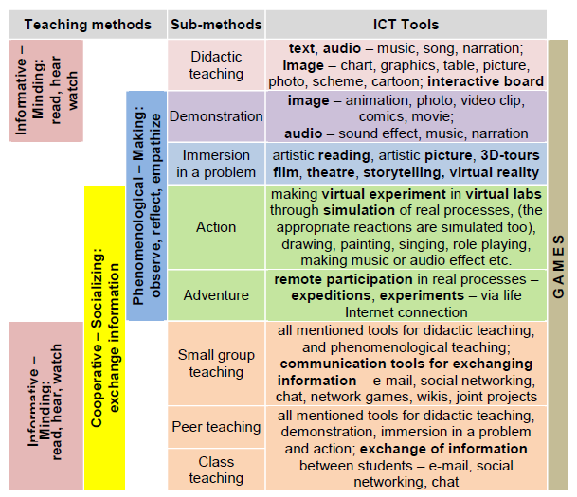

Figure 33. Implementation of ICT tools in different teaching methods
Referring to Figure 33 above, the challenge lies in shifting from teaching and learning about ICT to teaching and learning with and through ICT. This means rather than using technology to do old things in new ways, we want to do new things in new ways and use technology to enable and transform teaching, learning and the curriculum.
However, the rise of technologies has complicated its adoption and integration by teachers in classroom. The effective integration of technology into classroom practices poses a challenge to teachers than connecting computers to a network. For successful integration of ICT into teaching, the review has highlighted on factors that positively or negatively influence teachers’ use of ICT in developing countries in general, and in Jordanian schools in specific. These are personal, institutional and technological factors. Research has revealed that these factors are related to each other (Buabeng-Andoh, 2012).
On a personal level, there are numerous factors that influence teachers’ use of ICT. Teachers’ feelings, knowledge and attitudes influence their use of ICT in teaching. Research has shown that teachers’ attitudes towards technology influence their acceptance of the usefulness of technology and its integration into teaching (Huang & Liaw, 2005). If teachers’ attitudes are positive toward the use of educational technology then they can easily provide useful insight about the adoption and integration of ICT into teaching and learning processes (Ohiwerei, Azih, & Okoli 2013).
On the school (institutional) level, factors such as support, funding, training and facilities influence teachers’ adoption and integration of ICT into their classrooms. Teachers’ professional development is a key factor to successful integration of ICT into classroom teaching. ICT related training programs develop teachers’ competences in computer use, influencing teachers’ attitudes towards computers and assisting teachers reorganize the task of technology and how new technology tools are significant in student learning (Liaw, Huang, & Chen, 2007; Keengwe & Onchwari, 2008).
On the technological level, for successful adoption and integration of ICT into teaching, teachers must perceive the technology as better than previous practice; consistent with their existing values, past experiences and needs; ease to use, can be experimented with on a limited basis before making a decision to adopt, and finally the results of the innovation are visible to others. Many teachers are hesitant to change an existing program to something they only know through discussion and reading and not through observation. These three characteristics or attributes of teachers’ adoption and integration of ICT into teaching provide information of factors supporting their use of technology as well as barriers to ICT integration (Buabeng-Andoh, 2012). The key factor in the studies is teachers’ attitudes toward technology or intentions to use technology in their classrooms. If teachers have negative attitudes toward technology, providing them with excellent ICT facilities may not influence them to use it in their teaching. Therefore, teachers need to be assured that technology can make their teaching interesting, easier, more fun for them and students, more motivating and more enjoyable.
Finally, factors (barriers) that discourage the use of ICT by teachers were also reviewed. These factors categorized are into teacher-level, school-level and system-level barriers. Teacher-level barriers include lack of teacher ICT skills; lack of teacher confidence; lack of pedagogical teacher training; lack of follow-up of new and lack of differentiated training programs. The school-level barriers comprise absence of ICT infrastructure; old or poorly maintained hardware; lack of suitable educational software; limited access to ICT; limited project-related experience; lack of ICT mainstreaming into school’s strategy. The system-level barriers include rigid structure of traditional education systems; traditional assessment; restrictive curricula, and restricted organizational structure. Knowing the extent to which these barriers affect individuals and institutions may help in taking a decision on how to tackle them (Baek, Jong, & Kim 2008).
Teachers can maintain their subject content (lesson plans, exercises, evaluation) in digital format, making it easy to update, to share with other teachers, and to enhance with time. In fact, ICT tools such as a computer, a handheld device, or a portable iPods and Tablet PCs can help teachers in their instruction and in their administrative tasks as well. This should be carefully considered during teacher-training planning because before pedagogical use in the classroom, many teachers may prefer to become familiarized first with the technology outside the classroom. This can often be facilitated greatly by starting out with software applications or simple devices such as portable keyboards or handhelds that can be of immediate use. It is relatively easy to learn how to use these devices to store text in a portable keyboard, to construct spreadsheets, or to make use of word processing to record students’ marks and records as well as to facilitate the learning teaching process (Qablan, Abuloum, & Al-Ruz, 2009; Nyakowa, 2014).
Although, some research studies have shown that ICT has a huge impact on the ways in which principals work (Yuen, Law & Wong, 2003) the ICT research literature has largely ignored the role of principals as technology leaders (Schiller, 2003). This gap in the research literature is rather strange because many research studies related to school improvement, school effectiveness, and change showed that school principals play an important role in creating successful changes in schools. According to Schiller (2003), school leaders are key factors in ICT implementation in schools; they have to shoulder the heavy responsibility for creating changes in schools through the use of ICT and facilitating the process of making complicated decisions to integrate it in schools.
Although the role of the principal in supporting technology integration is very important, there are a few researches conducted on the role of the principal in ICT implementation. Also, little is known about the use of ICT by principals and the factors that are related to their level of computer use (Nyakowa, 2014).
A developing country’s educational technology infrastructure sits on top of the national telecommunication and information infrastructure. The infrastructure should be developed for the effective implementation and integration. Various competencies must be developed throughout the educational system for ICT implementation and integration to be successful. Teacher professional development in relation to skills with particular applications; integration into existing curricula; curricular changes related to the use of IT (including changes in instructional design); changes in teacher role should be done. Support at different levels should be considered. Sustainability and transferability in ICT implementation and integration as one of the greatest challenges should also be addressed (Seyoum, 2004).

Conclusions, implications, and recommendations for future research

Conclusions
As move into the 21st century, many factors are bringing strong forces to bear on the adoption of ICT in education; contemporary trends suggest will soon see large scale changes in the way education is planned and delivered as a consequence of the opportunities and affordances of ICT. It is believed that the use of ICT in education can increase access to learning opportunities. It can help to enhance the quality of education with advanced teaching methods, improve learning outcomes and enable reform or better management of education systems. It is imperative and equally inevitable to say that quality ICT tools are a prerequisite to quality ICT education. Therefore, quality ICT facilities should be made available, accessible, and equally made easy for teachers and students to obtain in order to have quality ICT education in Jordanian schools. Consequently, issues and challenges of ICT in education should be given urgent and adequate attention in any attempt at education reform; and the effective use of sophisticated ICT tools in education should be evaluated regularly (Khasawneh & Ibrahim, 2012).
A carefully thought-out, integrated approach to introducing computers and the Internet into learning environments in developing countries can have a significant impact on teaching and learning. In countries where learning resources are limited and teachers never dream of having a fully stocked library, let alone the Internet, teachers and students have been introduced to a new world of learning. As a result, those with access to ICT have been greatly empowered, and now believe they can compete in a global knowledge-based economy because they know that their knowledge, ideas, culture, and passions are as valuable as any in the world (Punie, Zinnbauer, & Cabrera, 2006).
In order to more effectively prepare students to participate in ICT-driven education, greater commitments and willingness to share and adopt innovative solutions are needed from all aspects of society—from Governments, the private sector, communities, donors, parents, and students. Schools should be transformed into active learning environments open to their communities; telecommunication and power infrastructure policies should focus on schools as starting points for rural transformation; teachers and students must be empowered to be creative agents for change in their schools; and leaders must embrace a vision that will prepare their youth for tomorrow’s challenges (Gable, Lee, Kwahk, & Green, 2007).
Despite the challenges outlined in the research study, ICT is being increasingly used in education in both the developed and developing world, in order to reach out to children from poor and remote communities, provide them with a quality education, and in general equip both teachers and students with a wider range of educational resource and enable them with greater flexibility (Al-Khasawneh, 2012). However, the growth and success of ICT in education in Jordan depends on the extent to which the issues and challenges outlined in this article are addressed.
There is a critical need to document every effort for the benefit of the various stakeholders—decision-makers, educational institutions, and civil society. It is necessary to know what works and what does not, and what the implications are for policy making, planning, and implementation. Specifically, it needs to be understood that any new technology comes not merely with hardware and software, but with a learning and teaching style and grammar of its own, and that management practices need to be adapted in order to use the technologies effectively (Al-adaileh, 2009).
ICT is, ultimately, only physical tools, which by themselves cannot bring benefits to students, teachers, and communities at large. Therefore the unique contextual realities of this region, including, primarily, the initiative and impetus of the various countries and its constituents, the involvement of private companies and the level of infrastructure, play determining roles in creating enabling environments promoting the use of ICT for primary and secondary education ("ICT in School Education," 2010).
Additionally, in areas with a continuous change of technological content, as with information and communication technologies, the problem is the difficulty in selecting and organizing the knowledge to be taught. In terms of technical support, experts, and course materials ICT-based education system is expected to enhance its capability to satisfy the user groups. On the one hand, new knowledge has to be added to the curriculum constantly, and at the same time any other knowledge becomes obsolete. On the other hand, content has to be organized and ordered, relating every concept to others, which is not a trivial task because of their volume and how often they change (Achimugu, Oluwagbemi, & Oluwaranti, 2010).
Yet, the ICT-based education system is a holistic approach where a very high level of integrity and moral standard is required by instructors, ICT experts, students, and other stakeholders. To be effective everyone concerned with the process has to upgrade themselves continuously to keep pace with the ever changing environment. While implementing ICT-based education program we have to consider indigenous factors that affect the effectiveness of such utilization (Twaissi, 2008).
In general, there is a need to address the challenges of infrastructure, connectivity, and pedagogical integration of ICT into the curriculum. Schools may have to address institutional issues of access and use of facilities and develop capacity especially of the educational leaders to guide the integration of ICT in education. There is a need for a general paradigm shift from associating ICT with only computers and considering how other technologies can be integrated in education (Hennessy et al., 2010).
In summary, ICT enables teachers to demonstrate understanding of the opportunities and implications of the uses for learning and teaching in the curriculum context; plan, implement, and manage learning and teaching in open and flexible learning environments (UNESCO, 2005). ICT also facilitates enhanced learning in subject areas and learning at home on one’s own, and these require the use of new tools like modeling, simulation, use of databases, etc. Changes in the teaching strategy, instructional content, role of the teachers and context of the curricula are all seen by teachers as obvious as well as inevitable. Using ICT is also perceived as having the advantage of heightening motivation for the learner; helping recall previous learning; providing new instructional stimuli; activating the learner’s response; providing systematic and steady feedback; facilitating appropriate practice; sequencing learning appropriately; and providing a viable source of information for enhanced learning (Hollow & Masperi, 2009).
The purpose of this study was to identify, explore and describe the ICT use, penetration, and diffusion in schools in Jordan. Consequently, this study reviews the literature related to the use of ICT in school education in general, and in Jordan in specific. Also, the study identifies prevalent factors, issues, and barriers influencing teachers’ adoption of ICT in the classroom, such as their ICT literacy and confidence levels, are also identified, focusing on impacts of teacher training and continuing professional development, as well as on teacher beliefs and cultures of teaching. Furthermore, the study presents the strengths, weaknesses, opportunities, and threats for adopting and utilizing ICT in schools in Jordan. So, the Jordanian Ministry of Education be able to utilize the strengths and build on them, mitigate the weaknesses, avoid the threats, and exploit the opportunities.

Implications
Although the Jordanian context is unique, some of the major issues identified in the current study are issues shared with other countries in the region and with developing countries in many parts of the world, particularly with countries from the Middle East and North Africa region.
The use of ICT in teaching and learning process has positive impact on teaching, learning, and research. In addition, it will increase flexibility so that learners can access the education regardless of time and geographical barriers. It can influence the way students are taught and how they learn. It would provide the rich environment and motivation for teaching learning process which seems to have a profound impact on the process of learning in education by offering new possibilities for learners and teachers. These possibilities can have an impact on student performance and achievement. Similarly wider availability of best practices and best course material in education, which can be shared by means of ICT, can foster better teaching and improved academic achievement of students. The overall literature suggests that successful ICT integration in education. In using ICT, the people or even the teacher should consider about the main difficuties or weaknesses of ICT. It should be done to have a good enjoyable connection.
The researcher concludes by drawing from the review a number of implications for further development of educational uses of ICT in Jordanian schools and some suggestions for future research and professional development initiatives. The implications of the study may provide areas of consideration for the administrators at the Jordanian Ministry of Education. The review imply that personal experience with ICT tools is an influential factor in individuals’ attitudes toward ICT use. If ICT diffusion strategies and efforts are to be promoted and expanded, it is important that teachers are provided with the opportunity to engage in a positive ICT use experience. This may be accomplished in several ways:

- Define what obstacles need to be overcome to ensure the success of ICT use in primary and secondary education. Also provide adequate training for teachers who use or would use ICT tools. This is important because training in ICT use is essential to encourage higher levels of teacher use and more effective uses of the technology.
- Provide institutional encouragement, support, and incentives for teachers who desire to use ICT tools in instruction in a pedagogically grounded manner.
- Find effective and radical solution to solve the problem of slow Internet connection in schools.
- Look for more effective and sustainable mechanisms to carry out maintenance of computers at schools, and under the supervision of the MoE.
- Provide extra computer labs at schools based on the students number, ones equipped with data show projectors to facilitate using the e-Content curricula.
- Provide schools with e-Content by creating an offline copy for each school to overcome the obstacle of slow Internet connection.
- Update the EduWave continuously and ensure regular maintenance to avoid the technical problems that occurs frequently.
- Increase the principals’ awareness regarding the importance of a school environment that will support implementing technology in education.
- Adopt a clear ICT strategy to show how technology can be employed in classroom.
- Highlight success stories of schools, which remarkably use technology and incentivize students and teachers who contribute with initiatives about using ICT in education by awarding the best and most creative works.
- Ensure continuous training for teachers and lab technicians, newly hired teachers in particular, to equip them with the latest educational technology.
- Provide schools with sufficient numbers of lab technicians.

Recommendations and suggestions for future research
This review synthesizes the literature on uses of ICT in primary and secondary schools in Jordan. It focuses on the role of ICT in improving the quality of learning and teaching in Jordanian schools (Grades K-12) with reference to technologies appropriate for this context. In so doing, the review casts new light on the supporting and constraining factors that influence ICT integration in education in the Kingdom. Additionally, in this study, barriers to the use of ICT as well as factors affecting the use of ICT by schools, teachers, and students in Jordan have been identified. Last but not least, SWOT analysis of ICT use in Jordanian school has been utilized and presented in this study to highlight and identify strengths, weaknesses, opportunities and threats related the use of ICT in schools in Jordan; particularly to help in identifying areas for development in order to fully grasp the benefits of ICT integration in teaching and leaning process.
The ICT enhancement of quality education among Jordanian schools requires that the following recommendations first be implemented:
- The current ICT policy framework must be reviewed to reposition it to function as a necessary tool for the development of schools. The focal point of this revised policy should be availability, acceptability, and accessibility of ICT tools to the school administrators. Consequently, a comprehensive ICT policy should be part of an effort towards improving the equity and quality of an educational system.
- The adoption of ICT international standards and its inclusion in the Jordanian education system. Continuous training and retraining of teachers and others supporting staff on computers and ICT skills acquisition should be provided.
- A high speed of Internet must be made available to all schools irrespective of their locations.
- If possible, ICT experts, specifically for instruction design and development, who will work in partnership with educators and teachers should assigned to each school or at least for each education district.
- The private sector and multinationals within the country must begin to collaborate with government and schools in funding, support, provision, and maintenance of ICT in schools.
- Jordanian Governments should improve the training of principals, teachers, and computer personnel on the use of computers applications and other ICT equipments through conducting professional seminars, workshops, and in-service training.
- Schools’ principals should be encouraged to use ICT equipments for the effective management of their schools. This could be done through improved usage of computers and other ICT materials supply to their schools for the storage and retrieval of data on staff and students as well as for data analysis.
- Emphasis should be aimed at developing a long term program effective for continuous commitment to training and use of instructional technologies. Teachers and administrators must have clear and positive incentives for participating in ICT in-service. For example, the Ministry of Education should provide such incentives as tuition for advanced college coursework or promotion in rank.
- Teachers need to be supported in meeting the challenge of effectively integrating ICT in their classroom practices so that Jordanian students are placed at the forefront of advances in teaching practices and learning techniques.
- Consideration should be given to ensuring that teachers are provided with opportunities to develop skills that are directly applicable to the use of ICT in the classroom. This should be addressed in a strategic way through a combination of pre-service, induction and in-service training.
- There should be continuous efforts within schools to improve the level of teachers’ access to ICT equipment.
- Teachers with good ICT skills should act as mentors to colleagues whose ICT skills are not as well developed. Good practice within schools should be disseminated among members of the staff at every opportunity.
- Teachers should exploit the potential of ICT to develop a range of students’ skills, including research and investigation, writing and presentation, communication, teamwork and collaborative skills, and the higher-order skills of analysis, evaluation, and problem-solving.
- When using ICT as a teaching aid for students with special educational needs, schools should endeavour to ensure that it is being used to support the widest possible range of students’ needs. It should be used, for example, to support the development of students’ numeracy skills, as well as their literacy skills.
- Schools should exploit the benefits of ICT in their assessment procedures and practices beyond purely administrative functions. This could include using ICT to assess, track, and analyze students’ progress through the use of appropriate software. Consideration could be given to assessing students’ ICT skill levels also.

This study suggests several areas for future research:
- Further research is needed to determine whether these negative (inhibiting) factors (obstacles and barriers) which affect ICT integration into teaching and learning that determined from the reviewed literature are correct; and within Jordanian context.
- Suggestions for further research into ICT barriers include: (a) looking at sector specific and subject specific barriers. This could then lead to identifying the ICT enablers – those factors which motivate teachers into fully engaging with ICT in their work. (b) Researching the barriers and enablers specific to individual technologies, such as the Internet, interactive whiteboards, or digital video. Such work could lead to developing targeted advice on increasing the use of these technologies in the classroom. And (c) investigating some of the barriers, as introduced in this study, in more detailed manner to understand how they group together, and the specific actions that may be taken to overcome the main ICT barriers. This could then lead to the trialing of possible interventions that might help to increase ICT use in schools.
- Conducting needs analysis for professional development to guarantee a successful integration of ICT in teaching and learning and to maximize the benefits of utilizing ICT in instruction in schools in Jordan.
- Conducting regular and specialized surveys to reflect teachers’ and students’ perspectives on ICT implementation in education.
The results of this study will tremendously help in taking the right decisions based on recent and accurate data related to the ICT use and diffusion in Jordanian schools, schools readiness and infrastructure, and the extent to which technology is being utilized and equally distributed in the different geographic areas of the kingdom.
Because of this pioneering study, the policy makers in the MOE will be more informed in their future endeavors regarding the factors that impede or facilitate the implementation of ICT and its adoption rate by Jordanian teachers through out the country’s educational system. This study is an initial step on that road; hopefully it will lead to further examinations of other areas to expand the research to make the employment of ICT in instruction better in the context of the Arab region as well other developing countries.
Finally, more attention should be paid to specific roles of ICT in offering multimedia simulations of good teaching practices, delivering individualized training courses, helping overcome teachers’ isolation, connecting individual teachers to a larger teaching community on a continuous basis, and promoting teacher-to-teacher collaboration. Intended outcomes as well as unintended results of using ICT for teacher professional development need to be explored (Jung, 2005).

References
Abuhmaid, A. (2008). An analysis of ICT integration within the Jordanian education system. Unpublished Doctoral Dissertation, University of Technology Sydney, Sydney, Australia.
Abuhmaid, A. (2010). Centralization and reform: Information technologies in large-scale education reform. Retrieved October 4, 2014 from http://elexforum.hbmeu.ac.ae/Proceeding/PDF/Centralization%20and%20Reform.pdf
Abuhmaid, A. (2011). ICT training courses for teacher professional development in Jordan. The Turkish Online Journal of Educational Technology, 10(4), 195-210.
Abu Samak, Z. (2006). An exploration of Jordanian English language teachers’ attitudes, skills, and access as indicator of information and communication technology (ICT) integration in Jordan. Unpublished Doctoral Dissertation, Florida State University, Tallahassee, Florida.
Achimugu, P., Oluwagbemi, O., & Oluwaranti, A. (2010). An evaluation of the impact of ICT diffusion in Nigeria’s higher educational institutions. Journal of Information Technology Impact, 10(1), 25-34.
Afshari, M., Bakar, K., Luan, W., Samah, B., & Fooi, F. (2009). Factors affecting teachers’ use of information and communication technology. International Journal of Instruction, 2(1), 77-104.
Al-adaileh, R. (2009). An evaluation of information systems success: A user perspective-the case of Jordan telecom group. European Journal of Scientific Research, 37(2), 226-239.
Al-Ansari, H. (2006). Internet use by the faculty members of Kuwait University. The Electronic Library, 24(6), 791-803.
Albirini, A. (2006). Teachers’ attitudes toward information and communication technologies: The case of Syrian EFL teachers. Computers & Education, 47(4), 373-398.
Alemneh, D., & Hastings, S. (2006). Developing the ICT infrastructure for Africa: Overview of barriers to harnessing the full power of the Internet. Journal of Education for Library and Information Science, 47(1), 4-16.
Alemu, B. (2013). Issues and challenges in integrating ICT into teaching and learning practices to improve quality of education. International Journal of Research in Computer Application & Management, 3(4), 53-62.
Alexander, J. (1999). Collaborative design, constructivist learning, information technology immersion, and electronic communities: A case study. Interpersonal Computing and Technology, 7, 1-28.
Alev, N. (2003). Integrating information and communications technology (ICT) into pre-service science teacher education: The challenges of change in a Turkish faculty of education. Unpublished Doctoral Dissertation, University of Leicester, Leicester, United Kingdom.
Al-Jaraideh, Y. (2009). Factors affecting information and communication technology (ICT) integration in Jordanian secondary schools. Unpublished Doctoral Dissertation, University Utara Malaysia, Kedah, Malaysia.
Al-Khasawneh, M. (2012). Adoption of information and communication technology in teaching and learning environment in Jordanian higher education institutions. Unpublished Doctoral Dissertation, University Utara Malaysia, Kedah, Malaysia.
Alkhawaldeh, N., & Menchaca, M. (2014). Barriers to utilizing ICT in education in Jordan. International Journal on E-Learning, 13(2), 127-155.
Almarabeh, T., & Mohammad, H. (2013). E-learning in the Jordanian higher education system: Strengths, weakness, opportunities, and threats. Journal of American Science, 9(3), 281-287.
Al-Mobaideen, H. (2009). ICT diffusion in Jordanian universities. Paper presented at European and Mediterranean Conference on Information Systems (July 13-14), Izmir, Turkey. Retrieved October 10, 2014 from http://www.iseing.org/emcis/CDROM%20Proceedings%20Refereed%20Papers/Proceedings/Presenting%20Papers/C57/C57.pdf
Al-Shboul, M. (2012). Teachers’ perceptions of the use of EduWave e-Learning system in public schools in Jordan. The Journal of Human Resource and Adult Learning, 8(2), 167-181.
Al-Shboul, M., Rababah, O., Al-Sayyed, R., Sweis, G., & Aldreabi, H. (2013). Roadmap to advance e-Learning management system at The University of Jordan. Journal of American Science, 9(1), 531-545.
Anderson, R., & Dexter, S. (2005). School technology leadership: An empirical investigation of prevalence and effect. Educational Administration Quarterly, 41(1), 49-82.
Baek, Y., Jong, J., & Kim, B. (2008). What makes teachers use of technology in the classroom? Exploring the factors affecting facilitation of technology with a Korean sample. Computers and Education, 50(1), 224-234.
Basu, S. (2004). E-government and developing countries: An overview. International Review of Law, Computers & Technology, 18(1), 109-132.
Bhattacharya, I. & Sharma, K. (2007). India in the knowledge economy – an electronic paradigm. International Journal of Educational Management. 21(6), 543- 568.
Bingimlas, K. (2009). Barriers to the successful integration of ICT in teaching and learning environments: A review of the literature. Eurasia Journal of Mathematics, Science & Technology Education, 5(3), 235-245.
Buabeng-Andoh, C. (2012). Factors influencing teachers’ adoption and integration of information and communication technology into teaching: A review of the literature. International Journal of Education and Development using ICT, 8(1), 136-155.
Cholin,V. (2005). Study of the application of information technology for effective access to resources in Indian university libraries. The International Information & Library Review, 37(3), 189-197.
Clarke, A., & Luger, E. (2007). ICT and e-Learning. Retrieved August 18, 2014 from http://www.niace.org.uk/lifelonglearninginquiry/docs/ICT%20and%20e-learning.pdf
Cox, M., Cox, K., & Preston, C. (1999). What factors support or prevent teachers from using ICT in their classrooms? Paper presented at the British Educational Research Association Annual Conference (September 2-5), Brighton, United Kingdom. Retrieved July 30, 2014 from http://www.leeds.ac.uk/educol/documents/00001304.htm
Daniel, J., West, P., D’Antoni, S., & Uvalić-Trumbić, S. (2006). E-Learning and free open source software: the key to global mass higher education? Proceedings of the International Seminar on Distance, Collaborative and e-Learning (pp. 19-24). Kuala Lumpur, Malaysia. Retrieved August 5, 2014 from http://www.col.org/SiteCollectionDocuments/speeches2_web.pdf#page=19
Farrell, G. (2007). Survey of ICT in education in Kenya. Washington, DC: infoDev/World Bank.
Fister, K., & McCarthy, M. (2008). Mathematics instruction and the tablet PC. International Journal of Mathematical Education in Science and Technology, 39(3), 285-292.
Flecknoe, M. (2002). How can ICT help us to improve education? Innovations in Education and Teaching International, 39(4), 271-279.
Free Management eBook (2013). SWOT analysis strategy skills. Retrieved October 12, 2014 from http://www.free-management-ebooks.com/dldebk-pdf/fme-swot-analysis.pdf
Gable, G., Lee, J., Kwahk, K., & Green, P. (2007). Administrative placement of the information systems academic discipline: A comparative SWOT analysis. Communications of the Association for Information Systems, 21(1), 136-166.
Garrison, D., & Anderson, T. (2003). E-learning in the 21st century: A framework for research and practice. London: Routledge Falmer.
Goktas, Y., Yildirim, S., & Yildirim, Z. (2009). Main barriers and possible enablers of ICTs integration into pre-service teacher education programs. Educational Technology & Society, 12(1), 193-204.
Haddad, W. & Jurich, S. (2002). ICT for education: Potential and potency. In W.D. Haddad and A. Draxler (Eds.) Technologies for education: Potential, parameters and prospects (pp. 28-40). Paris: UNESCO and Academy for Educational Development.
Hollow, D., & Masperi, P. (2009). An evaluation of the use of ICT within primary education in Malawi. Proceedings of the International Conference on Information and Communication Technologies and Development (pp. 27-34), Doha, Qatar.
Hennessy, S., Harrison, D., & Wamakote, L. (2010). Teacher factors influencing classroom use of ICT in Sub-Saharan Africa. Itupale online journal of African studies, 2(1), 39-54.
Hennessy, S., Onguko, B., Harrison, D., Ang’ondi, E., Namalefe, S., Naseem, A., & Wamakote, L. (2010). Developing the use of information and communication technology to enhance teaching and learning in East African schools: Review of the literature. Cambridge: University of Cambridge Press.
Hismanoglu, M. (2012). Heralding an ICT environment in initial EFL teacher training programms through a curricular innovation. Journal of Language Teaching and Research, 3(1), 01-10.
Huang, H., & Liaw, S. (2005). Exploring users’ attitudes and intentions toward the web as a survey tool. Computers in Human Behavior, 21(5), 729-743.
"ICT in School Education: Primary and Secondary" (2010). Retrieved September 9, 2014 from http://www.infodev.org/infodev-files/resource/InfodevDocuments_1016.pdf
Ihmeideh, F. (2009). Barriers to the use of technology in Jordanian pre-school settings. Technology, Pedagogy and Education, 18(3), 325-341.
Jabaka, S., & Danbaba, N. (2014). Barriers to ICT utilization in basic education in Nigeria. Proceedings of South Africa International Conference on Education (pp. 71-77). Pretoria, South Africa.
Jhurree, V. (2005). Technology integration in education in developing countries: Guidelines to policy makers. International Education Journal, 6(4), 467-483.
Jonassen, D. (1999). Computers as mind tools for schools: Engaging critical thinking (second Ed.). Englewood Cliffs, NJ: Prentice Hall.
Jonassen, D. & Reeves, T. (1996). Learning with technology: Using computers as cognitive tools. In D. Jonassen (Ed.), Handbook of Research Educational on Educational Communications and Technology (pp 693-719). New York: Macmillan.
Jones, A. (2004). A review of the research literature on barriers to the uptake of ICT by teachers. British Educational Communications and Technology Agency (Becta), Version 1. Retrieved October 5, 2014 from http://dera.ioe.ac.uk/1603/1/becta_2004_barrierstouptake_litrev.pdf
Jung, I. (2005). ICT-pedagogy integration in teacher training: Application cases worldwide. Educational Technology & Society, 8(2), 94-101.
Khasawneh, M., & Ibrahim, H. (2012). A model for Adoption of ICT in Jordanian Higher Education Institutions: An Empirical Study. Journal of e-Learning & Higher Education, 2012(1), 1-10. Retrieved October 13, 2014 from http://www.ibimapublishing.com/journals/JELHE/2012/877178/877178.pdf
Keengwe, J., Onchwari, G., & Wachira, P. (2008). Computer technology integration and student learning: Barriers and promise. Journal of Science Education and Technology, 17(6), 560-565.
Kennewell, S., Parkinson, J., & Tanner, H. (2000). Developing the ICT capable school. London: Routledge Falmer.
Khan, M., Hasan, M., & Clement, C. (2012). Barriers to the Introduction of ICT into Education in developing countries: The example of Bangladesh. International Journal of Instruction, 5(2), 61-80.
Kirkman, G., Cornelius, P., Sachs, J., & Schwab, K. (2002). The Global information technology report 2001-2002. New York: Oxford University Press. Retrieved August 9, 2014 from http://www.caribbeanelections.com/eDocs/development_reports/gitr_2001_2002.pdf
Kozma, R. (2005). National policies that connect ICT-based education reform to economic and social development. Human Technology, 1(2), 117-156.
Lai, K., & Pratt, K. (2004). Information and communication technology (ICT) in secondary schools: The role of the computer coordinator. British Journal of Educational Technology, 35(4), 461-475.
Leask, M., & Pachler, N. (2013). Learning to teach using ICT in the secondary school: A companion to school experience. London: Routledge.
Lemke, C., & Coughlin, E. (1998). Technology in American schools: Seven dimensions for gauging progress. Santa Monica, CA: Milken Exchange on Educational Technology.
Liaw, S., Huang, H., & Chen, G. (2007). Surveying instructor and learner attitudes toward e-learning. Computers & Education, 49(4), 1066-1080.
Lim, C., & Hang, D. (2003). An activity theory approach to research of ICT integration in Singapore schools. Computers & Education, 41(1), 49-63.
Lim, C., & Chai, C. (2004). An activity-theoretical approach to research of ICT integration in Singapore schools: Orienting activities and learner autonomy. Computers & Education, 43(3), 215-236.
Marshall, S. (2000). Report on the 2000 UTDC survey of academic staff needs for teaching technology support. Wellington, New Zealand: Victoria University of Wellington Press. Retrieved September 24, 2014 from http://www.cad.vuw.ac.nz/documentation/survey2000/surveyreport.pdf
Marshall, J. (2002). Learning with technology: Evidence that technology can, and does support learning. San Diego: San Diego State University Press. Retrieved September 20, 2014 from http://www.medialit.org/sites/default/files/545_CICReportLearningwithTechnology.pdf
Masino, M. (2013). The use of information and communications technology in teaching and e-learning in the Caribbean. Journal of Instructional Pedagogies,12, 1-9.
McCormick, R., & Scrimshaw, P. (2001). Information and communications technology, knowledge and pedagogy. Education, Communication & Information, 1(1), 37-57.
Mishra, M., Sharma, V., & Tripathi, R. (2010). ICT as a tool for teaching and learning in respect of learner with disability. Indira Gandhi National Open University, New Delhi, India. Retrieved September 2, 2014 from http://wikieducator.org/images/7/7b/SJ_M.P.Mishra.pdf
MoE, MoICT, & JEI (2012). ICT use and penetration in schools of Jordan. Retrieved August 29, 2014 from www.moe.gov.jo/Files/(5-8-2012)(2-32-35%20PM).pdf
MoHESR (2009). National e-Learning strategy for higher education (2007-2010). Retrieved July 31, 2014 from http://www.uop.edu.jo/download/research/members/Gissa-elearn-jordan.pdf
Moges, B. (2013). The role of information and communication technology (ICT) in enhancing the quality education of Ethiopian universities: A review of literature. International Journal of Research in Commerce, IT & Management, 3(7), 94-101.
Mooij, T. (1999). Guidelines to pedagogical use of ICT in education. Paper presented at the 8th Conference of the European Association for Research on Learning and Instruction (August 24-28), Göteborg, Sweden.
Mumtaz, S. (2000). Factors affecting teachers’ use of information and communications technology: A review of the literature. Journal of Information Technology for Teacher Education, 9(3), 319-341.
National Council for Curriculum and Assessment (NCCA) (2004). Information and communications technology (ICT) in the primary school curriculum: guidelines for teachers. Dublin: NCCA Publications. Retrieved September 1, 2014 from http://www.ncca.ie/uploadedfiles/ECPE/ICTEnglish.pdf
Noor-Ul-Amin, S. (2013). An effective use of ICT for education and learning by drawing on worldwide knowledge, research, and experience: ICT as a change agent for education. Scholarly Journal of Education, 2(4), 38-45.
Nusseir, Y. (2001). ICT initiatives in Jordan: Needs and aspirations. National Information Center, Amman, Jordan. Retrieved October 1, 2014 from http://www.ercim.eu/medconf/papers/nusseir.html
Nyakowa, L. (2014). Factors influencing ICT adoption among public secondary school teachers: A case of Webuye sub-county, Bungoma county, Kenya. Unpublished Doctoral Dissertation, University of Nairobi, Nairobi, Kenya.
Nyambane, C., & Nzuki, D. (2014). Factors influencing ICT integration in teaching: A literature review. International Journal of Education and Research, 2(3), 1-18.
Ohiwerei, F., Azih, N., & Okoli, B. (2013). Problems militating against utilization of ICT in teaching of business education in Nigerian universities. European International Journal of Science and Technology, 2(7), 40-48.
Papanastasiou, E., & Angeli, C. (2008). Evaluating the use of ICT in education: Psychometric properties of the survey of factors affecting teachers teaching with technology. Educational Technology & Society, 11(1), 69-86.
Plomp, T., Pelgrum, W., & Law, N. (2007). SITES2006–International comparative survey of pedagogical practices and ICT in education. Education and Information Technologies, 12(2), 83-92.
Pohjola, M. (2003). The adoption and diffusion of ICT across countries: Patterns and determinants. In D. C. Jones (Ed.), New Economy Handbook (pp. 77-100). San Diego, CA: Elsevier-Academic Press.
Punie, Y., Zinnbauer, D., & Cabrera, M. (2006). A review of the impact of ICT on learning: Working paper prepared for DG EAC. Seville, Spain: Joint Research Centre–Institute for Prospective Technological Studies. Retrieved October 17, 2014 from http://ftp.jrc.es/EURdoc/JRC47246.TN.pdf
Qablan, A., Juradat, S., & Al-Momani, I. (2010). Elementary science teachers’ perceptions of educational reform in relation to science teaching in Jordan. Jordanian Journal of Educational Sciences, 6(2), 161-173.
Qablan, A., Abuloum, A., & Al-Ruz, J. (2009). Effective integration of ICT in Jordanian schools: An analysis of pedagogical and contextual impediments in the science classroom. Journal of Science Education and Technology, 18(3), 291-300.
Rababah, L., Bani Melhem, N., Jdaitawi, M., Rababah, B., & Rababah, O. (2012). EFL teachers’ barriers to the use of ICT in instruction in Jordan. Paper presented at the First International Conference on Behavioural and Social Science Research (November 2), Kampar, Malaysia. Retrieved September 30, 2014 from http://faculty.mu.edu.sa/public/uploads/1393430207.1625EFL%20Teachers'%20Barriers.pdf
Seyoum, A. (2004). Key issues in the implementation and integration of ICT in education system of the developing countries. Retrieved September 17, 2014 from http://www.ictes2004-gstit.edu.et/session%20IV_fullpapers/Key%20Challenges%20factors%20implementation_Abebe%20Feleke.pdf
Sharma, R. (2003). Barriers in using technology for education in developing countries. Proceedings of International Conference on Information Technology: Research and Education (pp. 512-516). Neward, New Jersey, USA.
Schiller J (2003). Working with ICT: Perceptions of Australian principals. Journal of Education Administration, 41(3) 171-185.
Susman, E. (1998). Cooperative learning: A review of factors that increase the effectiveness of cooperative computer-based instruction. Journal of Educational Computing Research, 18(4), 303-322.
Tedla, B. (2012). Understanding the importance, impacts and barriers of ICT on teaching and learning in East African countries. International Journal for e-Learning Security, 2(3/4), 199-207.
Tella, A., Tella, A., Toyobo, O., Adika, L., & Adeyinka, A. (2007). An Assessment of secondary school teachers uses of ICT’s: Implications for further development of ICT’s use in Nigerian secondary schools. Turkish Online Journal of Educational Technology, 6(3), 5-17.
Terzieva, V., Paunova, E., Kademova-Katzarova, P., & Stoimenova, Y. (2014). Implementation of ICT-based teaching in Bulgarian schools. Proceedings of the 6th International Conference on Education and New Learning Technologies (pp. 6497-6506). Barcelona, Spain. Retrieved October 3, 2014 from http://iict.bas.bg/acomin/docs/sci-forums/7-9-July-2014/paper_2.pdf
Tolani-Brown, N., McCormac, M, & Zimmermann, R. (2009). An analysis of the research and impact of ICT in education in developing country contexts. Journal of Education for International Development, 4(2), 1-12.
Tondeur, J., Van Braak, J., & Valcke, M. (2007). Curricula and the use of ICT in education: Two worlds apart? British Journal of Educational Technology, 38(6), 962-976.
Tondeur, J., Van Keer, H., Van Braak, J., & Valcke, M. (2008). ICT integration in the classroom: Challenging the potential of a school policy. Computers & Education, 51(1), 212-223.
Twaissi, N. (2008) An evaluation of the implementation of total quality management (TQM) Within the information and communications technology (ICT) sector in Jordan. Unpublished Doctoral Dissertation, University of Huddersfield, Huddersfield, United Kingdom.
UNESCO. (2005). Information and communication technologies in schools: A handbook for teachers. Paris: UNESCO. Retrieved October 5, 2014 from http://unesdoc.unesco.org/images/0013/001390/139028e.pdf
UNESCO. (2012). ICT in primary education: Analytical survey. Moscow: UNESCO Institute for Information Technologies in Education . Retrieved October 16, 2014 from http://iite.unesco.org/pics/publications/en/files/3214707.pdf
Unwin, P. (2008). Information and communication technology for development. Cambridge: Cambridge University Press.
Young, J. (2002). The 24-hour professor. The Chronicle of Higher Education, 48(38), 31-33.
Yuen, A., Law, N., & Wong, K. (2003). ICT implementation and school leadership: Case studies of ICT integration in teaching and learning. Journal of Educational Administration, 41(2), 158-170.
Yusuf, M. (2005). Information and communication technology and education: Analyzing the Nigerian national policy for information technology. International Education Journal, 6(3), 316-321.
Webb, M., & Cox, M. (2004). A review of pedagogy related to information and communications technology. Technology, pedagogy and education, 13(3), 235-286.
Webb, I. (2007). Key factors in the use of ICT in primary school classrooms. Unpublished Doctoral Dissertation, University of Tasmania, Hobart, Australia.

About the author
Dr. Muhannad Al-Shboul is Associate Professor of e-Learning in the Department of Curriculum and Instruction at the Faculty of Educational Sciences, the University of Jordan, Amman, Jordan.
His primary research interests include e-Learning, Web-based Learning, Web Design, e-Government, Distance Learning, e-Content Development, Human Resources Development, and Educational Technology Utilizations in Higher Education. He has published more than 20 articles in reputed International Journals related to his field of specialization, published two books in e-Learning, delivered many oral presentations at international educational conferences, and conducted several training sessions including faculty development, human resources management, leadership skills, and instructional design strategies.
Dr. Al-Shboul received a M.S. in Computer Science from Northeastern Illinois University and a Ph.D. in Educational Technology from Northern Illinois University in the United States.
email: malshboul@ju.edu.jo

