InternAtional
Journal

of

Instructional Technology
and
Distance Learning

March 2017
Volume 14 Number 3
Editorial Board
Donald G. Perrin Ph.D.
Executive Editor
Elizabeth Perrin Ph.D.
Editor-in-Chief
Brent Muirhead Ph.D.
Senior Editor
Muhammad Betz, Ph.D.
Editor
ISSN 1550-6908

PUBLISHER'S DECLARATION
Research and innovation in teaching and learning are prime topics for the Journal of Instructional Technology and Distance Learning (ISSN 1550-6908). The Journal was initiated in January 2004 to facilitate communication and collaboration among researchers, innovators, practitioners, and administrators of education and training involving innovative technologies and/or distance learning.
The Journal is monthly, refereed, and global. Intellectual property rights are retained by the author(s) and a Creative Commons Copyright permits replication of articles and eBooks for education related purposes. Publication is managed by DonEl Learning Inc. supported by a host of volunteer editors, referees and production staff that cross national boundaries.
IJITDL is committed to publish significant writings of high academic stature for worldwide distribution to stakeholders in distance learning and technology.
In its first twelve years, the Journal logged over twelve million page views and more than two million downloads of Acrobat files of monthly journals and eBooks.
Donald G. Perrin, Executive Editor
Elizabeth Perrin, Editor in Chief
Brent Muirhead, Senior Editor
Muhammad Betz, Editor

Vol. 14. No. 3.
ISSN 1550-6908

Table of Contents – March 2017
Editorial: In Memoriam | 1

Donald G. Perrin
Does Artificial Neural Network support Connectivism’s Assumptions? | 3

Alaa A. AlDahdouh
Learners' perspectives of using ICT in higher education institutions in Jordan | 27

Muhannad Al-Shboul, Munim Al-Saideh, Nezar Al-Labadi

The effect of using Crocodile mathematics software on  Van Hiele level of geometric thinking and motivation  among ninth-grade students in Jordan | 87

Ahmad Moh'd Al-Migdady and Fadwa Qatatsheh
Quality of faculty feedback and its effects on learning and educational effectiveness of online master degree programs | 105

Yoram Neumann, Edith Neumann, Shelia Lewis
Socratic Method Distance Learning: An Oxymoron? | 117

Duane L. Dobbert, Jeffrey Kleeger, Lindsey Page

Return to Table of Contents

Editorial

In Memoriam

Donald G. Perrin

Dr. Elizabeth Perrin, Editor in Chief for this Journal, passed away on April 7, 2017 ending a brilliant and productive career as scholar and educator. In 1949 she was born of American parents in Chuqiqamata, Chile. She graduated from Garden City High School on Long Island NY in 1943. In 1946, she completed an A.B. from Barnard College and in 1947, studied Metaphysics and Logic at Oxford University in England. Elizabeth taught at Iowa State University and Orange County Community College, NY, and completed a Masters in Philosophy from Columbia University in 1951.
In 1953, Elizabeth graduated from the Neighborhood Playhouse School of the Theatre in Greenwich Village, New York, where she learned dance from Martha Graham, played ingénue, and shared the stage with Steve McQueen, Paul Newman, Joanne Woodward and others who distinguished themselves in Hollywood. For almost a decade, Elizabeth acted in stage and films in New York, Washington D.C., Europe and California, including a one year tour as foil to Groucho Marx.
Starting in 1962, she taught English as a Second Language (ESL) as an Adult Education teacher for the Los Angeles City Schools. She was writer and teacher for KMEX Channel 34 in Los Angeles with ESL courses that attracted half a million viewers each day. In 1966, she became Elizabeth Perrin. She received her Ph.D. in Education from the University of Southern California in 1976. When her family moved to the East Coast in 1969, Elizabeth worked in Media Research for the U.S. Office of Education and media design for Queen Anne School in Maryland. She was active in raising a family of five with horse training and frequent horse shows. In 1976 the family returned to Southern California.
Elizabeth went into Real Estate for a few years until drafted by California State University (CSU) Northridge to design, setup, and operate four distance-learning classrooms for the School of Engineering. A tower for ITFS broadcast on Mt. Wilson reached the Los Angeles area and South. She developed a microwave network to CSU campuses in central California, China Lake military base, and ultimately connected to the network developed by CSU Chico in Northern California. Later, at San Jose State University, Elizabeth developed a program in Total Quality Management for Silicon Valley industries described in the for October 2016 editorial of this Journal.
In 1996 to 2003, Elizabeth was publications editor for the United States Distance Learning Association - Ed at a Distance and USDLA Journal. In 2004 to the present, she was Editor-in-Chief for the International Journal of Instructional Technology and Distance learning. Her dedication and hard work as teacher, consultant, editor and publisher is deeply appreciated and will be sorely missed.

Return to Table of Contents

Return to Table of Contents
Editor’ Note: This paper seeks to understand and validate connectivism theory. The paper questions connectivism's principles, compares it with other learning theories, and validates it in relationship to Artificial Intelligence and Artificial Neural Networks.

Does Artificial Neural Network support
Connectivism’s assumptions?
Alaa A. AlDahdouh
Portugal

Abstract
Connectivism was presented as a learning theory for the digital age and connectivists claim that recent developments in Artificial Intelligence (AI) and, more specifically, Artificial Neural Network (ANN) support their assumptions of knowledge connectivity. Yet, very little has been done to investigate this brave allegation. Does the advancement in artificial neural network studies support connectivism’s assumptions? And if yes, to what extent? This paper addresses the aforementioned question by tackling the core concepts of ANN and matching them with connectivist's assumptions. The study employed the qualitative content analysis approach where the researcher started with purposely selected and relatively small content samples in connectivism and ANN literature. The results revealed that ANN partially supports connectivism’s assumptions but this does not mean that other learning theories such as behaviorism and constructivism are not supported as well. The findings enlighten our understanding of connectivism and where it may be applied.
Keywords: learning theory; connectivism; constructivism; behaviorism; artificial neural network; ANN; neural network; artificial intelligence; AI; machine learning; e-learning; online learning; distance learning

Introduction
In 2005, George Siemens started his proposed learning theory, connectivism, by asserting the huge impact of technology on our learning activities. In his words, "technology has reorganized how we live, how we communicate, and how we learn" (Siemens, 2005, p. 1). It thus follows that learning theory should reflect these changes. Based on this assumption, he criticized former learning theories such as behaviorism and constructivism; and advocated new theoretical framework. The suggested framework, of course, incorporates technology in its principles. Specifically, one of connectivism’s principles states that "Learning may reside in non-human appliances" (Siemens, 2005, p. 5). This principle alludes to the ability of technology to learn.
Before long, Stephen Downes embraced the theory and integrated it to the idea of connective knowledge where knowledge is distributed and it does not exist in a specific and single place (Downes 2005, 2006). Downes (2012) concentrated on network structure of the internet and how it may empower online students to do things that were hardly ever possible before, such as distance collaboration and information searching. More recently, Downes shared a sequence of posts on artificial intelligence and neural network findings in indication of their relevance to connectivism.
Aldahdouh, Osório and Caires (2015) explained the idea of networked knowledge thoroughly and made it clearer in relation to AI. They claimed that connectivism is based on network science principles. Their step-by-step explanation of knowledge network (neural, conceptual and external) has led them to argue that connectivism "has been drawn from a long history of Artificial Intelligence findings" (p. 17).
On the other hand, these allegations have brought criticisms to connectivism. Verhagen (2006) argued that machine learning, inductive learning, and fuzzy logic software have nothing to do with human learning. "Modern cognitive tools are nothing but an extension of the toolkit" (Verhagen, 2006, p. 4). In Verhagen’s perspective, artificial neural network does not differ from a pocket calculator. Moreover, Bell (2011) repeatedly mentioned that connectivism’s principles lack of rigor and are, in most part, untested.
Although these criticisms were presented right after proposing connectivism, very little has been done to examine the relationship between AI findings and connectivism’s principles. The question of whether connectivism was built on top of AI findings remained almost intact. In this article, ANN was selected to represent machine learning (which is a branch of AI) for many reasons. First, the core idea of ANN is inspired from human brain and, second, connectivists frequently refer to ANN as if ANN has supported their claims.
This study reviewed literature of both connectivism and ANN and tried to match their principles. The paper starts with brief description of connectivism. Then it moves to describe ANN concepts in relation to connectivism’s assumptions. Subsections include artificial neuron, network architectures and learning algorithm. The paper avoids presenting complex algorithms to improve text clarity and readability. In addition, it avoids going into ANN details that will not serve the purpose of this study; the reader should be aware of the extendibility of concepts presented here.

Connectivism
The reasons that make educators keen to develop new learning theory can be summarized in three broad motives: (1) international growth in internet usage and the gap between learners’ and school’s activities (Bell 2010; Brabazon 2016); (2) half-life of knowledge becomes shorter and knowledge changes rapidly (Aldahdouh and Osório 2016; Aldahdouh et al. 2015; Downes 2006; Siemens 2006); (3) and human-technology interaction where the interaction leads to changes in both sides of the equation; as technology changes, human also changes (Dirckinck-Holmfield, Jones, and Lindström 2009; Siemens 2005).
Connectivism started from these premises and integrated principles from different theories including chaos, network, and self-organization theories. Siemens (2005) introduced connectivism as an alternative theory which was not built on previous learning theories. In general, connectivism’s principles are shifting focus from content itself to the connections of content. Maintaining existing connections, making decision of which connections to add, and creating new connections between different fields are essential part of learning according to connectivism.
The core assumption of connectivism is that knowledge has a structure; and this structure is better to be conceived as a network (Aldahdouh et al. 2015; Downes 2005, 2006; Siemens 2006). A network is a group of nodes linked to each other by connections. A node can be in one of three different levels: neural, conceptual, and external (Aldahdouh et al. 2015; Siemens and Tittenberger 2009). A connection serves as a bridge that conveys information from one node to another. The more connections a network has, the more robust it will be. Without those connections, the whole network will fall apart. Thus, Siemens (2006) has concluded that "The pipe is more important than the content within the pipe" (p. 32). This makes the content less important in comparison to the connection. A more extreme view toward content sees it as something from the past; 'Content is a print concept' (Cormier 2016). However, Aldahdouh et al. (2015) adopted a moderate view toward content in that "The information needs a connection to reach the target and the connection needs the flow of information to stay alive. Therefore, no flow of information exists without connection and no connection remains without flow of information" (p. 11).
The second core assumption of connectivism is that a single connection between two nodes does not have meaning in its own. The meaning is distributed across group of connections called pattern (Downes 2006). The pattern "refers to a set of connections appearing together as a single whole" (Aldahdouh et al., 2015, p. 5). This pattern should be considered as the smallest unit that has meaning in its own. And hence, the network can be seen as a group of patterns that interact with each other to give the meaning of the entire network. Since connections may 'die' or 'live', the patterns and the knowledge are conceived as dynamic objects where some nodes become isolated and others become connected. The patterns change rapidly which made Aldahdouh et al. (2015) see knowledge as a "jellied creature" (p. 15).
The aforementioned assumptions can lead us directly to the definition of learning in connectivism. If knowledge has a network structure and meaning is distributed in dynamic patterns, then learning should be defined as "a continuous process of network exploration and patterns finding; it is a process of patterns' recognition" (Aldahdouh et al., 2015, p. 14).
This paper concentrates on one of connectivism’s principles which refers to the ability of technology to learn. This principle has been criticized and its meaning remains unclear for some researchers while others have questioned its validity (Bell 2011; Kop and Hill 2008; Verhagen 2006). The paper does not provide comprehensive review of connectivism literature. The reader is recommended to see the work of Aldahdouh et al. (2015) for clearer explanation of the theory. Nevertheless, the paper will return to connectivism’s principles as it explains the concepts of ANN.

Artificial Neural Network
Artificial Intelligence (AI) refers to the art of creating machines that are able to think and act like humans; or think and act reasonably (Russell and Norvig 2010). In order to build an agent that can think and act as so, the agent must be able to learn new things. To learn means that the agent should improve its performance on future tasks taking its past experience into account (Russell and Norvig 2010). Making an agent able to learn is an area of study called Machine Learning (ML).
Artificial Neural Network or ANN is a software structure developed and based on concepts inspired by biological functions of brain; it aims at creating machines able to learn like human (Goodfellow, Bengio, and Courville 2016; Nielsen 2015; Russell and Norvig 2010). Thus, ANN is part of ML. Interestingly, ANN has many other names in AI field including parallel distributed processing, neural computation and connectionism (Russell and Norvig 2010). Most ANN types are supervised learning network. That is, both an input and the correct output should be given to a network where the network should learn a function that maps inputs to outputs. There are some types of ANN such as Deep Belief Network (DBN) which can do unsupervised and semi-supervised learning (Nielsen 2015). However, research is still conducting on DBN to improve its performance. This article concentrates on supervised learning networks which showed a very good performance in wide variety of tasks.
Before proceeding into details, it is important to know that ANN is a vivid research area. Recent years, namely from 2011 to 2015, have witnessed a sequence of records breaking in the field of ML driven by ANN (Nielsen 2015). Even more, Goodfellow et al. (2016) indicated that ANN evolves rapidly so that new best architecture "is announced every few weeks to months" (p. 331). This makes writing this article a very challenging task.

Artificial Neuron
Since a structure of ANN has been inspired by biological brain, ANN should consist of a collection of neurons. AI researchers designed artificial neurons called perceptron and sigmoid which are believed to have similar function to a biological neuron (Goodfellow et al. 2016; Nielsen 2015). Artificial neuron is hereafter referred to as neuron for short. A neuron is a node that receives input from preceding neurons and makes a decision to 'fire' to the next neurons. To make that decision, it should first evaluate each input according to its own perspective and then sum all inputs up to get a single and holistic view. Finally, a neuron presents the holistic view to its internal judgment system to make a decision to fire or not.
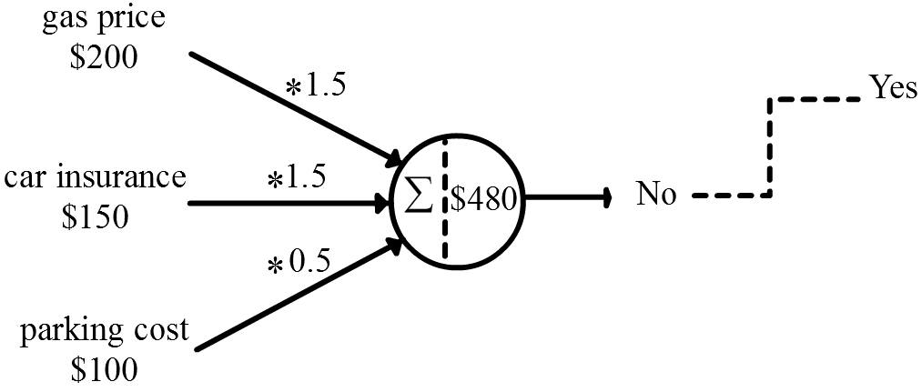

Fig. 1 Perceptron neuron
This system seems trivial but it turns out to be a complicated decision-making model. For example, suppose that you are a neuron and you want to make a decision to buy car. You probably make that decision based on many variables which may include gas price ($200), car insurance ($150), and parking cost ($100). In your perspective, car insurance and gas price are more important and more likely to increase in near future than parking cost. In this case, you weigh up car insurance (1.5) and gas price (1.5) while downplay parking cost (0.5). Then you sum that up to get the holistic perspective (100*0.5 + 1.5*150 + 1.5*200). Therefore, according to your own perspective, a car would cost you $575 per month. Then you present this holistic perspective to your internal judgment system which may have been previously set on a specific threshold ($480). Therefore, you make a decision not to buy a car because it exceeds the threshold ($575 > $480). Your own perspectives of inputs, the internal judgment system, and the threshold are called weights, activation function and bias respectively. By changing weights and bias you reach a completely different decision. For example, set gas weight to 1 instead of 1.5 and notice the difference. Searching for weights and bias that generate the desired output is the job of learning algorithm.
In the previous example, we imagined a neuron as a person. This sounds familiar in connectivism literature. Connectivists often argue that networks exist everywhere and these networks are similar in some way or another (Downes 2016). Interestingly, researchers in ANN share the same assumption with connectivists (Nielsen 2015). They sometimes conceive a single neuron as a person and in some other times conceive the whole network as a single human brain. Zooming in and out help them understand and modify both the neuron and the network in very similar way. We will see in next how this assumption works well in both levels. Another thing that matches connectivism well is the bias of a neuron. Each neuron has its own bias and, therefore, ANN contains a variety of neurons in which each neuron works in completely different way. In connectivism, Downes (2010) identifies four principles for applying democracy in education: autonomy, diversity, openness and interactivity. Siemens (2005, 2006) states that knowledge and learning rests in diversity of options and Aldahdouh et al. (2015) argues that educational systems should foster the learners' diversity, not their similarity.
Previously given example seemed as though a neuron works well in simulating human decision-making system. However, with little thinking, one can figure out that it does not. Suppose for instance that you kept all variable values as they were in the previous example except your perspective of (weight of) gas price. If you set the weight to be (1), then your holistic perspective becomes ($475). This is below your bias value ($480), thus you decide to buy a car. Now, try to set your perspective of gas to be (1.05). Your holistic perspective becomes ($485). That is greater than your bias value ($480), thus you decide not to buy a car. This is really a naive system. Our internal judgment systems do not do that. In real world, 5 dollars below or above a predefined threshold may not make that difference. This is called perceptron neuron which has a hard activation function (Russell and Norvig 2010). It would be better if a neuron has a soft activation function. Soft so that it goes gradually from (Yes, I will absolutely buy a car) to (No, I will absolutely not buy a car). Note that we have just concentrated on the meaning of the output itself but it is even not logical that a very tiny shift in a single weight (from 1 to 1.05) makes that big difference in the output. If ANN is going to learn the right weights and biases, a small change in one weight or bias should produce small change in network output (Nielsen 2015). In order to be able to learn, ANN should move slowly and smoothly from one decision to another. For these reasons, ANN researchers have examined many alternative soft activation functions such as sigmoid, tanh and rectified linear neuron.
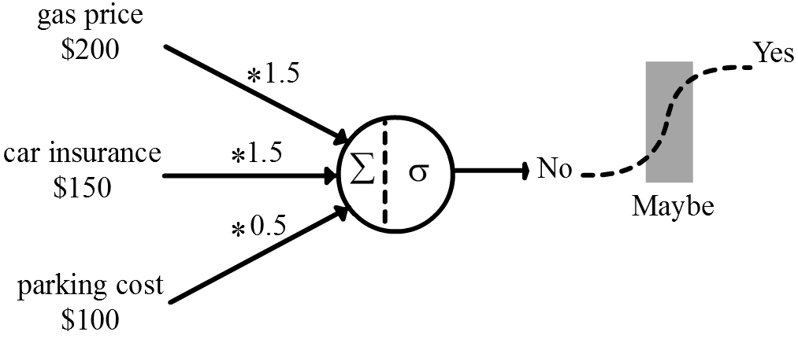

Fig. 2 Sigmoid neuron
In comparison, connectivism has been criticized for its oversimplification of interaction between nodes as the connection can be either active or inactive (Clarà and Barberà 2014). However, connectivism proponents (Aldahdouh et al. 2015) have shown that a connection is graded and not necessarily sharp. The graded view of a connection is congruent with sigmoid neuron function. Other issue presented here is the speed of learning. Connectivism puts the bulk of its attention on the rapid change of knowledge but it does not describe how exactly a learning process is in this dynamic environment. However, there are signs in connectivism literature that a learning process should cope with this rapid change. For example, one of the connectivism’s principles states that:
Decision-making is itself a learning process. Choosing what to learn and the meaning of incoming information is seen through the lens of a shifting reality. While there is a right answer now, it may be wrong tomorrow due to alterations in the information climate affecting the decision (Siemens, 2005, p. 5).
Aldahdouh et al. (2015) emphasized the same concept and criticized the education system as they said, "Sciences are developing very rapidly and the (reluctant) derivers' decisions are coming too late" (p. 13).
Thus, the output of soft neuron goes smoothly from 0 to 1. The output is now a real number. Even though this soft neuron seems to work better than hard neuron, it still has its own problems. Take for example a sigmoid neuron.
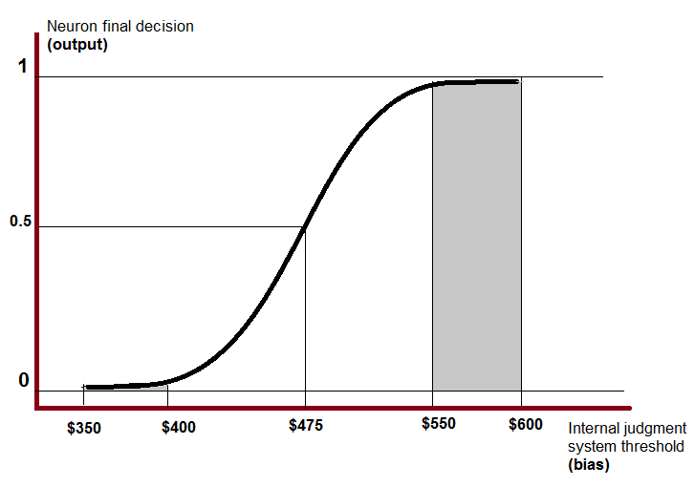

Fig. 3 Sigmoid activation function
Suppose that your initial thought was to buy a car only if it costs you less than $600 per month. That is, your bias was set to $600. Suppose further that you were wrong and you should learn that $475 is the right threshold using a sigmoid function as shown in Fig. 3. Since you learn according to a sigmoid function, you should go slowly from $600 down a curve to $475. Note that as your bias changes from $600 to $550, your decision remains nearly constant; it is almost 1. The same has to be said if you should go from $350 to $400. In these periods, the output of the neuron is saturated (Nielsen 2015). It seems as though a neuron does not learn anything; bias changes but that does not produce a change in a decision. This is one of the problems of sigmoid neuron. To solve this issue, researchers make learning speed independent on activation function (Nielsen 2015). Sigmoid neuron is still one of the most used neuron types in ANN. Other common soft neuron types show similar and, in some cases, better performance than sigmoid (Goodfellow et al. 2016; Nielsen 2015). Different soft neuron types and how they reflect to educational context deserve a separate work.
An obvious and legitimate question to ask is whether these functions reflect human internal judgment system. For example, suppose a learner in an online learning setting has internal judgment system like a sigmoid. In this case, when a student decides to share and comment all the time or decides to be silent all the time, could that be a sign that he is at saturation level? Could that be a sign that he is not learning new things? Wang, Chen and Anderson (2014) indicated that "the interaction of connectivist learning is divided into four levels: operation interaction, wayfinding interaction, sensemaking interaction, and innovation interaction" (p. 121). These levels grade from concrete to abstract and from surface to deep cognitive engagement. Pattern recognition, decision making, aggregation and sharing appear on sensemaking level. This means that sharing activity resides in the same level as learning process in connectivism. Downes (2009) asserted the same concept and suggested four steps for network creation: aggregation, remix, repurpose and feed forward. Thus, educating students to share information frequently is one of the connectivism aims and it is part of student's learning process. This is not congruent with at least a flat part of sigmoid function.
Nielsen (2015) has shown that a neuron can also implement any logic gate (e.g. NOT, AND, OR and NAND). This means a single neuron has some sort of logic in its own and a network of neurons is actually a network of logic gates. For example, if you want to design a network to compute a sum of two bits, you may need a network of (n) neurons. And if you want to multiply two bits, you may need a network of (m) neurons, and so on.
From this, we have a hunch that meaning exists in pattern of connections which is one of the main connectivism’s assumptions. But for now, a thing we are sure about is that one node in a network has trivial meaning in comparison to the meaning of a group of nodes. Actually, we are usually not interested in a single node meaning (AND, OR, NAND); we are interested in the meaning of the group of nodes as a whole (summation, multiplication). In connectivism, this matches the concept of emergent property (Downes 2016) where "a compounded node is larger than the sum of its inner nodes" (Aldahdouh et al., 2015, p. 12).

Artificial neural network architectures
The previous section describes a single neuron function. It is time now to see how researchers arrange group of neurons to form a learnable network. In this article, the way of arranging neurons in certain order is called network architecture. Recall that ANN may refer to two levels of abstraction: (1) ANN as a person’s brain and (2) ANN as a group of learners. Thus, network architecture refers first to a learner's inner abilities and mental capacities and; second, refers to a way in which designers of learning-environment arrange a network of learners.
It is worth noting that ANN is a universal modeling system. Universality means that ANN can learn any given function no matter what neuron type is used. It has been proved that with few neurons and by changing biases and weights only, ANN can compute any zigzag-shaped function (Nielsen 2015). The question now is how we arrange neurons in ANN to make it easier for a learning algorithm to find those biases and weights. For clarity and simplicity, the paper divides the most common ANN architectures based on three criteria: (1) number of layers, (2) flow of information and (3) neuron connectivity.

Number of layers:
By looking on how many layers a network has, ANN can be divided into (1) shallow and (2) deep networks.

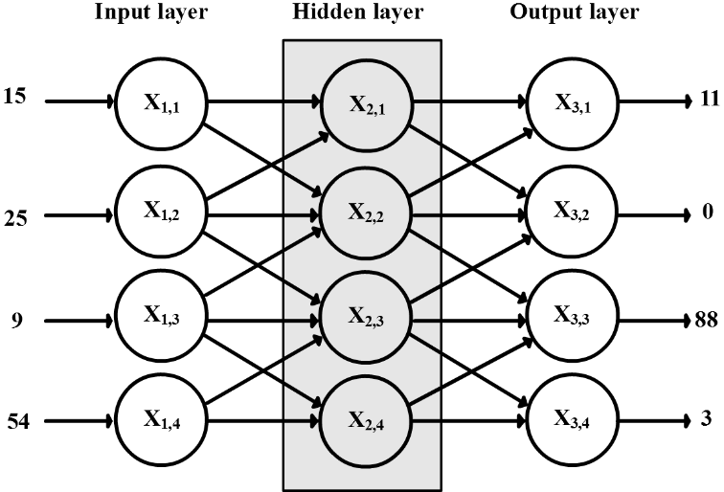

Fig. 4 Shallow neural network
A shallow neural network consists of three layers ordered from left to right: (1) input, (2) hidden and (3) output layer. The input layer does not really consist of neurons. Actually, it carries the input values to the network. For example, a value that passes from X_{1,2} to next neurons is 25, which is the input value. The second layer is named 'hidden' because it resides in the middle and does not appear in either the input or the output of the network. Other than that, it is a normal neural layer which contains normal neurons (Nielsen 2015). The output layer also contains normal neurons and its output represents the output of the network.
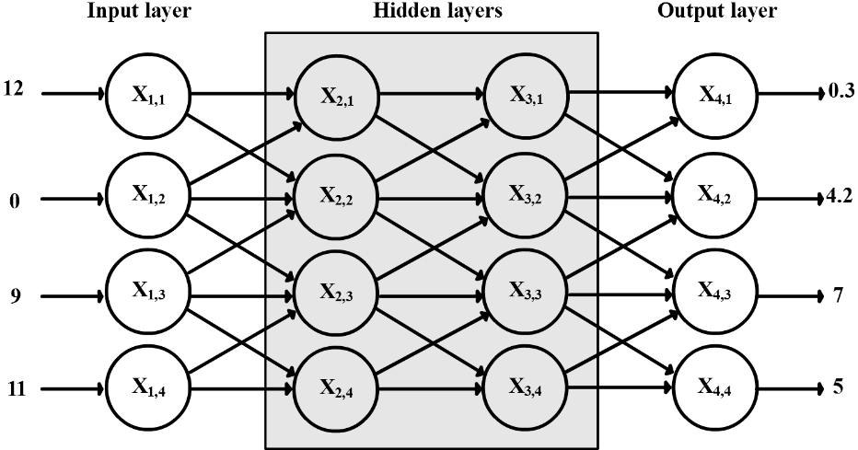

Fig. 5 Deep neural network
A deep neural network is the same as shallow neural network but it has two or more hidden layers. This architecture is also called Multilayer Perceptron (MLP). The original thought of presenting deep network stems from the idea of complex problem defragmentation. ANN researchers first noted that people are usually splitting the problem into sub-problems, solving each sub-problem alone and then reconstructing them to solve the entire problem (Nielsen 2015). They inferred that if the first hidden layer is going to handle the first level of the problem, then there should be second, third and more hidden layers to handle next levels of the problem. The initial steps of training deep network were frustrating because the network took long time to train and didn't show a big difference from shallow network results.
In general, the terms shallow and deep are somehow misleading because they are not in line with educational terminology of surface and deep learning (Vermunt and Vermetten 2004). Actually, there is nothing special in deep neural network except it gives more accurate results, if it was trained well. Moreover, the concept of layers is completely incompatible with connectivism’s assumptions. The idea of that a network consists of a sequence of layers contradicts with chaos theory which is one of the underpinning theories of connectivism. One can argue that organizing neurons in layers is a matter of rearranging neurons positions spatially and this does not impose any constraint on neurons connectivity. This is not true, even though, because by arranging neurons in layers a neuron output is not allowed to connect to neurons in any layer other than the next layer. It should be understandable, however, that ANN researchers thought to arrange ANN in layers to facilitate the computational model of a network where each layer is represented by two mathematical vectors, one for biases and another for weights.

Flow of information:
By looking on how information flows through a network, ANN can be divided into (1) feedforward and (2) recurrent networks.
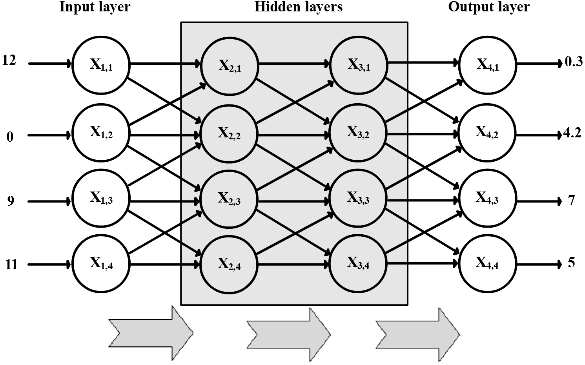

Fig. 6 Feedforward neural network
In feedforward networks, the output of a layer is used as an input for the next layer. There are no loops in feedforward networks; information flows in one direction where the output of a neuron can never return to its input. Feedforward network is one of the most used network structures. The value of this structure is self-explanatory since it significantly reduces the network complexity.
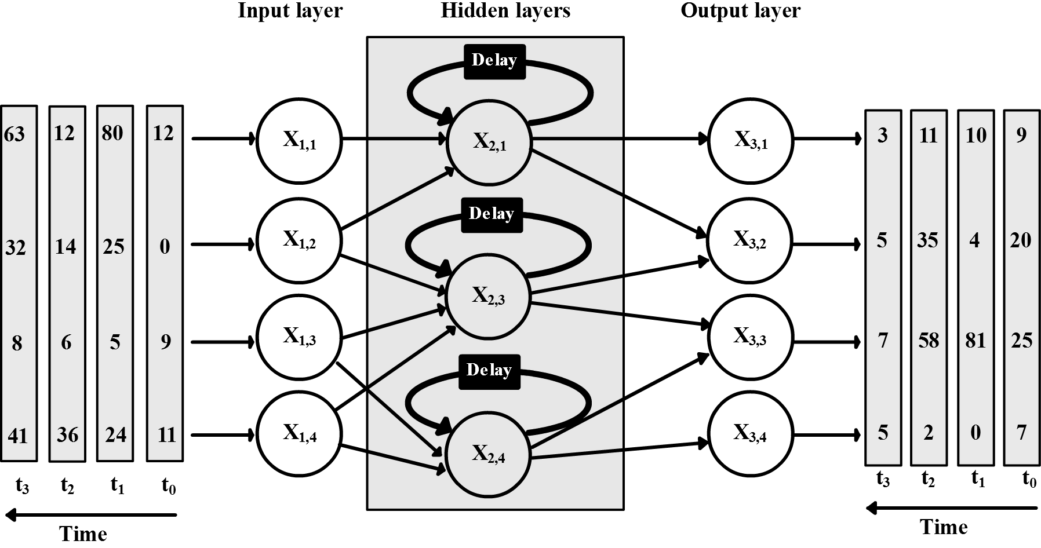

Fig. 7 Recurrent neural network
Recurrent network is a family of neural networks that processes the input sequentially and allows feedback connections (Goodfellow et al. 2016). Feedforward network structure assumes that all inputs are independent of each other (Britz 2015). It assumes that inputs order has no meaning. This, however, turns out to be false assumption for some tasks. For example, in natural language processing, the order of words makes a significant difference in meaning. Recurrent network tries to recover this issue by allowing feedback in a network. The feedback is allowed but with a delay constraint. That is, if the inputs are a sequence of A, B and C; then the output of hidden layer in step A can only be passed to the input of the hidden layer in step B, not the hidden layer in step A itself. To make a network simple, ANN researchers usually unfold the loop to see what it looks like on each step of the inputs. In Fig. 8Fig. 8, one can see that a loop allows information to flow from one step to another, and, therefore, acts as a memory (Britz 2015; Goodfellow et al. 2016; Olah 2015).
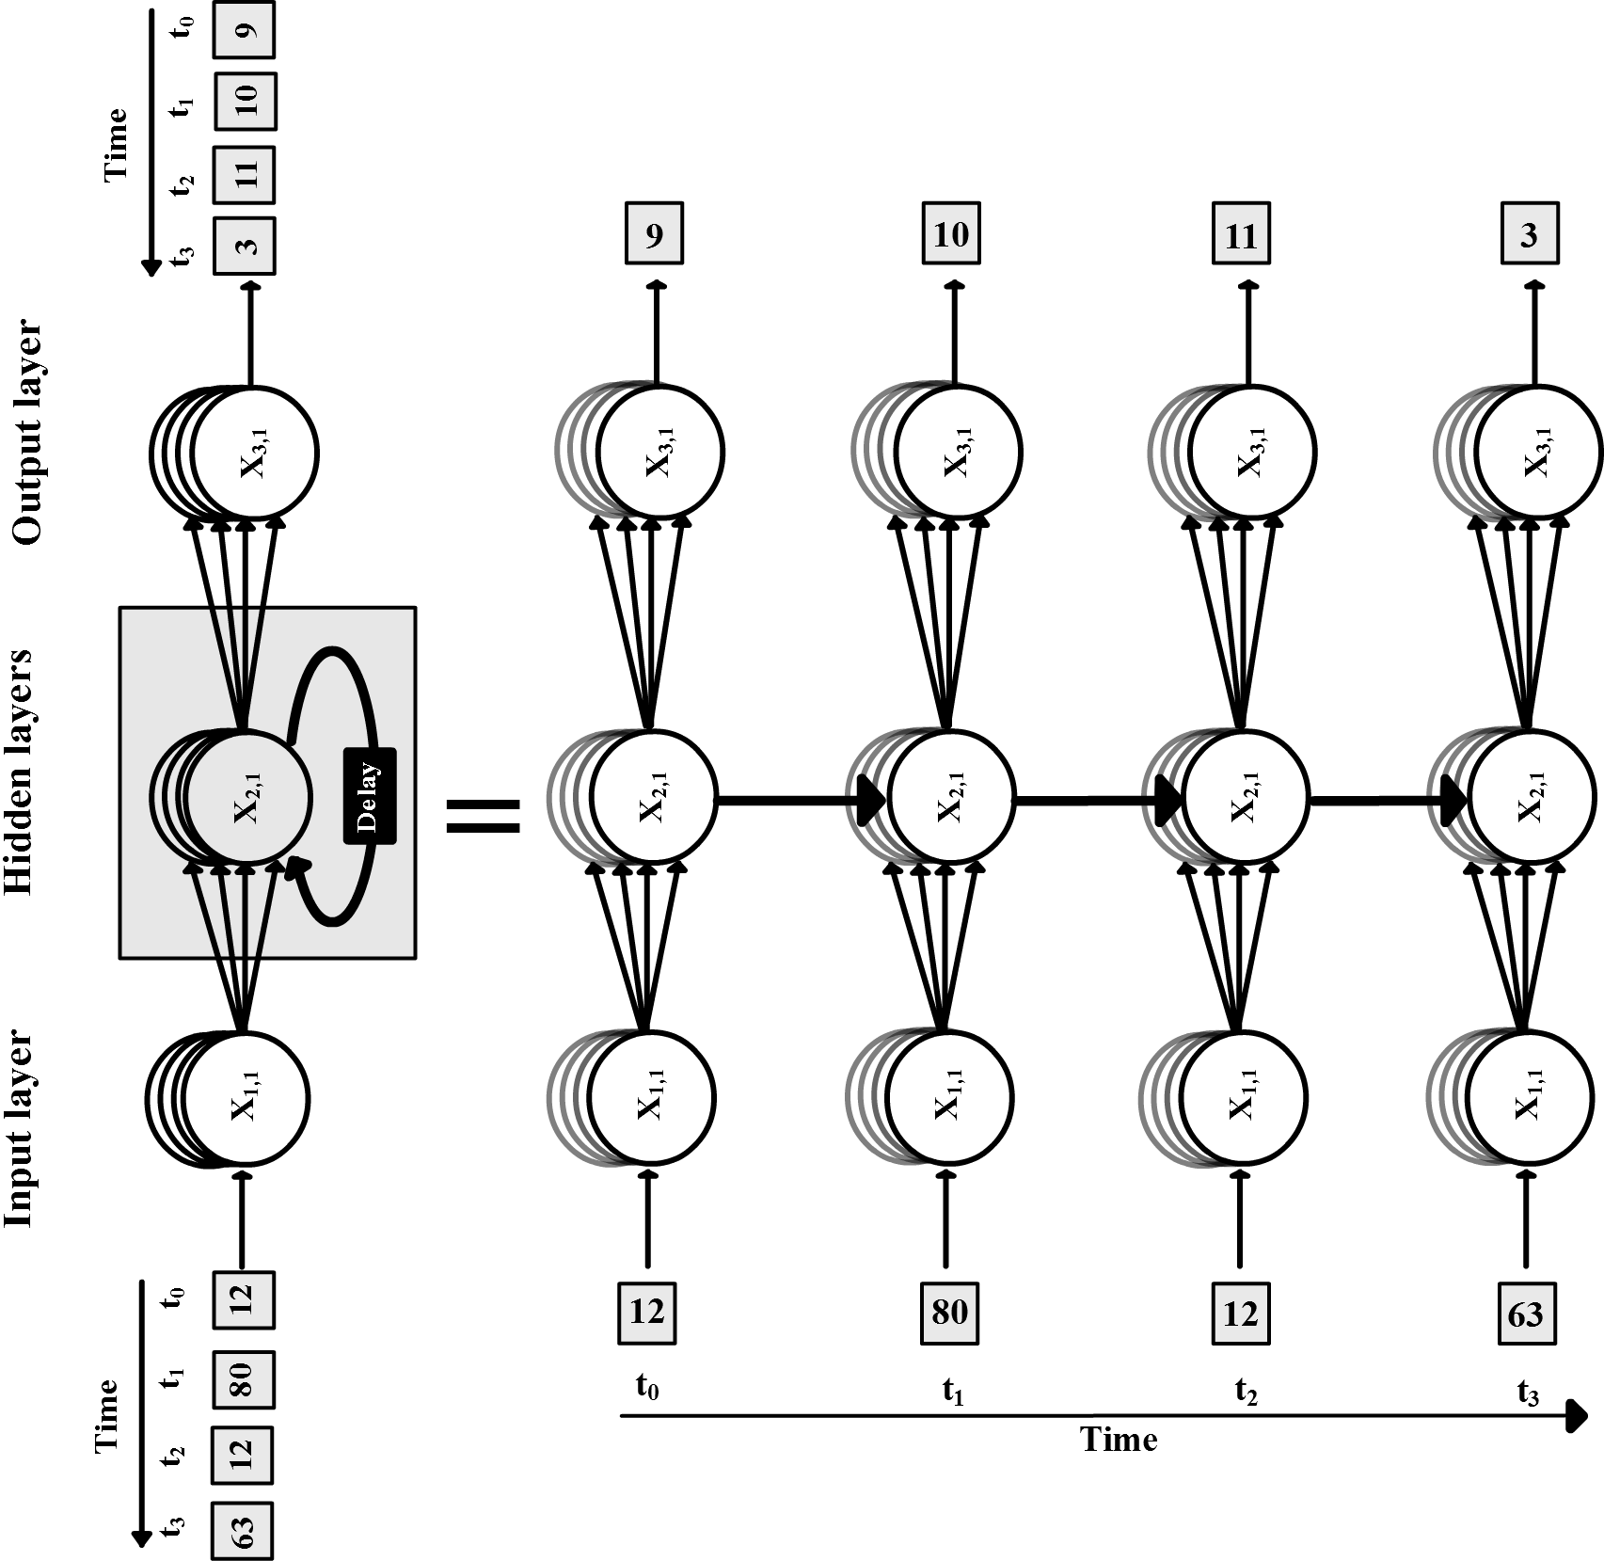

Fig. 8 Unfolded recurrent neural network
Note that at t₀, the input of neuron (X_{1,1}) is 12 and the output of neuron (X_{3,1}) is 9. At t₂, the same neuron (X_{1,1}) receives the same input (12) but the neuron (X_{3,1}) shows 11 as an output. This is mainly because the hidden neuron (X_{2,1}) receives feedback from its previous state at t₁.
Flow of information and connection directionality are some of subjects discussed in connectivism literature. Aldahdouh et al. (2015) showed that some connections in knowledge network are bidirectional while others unidirectional. They also showed that "The node can connect to itself" (p. 5). A latter concept is congruent with recurrent but not with feedforward network. However, caution should be taken when comparing ANN architecture with connectivism. Researchers restrict the flow of information in feedforward network and delay the feedback in recurrent network because it is the only way they can control and compute the output; not because they believe it is the right way of controlling the flow of information. With that said, one can consider ANN structure as a special case of connectivism network structure. The second and very important point to make here is the inclusion of time in network design. The time makes a significant difference in network output and that is one of the common points with connectivism. Connectivism’s principle of shifting reality matches the example given above. "While there is a right answer now, it may be wrong tomorrow due to alterations in the information climate affecting the decision" (Siemens, 2005, p. 5). Moreover, Aldahdouh et al. (2015) clearly called for considering the time as one of knowledge dimensions.

Neuron connectivity:
By looking on how each neuron connects to other neurons, ANN can be divided into (1) fully connected and (2) convolutional networks.
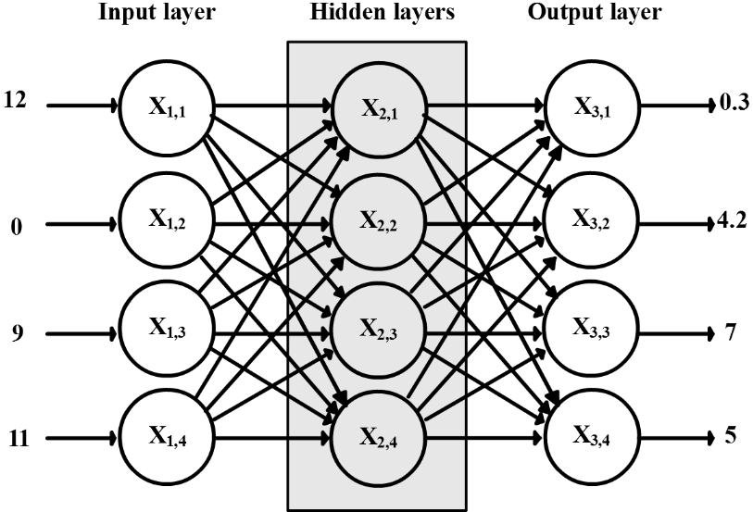

Fig. 9 Fully connected neural network
In fully connected network, each neuron in a specific layer is connected to all neurons in the next layer. The idea of this connectivity is to allow maximum interactions between neurons. It is also logical to think of fully connected network since we don't know in advance which connections should be removed and which ones should be remained. It is the job of learning algorithm to detect those connections. For example, if the connection between X_{1,2} and X_{2,1} should be removed in order to generate the desired output, the learning algorithm should figure out that the weight of this connection is 0. In other words, the learning algorithm should kill this link. One may wonder why would killing a specific connection generate a desired output? Recall the car example and how you downplayed the weight of parking cost. In some cases, you may even need to ignore the input at all; for example, you may need to ignore traffic fine as a monthly cost of a car. Full connectivity may add potentiality to the network but it adds severe difficulty on learning algorithm as well. Adding tens of neurons to fully connected network increases the number of weights and biases to be learned dramatically. Try to add two neurons to the hidden layer in Fig. 9 and notice how many new weights are added.
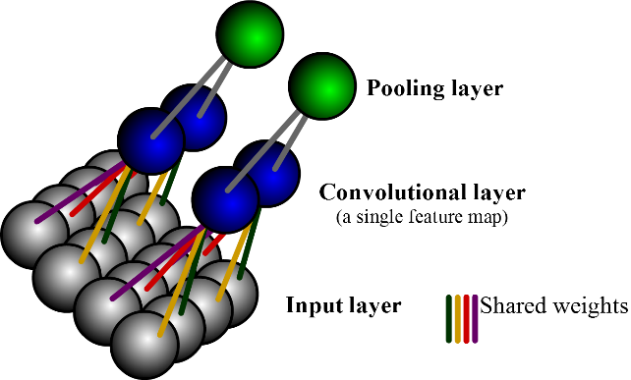

Fig. 10 Convolutional neural network
A convolutional network limits the connectivity between neurons so that a neuron in specific layer is connected only to a set of spatially adjacent neurons in the previous layer (Goodfellow et al. 2016; Olah 2014). Moreover, neurons in the convolutional layer should weigh up the corresponding input neurons with the same values. In Fig. 10 the same color connections between the input and convolutional layer should have the same value. Those connections are called shared weights. The output of convolutional layer is often called a feature map. It is called so because when you arrange a layer as described, the output would be detecting a single feature in the input (see Goodfellow et al., 2016 for details). For example, if the input layer represents an image, a convolutional layer may detect a vertical line in that image. A convolutional layer is usually followed by a pooling layer. A pooling layer takes a feature map and tries to summarize it. For example, if a feature map detected a vertical line in a tiny spot of the image, the pooling layer would summarize that in a larger region and says: there is a vertical line in this region. The assumptions of convolutional network sound weird and complicated. From where did those assumptions come? Actually, "Convolutional networks are perhaps the greatest success story of biologically inspired artificial intelligence" (Goodfellow et al., 2016, p. 364). A convolutional network was designed to capture the same functionality of the primary visual cortex in the brain.
Connectivism appreciates network connectivity and seeks to increase it as much as possible. Three out of eight connectivism’s principles refer directly to the value of the connection (Siemens 2005). Actually, connectivism defines learning as the process of connecting nodes in a network (Aldahdouh et al. 2015; Siemens 2005). This may indicate that connectivism aims to make a learner as a node in the fully connected network. However, it has been proved that increasing connectivity adds complexity to ANN. This complexity makes learning harder and slower. A convolutional network, on the other hand, decreases the connectivity and achieves better results. Connectivists should pay attention to this because it disagrees with their main network designs (see Downes 2010a work). In short, one can argue that connectivism agrees with fully connected network but disagrees with convolutional network.
It is important to note that the classification shown above is superficial and AI researchers are used to mixing network architectures together. For example, a network could be deep fully-connected feedforward network or deep convolutional network. Sometimes, a network architecture and its opposite can be mixed together. For example, a deep network may consist of two convolutional layers followed by one fully-connected layer. In general, mixing different network architectures shows better result and accuracy. In connectivism context, this may indicate that mixing connectivist's network structure (fully connected network) with other limited and loosely-connected structures would give us better educational results.

Learning algorithm
Designing network architectures is a difficult task but training and teaching these networks are surely more difficult. To understand how ANN has been trained, it is better to start with a very simple one neuron example (Goodfellow et al. 2016; Nielsen 2015). The principles which are used to teach a single neuron are also used to teach a whole network. However, a network level adds extra complexity which requires an additional step.
Suppose you have a very simple neuron with one input and one output. You want to teach this neuron to do a certain task (for example to memorize a multiplication table for number 5). To teach this neuron, ANN researchers usually give it a so-called training set. A training set contains a number of different input values (1, 2, 3, 4, 5, 6 ...) paired with the correct output (5, 10, 15, 20, 25, 30 ...).
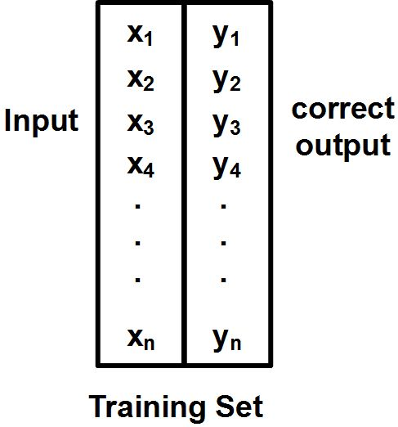

Fig. 11 Labeled training data
In the beginning, the neuron receives input and generates output according to its own weight and bias which were randomly selected. This means, the output of the neuron (as) would most probably differ from the correct output (ys).
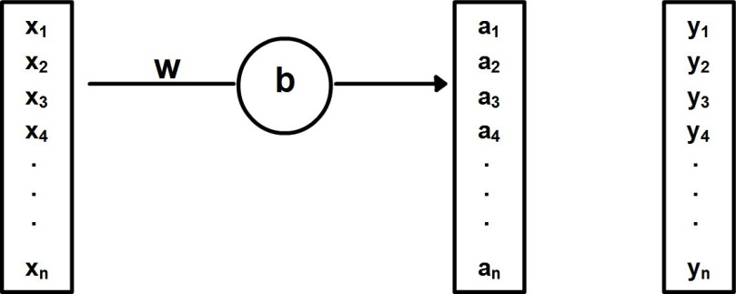

Fig. 12 Single neuron training
The difference between the neuron output and the desired output presents something useful. The function which measures the difference is often called a cost or loss function. There are many ways to calculate the cost function. One of the simplest cost functions is the Mean Squared Error (MSE):
(1)
MSE is the average of square of differences between the correct output (y_{x}) and the output of the neuron (a_{x}) for each given input x in the training set. One may simply understand this function as a way to measure the difference between all as and corresponding ys. It is also important to note that a cost function is written as a function of weight (w) and bias (b). That is to say, this is a cost of setting the weight and bias of the neuron in specific values. If we change the values of w and b, then we should re-calculate the cost again. If the new cost was lower, this means that the difference between the desired output (ys) and the neuron output (as) became smaller. That is, if we found w and b that make C(w,b) approaching to 0, then we in fact have found the right value of w and b. The job of learning algorithm is now to search for weights and biases that reduce the cost to minimum.
Before going further in a learning algorithm, it is better to stop a while on some of the ideas presented so far and match them to educational concepts. First, the labeled training data which contains the input values along with correct output assumes knowledge as something static and something we know in advance. Learning algorithm is not allowed to manipulate inputs or correct outputs in any case (Nielsen 2015). This limits the ability of ANN to learn something previously known, not to discover something new. The idea of static knowledge contradicts with connectivism’s principle of dynamic knowledge. The second important point here is how we could interpret this algorithm in an educational context. Let us continue with the connectivism’s assumption that a single neuron represents a person. Thus, the inputs of the neuron would represent the training material or the current learning experiences. The correct outputs represent the reality (ontology) and neuron outputs represent a person's perceptions about the reality (epistemology). The difference between neuron outputs and correct outputs represents the gap between learner's perceptions and the reality. That is to say, learning is the process of minimizing the gap between learner's perceptions and the reality. Of course, this definition perfectly fits constructivist theory of learning. Jean Piaget (2013) interprets learning process mainly using two sub-processes: assimilation and accommodation. Assimilation refers to learner's tendency to use his current knowledge to deal with new situations while accommodation refers to learner's tendency to change his current knowledge when it conflicts with reality. This theory clearly matches the way used to teach a neuron using labeled training data. ANN researchers, furthermore, insist that, in the learning stage, one should look at the gap between epistemology and ontology not at the correctness of epistemology (Nielsen 2015). The reason for this claim is that the number of correct answers is not smoothly related to the changes in weights and biases. That is, in learning stage, a teacher should not count how many times a learner gives correct answers and try to increase them. Instead, a teacher should focus on the gap between what a learner believes and the reality and try to decrease it. In other words, if a learner gives two wrong answers (123, 24) for a given question (5x5=?), these answers should not be treated equal. Because when a learner says 24, it seems he learned something closer to the reality even though the answer is not correct.
The time has come to see how a learning algorithm finds weight and bias that minimize the output of a cost function. To understand what the algorithm does, it is better to plot a cost function in relation to the variation of weight and bias. Since the output of a cost function (C) depends on weight (w) and bias (b) of the neuron, then we may plot C in three-dimensional space where each one of w, b and C represents one dimension.
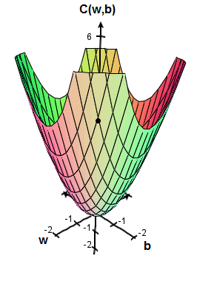

Fig. 13 Cost function in relation to weight and bias
The variation of weight and bias pair in relation to a cost function may constitute any terrain forms. Suppose it looks like a valley as shown in Fig. 13Fig. 13. Since we selected the value of weight and bias randomly at the beginning, the initial values of weight and bias can represent any point located on the surface. Suppose the point is located as shown. A learning algorithm should find a way to roll the point down the hill and make it settle at the bottom. Finding a right direction in three-dimensional space is not an easy task because it comprises watching the variation of three variables at once. It is better to split the task so we watch every two variables alone. To do so, we should pretend as if the third variable is constant.
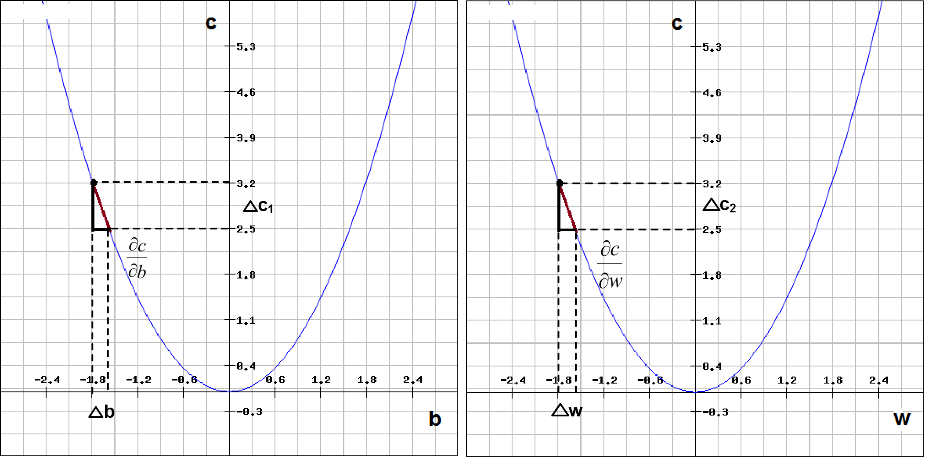

Fig. 14 (1) Cost function in relation to bias. (2) Cost function in relation to weight
In the first plot in Fig. 14, we are interested in finding a tiny change in bias that makes the cost smaller while keeping the weight constant (the same has to be said for the weight change in the second plot). To find this tiny change, we have to find a ratio (∂c/∂b) that relates the change of bias (∆b) to the change of cost while keeping the weight constant (∆C₁). This ratio is known as partial derivative.
 | , | (2)
A total change in cost is the summation of ∆C₁ and ∆C₂.
(3)
Note that a change of cost ∆C also means the difference in the cost value before C_{old} and after C_{new} the change occurs.
(4)
Since we need a new cost C_{new} to be smaller, this means ∆C should be negative. But how to guarantee that ∆C is always negative? If we choose ∆w and ∆b as following, this would guarantee ∆C to be always negative.
 | , | (5)
Why choosing these values of ∆w and ∆b would guarantee ∆C to be always negative? Because by substituting these choices into ∆C equation (3), one may easily find that these choices make sure ∆C negative.
(6)
Selecting ∆w and ∆b repeatedly as such will roll the point down the curve slowly and keep it settle at the bottom. This process is called gradient descent (see gradient in mathematics for general perspective and Nielsen, 2015 for specific discussion). So far so good but what we haven't mentioned yet what a factor (η) which appears in ∆w, ∆b and ∆C equations is called. They call it learning rate.
To understand why ANN researchers called η factor a learning rate, it is better to concentrate on one equation, take for example the equation of ∆b:
(7)
Note first that a sign of η refers to the direction in which we want to go to. A negative sign means we want to go down the curve. Now, if we choose η large, the step of ∆b becomes wide. And if we choose η small, the step of ∆b becomes tiny. Therefore, η controls the speed of ∆b learning. Since η appears on ∆w and ∆C equations as well, then we can say that η controls the speed of a neuron learning and it is logical to call it learning rate. It seems tempting to increase η so the step becomes wider and, hence, the point reaches the bottom faster. However, this is a false conclusion because a slope (∂C/∂b) is only valid for a tiny shift of b. To understand why, look at Fig. 15 below:
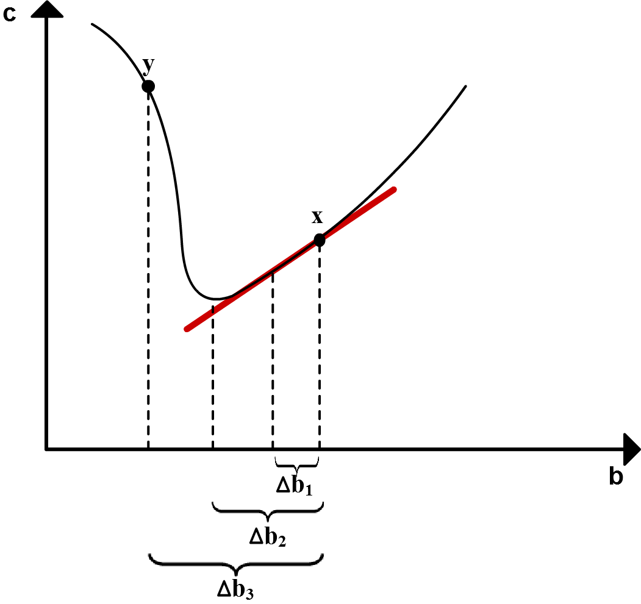

Fig. 15 Effect of selecting different value of bias on learning
Suppose you have a cost function in relation to bias as shown in the figure. The initial point is in (x). The red line represents the slope (∂C/∂b) at this point. First, if we choose η very small, the result would be a very small step like ∆b₁. This is not a good strategy because it requires many steps before we reach the bottom of the curve. Therefore, learning becomes very slow. On the other hand, if we choose η very large, the result would be a very wide step like ∆b₃. This is not a good strategy as well. It makes the point jump to higher cost (y). In this case, the right choice of η should be an intermediate value that produces step like ∆b₂. How do ANN researchers tune the value of η? So far, there is no rule and they depend merely on try-and-error strategy (Nielsen 2015)!
It is obvious that extracting an understandable educational interpretation out of this part of the algorithm is not an easy task. This paper does not also claim that it will offer a comprehensive interpretation. Instead, the interpretation coming shortly should be seen as an initial step toward understanding machine learning algorithms in a humanitarian learning context. Cumulative efforts from concerned researchers may eventually lead us to better understanding human and machine learning.
Recall that the cost represents a gap between learner's epistemology and ontology. Thus, one may argue that C_{old} represents the gap before passing through a learning experience. Likewise, C_{new} represents the gap after passing a learning experience. As a learner passes through a learning experience, the gap reduces from C_{old} to C_{new}. The gap shrinkage is ∆C. Therefore, ∆C represents the learning outcome. The learning outcome stems from the change in a bias of a learner's internal judgment system (∆b) and his own perspective (∆w). Changing student's perspectives ∆w and his bias ∆b toward smaller gap between epistemology and ontology (C_{new} < C_{old}) represents a learning outcome ∆C. Or in short, the learning outcome refers to the extent of progress a learner makes in bridging the gap between his epistemology and the ontology after passing learning experience.
A learning rate refers simply to the speed of learning outcome. Or how fast a learner should learn. The learning rate should not be too fast that makes a learner jump from point to point; long jumps disrupt learning. A learning rate should not be very slow too; it makes a learner crawl in details that would not serve him to achieve his goal. Finding the right pace of learning is a difficult task that depends on the initial state of the learner’s perspectives and bias. The determinant factor of learner’s speed of learning is where his epistemology is located in relation to the ontology. This may interpret why each learner has his own learning rate and why the same learner may change his rate from task to task.
One note in ANN model of learning is how AI researchers are setting the value of learning rate. Actually, learning rate is one of many other parameters which are left free for human and outside of ANN’s control. For example, (1) the number of layers, (2) the number of neurons in each layer, (3) the size of training set, (4) the activation function type, and (5) regularization parameter as well as (6) the learning rate are some of those free parameters which are called hyper-parameters (Nielsen 2015). Choosing the right values of hyper-parameters is left for a person who manages the ANN (see Fig. 16).
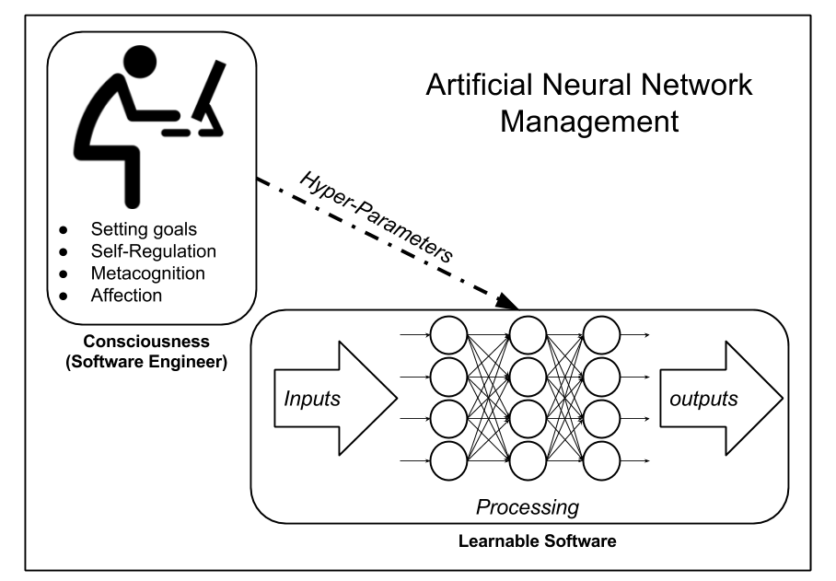

Fig. 16 Artificial Neural Network and human management
As we assumed in the beginning that ANN may represent a learner, this makes us wonder what does this person who is playing with hyper-parameters represent in a human’s mind? Arguably, hyper-parameters are a way in which the learner exercises control over his thoughts and learning and, therefore, this person represents human’ agency or consciousness. Bandura (2006) contends that human agency has four core properties which distinguish humans from automatons: intentionality, forethought, self-reactiveness, and self-reflectiveness. These four properties are sometime referred in educational literature as self-regulation and metacognitive processes. According to Vermunt and Verloop (1999), metacognitive regulation activities are those thinking activities learners use to decide on their goals, to exert control over their processing and affective activities and to steer the course and outcomes of their activities. For purposes of illustration, consider the following analogy of a software engineer and a learnable software. The software engineer represents the consciousness who sets the goals, plans for experiences, monitors and evaluates the progress of learning. A learnable software represents a neural pattern written in the brain. This learnable software is an elastic program which can automatically detects its mistakes and rewrites itself but under supervision of the engineer. The engineer manages, directs, and gives instructions to the learnable software but does not engage in writing the software by hand. The engineer is not a programmer and he does not even aware of how the software is written. Once the software is written ‘correctly’, the consciousness releases its control over the written software and the software is working deliberately. Only when something goes unexpected, the consciousness comes back to exercise control and regulates the process of rewriting the software again. Bandura (1999, 2006) criticizes connectionist’s view of human learning as it concentrates merely on neural patterns to interpret learning and argues that this view strips humans of agentic capabilities and a self-identity. In contrary, Bandura (2006) conceives consciousness as an emergent property of brain activities which is not reducible solely to the property of neurons activity. In other words, the consciousness is higher-level force which is a result of lower-level neural activities but its properties are not limited to them. As clarified in this study, ANN design shows the need for consciousness force to manage and regulate ANN learning but this force does not occur as an emergent property of neural activity as Bandura proposes. Rather, it is a completely distinct entity which uses, guides and manages the neural activity and does not result from it. Siemens (2005) defines learning as a process of connecting specialized nodes but, as far as we know, connectivism does not refer to learning rate and other hyper-parameters in its assumptions. Connectivism is also criticized for its ambiguity in that it does not show how pattern recognition is done (Aldahdouh et al. 2015). It is not clear in connectivism what the characteristics of pattern recognition are.
Up to now, the paper presents learning in one neuron level. Even though the rules of learning in one neuron level are applicable for a network level, the complexity and time spent in training a network increase dramatically. Suppose that you have a deep fully-connected network as shown in Fig. 17:

Fig. 17 Fully connected neural network with 44 neurons
In this network, you need to repeatedly calculate biases and weights according to the equations:
 | , | (8)
Old values of weight (w_{old}) and bias (b_{old}) were given from the previous step or were set randomly at the first step. You provide an arbitrary value for learning rate (η) and tune it by try-and-error strategy. The remaining part is to calculate partial derivatives (∂c/∂b) and (∂c/∂w). Our network has 44 neurons but a typical ANN may have millions of neurons. In such networks, finding gradient becomes a tedious task. Part of the difficulty in finding partial derivatives for each neuron returns to the fact that a tiny shift in single neuron weight or bias will propagate to all neurons in the next layer. And the next layer will propagate changes to the next layer, and so on. This tiny shift significantly changes the cost of the whole network. ANN researchers have found a way to trace these changes called back-propagation. Back-propagation outperformed all other methods used previously to compute gradient (Goodfellow et al. 2016; Nielsen 2015). The core idea of back-propagation depends on calculating partial derivatives using multivariable chain rule in mathematics. Presenting the mathematical model of back-propagation does not serve the purpose of this study. Intuitively speaking, back-propagation starts by computing the error in the output layer and then uses this error to compute the error in the preceding layers, one after another. That is, it goes through the network backward. At the end, it uses the error matrix to calculate the gradient that is required to compute the next values of bias b_{new} and weight w_{new} (see Goodfellow et al., 2016 and Nielsen, 2015 for more details).
Combined with back-propagation, gradient descent algorithm moves gradually to reduce the gap between correct output and network output. In each step of this movement, it computes the cost function and its gradient. The result is that each neuron in the network moves one step toward learning its right weights and bias. Eventually, the gradient descent reaches a point in which it can't reduce the cost anymore. At that point, the network reaches the maximum approximation to the correct output. This process is done automatically by gradient descent algorithm. In a network of millions of neurons, what are those right weights and bias that a single neuron learns? What is the meaning of those connections and biases? Why does each neuron connect to other neurons in that way? Until now no one has a theory. As Nielsen (2015) put it,
In the early days of AI research people hoped that the effort to build an AI would also help us understand the principles behind intelligence and, maybe, the functioning of the human brain. But perhaps the outcome will be that we end up understanding neither the brain nor how artificial intelligence works (ch. 1)!
Learning in network level clearly supports the core assumption of connectivism: A single connection between two nodes does not have meaning in its own. A meaning is distributed across group of connections or patterns (Aldahdouh et al. 2015; Downes 2006). Looking at the network from higher level mitigates its complexity (Downes 2016). But that does not give us the answer and the exact meaning of the entities in the lower level. The inner entities are well organized and they certainly serve the purpose of the whole network but by looking at single entity or small number of entities, one may fall in the illusion of finding conflicting and contradictory ideas with the whole network.

Discussion
It has been argued that machine learning has nothing to do with human learning. Some researchers in education field do not even see the difference between recent technologies and traditional tools like books (Verhagen 2006). Connectivists, on the other hand, argue that learning resides in non-human appliances (Siemens 2005). They insist on the relevance of machine learning and, frequently, share ANN findings to support their assumptions. This paper tried to bridge the gap and examine the relationship between connectivism’s assumptions and AI findings. Table 1 below summarizes, in points, the relationship between ANN concepts and connectivism’s assumptions.

Table 1

Relationship between ANN concepts and connectivism’s assumptions
ANN concept | Yes | No | Not clear | Clarification
Perceptron neuron |  | X |  | The connection is not necessarily sharp; it can be graded.
Neuron bias | X |  |  | A bias of neuron represents learner autonomy.
Sigmoid neuron |  |  | X | The graded feature of sigmoid is congruent with connectivism but the flat part of the curve is not.
Neuron as logic gate | X |  |  | A group of logic gates interprets the emergent property.
Network Layers |  | X |  | Arranging network in layers contradicts with chaos theory.
Feedforward net |  | X |  | Information in connectivism flows in both directions.
Recurrent net | X |  |  | Self-join connections are allowed in connectivism
Fully connected net | X |  |  | Connectivism seeks to increase connectivity as much as possible.
Convolutional net |  | X |  | Connectivism does not see the value of limiting connectivity.
Supervised learning |  | X |  | Supervised learning techniques are congruent with constructivism and former learning theories.
Unsupervised learning | X |  |  | Unknown and dynamic knowledge can only be learned by pattern recognition.
Learning rate |  |  | X | Connectivism has been criticized for its ambiguity in interpreting the process of pattern recognition.
Learning in network level | X |  |  | A single connection between two nodes does not have meaning in its own as connectivism suggests.
In this paper, we argue that the definition of learning as pattern recognition can only describe a learning process under certain conditions. As shown in the paper, ANN researchers use constructivist’s principles for teaching a network. Although not mentioned previously, we found that AI researchers use almost all previous learning theories. For example, one technique in AI mimics behaviorism and it is called reinforcement learning. In this technique, the agent learns from a series of rewards and punishments (Russell and Norvig 2010). ANN researchers also use a technique called Long-Short Term Memory which mimics cognitivism (Olah 2015). But all these methods should be seen from the lens of known and static knowledge only. That is, if the knowledge is known and static, ANN researchers may use labeled training data and make use of the gap between the network output and the correct output. In a situation where knowledge is not known or is not static, all these techniques will fail. The question of how to teach a network in these conditions remains not fully answered in AI field. As Russell and Norvig (2010) say, "how do we know that the hypothesis h is close to the target function f if we don't know what f is?"
(p. 713). In such cases, the only hope is to use unsupervised learning model in which a learner should extract the pattern from given examples without explicit feedback. The repetition and relative similarity between objects in given examples may help a learner to cluster and combine different ideas together to come up with new object. And that is where connectivist's theory lies.
Even though connectivism’s assumptions are not congruent with some points in ANN, they are certainly valuable in interpreting machine learning algorithm in general. Assuming knowledge as a network; viewing learner as a node in network; and the connectivity between learners serve us to understand the relationship between neurons and the complexity of artificial learning network. Without such assumptions, one may find it extremely difficult to approach machine learning algorithm from an educational perspective.
Studying ANN reveals that the flow of information should be free but educators should not seek to increase the connectivity as much as they can. A fully-connected learning environment increases the complexity and makes the learning process harder. The learner should be free to share knowledge and to act within a reasonable number of valuable connections. In addition, studying ANN shows that learning is a slow and smooth process. This is in comparison to knowledge which is changing rapidly. Connectivism presents two solutions for this paradox:
(1) to allow students to copy-and-paste and (2) to store their information outside themselves. Educators are also invited to find other innovative solutions.
This paper presents a very limited part of ANN literature. There are still some other topics that are valuable and deserve careful study from an educational perspective. Such topics include the number of nodes in each layer; different types of neurons; different cost functions; weight initialization; overfitting and regularization; Long Short Term Memory technique; bidirectional recurrent network; and Deep Belief Network.

References
Aldahdouh, Alaa A. and António J. Osório. 2016. “Planning to Design MOOC? Think First!” The Online Journal of Distance Education and e-Learning 4(2):47–57.
Aldahdouh, Alaa A., António J. Osório, and Susana Caires. 2015. “Understanding Knowledge Network, Learning and Connectivism.” International Journal of Instructional Technology and Distance Learning 12(10):3–21. Retrieved (http://www.itdl.org/Journal/Oct_15/Oct15.pdf#page=7).
Bandura, Albert. 1999. “Social Cognitive Theory: An Agentic Perspective.” Asian Journal of Social Psychology 2:21–41.
Bandura, Albert. 2006. “Toward a Psychology of Human Agency.” Perspective on Psychological Science 1(2):164–80. Retrieved (http://www.jstor.org/stable/40212163).
Bell, Frances. 2010. “Network Theories for Technology-Enabled Learning and Social Change: Connectivism and Actor Network Theory.” Pp. 526–33 in 7th International Conference on Networked Learning. Retrieved (http://usir.salford.ac.uk/9270/1/Bell.pdf).
Bell, Frances. 2011. “Connectivism: Its Place in Theory-Informed Research and Innovation in Technology-Enabled Learning.” The International Review of Research in Open and Distance Learning 12(3):98–118. Retrieved (http://www.irrodl.org/index.php/irrodl/article/view/902/1664).
Brabazon, Tara. 2016. The University of Google: Education in the (Post) Information Age. Routledge. Retrieved (https://books.google.fi/books?hl=en&lr=&id=QdeXCwAAQBAJ&oi=fnd&pg=PT7&ots=JbNthv0zbm&sig=QTtI95zOhlT9ibCjonqJeuO3he8&redir_esc=y#v=onepage&q&f=false).
Britz, Denny. 2015. “Recurrent Neural Networks Tutorial, Part 1 – Introduction to RNNs.” Retrieved August 22, 2016 (http://www.wildml.com/2015/09/recurrent-neural-networks-tutorial-part-1-introduction-to-rnns/).
Clarà, Marc and Elena Barberà. 2014. “Three Problems with the Connectivist Conception of Learning.” Journal of Computer Assisted Learning (OCTOBER 2013).
Cormier, Dave. 2016. “Content Is a Print Concept.” Retrieved June 19, 2016 (http://davecormier.com/edblog/2016/06/11/content-is-a-print-concept/).
Dirckinck-Holmfield, Lone, Chris Jones, and Berner Lindström. 2009. Analysing Networked Learning Practices in Higher Education and Continuing Professional Development. Sense Publishers.
Downes, Stephen. 2005. “An Introduction to Connective Knowledge.” Pp. 77–102 in, edited by K. Habitzel, T. D. Märk, and S. Prock. innsbruck university press. Retrieved (http://www.oapen.org/download?type=document&docid=449459#page=84).
Downes, Stephen. 2006. “Learning Networks and Connective Knowledge.” Pp. 1–26 in Collective intelligence and elearning, edited by H. H. Yang and S. C.-Y. Yuen. New York: Information Science Reference. Retrieved (https://books.google.fi/books?hl=en&lr=&id=GGx0GlvbYa0C&oi=fnd&pg=PA1&dq=Learning+Networks+and+Connective+Knowledge&ots=t48QLHJ56R&sig=z-9LiYdqRJG8H4Syp2fkT9WW5Z4&redir_esc=y#v=onepage&q=Learning Networks and Connective Knowledge&f=false).
Downes, Stephen. 2009. “New Tools for Personal Learning.” Presentation delivered at the MEFANET 2009 Conference, Brno, Czech Republic. Retrieved May 11, 2016 (http://www.downes.ca/presentation/234).
Downes, Stephen. 2010a. “Dimensions of a Learning Network.” Retrieved January 10, 2017 (http://www.slideshare.net/Downes/dimensions-of-a-learning-network-5560762).
Downes, Stephen. 2010b. “What Is Democracy in Education.” Retrieved February 1, 2016 (http://halfanhour.blogspot.pt/2010/10/what-is-democracy-in-education.html).
Downes, Stephen. 2012. Connectivism and Connective Knowledge: Essays on Meaning and Learning Networks. Retrieved (http://www.downes.ca/files/books/Connective_Knowledge-19May2012.pdf).
Downes, Stephen. 2016. “NRC01PL 07 - The MOOC Ecosystem - YouTube.” Retrieved September 2, 2016 (https://www.youtube.com/watch?v=kxstCBbIrUs&feature=youtu.be).
Goodfellow, Ian, Yoshua Bengio, and Aaron Courville. 2016. Deep Learning. Book in preparation for MIT Press. Retrieved (http://www.deeplearningbook.org/).
Kop, Rita and Adrian Hill. 2008. “Connectivism: Learning Theory of the Future or Vestige of the Past?” International Review of Research in Open and Distance Learning 9(3). Retrieved (http://www.irrodl.org/index.php/irrodl/article/view/523).
Nielsen, Michael a. 2015. Neural Networks and Deep Learning. Determination Press. Retrieved (http://neuralnetworksanddeeplearning.com/).
Olah, Christopher. 2014. “Conv Nets: A Modular Perspective.” Retrieved August 23, 2016 (http://colah.github.io/posts/2014-07-Conv-Nets-Modular/).
Olah, Christopher. 2015. “Understanding LSTM Networks.” Retrieved August 22, 2016 (http://colah.github.io/posts/2015-08-Understanding-LSTMs/).
Piaget, Jean. 2013. The Construction of Reality in the Child. Routledge. Retrieved (https://books.google.fi/books?hl=en&lr=&id=PpfGxMDZP-4C&oi=fnd&pg=PP2&dq=The+construction+of+reality+in+the+child&ots=LLsJNq8Qud&sig=RtAqeUgF2hA30rsG9-GOW4e9kn4&redir_esc=y#v=onepage&q=The construction of reality in the child&f=false).
Russell, Stuart and Peter Norvig. 2010. Artificial Intelligence: A Modern Approach. Third Edit. New Jersey: Prentice Hall. Retrieved (http://aima.cs.berkeley.edu/).
Siemens, George. 2005. “Connectivism: A Learning Theory for the Digital Age.” International journal of instructional technology and distance learning 2(1):3–10. Retrieved (http://www.itdl.org/Journal/Jan_05/article01.htm).
Siemens, George. 2006. Knowing Knowledge. Lulu. com. Retrieved (http://www.elearnspace.org/KnowingKnowledge_LowRes.pdf).
Siemens, George and Peter Tittenberger. 2009. Handbook of Emerging Technologies for Learning. Manitoba, Canada: University of Manitoba. Retrieved April 11, 2014 (http://elearnspace.org/Articles/HETL.pdf).
Verhagen, Pløn. 2006. “Connectivism : A New Learning Theory?” University of Twente 2(1):3–10. Retrieved (http://elearning.surf.nl/e-learning/english/3793).
Vermunt, Jan D. and Nico Verloop. 1999. “Congruence and Friction between Learning and Teaching.” Learning and Instruction 9(3):257–80.
Vermunt, Jan D. and Yvonne Vermetten. 2004. “Patterns in Student Learing: Relationships between Learning Strategies, Conceptions of Learning and Learning Orientations.” Educational Psychology Review 16(4):359–84.
Wang, Zhijun, Li Chen, and Terry Anderson. 2014. “A Framework for Interaction and Cognitive Engagement in Connectivist Learning Contexts.” International Review of Research in Open and Distance Learning 15(2):121–41.

About the author
Alaa A. AlDahdouh PhD candidate, Institute of Education of University of Minho, Portugal. He has B.S in computer engineer with cumulative experience in software programming. He is interested in studying human and machine learning as well. His work focuses on investigating new educational theories such as connectivism and their role to enhance educators' understanding of learning process.
E-mail: AlaaAldahdouh@gmail.com
Find him on Social Media: ResearchGate & Twitter

Return to Table of Contents
Editor’s Note: This is a comprehensive and carefully crafted study to determine student perception of the role of Information and Communication Technologies (ICTs) in distance learning. It studied advantages, availability, teaching/learning strategies, and potential barriers to effective use from a student point of view. It produced significant information to determine effectiveness of the system as currently implemented and data to guide further improvement from a learner point of view.

Learners' perspectives of using ICT in higher education institutions in Jordan

Muhannad Al-Shboul, Munim Al-Saideh, Nezar Al-Labadi

Jordan

Abstract
Information and Communication Technology (ICT) plays a major role in Jordanian higher education institutions by facilitating and improving the teaching and learning process to be in line with the information technology era. Higher education sector in Jordan highly values the importance of utilizing and integrating ICT tools into its post-secondary educational system. Towards institutional excellence, Jordanian universities should strive towards competitive academic institutions; by enhancing teaching and learning process related to the advancement of ICT. However, this study attempts to focus on the current status and issues related to the ICT utilization in Jordanian universities as perceived by undergraduate students. Moreover, this study investigates the barriers that might prevent the effective use of ICT in higher education in Jordan from the learners' perspectives. A quantitative research approach was used in this study. A self- administered Web-based questionnaire was employed and distributed to all undergraduate students who enrolled in four selected universities in Jordan for the Fall Semester 2016/2017. A total of 724 participants have responded and completed the survey. Series of data analyses of variables measurement for reliability and validity tests were performed. The results of the analysis, however, revealed that most students have positive perceptions towards the use of ICT in the classroom instruction in institutions of higher education in Jordan. The study provides some recommendations to the higher education leaders and policy makers towards promoting a successful adoption and diffusion of ICT in the future. Moreover, it suggests some area of investigations for future researchers who are interested in conducting similar studies about ICT integration in higher education; in the context of developing countries in general and Jordan in particular.
Keywords: ICT, technology integration, educational technology, learner's perception, ICT barriers, higher education, Jordan.

Introduction
With the rapid technological developments during the last few years, new methods and areas of utilization have emerged in the field of higher education. As a result, the educational system is constantly being challenged to offer better education to more learners, at the same time as technological development continually opens up new possibilities and methods of learning (Ashrafzadeh & Sayadian, 2013). By employing ICT in the classroom and involving it in the curriculum, students can improve their learning and also collaboration and cooperation among instructors; in addition, making use of ICT in higher education can make learning more beneficial. It can effectively improve the educational system and be a tool to facilitate learning. To integrate ICT in the classroom instruction, students need to be proficient enough to use ICT in their learning environments. The way they integrate ICT in their learning activities, the amount of their ICT use and success can be related to some factors like the way they think about ICT integration, their degree of ICT acceptance and competence, and their beliefs and concerns about integrating ICT in classroom instruction (Khasawneh & Ibrahim, 2012; Khasawneh, 2015). Therefore, by determining students and learners’ perceptions about utilizing ICT in the classroom, it may be possible to increase the benefits of integrating technology in the educational system and also improve learning process.
The ICT revolution have placed great pressure on higher education institutions and universities worldwide to create efficient infrastructures to handle the continued growth in the numbers of incoming students while ensuring the delivery of high-quality education (Brown, 2002). There is a continual need to improve ICT infrastructure and develop innovative approaches to quality teaching and learning that fully exploit ICT. However, as countries continue to invest in ICT for use in education, there is a greater need for performance indicators to monitor the use and effects of ICT (Al-Zoubi, Kahhaleh, Hasan, & Kharouf, 2007).
The acceptance and use of ICT by students and learners plays an essential and important role in higher education institutions. Worldwide, especially in developed countries, most students and learners are able to use ICT in their learning activities. Numerous universities in developing countries are greatly concerned about ICT use and acceptance among learners. ICT facilities and services are provided in developing countries’ universities in order to enable learners to efficiently use Web-based resources and have the ability to utilize various applications of the Internet within their classroom instruction (Osman, 2014). Thus, there is a need to investigate the issue of acceptance and use of ICT, and examine factors that influence and predict acceptance and use of ICT among users and learners at higher education institutions.
The use of ICT to enhance the quality of students' learning is generally observable in higher education institutions. Although ICT has positioned itself in higher education, its implementation to enhance students' learning has been received with mixed feelings, attitudes, and perceptions among students and learners. However, the use of ICT in relation to learning paradigm, collaborative and/or co-operative learning, deep learning approach and assessment seem to be problematic among learners and may affect their learning. Issues related to ICT access, ICT skills and support (technical and service) contribute to learners’ perceptions towards the use of ICT in learning (Chainda, 2011). Hence, the purpose of this study was to investigate learners’ perceptions of the possible effect of ICT utilization on teaching and learning process at four academic institutions in Jordan in order to determine the ICT skills that learners need to have to enhance their learning.
However, Middle Eastern universities, including Jordan, are making efforts and planning to enhance ICT use among learners. Jordan is looking to the educational possibilities offered by ICT as a way to expand and improve its education system. To support these efforts, this research study is designed to understand how learners at undergraduate level accept and use of ICT in their learning practices.
This study is mainly aimed to investigate the issues of acceptance and use of ICT as perceived by learners, as well as to examine potential barriers that may affect the use of ICT among students and learners at four Jordanian universities. To achieve these objectives, the study was organized in seven sections that represent the chronological development of the study.
Thus, the rest of this research paper is structured as follows: Section-Two provides a literature review of learners' perceptions about the use of ICT in teaching-learning process, particularly in higher education institutions in Jordan, and the major barriers affecting learners' use of ICT in education. Section-Three introduces the problem of the study, describes the purpose of the study, and lists research questions. Section-Four describes the research method that was used in the study, including a description of the study population and participants, data collection procedures, and data analysis. Section-Five presents the results and findings of the study, Section-Six provides a discussion related to the use of ICT in higher education institutions in Jordan as perceived by learners at four Jordanian universities, and Section-Seven provides conclusions, implications of the study, and recommendations for future research.

Literature review

ICT in higher education
The adoption and diffusion of educational technologies that leverage ICT and the Internet has provided an unprecedented opportunity for improving higher education around the world (Davis & Wong, 2007). ICT can increase learners’ motivation, accelerate the knowledge process, and facilitate the information access (Herrero et al., 2015). The use of ICT in education lends itself to more student-centered learning settings. However with the world moving rapidly into digital media and information, the role of ICT in education is becoming more and more important and this importance will continue to grow and develop in the 21st century (Noor-Ul-Amin, 2013).
Some reviewed literature indicated that the adoption and use of ICT in higher education have a positive impact on teaching, learning, and research (Noor-Ul-Amin, 2013; Tan & Eze, 2008). ICT can affect the delivery of education and enable wider access to the same. In addition, it will increase flexibility so that learners can access the education regardless of time and geographical barriers. It can influence the way students are taught and how they learn. It would provide the rich environment and motivation for teaching and learning process which seems to have a profound impact on the process of learning in education by offering new possibilities for learners and instructors. These possibilities can have an impact on learner performance and achievement. Similarly wider availability of best practices and best course material in education, which can be shared by means of ICT, can foster better teaching and improved academic achievement of students. The overall literature suggests that successful ICT integration in education (Flecknoe, 2002; Al-Ansari, 2006; Plomp, Pelgrum, & Law, 2007).
According to Achimugu, Oluwagbemi and Oluwaranti (2010), higher education is approaching the point at which ICT plays a vital role in nearly all phases of the educational process. Mofleh and Wanous (2008) indicated that, in the last two decades, there has been a wide spread of ICT in the universities at higher education sector around the globe, driven by the benefits that have been achieved, and fine-tuned by deploying ICT in education.
Lei and Zhao (2007) described how the technology, ICT in particular, is likely to play a different role in students’ learning in institutions of higher education. Yet, rather than trying to describe the impact of all technologies as if they were the same, it is clear that there is a need to think about what kind of technologies are being used in the classroom and for what purposes. According to Lei and Zhao's study, two general distinctions are found in the literature; first, students can learn from computers where technology is used essentially as tutors to increase students’ basic skills and knowledge, and second, they can learn with computers where technology is used as tools applied to a variety of goals in the learning process and being a resource to help develop higher order thinking, creativity and research skills (Resta, 2002; Olakulehin, 2007).
Higgins (2003) pointed out that there is evidence from the research that ICT can help students to learn and instructors to teach more effectively; moreover, he indicated that findings suggest that although ICT can improve learning there are a number of issues that need to be considered if such technology is going to make a difference. However, in order for learners to benefit fully from ICT they will need to become confident and competent users of technology, having ICT skills and be media and information literate (Clarke, 2004).
According to Tinio (2003), the experience of introducing ICT in the classroom and other educational settings all over the world over the past several decades suggests that the full realization of the potential educational benefits of ICT is not automatic. The effective integration of ICT into the post-secondary educational system is a complex, multifaceted process that involves not just technology but also curriculum and pedagogy, institutional readiness, instructor and learner competencies, and long-term financing, among others.
ICT in higher education provides an opportunity to faculty members to transform their practices by providing them with improved educational content and more effective teaching and learning methods. ICT improves the learning process through the provision of more interactive educational materials that increase learner motivation and facilitate the easy acquisition of basic skills. The use of various multimedia devices such as animation, videos, and computer applications offers more challenging and engaging learning environment for students of all ages (Jhurree, 2005).
Stack (2008) provided several key recommendations for higher education institutions regarding the use of ICT such as: (a) Instructors should regularly review the use of ICT in their work; in particular, they should strive to ensure greater integration of ICT within teaching and learning activities in classrooms and other settings. (b) Instructors should exploit the potential of ICT to develop as wide a range of students’ skills as possible, including the higher-order skills of problem-solving, synthesis, analysis, and evaluation. (c) Universities should endeavor to provide all their students with an appropriate and equitable level of experience of ICT at all class levels. And (d) Institutions of higher education should exploit the benefits to be had from ICT in their assessment procedures and also in their administrative practices.
According to National Council for Curriculum and Assessment (NCCA) (2006), when used to support learning objectives in the post-secondary curriculum, ICT can positively contribute to students’ learning across the curriculum, including their literacy and numeracy skills, higher-order thinking skills (critical thinking, creative thinking, problem-solving) and collaborative and interpersonal skills. Perhaps most importantly, ICT facilitates the differentiation of the curriculum to suit the range of learning needs and styles of individual learner. In this way, ICT can offer the instructor a powerful teaching and learning resource helping to ensure that all undergraduates can enjoy success as learners.
According to UNESCO Institute for Statistics (UIS) (2004), ICT can be used in higher education to: improve administrative efficiency, disseminate teaching and learning materials to instructors and students, improve the ICT skills of instructors and students, allow instructors and students access to sources of information from around the world, share ideas on education and learning, collaborate on joint projects, and conduct lessons from a remote location. Furthermore, to the extent that higher education institutions aim to achieve these goals they need to measure their progress, successes and problems (UIS, 2004).
Bizi and Shittu (2014) mentioned several benefits of ICT in higher education such as: support conventional classroom work; electronic teaching materials can be exchanged through ICT; the computer can help in the design and development of learning materials; through ICT, the user can access, store, analyze information in electronic form; ICT is particularly useful in research as it gives access to a world of resources, especially in electronic form; and ICT can play a key role in administration, where student’s data, personnel administration, purchasing and supplies, advertisement, etc. can be handled with ease using ICT.
Yusuf (2005) suggested that ICT in higher education is usually (a) a tool for addressing challenges in teaching and learning, (b) a change agent, and (c) a central force in economic competitiveness. As a tool for addressing challenges in teaching and learning, ICT has capabilities for delivery, management, and support of effective teaching and learning. It is equally good for geographically dispersed audiences, and it also helps students to collect and make sense of complex data. It also supports diverse and process–oriented forms of writing and communication, and it broadens the scope and timeliness of information resources available in the classroom. As a change agent, it catalyses various other changes in the content, methods, and overall quality of teaching and learning, thereby ensuring constructivist inquiry-oriented classrooms. As a central force in economic competitiveness, it deals with economic and social shifts that have technology skills critical to future employment of today’s students.
In addition, ICT is a powerful tool for the development of quality teaching and learning; it is a catalyst for radical change in existing university practices and a veritable vehicle for preparing the students for the future. Success in the implementation of ICT tools will be dependent on the recognition of the importance of sectoral application to education and sustainable implementation. Maximizing ICT potentials will involve quality ICT policy, greater involvement of private and public in the funding of the implementation, and proper implementation and monitoring (Yusuf, 2005).
Ping (2004) indicated that adequate physical and technological infrastructures are necessary conditions for effective ICT integration. Furthermore, Ping declared that, according to many researchers, the most frequently mentioned problem in integrating ICT in education is the insufficient number of computers. Countries with adequate budgets for ICT in education tend to have good physical and technological infrastructures. Other countries have successfully overcome budget constraints and are able to provide necessary infrastructure based on the needs of the school or region. Some other countries that have large budgets for ICT in education lack the expertise to identify appropriate hardware and software to purchase and, as a result, ICT integration is not well-supported by adequate infrastructure.
Moeller and Reitzes (2011) pointed out that technology in general, and ICT in particular, can equip students to independently organize their learning process. So, instead of being passive recipients of information, students using technology become active users. Also, [30] found that ICT provides high-quality, ongoing feedback to instructors and students that can help guide the learning process; and when ICT mirrors how professionals use it in the workplace, it can enhance academic achievement, civic engagement, acquisition of leadership skills, and personal/social development. Moreover, ICT can be designed to provide adaptive learning and assessment experiences for students. Most important to student-centered learning, ICT can enable outcomes that vary based on student strengths, interests, and previous performance. In addition, Moeller and Reitzes found that 60 percent of instructors reported that they use ICT in the classroom, but just 26 percent of the students indicated they are encouraged to use technology themselves. However, according to Moeller and Reitzes' study, computer-based delivery of education is one of the fastest growing trends in educational uses of technology.
Sharma (2015) stated that ICT is making major differences in the teaching approaches and the ways students are learning. ICT-enhanced learning environment facilitates active, collaborative, creative, integrative, and evaluative learning as an advantage over the traditional method. In addition, Sharma discussed the key challenges of ICT integration into higher education systems.
A number of studies indicated that ICT is utterly important for schools and higher education institutions. If students are prepared to use ICT in schools, the transition from schools to higher education will be feasible. Higher education, in particular, constitutes a critical factor in the processes of social, cultural and economic development. ICT permits restructuring of education by the introduction of online or distance learning whereby the classroom becomes merely one more instance of support for learning. ICT allows new forms of engagement; it can be used to engage those who may have been marginalized, disadvantaged, or excluded from traditional education programs. The integration of ICT permits exchanges among learners in terms of communication, knowledge, information and ideas that were not apparent before the adoption of technology and the knowledge society. ICT provides students with the opportunity to become self-directed learners by accessing and retrieving information via the World Wide Web and discovering their own approaches to learning based on their own interests and needs. ICT also impacts cultural heritage education which previously relied on traditional teaching methods where the instructor was the sole provider of learning and textbooks were the only sources of knowledge (Gulbahar & Guven, 2008; Mohammad, Al-Karaki, & Abu-Naba’h, 2008; Papanastasiou & Angeli, 2008; Vajargah, Jahani, & Azadmanesh, 2010; Abdel-Jabbar, Betawi, & Al-Shboul, 2013; Edward, Vimbai, & Misheck, 2013; Gilakjani, Leong, & Ismail, 2013; Kusano et al., 2013).
In terms of the use of ICT for higher education, Tan (2011) pointed out there are some major issues and challenges that should be considered by higher education institutions when designing and implementing their own ICT plans, such as: lack of support from management; unclear division of function and power; uncoordinated planning and implementation; question of ownership; shortage of trained staff to cope with the diversity of responsibilities and tasks; resistance from staff and reluctance to be re-trained; and insufficient funds for developing, purchasing and implementing ICT. However, some of these issues can be avoided through proper preparation and planning.
Additionally, Tan (2011) stated it must be remembered that integration of ICT into higher education cannot be accomplished overnight; it takes years of planning and preparation, refining and retuning the systems. The other thing to keep in mind is the rapid change and development in technology; it is not uncommon to find innovative tools and practices once very much in vogue quickly losing grounds to newer inventions. Any investment made in the now “outdated” technology could therefore be lost – a situation to be avoided at all costs especially in view of limited resources. This certainly creates a dilemma. On the one hand, development of ICT for learning is a long-term project; on the other, the ICT sector advances too fast to permit ponderous consideration and decision making. Clearly, this requires holistic and careful planning, supported by up-to-date information and expert advice that will consider factors such as pedagogy, quality learning, affordability, existing infrastructure and resources, staff capacity and course content development and above all, it is critical to have a vision with clear objectives and strategies based on candid understanding of the institution's strengths, weaknesses and core competencies.
According to Tan (2011), students are ultimately the main beneficiaries of the push to capitalize on ICT to improve the access to and quality of higher education. Students in the 21st century are ICT natives who welcome the introduction of technologies in their learning process. They may even demand the universities to modernize their systems and teaching practices to keep up with workplace requirements. The anywhere, anytime mode of learning and the networked communities harmonize very well with young people's lifestyles and the communication media of their time and age. All e-Learning courses will have to be designed to match their learning styles and needs.
Toro and Joshi (2012) indicated that there are various advantages from the use of ICT in teaching, but they bring changes that affect students, instructors and the higher education institution itself. The use of ICT in classrooms provides greater motivation and attention from students, especially when using multimedia contents. There is a greater independence and responsibility once they take work for themselves. Improvements are also seen by learners; whereas regarding instructors can highlight two important aspects: have a more positive attitude in relation to ICT, and plan their classes more efficiently and effectively. However, key benefits of using ICT in higher education includes: ICT can make learning more interesting, authentic and relevant; ICT allows more time for observation, discussion and analysis; and using ICT increases opportunities for communication and collaboration.
In addition, Toro and Joshi (2012) stated that in order for ICT to impact most effectively on traditional school-based learning and teaching, educators need to critically review available digital multimedia to assess advantages and disadvantages so that selection and utilization of digital resources and objects best meet the needs of particular students and learning contexts. The research has noted that instructors need support to implement ICT effectively in their arts programs.
Finally, Toro and Joshi (2012) declared that the purposes of utilizing ICT in education need to be clearly understood by instructors, their students and the school community, including parents. What is important is to ensure a quality media culture of the future where student’s safety is protected in cyberspace. ICT use in higher education can enhance both student and instructor motivation. It undeniably provides new ways of accessing information through the internet.
Gülbahar (2008) explored the level of usage of preservice teachers’ and instructors’ utilization of ICT; as well as examined factors that contribute to preservice teachers’ utilization of technology and suggest recommendations regarding to the effective utilization of technology. Furthermore, the study found that there were three factors that appear to have a significant influence on the effective use of technology: (a) the quantity and quality of the lessons addressing technology in the curriculum, (b) incompetent teachers/lack of in-service training, and (c) insufficient technological infrastructure.
According to Bindu (2016), ICT has the potential to create powerful learning environments in various ways; it has the potential to access information using various sources. It also helps in examining information from different perspectives, thus promoting the credibility of learning environments. Furthermore, ICT may also help to understand complex concepts through simulations, contributing to an authentic learning environment. Consequently, ICT functions as a facilitator of active learning and high-order thinking. Moreover, ICT can also function as an instrument of curriculum differentiation; it promotes opportunities to modify the learning material and activities to the requirements and capabilities of every individual learner, particularly by giving personalized feedback. ICT also can strengthen the quality of education in different ways; it can boost up the learner motivation and involvement, by providing the opportunity to gain basic learning skills. Multimedia computer software can be used to provide an audio-visual effect which helps to create interest and engage students in the learning process. Interactive software applications can also help students to get engaged in the lesson activities.
Thus, it can be concluded that ICT integration in education has a positive impact on both teaching and learning process. Technology makes a lot of difference in the delivery of lessons or even education at large. ICT has the potential for a wider accessibility to educational resources. Furthermore, it enhances flexibility, so that, students can have access to learning irrespective of time and geographical limitations. It can also have an impact on the way students are taught in the classroom and the way they learn. It helps to motivate the learners by creating a rich learning environment by providing new opportunities for both instructors and students. These opportunities can have a significant influence on students' academic performance and educational achievement. Likewise, broader availability of good educational practices and educational programs, which can be shared through ICT, can enhance the spread of best education system (Bindu, 2016).
Successful utilization of digital technology (ICT) depends not just upon sufficient access to equipment, tools and resources, but also on the availability of sufficient training, and knowledge and support networks for instructors and learners. Providing instructors and learners with this support will allow them to understand the benefits and applications of digital technologies (ICTs) and enable them to use digital technologies effectively. As a consequence, successful implementation of digital learning and teaching requires support to instructors and learners and in the form of opportunities to learn (both formally and informally), embedding digital learning in continuing professional development and initial learner training, direction and leadership within the university, functioning digital equipment and tools, and an environment that gives instructors and learners the flexibility to introduce and use digital learning (ICF Consulting Services, 2015).
Understanding why people accept or reject new ICT tool has been one of the most challenging issues in the study of ICT acceptance model in higher education. There are numerous conditions to be met before ICT innovations can be introduced, adopted and diffused through higher education institutions. However, the challenges to ICT usage among academic staff and students ranges from, lack of funds, lack of training opportunity, lack of sponsorship by the university administration, inability to acquire personal ICT facilities, no ICT facilities at workplace, lack of ICT knowledge, insufficient time due to workload, lack of interest in learning, and lack of time for practice. It was found that lack of time and training opportunities were the major issues and barriers to using ICT in higher education institutions (Oye, Iahad, & Rabin, 2011; Makura, 2014).
According to Sarkar (2012), as move into the 21st century, many factors are bringing strong forces to bear on the adoption of ICT in education and contemporary trends suggest will soon see large scale changes in the way education is planned and delivered as a consequence of the opportunities and affordances of ICT. It is believed that the use of ICT in education can increase access to learning opportunities. It can help to enhance the quality of education with advanced teaching methods, improve learning outcomes and enable reform or better management of education systems. Extrapolating current activities and practices, the continued use and development of ICT within education will have a strong impact on: What is learned, how it is learned, when and where learning takes place, and who is learning and who is teaching. The continued and increased use of ICT in education in years to come, will serve to increase the temporal and geographical opportunities that are currently experienced (Sarkar, 2012).
The integration of ICT in higher education is inevitable. The use of ICT creates an open environment which enables the storage and the reuse of information materials as also it enables the interface among the teachers as well as students. However, apart from having enabling telecommunications and ICT policies, governments and higher education institutions will need to develop strategies for effective ICT and media deployment and sustainability (Aoki, 2010).
On the one hand, with the advent of ICT, many countries have incorporated more technological tools in their educational system. Some research has suggested that using ICT in higher education instruction enables students to take a more active role in their learning rather than their more traditional role of passive observer and listener. On the other hand, other research shows that changes in classroom practices will not occur simply because ICT is more available in the classroom unless it is used effectively. Facilitating the proper access to ICT resources in classrooms is only one step in the process. Thus, calls have been made to pay more attention to the way ICT has been implemented and how to achieve effective ICT implementation. In this regard, Al-Harbi (2014) conducted a study that focuses on the issues educators may need to consider when pursuing effective implementation of ICT in education. It reviews relevant literature about the successful use of ICT, articulating the barriers and the requirements to the effective use of ICT. The findings indicate that ICT implementation should begin with the identification of an educational problem and deciding what students, instructors or universities want to achieve, not with the provision of technology.

ICT utilization in higher education in Jordan
Beyond the rhetoric and of equal if not greater importance to policymakers, are basic questions about the role that ICT plays in basic educational outcomes, including retention and learning achievement. There are those that argue that ICTs are merely a delivery mechanism for teaching and learning, while it is the foundational pedagogy which matters. Others, however, contend that computers and other ICTs may possess properties or affordances that can directly change the nature of teaching and learning. For instance, it is believed that ICT can help to bring abstract concepts to life using images, sounds, movement, animations and simulations. In any case, a better understanding of ICTs and their impact on learner outcomes are priorities in all countries, regardless of level of economic development (UNESCO Institute for Statistics (UIS), 2013).
The emerging ICT has become a strategic alternative for universities all over the world to enhance learning and deliver both quantity and quality programs. On the one hand, ICT plays an important role in higher education institutions by facilitating and improving the teaching and learning process to be in line with the information technology age. Jordan, as one of the developing countries, highly values the importance of utilizing ICT tools in higher education institutions and their role in the development of human resources. Unfortunately, the adoption and usage of ICT in teaching and learning process is quite low among the users in higher education institutions in Jordan (Khasawneh, 2012).
On the other hand, as we enter the 21st century, there has been considerable international attention given to the role that ICT can play in educational change. In this regard, the Government of Jordan notes the potential of ICT to expand access to quality education, to boost literacy, and to provide universal primary education in this developing country. It also recognizes that ICT can play a particularly important role in supporting education reform and transformation.
In particular, the use of ICT for learning in higher education in Jordan encourages: learner-centered learning; active, exploratory, inquiry-based learning; collaborative work among learners and instructors; and creativity, analytical skills, critical thinking and informed decision-making. Moreover, the ability of the educational system to develop and nurture creativity and innovation among learners is a cornerstone of an educational system that contributes to the development of a knowledge economy in Jordan. To do this, the educational system must itself be capable of nurturing an environment that encourages individuals to think in creative ways, innovate to solve problems, and capture what is learned and apply this within the wider system (Kozma, 2008).
Thus, the main purpose of this study is to investigate the perceptions of learners at Jordanian higher education institutions and to examine the potential prominent barriers related to the adoption and usage of ICT among the learners; in particular, undergraduate students. The study provides recommendations to the higher education leaders and policy makers towards promoting a successful adoption and diffusion of ICT in the future.
The Jordanian higher education system is one of the fastest growing systems in the Arab region. The Jordanian higher education system dates back to the 1950s, with the introduction of a one-year post-secondary Teacher Training Institute in 1951. A key milestone has been in 1962 with the establishment of the University of Jordan. The number of universities increased significantly thereafter, with four public universities created in the 1990s. During the same period, private universities started to show a presence in the higher education landscape in Jordan beginning in 1990-91 with the establishment of Al-Ahliyya Amman University. Today, the Jordanian higher education system boasts ten public universities, more than twenty private universities, and fifty-two community colleges divided equally between public and private governance. The number of students enrolled in public and private universities nearly doubled in the 1990s from less than 57,000 in 1990-1991 to nearly 127,000 in 2000-01, and there were over 290,350 undergraduate and postgraduate students in 2014-2015 (Barsoum & Mryyan, 2014).
The status of knowledge and experience of ICT infrastructure and deployment in higher education in Jordan was investigated by several Jordanian scholars in order to explore the prospect and potential of future university e-Education. According to the reviewed literature, the backbone infrastructure seems adequate in terms of supporting access to online courses and resources but the role and strategic impact of ICT for teaching and learning has yet to be realized. Hence, the followings are a number of relevant reviewed literature related to the topic of the current research study.
Alkhawaldeh and Menchaca (2014) investigated the barriers to utilizing ICT for teaching and learning in Jordan as perceived by students, teachers, and administrators; fifteen barriers were identified based on this study. Twelve barriers were directly attributed to utilization factors; whereas the rest were related to facilitating conditions, a category that placed significant responsibility on the Ministry of Education to offer increased resources and opportunities to facilitate the process of integrating technology into education in Jordan. However, Alkhawaldeh and Menchaca indicated that the ICT barriers are evident and obvious and that there are some common barriers that exist in higher education sector within the Jordanian context: lack of ICT skills, lack of infrastructure, lack of time, lack of institutional support, lack of available technical staff, lack of training, and difficulty of ICT integration into teaching and learning process.
In order to facilitate and improve the teaching and learning process in Jordanian higher education sector, Jordanian public and private universities must attempt to move in parallel with the rapid advancements of ICT by increasing the adoption of ICT as tools to develop and improve the teaching and learning process and to become more flexible by reducing some difficulties in the education process. Therefore, there is a need to identify the factors influencing the adoption of ICT in Jordanian universities teaching and learning process (Al-Shboul, 2014).
Jordan has identified the significant role of ICT in improving education and has invested heavily in increasing the number of computers in schools and universities and in the networking of classrooms; consequently, the importance of educational technology in the classroom will continue to increase. However, the integration of technology in the school and university curriculum continues to be a complex and challenging process and the seamless integration of computers in teaching and learning has yet to be achieved (Qablan, Abuloum, & Al-Ruz, 2009).
Alassaf (2014) investigated the use of ICT in undergraduate levels at Jordanian universities. Results of the study indicated positive attitudes and high levels of ICT use in teaching and learning. The results also revealed a medium effect of factors affect ICT use in teaching and learning. Lecturers and students believe that ICT use saves time and efforts and helps them gaining new knowledge and skills, while they believe that the lack of technological infrastructure, lack of support, lack of training and lack of financial resources are the most important factors that have huge impact on ICT in teaching and learning. It was concluded that it is important to overcome the factors inhibiting adopting ICT integration in higher education in Jordan.
Jordan is one of those countries which have adopted the ICT tools and the Jordanian universities have started to implement ICT aiming to improve the effectiveness and efficiency of the educational process for both instructors and students. Thus, Almarabeh and Mohammad (2013) reviewed in a constructive way the current status of ICT in Jordan higher education, and shed light on the strengths, weakness, opportunities, and threats of employing ICT in the Jordanian higher educational system. The results showed that Jordan has sufficient awareness of the importance ICT, what are the factors that help in the success of the ICT utilization in higher education, what are the challenges that help in failing such use. All the parties of ICT are fully aware that the implementation process is gradual and needs patience, encouragement, and continuous technical support. As a consequence, Jordan ICT adoption becomes the most advanced and developed in the Arab world.
El-Bahsh and Daoud (2016) examined the use of a Moodle Learning Management System in the educational sector in higher education institutes in Jordan. They found that a Moodle-based e-learning system provides several functionalities that are crucial to support interactive and effective learning. In particular, El-Bahsh and Daoud evaluated the students’ perspectives towards expanding the integration of Moodle in the learning process. The study results also indicated that Moodle is mainly used as an online repository to access course materials. While, the interactive learning tools of Moodle are not effectively utilized in Jordanian universities according to the results of this study, the students demonstrated a positive perspective towards expanding the use of Moodle in the learning process. In addition, the results suggested expanding the use of Moodle in the educational process, particularly by employing its interactive learning tools to achieve an effective and interactive learning environment.
Al-Adwan, Al-Adwan, and Smedley (2013) investigated students’ acceptance of ICT (e-Learning), who attempt to successfully adopt e-Learning systems at Jordanian Universities; the study also has provided an indicator of students’ acceptance of e-Learning as well as identified the important factors that would contribute to its successful use. According to Al-Adwan, Al-Adwan, and Smedley's study, the adoption of e-Learning and ICT tools at higher education institutions in Jordan has resulted in several challenges, more particularly users' acceptance; thus their study aimed to predict the acceptance of e-Learning and ICT by Jordanian students.
The findings of Al-Adwan, Al-Adwan, and Smedley's study have clearly revealed several useful implications: (a) in order to motivate students’ intentions to use technology in their learning environment, it is essential to present a positive perception of technology usefulness. (b) e-Learning and ICT training and development helped to focus on how technology could assist students to improve their performance and effectiveness, rather than on the actual usage of technology. And (c) learning technologists and educational developers should ensure that e-Learning and ICT tools interfaces are user-friendly through regular user engagement during the development process. Outcomes suggested that this will encourage users (students) to more readily identify the benefits of e-Learning and explore the opportunities it offers them to improve their performance and learning. Consequently, this can lead to greater learner participation in ICT with a positive and creative attitude.
Allahawiah and Tarawneh (2015) studied the factors affecting the use of ICT by southern colleges' teachers in Balqa applied university in Jordan; they indicated that providing more availability of ICT to teachers and students is essential. Aljaraideh and Shdooh (2014) explored the factors affecting the extent to which ICT is used by the academic staff at Jerash University in Jordan. They indicated that ICT tools help expands student cognitive bases and develop critical and creative thinking skills. They also indicates that, for instructors to become successful in using ICT in their teaching process, they have to plan and prepare well for lessons, maintain updated activities and have a variety of learning strategies. Therefore, to use ICT alone does not help achieve the learning objectives as there should be teachers who can effectively make use of such ICT tools. Several factors have been defined to affect the usage of ICT by university instructors, most importantly the emotional aspect, advantage and self-efficiency.
Al-Zoubi, Kahhaleh, Hasan, and Kharouf (2007) investigated the status of ICT infrastructure and utilization in higher education institutions in Jordan, for technology-enhanced learning purposes, through a number of core indicators to identify the underlying factors which emerge as serious obstacles to the progress of university e-Education. Findings showed that Jordan has made a good progress in international ranking in both the networked readiness index, to stand 44 among 104 nations, and the digital access index with a position of 78 amongst 181 economies.
Al-Zoubi et al. (2007) have also explored university academics perceptions on the utilization of ICT as a tool in university teaching. Results showed that a large majority of respondent Jordanian professors make advantage of the internet in making presentations and lectures, preparing lessons and preparing teaching materials. However, almost two thirds of professors do not receive any training on ICT before or during their teaching career and that the main area where ICT training seems to be essential is Web page design. This finding is justifiable because web-page design is an important component of e-Education, particularly for posting lecture notes, homework, quizzes and other appropriate material which are essential for interacting with students using portals or websites in a virtual ICT environment.
According to Al-Zoubi et al. (2007), Jordan, however, still needs to provide stable, robust, secure and efficient in-campus infrastructure with sufficient network bandwidth, while strengthening its availability and reliability and providing mobile and remote access to campus resources. Installation of data shows in every classroom with state-of-the-art teaching and learning technologies including desktop computers, display screens and video conference facilities and laboratories based on various platforms are being envisaged by universities to include campus-based wireless infrastructure and student acquisition of laptop. In addition, high-bandwidth and secure network infrastructure that supports wireless communication and fast Ethernet connections to all laboratories, classrooms, and offices are one major technically valuable facility which should be provided in all campuses to facilitate easy internet connectivity to facilitate the teaching and learning process.
Accordingly, the main future obstacle for the utilization of technology-enhanced learning may be the surprisingly very low subscription of fixed telephone lines and PC penetration which show a decreasing trend over the past few years. This is an alarming indicator as it will lead to limiting internet access from the home, particularly with the relatively high cost of dial up facilities, and will eventually result in reduced broadband services (Al-Zoubi et al., 2007).
Gasaymeh, AlJa'afreh, Al-Dmour, and Abu-Alrub (2016) stated that the institutions of higher education in Jordan have focused on supporting faculty members and students to use different ICTs for educational purposes. Jordanian faculty members have been provided with technological training and university students are familiar with the current versions of ICTs. The widespread use of technologies for educational purposes among university students and faculty members in Jordan requires pedagogical and instructional changes and support. According to Gasaymeh, AlJa'afreh, Al-Dmour, and Abu-Alrub's study, the principles of constructivism have been recommended as appropriate for shaping teaching and learning processes in educational environments that use ICTs.
Al-Shboul (2013) stated that one of the top priorities expressed by Jordanian higher education reform experts is the need to explore new developments in e-Learning and their implications for access to and innovation of teaching and learning more generally. Many academics, higher education institutions and policy makers in Jordan have expressed interest in how to better harness the opportunities that ICT, blended learning, and online course delivery may offer. However there are many questions and challenges, including how to build capacity for utilizing ICT tools and infrastructure, recognition of online courses, quality assurance, and training of academic staff to utilize such technology. This priority is shared by many higher education institutions in Jordan who are developing strategies toward e-Learning and attempting to mainstream ICT in their teaching and learning offer.
Al-Mobaideen (2009) explored ICT acquisition in Jordanian universities and evaluated the implementation of ICT, the innovation and its acceptance within university life in Jordan. He investigated the experience of ICT diffusion in Jordanian universities in an attempt to identify the critical success factors that might influence the adoption and implementation of ICT innovation in Jordanian universities. These factors, including culture, policies and strategies, infrastructure and networks, and funding and sustainability, all contributed significantly to the rapid adoption of ICT innovation in universities in Jordan. ICT led the change at a variety of levels: personal, organizational and environmental. Also, environmental elements play an important role in ICT adoption.
Tubaishat, Bhatti, and El-Qawasmeh (2006) explored the impact of technology and culture on higher education in two Arab countries. They argued that adoption of technology could provide a comparable learning environment to students in these countries. They conducted a study in two universities, Jordan University of Science and Technology in Jordan and Zayed University in United Arab Emirates. They found that adoption of technology has (a) improved the motivation and confidence level of students, (b) improved their communication and technical skills, (c) encouraged students to collaborate using ICT tools, and (d) allowed students to be more independent.
Al-Adwan and Smedley (2012) stated that, undoubtedly, the implementation of e-Learning systems and ICTs in higher education has enabled a dramatic change in teaching and learning practice. The success of e-Learning and ICT adoption across an organization depends on several factors, for example, the availability of technology, how students and instructors are supported in its use, and the integration of technology within the student learning experience. Transformation of the learning style presents several challenges including changes in the cultural expectations and the continuing development of technological skills of staff and students. These aspects need to be managed and implemented effectively to achieve overall enrichment of student learning experiences, which are enhanced through the appropriate use of technological blends.
Therefore, Al-Adwan and Smedley (2012) explored the abilities of full time students and faculty members of two universities in Jordan to successfully engage with ICT tools and e-Learning programs. They investigated the technological factors that could influence the involvement of both groups in participating. They also explored full-time faculty and students attitudes and readiness to integrate learning through technology into their learning experiences. Outcomes demonstrated that students in Jordan need to increase the level of their technological skills to significantly benefit from the opportunities offered by ICT and e-Learning. Considerable preparatory support is required to ensure that faculty members and students feel adequately and appropriately supported in their individual learning processes. Furthermore, according to Al-Adwan and Smedley's study, the organizational infrastructure often presents the greatest barrier to such involvement.
Abu-Qudais, Al-Adhaileh, and Al-Omari (2010) identified the main factors affecting the attitude of the seniors of faculty members in Jordanian universities towards using technology (ICT) especially in their teaching activities. They found that senior instructors do have the basic necessary knowledge and skills, but focused training on ICTs in instruction should be considered. However, the seniors’ attitude towards using ICT in their classes is clearly positive and most of them willing to be trained to practice that. Additionally, Abu-Qudais et al. (2010) identified several institutional and personal barriers to the use of technology (ICT) that have been referred to elsewhere; resistance to change, fear of technology, and workload seems to be an additional barriers.
Qablan (2015) identified the status of ICT and e-Learning usage as perceived by students at Jadara University in Jordan; results of Qablan's study indicated that there was significant difference between the usage scores of students on the domain of advantage, disadvantage and obstacle of ICT and e-Learning at Jadara University.
Almarabeh (2014) examined students’ perception of e-Learning and ICT at the University of Jordan based on Technology Acceptance Model. The results of the study show that the students were highly qualified and accepting the e-Learning system with the desire to use it in more advanced manner. In addition, the findings of Almarabeh's study demonstrate some interesting issues. First, the students of the University of Jordan are highly qualified to use ICT and e-Learning system and have sufficient awareness of benefits of them. Second, the results revealed that the perceived usefulness and perceived ease of use are factors that directly affect students’ attitudes toward using ICT and e-Learning system, whereas the perceived usefulness is the strongest and most significant determinant of students’ attitude towards using.
Zureikat (2014) identified the impact of using ICT in the educational process in universities in Jordan according of instructors and students. Whereas, Alarabiat and Al-Mohammad (2015) explored the current and potential use of ICT and social networking sites (Facebook) for learning purposes by Jordanian university students. Furthermore, they investigated Jordanian university students’ attitudes towards using ICT (Facebook) as a formal academic tool, through the use of course-specific Facebook groups. Findings indicated that the vast majority of Jordanian students had Facebook accounts, which echoes its popularity amongst Jordanian youth compared to other types of online social networking sites. While both “social activities” and “entertainment” were the primary motivators for Jordanian students to create and use Facebook accounts, a growing number of them were using Facebook for academic purposes too. Further, Jordanian students had a positive attitude toward the use of ICT communication tool (Facebook groups) as an educational tool for specific courses, and under specific conditions.
Almarabeh, Mohammad, Yousef, and Majdalawi (2014) investigated the impact of e-Learning management system (ICT) at the University of Jordan, examined the students’ acceptance for this new system, and addressed the challenges facing the students while using the e-Learning management system. They indicated that students undergo a number of problems when taking an e-Learning course. Some of these problems were addressed by the University of Jordan’s students; such as lacking confidence and experience with the use of computers, lacking skills in commonly used applications, self-motivation, time-management, language problems, privacy and security, and resistance to change.
Thus, according to Almarabeh, Mohammad, Yousef, and Majdalawi's study, there are many obstacles facing students when using the University of Jordan platform (Moodle) in learning; some of those obstacles are related to the hardware resources followed by defects in the university network. Other obstacles related to students facing difficulties in asking for help to work on Moodle or solving technical problems. Other obstacles related to students facing difficulties in learning at the computer screen. However, these barriers can be overcome if the decision makers at the university give instructions to make maintenance for computer labs and assign more technical support to these labs which will help the students to overcome the main problems facing them when using ICT in their learning.

Advantages of using ICT in higher education
Understanding the benefits and detriments of using ICT in education is an important matter for users, in order to enhance ICT benefits, improve the correct use, and reduce the harmful effects and avoid falling into them (Arkorful & Abaidoo, 2014). Recently there are a growing number of studies that confirm the integration of ICT in education have several advantages and disadvantages (Chen & Li, 2011).
ICT can affect in the spread of education and to enable greater access to it. Moreover, ICT increases flexibility so that students can access educational resources regardless of time and geographical barriers. ICT can affect the way that students are given instruction and how they learn. It enables collaborative development of skills and abilities to create knowledge. Several literature indicated that the majority of students think that ICT plays important role in their education; and the undergraduate students estimate the importance of usage the ICT as very important factor of the effective university learning environment (Kurelovic, 2016).
In general, there are many advantages that ICT and online learning and can offer to students and faculty members in higher education institutions. In this regard, O’Donoghue, Singh, and Green (2004) suggested that there are three main advantages to ICT and online learning: (a) learner-determined location for learning – whereby students are able to choose their own place of study; (b) learner-determined time of learning – students are able to organize their own individual learning schedule, rather than having to study on a specific day at a specific time, and finally; (c) learner-determined pace of study – students are able to set their own individual pace of study without being held up by slower students or vice-versa.
Albugami (2016) mentioned several advantages of ICT in education such as: (a) Raise education level: ICT integration has made education an open system, expanding and simplifying access to information, with the Internet providing global access to different data resources and facilitating global communication without boundaries. (b) Documentation management: ICT is an effective tool in academic documentation management, enabling the control and maintenance of databases, spreadsheets, and presentations. In addition, ICT offers the most diversified and solid data source that can assist researchers in their data gathering and investigations. (c) Improve learners' capabilities: Learners are likely to demonstrate ICT capability (access, retrieve, use, produce, develop and disseminate information appropriately) when they know how to apply and use technology in a way that facilitates their learning. As a result, learners are able to solve problems, to exchange and analyze information, to produce their own ideas, to develop models and take control over devices, showing discernment in their use and choice of ICT tools and information. (d) Prepare students to the labour market: A more regularly cited reason for the employment of ICT within classrooms, especially in higher education, is that it prepares the present generation of learners more effectively for a work environment in which the use of ICT, especially computers and the internet, is becoming progressively omnipresent. Technological literacy or the capability to employ ICT tools competently and successfully is therefore viewed as providing a competitive advantage in a progressively globalize labour market. Hence, it can help present generation of learners to understand the importance of how computers and computer software are applied their future jobs. And (e) Communication: ICT facilitates communication between teachers and students to discuss their thoughts and share their perceptions in the subject area, so allowing for the matching of learning styles and techniques in a more effective way.
Rabah (2015) investigated the benefits and challenges of ICT integration in education; the main benefits of ICT integration are: (a) Higher student engagement levels: educational technology aids instructors deliver diversified instruction to a larger number of students; it also allows learners more autonomy, more cooperative learning, while individualizing information and resources related to the students’ needs and interests, all of which can help secure higher student engagement levels. (b) Globalization of the 21st century education: educational technology gives instructors the affordances of connecting the local classroom to global places; the global world can be opened up in the classroom. And (c) Enhancement of the learning process: using ICT in the classroom, instructors have the opportunity to develop their lesson plans, make it more inquiry-based, project-based or collaborative-based; there are a plethora of opportunities for students to benefit from technology in the classrooms; they range from simple browsing of the World Wide Web, to using word processors, presentation tools, and professional graphic software.
Karsenti and Collin (2011) identified the main benefits and challenges of using ICT in education; the main benefits of ICT are: facilitates the work of students and teachers (saves time), increased access to current, high-quality information, greater student motivation, students pay more attention, development of student autonomy, improved interaction between students and instructors, individualized and differentiated learning (which means students can learn at their own pace), active/interactive and meaningful learning with multimedia support, development of ICT skills, universal access, breaking down the barriers between the educational institution and society, more opportunities for the future, and ICT can significantly reduce learning costs.
Livingstone (2012) pointed out several advantages of using ICT in teaching and learning process such as: flexibility of anytime/anywhere access, access to remote learning resources (learners no longer have to rely solely on printed books and other materials in physical media for their educational needs), prepares individuals for the workplace, facilitates sharing of resources, access to up-to-date data, higher quality lessons and more focused learning, development of higher level learning styles, and encouragement of independent and active learning.
Fu (2013) reported the benefits of using ICT in education: assist students in accessing digital information efficiently and effectively, support student-centered and self-directed learning, produce a creative learning environment, promote collaborative learning in a distance-learning environment, offer more opportunities to develop critical (higher-order) thinking skills, improve teaching and learning quality, and support teaching by facilitating access to course content. Talebian, Mohammadi, and Rezvanfar (2014) explored some of the advantages of using ICT in education includes: time and place access, enhancing group collaboration, direct access to many electronic resources via digital libraries, enhancing the international dimension of educational services, determining the rate of progression in courses, and travel cost and time saving.
Overall, several studies have documented the advantages of ICT for teaching and learning. The findings of these literature on the advantages of using ICT in higher education revealed that the use of ICT is beneficial in terms of attracting students’ attention, students’ engagement, improvement in academic ability, a paradigm shift in teaching and learning, an assessment shift, collaborative learning enhancement, lowering learning anxiety level, attracts students’ interest in learning; increases learner motivation and performance; encourages lifelong learning; facilitates positive interactions and relationships, capacity to control presentation (which can combine visual with listening materials, text with graphics and pictures), novelty and creativity (an instructor can use different materials for each lesson), feedback (ICT provides a fast feedback to students` answers through error correction), adaptability (ICT tools can be adapted by instructors to suit their students` needs and level of knowledge), ability to focus on the needs of individual learners, cost effective, ICT helps compensate for scarcities of academic staff, the use of ICT allows self-pacing, enabled personalized learning, enhanced teamwork and cooperation, and enriched learning (Postholm, 2007; Trucano, 2010; Yunus, Nordin, Salehi, Sun, & Embi, 2013; Zakaria & Khalid, 2016).
Barriers to the use of ICT in higher education
In spite of growing amount of technologies and ICT provided to the instructors and students to use in their classrooms and learning, respectively, instructors and learners' ICT utilization is not still as predicted; research shows many barriers influencing instructors and students’ utilization of ICT. Moreover, many researchers have identified a number of factors to describe why learners do not feel ready to use ICT in their learning; they also investigated the key obstacles that prevent instructors and students to utilize ICT in teaching and learning process. The literature showed that the key barriers for utilization of ICT in education are lack of enough training, lack of suitable software and hardware, lack of knowledge and skills, lack of ICT leadership support, lack of time, and lack of self-efficacy. Therefore, understanding the amount to which these obstacles affect ICT users and institutes can support decision-making on how to equip them (Al-Shboul, Rababah, Al-Saideh, Betawi, & Jabbar, 2013).
The implementation of educational technology and ICT could facilitate and support effective teaching and learning, but there are many challenges involved in implementing technology in developing countries. In addition, while ICT continues to advance in developed countries, developing countries still experience a lag in its implementation, and that continues to widen the digital and knowledge divides. However, educational technology and ICT will continue to be implemented incrementally in many parts of the developing world. More rapid uptake and success are unlikely to occur unless five items are addressed – electrical power, Internet connectivity and bandwidth, quality instructor training, respect and better pay for instructors, and the sustainability of implementations (Wright, 2014).
It is a fact, electrical power is needed to run technological devices and until electrical power is widely available, reliable, and affordable for many developing countries, educational technology and ICT uptake will be slow. The potential to increase Internet connectivity has been risen substantially during the recent years due to the laying and planned installation of marine telecommunication cables; increased Internet accessibility and increased bandwidth are unlikely to occur without commitment by governments and the involvement of private enterprise such as the mobile phone operators. Instructors who have been brought up in a world with limited technology can find it difficult to use technology to engage and support learning. Whatever training and professional development opportunities that are provided to instructors must be long enough for them to grasp the concepts behind teaching with technology, to have hands-on experience using the technology, and to revise or develop lessons that they can use when they return to their classroom or online environment. Instructors should be valued more and paid a proper living wages; in addition to respect for the profession. In terms of sustainability, the outcome of any educational technology and ICT project in the developing world must have at least two aspects: first, how does the technology or instructional method improve learning and second, how will the technology or method be sustained once initial funding has ended (Wright, 2014).
Numerous researchers have classified obstacles into two categories: the external and internal obstacles. The external obstacles include: lack of operational education and technological difficulties, and technical problem, lack of enough time, inadequate technical support, and incomplete resources or lack of contact to quality multiplying resources. Internal obstacles relate to the educators’ approaches to use ICT such as resistance to change, lack of self-confidence, instructors’ negative attitudes, and lack of awareness about advantage of using ICT (Elshaikhi, 2015). However, Mirzajani, Mahmud, Ayub, and Luan (2015) reviewed the obstacles to the use of technology and ICT in higher education institutions; as well as organized the barriers into several categories that include: (a) resource-related obstacles (b) institutional obstacles, and (c) attitudinal obstacles.
According to Mirzajani, Mahmud, Ayub, and Luan's study, resource-related obstacles include obstacles such as availability of resources, lack of sufficient education, lack of knowledge and skills, lack of leadership, lack of adequate training, lack of adequate ICT equipment and tools, complexity of hardware and software, lack of suitable software and tools, lack of elementary skills, knowledge of ICT, the rapid pace of technological change, lack of technical support, and shortage of high-quality software. Institutional obstacles include obstacles such as inadequate financial resources for institutions to invest in technology, lack of enough time, lack of incentives, rewards and encourage for future teacher's improvement for using ICT, insufficient time given for lecture to learn to use technology, and lack of appropriate commitment. Attitudinal obstacles include obstacles such as fear of things going wrong, users resistance to change, self-efficacy beliefs, negative attitudes, anxiety of shame in front of classmates, percipience that technology does not improve learning change, percipience of computer as being difficult to use, lack of self–confidence in using technology, undesirable experiences with using ICT in the past, and lack of motivation to change.
Achimugu et al. (2010) explored challenges facing ICT utilization or diffusion in Nigerian tertiary institutions; they categorized these challenges into four categories: inadequate infrastructure, inadequate skilled manpower, resistance to change, and inadequate funding. Gilakjani, Sabouri, and Zabihniaemran (2015) reviewed some of the important barriers toward using computer technology in instruction; these barriers are availability of hardware and software, lack of computer knowledge, lack of computer experience, inadequate computer technology support, time factor, instructor attitudes, and lack of professional development in computer technology integration. A review of these barriers will indicate how they influence the teaching and learning processes and what could be done to urge higher education instructors to use computer technology in their instruction.
Raman and Yamat (2014) examined the barriers faced by instructors in integrating ICT tools in teaching the English language in the classrooms; and determined the reasons teachers do not use ICT in the classrooms. These barriers are insufficient technical supports, instructors’ hesitancy in integrating ICT, instructors' workload, lack of time, teaching experiences and age, and lack of ICT skills. Understanding these barriers may assist educators and learners to overcome these barriers and become successful ICT adopters in the future.
In general, ICT integration into instruction is beneficial for learners' achievement and learning and, in an ideal world, would be fully assimilated into the curriculum. Unfortunately, there are often significant barriers to the successful integration of ICT in teaching and learning environments.
According to the reviewed literature (Schoepp, 2005; Wee & Abu Bakar, 2006; Postholm, 2007; Gulbahar & Guven, 2008; Bingimlas, 2009; Goktas, Yildirim, & Yildirim, 2009; Zindi & Ruparanganda, 2011; Alrawabdeh, Salloum, & Mingers, 2012; Buabeng-Andoh, 2012; Khan, Hasan, & Clement, 2012; Rababah, Bani-Melhem, Jdaitawi, Rababah, & Rababah, 2012; Tedla, 2012; Unal & Ozturk, 2012; Al-Hujran, Aloudat, Al-Hennawi, & Ismail, 2013; Alturise & Alojaiman, 2013; Fu, 2013; Habibu, Abdullah-Al-Mamun, & Clement, 2013; Parvin, 2013; Alkhawaldeh & Menchaca, 2014; Al Mulhim, 2014; Arkorful & Abaidoo, 2014; Nyambane & Nzuki, 2014; Islam, Beer, & Slack, 2015; Khasawneh, 2015; Mirzajani et al., 2015; Aslan & Zhu, 2016; Ghavifekr, Kunjappan, Ramasamy, & Anthony, 2016; Kurelovic, 2016; Zakaria & Khalid, 2016; Villalba, González-Rivera, & Díaz-Pulido, 2017), the major factors influencing integration of ICT and the key challenges and barriers to integrating ICT in higher education from the students and instructors perspectives are lack of infrastructure, lack of resources, lack of technology, lack of access to technology, lack of time, inadequate technical support, lack of knowledge and skills, lack of appropriate administrative support, user's attitudes, lack of technical support, lack of competence, lack of access to resources, resistance to change, lack of ICT equipment in classrooms, rigid structure of traditional education systems, users' beliefs and practices, lack of incentives and motivations, lack of sharing best practices, disbelieving ICT benefits, lack of confidence, lack of technical staff, low speed internet, restrictive curricula, lack of timely feedback from instructors, lack of awareness, Internet usage, language barriers, teaching workload, and lack of ICT policy.
In short, ICT utilization in higher education continues to be critical all around the world; low level of use of ICT into teaching and learning environment is critical issue in higher education. According to reviewed literature, it is observable that utilization of ICT in higher education is affected by numerous obstacles. A diversity of activity plans have been established to an efficient utilization of ICT in teaching and learning process, but numerous obstacles still happen in preparation. To facilitate these activities, obstacles are necessary to be recognized so that they might be solved. Hence, it is suggested that understanding the amount to which these obstacles affect ICT users and institutes can support decision-making on how to overcome and equip them.

Statement of the problem, importance of the study, and questions of the study

Statement of the problem
Research on ICT diffusion in Jordanian universities stated that there is a clear gap between the availability of ICT tools in Jordanian higher education institutions and strategies/methods of implementation. Recent studies related to ICT in post-secondary education in Jordan (Al-Zoubi et al., 2007; Mofleh & Wanous, 2008; Al-Mobaideen, 2009; Al-Khasawneh, 2012; Khasawneh & Ibrahim, 2012; Alassaf, 2014; Alkhawaldeh & Menchaca, 2014) concluded that the Jordanian government needs to develop an effective strategy for ICT in education, to implement it into practice. Unfortunately, although the Jordanian government has allocated funds to integrate ICT in education, there is no clear strategic framework towards equipping ICT in higher education (Mohammad, Al-Karaki, & Abu-Naba’h, 2008; Abu-Qudais, Al-Adhaileh, & Al-Omari, 2010; Alrawabdeh, W., Salloum, A. and Mingers, 2012; Al-Adwan, Al-Adwan, & Smedley, 2013; Allahawiah & Tarawneh, 2015; Khasawneh, 2015). Consequently, there is no meaning in just investing huge amounts of money in equipping universities with ICT tools unless they are used effectively (Tezci, 2009). Furthermore, the greater availability of technological resources in the classroom does not necessarily equate to improved academic achievement (Wozney, Venkatesh, & Abrami, 2006).
Additionally, teachers and faculty members' perspectives on the use of ICT in education have recently been examined and explored by many researchers, whereas research studies on learners and students' perspectives on the use of ICT in the teaching and learning process were rarely investigated.
Hence, how to support the implementation of ICT in higher education sector in Jordan, what barriers hinder its successful implementation, what the best methods to make the ICT application more effective are, and what kind of support ICT stakeholders need remain serious questions for Jordanian decision-makers and educators. Accordingly, this research sets out to explore the barriers that might prevent the effective utilization of ICT in institutions of higher education in Jordan as perceived by students and learners, in order to propose a strategic approach for successful ICT implementation in Jordan at the post-secondary level.

Significance of the study
This study is important research in the field of technology integration in higher education in a developing country. However, the significance of this study comes from its aim, which is to examine learners' perceptions on the use of ICT in higher education institutions in Jordan and to explore the barriers that might prevent the effective integration of ICT in teaching and learning process in higher education from the learners’ perspectives at Jordanian universities.
Although the factors that hinder ICT employment in higher education and the success factors for ICT deployment from the perspective of teachers and instructors, in general, have been the subject of many studies over the last two decades, only a few studies, for instance, (Al-Adwan & Smedley, 2012; Al-Adwan, Al-Adwan, & Smedley, 2013; Almarabeh, 2014; Almarabeh, Mohammad, Yousef, & Majdalawi, 2014; Qablan, 2015; Gasaymeh, AlJa'afreh, Al-Dmour, & Abu-Alrub, 2016) have been conducted in order to examine and explore ICT utilization in Jordanian universities from students' point of view.
Most Jordanian research studies have focused on the use of ICT on specific subjects, such as Science, Mathematics and English. In addition, the majority of these studies (in the ICT context) were of a small scope; unpublished research projects conducted to fulfill degree requirements (i.e. Master’s and PhD degrees). Therefore, this study attempts to fill a key gap in the literature, proposing a framework to gather essential data that allows an emphasis on the areas where the hindrances mainly lie and how they can be resolved in Jordan higher education institutions. This approach means that previously unheard voices can now be considered and, subsequently, key areas can be underpinned that will clearly show where steps can be taken to make improvements at the post-secondary education level, within the Jordanian context.
However, the majority of studies related to ICT implementation in higher education have been carried out in developed countries (Shaw, 2010), while ICT in the Jordanian educational system is somewhat new. There are some factors affecting ICT implementation in Jordanian higher education institutions which differ from Western countries; for example: culture, economy and educational system. Therefore, further research needs to be undertaken to investigate the current situation in Jordanian universities, in order to determine the challenges that could prevent the implementation of ICT and suggest the main factors that could make the use of ICT in Jordanian universities more successful.
Finally, the results of this study could considerably benefit the Ministry of Higher Education and Scientific Research in Jordan by enhancing their awareness about the current situation in Jordanian higher education institutions and barriers that might hinder the successful utilization of ICT. In addition, the findings of this study might assist the decision makers at the Ministry of Higher Education and Scientific Research in making informed decisions regarding the training and development of instructors that will result in increased use of ICT to gain maximum benefit for students/learners and to support the educational process in Jordan at the undergraduate level.
In summary, the results of this study would be useful to modify, develop, and adopt new methods of teaching, training, and preparation programs in Jordan regarding the use of ICT in learning environments at the post-secondary education level. Moreover, the results of this study provide a variety of information that can benefit the relevant decision makers by considering the barriers that might prevent the effective deployment of ICT in higher education in Jordan. Additionally, this study presents patterns of good practice as well as areas of concern and provides a series of recommendations for policy-makers and universities administrators that, if implemented, would serve to enhance the learning experience of the learners in Jordanian universities.

Purpose of the study
Students’ attitudes and perceptions toward introducing new technology to support learning and teaching represent an important factor in predicting their adoption of this technology in the educational environment (Rogers, 2003). Students’ perceptions and attitudes have been identified as key factors in the successful integration of new technology in education (Rogers, 2000). For ICT to be effectively used in higher education, its introduction into learning and teaching needs to be accompanied with assessments of students’ perceptions and attitudes in order to provide information on how it can be implemented.
Margaryan, Littlejohn & Vojt, (2011) recommend that to inform policy and practice regarding technology integration, higher education practitioners should examine what technologies students have access to and what their preferences are, as well as the educational value of these technologies. Therefore, this study investigated and examined undergraduate students’ perceptions of the utilization of ICT in the universities' classrooms in Jordan. Furthermore, the purpose of this study was to determine the current level of integration of ICT and explore the barriers that might prevent the effective integration of ICT into Jordanian universities from the perspectives of learners.

Research questions
The main aims and objectives of this study are (a) to understand learners' perceptions regarding the effectiveness of ICT use in education at the undergraduate level, (b) to examine current ICT implementation in Jordanian higher education institutions, (c) to identify the barriers that might prevent the effective use of ICT tools in general and in Jordanian universities in particular, and (d) to propose a strategic approach for ICT implementation in higher education in Jordan and draw recommendations. Thus, based on the research purpose and objectives, the study aims to answer the following research questions:
- What are the perceptions of learners towards the use of ICT in higher education in Jordan?
- What is the current status of using ICT in teaching and learning process at Jordanian universities as perceived by learners?
- What are the main barriers for using ICT in higher education institutions in Jordan as perceived by learners?

Research methodology
Research methodology is ‘a framework which is associated with a particular set of paradigmatic assumptions that are used by a researcher to conduct research’ (O'Leary, 2004, p.85). Allan and Randy (2005) stressed that in conducting a research methodology, it should meet two criteria; firstly, the methodology should be the most appropriate to achieve the research objectives. Secondly, it should be possible to replicate it in other researches of the same nature.
This section of the research paper presents the methodology and research design used to explore students’/learners' perceptions and attitudes towards the use of ICT to support teaching and learning in institutions of higher education in Jordan. The current study followed a quantitative method approach in which data were collected using a Web-based questionnaire. The focus of the study is the use of ICT tools in higher education in Jordan as perceived by learners. However, this section aims to describe the research method, study population, research instrument, validity and reliability measures, data collection methods, and data analysis procedures, aiming at highlighting those used throughout the study to achieve its objectives.

Research method
A quantitative research approach was used in this study; thus, the methodology used in this study employed quantitative data collection procedures. However, descriptive research was used as a methodology to answer the research questions. The majority of the survey questions took the form of an attitude scale similar to a Likert-type scale. Respondents addressed each statement using a five-point Likert-type response set: 1= strongly disagree, 2=disagree, 3=neutral, 4=agree, 5= strongly agree; in addition to some statements took the form of closed-ended questions, or what is called dichotomous or two-point questions, (e.g. 'Yes' or 'No', 'Satisfied' or 'Unsatisfied').

Population of the study
The accessible population for this study was all undergraduate students from four Jordanian universities: The University of Jordan (UJ), Jordan University of Science and Technology (JUST), The Hashemite University (HU), and Middle East University (MEU). Each university participated in the study has uploaded an electronic version of the survey on its online registration system and sent invitation letters via email to all its undergraduate students containing the link to the Web-based survey asking them to participate in the study. The study was conducted at the beginning of November of Fall Semester 2016/2017; a total of 724 surveys were completed and returned. Thus, the sample size of the study was 724 respondents from all academic disciplines from four Jordanian universities. Table 1 shows the participants’ representation with regard to the university.
Table 1
Participants representation with regard to the university (N=724)
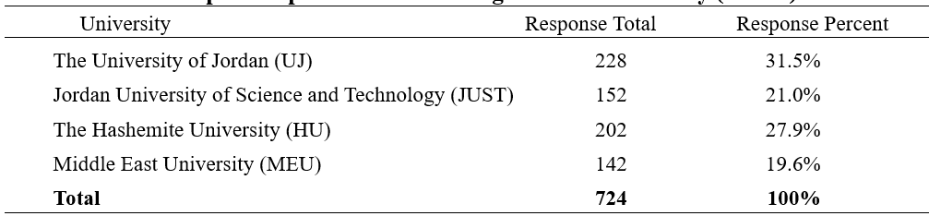

Data collection procedures
The data were collected via a Web-based survey that was developed for exploring the learners' perspectives of using ICT in higher education in Jordan as well as investigating the major barriers to integrating ICT into Jordanian higher education. Since the target population for this study was consisted of undergraduate students from four Jordanian universities, the researchers obtained the Human Subjects Committee approval from the Institutional Review Board (IRB) of each university at the end of October 2016. A request to conduct this study was sent to the administrative offices at these universities. The survey was distributed to the selected students (undergraduate only) at the beginning of November 2016; email reminder notices were sent to the participants two weeks following the initial distribution; the survey was completed at the beginning of December 2016. A total of 856 surveys were returned, and 132 incomplete surveys were excluded. Hence, the sample size was 724 participants, with 309 male participants and 415 female participants from the four universities participated in this research study.

Limitations of the study
This study has encountered some limitations and constraints; so generalization of the results to other academic institutes should cautiously be done. These limitations are as follows:
- The study was conducted in Fall Semester during the academic year of 2016/2017, it only focused on higher education undergraduate students, and the sample was drawn from only four universities in Jordan: UJ, JUST, HU, and MEU.
- The study was focused only on examining the learners' perceptions towards the use of ICT in higher education institutions in Jordan, and investigating the barriers that might prevent the effective implementation of integrating ICT tools into Jordanian higher education.
- The barriers that might prevent the effective utilization of ICT tools into Jordanian higher education were explored only from the perspective of undergraduate students at four universities in Jordan.
- The participants were selected to participate in this study based on those who have an access to the Internet and have official university email accounts which are available for all enrolled students.
- There was a limitation related to the selection bias, in "open" Web-based surveys, selection bias may occur due to the non-representative nature of the Internet population, and more importantly through self-selection of participants, i.e. the non-representative nature of respondents.
- Using the Internet for surveys requires an awareness of technical issues such as the user's Web browser, network connectivity, and user interface design.
- Throughout this research paper, the terms 'learners' and 'students' are used interchangeably by the researchers.

Research instrument
To collect data, the researchers used a Web-based survey that explored learners' perceptions on the use of ICT in higher education institutions in Jordan and examined the barriers to utilizing ICT into Jordanian higher education. The survey was developed after reviewing several existing surveys that are related to topic of the study. The researchers created most of the survey items, and used some from the literature review after modified them to fit with the aims and scope of the current study. The majority of the items came from one source and were modified to fit the objectives of this study; this source was a study conducted in 2013 by Al-Shboul, titled “Faculty Members' Perceptions of E-Learning at The University of Jordan”. Since the author of the indicated source is also one of the authors of this research paper, there was no need to obtain a permission request for the researchers to use some items from the Al-Shboul's survey.
After modification and development, the survey consisted of four main parts: demographic information which consists of three items, learners’ perceptions towards ICT which consists of eleven items, current status of ICT as perceived by learners which consists of thirteen items, and barriers concerning the use of ICT as perceived by learners which consists of eight items. Accordingly, the survey contains 35 items in total (See Appendix).
However, in most survey items, Learners' responses were measured on a five-point Likert-type scale of either (1= strongly disagree, 2=disagree, 3=neutral, 4=agree, 5= strongly agree) or (1 = Never, 2 = Rarely, 3 = Sometimes, 4 = Often, 5 = Always); in addition to two-point questions ('Yes' or 'No'). The average time to fill out the students’ questionnaire was 10 minutes.

Validity and reliability
To ensure consistency within collected data, validity and reliability issues were addressed throughout this study. According to Frey (2006), "validity is the extent to which the instrument measures what it is intended to measure" (p. 136). To ensure that the survey is accurate in measuring learners' perceptions towards the use of ICT and barriers to integrating ICT in higher education in Jordan, the construct of the survey was reviewed and the feedback was provided by a panel of experts, six faculty members (three from The University of Jordan, two from the Hashemite University, and one form Middle East University) who specialize in educational technology, educational psychology, curriculum and instruction, and information technology. Based on the feedback that the researchers received, some survey items were removed, some new items were added, some items were modified, and some items kept as they were based on the experts' suggestions. After the researchers modified the survey based on the provided suggestions, the final draft of the survey was reviewed by the researchers and sent to the Human Subjects Committee.
The term reliability refers to the degree to which a survey instrument consistently measures whatever it is designed to measure (McIntire & Miller, 2006). In simple terms, reliability is how stable and dependable a test is in measuring the same thing each time. However, the reliability of the instrument was calculated for this study using test-retest reliability and internal consistency reliability (the Cronbach’s Alpha coefficients (α)). Test-retest reliability is the degree to which scores are consistent over time. Therefore, to obtain stable and consistent results, the test-retest reliability method was conducted in this study. The researchers administered the survey twice over a period of two weeks interval between the first and second implementation to a group of (n = 32) students from the study population, who were chosen randomly from the four universities participated in this research study.
Then, Pearson's correlation coefficient was calculated for the two tests; the (r) values were as follows: r = 0.84 for learners' perspectives towards the use of ICT dimension (subscale), r = 0.86 for the current status of ICT subscale, and r = 0.81 for the perceived barriers to ICT use subscale. The reliability of overall scale (32-items) was also calculated using Pearson's correlation coefficient, with a value of (r = 0.89); which is considered acceptable value for test-retest reliability (See Table 2).
Cronbach’s alpha coefficient, one of the most commonly used measures of reliability to determine the internal consistency reliability of various measuring instruments. Therefore, the researchers also calculated the questionnaires’ internal consistency coefficient (Cronbach’s Alpha) between items to evaluate the reliability of the survey instrument used in this study. There were three main sections of the survey– learners’ perceptions towards ICT (11 items), current status of ICT as perceived by learners (13 items), and barriers regarding the use of ICT as perceived by learners (8 items). The researchers calculated the Cronbach’s Alphas separately for each dimension in order to measure the consistency of scores across items. Thus, a total of 32 items out of 35 were involved in the calculations; whereas the three items of demographic information were excluded.
Cronbach’s alpha coefficients for the data reported in this study were as follows: α = 0.82 for learners' perspectives towards the use of ICT dimension (subscale), α = 0.83 for the current status of ICT subscale, and α = 0.79 for the perceived barriers to ICT use subscale. The reliability of overall scale (32-items) was also calculated using Cronbach’s alpha coefficient, with a value of (α = 0.87); which is considered to be an acceptable level for internal consistency reliability. Since α = 0.70 is considered an acceptable level for social science research (Bryman, 2012; Field, 2013), the internal consistency reliability for the instrument as well as for the questions related to each subscale can be considered acceptable.
In summary, the researchers calculated the Cronbach’s Alphas separately for each dimension in order to measure the consistency of scores across items. As shown in Table 2, the values of the Cronbach’s Alpha coefficients for these dimensions/subscales were high enough to indicate that there is adequate consistency among the survey items in each subscale; these values showed acceptable high levels of consistency. Overall reliability is good, reflecting that each of the subscales include items that have consistent answers with each other.

Table 2

Current reliability coefficients
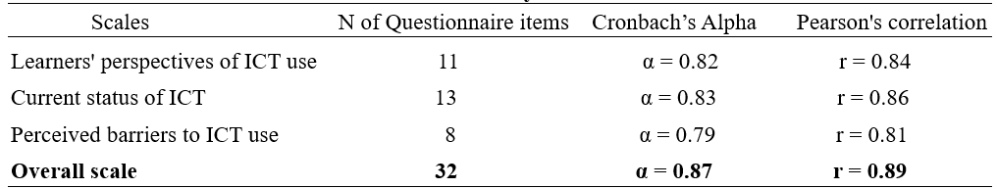

Data analysis procedures
Following data collection, descriptive statistics were used in the study; statistical analyses were performed on the data collected from the surveys. Data analysis included the use of frequencies, percentages, means, and standard deviation. Data analysis and computations for all statistical techniques were performed using the Statistical Package for Social Science (SPSS), version 20.0, to analyze the data in light of the research questions. Then, the results were reported based on the analyzed data; however, the results from the analyses assisted the researchers in reaching conclusions on the learners' perceptions towards the utilization of ICT in higher education in Jordan, as well as on the potential barriers that might prevent the effective use of ICT in higher education in Jordan.

Data analysis and results
The purpose of this study was to investigate learners’ perceptions towards the use of ICT in higher education institutions in Jordan. In addition, it explored the major barriers that might prevent the effective use of ICT in higher education in Jordan from the learners' perspectives. As mentioned earlier, participants were requested to respond to thirty-five Likert-type statements dealing with undergraduate students' perceptions towards ICT integration into higher education (See Appendix); the ICT perceptions of undergraduate students were presented by frequencies, percentages, and mean scores on a five-point Likert scale where five (Strongly Agree) shows the maximum score and one (Strongly Disagree) represents the minimum score. The findings of this study are presented in the following sections.

Demographic information
Out of 724 respondents who returned and completed the survey from the four universities participated in this study, 228 (31.5%) were from the University of Jordan (UJ), 152 (21.0%) were from Jordan University of Science and Technology (JUST), 202 (27.9%) were from the Hashemite University (HU), and 142 (19.6%) were from Middle East University (MEU) as shown in Figure 1. It can be noted that the UJ has the largest percentage of all universities; this is expected due to large size of the university.
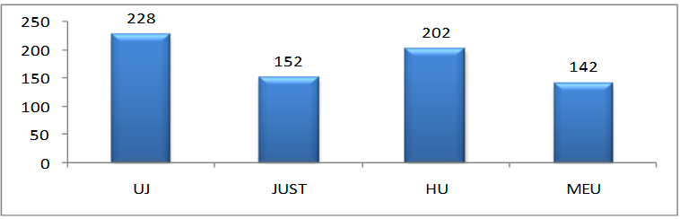

Figure 1. Distribution of the participants by university
The average age of the respondents was almost 21 years old, with ages ranging from 17 to 31 years old. However, as the survey was administered to undergraduate students only, most students fall in the 17-25 year age range. 398 respondents were in the 17-20 year range (55.0%); 265 were in the 21-25 year range (36.6%); 35 answered that they were 26-30 years old (4.8%); 15 were 31-35 (2.1%); and 11 were over 35 years old (1.5%). Figure 2 shows the distribution of respondents by age.
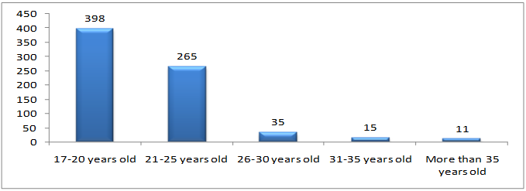

Figure 2. Distribution of the participants by age
The results gathered from this question of the survey indicated a normal distribution of students' respondents; (91.6%) of the participants' ages is between 17 and 25 years old. This is expected due to that the majority of the students who are enrolled and accepted to pursue their fields of studies at the four universities participated in the study are at undergraduate level (bachelor's degree).
Figure 3 below shows the distribution of respondents by academic discipline; it can be noted that 403 of the participants were from the scientific faculties (55.7%) and 321 of the participants were from the humanities faculties (44.3%).

Figure 3. Distribution of the participants by academic discipline

Learners’ perceptions towards the use of ICT in higher education
In a question (4) asked learners about their perceptions towards the use of ICT at their university; only 39 students indicated that he/she is highly resistant to using ICT (5.4%). Sixty-two students indicated that they resist using ICT (8.6%). Three hundred and nineteen students indicated that they have neutral feelings toward the use of ICT (44.1%). Two hundred and three students indicated that they support using ICT (28.0%). One hundred and one students indicated that they highly support using ICT (14.0%). It can be noted that most participants were generally either neutral (44.1%) or positive (42.0%) in their perceptions of ICT tools to support teaching and learning at these four Jordanian academic institutions. Figure 4 correspond to question 4 of the survey which asked about how learners, overall, perceive the use of ICT tools.
Figure 4. Learners’ perceptions of the use of ICT tools
In a question (5) asked if the nature of the courses that learners are studying influence their decision about whether or not to use ICT tools in their learning, four hundred and twinty-two students (58.3%) indicated that the nature of the courses they are studying influence their decision about whether or not to use ICT tools, while three hundred and two students (41.7%) indicated that the nature of the courses they are studying does not influence their decision about whether or not to use ICT tools as shown in Figure 5.
Figure 5. The influence of the nature of the courses that learners' studying on their decisions about whether or not to use ICT tools
Question 6 of the survey asked learners about how important it is to use ICT tools in their academic disciplines (subjects), sixty-six respondents found it very unimportant to use ICT tools in (9.1%) their subject, twenty-six respondents found it unimportant to use ICT tools in their subject (3.6%), one hundred and forty-seven do not know whether is it important or not to use ICT tools in their subject (20.3%), tree hundred and twenty-two (44.5%) respondents found it important to use ICT tools in their subject (44.5%), and one hundred and sixty-three respondents found it very important to use ICT tools in their subject. Thus, four hundred and eighty-five (67.0%) out of 724 participants indicated that it is important or very important to use ICT tools in their academic disciplines as shown in Figure 6.
Figure 6. The importance of using ICT tools in learners' academic disciplines
Figure 7 corresponds to question 7 of the survey, asking students whether ICT will improve their learning effectiveness and quality. Sixteen respondents found themselves strong disagreed that ICT will improve their learning effectiveness and quality (2.2%), twenty-one respondents found themselves disagreed that ICT will improve their learning effectiveness and quality (2.9%), one hundred and sixty-four respondents found themselves neutral towards whether ICT will improve their learning effectiveness and quality (22.7%), three hundred and eighteen respondents found themselves agreed that ICT will improve their learning effectiveness and quality (43.9%), and two hundred and five respondents found themselves strong agreed that ICT will improve their learning effectiveness and quality (28.3%). Thus, the result indicated that the majority of the students (72.2%) found themselves either agreed or strong agreed that ICT will improve their learning effectiveness and quality.
Figure 7. Learners' opinions about the effectiveness and quality of ICT
on improving their learning
In a question asked the participants to rate the extent to which they agree with the provided statements (items 8-14) about their perceptions towards the ICT use, the respondents addressed each statement using a five-point Likert-type response set: 1=Strongly Disagree, 2=Disagree, 3=Neutral, 4=Agree, 5=Strongly Agree. Consequently, the maximum possible mean score for each statement is 5 and the minimum possible mean score is 1. Furthermore, the following arithmetic means were adopted for analyzing results: (1- 2.33) indicate a low degree, (2.34- 3.67) indicate a moderate degree, and (3.68- 5) indicate a high degree.

Table 3

Learners' agreement with the provided statements
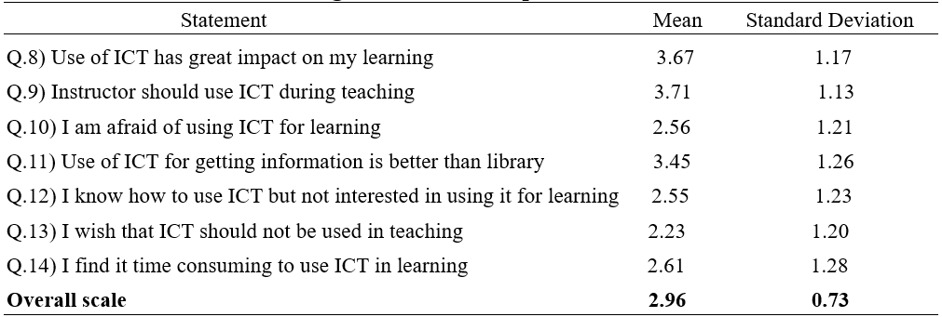
Referring to Table 3, the results showed that the arithmetic means have ranged between (2.23 - 3.71), where the statement (item 9) "Instructor should use ICT during teaching" came in the first rank by the highest arithmetic mean (3.71), while the statement (item 13) "I wish that ICT should not be used in teaching" came in the last rank by an arithmetic mean of (2.23). Moreover, the arithmetic mean (total average) of these seven statements (items 8-14) as a whole is (2.96) by a moderate degree as shown in Figure 8.
Figure 8. Learners' perceptions towards the use of ICT on the provided statements

Referring to Figure 8 above, the order of the students' perceptions towards ICT use, ranking in descending order according to the mean is presented in Table 4.

Table 4

Learners' perceptions towards ICT use, in descending order according to mean
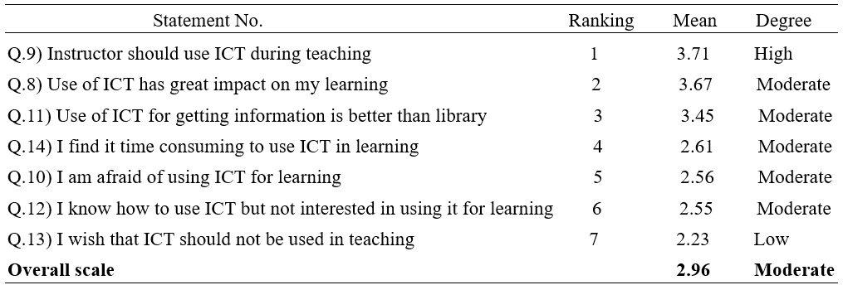

Current status of ICT as perceived by learners
In a question (15) about the regularity of using ICT tools to support learners' studies, in other words, how often do they use ICT tools in their learning, forty-six respondents indicated that they 'never' used ICT in their studies (4.1%), two hundred and twenty respondents indicated that they 'sometimes' use ICT in their studies (30.4%), one hundred and seventy respondents indicated that they 'usually' use ICT in their studies (23.5%), one hundred and thirty-seven respondents indicated that they 'most of time' use ICT in their studies (18.9%), and one hundred and fifty-one respondents indicated that they 'always' use ICT in their studies (20.9%) as shown in Figure 9. However, it can be concluded that the majority of the participants (63.3%) either 'usually', 'most of time' or 'always' use ICT in their studies.

Figure 9. Distribution of learners' respondents by regularity of using ICT tools
to support their studies
The results related to the learners' confidence in using ICT tools in their university studies (survey question 16) indicated that seventy-one respondents are 'very apprehensive' about using ICT tools in their university studies (9.8%), two hundred and twelve respondents are 'a little apprehensive' about using ICT tools in their university studies (29.3%), two hundred and seventy-nine respondents are 'enjoying the challenge' to use ICT tools in their university studies (38.5%), and one hundred and sixty-two respondents are 'very confident' about using ICT tools in their university studies (22.4%) as shown in Figure10.

Figure 10. Distribution of learners' respondents by the confidence
about using ICT tools in their studies
Figure 11 correspond to question 17 of the survey, which was about how helpful have the learners found ICT tools to be in their studies. The results indicated that there were thirty respondents found it 'hindrance' to use ICT tools in their studies (4.1%), fifty-four respondents found it 'not helpful' to use ICT tools in their studies (7.3%), four hundred and thirty-four respondents found it 'helpful' to use ICT tools in their studies (58.8%), and two hundred and twenty respondents found it 'very helpful' to use ICT tools in their studies (29.8%). Therefore, it can be concluded that students found it either helpful or very helpful (88.6%) to use ICT tools in their studies.

Figure 11. Distribution of learners' respondents by the helpfulness of ICT tools
in their studies
In a question (18) about the type of technology learners do have access to, the students' respondents indicated that they have access most to Laptops and Smart Phones (58.9%) as dominant technology as shown in Figure 12. However, it is important to mention that the total responses for this question is (N=1897) since the respondents were allowed to choose more than one answer in this question.
Figure 12. Type of technology have accessed most by the learners respondents
In a question (19) about the type of technology learners do use most for study purposes, the results revealed that 359 respondents out of 724 (49.6%) prefer to use Laptop for study purposes. Figure 13 illustrates the type of technology that the respondents use most for study purposes.
Figure 13. Type of technology learners use most for study purposes

As shown in Figures 14 below, the result related to the survey question 20 indicated that the students who use laptop/notebook for study purposes slightly do carry their laptop/notebook (51.4%) to the university campus regularly.

Figure 14. Carrying a laptop to the university campus in a regular basis
Survey question 21 asked if learners have a fast connection to the Internet from their term time residence. Three hundred and forty-two students indicated that they have a fast connection to the Internet from their term time residence (47.2%); whereas three hundred and eighty-two students indicated that they have not a fast connection to the Internet from their term time residence (52.8%) as shown in Figure 15.
In a question (22) about the type of ICT delivery tools learners do use most to support their studies, results from the completed surveys revealed that the highest number of students (23.7%) prefer to use Moodle to support their study as shown in Figure 16.

Figure 15. Having a fast Internet connection from learners' residency

Figure 16. Type of ICT delivery tools learners use most to support their study
Survey question 23 asked if learners have been asked to attend a training session about ICT use. Two hundred and fifty-five students indicated that they have been asked to attend a training session about CIT use (35.2%); while four hundred and sixty-nine students indicated that they have not been asked to attend a training session about ICT use (64.8%) as shown in Figure 17. Thus, the result confirms that the majority of the students have not been asked to attend a training session about ICT use.

Figure 17. Asked to attend a training session about ICT use
In survey question 24, learners were asked whether they received any formal training at their academic institution regarding the use of ICT. Hundred and fifty-five students indicated that they have received formal training at their academic institution regarding the use of ICT (21.4%); while five hundred and sixty-nine students indicated that they have not received any formal training at their academic institution regarding the use of ICT (78.6%) as shown in Figure 18. The findings of the study revealed that the majority of the learners have not received a formal training at their institution regarding the use of ICT.

Figure 18. Receive a formal training regarding the use of ICT
Survey question 25 was related to survey question 24; respondents who answered yes to Question 24 were then asked whether they thought the received formal training regarding the use of ICT was adequate. One hundred and fifty-five students answered yes to the survey question (24) and 569 answered no (hence, n=155 for this question). One hundred and seven (out of 155 who responded to this question) indicated that the formal training they received regarding the use of ICT was adequate (69.0%); whereas 48 students indicated that the formal training they received regarding the use of ICT was not adequate (31.0%) as shown in Figure 19.

Figure 19. Receive adequate training regarding the use of ICT

In survey question 26, participants were asked how often their instructors use ICT tools during lectures. Twenty-nine students indicated that their instructors have never used ICT tools during lectures (4.0%), two hundred and thirty students indicated that their instructors rarely use ICT tools during lectures (31.8%), three hundred and twenty-seven students indicated that their instructors sometimes use ICT tools during lectures (45.2%), ninety-five students indicated that their instructors often use ICT tools during lectures (13.1%), forty-three students indicated that their instructors always use ICT tools during lectures (5.9%) as shown in Figure 20.

Figure 20. How often the instructors use ICT tools during lectures
as perceived by learners
In a question (27) about learners' basic knowledge of using ICT tools, the students' respondents pointed out: 252 of them indicated that their basic knowledge of "Customizing Desktop Environment" is (10.4%), 163 of them indicated that their basic knowledge of "OS Installation" is (6.7%), 408 of them indicated that their basic knowledge of "Word Processing" is (16.8%), 419 of them indicated that their basic knowledge of "Excel" is (17.3%), 251 of them indicated that their basic knowledge of "Access" is (10.4%), 215 of them indicated that their basic knowledge of "Office Publisher" is (8.9%), 466 of them indicated that their basic knowledge of "PowerPoint" is (19.2%), and 249 of them indicated that their basic knowledge of "Web publishing" is (10.3%). The result indicated that students' knowledge of using Word Processing (16.8%), Excel (17.3%), and PowerPoint (19.2%) respectively, were the highest. However, it is important to mention that the total responses for this question is (N=2423) since the respondents were allowed to choose more than one answer to this question. Figure 21 represents students' responses regarding their basic knowledge of using ICT tools.

Figure 21. Learners' basic knowledge of using ICT Tools

Barriers concerning the use of ICT as perceived by learners
Question 28 of the survey asked learners about the main barriers for integrating ICT in educational activities at their university, the participants pointed out: 331 of them indicated that the "financial issues" is the major barriers for integrating ICT in educational activities at their university (19.8%), 377 of them indicated that the "insufficient technological infrastructure" is the major barrier for integrating ICT in educational activities at their university (22.6%), 254 of them indicated that the "insufficient lab number and desktops" is the major barrier for integrating ICT in educational activities at their university (15.2%), 162 of them indicated that the "slow Internet connection" is the major barrier for integrating ICT in educational activities at their university (9.7%), 286 of them indicated that the "hardware and software availability" is the major barrier for integrating ICT in educational activities at their university (17.1%), 121 of them indicated that the "lack of training" is the major barrier for integrating ICT in educational activities at their university (7.3%), 81 of them indicated that the "unqualified instructors relating to the use of ICT" is the major barrier for integrating ICT in educational activities at their university (4.9%), and 56 of them indicated that the "instructors’ attitudes towards ICT" is the major barrier for integrating ICT in educational activities at their university (3.4%).
The results revealed that the main barriers for integrating ICT in educational activities at students' university were insufficient technological infrastructure (22.6%) and financial issues (19.8%) respectively, as perceived by learners. However, it is important to mention that the total responses for this question is (N=1668) since the respondents were allowed to choose more than one answer to this question. Figure 22 represents students' responses regarding the main barrier for integrating ICT in educational activities at their university.

Figure 22. Main barriers for integrating ICT in educational activities
as perceived by learners
In a question asked the participants about the significance of the provided barriers (statements 29-35) to their present and future use of ICT tools, the respondents addressed each statement using a five-point Likert-type response set: 1=Strongly Disagree, 2=Disagree, 3=Neutral, 4=Agree, 5=Strongly Agree. Consequently, the maximum possible mean score for each statement is 5 and the minimum possible mean score is 1. Furthermore, the following arithmetic means were adopted for analyzing results: (1- 2.33) indicate a low degree, (2.34- 3.67) indicate a moderate degree, and (3.68- 5) indicate a high degree.

Table 5

The significance of the provided barriers to learners' present and future use
of ICT tools
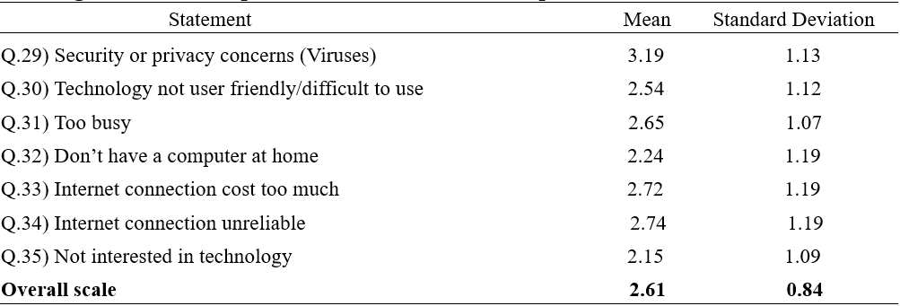

Referring to Table 5, the results showed that the arithmetic means have ranged between (2.15 - 3.19), where the statement (item 29) "Security or privacy concerns (Viruses)" came in the first rank by the highest arithmetic mean (3.19), while the statement (item 35) "Not interested in technology" came in the last rank by an arithmetic mean of (2.15). Moreover, the arithmetic mean (total average) of these seven statements (items 29-35) as a whole is (2.61) by a moderate degree as shown in Figure 23.
Figure 23. How significant are the provided barriers
to learners' present and future use of ICT tools
Referring to Figure 23 above, the order of how significant are the provided barriers to learners' present and future use of ICT tools, ranking in descending order according to the mean is presented in Table 6.

Table 6

The significance of the provided barriers to learners' present and future use
of ICT tools, ranking in descending order according to the mean
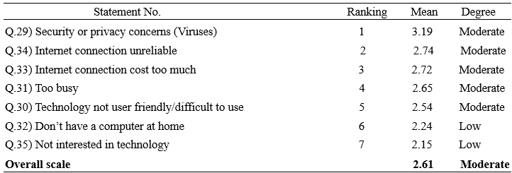

Discussion
The study examined the learners' perceptions towards the use of ICT in higher education institutions in Jordan; additionally, it explored the perceived barriers to utilizing ICT for educational purposes in institutions of higher education in Jordan as perceived by learners. For the purpose of this study, three major research questions were investigated: (a) what are learners’ perceptions towards the use of ICT in higher education institutions in Jordan; (b) what is the current status of using ICT in teaching and learning process at Jordanian universities as perceived by learners; and (c) What are the main barriers for using ICT in higher education institutions in Jordan as perceived by learners. The discussion of the findings of these research questions are presented below.

Discussion of the findings of research question one
This question sought to reveal the perceptions of learners towards the use of ICT tools at four Jordanian universities participated in this study. A total of 724 respondents returned and completed the survey. Data from the completed surveys revealed that (a) most participants were generally neutral (44.1%) in their perceptions of the use of ICT tools to support teaching and learning at these four Jordanian academic institutions, (b) most participants indicated that it is important to use ICT tools in their academic disciplines (44.5%), and (c) the majority of the participants (43.9%) found themselves agreed that ICT will improve their learning effectiveness and quality.
Also, results from the completed surveys revealed that the majority of the participants (42.0%), overall, were either supportive or highly supportive toward the use of ICT tools at higher education institutions in Jordan; this means that learners were generally positive in their perceptions of ICT utilization in higher education. Additionally, the results revealed that the majority of the participants (58.3%) indicated that the nature of the courses that they are studying influences their decision about whether or not to use ICT tools while learning.
The results of this study proved that the use of ICT is related to many aspects; one of these aspects is the perceptions toward ICT use. The findings of this study showed that most of the learners have positive perceptions about ICT use; this could be due to that they realized its benefits when used inside or outside of the classroom such as to increase students’ understanding by offering a variety of displaying channels that overcome individual differences, to prevent losing important documents, to enable learners to work effectively and accurately, to benefit from the large storage that ICT provides; to overcome the time and place boundaries, to communicate effectively, and to use e-Libraries which make the searching process easier. On the other hand, based on the results of this study, the learners' perceptions are affected by several barriers such as the lack of training, lack of technological infrastructure, students’ skills and motivation, lack of institutional support, lack of financial resources, and lack of technical support.
Additionally, many university students in Jordan consider the internet as a device for passing time and communicating with others (Zureikat, 2014). Within such an educational culture, students’ attitudes and perceptions are negatively positioned towards ICT as they defer to their teachers’ direct instructions rather than following independent thinking.
In summary, this research question is motivated by the need to inform researchers and practitioners about what are the issues that affect the learners' perceptions to adopt/reject ICT or influence the use of ICT among students in the Jordanian higher education institutions. However, there is no known study that has investigated such perceptions from learners' point of view within the Jordanian context. Little attention has been paid in the literature to the adoption of ICT in the context of developing countries in general, and from learners' perspectives in particular. This was affirmed by the literature (Al-Khasawneh, 2012, Al- Adwan et al., 2013; Alassaf, 2014; Aljaraideh & Shdooh, 2014; Allahawiah & Tarawneh, 2015; Bahsh & Daoud, 2016).
In conclusion, rapid growth and improvement in ICT have led to the diffusion of technology in education. Studies in controlled environments suggest that the use of technology under the right circumstances improves educational outcomes, and many educators believe that a new pedagogy that incorporates technology is necessary to prepare students for work in the information age. The study investigated the perceptions and ICT usage of learners at higher education institutions in Jordan. Perceptions and skills in relation to ICT have been universally recognized as an important factor in the success of technology integration in education (Gulbahar & Guven, 2008).
Overall, learners were generally positive in their perceptions of the use of ICT at these Jordanian academic institutions; they affirmed that ICT tools must be used to enhance the teaching and learning process.

Discussion of the findings of research question two
This question sought to reveal current status of using ICT at higher education institutions in Jordan as perceived by learners. The findings revealed that (a) the majority of the participants (53.9%) either 'sometimes or 'usually' use ICT in their studies, (b) the majority of the participants (60.9%) are either 'enjoying the challenge' to use ICT tools or 'very confident' about using ICT tools in their university studies, (c) the majority of the participants (58.8%) found it 'helpful' to use ICT tools in their studies, (d) the majority of the participants (49.6%) prefer to use Laptop most for study purposes, (e) the majority of the participants (52.8%) have not a fast connection to the Internet from their term time residence, (f) the majority of the participants (23.7%) prefer to use Moodle Learning Management System to support their study, (g) the majority of the participants (64.8%) have not been asked to attend a training session about ICT use as well as (78.6%) of the participants have not received a formal training at their institution regarding the use of ICT, and (h) the majority of the participants (45.2%) indicated that their instructors sometimes use ICT tools during lectures.

The descriptive results of this study indicated that learners had an acceptable level of knowledge and skill in using ICT in educational activities. In addition, computer and internet are available to majority of respondents. It appeared from the findings of this research that technologies are used at the moderate level. Providing more availability of ICT to students to enhance their information, knowledge, and skills will be essential.

As mentioned earlier, one important finding of this study is that students in general have a positive perspective towards the use of ICT tools in learning. This might be attributed to the fact that most students have long experience with educational technology and Internet services. Moreover, the participants indicated that Moodle is mainly used to support their studies (as a repository to exchange course materials); however, the interactive learning tools of Moodle are not effectively utilized. Therefore, the results of this study suggest expanding the use of Moodle in the learning process, with particular focus on integrating the interactive learning tools of Moodle to achieve an interactive and effective learning environment.

Data from the completed surveys revealed that providing training to the learners is a critical issue in integration of ICT into the classroom instruction. This confirmed by the reviewed literature; several studies imply clearly that training on the use of ICT is an essential issue for successful implementation of new technology in higher education settings (Al-Zoubi et al., 2007; Oye et al., 2011; Unal & Ozturk, 2012; Makura, 2014; Elshaikhi, 2015; Mirzajani et al., 2015).

Using technology to support learning was a key attribute in the success of the overall student learning experience. The findings demonstrated that students who suffered from a lack of ICT skills were not able to benefit or engage with ICT opportunities whether these took place in classes or elsewhere. This lack of ICT skills resulted in a type of resistance among students which led to uncertainty about the benefits of ICT. Hence, increased availability and familiarity with the desired technologies could contribute to raising the level of ICT skills of students (Al-Adwan & Smedley, 2012).

The results of the study revealed that many students had limited interaction with computer applications as some of them did not have computers at home or they only use computers in specific places, such as their universities. Students with limited access were usually keen to keep lecturers at the centre of the learning process. Difficulties with obtaining the required technological infrastructure meant that students often performed poorly compared to students who had adequate IT infrastructure. This may have influenced students’ lack of interests in ICT use, and lead them to prefer the traditional education environment in which they perceived that they could perform better.

Self-motivation is considered to be a crucial factor to the success of students in utilizing ICT in higher education. Integrating ICT with the process of learning depends on the personal motivation of the participants. Clearly, students in Jordan need to be supported with their digital enhanced learning to enable them to maximize the potential of ICT in their learning process.

In summary, the status of knowledge and experience of ICT infrastructure and deployment at higher education in Jordan was investigated in order to explore the prospect and potential of future university e-Education, from learners' point of view. The backbone infrastructure seems adequate in terms of supporting access to online courses and resources but the role and strategic impact of ICT for teaching and learning has yet to be realized. However, it is obvious that the use of technology improved students' communication skills, allowed students to be more independent, it also improved motivation and confidence levels of students, and allowed students to express their feelings and ideas more openly with others. Therefore, more attention should be paid to the current status of using ICT in teaching and learning process in Jordan to grasp and obtain all the benefits that ICT may offer.

In short, outcomes demonstrated that students in Jordan need to increase the level of their technological skills to significantly benefit from the opportunities offered by ICT tools. Considerable preparatory support is required to ensure that students feel adequately and appropriately supported in their individual learning processes. Further studies could be undertaken to explore the strategic and operational opportunities focusing on technological readiness, skills and attitudes alongside cultural influences before ICT can have a significant impact to influence changing practices within the Jordanian student learning experience.

Discussion of the findings of research question three
This question sought to reveal the main barriers for using ICT in higher education institutions in Jordan as perceived by learners. The results revealed that the main barriers for integrating ICT in educational activities at students' university, as perceived by learners, were insufficient technological infrastructure (22.6%), financial issues (19.8%), hardware and software availability (17.1%), and insufficient lab number and desktops (15.2%) respectively. Furthermore, referring to Table 6 and in terms of the significance of barriers to learners' present and future use of ICT tools, data from the completed surveys revealed that the majority of the participants indicated that the following were the most significant barriers respectively: security or privacy concerns (viruses), technology not user friendly or difficult to use, too busy, don’t have a computer at home, Internet connection cost too much and unreliable, and not interested in technology.

The results showed that barriers are evident which leads to the underutilization of ICT in education at these Jordanian higher education institutions. Several barriers were identified; they were similar to those obstacles and hindrances that stated in the reviewed literature (Al-Mobaideen, 2009; Bingimlas, 2009; Khan et al., 2012; Alkhawaldeh & Menchaca, 2014; Al Mulhim, 2014; Khasawneh, 2015).

The results lead to the argument that the barriers to the uptake of technology in education will be always present. Although these four Jordanian universities participated in this study are adequately-equipped with ICT infrastructure compared to the rest of public and private universities in Jordan; barriers to utilizing ICT in higher education institutions are still evident. This means that even if all Jordanian universities were fully equipped with ICT infrastructure, there will always be some instructors who resist the change or disbelieve in ICT benefits. This argument is supported by Cuban, Kirkpatrick, & Peck (2001) when they stated “We found that access to equipment and software seldom led to widespread teacher and student use. Most teachers were occasional users or nonusers.” (p. 813).

Also, the findings of the study revealed that 'financial issues' is one of the major barriers for utilizing ICT in higher education. Therefore, since the Ministry of Higher Education and Scientific Research is the responsible for providing the best means to enhance higher education in Jordan; the ministry should take bigger role in allocating more resources and opportunities to facilitate the process of integrating technology into higher education. It is true that ministry cannot do much regarding the barriers are related to financial reasons; but the ministry should still be able to facilitate the process by offering occasions for sharing the best practices, providing more training to instructors and students, and by controlling the issue of “transferring qualified instructors” who have succeeded in the use of ICT in their teaching for the purpose of benefit their students.

Identifying barriers is important that it may assist decision-makers overcome them. However, university barriers often result from not having the correct ICT infrastructure such as smart buildings, proper equipment, servers, networks, and alike. Without good technical support for university resources administrators, faculty members, and students cannot overcome the barriers that are often related to ICT. Effective training is one of the strongest support strategies that learners can use when ICT has to be used effectively and properly (Al-Shboul, 2013).

Another barrier occurs at the learner level, students usually do not have enough income to purchase or hire rapidly changing hardware and software technology and therefore how much money is spent on a university ICT system is a critical issue (Alturise & Alojaiman, 2013). However, many students who do not have much technical knowledge about ICT may experience ICT-related problems. Moreover, lack of access to resources such as home access is a complex problem that discourages students from integrating new technologies into their learning. Students are worried about how difficult it is to have 24-hour access to computers or networks to do their homework or research.

In general, obstacles are necessary to be recognized so that they might be solved; the results of this study reveal the key obstacles that prevent the use of ICT by learners. Lack of adequate training, inadequate resources, lack of knowledge and skills, inadequate financial resources, resistance to change and negative attitudes, students' self-efficacy beliefs and attitudes, lack of suitable software and hardware, and lack of ICT institutional support are the key barriers for utilization of ICT in higher education. The findings of this study also suggested that understanding the amount to which these obstacles affect ICT users and institutes can support decision making on how to equip them.

In short, like all technology, ICT tools have their own advantages and disadvantages; however, the success of ICT utilization in higher education rests on the willingness of instructors to use such technology, the learners' cooperation and positive perceptions towards the use of such technology, and the academic institutional support provided to facilitate the desired implementation.

Conclusions, Implications, and Recommendations for Future Research

Conclusions
This study has contributed to the growing body of knowledge in the field of ICT diffusion in higher education, particularly in Jordan. Also, it has added to ICT diffusion research in general and the diffusion of innovation in developing countries in particular. The findings of the study are relevant to educational systems to evaluate the utilization of ICT, the innovation and its acceptance within university life. Consequently, the purpose of this study was to identify prevalent learners' perceptions towards the use of ICT tools in higher education institutions in Jordan and to explore the main barriers that might prevent the effective use of ICT in four Jordanian universities, form learners' perspectives. The data were collected via a Web-based survey that was developed to explore barriers to integrating ICT in Jordanian higher education. The participant sample for this study consisted of undergraduate students who enrolled at four Jordanian universities during the Fall Semester of 2016/2017. The total numbers of participants who returned and completed the survey was 724.
Based on the findings/results of the study, learners were generally positive in their perceptions of the use of ICT at higher education institutions in Jordan. However, the systematic review of the literature identified important issues which need to be in place for ICT to effectively take place. The barriers and potential solutions identified are useful for those designing ICT tools in any professional context. The results of the current study suggest that when universities and students have greater access to technological resources in the classroom, attitudes of students are more positive towards the use of technology and they tend to use technology to a greater degree while learning. In the present study, the population sample that responded to the surveys came from four universities located in urban areas. Future research should collect a larger population sample including a broader range of respondents from both urban and rural areas.
Universities are faced with some challenges and barriers that prevent them employing ICT in the classroom or develop supporting materials through ICT. The findings of this study indicate that students are familiar with basic ICT tools and ICT usage but this does not necessarily mean that they integrate ICT into their learning. They encountered many drawbacks. First, they do not have enough skills to use ICT; furthermore, students face many problems and barriers in that they do not trust ICT services because they are unreliable. They also do not have enough money to own such services because they stated they are expensive to maintain. Other unexpected barriers emerged, such as students not being interested in technology which was the opposite of what researchers of this study expected to find.
Finally, in terms of the limitation of the study, it is suggested that the findings of this study can be further validated by using larger heterogeneous sample by involving an element of quantitative approach to be more able to generalize the findings and identify the major barriers among the identified ones.

Implications
Important implications of this study include the need to provide more technical training for students, and the need for more institutional support in terms of providing sufficient technological infrastructure, increasing the number of computer labs, providing high-speed Internet, and providing technical support. As it could be the one of the few studies that addresses educational technology in Jordan from learners' perspectives and the first one conducted with a large sampling size within the Jordanian context; the findings of this study can add value to researchers and decision- makers. The findings could be also applicable to countries that share similar socio-economic characteristics with Jordan especially the developing countries. However, the Jordanian higher education system must realize that the universities that integrate ICT into their classrooms will survive and thrive, while those who do not do so will not.
In the light of the results of this study, the researchers offer the following recommendations that might assist higher education decision makers and learners in integrating ICT in higher education institutions in Jordan:
- The level of ICT infrastructure in universities needs to be improved.
- ICT technical support and maintenance must be provided.
- Funding for ICT infrastructure should not only provide universities with the capacity to acquire ICT facilities but also to regularly upgrade these facilities and to dispose of obsolete computers and other equipment in a planned way.
- Universities should consider convening an ICT steering committee, which could assist in managing the development of the ICT plan and in monitoring and reviewing its continuing implementation.
- Universities should develop strategies for evaluating the impact of ICT at different levels in the university, so that staff members are confident in assessing its influence on teaching and learning.
- All computer labs at Jordanian Universities should be equipped with the newest technological tools, and high-speed Internet.
- The necessary technological infrastructure should be developed in the classrooms.
- Universities should be provided with adequate technical support to assist both instructors and students in using different ICT tools.
- There must be sufficient access to digital libraries and variety of online resources enabled.

Recommendations for Future Research
The results from this study suggest several areas for future research:
- Conduct a follow-up study with a selected sample of the original respondents using a qualitative data collection method to verify the findings of this study.
- Conduct a similar study at different academic institutions (other Jordanian universities) to examine the identified issues related to learners' perceptions towards the use of ICT.
- Conduct further research on the best strategies for effective integration of ICT in educational practices at Jordanian higher education.
- Conduct a comparative study between private and public Jordanian universities to identify the role and impact of funding resources on the effectiveness of ICT utilization.
- Conduct a study to investigate the barriers to utilizing ICT in higher education in Jordan from the perspective of the decision makers at the Jordanian Ministry of Higher Education and Scientific Research.

Should higher education institutions decide to become more involved in the use of ICT tools, then, learners' participation as well as additional research will be essential. It is important to point out that this study is not meant to be the definitive word on students' perceptions; rather, it is intended to encourage robust investigations into the issues related to learners' perceptions towards the use of ICT tools with more powerful treatments and greater sample sizes.

Finally, there is a desperate need to develop an ICT infrastructure in universities in Jordan. Universities need to adopt a rational use of resources by giving ICT the first priority. Integrating new advanced technology means that universities need more training for both instructors and students, which involves extra time, effort and cost. Furthermore, Jordanian universities need to harness e-Learning and ICT tools to make the classroom experience more appealing to prospective students (Al-Mobaideen, 2009). In conclusion, Jordanian universities need to introduce and develop teaching modules in an electronic manner and establish adequate technical laboratories with modern facilities, as well as provide information networks from off-campus to be online which can be used by all students.

References
Abdel-Jabbar, S., Betawi, I., & Al-Shboul, M. (2013). ICT based education at the university of Jordan. International Journal of Instructional Technology and Distance Learning, 10(4), 3-19.
Abu-Qudais, M., Al-Adhaileh, M., & Al-Omari, A. (2010). Senior faculty members' attitudes in Jordanian Universities towards using information and communication technology. International Arab Journal of e-Technology, 1(4), 135-141.
Achimugu, P., Oluwagbemi, O., & Oluwaranti, A. (2010). An evaluation of the impact of ICT diffusion in Nigeria’s higher educational institutions. Journal of Information Technology Impact, 10(1), 25-34.
Al-Adwan, A., & Smedley, J. (2012). Implementing e-Learning in the Jordanian higher education system: Factors affecting impact. International Journal of Education and Development Using Information and Communication Technology, 8(1), 121-135.
Al-Adwan, A., Al-Adwan, A., & Smedley, J. (2013). Exploring students' acceptance of e-Learning using technology acceptance model in Jordanian universities. International Journal of Education and Development using Information and Communication Technology, 9(2), 4-18.
Al-Ansari, H. (2006). Internet use by the faculty members of Kuwait University. The Electronic Library, 24(6), 791-803.
Alarabiat, A., & Al-Mohammad, S. (2015). The potential for Facebook application in undergraduate learning: A study of Jordanian students. Interdisciplinary Journal of Information, Knowledge, and Management, 10, 81-103.
Alassaf, H. (2014). Effective strategies on using ICT for teaching and learning undergraduate level at Jordanian universities. Journal of Education and Practice, 5(3), 81-89.
Albugami, S. (2016). Developing a strategic approach to ICT implementation in Saudi secondary schools. Unpublished Doctoral Dissertation, University of Salford, Salford, United Kingdom.
Al-Harbi, H. (2014). Towards successful implementation of ICT in education. Proceedings of the West East Institute International Academic Conference on Education, Humanities and Social Sciences, (pp. 33-45). Vienna, Austria.
Al-Hujran, O., Aloudat, A., Al-Hennawi, H., & Ismail, H. (2013). Challenges to e-learning success: The student perspective. Proceedings of the International Conference on Information, Business and Education Technology (ICIBET 2013), (pp. 1197-1205). Beijing, China.
Aljaraideh, Y., & Shdooh, W. (2014). Factors effecting the usage of ICT by the teaching members at Jerash University. Canadian Social Science, 10(6), 222-226.
Al-Khasawneh, M. (2012). Adoption of information and communication technology in teaching and learning environment in Jordanian higher education institutions. Unpublished Doctoral Dissertation, Universiti Utara Malaysia, Kedah, Malaysia.
Alkhawaldeh, N., & Menchaca, M. (2014). Barriers to utilizing ICT in education in Jordan. International Journal on E-Learning, 13(2), 127-155.
Allahawiah, S., & Tarawneh, S. (2015). Factors affecting information and communication technology (ICT) use by southern colleges teachers in Balqa applied university. Proceedings of the West East Institute International Academic Conference on Education, Humanities and Social Sciences, (pp. 138-145). Barcelona, Spain.
Allan, A., & Randy, L. (2005). Writing the winning thesis or dissertation: A step-by-step guide. Los Angeles: Corwin Press Inc.
Almarabeh, T., & Mohammad, H. (2013). E-learning in the Jordanian higher education system: Strengths, weakness, opportunities, and threats. Journal of American Science, 9(3), 281-287.
Almarabeh, T., Mohammad, H., Yousef, R., & Majdalawi, Y. (2014). The University of Jordan e-Learning platform: State, students' acceptance and challenges. Journal of Software Engineering and Applications, 7(12), 999-1007.
Almarabeh, T. (2014). Students' perceptions of e-Learning at the University of Jordan. International Journal of Emerging Technologies in Learning (iJET), 9(3), 31-35.
Al-Mobaideen, H. (2009). ICT diffusion in Jordanian universities. Proceedings of the European and Mediterranean Conference on Information Systems (EMCIS2009), (pp. 1-21). Izmir, Turkey.
Al Mulhim, E. (2014). The barriers to the use of ICT in teaching in Saudi Arabia: A review of literature. Universal Journal of Educational Research, 2(6), 487-493.
Alrawabdeh, W., Salloum, A., & Mingers, J. (2012). Key factors influencing the diffusion of information and communication technology (ICT) in the Arab world. British Journal of Economics, Finance and Management Sciences, 5(2), 45-59.
Al-Shboul, M., Rababah, O., Al-Saideh, M., Betawi, I., & Jabbar, S. (2013). A vision to improve e-Learning at the University of Jordan. World Applied Sciences Journal, 21(6), 902-914.
Al-Shboul, M. (2013). The level of e-Learning integration at the University of Jordan: Challenges and opportunities. International Education Studies, 6(4), 93-113.
Al-Shboul, M. (2014). Faculty members' perceptions of e-Learning at the University of Jordan. International Journal of Instructional Technology and Distance Learning, 11(10), 3-44.
Alturise, F., & Alojaiman, B. (2013). Benefits and challenges of using ICT in Saudi Arabia universities: A literature review. Proceedings of the International Conference on Advanced in Computing, Engineering and Learning Technologies (ICACELT 2013), 2(2013), (pp. 2-46). Abu Dhabi, United Arab Emirates.
Al-Zoubi, A., Kahhaleh, B., Hasan, O., & Kharouf, H. (2007) Future potential of ICT implementation in university education in Jordan. Proceedings of the 10th International Conference of Interactive Computer Aided Learning (ICL2007), (pp. 1-9). Villach, Austria.
Aoki, K. (2010). The use of ICT and e-Learning in higher education in Japan. International Journal of Social, Behavioral, Educational, Economic, Business and Industrial Engineering, 4(6), 986-990.
Arkorful, V., & Abaidoo, N. (2014). The role of e-Learning, the advantages and disadvantages of its adoption in Higher Education. International Journal of Instructional Technology and Distance Learning, 12(1), 29-42.
Ashrafzadeh, A., & Sayadian, S. (2013). An overview of Asian instructors’ perceptions about technology integration in English classes. Proceedings of World Conference on Educational Media and Technology (EdMedia '13), 2013(1), (pp. 1836-1841). Victoria, Canada.
Aslan, A., & Zhu, C. (2016). Influencing factors and integration of ICT into teaching practices of pre-service and starting teachers. International Journal of Research in Education and Science (IJRES), 2(2), 359-370.
Barsoum, G., & Mryyan, N. (2014). Incentives structure and accountability in the Jordanian higher education system. Cairo: Publications of the Economic Research Forum.
Bindu, C. (2016). Impact of ICT on teaching and learning: A literature review. International Journal of Management and Commerce Innovations, 4(1), 24-31.
Bingimlas, K. (2009). Barriers to the successful integration of ICT in teaching and learning environments: A review of the literature. Eurasia Journal of Mathematics, Science & Technology Education, 5(3), 235-245.
Bizi, A., & Shittu, F. (2014). Information and Communication Technology (ICT) and Education. Journal of Educational and Social Research, 4(7), 88-91.
Brown, D. (2002). Proven strategies for teaching and learning. Proceedings of International Conference on the New Educational Benefits of ICT in Higher Education, (pp. 9-11). Rotterdam, Netherlands.
Bryman, A. (2012). Social Research Methods. New York: Oxford University Press.
Buabeng-Andoh, C. (2012). Factors influencing teachers' adoption and integration of information and communication technology into teaching: A review of the literature. International Journal of Education and Development using Information and Communication Technology (IJEDICT), 8(1), 136-155.
Chainda, A. (2011). Third-year students’ perceptions of the use of ICT at a teacher training college in Namibia. Unpublished Doctoral Dissertation, Stellenbosch University, Stellenbosch, South Africa.
Chen, S., & Li, S. (2011). Recent related research in technology acceptance model: A literature review. Australian Journal of Business and Management Research, 1(9), 124–127.
Clarke, A. (2004). E-learning skills. New York: Palgrave Macmillan.
Cuban, L., Kirkpatrick, H., & Peck, C. (2001). High access and low use of technologies in high school classrooms: Explaining an apparent paradox. American educational research journal, 38(4), 813-834.
Davis, R., & Wong, D. (2007). Conceptualizing and measuring the optimal experience of the eLearning environment. Decision Sciences Journal of Innovative Education, 5(1), 97-126.
Edward, M., Vimbai, M., & Misheck, M. (2013). Challenges and opportunities in harnessing computer technology for teaching and learning: A case of five schools in Makoni east district. International Journal of Humanities and Social Science, 3(1), 105-112.
El-Bahsh, R., & Daoud, M. (2016). Evaluating the use of Moodle to achieve effective and interactive learning: A case study at the German Jordanian University. Proceedings of the 35th Annual IEEE International Conference on Computer Communications, (pp. 1-5). San Francisco, USA.
Elshaikhi, F. (2015). Integrating information technology in Libyan higher education. Unpublished Doctoral Dissertation, University of Kansas, Kansas, USA.
Field, A. (2013). Discovering Statistics using SPSS, 4th edition. London: SAGE.
Flecknoe, M. (2002). How can ICT help us to improve education? Innovations in Education and Teaching International, 39(4), 271-279.
Frey, B. (2006). Statistics hacks: Tips & tools for measuring the World and beating the odds. Sebastopol: O'Reilly Media.
Fu, J. (2013). ICT in education: A critical literature review and its implications. International Journal of Education and Development using Information and Communication Technology, 9(1), 112-125.
Gasaymeh, A., AlJa'afreh, I., Al-Dmour, A., & Abu-Alrub, M. (2016). Higher education students' preferences for applying the principles of constructivism in learning programming languages with the use of ICTs. Journal of Studies in Education, 6(3), 168-187.
Ghavifekr, S., Kunjappan, T., Ramasamy, L., & Anthony, A. (2016). Teaching and learning with ICT tools: Issues and challenges from teachers' perceptions. Malaysian Online Journal of Educational Technology, 4(2), 38-57.
Gilakjani, A., Leong, L., & Ismail, H. (2013). Teachers' use of technology and constructivism. International Journal of Modern Education and Computer Science, 5(4), 49-63.
Gilakjani, A., Sabouri, N., & Zabihniaemran, A. (2015). What are the barriers in the use of computer technology in EFL instruction? Review of European Studies, 7(11), 213-221.
Goktas, Y., Yildirim, S., & Yildirim, Z. (2009). Main barriers and possible enablers of ICTs integration into pre-service teacher education programs. Educational Technology & Society, 12(1), 193-204.
Gulbahar, Y., & Guven, I. (2008). A Survey on ICT Usage and the Perceptions of Social Studies Teachers in Turkey. Educational Technology & Society, 11(3), 37-51.
Gülbahar, Y. (2008). ICT usage in higher education: A case study on preservice teachers and instructors. The Turkish Online Journal of Educational Technology (TOJET), 7(1), 32-37.
Habibu, T., Abdullah-Al-Mamun, M., & Clement, C. (2012). Difficulties faced by teachers in using ICT in teaching-learning at technical and higher educational institutions of Uganda. International Journal of Engineering, 1(7), 1-10.
Herrero, R., Bretón-López, J., Farfallini, L., Quero, S., Miralles, I., Baños, R., & Botella, C. (2015). Acceptability and satisfaction of an ICT-based training for university teachers. Educational Technology & Society, 18(4), 498–510.
Higgins, S. (2003). Does ICT improve learning and teaching in schools? Newcastle: British Educational Research Association.
ICF Consulting Services (2015). Literature review on the impact of digital technology on learning and teaching. Edinburgh: The Scottish Government Publications.
Islam, N., Beer, M., & Slack, F. (2015). E-learning challenges faced by academics in higher education: A literature review. Journal of Education and Training Studies, 3(5), 102-112.
Jhurree, V. (2005). Technology integration in education in developing countries: Guidelines to policy makers. International Education Journal, 6(4), 467-483.
Karsenti, T., & Collin, S. (2011). Benefits and challenges of using laptops in primary and secondary school: An investigation at the Eastern Townships School Board. Montreal: CRIFPE Publications.
Khan, M., Hasan, M., & Clement, C. (2012). Barriers to the introduction of ICT into education in developing countries: The example of Bangladesh. International Journal of Instruction, 5(2), 61-80.
Khasawneh, M., & Ibrahim, H. (2012).A model for adoption of ICT in Jordanian higher education institutions: An empirical study. Journal of e-Learning & Higher Education, 2012(2012), 1-10.
Khasawneh, M. (2015). Factors influence e-learning utilization in Jordanian universities - academic staff perspectives. Procedia-Social and Behavioral Sciences, 210(2015), 170-180.
Kozma, R. (2008). Comparative analysis of policies for ICT in education. In International Handbook of Information Technology in Primary and Secondary Education (pp. 1083-1096). New York: Springer.
Kurelovic, E. (2016). Advantages and limitations of usage of open educational resources in small countries. International Journal of Research in Education and Science, 2(1), 136-142.
Kusano, K., Frederiksen, S., Jones, L., Kobayashi, M., Mukoyama, Y., Yamagishi, T., Sadaki, K., & Ishizuka, H. (2013). The effects of ICT environment on teachers’ attitudes and technology integration in Japan and the US. Journal of Information Technology Education: Innovations in Practice, 12(1), 29-43.
Lei, J., & Zhao, Y. (2007). Technology uses and student achievement: A longitudinal study. Computers & Education, 49(2), 284-296.
Livingstone, S. (2012). Critical reflections on the benefits of ICT in education. Oxford Review of Education, 38(1), 9-24.
Makura, A. (2014). Students’ perceptions of the use of ICT in a higher education teaching and learning context: The case of a South African University. Mediterranean Journal of Social Sciences, 5(11), 43-47.
Margaryan, A., Littlejohn, A., & Vojt, G. (2011). Are digital natives a myth or reality? University students’ use of digital technologies. Computers & Education, 56(2), 429-440.
McIntire, S., & Miller, L. (2006). Foundations of psychological testing: A practical approach. Thousand Oaks: SAGE Publications.
Mirzajani, H., Mahmud, R., Ayub, A., & Luan, W. (2015). A review of research literature on obstacles that prevent use of ICT in pre-service teachers' educational courses. International Journal of Education & Literacy Studies, 3(2), 25-31.
Moeller, B., & Reitzes, T. (2011). Integrating technology with student-centered learning. Quincy: Nellie Mae Education Foundation.
Mofleh, S., & Wanous, M. (2008). Developing countries and ICT initiatives: Lessons learnt from Jordan's experience. The Electronic Journal on Information Systems in Developing Countries, 34(5), 1-17.
Mohammad, J., Al-Karaki, J., & Abu-Naba’h, A. (2008). Analysis of the faculty members’ attitude towards using IT applications in the university education and its relation with some variables. Journal of Educational & Psychological Sciences, 9(3), 25-53.
National Council for Curriculum and Assessment (NCCA) (2006). Information and communications technology (ICT) in the primary school curriculum: Guidelines for teachers. Québec: UNESCO Publications.
Noor-Ul-Amin, S. (2013). An effective use of ICT for education and learning by drawing on worldwide knowledge, research, and experience: ICT as a change agent for education. Scholarly Journal of Education, 2(4), 38-45.
Nyambane, C., & Nzuki, D. (2014). Factors influencing ICT integration in teaching-A literature review. International Journal of Education and Research, 2(3), 1-18.
O'Donoghue, J., Singh, G., & Green, C. (2004). A comparison of the advantages and disadvantages of IT based education and the implications upon students. Digital Education Review, (9), 63-76.
Olakulehin, F. (2007). Information and communication technologies in teacher training and professional development in Nigeria. Turkish Journal of Distance Education (TODJE), 8(1), 133-142.
O'Leary, Z. (2004). The essential guide to doing research. London: Sage Publishing.
Osman, N. (2014). The acceptance and use of information and communication technologies by staff members in Khartoum state's universities (Sudan). Unpublished Doctoral Dissertation, Dresden University of Technology, Dresden, Germany.
Oye, N., Iahad, N., & Rabin, Z. (2011). A model of ICT acceptance and use for teachers in higher education institutions. International Journal of Computer Science and Communication Networks, 1(1), 22-40.
Papanastasiou, E., & Angeli, C. (2008). Evaluating the use of ICT in education: Psychometric properties of the survey of factors affecting teachers teaching with technology (SFA-T3). Educational Technology & Society, 11(1), 69-86.
Parvin, S. (2013). Integrations of ICT in education sector for the advancement of the developing country: some challenges and recommendations-Bangladesh perspective. International Journal of Computer Science & Information Technology, 5(4), 81-92.
Ping, L. (2004). Integrating ICTs into education: Lessons learned. Bangkok: UNESCO Asia and Pacific Regional Bureau for Education.
Plomp, T., Pelgrum, W., & Law, N. (2007). SITES2006—International comparative survey of pedagogical practices and ICT in education. Education and Information Technologies, 12(2), 83- 92.
Postholm, M. (2007). The advantages and disadvantages of using ICT as a mediating artefact in classrooms compared to alternative tools. Teachers and Teaching: theory and practice, 13(6), 587-599.
Qablan, A., Abuloum, A., & Al-Ruz, J. (2009). Effective integration of ICT in Jordanian schools: An analysis of pedagogical and contextual impediments in the science classroom. Journal of science Education and technology, 18(3), 291-300.
Qablan, B. (2015). Status of e-learning usage as perceived by Jadara University students-Jordan. Journal of Studies in Education, 5(2), 266-279.
Rababah, L., Bani-Melhem, N., Jdaitawi, M., Rababah, B., & Rababah, O. (2012). EFL teachers' barriers to the use of ICT in instruction in Jordan. Proceedings of the 1st International Conference on Behavioural and Social Science Research (ICBSSR), (pp. 1-5). Kampar, Malaysia.
Rabah, J. (2015). Benefits and challenges of information and communication technologies (ICT) integration in Québec English schools. The Turkish Online Journal of Educational Technology (TOJET), 14(2), 24-31.
Raman, K., & Yamat, H. (2014). Barriers teachers face in integrating ICT during English lessons: A case study. Malaysian Online Journal of Educational Technology, 2(3), 11-19.
Reiser, R., & Dempsey, J. (2002). Trends and issues in instructional design and technology. Upper Saddle River, NY: Merril Prentice Hall.
Resta, P. (2002). Information and communication technologies in teacher education: A planning guide. Paris: UNESCO Publications.
Rogers, D. L. (2000). A paradigm shift: Technology integration for higher education in the new millennium. Educational Technology Review, 1(13), 19-33.
Rogers, E. M. (2003). Diffusions of innovations, 5th Edition. New York: Free Press.
Sarkar, S. (2012). The role of information and communication technology (ICT) in higher education for the 21st century. The Science Probe, 1(1), 30-41.
Schoepp, K. (2005). Barriers to technology integration in a technology-rich environment. Learning and teaching in higher education: Gulf perspectives, 2(1), 1-24.
Sharma, H. (2015). Role of ICT in Improving the Excellence of Education. International Journal on Computer Science and Engineering (IJCSE), 7(8), 78-81.
Shaw, D. (2010). Bridging differences: Saudi Arabian students reflect on their educational experiences and share success strategies. Unpublished Doctoral Dissertation, Oregon State University, Oregon, USA.
Stack, E. (2008). ICT in schools: Inspectorate evaluation studies. Dublin: Inspectorate-Evaluation Support and Research Unit.
Talebian, S., Mohammadi, H., & Rezvanfar, A. (2014). Information and communication technology (ICT) in higher education: Advantages, disadvantages, conveniences and limitations of applying e-Learning to agricultural students in Iran. Procedia-Social and Behavioral Sciences, 152, 300-305.
Tan, K., & Eze, U. (2008). An empirical study of Internet-based ICT adoption among Malaysian SMEs. Communications of the IBIMA, 1(1), 1-12.
Tan, L. (2011). Integrating technology with student-centered learning. Bangkok: UNESCO Publications.
Tedla, B. (2012). Understanding the importance, impacts and barriers of ICT on teaching and learning in East African countries. International Journal for e-Learning Security (IJeLS), 2(3/4), 199-207.
Tezci, E. (2009). Teachers’ effect on ICT use in education: The Turkey sample. Procedia-Social and Behavioral Sciences, 1(1), 1285-1294.
Tinio, V. (2003). ICT in education. New York: United Nations Public Administration Network.
Toro, U., & Joshi, M. (2012). ICT in higher education: Review of literature from the period 2004-2011. International Journal of Innovation, Management and Technology, 3(1), 20-23.
Trucano, M. (2010). Perspectives on the use of information and communication technologies (ICTs) to benefit education in developing countries: Excerpts from the World Bank’s EduTech blog. Washington, D.C.: The World Bank Publications.
Tubaishat, A., Bhatti, A., & El-Qawasmeh, E. (2006). ICT experiences in two different Middle Eastern universities. Issues in Informing Science and Information Technology, 3, 667-678.
Unal, S., & Ozturk, I. (2012). Barriers to ITC integration into teachers’ classroom practices: Lessons from a case study on social studies teachers in Turkey. World Applied Sciences Journal, 18(7), 939-944.
UNESCO Institute for Statistics (UIS) (2004). ICTs and education indicators. Dublin: NCCA Publications.
UNESCO Institute for Statistics (UIS) (2013). Information and communication technology (ICT) in education in five Arab states: A comparative analysis of ICT integration and e-readiness in schools in Egypt, Jordan, Oman, Palestine and Qatar. Montreal: UNESCO Institute for Statistics Publications.
Vajargah, K., Jahani, S., & Azadmanesh, N. (2010). Application of ICTs in teaching and learning at university level: The case of Shahid Beheshti University. The Turkish Online Journal of Educational Technology (TOJET), 9(2), 33-39.
Villalba, A., González-Rivera, M., & Díaz-Pulido, B. (2017). Obstacles perceived by physical education teachers to integrating ICT. The Turkish Online Journal of Educational Technology (TOJET), 16(1), 83-92.
Wee, M., & Abu Bakar, Z. (2006). Obstacles towards the use of ICT tools in teaching and learning of information systems in Malaysian universities. The International Arab Journal of Information technology, 3(3), 203-209.
Wozney, L., Venkatesh, V., & Abrami, P. (2006). Implementing computer technologies: Teachers' perceptions and practices. Journal of Technology and Teacher Education, 14(1), 173-207.
Wright, C. (2014). 5 Key barriers to educational technology adoption in the developing world. Retrieved December 13, 2016 from http://edutechdebate.org/2014-ict4edu-trends/5-key-barriers-to-educational-technology-adoption-in-the-developing-world/
Yunus, M., Nordin, N., Salehi, H., Sun, C., & Embi, M. (2013). Pros and cons of using ICT in teaching ESL reading and writing. International Education Studies, 6(7), 119-130.
Yusuf, M. (2005). Information and communication technology and education: Analysing the Nigerian national policy for information technology. International Education Journal, 6(3), 316-321.
Zakaria, N., & Khalid, F. (2016). The benefits and constraints of the use of information and communication technology (ICT) in teaching mathematics. Creative Education, 7(11), 1537-1544.
Zindi, F., & Ruparanganda, F. (2011). Evaluation of barriers to the integration of ICT in teaching and learning of science and mathematics in Zimbabwe's secondary schools. Zimbabwe Journal of Educational Research, 23(3), 222-235.
Zureikat, K. (2014). The effect of information and communications technologies (ICT) in the Jordanian Universities. Information and Knowledge Management, 4(12), 122-132.

Appendix

Learners’ Perspectives on the Use of ICT Questionnaire

Part One: Demographic information

- What is the name of your university?
  - The University of Jordan
  - Jordan University of Science and Technology
  - The Hashemite University
  - Middle East University

- What is your age?
  - 17-20 years old
  - 21-25 years old
  - 26-30 years old
  - 31-35 years old
  - More than 35 years old

- In what faculty do you study?
  - Scientific Faculties
  - Humanities Faculties

Part Two: Learners’ perceptions towards ICT

- Overall, how do you perceive the use of ICT at the university?
  - Highly Resistant
  - Resist
  - Neutral
  - Supportive
  - Highly Supportive

- Does the nature of the courses (subject matter or content) that you are studying influence your decision about whether or not to use ICT tools while learning?

  - Yes
  - No

- How important is to use ICT tools in your subject?

  - Very Unimportant
  - Unimportant
  - Do not know
  - Important
  - Very Important
- Do you think ICT will improve your learning effectiveness and quality?

  - Strongly Disagree
  - Disagree
  - Neutral
  - Agree
  - Strongly Agree

- How far do you agree with the following statements?

- Use of ICT has great impact on my learning

  - Strongly Disagree
  - Disagree
  - Neutral
  - Agree
  - Strongly Agree

- Instructor should use ICT during teaching

  - Strongly Disagree
  - Disagree
  - Neutral
  - Agree
  - Strongly Agree

- I am afraid of using ICT for learning

  - Strongly Disagree
  - Disagree
  - Neutral
  - Agree
  - Strongly Agree

- Use of ICT for getting information is better than library

  - Strongly Disagree
  - Disagree
  - Neutral
  - Agree
  - Strongly Agree

- I know how to use ICT but not interested in using it for learning

  - Strongly Disagree
  - Disagree
  - Neutral
  - Agree
  - Strongly Agree

- I wish that ICT should not be used in teaching

  - Strongly Disagree
  - Disagree
  - Neutral
  - Agree
  - Strongly Agree

- I find it time consuming to use ICT in learning

  - Strongly Disagree
  - Disagree
  - Neutral
  - Agree
  - Strongly Agree

Part Three: Current status of ICT as perceived by learners

- How often do you use ICT tools to support your study?

  - Never
  - Sometimes
  - Usually
  - Most of time
  - Always

- How confident are you about using ICT tools in your university studies?

  - Very Apprehensive
  - A Little Apprehensive
  - Enjoy the Challenge
  - Very Confident

- How helpful have you found ICT tools to be in your studies?

  - Hindrance
  - Not Helpful
  - Helpful
  - Very Helpful

- What type of technology do you have access to? Tick all that apply.

  - Desktop
  - Laptop
  - A ‘Smart’ Phone (e.g. iPhone, Blackberry or Android)
  - Ipad
  - Games Console (e.g. PSP, DSI)
  - e-Book Reader (e.g. Kindle)
  - Tablet (e.g. galaxy, iPad)
  - Other (please specify): __________________

- Referring to the previous question, which do you use most for study purposes?

  - Desktop
  - Laptop
  - A ‘Smart’ Phone (e.g. iPhone, Blackberry or Android)
  - Ipad
  - Games Console (e.g. PSP, DSI)
  - e-Book Reader (e.g. Kindle)
  - Tablet (e.g. galaxy, iPad)
  - Other (please specify) __________________

- If you indicated that you have a laptop/notebook, do you carry your laptop to the university campus regularly?

  - Yes
  - No

- Do you have a fast/reliable connection to the internet from your term time residence?
  - Yes
  - No

- What kinds of ICT delivery tools do you use most to support your study?
  - Blackboard
  - Moodle
  - Webboard
  - WebCT
  - Specialized Webpage
  - Faculty Member’s Official Website
  - E-Coursework
  - Simulation
  - Others (please specify)

- Have you been asked to attend a training session about ICT use?

  - Yes
  - No

- Have you received any formal training at your institution regarding the use of ICT?

  - Yes
  - No

- If the answer of question (24) is “Yes”, do you think the training was adequate?

  - Yes
  - No

- How often does your instructor use ICT tools during lectures?
  - Never
  - Rarely
  - Sometimes
  - Often
  - Always

- Which of the following ICT tools that you have a basic knowledge on? (Tick all that apply)

  - Customizing Desktop Environment
  - OS Installation
  - Word Processing
  - Excel
  - Access
  - Office Publisher
  - PowerPoint
  - Web publishing
Part Four: Barriers concerning the use of ICT as perceived by learners

- Which of the following do you consider as the main barriers for integrating ICT in educational activities at your university? (Tick all that apply)
  - Financial issues
  - Insufficient technological infrastructure
  - Insufficient lab number and desktops
  - Slow Internet connection
  - Hardware and Software availability
  - Lack of training
  - Unqualified instructors relating to the use of ICT
  - Instructors’ attitudes towards ICT

- How significant are the following barriers to your present and future use of ICT tools?

- Security or privacy concerns (Viruses)

  - Strongly Disagree
  - Disagree
  - Neutral
  - Agree
  - Strongly Agree

- Technology not user friendly/difficult to use

  - Strongly Disagree
  - Disagree
  - Neutral
  - Agree
  - Strongly Agree

- Too Busy

  - Strongly Disagree
  - Disagree
  - Neutral
  - Agree
  - Strongly Agree

- Don’t have a computer at home

  - Strongly Disagree
  - Disagree
  - Neutral
  - Agree
  - Strongly Agree

- Internet connection cost too much

  - Strongly Disagree
  - Disagree
  - Neutral
  - Agree
  - Strongly Agree

- Internet connection unreliable

  - Strongly Disagree
  - Disagree
  - Neutral
  - Agree
  - Strongly Agree

- Not interested in technology

  - Strongly Disagree
  - Disagree
  - Neutral
  - Agree
  - Strongly Agree

About the authors
Dr. Muhannad Al-Shboul is an Associate Professor of Educational Technology and e-Learning in the Department of Curriculum and Instruction at the School of Educational Sciences, The University of Jordan, Amman, Jordan. His primary research interests include e-Learning, Web-based Learning, Web Design, e-Government, e-Publishing, e-Content Development, Distance Learning, Human Resources Development (at higher education level), and Educational Technology Utilizations in Higher Education. So far, he has published more than 21 articles in reputed International Journals related to his field of specialization, published two books in
e-Learning, delivered many oral presentations at international educational conferences, and conducted several training sessions including faculty development, human resources management, leadership skills, and instructional design strategies. Dr. Al-Shboul received a M.S. in Computer Science from Northeastern Illinois University and a Ph.D. in Educational Technology from Northern Illinois University in the United States.
Email: malshboul@ju.edu.jo
Dr. Munim Al-Saideh is an Associate Professor of Vocational Education in the Department of Curriculum and Instruction at the School of Educational Sciences, The University of Jordan, Amman, Jordan. His primary research interests include prevocational education curricula, science education, nature of science and nature of technology, vocational education and labor market needs, vocational education and labor market needs, vocational education (curriculum and technology integration), vocational teacher education and training, and teaching strategies for vocational education. Dr. Al-Saideh received a M.S. in Industrial Engineering from the University of Jordan and a Ph.D. in Vocational Education from Huddersfield University in the United Kingdom.
Email: mon.saideh@ju.edu.jo
Dr. Nezar Al-Labadi is a Lecturer of Statistic, Measurement, and Evaluation in the Department of Educational Psychology at the School of Educational Sciences, The University of Jordan, Amman, Jordan. His primary research interests include achievement tests, applied statistics in educational research, measurements, assessment policies, and research methods. Dr. Al-Labadi received a M.S. in Educational Psychology from the University of Jordan and a Ph.D. in Educational Psychology from the University of Jordan in Jordan.
Email: n.labadi@ju.edu.jo

Return to Table of Contents

Return to Table of Contents
Editor’s Note: This paper studies the relationship between constructivism and technology in the mathematics classroom, and ways to encourage students to be active participants in building their mathematical thinking skills and mathematical meaning using dynamic geometry software.

The effect of using Crocodile mathematics software on
Van Hiele level of geometric thinking and motivation
among ninth-grade students in Jordan

Ahmad Moh'd Al-Migdady and Fadwa Qatatsheh

Jordan

Abstract
The present study investigated the effect of using Crocodile Mathematics Software on students' Van Hiele of geometric thinking and their motivation to learn mathematics. The investigation was conducted by using 9th graders in two different schools from the southern region of Jordan (one for females and the other for males). Two way analysis of covariance (Two Way ANCOVA) showed that the Crocodile Mathematics Group (CMG) outperformed the Noncrocodile Mathematics Group (NCMG) not only on students' Van Hiele level of geometric thinking, but also on their motivation to learn mathematics. Classroom implementations and suggestions for further research are included.
Keywords: Crocodile Mathematics software, Dynamic Geometry software, Motivation to Learn Mathematics, Van Hiele Model of Geometric Thinking.

Introduction
Several reform documents and position papers issued by the National council of Teachers of Mathematics (NCTM) such as Principles and Standards for School Mathematics (NCTM, 2000), Curriculum Focal Points for Pre-Kindergarten through Grade 8 Mathematics (NCTM, 2006), The Role of Technology in the Teaching and Learning Mathematics: Position Paper (NCTM, 2008) and Principles to Actions: Ensuring Mathematical Success for all (NCTM, 2014) consider technology as an essential tool that strengthens mathematics teaching and learning and helps prepare students to live in the twenty-first century. As a result, NCTM recommends that technology must be one of the essential elements of any mathematics program and schools must ensure that all students have access to technology.
Further, in the field of mathematics education, a complementary relationship seems to exist between constructivism and technology; the implementation of each one in mathematics classroom implies the other. Constructivism provides a useful framework for teaching and learning mathematics through advising mathematics teachers to create a learning environment that helps learners construct their own understanding based on their prior knowledge. While technology refers to the designing of a learning environment that encourages teachers to present problem-situations and tasks to help students discover mathematical concepts on their own and help students make sense of mathematics and communicate their mathematical thinking. As a result, one can conclude that using technology on a constructivist classroom is a student-centered approach of learning. Within this environment, mathematics educators have called for a new role of students as constructivist participants in building their own knowledge and a new role for teachers in selecting learning experiences that encourage students to construct their own knowledge and technology as a constructivist tool that helps students to be active constructors of mathematical meaning rather than passive absorbers of new information (Malabar & Pountney, 2002; Gomes1 & Vergnaud2, 2004; Amarin & Ghishan, 2013; Ertmer & \newby, 2013; Gilakjani, Leong & Ismail, 2013; Tatar, 2013; Denbel, 2014; Laz & Shafei, 2014; Mohammazadeh, Behazadi, & Lotfi, 2014; Sarhangi, 2014; U.S Department of Education , 2014; Karakus & Peker, 2015; Lysenko, Rosenfield & Dedic, 2016).
Dynamic (Interactive) Geometry Software such as GeoGebra, Cabri, The Geometer's Sketchpad and Crocodile Mathematics Software can be used to help students visualize geometry concepts. With such packages, students can explore and examine geometry concepts as parallel and perpendicular lines as well as similarity and congruence of triangles. Also, such dynamic packages offer students opportunities to use multiple representations of geometric concepts such as graphical (visual) and algebraic (abstract) representations. This connection between abstract and concrete representations of the same concept might help students in building their geometric thinking skills and stimulating their interest to learn mathematics especially students who have difficulty constructing proper geometric shapes (Ave, 2007; Ruthven, Hennessy & Deaney 2007; Armella, Hegedus & Kaput, 2008; Kumar & Kumareson, 2008; Kumar, 2012; Hohenwarter, Hohenwarter; Kreis and Lavicza,, 2008; Preiner, 2008; Dikovic, 2009; PCMI, 2010; Bulut &Bulut , 2011; Ghislaine & Luc, 2011; Formaneck, 2013; Shadaan & Kwan, 2013; Tatar, 2013; Tieng & Kwan Eu, 2014; Tran, Niguyen Bui & Phan, 2014; Lysenko, Rosenfield & Dedic, 2016).

Review of related literature:
A careful look at the research literature about using dynamic geometry software shows that these studies can be grouped according to three major themes. The first group of studies investigated the effects of using dynamic geometry software on students' achievement and understanding of basic concepts and skills (Hansen, 2004; Al-Refai, 2011; Al-Kazalha, 2011; Dogan, 2011; Shadaan & Kwan, 2013; Denbel, 2014; Lysenko, Rosenfield & Dedic, 2016). Overall results of these research studies indicated that the use of such technology has a positive impact on students' achievement and understanding of geometric basic concepts and skills. Whereas Sarracco (2005), Mohammazadeh, Behazadi & Lotfi (2014), Mustafa (2014) and Tieng & Kwan (2014) indicated that the dynamic software has a little impact on students' achievement in low level of cognitive knowledge as compared with students' motivation to learn mathematics or on students' meta-cognitive level in mathematics.
Another group of studies investigated the effect of using dynamic geometry software on students understanding of thinking skills related to geometry such as problem solving, reasoning, proofs, spatial sense and Van Hiele level of geometric thinking (Gomes1 & Vergnaud2, 2004; Guven & Kosa, 2008; Merrill, Devine, Brown & Brown, 2010; Furner & Marinas, 2014; Mainali, 2014; Mohammazadeh et al., 2014; Mustafa, 2014). Overall results of these research studies indicated that the dynamic nature of such software has a positive impact on students' meta-cognitive knowledge such as problem solving, spatial sense and Van Hiele level of geometric thinking. But Tieng & Kwan (2014) indicated that the short period of the intervention (two weeks) was a main reason of a non-significant difference between the experimental group who used Geometer's Sketchpad and the control group on student's Van Hiele level of geometric thinking. Whereas, Karakus & Peker (2015) reported a non-significant difference on the posttest scores of the two groups on students' understanding of spatial abilities and Van Hiele levels.
A third group of studies investigated the effects of using dynamic geometry software on students' performance in the affective domain such as students' motivation, attitudes and interests (Hansen, 2004; Sarracco, 2005; Abumosa, 2008; Dogan, 2011; Kilic, 2013; Shadaan & Kwan, 2013; Denbel, 2014; Mainali, 2014; Tieng & Kwan, 2014). Overall results of these research studies indicated that the use of dynamic geometry software has a positive impact on students' performance in the affective domain. While Mustafa (2014) indicated that the dynamic geometry software had no significant effect on students' attitude towards mathematics.

Rationale and importance of the study
The broad issue of learning mathematics all around the world moves around low motivation toward learning mathematics and low level of mathematical thinking skills (Mulis, Martin, Foy, and Arora, 2012; OECD, 2013; Organization of Arabic Education for culture and Science, 2014; Jordan Ministry of Education, 2016). Therefore, the main goal of the current study is whether using dynamic geometry software enhances geometry learning or not and this goal can be broken down into a number of cognitive and affective domains.
Thus, the current study investigated the effect of using the Crocodile Mathematics Software on students' Van Hiele level of geometric thinking and their motivation to learn mathematics. Instructors of mathematics at all grades and levels, mathematics education researchers, designers of dynamic geometry software and publishers of mathematics textbooks could benefit from this study. Moreover, such study may contribute to developing teaching and learning mathematics in Jordanian schools, especially because the Ministry of Education launched a program entitled Education Reform for Knowledge Economy (ERfKE). This program aims at providing students with mathematical-learning experiences relevant to their current and future needs with a great benefit from different tools of technology such as computers and calculators (Jordan Ministry of Education, 2014; 2015; 2016).
In the present study, the Crocodile Mathematics Software can be conceptualized as a constructivist tool if it is used to encourage students to be active participants in building their mathematical understanding. The teacher presents problem situations and tasks to help students build their geometric thinking skills and simulate their motivation to learn mathematics.

Purposes of the study
The overall issue of whether the use of Crocodile Mathematics Software enhances mathematics learning or not. The present study investigates the effect of using the Crocodile Mathematics Software on students' Van Hiele level of geometric thinking and their motivation to learn mathematics. In particular, the study has the following two research questions:
- Is there a significant difference in Van Hiele level of geometric thinking among 9th grade students who use the Crocodile Mathematics Software with teacher's explanation as compared with students who use teacher's explanation only?
- Is there a significant difference between motivation to learn mathematics among 9th grade students who use the Crocodile Mathematics Software with teacher's explanation as compared with students who use teacher's explanation only?

Definitions of terms used in the study
- Dynamic Geometry Software: The dynamic geometry software is a computer program which allows users manipulate (or drag) geometric shapes. In geometry classes, this type of software offers students opportunities to study geometric concepts and formulas that correspond to these shapes. For the purpose of the current study, the Crocodile Mathematics V401 is used. This package has some features that allows students manipulate and create geometric shapes such as lines and triangles. Also, students can manipulate a geometric shape by moving some of its parts and the program produces the other parts. As a result, students can visualize a concrete representation for an abstract concept of geometry which helps them in testing geometric formulas such as congruence and similarity (Appendix 1).
- Students' motivation to learn mathematics: Motivation to learn mathematics is an individual's interest towards mathematics which refers to reasons that underlie willingness to learn mathematics (Huitt, 2011; Liu & Lin, 2011). For the purpose of the current study, a motivation towards learning mathematics scale was used (Zayton & Al-Migdady, 2014). This scale consisted of 42 items and distributed into three dimensions: perseverance (16 items), ambition (14 items) and the existence of a goal to achieve (12 items).
- Van Hiele's model of geometric thinking: This model consists of five sequential levels of geometric-thinking processes. These levels are: Level 1(The Visual level). In this level, students are able to recognize a geometric shape based on its physical appearance.
Level 2 (The Analytical Level). In this level, students are able to describe a geometric shape based on its characteristics and components. Also, students at this level can build simple logical arguments using concrete reasoning.
Level 3(The Informal-Deduction Level). In this level, students can build simple logical arguments or complete a part of geometric proof using abstract reasoning.
Level 4(The Formal-Deduction Level), In this level, students can construct or create a geometric proof using theorems, axioms and postulates.
Level 5(The Rigor Level). In this level, students can understand different types of geometric system such as Euclidean and Non-Euclidean geometries using different systems of theorems and axioms (Van de Wale, 2001). Since the fifth level relates to the university level of geometry, a geometric-thinking test that consisted of 24 items based on the first fourth levels of Van Hiele levels of geometric thinking (6 items for each level) was developed. A Chicago Test of Geometric Thinking (Usiskin, 1982), the test developed by Al-Hazemeh (2004) and the test developed by Al-Kasawneh (2007) were used as a model to develop a suitable test for the current study.

Methodology

The sampling strategy
The current study was conducted using 9th grade students in two different schools from the southern region of Jordan; one school for female students and the other school for male students. In this case, it is impractical to use the random assignment procedure of students from a population to the Crocodile Mathematics Group (CMG) and the Noncrocodile Mathematics Group (NCMG), so this study dealt with intact classes. However, the treatments were randomly assigned to the classes so that the CMG could contain one section from each school and the NCMG could contain the other section from each school. The sample size was 80 students (21 female and 19 male students in the CMG and 21 female and 19 male students in the NCMG). The teachers and students of the four sections volunteered to participate in the study.

The treatment:
To create a learning environment suitable for using the Crocodile Mathematics Software, classroom activities that cover the unit of congruence and similarity of geometric shapes for ninth grade students were developed. Also, before starting the treatment, a ten-hour workshop was held between the second researcher and the teachers in the CMG classes. During this workshop, the researcher discussed the goals of the research and the instructional strategy of using this software. On the other hand, the learning environment in the NCMG is a typical session in which students study the mathematical concepts in a regular learning environment from their textbooks. Appendix (1) gives an example of one activity used in the CMG.
Instruction took place for a period of four weeks and classroom observations were conducted by the second researcher to confirm that both groups spent approximately the same amount of time on the teaching of the unit of congruence and similarity of geometric shapes and the CMG did not have additional time for the teaching of the same unit. Also, observations were made for the CMG to confirm that the instructional strategy is based on using the Crocodile Mathematics Software.

Variables of the study
The Independent Variable: Methods of instruction for teaching geometry using the Crocodile Mathematics Software along with teacher explanation VS. teaching geometry using teacher explanation only.
- The Moderating Variable: Gender (Female Vs. Male Students). This variable was used to strengthen the relationship between the independent variable and dependent variable in data analysis.
- Dependent variables: There were two dependent variables: the first dependent variable was students' Van Hiele Levels of geometric thinking and the second dependent variable was students' motivation to learn mathematics.
- Covariate variables: The two instruments administered at the beginning of the treatment were used as covariate variables. The first instrument measured students' Van Hiele levels of geometric thinking and the second instrument measured students' motivation to learn mathematics. The covariate variables were used to adjust the pre-existing differences between the two groups.

Data sources, and credibility issues
In this study, two major instruments were developed; the first instrument was a geometric- thinking test and the second instrument was a motivation to learn mathematics scale. The first instrument consisted of twenty four-multiple choice items which aimed at measuring students' Van Hiele levels of geometric thinking and the second instrument consisted of forty-two multiple choice items which aimed at measuring students' motivation to learn mathematics. These two instruments were administered before starting the treatment and used as covariate variables. Then, they were administered at the end of the treatment and used as dependent variables.
Eight expert judges in the field of mathematics and mathematics education were kindly requested to examine the content validity of these two instruments. Therefore, these instruments were considered content valid as they were designed to measure students' geometric thinking (the first instrument) and students’ motivation to learn mathematics (the second instrument). Moreover, Cronbach alpha coefficient was used to estimate the internal reliability of these two instruments. The values of Cronbach alpha coefficient were found to be 0.87 and 0.88 for these two instruments respectively. These values were considered quite high for this type of instruments.
Two way analysis of covariance (Two Way ANCOVA) was used to analyze data. Since intact groups were used, this statistics technique can be used to strengthen the relationship between the independent and the dependent variables and adjust the pre-existing differences between the two groups. Intact groups were chosen because of the impracticality of randomly assigning students to the CMG and the NCMG.
Two Way ANCOVA, which combines regression and analysis of variance, controls the effect of an extraneous variable and explains more of the error variance in the study. The covariates for the study were scores on the pretests, whereas the dependent variables were scores on the posttests. The treatment conditions were monitored by observing both groups to verify that the Crocodile Mathematics Software was not used in the NCMG while it was used in the CMG.

Results of data analysis
To answer the first research question “Is there a significant difference in Van Hiele level of geometric thinking among 9th grade students who use the Crocodile Mathematics Software with teacher's explanation as compared with students who use teacher's explanation only?",three null hypotheses were stated: the first null hypothesis states that there is no significant difference in the adjusted mean posttest scores on Van Hiele level of geometric thinking for 9th grade students in the Crocodile Mathematics Group (CMG) and Noncrocodile Mathematics (NCMG); the second null hypothesis states that there is no significant difference in the adjusted mean posttest scores on Van Hiele level of geometric thinking for 9th grade students due to gender; the third null hypothesis states that there is no significant difference in the adjusted mean posttest scores on Van Hiele level of geometric thinking for 9th grade students due to the interaction between the method of instruction and gender.
Table 1 gives the counts, means, the adjusted means and the standard deviations for each group. This table shows that both groups had low pretest scores with roughly high variations among scores. It also shows that both groups gained more scores in their posttest after the unit of geometry had been taught. But students in the CMG gained higher scores in the posttest than students in the NCMG. Moreover, for both groups, females posttest mean scores were higher than males posttest scores.

Table 1

Descriptive Statistics for Pre-and Post-Tests of Van Hieles Level
of Geometric Thinking
 |  |  | The Pretest |  | The Posttest |  | Adjusted Mean of the Posttest
Group | Gender | Number | Mean | Standard Deviation | Mean | Standard Deviation
CMG | Male | 19 | 7.84 | 5.59 | 11.37 | 4.80 | 11.84
 | Female | 21 | 11.24 | 5.42 | 15.52 | 5.34 | 13.37
 | Total | 40 | 9.63 | 5.70 | 13.55 | 5.45 | 12.64
NCMG | Male | 19 | 8.58 | 5.23 | 9.63 | 6.22 | 10.22
 | Female | 21 | 11.00 | 4.86 | 10.71 | 4.30 | 11.75
 | Total | 40 | 9.85 | 5.12 | 10.20 | 5.26 | 11.02
Note. The maximum possible score = 24.
As noted in Table 1, the CMG had a higher mean posttest score than the NCMG. In order to test whether this difference was significant, a two way analysis of covariance (Two Way ANCOVA) was used. Table 2 summarizes the results of the Two Way ANCOVA for Van Hieles level of geometric thinking of 9th grade students.

Table 2

Two Way Analysis of Covariance Summary Table of Van Hiele Levels of Geometric Thinking
Source of variation | Sum of Squares | Degrees of Freedom | Mean of Squares | F | P Value | η2
Covariate | 47.95 | 1 | 47.95 | 1.794 | 0.184 | 0.0195
Group | 208.74 | 1 | 208.74 | 7.811 | 0.007 | 0.0848
Gender | 172.66 | 1 | 172.66 | 6.460 | 0.013 | 0.0702
Group× gender | 51.58 | 1 | 51.58 | 1.93 | 0.169 | 0.0210
Errors | 2004.41 | 75 | 26.73 |  |  | 0.8145
Overall | 2460.75 | 79 | 2460.75
*P< 0.05
In this case, the pretest forVan Hiele levels of geometric thinking given at the beginning of the treatment was used as a covariate, whereas the posttest given at the end of the treatment was used as the dependent variable.
Based on Table 2, the first null hypothesis is rejected at.05 level (F =7.811, Sign. of P. = .007. This indicates that taking the pretest as a covariate and the posttest as a dependent variable implies that, at the end of the treatment, the CMG outperformed the NCMG on the posttest scores in terms of students' Van Hiele levels of geometric thinking. Also, Table 2 shows that the second null hypothesis is rejected at .05 level (6.460, Sign. Of P. =.013. This indicates a significant difference between females and males in favor of females' Van Hiele levels of geometric thinking. But Table 2 shows a non significant difference in the posttest scores of students Van Hiele levels of geometric thinking due to the interaction between the method of instruction and gender.
Further, Table 2 reports the values of η2 for the independent variable (group), the moderating variable (gender) and the interaction between group and gender. The value of η2 is defined as the proportion of variance accounted for each of the independent and moderating variables and the interaction. If the decimal point is moved two phases to the right in each case, the result is the percentage of variance accounted for each of the main effects and the interaction (Shiken, 2008; Privitera, 2017). Starting with group, the value of 0,0848 indicates that a .08% of the variance is accounted for by group and the value of 0.0702 indicates that a .07% of the variance is accounted for by gender. According to Privitera (2017) these values represent quite medium vales of effect size.
Overall results show a significant difference between Van Hiele level of geometric thinking of 9th grade students using Crocodile Mathematics Software along with teacher's explanation and students using teacher's explanation only in favor of the CMG and a significant difference between Van Hiele level of geometric thinking of 9th grade females and males in favor of females. Also, overall results show a non-significant difference between Van Hiele level of geometric thinking of 9th grade students due the interaction between the method of instruction and gender.
To answer the second research question “Is there a significant difference between motivation to learn mathematics among 9th grade students who use the Crocodile Mathematics Software with teacher's explanation as compared with students who use teacher's explanation only?", three null hypotheses were stated: the first null hypothesis states that there is no significant difference in the adjusted mean posttest scores on motivation to learn mathematics for 9th grade students in the Crocodile Mathematics Group (CMG) and Noncrocodile Mathematics (NCMG); the second null hypothesis states that there is no significant difference in the adjusted mean posttest scores on motivation to learn mathematics for 9th grade students due to gender; the third null hypothesis states that there is no significant difference in the adjusted mean posttest scores on motivation to learn mathematics for 9th grade students due to the interaction between the method of instruction and gender.
Table 3 gives the counts, means, the adjusted means and the standard deviations for each group in the pretest and the posttest. This table shows that both groups had quiet medium pretest scores with roughly high variations among scores. This table also shows that both groups gained more scores in their posttest after the unit of geometry had been taught. But students in the CMG gained higher scores in the posttest than students in the NCMG.
In this case, the pretest for motivation to learn mathematics given at the beginning of the treatment is used as a covariate, whereas the posttest given at the end of the treatment was used as the dependent variable.

Table 3

Descriptive statistics for the pre-and the post-tests of students' motivation
to learn mathematics
 |  |  | The Pretest |  | The Posttest |  | The Adjusted Mean of the Posttest
Group | Gender | Number | Mean | Standard Deviation | Mean | Standard Deviation
CMG | Male | 19 | 115 | 14.04 | 128 | 22.11 | 133.075
 | Female | 21 | 132.57 | 11.79 | 143.9 | 17.86 | 131.127
 | Total | 40 | 124.22 | 15.33 | 136.9 | 21.30 | 131.577
NCMG | Male | 19 | 116.11 | 19.50 | 124.21 | 19.61 | 127.47
 | Female | 21 | 119.52 | 18.11 | 120.29 | 13.67 | 126.519
 | Total | 40 | 117.9 | 18.62 | 122.15 | 16.65 | 126.97
Note. The maximum possible score = 210.
As noted in Table 3, the CMG had a higher mean posttest score than the NCMG. In order to test whether this difference was significant, a two way analysis of covariance (Two Way ANCOVA) was used. Table 4 summarizes the results of Two Way ANCOVA for motivation to learn mathematics of 9th grade students.

Table 4

Two way analysis of covariance summary table of students' motivation
to learn Mathematics
Source of variation | Sum of Squares | Degrees of Freedom | Mean of Squares | F | P Value | η2
Covariate | 11142.437 | 1 | 11142.437 | 56.90 | 0.00 | 0.3424
Group | 1635.999 | 1 | 1635.999 | 8.354 | 0.005 | 0.0502
Gender | 64.540 | 1 | 64.540 | 0.330 | 0.568 | 0.00198
Group× gender | 401.353 | 1 | 401.353 | 2.050 | 0.156 | 0.01233
Errors | 14686.816 | 75 | 195.824 |  |  | 0.4513
Overall | 13244.329 | 79
*P< 0.05
Based on Table 4, the first null hypothesis is rejected at.05 level (F =8.345, Sign. of P. = .005. This indicates that taking the pretest as a covariate and the posttest as a dependent variable implies that, at the end of this treatment, the CMG outperformed the NCMG on the posttest scores in terms of motivation to learn mathematics of 9th grade students. Also, Table 3 shows that the second null hypothesis is accepted at .05 level (F=0033, Sign. Of P =.568).This indicates a non-significant difference between females males in terms of motivation to learn mathematics of 9th grade students. Moreover, Table3 shows a non-significant difference in the posttest scores of motivation to learn mathematics due to the interaction between the method of instruction and gender.
Table 4 also reports the values of η2 for the independent variable (group), the moderating variable (gender) and the interaction between group and gender. Starting with group, the value of 0.0502 indicates that a .05% of the variance is accounted for by group and this value represents a quite medium value of effect size (Privitera, 2017).
Overall results show a significant difference between motivation to learn mathematics of 9th grade students using Crocodile Mathematics Software along with teacher’s explanation and students using teacher's explanation only in favor of the CMG and a non-significant difference between motivation to learn mathematics of 9th grade students due to gender and due to the interaction between method of instruction and gender.

Conclusions and discussions of findings:
Low levels of students' geometric thinking skills and their lack of motivation toward learning mathematics are major problems that are addressed in the current study. Overall findings of this study suggest that incorporating the Crocodile Mathematics Software in geometry classes not only improves students' Van Hiele levels of geometric thinking but also stimulates their motivation to learn mathematics.
One possible explanation for these results may come from some features of the Crocodile Mathematics Software such as interaction and visuality. These features offer students opportunities to spend more time in exploring and testing geometric concepts and formulas. As a result, students develop their geometric thinking skills and simulate their willing to learn mathematics. Moreover, it is obvious to mention that geometric concepts and formulas are abstract in nature, but the concrete shapes that are dragged by the software help students visualize concrete representations of the same concepts and formulas. This connection between the abstract and concrete meaning of the same concepts and formulas has a positive impact on students' geometric thinking, which may contribute to improving their motivation to learn mathematics. These findings are consistent with overall findings of other related research studies such as Gomes1 & Vergnaud2 (2004), Hansen,(2004), Sarracco (2005), Abumosa (2008), Guven & Kosa (2008), Merrill et al. ( 2010), Dogan (2011), Kilic (2013), Shadaan & Kwan ( 2013), Denbel (2014), Mainali ( 2014), Furner & Marinas (2014), Mainali (2014), Mohammazadeh et al. (2014), Mustafa (2014), Tieng & Kwan (2014) which indicated that using dynamic geometry software has a positive impact on students' metagonitive levels of geometric thinking and on students' performance in the affective domain. Whereas, a very few research studies indicated different results with the current study (Tieng & Kwan, 2014; Karakus & Peker, 2015; Mustafa (2014). This may lead to a conclusion of superiority of using the Crocodile Mathematics Software on students' learning of geometry.
Also, using the Crocodile Mathematics Software helps students become more active participants in building their own knowledge not passively receiving information from the teacher. Within this learning environment, constructivism postulates that knowledge is constructed in students' minds while technology refers to designing of the learning environment in a direction of engaging students in activities that challenge their thinking and the teacher is considered as a facilitator who helps students in building their own knowledge. The Crocodile Mathematics Software like other dynamic software has made this thing possible in students' learning of congruent and similar triangles. Within this learning environment, students not only answer the teacher's questions but also pose questions and participate in a constructivist discussion taking place in the classroom. Therefore, students in the Crocodile Mathematics group construct their own knowledge rather than waiting to get help from the teacher. As a result, this learning environment might help students in developing geometric thinking skills and in stimulating their willing to learn mathematics. This claim of constructing knowledge is consistent with the complementary relationship that seemed to exist between constructivism and technology. According to this relationship, students are active participants in constructing their own mathematical understanding and that might contribute to stimulating students' motivation to learn mathematics (Malabar & Pountney, 2002; Gomes1 & Vergnaud2, 2004; Amarin & Ghishan, 2013; Gilakjani, Leong & Ismail, 2013; Tatar, 2013; Laz & Shafei, 2014; Mohammazadeh, Behazadi, & Lotfi, 2014; Sarhangi, 2014; U.S Department of Education , 2014; Karakus & Peker, 2015; Lysenko, Rosenfield & Dedic, 2016).
Even, Crocodile Mathematics Software has a significant impact in improving students geometric thinking and in stimulating their motivation to learn mathematics, but the interaction between the method of instruction and gender has a non- significant impact in improving students geometric thinking and in stimulating their motivation to learn mathematics. A possible interpretation of the absence of a significant interaction effect means that the change in students' geometric thinking (Research Question # 1) and in students' motivation to learn mathematics (Research Question # 2) has come due to the method of instruction not to gender. This implies using the Crocodile Mathematics Software has improved students' geometric thinking and motivation to learn mathematics regardless of gender.

Classroom implementations and suggestions for further research
From the results of this study and the discussions made so far, many classroom implementations and suggestions for further research could be provided. Some of these are as follows:
  - Since intact groups were used, findings of this study may reflect actual classroom practices. Therefore, mathematics teachers and publishers of textbooks at all grade levels and designers of dynamic geometry software are encouraged to create a constructivist-learning environment as described in the current study.
  - In the present study, classroom observations were conducted to confirm that the learning environment in the CMG is based on using the Crocodile Mathematics Software and a typical learning environment in the NCMG. These observations revealed that students in the CMG /became more engaged in classroom discussions as compared with students in the NCMG. This tentative finding may lead to the conclusion that the instruction in the CMG encourages learners to take more responsibility for their learning as it compares with instruction in the NCMG. Studying the differences between the two groups with instruction as a variable was beyond the scope of the current study and could be appropriate for further research which may focus on types and cognitive levels of questions posed on both groups.
  - The current study dealt with the differences between CMG and NCMG in terms of students’ geometric thinking and on students' motivation to learn mathematics, but there are other differences that could be found among students in both groups such as their creative thinking and critical thinking and they could be appropriate for further research.
  - Keeping the analysis of data for the current study manageable, the current study compared the two groups based on their overall results of Van Hielel levels of geometric thinking. Additional analysis of data for each level of Van Hiele is needed and is already started by the first author of the current study and could be published later.
  - This current study dealt with two-dimension geometric shapes. The results uncovered that using the Crocodile Mathematics Software has a positive impact on students' levels of geometric thinking. But these shapes are easier to deal with as compared with three-dimension geometric shapes. The current study recommends research studies that investigate the impact of using Crocodile Mathematics Software on students' Van Hiele level of geometric thinking in a plan geometry which deals with three-dimension of geometric shapes.
  - The current study used students at a school level and uncovered that using the Crocodile Mathematics Software has a positive impact on students' levels of geometric thinking. Further investigations of using such software on students' level of geometric thinking at the university level is recommended. Within such investigation, researchers could study the impact of using the Crocodile Mathematics Software on students' Van Hiele of geometric thinking based on different kinds of geometric systems such as Euclidean and Non-Euclidean geometries.

References
Abumosa, M. (2008). Using a dynamic software as a tool for developing geometrical thinking. Instructional Technology and Distance Learning. 5(12), 45-54.
Al-Hazemeh (2004). The Effect of teaching strategy through the oriented-inquiry strategy on the achievement and development of geometrical thinking of sixth and eighth students in Jordan. Unpublished Dissertation. Amman) Arab University.
Al-Kazalha, A. (2011). The Effect of using crocodile mathematics software in teaching geometry on the sixth grade students' achievement in mathematics and their attitudes towards the software. Unpublished thesis. Al-Al-Bait University.
Al-Kasawneh, A. (2007). Spatial geometric thinking levels among tenth grade students. Journal of Educational Sciences. 3(1), 1-32.
Al-Refai, A. (2011). The Impact of teaching geometry with the aid of computer software on the achievement and attitudes towards mathematics of seventh graders. Unpublished Thesis. The University of Jordan. Amman-Jordan.
Amarin, N. and Ghishan, R. (2013). Learning with technology from a constructivist point of view. International Journal of Business, Humanities and Technology. 3(1), 52-57.
Armella, L., Hegedus, S and Kaput, J. (2008). From static to dynamic: Historical and representational perspectives. Educ Stud Math, 68:99-111.
Ave, W. (2007). How Geometer's sketchpad improves student learning. Unpublished Thesis. Bemidji State University. Bemidji, Minnesota: USA.
Bulut, M. and Bulut, N. (2011). Pre-service teachers' usage of dynamic mathematics software. TOJET: The Turkish Online Journal of Educational Technology. 104, 294-299.
Debel, D. (2014). Students' learning experiences when using a dynamic geometry software tool in a geometry lesson at secondary school in Ethiopia. Journal of Education and Practice. 5(34), 1-17. www.liste.org.
Dogan, M. (2011). The role of dynamic geometry software in the process of learning: GeoGebra example about triangles. www.time.2010/Proceedings/papers.
Dikovic, L. (2009). Applications GeoGebra into teaching some topics of mathematics at the college level. Comsis, 6(2), 191-203.
Ertmer, P. and Newby, T. (2013). Behaviorism, cognitivism, constructivism: Comparing critical feature from an instructional design perspective. International Improvement Quarterly, 26(2), 48-71. International Society for Performance Improvement. Available at Wileyonlineliberary.com. Retrieved 7/9/2016.
Formanck, S. (2013). Math software in the classroom: Pros, cons and tips for implementation. International Journal of Pedagogical Innovations. 1(1), 11-14.
Furner, J. and Marinas, C. (2014). Learning math concepts in your environment using photography and Geogebra. International Confrence on Technology in College in Mathematics (ICTCM). 25 Anniversary. Available at www.icticm..com Retrieved 5/10/2016.
Ghislaine, G and Luc, T. (2011). Mathematics teacher education advanced methods: An Example in dynamic geometry. ZDM/ZDM Mathematics Education. 433, 399-411.
Gilakjani, A., Leong, L.and Ismail, H. (2013). Teachers' use of technology and constructivism. I.J Modern Education and Computer Science. 4, 49-63. Available at http;//www.mecs-press.org/. Retrieved 21/8/2016.
Gomes1, A.and Vergnaud2, G. ( 2004). On the learning of geometric concepts using dynamic geometry software. Marco. 2(1), 5-10.
Guven, B and Kosa, B. (2008). The Effect of dynamic geometry software on students mathematics teacher's spatial visualization skills. TOJET: The Turkish Online Journal of Educational Technology. 74, 100-107.
Hansen, H. (2004). The Effects of the use of dynamic geometry software on student achievement and interest. Unpublished Thesis Bemidji State University, Minnesota: USA.
Huitt, W. (2011). Motivation to learn: An Overview. Educational Psychology Interactive. Valdosta, GA.
Hohenwarter, M., Hohenwarter J. Kreis, Y. and Lavicza, Z. (2008). Teaching and learning calculus with free dynamic mathematics software GeoGebra. Proceedings of 11th International Congress on Math Education (ICME). July, 6-13, Mexico, 1-10.
Jordan Ministry of Education (2014). Education reform for knowledge economy: Second phase (Annual Narrative. Amman: Jordan, The Ministry of Education: Author. Available at www.moe.gov.jo/erfke.Retrieved April 15, 2016.
Jordan Ministry of Education (2015). Vision, mission and values. Amman: Jordan, The Ministry of Education: Author. Available at www.moe.gov.jo. Retrieved April 15, 2016.
Jordan Ministry of Education (2016). A Plan for improving teachers of basic grades. Amman: Jordan, The Ministry of Education: Author. (this Paper is written in Arabic). Available at www.moe.gov.jo. Retrieved April 15, 2016.
Mainali, B. (2014). GeoGebra from students' perspectives. Available at https://ggijrol.files.wordpress/com . Retrieved Dec. 15, 2016
Karakus, F and Peker, M. (2015). The effect of dynamic software and physical manipulatives on pre-service primary teachers' Van Hiele levels and spatial ability. Turkish Journal of Computer and Mathematics Education. 63, 338-365.
Kilic, H. (2013). The Effect of dynamic geometry software on learning geometry. Proceedings of CERME. https:77bibliotecadigital.iphpt.
Kumar, A. and Kumareson, S/ (2008). Use of mathematical software for teaching and learning. Proceedings of 11th International Congress on Math Education (ICME). July, 6-13, Mexico, 373-388.
Kumar, A. (2012). Software for algebra, geometry and experimentation. Proceeding of National Seminar on the Use of Technology in Math Education. SSCE, Shimurahi, WB, Sep. 11-12, 38-48.
Laz, H. and Shafei, K. (2014). The Effectiveness of constructivist learning model in the teaching of mathematics. Journal of Applied and Industrial Sciences. 23, 106-109.
Liu, E. and Lin, C. ( 2011). The Survey of Mathematics Motivated Strategies for Learning Questionnaire (MMSLQ) for grade 10-12 Taiwanese students. The Turkish Online Journal of Educational Technology (TOJET). 9(2), 212-233.
Lysenko, L.,Rosenfield, S. and Dedic, H.(2016). Using interactive software to teach foundational mathematical skills. Journal of Information Technology Education: Innovations in Practices. 15, 19-34.
Malabar, I.Pountney, D. (2002). Using technology to integrate constructivism and visualization in mathematics education. In Proceedings of the Second International Conference on the Teaching of Mathematics. Hersonissos. Crete.
Merrill, C., Devine, K., Brown, J. and Brown, R. (2010). Improving geometric and trigonometric knowledge and skill for high school mathematics teacher: A Professional development partnership. The Journal of Technology Studies. Digital Library and Archives: Virginia Tech Invent the Future. 26(2), 12-18.
Mohammazadeh, F., Behazadi. M. and Lotfi, F,( 2014). Study the effect of Crocodile ICT 605 Software on mathematics learning for teaching flowchart based constructivist theory. Mathematics Education Trends and Research. Available at www.ispacs.com/metr. Retrieved 21/8/2016.
Mulis, I., Martin, M., Foy, P., and Arora, A. (2012). TIMSS 2011 International Results in Mathematics. TIMSS & PIRLS, International Study Center: IEA.
Mustafa, A. (2014). The Effect of using dynamic geometry software on eight grade students' achievement in transformation geometry, geometric thinking and attitudes toward mathematics and technology. Unpublished Thesis. Middle East Technical University.
National council of Teachers of Mathematics. (NCTM, 2000)). Principles and standards for school mathematics. Reston, VA: Author.
National council of Teachers of Mathematics (NCTM, 2006)). Focal points for pre-kindergarten through grade 8 mathematics. Reston, VA: Author.
National council of Teachers of Mathematics. (NCTM, 2008). The role of technology in the teaching and learning mathematics: Position Paper. Reston, VA: Author.
National council of Teachers of Mathematics. (NCTM, 2014). Principles to actions: Ensuring mathematical success for all. Reston, VA: Author.
OECD. (2013). Pisa 2012, results: Which country does best at reading, math and science? Available at www.theguardian.com. Retrieved Dec. 10, 2015.
Organization of Arabic Education for Culture and Science (2014). Analyzing of TIMSS 2011 for Arabic Countries (This paper is written in Arabic). Available at www.marsad.aleco.com. Retrieved Dec. 10, 2015.
PCMI (2010). The Use of dynamic geometry software in the teaching and learning geometry through transformation. Available at http://pcmi.ias.edu. Retrieved 13/10/2016.
Preiner, J. (2008). Introducing dynamic mathematics software to mathematics teachers: The case of GeoGebra. Unpublished Dissertation. University of Salzburg.
Privitera, G.( 2017, 2nd ed. ). Student study guide with IBM SPSS workbook for research methods for behavioral sciences. SAGE Publications: USA.
Ruthven, K., Hennessy, and Deaney, R. (2007). Constructions of dynamic geometry: A Study of the interpretative flexibility of educational software in classroom practice.
Shadaan, P. and Kwan, L. (2013). Effectiveness of using Geogebra on students' understanding in learning circles. The Malaysian Online Journal of Educational Technology (MOJET). 14, 1-11. Elsevier Ltd. Available online at www.science direct.com. Retrieved 21/8/2016
Sarhangi, R. (2014). An Art and technology approach to actively engage students in the mathematics of the regular polyhedral. Mathematics Education Trends and Research. Available at www.ispacs.com/metr. Retrieved 21/8/2016.
Sarracco, L. (2005). The Effect of using dynamic geometry software in the middle school classroom.
EDT 896 Research Report, Iona College.
Shiken, J. (2008). Question and answers about language, testing, statistics: Effect size and eta squared. JALT. Testing & Evaluation: SIGN Newsletter, 12(2), 38-43. Available at http://jait.org/teat/PDF/brown28.pdf. Retrieved 24/1/2017.
Turkish Journal of Computer and Mathematics Education. 63, 338-365.
Tatar, E. (2013). The Effect of dynamic software on prospective mathematics' teacher perceptions regarding information regarding information and communication technology. Australian Journal of Teacher Education. 38(12), 1-16.
Tieng, P. and Kwan Eu, L.,( 2014). Improving students' Van Hiele level of geometric thinking using Geometer's Sketchpad. The Malaysian Online Journal of Educational Technology (MOJET). 23, 20-30.
Tran, T., Niguyen, N, Bui, M. and Phan, A. (2014). Discovery learning with the help of the GeoGebra dynamic geometry software. International Journal of Learning, Teaching and Educational Research. 7(1), 44-57.
Usiskin, Z. (1982), Van Hiele geometry test. The University of Chicago. Chicago.
U.S Department of Education (2014). Learning technology effectiveness. Office of Education and Technology. June 30. Available at https://tecg.ed.gov/brief.pdf. retrieved 6/10/2016
Van de Wale. (2001, 4th ed.). Geometric thinking and geometric concepts in elementary and middle-school mathematics: Teaching developmentally. Boston, Allyn and Bacon.
Zayton, E and Al-Migdady, A. ( 2014). The Impact of an instructional program based on integrating multiple intelligence and learning style on female students' mathematical problem solving ability and their motivation to learn mathematics. An International Refereed Research Journal: Educational Sciences. 41(1), 32-45.

Appendix 1: An Example of Similar Triangles
The teacher starts by directing students to open the Crocodile Mathematics Software. The teacher helps students to recognize features of this software. Crocodile Mathematics V401 is an interactive software that can be used for creating mathematical models. Both teachers and students can use it to model mathematical concepts. The main screen has three parts. The Math space allows users create models, the Sidebar allows users drag parts into user's model and the top toolbar allows users access basic function like opening, saving and copying. Click on the "model" tab at the top of the sidebar to browse through the example files that come with crocodile mathematics Software.
Open this file by clicking once on the name of the file. If you need more information, press the "F1" key or click "contents" in the "Help" menu at the top of the screen. This will open the online Help file, which has a comprehensive overview of how to use the Crocodile Mathematics Software. The teacher asks students click on the "model" then open "Similar Shapes" by clicking once on the name of this file. The teacher asks students to use Crocodile Mathematics Software to think about and answer the following questions:
Can Similar shapes be identified?
How can we decide that two squares are similar?
Are all triangles similar?
The Crocodile Mathematics software helps integrating technology with classroom learning. This learning environment offer students opportunities of self learning which allows them to be active participant in building their own knowledge rather than passive absorbers of new information.
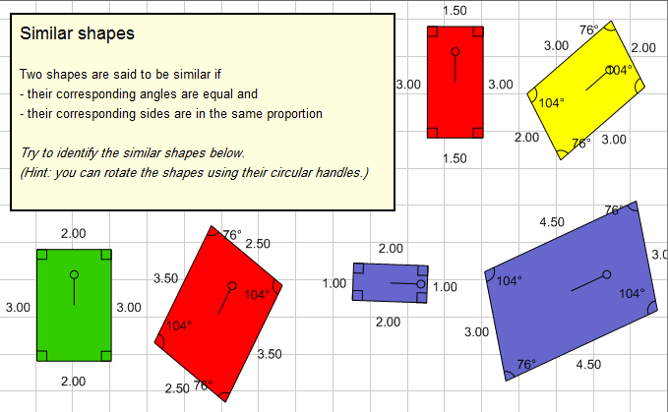

During this learning environment, the teacher and students discuss some questions like:
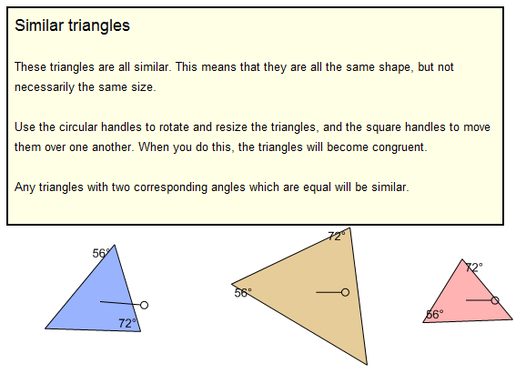
When do two triangles become similar?
What are the conditions required for two
triangles to be similar?
Students can examine some cases of similar triangles like: "Two triangles become similar
if their corresponding angles are the same".

Also, students will be able to examine if they draw a straight line that connects between two sides of a triangle and parallels to the third side, then the two resulting triangles get to be similar.

oreover, the software provides daily life situations that can be used by students to ensure that what they learn is related to their daily lives.
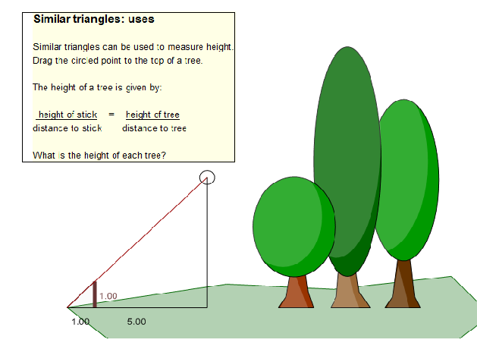

About the Authors:
Ahmad Moh'd AL-Migdady received his PhD from the University of New Orleans in Mathematics Education. He is now an associate professor in the Dept. of Curriculum and Instruction at the College of Educational Sciences, the University of Jordan, Amman-Jordan.
e-Mail: a.migdady@ju.edu.jo
Fadwa Qatatsheh received her PhD from the University of Jordan in Mathematics Education. She is now an educational expert in Mathematics Education, the Ministry of Education, Amman-Jordan.
e-Mail:fadwamath1@yahoo.com

Return to Table of Contents

Return to Table of Contents
Editor’s Note: Feedback plays an important role in all communication, and especially in learning. Its many values include motivation, positive and negative reinforcement and social recognition and engagement.

Quality of faculty feedback and its effects on learning and educational effectiveness of online master degree programs

Yoram Neumann, Edith Neumann, Shelia Lewis

USA

Abstract
This study assessed the unique contribution of quality of faculty feedback in the first course of online master degree programs, by itself, on a wide range of student educational effectiveness indicators: retention, degree completion, performance in the integrative capstone course, overall program GPA, and overall program time-to-degree while statistically controlling for the effects of student academic performance in the same first course. This assessment was conducted in the context of the Robust Learning Model with Spiral Curriculum. Using logistic regression and multiple regression models, the results of this study confirmed that not only the quality of faculty feedback was crucial to student learning and educational outcomes but this element was of utmost importance in the first core course in an online master degree program. The study presented several important conclusions and evidence for the improvement of online learning. One of the most promising paths for improving online degree program's educational effectiveness was the selection of faculty for teaching the core courses of the program.

Introduction
The quality of faculty feedback on student's learning activities played an important role in various studies in higher education and many of these studies found that effective feedback is crucial to student learning (Ackerman & Cross, 2010; Ferguson, 2011; Ghilay & Ghilay, 2015; Hattie & Thompson, 2007). High-quality faculty feedback is the single most dominant role in determining student academic performance (Hattie & Thomson, 2007). Other studies developed sustainable practices of quality feedback (Careless et al., 2011) and an entire program focused on feedback-based learning (Ghilay & Ghilay, 2015). Burksaitiene (2011) unequivocally concluded that, without the improvement of faculty feedback, student learning would not improve. Black & McCormick (2010) found a strong connection between the quality of faculty feedback and student self-reflective learning.
The quality of faculty feedback involved clear comments (Ferguson, 2011) with encouraging and constructive sentiments (Carless et al., 2011; Nicol & Macfarlane-Dick, 2006), pointing toward reducing the learning gap (Brown & Glover, 2006), developing the student self-assessment skill (Nicol & Macfarlane-Dick, 2006) and a prompt and timely faculty response (Poulos & Mahoney, 2008). Finally, the quality of faculty feedback had a strong effect on students’ receptiveness and attitudes toward faculty feedback (Mulliner & Tucker, 2017).
The vast majority of the studies on faculty feedback involved traditional classroom instruction while online learning courses and degree programs have received considerably less attention, let alone studies of the effect of faculty feedback on online degree program educational effectiveness.

The role of faculty feedback in the robust learning model
One exception to the lack of presence of faculty feedback as a determinant of educational effectiveness in online education was the Robust Learning Model (RLM). The Robust Learning Model (Neumann & Neumann, 2010, 2016) and the revised Robust Learning Model with Spiral Curriculum (Neumann, Neumann, & Lewis, 2017) included quality faculty feedback as part of the overall online learning experience. They developed a "multi-factorial model based on the basic belief that successful learning outcomes depend on multiple factors employed together in a holistic approach, which can be used to manage an entire university” (Neumann & Neumann, 2010, p. 28).
The pedagogy of the programs was one of the basic factors developed in the RLM and included multiple levels: university learning outcomes, degree program learning outcomes (PLOs), and course-level student learning outcomes (SLOs) (Neumann & Neumann, 2010). The main focus was on consistency across programs and courses, alignment of mission and goals of the university with those of the program, alignment of degree program learning outcomes with course level learning outcomes, and being hierarchical and exhaustive at a rigor commensurate with the degree level (Neumann & Neumann, 2010). A faculty committee assessed the degree to which the totality of the course SLOs was rigorously leading to the attainment of the PLOs (Neumann, Neumann, & Lewis, 2017).
The courses were developed as module-based across all degree programs. At the course level, students engaged in a variety of learning activities as follows:
Threaded Discussion
Case Assignment (Problem-Based Learning)
Signature Assignment
Self-Reflective Essay
In the self-reflective essay, students reflected upon what they learned or how they performed in the course by comparing those self-assessments with their own expectations or goals. Students were to address five items ranging from how they felt the course improved their knowledge, skills, and abilities to a self-report of whether course SLOs were achieved. The University used content analysis to assess the achievement of the SLOs in the Self Reflective Essays (Neumann & Neumann, 2010).
The last component in each course expressed throughout the various active learning engagements was the faculty feedback. The standards of conduct for faculty were (Neumann & Neumann, 2010):
Responsiveness (24-hour turnaround on email; 72-hour turnaround for grading assignments).
Flexibility with students on course and assignment deadlines.
Constructive and supportive feedback and communications with students.
Providing timely and constructive feedback (including text-based and audio) on students’ assignments for each module.
Grading of all assignments and submitting final grades.
Engaging students in meaningful learning through discussions with their peers and faculty.
Recently, the RLM was revised by introducing the spiral curriculum into the degree program's pedagogy (Neumann, Neumann & Lewis, 2017). Harden (1999) building on the work of Bruner (1960) defined the following four steps as the main characteristics of the Spiral Curriculum:
- Topics were revisited throughout the curriculum with increased complexity.
- There were increasing levels of difficulty and/or depth throughout the curriculum.
- New learning was related to previous learning.
- The learner’s competence increased throughout the curriculum until the overall PLOs are achieved.
The first course in each degree program was designed as the main point of introduction to the subject matter. One criterion was to introduce the students, at the minimum, to 50% of the PLOs of the degree program. A curriculum map was designed for each program where subsequent courses were sequentially built where the PLOs are identified in each course as developed, practiced, mastered, and finally integrated. Specialty courses were the last part of the curriculum map and are organized into concentrations. In the final course (the Capstone) students were required to demonstrate the full mastery and integration of course PLOs. The result was a revised RLM with Spiral Curriculum, or in short, RLM-SC. Although all courses in the degree programs were important, the first and last courses played a critical role. The first course laid the framework and foundations of the degree program and key concepts. In the last course, students demonstrated their understanding, comprehension, application, and integration of all the competencies and program learning outcomes required for successful completion of the degree program.
Neumann, Neumann, and Lewis (2017), tested the full RLM-SC that was predicated on the pedagogical principle by repeating and increasing the complexity level of the program knowledge, comprehension, application, and mastery. The end result was a fully interlinked curriculum with cause-and-effect relationship from the first course through the final Capstone as well as various educational outcomes. The components of the first course in RLM-SC (Threaded Discussion, Case Assignment, Signature Assignment, Self- Reflective Essay, and the Quality of Faculty Feedback) were then the independent variables that can predict an array of educational effectiveness outcomes (Retention Rates, Mastery of Competencies in the Capstone Course, Degree Completion, Time-To-Degree, and Overall GPA).
The goal of this study was to assess the unique contribution of quality of faculty feedback on a wide range of student educational effectiveness indicators: retention, degree completion, integrative capstone course performance (the culminating learning experience where students are required to demonstrate the attainment of all PLOs), overall program GPA, and overall program time-to-degree. Figure 1 below illustrates the conceptual framework for this study. 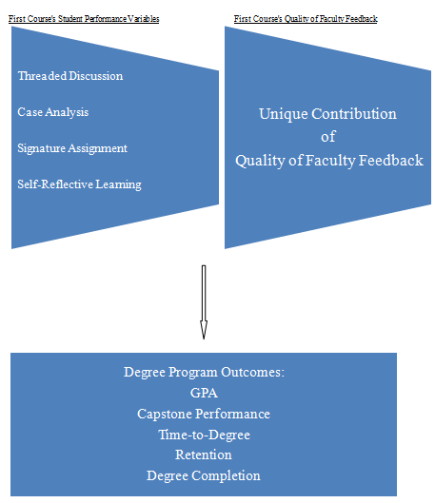

Figure 1. The unique contribution of first course quality of faculty feedback
on degree program outcomes

Method

Subjects
All students in non-clinical online master degree programs who could have graduated under the revised RLM-SC within three years from their starting date until the end of fall 2016 were included in this study for a total of 397 cases. Although this was the total population for the revised learning model it could serve as a sample for future students of the university as the university student demographics has been quite stable over time.

Measures
The variables for the first (and crucial) course in the degree program were measured as follows:
- Threaded Discussion Performance (TDP) was assessed by the average grade that the instructor assigned to each of the student's required 16 unique postings throughout the course (twice per week). The grades (A-F) assessed the extent to which the student demonstrated: (a) the complete understanding, comprehension, and application of the key concepts and quality constructive feedback to other postings, (b) used citations to support opinions, interpretations, and facts, and (c) expressed new ideas in an articulated and concise form. The letter grades are transformed to the regular (0 to 4) scale.
- Case Analysis Performance (CAP) was assessed by a rubric comprised of six areas. The first area was completeness where the case analysis needed to be complete in all aspects and a reflection all requirements. The second area was students’ understanding of the topics and issues covered in the case. The third area was analysis, evaluation and recommendations where the rubric examined the extent to which the case analysis: (a) represented an insightful and thorough analysis of all issues identified in the case; (b) made powerful connections among the various concepts, and (c) supported opinions with strong arguments and evidence while presenting critical and objective interpretations. The fourth area was the extent to which research was incorporated into the case analysis. The fifth area was the accuracy and clarity of the case analysis. The last area was the completeness of the presentation, citations and bibliography. The CSP was assigned an A to F grade with the corresponding numerical interpretation.
- The Signature Assignment Performance (SAP) was assessed by direct evidence that all the Student Learning Outcomes (SLOs) for the course (including skills and competencies) were fully demonstrated at all levels (knowledge, comprehension, application, critical thinking, communication and integration). The SAP was assigned an F to A grade with the corresponding numerical interpretation.
- Self-Reflective Learning (SRL) was based on a Self-Reflective Essay that students completed at the end of each course. The students responded to five 5 statements in the self-reflective essays which included the following:
- Descriptions of how the student felt he/she improved their knowledge, skills, abilities, and self through the course.
- Evaluation of the work the student did during the session and explanations of ways he/she could have performed better.
- Topics that the student did not understand or applied suggestions about how to improve the course materials on those topics.
- Students self-reported measures regarding the future effects of what he/she learned in the course.
- A student statement of whether or not he/she achieved the course outcomes (Student Learning Outcomes). The SRE performance was assessed by the extent to which a student completely responded to all five items and also employed the self-reflection to increase his/her ability to self-regulate the mastery of learning outcomes and competencies of the course (a dominant dimension of self-reflection). If the assessment is "Yes" on each of the 5 items, then the student scored 1 on SRE performance, otherwise the score was 0.
- The Quality of Faculty Feedback (QFF) was a main differentiating factor in the Robust Learning Model. All university faculty were trained on effective feedback and their performance was regularly assessed by the Director of Quality Assurance. In the revised RLM-SC, the role of the faculty was as crucial as in the traditional RLM. QFF performance was measured by four major factors:
- Timeliness of the feedback on all required course assignments meaning that feedback on threaded discussions were received within 24 hours, and the feedback on the case study and signature assignment were received within 72 hours.
- The constructiveness of the feedback needed for effective student positive reinforcements.
- The substantiveness and clarity of the feedback.
- The extent to which the feedback guided students in how to strengthen their learning efficacy.
- If the assessment by an independent expert of each of the four items was "Yes" then the QFF score was 1, otherwise the QFF score was 0.
The Educational Effectiveness variables are measured as follows:
- Retention Rates was the percentage of master degree students returning the following 12 months after their initial enrollment.
- Degree Completion Rates (or Graduation Rates) was the percentage of students who completed their degree requirements within 36 months after their initial enrollment.
- Capstone Course Performance (CCP) was the student performance in their Capstone Integrative at the end of their master degree program (see description above). Students in this course should have demonstrated an understanding, application, and integration of all the PLOs in the program. A rubric was developed to assess the depth to rigor to which students demonstrate the attainment of the degree PLOs acquired through core, advanced, and concentration courses. CCP was graded from F to A with its 0-4 corresponding numerical interpretation.
- The GPA measure was the cumulative grade point average on a 0 to 4 range based on the A through F grade assessment.
- Time-to-Degree was measured as the time between student's initial enrollment and degree completion.

Analysis
Assessing the unique contribution of QFF on the educational effectiveness indicators involved two stages. For retention and degree completion (each served as the binary dependent variable), stage one involved a logistic regression with TDP, CAP, SAP, and SRL as the independent variables. In stage two, FQQ was added to the model. The difference between the Nagelkerke R² coefficients for stage one and stage two was the unique contribution due to QFF.
For the other educational effectiveness indicators (Capstone Course Performance, GPA, or Time-to-Degree), they are the dependent variables and were assessed by a two-stage multiple regression analysis needed to assess the unique contribution of QFF. In stage one, TDP, CAP, SAP, and SRL were entered as the independent variables. In the second stage, the QFF was added to the model as an independent variable. The differences in R² coefficients between stage one and stage two was the unique contribution of QFF on the specific dimension of educational effectiveness.

Results

Table 1

The unique contribution of QFF to explaining retention
(Educational Effectiveness Indicator)
Comparison Between The Model Without SRL and the Model With QFF (the first core course in the program) | Nagelkerke R² | Dominant Predictors of Capstone Performance
Logistic Regression Model Without QFF | 0.52** | Self-Reflective Learning and Case Analysis Performance
Logistic Regression Model wWith QFF | 0.56** | Self-Reflective Learning and Case Analysis Performance
Unique Contribution by QFF to the Nagelkerke R² | 0.04**
*p < 0.05 **p < 0.01
Table 1 presented the logistic regression where one-year retention was the dependent variable and the first course indicators in the degree program were the independent variables. The Nagelkerke R² for the entire model was 0.56, and the percent with the same coefficient without QFF was only 0.52. Quality of faculty feedback added 4% the explained variation of retention (p < 0.01). In both models the dominant predictors remained the same, i.e., student performance on the first course's self-reflected learning (SRL) and student performance on the first course's case analysis (CAP). Although, the unique contribution of QFF was statically significant, it was not one of the dominant predictors.

Table 2

The unique contribution of QFF to explaining degree completion
(Educational Effectiveness Indicator)
Comparison Between The Model Without SRL and the Model With QFF (the first core course in the program) | Nagelkerke R² | Dominant Predictors of Capstone Performance
Model Without QFF | 0.51** | Case Analysis Performance
Model With QFF | 0.56** | Self-Reflective Learning, Case Analysis Performance, and Quality of Faculty Feedback
Unique Contribution by QFF to the Nagelkerke R² | 0.05**
*p < 0.05 **p < 0.01
Degree completion was significantly affected, with and without QFF, by all the first course's independent variables as Table 2 presented. In the model without QFF, case analysis performance played a significant role in explaining degree completion (Nagelkerke R² of 0.51; p < 0.01). The Nagelkerke R² for the whole model including QFF was 0.56 with an increase of 0.05 in the explained variation due to QFF's unique contribution ( p < 0.01). In the full model, QF, SRL, and CAP were the dominant predictors of degree completion.

Table 3

The Unique Contribution of QFF to explaining capstone performance
(Educational Effectiveness Indicator)
Comparison Between The Model Without SRL and the Model With QFF (the first core course in the program) | R² | Dominant Predictors of Capstone Performance
Model Without QFF | 0.64** | Self-Reflective Learning and Case Analysis Performance
Model With QFF | 0.79** | Quality of Faculty Feedback and Self-Reflective Learning
Unique Contribution by QFF to the R² | 0.15**
* p < 0.05 **p < 0.01
The capstone course was the last course in the online master degree program. As presented in Table 3, the model without the quality of faculty feedback (QFF) explained 64% of the capstone performance's variation. The dominant predictors for this model were the student's self-reflective learning and student's case analysis performance, both in the first core course of the degree program. The addition of the QFF in the first course increased the R² from 0.64 (the model without QFF) to 0.79 (the model with QFF). This 15% increment in the explained variation was significant (p < .01). The dominant determinants in the model with SRL were self-reflective learning and the quality of the faculty feedback.

Table 4

The unique contribution of QFF to explaining time-to-degree
(Educational Effectiveness Indicator)
Comparison Between The Model Without SRL and the Model With QFF (the first core course in the program) | R² | Dominant Predictors of Capstone Performance
Model Without QFF | 0.31** | Self-Reflective Learning and Signature Assignment
Model With QFF | 0.63** | Quality of Faculty Feedback and Self-Reflective Learning
Unique Contribution by QFF to the R² | 0.32**
*p < 0.05 **p < 0.01
Time-to-Degree was the dependent variable in Table 4. The model without QFF resulted in a low level of predictability (R² = 0.31; p < 0.01). Self-reflective learning and student's performance on signature assignment were the most dominant predictors on reducing time-to-degree in the first model. Adding the QFF into the second model substantially increased the predictability of the model from 0.31 to 0.63 with a statistically significant increase (p < 0.01). The dominant predictors on reducing time-to-degree in the second model were self-reflective learning and quality of faculty feedback. Just to iterate, all independent variables were measured in the first course of the degree program.

Table 5

The unique contribution of QFF to explaining overall GPA
(Educational Effectiveness Indicator)
Comparison Between The Model Without SRL and the Model With QFF (the first core course in the program) | R² | Dominant Predictors of Capstone Performance
Model Without QFF | 0.62** | Self-Reflective Learning and Signature Assignment Performance
Model With QFF | 0.74** | Self-Reflective Learning and Signature Assignment
Unique Contribution by QFF to the R² | 0.11**
*p < 0.05 **p < 0.01
The first course’s indicators predicted the program GPA in Table 5. The Model without QFF resulted in a strong level of predictability (R² = 0.62; p < 0.01). Self-Reflective Learning and Signature Assignment Performance were the most dominant predictors on reducing time-to-degree in the first model. Adding the QFF into the second model increased the predictability of the model from 0.62 to 0.74, and this increase was also statistically significant (p < 0.01). The dominant predictors on reducing time-to-degree in the second model were self-reflective learning and quality of faculty feedback.

Conclusion
The results of this study confirmed that not only the quality of faculty feedback was crucial to student learning and educational outcomes, but was of utmost importance in the first core course in an online master degree program. Engagement in a variety of learning activities and assignments (problem identification, problem solving, analytical tools, projects, discussions, critical thinking, and self-reflective learning) enhanced program educational outcomes when a component of quality faculty feedback was added to each of those activities. In each indicator of overall degree program educational effectiveness, QFF adds significantly to the explained variation beyond the first course of student's performance predictors. However, QFF played the most dominant roles in predicting student's time-to-degree, student's capstone course performance, and degree completion. In each of these three facets of outcomes assessment, QFF was one of the dominant variables. Among the three, QFF was the most dominant predictor in determining time-to-degree (beta coefficient of -0.57; p < 0.01).
The adaptation of the Robust Learning Model (Neumann & Neumann, 2010) to an RLM with Spiral Curriculum (Neumann, Neumann, & Lewis, 2017) places an increasing emphasis on the first course in a degree program curricula. Therefore, the instructors for these courses were carefully selected and trained by the Academic Quality Assurance function of the University in the areas of effective and continuous interaction with their students while providing cognitive, metacognitive, and affective feedback to each component of the course. While this faculty orientation and development were done for all courses, the first course deserved special attention. The involvement of faculty in all stages of the course development was paramount to quality faculty feedback. Neumann & Neumann (2016) further elaborated on this point:
"The professor’s direct involvement in all facets of course development and management, including design, instruction, meaningful and frequent interactions with the learners and assessment, enhances student learning outcomes across all degree levels and programs. When the learning experience is divided (unbundled) among several segments, student learning outcomes are considerably lower. We have tried unbundling the learning process and have experimented with course developers and designers, teaching assistants, mentors, success coaches and a learning team, and consequently, we have always received inferior results compared to when a faculty member is fully involved in all facets of the course."
The faculty direct involvement led to faculty initiations of new forms of feedback (Neumann & Neumann, 2016), in that "students who received weekly tips directly from their professors encouraging them to take control of their learning activities outperform students who do not receive such tips. Based on this finding, the weekly tips are implanted as a practice as part of the threaded discussion".
Quality faculty feedback was key to enhancing the student learning-to-learn ability (Neumann & Neumann, 2016), which is described as the "ability to persist in learning through an awareness of his or her learning needs, to effectively search for information and raise questions, to manage time to focus on learning, and to acquire or use support mechanisms to overcome challenges. Students with a high learning-to-learn ability will successfully prepare in advance how to progress and benefit from their learning experiences as well as persevere in finding the path to learning, despite adverse circumstances."
This study found that the overall quality of educational experience of the students in their first course (including their level of engagement and performance in a variety of learning activities) had a pronounced effect on the overall program performance when enhanced by the quality of faculty feedback in the first course.
The results of this study has implications for faculty, leadership, and policy makers who are actively looking for ways to effectively and efficiently develop or improve their online degree programs. The emphasis on faculty selection for core courses in an online degree program is a promising path for improving online degree program's educational effectiveness. The aforementioned conclusion received unequivocal evidence from this study.

References
Ackerman, D. S., & Gross, B. L. (2010). Instructor feedback: how much do students really want?. Journal of Marketing Education, 32(2), 172-181. http://dx.doi.org/10.1177/0273475309360159
Black, P., & McCormick, R. (2010). Reflections and new directions. Assessment & Evaluation in Higher Education, 355, 493-499. http://dx.doi.org/10.1080/02602938.2010.493696
Brown, E., and C. Glover. (2006). “Evaluating Written Feedback.” In Innovative Assessment in Higher Education, edited by C. Bryan and K. Clegg, 81–91. London: Routledge.
Carless, D., D. Salter, M. Yang, and J. Lam. (2011). “Developing Sustainable Feedback Practices.” Studies in Higher Education, 364: 395–407. http://dx.doi.org/10.1080/03075071003642449
Ferguson, P. (2011). Student perceptions of quality feedback in teacher education. Assessment & Evaluation in Higher Education, 36(1), 51-62. http://dx.doi.org/10.1080/02602930903197883
Ghilay, Y., & Ghilay, R. (2015). FBL: Feedback Based Learning in Higher Education. Higher Education Studies, 55, 1-10. http://dx.doi.org/10.5539/hes.v5n5p1
Hattie, J., & Timperley, H. (2007). The power of feedback. Review of Educational Research, 77(1), 81-112. http://dx.doi.org/10.3102/003465430298487
Mulliner, E., & Tucker, M. (2017). Feedback on feedback practice: perceptions of students and academics. Assessment & Evaluation in Higher Education, 42(2), 266-288. http://dx.doi.org/10.1080/02602938.2015.1103365
Neumann, Y. & Neumann, E. (2010). The Robust Learning Model (RLM): A Comprehensive approach to a new online university. Journal of College Teaching & Learning, 7(1), 27-36. http://dx.doi.org/10.19030/tlc.v7i1.76
Neumann, Y. & Neumann, E. (May 3, 2016). Lessons about online learning. Inside Higher Ed. Retrieved from https://www.insidehighered.com/views/2016/05/03/what-weve-learned-after-several-decades-online-learning-essay
Neumann, Y., Neumann, E.F., & Lewis, S. (In Press, April 2017). The Robust Learning Model with a Spiral Curriculum: Implications for the Educational Effectiveness of Online Master Degree Programs. Contemporary Issues in Education Research.
Nicol, D. J., & Macfarlane‐Dick, D. (2006). Formative assessment and self‐regulated learning: A model and seven principles of good feedback practice. Studies in higher education, 31(2), 199-218. http://dx.doi.org/10.1080/03075070600572090
Poulos, A., & Mahony, M. J. (2008). Effectiveness of feedback: The students’ perspective. Assessment and Evaluation in Higher Education, 33(2), 143-154. http://dx.doi.org/10.1080/02602930601127869

About the authors
Dr. Yoram Neumann | Yoram Neumann Ph.D. (Cornell University), is the Chief Executive Officer and University Professor of Business Administration at Touro University Worldwide. He assumed this position in 2012. Previously he was the Founder, President, and CEO of Touro University International (TUI). TUI was later sold and is currently Trident University International. Prior to founding TUI, Dr. Neumann served as the Executive Vice President and Vice President for Academic Affairs and Dean of the College of Business and Public Administration at California State University, Dominguez Hills. Professor Yoram Neumann also served as Research Professor and the Director of the Graduate Program in Technology Strategy and Policy at Boston University and Dean of the Faculty of Humanities and Social Sciences at Ben-Gurion University.  (Yoram.neumann@tuw.edu)
Dr. Edith Neumann | Edith Neumann, Ph.D. (Boston University) is the Provost and Chief Academic Officer and University Professor of Health Sciences at Touro University Worldwide. She assumed this position in 2012. Dr. Edith Neumann was the Vice President for Academic Affairs and is the founding Dean of the Colleges of Education and Health Sciences at Touro University International (currently Trident University International). Dr. Neumann served as Dean of the School of Health and Director of the Center for Policy Research and Evaluation at California State University, and on the faculty of Boston University and Ben-Gurion University. (edith.neumann@tuw.edu)
Dr. Shelia Lewis | Shelia Lewis, Ph.D. (Touro University International) is the Associate Provost, Director of the School of Business Administration, and Professor of Business Administration at Touro University Worldwide. She assumed this position in 2013. Previously, Dr. Lewis served as the Associate Provost and Professor of Business Administration at United States University. Prior to joining United States University, Dr. Lewis served as the Director of Institutional Research at Touro University International.  (shelia.lewis@tuw.edu)

Return to Table of Contents

Return to Table of Contents
Editor’s Note: This article discusses research to compare traditional Distance Learning pedagogy with the Socratic Method pedagogy in Distance Learning.

Socratic Method Distance Learning: An Oxymoron?

Duane L. Dobbert, Jeffrey Kleeger, Lindsey Page

USA

Abstract
Distance learning is instructional delivery that makes use of computer technology to permit an instructor and a group of students the opportunity to interact for the purpose of teaching and learning at different times and in different places. The classroom experience may be synchronous or asynchronous. Textbooks, access to databases and a centralized meeting place of the course in its on-line presence allow all members to interact with one another and with the subject matter. Benefits from the use of distance learning include the saving of time and travel costs. Students, who could not otherwise enroll in a particular course because of time-constraints or issues of physical proximity, can do so in the distance-learning format. The purpose of this research is to ascertain which Distance Learning pedagogy is most effective in meeting student learning objectives. This article discusses research conducted comparing traditional Distance Learning pedagogy with the Socratic Method pedagogy in Distance Learning. The research compares students’ acquisition of the learning objectives of academic content knowledge and critical thinking skills. The analysis is a comparison of the acquisition of these student learning objectives in 3 sections of the same course taught by the same Instructor with the exactly the same curriculum. Two of the sections utilized the traditional Distance Learning pedagogy and the third utilized Socratic Learning pedagogy. The findings demonstrated that there was no significant difference in the acquisition of academic content knowledge, however, the Socratic Method pedagogy demonstrated significantly higher acquisition of the critical thinking learning objective.
Keywords: distance learning, student assessment of learning outcomes, teaching methodologies, Socratic method, content knowledge, critical thinking, knowledge, comprehension, application, analysis, evaluation, synthesis.

Introduction
Distance learning is instructional delivery that makes use of computer technology to permit an instructor and a group of students the opportunity to interact for the purpose of teaching and learning at different times and in different places. The classroom experience may be synchronous or asynchronous. Textbooks, access to databases and a centralized meeting place of the course in its on-line presence allow all members to interact with one another and with the subject matter. Benefits from the use of distance learning include the saving of time and travel costs. Students who could not otherwise enroll in a particular course because of time-constraints or issues of physical proximity, can do so in the distance-learning format.
With that said, there are costs to distance learning and such learning is not best for all students, as learning styles vary. In distance learning there is no face-to-face, direct contact between students and the instructor. This can negatively impact student learning outcomes if a particular learner needs direct contact to better assimilate course material or possibly is not sufficiently disciplined to work diligently to understand course content without face-to-face reinforcement. Distance learning can work well for self-motivated students who cannot physically attend assigned classroom sessions that meet at a particular location and time consecutively for the required number of contact hours.
The State University System in Florida (SUS), collectively offers hundreds of programs and thousands of course sections in the distance learning format using web-based technologies. These programs and courses are accessed through institutions and the Florida Virtual Campus, which houses the Complete Florida program. Complete Florida provides free services to help students go to college and succeed in school for the purpose of improving their knowledge, marketability for gainful employment and thereby, the quality of their lives (Florida Virtual Campus).
The purpose of Complete Florida is to provide statewide innovative public educational services for Florida's K-adult students (Florida Virtual Campus). Working collaboratively with Florida’s 12 universities, 28 colleges, K-12 school districts, and other partners, the virtual campus provides services to promote academic success (Florida Virtual Campus). The virtual campus facilitates degree completion at public postsecondary educational institutions in Florida (Florida Virtual Campus). Academic support services and resources are provided across institutions to capitalize on implementation of cost-effective scales of economy (Florida Virtual Campus). The Florida Virtual Campus is funded by the state legislature and administered by the University of West Florida Innovation Institute (Florida Virtual Campus).
Distance learning is no different than traditional face-to-face learning in terms of the cost of the degree, course objectives, how programs are structured and with respect to accreditation. For these reasons, institutions offering distance learning options demand the quality of instruction and effectiveness of teaching methodology always remain equivalent to that of traditional face-to-face learning. The courses taught under each method must cover the same objectives, use the same or similar course materials and be equivalent in every respect other than the modality of instructional delivery, classroom interactions and style of instructional design. If, for any reason, it is determined through collection of data for assessment of student learning outcomes that one or the other teaching and learning method is deficient in any respect as compared to the other, then action must be quickly taken to remedy any such identified deficiency. This is to preserve the reputation of the institution and avoid sanctions imposed should there be any deficiency discovered, particularly in an accreditation review.
Distance learning thus allows certain students who might not otherwise be able to move forward in their education process the capacity to do so. It is conventionally agreed, education improves life in society because those who are better educated are more likely to positively contribute thereby enhancing social relations and social value. The problem this paper addresses is determining through specific data collection whether distance learning is indeed equivalent to traditional face-to-face learning; and if there are deficiencies in one mode of delivery or the other, identifying the cause and determining how best to correct them for the purpose of improving student learning outcomes.
This study begins with the struggle to select the best pedagogical model for the acquisition of critical thinking skills and determining whether the selected model would be appropriate for this investigation. It also begins with the admission that while the acquisition of content knowledge can be ascertained through examinations, the acquisition of critical thinking skills is more difficult to assess. In the evaluation of a variety of pedagogical models, the Socratic Method offered the most provocative delivery method for the acquisition of critical thinking skills.
Inquiry: Could the Socratic Model which is so effective in small graduate seminars effectively be utilized in undergraduate Distance Learning formats, and how would one assess the efficacy?
The concept of critical thinking originated through the teachings of the classic Athenian philosopher, Socrates (Oyler & Romanelli, 2014). For Socrates, answers were always steps on the way to deeper understanding (Cookson, Jr., 2009). He encouraged people to look beyond the face value of the generally accepted beliefs and assumptions. Socrates encouraged instructors to teach their students to investigate reality instead of accepting the face value of what they were told. The Socratic Method equips us with the ability to consider that things may not always be what they appear to be on the surface. The truth may not be in conventional wisdom and one must look beyond matters of fact to discover the facts of the matter (Goldman, 1994). The invalidation of one viewpoint may facilitate additional viewpoints each with their own degree of error. As this method is extensively employed so too does the depth of understanding and openness to additional possibilities simultaneously expand (Goldman, 1984).
By looking at a challenge from multiple viewpoints it is more likely one will arrive at a realistic, and logically effective solution. The method of Socratic questioning by its very definition leads to additional questioning and from this process, patience and deeper understanding are learned and employed rather than merely the ‘right answer’. ‘Good teaching’ ought to challenge preconceptions and encourage the consideration of multiple viewpoints (Szypszak, 2015). The focus of Socratic teaching and questioning needs to center on the students’ thoughts and responses as they are expressed and not on how well their answers match word for word what the teacher was expecting to hear. The Socratic Method should not be used as a ‘guess what I am thinking’ game but as a vehicle for investigative, inquisitive inquiry in a search for deeper thinking and understanding.
Simply stated, the Socratic Method does not employ the “Sage on the Stage” lecture. Effective use of the Socratic Method affords students the insight that they have or have had beliefs and assumptions that are inconsistent with reality through their own search for deeper understanding. Research shows that teaching for deeper learning as opposed to surface learning requires challenging existing mental models and long-standing beliefs which teachers can do by asking questions (Bain, 2004; Szypszak, 2015).
The Socratic Method can best be described in terms of Hackmann’s (1981) six pedagogical measures that the facilitator, or instructor in this case, employs during the Socratic dialogue.
- The facilitator is impartial to the content in order to ensure the participants’ deployment of their own capacity to judge.
- The facilitator stimulates working from the concrete and thus incites the participants to ground general statements in concrete example.
- A mutual understanding is promoted and ensured.
- The facilitator keeps the group’s focus on the current question.
- The group is encouraged to strive for consensus in terms of valid inter-subjective statements.
- The facilitator intervenes in order to steer the dialogue in fruitful direction
(Knezic et al., 2010).
The goal of this facilitation is to guide the dialogue in order to assist students in their efforts to reach further insight and ensure that the pertinent questions are being addressed in a timely fashion with equal contribution from all participants (Knezic et al., 2010). From Plato’s perspective, stemming from the original Socratic route of thought, the purpose of education is the search for truth through knowledge (Shim, 2008). The ‘uneducated’ condition is transformed into the ‘educated’ condition through the gradual process of enlightenment (Shim, 2008). Teachers serve the purpose of transitioning their students from a state of ignorance, regarding a given area of knowledge or topic, to a state of truth, enlightenment and cohesive comprehension by correcting the direction in which their students are searching for such answers.
One of the most effective and long-term methods of learning something is through the ability to teach that something to others so that they are able to coherently comprehend it. Memorization and regurgitation of information does not nearly serve the same means to an end that is experienced through the effective use of the Socratic method where one employs the role of teaching others while simultaneously furthering their own learning on the subject. Instructors and students teach and learn at the same time, critically investigating a subject together, relating it to their lives in empirical situations and respectfully challenging each other by contributing new ideas and reforming their old ideas (Freire, 1970).
The best examples of the Socratic Method are found in small seminar size graduate education courses. The authors propose that the Socratic Method can be effectively employed in undergraduate Distance Learning courses. The authors also propose that student acquisition of the academic skill sets of content knowledge and critical thinking can be accomplished as is required in Distance Learning courses that do not utilize the Socratic Method.

Hypothesis 1.
Student acquisition of content knowledge in a Distance Learning course employing the Socratic Method will be equivalent to the acquisition level of students in a Distance Education course that does not employ the Socratic Method.

Hypothesis 2
Student acquisition of critical thinking skills in a Distance Learning course employing the Socratic Method will be equivalent to the acquisition level of students in a Distance Learning course that does not employ the Socratic Method.

Research methodology
The authors conducted a comparative analysis of student acquisition of content knowledge and critical thinking skills by utilizing three Distance Learning sections of Theories of Criminal
Behavior taught by the same instructor over three semesters. The total number of students enrolled in these sections was 214. Each section was randomly divided in half; half in the traditional distance learning format utilized at the University (Group A), and half in the experimental Socratic Method (Group B) This random division of the sections was completed by the department’s in house Distance Learning Coordinator.
The reading assignments were identical for both groups in all 3 sections. Two discussion questions were written for each week in the course. Each discussion question required a scholarly response of at least 250 words utilizing the text book and outside scholarly journals.
Group A was required to answer both of the discussion questions and provide a scholarly response to one of the discussions of a Group A peer in each question. In contrast, Group B was only required to provide a scholarly response of at least 250 words utilizing the textbook and outside scholarly journals for the first of the two questions. Group B was additionally required to provide a scholarly response to the discussions of at least three of their Group B peers. The Group B activity involved more interaction between its members and due to the crafting of the questions, more closely approximated Socratic learning style than the work required of Group A.

Assessment

Acquisition of Content Knowledge.
Both groups were given the same multiple choice midterm and final examinations. These examinations assessed student acquisition of content knowledge.
Socratic Method Distance Learning: An Oxymoron?
Acquisition of Critical Thinking Skills.
Two discussion questions that were particularly arduous and provocative were selected to be evaluated on a scoring rubric designed by the Faculty for the express purpose of measuring student acquisition of critical thinking skills. The scoring rubric incorporated the Anderson and
Krathwohl (2001) revised Bloom’s Taxonomy of Educational Objectives. The scoring rubric created 7 categories based upon the Taxonomy from the shallowest to the most advanced processing. Verbs applicable to the domains were used in the assessment.
1. Remember (knowledge) 1 point
2. Understand (comprehension) 2 points
3. Apply 3 points
4. Analyze 4 points
5. Evaluate 5 points
6. Create Synthesis 6 points
Each discussion question was blindly scored on the rubric by the instructor and the instructor’s teaching assistant. If the instructor’s score and the teaching assistant’s score were significantly divergent, an impartial faculty member, utilizing the same scoring rubric, blindly scored the question.

Findings
Acquisition of Content Knowledge:
Content knowledge assessed through the multiple choice midterm and final examinations;
Group A 76.7%
Group B 76.4%
Acquisition of Critical Thinking Skills (low of 1.0, high of 6.0)
Group A 4.1 points
Group B 5.4 points

Conclusions
The acquisition of content knowledge was virtually identical for Groups A and B, thus indicating that the research and responding to only 1 of the Discussion Questions did not hamper the Socratic Method group from achieving content knowledge.
In contrast, the Socratic Method group achieved a higher level of acquisition of critical thinking skills. Anderson and Krahlwohl (2001) describe the categories as follows:
Analyze (4.0 on the scoring rubric) “(breaking down into parts, forms), (the ability to segment material into its constituents to allow for better comprehension). Verbs commonly associated with Analyze: analyze, categorize, classify, compare, differentiate, distinguish, identify, infer, point out, select, subdivide, survey.”
Evaluate (5.0 on the scoring rubric) “(according to some set of criteria, and state why).
Verbs commonly associated with Evaluate; appraise, judge, criticize, defend, compare.”
Creating Synthesis (6.0 on the scoring rubric) “(combining elements into a unique pattern.
Verbs commonly associated with Creating Synthesis; choose, combine, compose, construct, create, design, develop, formulate, hypothesize, invent, originate, organize.”
The authors conclude that the Socratic Method can be effectively implemented in a Distance Learning format without loss of student acquisition of content knowledge and enhanced acquisition of critical thinking skills due to the increased participation between peers.

Resources
Anderson, L.W. & Krathwohl, D.R. (2001). A Taxonomy for learning, teaching, and assessing. www.center,iupui.edu.edu/ctl/idd/docs/Bloom_revised 021.doc. Feb 8, 2006
Ayers, W. (1995). To become a teacher: Making a difference in children’s lives. New York: Teachers College Press.
Bain, Ken. 2004. What the Best College Teachers Do. Cambridge, MA: Harvard University Press.
Bloom, B.S. (Ed) (1956). Taxonomy of Educational Objectives: The Classification of Education Goals by a Committee of College and University Examiners. New York: Longmans.
Boghossian, P. G. (2006). Socratic pedagogy, critical thinking, moral reasoning and inmate education: An exploratory study. The Journal of Correctional Education. 57(1). 42-63.
Boghossian, P. G. (2012). Socratic Pedagogy: Perplexity, humiliation, shame and a broken egg. Educational Philosophy and Theory. 44(7). 710-720.
Cookson, Jr., P. W. (2009). When technology pairs up with Socratic inquiry, students have an opportunity to start a purposeful conversation - with the world. Educational Leadership. 8-14.
Florida Virtual Campus. A Complete Florida Plus Program. https://www.flvc.org/home. Socratic Method Distance Learning: An Oxymoron?
Fonseca, B.A. and Chi, M.T.H. (2011). “Instruction Based on Self-Explanation.”
“In Handbook of Research on Learning and Instruction, eds. Richard E. Mayer and Patricia A. Alexander. New York: Routledge. 296–321.
Freire, P. (1970). Pedagogy of the oppressed. New York: Continuum.
Goldman, L. (1984). Warning: The Socratic Method can be dangerous. Educational Leadership. 57-62.
Goldman, L. (1984). Unintended consequences: Louis Goldman’s reply. Educational Leadership. 64-65.
Heckmann, G. (1981). Das sokratische Gespräch: Erfahrungen in philosophischen Hochschulseminaren. Hannover: Schroedel.
Kerr, O.S. (1999). The Decline of the Socratic method at Harvard. Nebraska Law Review. 78
Knezic, D., Wubbels, T., Elbers, E. & Hajer, M. (2010). The Socratic dialogue and teacher education. Teaching and Teacher Education. 26. 1104-1111.
Nails, D. (1998) Plato’s Antipaideia: Perplexity for the guided. Proceedings of the 20th World Congress of Philosophy.
Overholser, J.C. (1992). Socrates in the classroom: A journal for readers, students and teacher of history. The Social Studies. 83(2). 77-82.
Oyler, D., Romanelli, F. (2014). The Fact of ignorance: Revisiting the Socratic as a tool for teaching critical thinking. American Journal of Pharmaceutical Education. 78(7).
Robinson, R. (1971). Elenchus. In The Philosophy of Socrates: A collection of critical essays, edited by G. Vlastos 78-93. Notre Dame, Ind.: University of Notre Dame Press.
Saran, R., & Neisser, B. (Eds.). (2004). Enquiring minds. Stoke on Trent: Trentham Books. Shim, S. H. (2008). A philosophical investigation of the role of teachers: A synthesis of Plato, Confucius, Buber, and Freire. Teaching and Teacher Education.
State University System, Florida Board of Governors. Distance Learning Opportunities. http://www.flbog.edu/forstudents/upi/distancelearning.php.
Szypszak, C. (2015). Socratic Method for the Right Reasons and in the Right Way: Lessons from Teaching Legal Analysis Beyond the American Law School. Journal of Political Science Education. 113. 358-369.

About the authors
Duane Dobbert is a Full Professor of Justice Studies at Florida Gulf Coast University. He is a 47 year veteran scholar/practitioner of the criminal justice/public safety professions. He is a Fellow of the American College of Forensic Examiners; Psychological Specialties, and author/editor of 5 books. His research interests include child sexual predators, serial sexual predators, lust homicide, and domestic violence. He can be reached at ddobbert@fgcu.edu.
Jeffrey Kleeger is Legal Studies Program Coordinator and Department of Justice Studies Chair in the College of Arts & Sciences at Florida Gulf Coast University in Ft. Myers, Florida. His research interest is in connections between law and society, and the pedagogy of law and related disciplines. He can be reached at jkleeger@fgcu.edu.
Lindsey Page is a recent graduate of the Criminal Forensic Studies Department at Florida Gulf Coast University with a Master’s Degree in Forensic Behavioral Analysis. Her research interests are comprised of a hybrid combination of Forensic Psychology, Forensic Anthropology, Biological/Physical Anthropology, Trauma Analysis (both Psychological and Anthropological), Human Rights Violations (International and Domestic), International Genocide and LGBT Rights and Violations. She can be reached at lipage@keiseruniversity.edu.

Return to Table of Contents

