## InternAtional Journal

## of

## Instructional Technology and Distance Learning

**June 2012  
Volume 9 Number 6**

**Editorial Board**

**Donald G. Perrin Ph.D**.  
Executive Editor

**Elizabeth Perrin Ph.D.**Editor-in-Chief

**Brent Muirhead Ph.D.**Senior Editor

**Muhammad Betz, Ph.D.**  
Editor

**ISSN 1550-6908**

|  |
| --- |
| PUBLISHER'S DECLARATION |
| Research and innovation in teaching and learning are prime topics for the *Journal of Instructional Technology and Distance Learning* (ISSN 1550-6908). The Journal was initiated in January 2004 to facilitate communication and collaboration among researchers, innovators, practitioners, and administrators of education and training involving innovative technologies and/or distance learning.  The Journal is monthly, refereed, and global. Intellectual property rights are retained by the author(s) and a [Creative Commons Copyright](http://creativecommons.org/licenses/by-nc-sa/2.5/) permits replication of articles and eBooks for education related purposes. Publication is managed by DonEl Learning Inc. supported by a host of volunteer editors, referees and production staff that cross national boundaries.  IJITDL is committed to publish significant writings of high academic stature for worldwide distribution to stakeholders in distance learning and technology.  In its first six years, the Journal logged over six million page views and more than one million downloads of Acrobat files of monthly journals and eBooks.  Donald G. Perrin, Executive Editor  Elizabeth Perrin, Editor in Chief  Brent Muirhead, Senior Editor  Muhammad Betz, Editor |

###### ITDLJournal

**Vol. 9. No. 6.**

**ISSN 1550-6908**

# Table of Contents – June 2012

|  |  |
| --- | --- |
|  | Page |
| Editorial: Future Based Curriculum | 1 |
| Donald G. Perrin |  |
| Distance Content-based Language Instruction: Activity Theoretical Perspective | 3 |
| Irshat Madyarov |  |
| An Action Research on Online Teaching Design Strategies and Practices | 17 |
| Shuyan Wang |  |
| Student Access to Online Interaction Technologies: The Impact on Grade Delta Variance and Student Satisfaction | 31 |
| Mark Ciampa and Mark Revels |  |
| What Does the Teacher Do when the Computer does all of the Work? Examining the Impact of Teacher-Generated Feedback in Online Secondary Self-Paced Courses that Use Computer-Assisted Instruction | 43 |
| Rebecca Hoey |  |
| Understanding the Pedagogies of Blogs, Wikis and Discussion Boards | 59 |
| Hani A. Weshah |  |
|  |  |
|  |  |

##### Editorial

# Future Based Curriculum

##### Donald G. Perrin

Education is a system grounded in the past. Knowledge and skills become obsolete, and it takes time to introduce current wisdom. Today’s schools are preparing students for the world that is still emerging using tools and ideas from a previous era. How can education be relevant and anticipate future needs? What are the implications for the art and science of teaching in the future? This will require innovative approaches to teacher training, curriculum design, teaching methods, learning technologies, and evaluation.

#### Pedagogy – the art and science of teaching

Emphasis on learning, as opposed to teaching, is giving more responsibility to learners. This is made possible by computers, interactive multimedia, and learning management systems (LMS). Diagnostic-prescriptive tools in the LMS help to optimize learning sequence and difficulty for the needs of individual learners. Emphasis on learning to criterion, as opposed to grading, achieves a more desirable result because it assures an acceptable level of learning for all students. While much of the learning is accomplished by self paced learning and interactive multimedia, teachers can focus on students that need individual assistance or tutoring. Over time, an increasing portion of the curriculum can be taught by media that is professionally prepared and easily upgraded based on student responses. There is an opportunity for continuous improvement of the learning media and flexibility to update for environmental changes and conditions yet to be defined.

#### Future orientation

It would be helpful if teachers and students acquired futurist skills to detect, monitor and successfully adapt to change. This requires research skills to study trends and disruptive changes that occur in the present and anticipate how these will impact the future. The present is a narrow ribbon on the timeline: between the past and the future. What we learn in school comes mostly from the past. We need greater focus on the present and how it will affect the future. Since the present is the beginning of the future, we actually know more about the (present and) future than the past. We also have the opportunity to shape that future by involvement in areas that impact us individually and collectively. The future is affected by the following kinds of changes:

Demographics: social, cultural, political, economic, geographic change;

Innovations: discoveries, inventions, paradigm shifts, technological change

Catastrophic events: natural disasters, pestilence, war, terrorism, death, and taxes.

Except for catastrophic events, technology has been the greatest force for change throughout the history of man.

Trends are useful for forecasting the immediate future. Disruption of a trend leads to revision or a completely new forecast. Models and simulations enable us to study problems and test theories, hypotheses, and proposed solutions. Brainstorming, clustering, and mind mapping assist in the creative exploration of ideas and developing alternative solutions to problems. Expert assessment, as with Delphi studies, help us to develop scenarios about the future where hard data is sparse or nonexistent.

#### Teacher training

The role of the teacher is changing and teacher training institutions must transform themselves to be relevant and effective in their mission. Instead of reacting to changes in the environment, they must become leaders in the change process, not only for the next generation of teachers, but for lifelong learning to keep the all previously and currently trained teachers up-to-date. The editors of IJITDL welcome papers that would help to accelerate changes in teacher education worldwide.

#### Curriculum design and instructional design

Curriculum takes time to develop. The ADDIE process is a popular model – Assess – Design – Develop – Implement – Evaluate. It takes several years to assess needs, define goals and performance objectives, and design and develop structures, pre-tests, lessons and learning activities to achieve the required knowledge, skills and aptitudes. It also takes time to develop evaluation instruments to determine when the criterion is reached. The curriculum and related instructional materials go through several iterations of testing, review, revision, and approval before being propagated to teacher training institutions, schools, and teachers. Time from initiation to implementation may be several years and it is possible that aspects of the curriculum will become obsolete by the time it is implemented. Updating is also a lengthy process.

Computers and interactive media can speed the development and revision process. Learning Management Systems (LMSs) help in two ways. 1) They use student responses to interactive multimedia to determine where the learning experience needs revision, and 2) they direct the student to alternative materials to correct a learning problem or gain additional experience. The LMS retains learner data to assist in revision. And when changes are made in the master copy, all existing copies are automatically updated. Thus, technology provides a solution for continuous updating and improvement to ensure relevance and effective learning.

#### Methods of teaching and learning

There has been extensive research in models of human teaching (Joyce et.al., 2008) and in use of educational technologies. For more than a century, instructional technologies have added resources for large group instruction, such as film and projected media, television, radio, and audio recordings. In the 1960s the emphasis changed to individualized instruction, such as language laboratories, teaching machines, interactive multimedia, computers, and more recently to computer networks and a plethora or computer related devices such as smart phones. Research (USDOE, 2012) is now moving to determine how best to use technology to improve educational productivity.

#### Evaluation

Evaluation tells us how-well we have achieved our goals and objectives. Much of the evaluation effort has been sidelined by methods to prevent cheating, a product of our competitive reward system and testing that does not adequately challenge problem solving abilities. Evaluation should reflect what students will do in real world situations beyond graduation. The real world is not governed by true-false and multiple choice decisions, but by higher learning skills of analysis, synthesis, problem solving, and creativity and by our personal skills and ability to express ourselves in clear and simple language.

### References

[Bruce R. Joyce](http://www.amazon.com/Bruce-R.-Joyce/e/B001H6MEI2/ref=sr_ntt_srch_lnk_1?qid=1352489562&sr=8-1) and Marsha Weil with Emily Calhoun (2008) [Models of Teaching (8th Edition)](http://www.amazon.com/Models-Teaching-Edition-Bruce-Joyce/dp/0205593453/ref=sr_1_1?ie=UTF8&qid=1352489562&sr=8-1&keywords=joyce+models+of+teaching). Pearson.

US Department of Education. (2012) Understanding the implications of online learning for educational productivity.   
<http://www2.ed.gov/about/offices/list/os/technology/implications-online-learning.pdf>

Return to Table of Contents**Editor’s Note**: Dr. Madyarov’s research provides a powerful theoretical base to interpret learning patterns of individual learners as they develop linguistic skills in a foreign language. This information has particular value for designing content-based learning materials to support students with different learning styles and different levels of ability.

# Distance Content-based Language Instruction: Activity Theoretical Perspective

##### Irshat Madyarov

##### Armenia

### Abstract

This study brings together activity theoretical framework and content-based language instruction to investigate how English as a foreign language learners go about developing their linguistic and subject matter competencies. The research was conducted using the case study design with 6 student participants, who were enrolled in an undergraduate distance course in critical thinking. The findings indicate that within the content-based course, all student participants positioned English as a mediating instrument in their activity systems of learning. Further, the content-based design of the course encouraged the students to introduce various regulative behaviors so as to improve performance of English as a mediating instrument. The study shows that activity theory has a natural theoretical fit with content-based pedagogy due to their common assumptions of learning. The paper highlights how activity theory may provide insights about the nature of language development within content-based courses versus courses that directly teach foreign or second language.

**Keywords**: Content-based instruction; activity theory; distance learning.

### Introduction

Content-based language instruction (CBLI) has established a significant niche in the literature on foreign/second language pedagogy and second language acquisition for the last 30 years of research (e.g., Edwards, et al., 1984; Hauptman, Wesche & Ready, 1988; Snow & Brinton, 1988; Brinton, Snow & Wesche, 2003; Chappell & de Courcy, 1993; Day and Shapson, 1993; Burger, Wesche & Migneron, 1997; Chadran & Esarey, 1997; Corin 1997; Kasper, 1997; Klahn, 1997; Klee & Tedick, 1997; Leaver 1997; Ryding & Stowasser 1997; Shaw, 1997; Sternfeld, 1997; Straight, 1997; Stryker, 1997; Vines, 1997; Kerans, 2001; Opp-Beckman, 2002). However, very few if any of these and other reports have investigated this instructional framework from the theoretical lens of sociocultural or activity theory.

Activity theory and sociocultural theory are inherently consistent with the philosophy of CBLI. The main premise of CBLI is that language is an instrument for learning the content, and as the content is tackled, the instrument is improved too. This principle is foundational in sociocultural and other related theories. According to Vygotsky (1982a; 1982b), the human mind is constantly mediated by a number of physical and psychological tools. This mediation is critical for social and psychological development of any person. Language is one of the psychological instrumental assets we possess, and it is, likewise, a key instrument in any academic or professional learning, including CBLI contexts.

This study brings together the activity theoretical and content-based instructional frameworks to investigate what kind of impact CBLI has on learners’ English as a foreign language and their understanding of the subject matter of a distance college-level course when viewed from an activity theoretical perspective.

### Background

Activity theory springs forth from cultural historical psychology more commonly known as sociocultural theory in Western schools of thought. The triangle in Figure 1 is present implicitly or explicitly in many studies conducted within the sociocultural theoretical framework. It demonstrates the central premise of the theory about the relationships between three central elements of human action: subject, instrument, and object. Man, as a subject in this triangle, performs all conscious actions towards achieving an object by means of mediating instruments, either physical, such as a pen or hammer, or psychological, such as language. Conscious actions, such as writing, hammering a nail, using voluntary memory, attention giving, or conveying thoughts are examples of higher psychological functions. While lower psychological functions are inherent in the biological makeup of the human body, higher psychological functions are acquired only through human interaction, where psychological instruments are of primary importance (Vygotsky, 1983b). Object within this theoretical framework is ‘raw material’ or ‘a problem space‘, which is molded or transformed with the help of instruments (Lantolf & Thorne, 2006, p. 223). Simply put, object is the goal that a subject holds for every action performed.

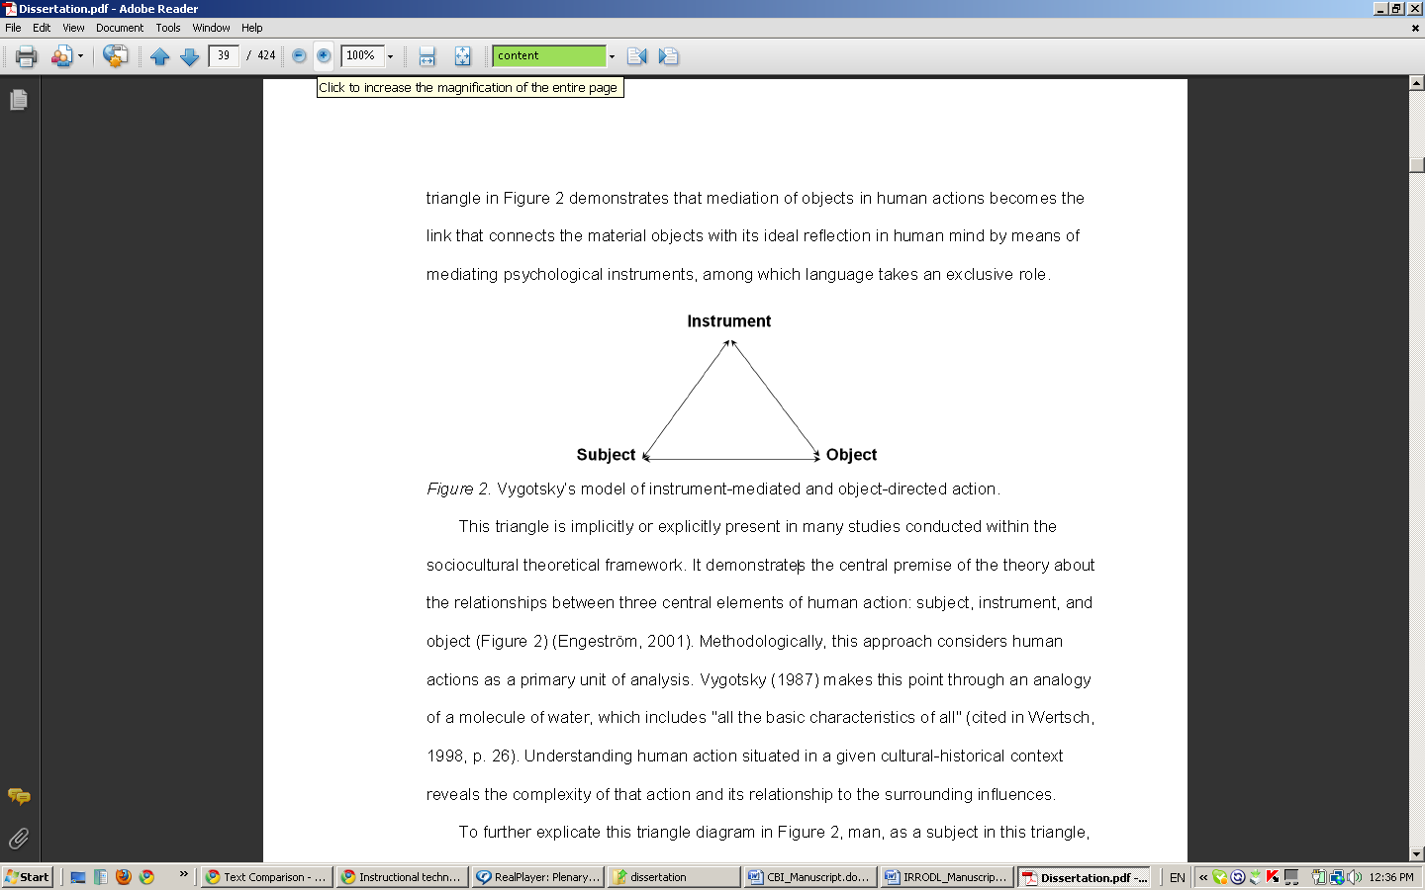

##### *Figure 1.* Vygotsky‘s model of instrument-mediated and object-directed action.

According to Vygotsky (1982a), as newborns come into social contact with adult caregivers, they start developing their higher psychological functions through the assistance of the adults. Thus, a mother would first draw attention of her child to certain things in their environment. At this stage, the higher psychological function of attention drawing exists at the “interpsychological” level (Vygotsky, 1982a, p. 116). As this function moves to the “intrapsychological” level, it becomes voluntary. As Vygotsky puts it, the child from being directed by others, starts to direct him/herself.

Similarly, language, as a sign system, first exists at the interpsychological level, and then becomes intrapsychological. Vygotsky (1984) terms this process “internalization”, a complex process of “grafting” of a function inside the mind, which entails a very intricate transformation of the brain (personal translation, 1984, p. 15). Thus, speech first exists in its social function and is always externally produced. By the time higher psychological functions have developed enough, speech acquires another function – that of cognitive. In its cognitive function, language is referred to as inner speech, and as such, it is never externally produced. However, the language part of the brain is still actively engaged during thinking processes even if a person is not speaking. This was confirmed by studies that recorded electrical brain activity (Lantolf & Thorne, 2006).

Leont’ev (1975; 1981; 1989), a colleague of Vygotsky's, further developed his conceptual framework into activity theory. Leont'ev’s key contribution to Vygotsky's work was the idea that human activity is always collective. In activity theory, the original Vygotsky's triangle (Figure 1) appears at the top part of the larger triangle referred to as an activity system (see Figure 2). Here, the subject is engaged in an activity towards an object.

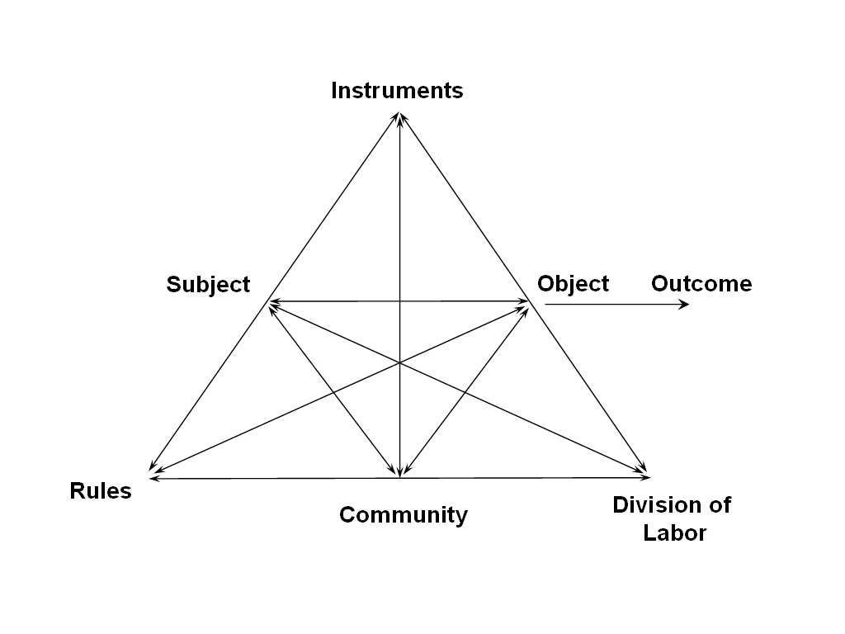

##### *Figure 2.* A model of human activity proposed by Leont’ev (cited in Engeström 2001: 135).

At the lower part of the triangle are the other factors of an activity system: community, division of labor, and rules. Leont'ev's (1981) illustrated his model with a hunt analogy. A collective hunt activity involves a group of people working towards a common object – procuring food and skin for the community. Every participant of the hunt has his roles; for example, beating of the bushes is the role of the beater. These roles result from a certain division of labor. Finally, rules include agreements among the hunters as to who is doing what, at what point of time, in what order, and the like.

Today, activity theory has several manifestations. Engeström (1999a; 1999b; 2001), a leading activity theorist in the West, talks about activity theory as a constellation of multiple activity systems constantly changing and interacting with each other. His thesis is that any human activity has a potential to grow, and that this growth is cyclical, going through cycles of internalization (learning) and externalization (problem-solving or creation). Central to this growth are the contradictions within the elements of each individual activity (subject, instruments, object, division of labor, community, and rules), between these elements, and between surrounding activity systems. As contradictions are resolved, the activity continues to develop and grow. Unresolved contradictions lead to the stagnation of activity and possibly its death.

Figure 3 shows how a central activity system interacts with surrounding activity systems through the six nodes: subject, instruments, object, division of labor, community, and rules, and where potential contradictions may arise. Engeström (1987) identities four types of contradictions in such a network of activity systems: primary, secondary, tertiary, and quaternary. Primary contradictions can arise within any of the six elements of the activity: subject, instruments, object, division of labor, community, and rules (marked as 1 in Figure 3). Secondary contradictions occur between the six elements of the activity, for example between the subject and the instrument of the activity (marked as 2 in Figure 3). Tertiary contradictions take place only at the object node of the activity system when an outside more advanced activity introduces a new object into the central activity system (marked as 3 in Figure 3). This new object may create disagreement and clashes of interest, which is the result of tertiary contradictions. Finally, the quaternary contradictions occur between the central activity and any surrounding activity system (marked as 4 in Figure 3)

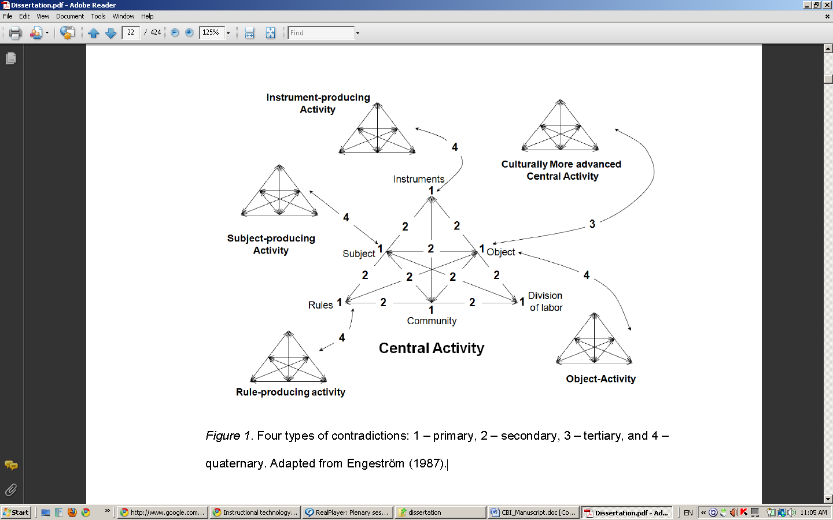

##### *Figure 3.* Interactions of surrounding activities and potential contradictions within and between them (Engeström 1987).

This study views learners of the content-based course as subjects of their own central activity systems that emerged within the course environment. Each individual activity system had its own object mediated by instruments, community of classmates and instructors, division of labor, and rules.

### Methodology

#### Research questions

The original study investigated all contradictions and their consequences within and between activity systems of individual students in a distance CBLI course. To this end, the research questions were the following:

1. What types of contradictions arise at the four levels of the central activity systems of individual learners: primary, secondary, tertiary, and quaternary?
2. What are the consequences of the identified contradictions?
3. For the purposes of this paper, we limit our discussion to the findings that have most relevance to CBLI pedagogy.

#### The Context

The course under investigation was offered via distance at a Middle Eastern university (henceforth, the University). The University occupies a unique position in the host country in that it provides education to the followers of the Bahá'i Faith, a marginalized segment of the population, which is otherwise deprived of access to higher education on the grounds of their religious beliefs (International religious freedom report 2007: Iran, 2007). As such, the University runs contrary to the socio-political system in the country, and all the faculty and students are subject to persecution.

A few years ago, the University started converting its courses to deliver them online in the face of the on-going persecutions and unpredictable circumstances surrounding the physical facilities of the University. This increased the need of engaging international faculty who primarily speak English, hence the need for academic English proficiency among the University students. Within the past six years, the University has developed an academic EFL curriculum comprising four courses. Following these courses, students take a bridge course, which is the object of this study.

The subject matter of the bridge course is critical thinking. It follows a sheltered model of content-based language instruction (CBLI), according to the definition of Brinton, Snow, and Wesche (2003). The course included eight modules:

1. History of Critical Thinking
2. Intellectual Attributes of Critical Thinking
3. Ethics and Critical Thinking
4. Faith and Critical Thinking
5. Asking Questions
6. Evaluating Evidence
7. Detecting Fallacies
8. Consensus Building and Critical Thinking

The students completed two types of required assignments per module: 1) a draft and final paper based on each reading assignment; 2) asynchronous threaded discussions (forums); and two optional assignments for bonus points: 1) a wiki-based pre-writing activity; and 2) synchronous sessions with the instructor. Most of the course materials were available via Moodle, a learning management system, and course CDs. Student connected with their instructors via Moodle, Skype and Yahoo Messenger.

#### Participants

The study investigated course-related activity systems of six students. The sample represented a wide variety of English proficiency levels, age, gender, majors, and employment options (see Table 1). The names of the students have been changed to protect their identity.

##### Table 1

##### *Profile of the student participants*

|  |  |  |  |  |  |  |
| --- | --- | --- | --- | --- | --- | --- |
| Student | Gender | Age | Major | English proficiency | | Employment |
| Azita | F | 23 | management | Intermediate | Repairs computers | |
| Azad | M | 36 | management | Advanced | Executive/Computer company | |
| Noushin | F | 20 | psychology | Low-intermediate | Unemployed | |
| Nazanin | F | ~20 | pharmacy | Advanced | Unemployed | |
| Shahin | M | 21 | computer engineer | Low-intermediate | Network specialist | |
| Amir | M | 18 | biology | Advanced | Unemployed | |

#### Design of the study, data collection and analysis

Following the epistemology of activity theory, this study adopted a naturalistic model of inquiry like many other studies conducted within this theoretical framework (Nardi, 1996a; Nardi, 1996b; Barab, et al., 2002; Mwanza, 2002; Lantolf & Thorne, 2006). Each of the six student participants represented an individual case with multiple activity systems included therein.

The following data sets were collected and analyzed throughout and at the end of the semester:

Students’ background questionnaire

Participants’ assignments submitted to the Moodle course site

Moodle-tracked logs to identify student participants’ online presence and behavior

Interactions between the student and instructor participants

Monthly semi-structured interviews with the student participants

An interview with the instructors at the end of the semester

Researcher field-notes

Data collection and analysis had to take place concurrently. Figure 4 summarizes the data collection and analysis procedure. Starting from the second stage, the procedure consisted of three to four cycles of data collection and analysis: 1) observing students‘ online participation,   
2) confirming the emerging evidence through interviews with the students, 3) interpreting preliminary contradictions and their consequences (identifying patterns of disturbances and innovations within activity systems), and 4) preparing data for member checking in the subsequent interview.

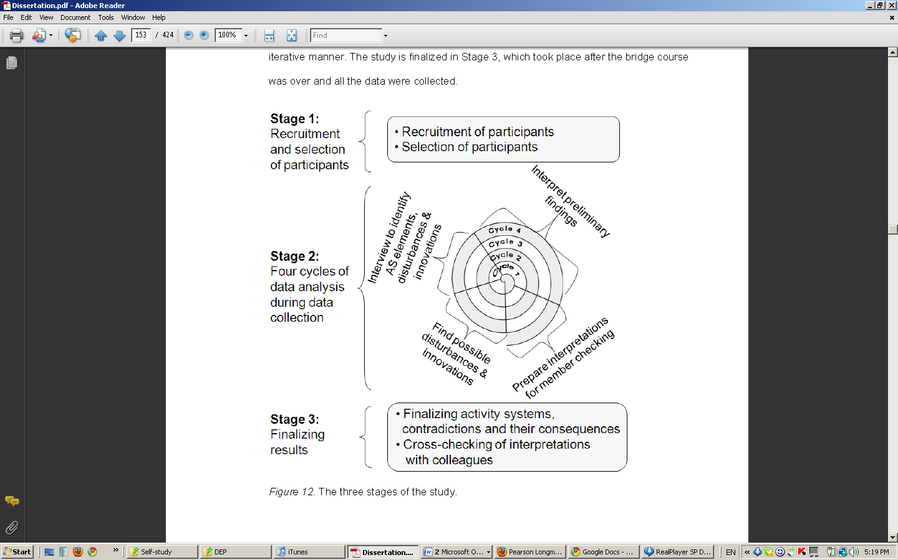

##### *Figure 4.* Three stages of data collection and analysis.

Tracing contradictions and their consequences was the heart of this research study. Going back to the theoretical distinction of activity and action, Lantolf and Thorne (2006) propose that these two constructs belong to different unites of analysis. Multiple actions constitute activity if they are motivated by one unifying object. Actions are finite and linear occurrences, while activity is a long-term and cyclical formation. Theoretically, contradictions are operationalized at the level of activity. Contradictions become visible via disturbances and innovations that occur at the action level (Engeström, 1987; 1999a). To be able to identify contradictions, the methodology had to be sensitive to disturbances that the student participants experienced and innovations that they may have implemented in order to overcome the challenges as they were transforming their objects.

### Results

#### Students’ activity systems

Despite the fact that all six students were part of the same course, they all engaged in their unique activity systems. Given the current discussion of content-based language instruction (CBLI), one can distinguish two categories of students: those that engaged in activity systems of improving English as a foreign language (EFL) (Figure 5), and those that did not (Figure 6). Those that did (Azita, Shanin, and Nazanin) had been actively seeking opportunities to transform their objects of improving English prior to this course by browsing Internet resources, watching movies in English, attending private English courses, and the like. For such students, the critical thinking course offered a natural environment that was conducive to further transforming their objects that already existed outside of the schooling environment. Those students who did not have an activity system of improving English (Azad, Noushin, and Amir) did not seem to have this activity outside of the course either.

Along with activity systems related to coursework, such as learning critical thinking or improving EFL, some students were engaged in activities that sometimes lay outside of a purely academic domain. For example, Azita had an activity system of maintaining a good self-image (Figure 5), and Azad had an activity system of engaging in criticism (Figure 6). These activity systems, like the activity system of improving EFL, emerged within the course environment because it was conducive to the transformation of the students’ objects.

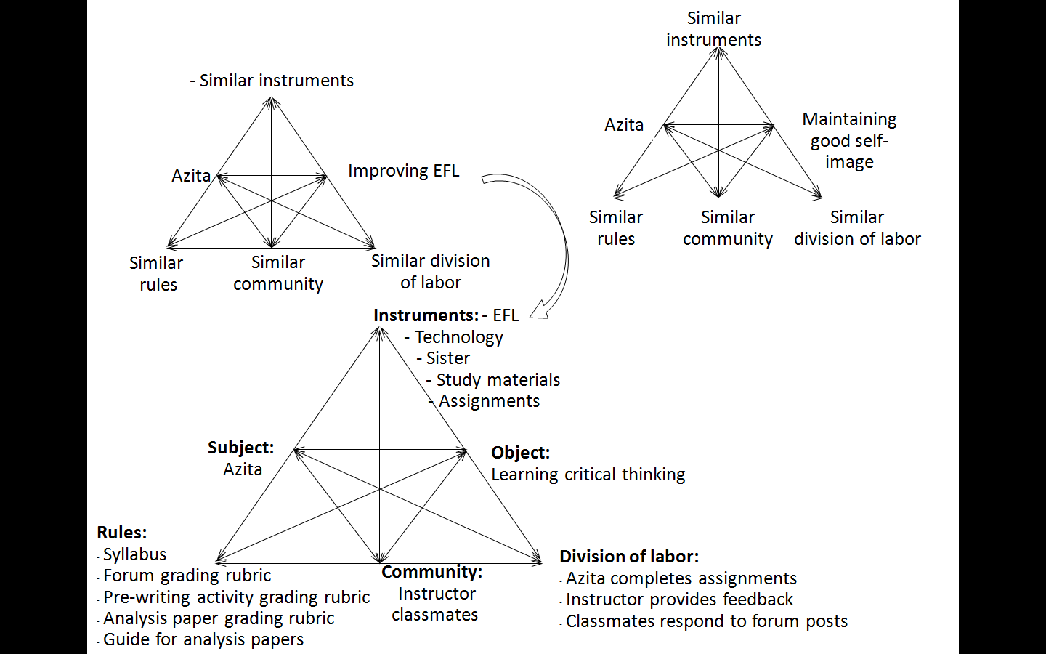

##### *Figure 5.* Azita’s activity systems in the critical thinking course.

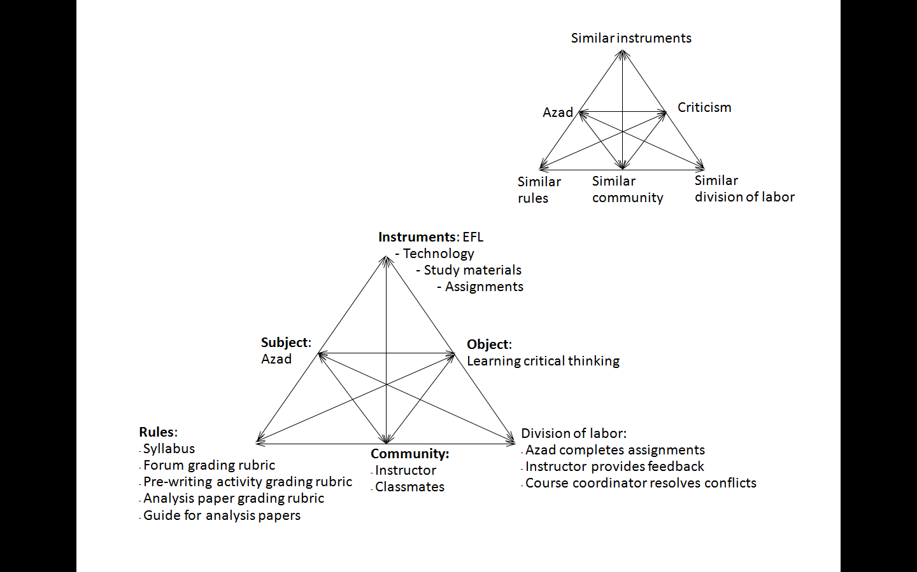

##### *Figure 6.* Azad’s activity systems in the critical thinking course.

In this respect, this study suggests that students do not necessarily engage in course taking activities when they formally take a course. Rather, a course may act as an environment where students’ new or already existing activity systems emerge. Alternatively and unfortunately, students simply perform isolated actions not situated within any particular activity systems, much like Engeström (1987) suggests. To account for this emerged theoretical finding, we propose a concept of an *activity* *shell* to refer to the kind of environment that includes all potential mediators for an activity system to emerge (instruments, division of labor, community, and rules). The only two components an activity shell misses to become an activity system are the subject and object. In this light, most modern schools offer activity shells of different shapes, some of which are conducive to transforming students’ own activity systems or generating new ones, while others are not. The latter produces learners that are not driven by motives in sociocultural terms.

#### Contradictions and consequences

All contradictions have a dual nature (Engeström, 1987). At the primary level, it is the duality between use and exchange value within the elements of the activity system: subject, instruments, object, division of labor, community, and rules. At the secondary level, it is the contradiction between these elements of the activity system. At the tertiary and quaternary levels, these contradictions occur between activity systems.

The study revealed a number of contradictions at the primary, secondary, and quaternary levels of students’ activity systems. However, given the scope of this discussion, we address only the contradictions relevant to the content-based nature of the critical thinking course: a selection of primary and secondary contradictions.

In the everyday world, the nature of primary contradictions may depend on the socio-economic formation of the society (Engeström, 1987). In a capitalist society, this contradiction represents a struggle between use and exchange value. Engeström applies this theory to schooling settings and proposes that activity systems with an exchange value orientation transforms learning into a commodity which learners exchange for a grade. According to Engeström, an activity system driven by an orientation towards exchange value at the level of primary contradictions results in: instruments that promote rote learning and memorization; texts that are used as objects; a community that encourages individualistic interests; division of labor that assigns isolated roles to individual participants; and rules that encourage competition. Conversely, use value orientation leads to genuine learning, with instruments of sense-making, objects with real-life application, a community of collaborators, and a division of labor and rules that encourage this collaboration.

The student participants had different orientations in their primary contradictions. Most participants shifted from being use value-oriented to exchange value-oriented closer to the end of the semester. There was only one student who changed her orientation from exchange value to use value, but then she shifted back to the exchange value at the end of the semester. Otherwise, reversing this shift from exchange to use orientation was rare. On the other hand, there was a participant who exhibited a stable use value-orientation and another one who remained mostly exchange value-oriented. All primary contradictions led to secondary contradictions between that element (e.g., object, instrument, or community) and another element of the activity system.

The findings of this study support Engeström’s (1987) argument that exchange value-oriented activities result in poorer learning. Both in terms of content learning and improving EFL, all student participants exhibited the same relationship between value orientation and their engagement in course actions: exchange value orientation led to less engagement and poorer quality of work, and use value orientation led to more active engagement in course actions and better quality of work.

Another finding worth mentioning is that value orientation in the primary contradiction of the object sometimes spreads to the same orientation in the other elements of the activity. For example, when a student has an exchange value orientation to learning (i.e. learning for the sake of the grade), such orientation spreads to the community and rule elements of the activity system. Simply put, a grade orientation towards learning promoted individualistic learners who bend to the rules, such as a grading policy, and become regulated by them. The data provided this evidence only for two elements of the activity system: community and rules. Instruments did not seem to be affected by the orientation in the object possibly because most instruments in this study were obvious commodities, such as Internet and content management systems.

This course produced a number of consistent secondary contradictions, and the most evident in the data was the contradiction between the students’ inadequate EFL proficiency as their instrument and their academic oriented objects: critical thinking and intellectual self-improvement. Regardless of whether participants had an EFL activity system, they all engaged very actively in the course materials in order to resolve this contradiction. All six student participants had this contradiction, and it led to two types of consequences: desirable and undesirable.

Among the desirable consequences are a number of anticipated and innovative solutions. The participants actively used glossaries that came with the course articles. They used their own dictionaries and encyclopedias. They re-read articles up to five times. Many of them sought help from their family members, friends, classmates, and instructors. Among other innovative solutions were translating the assigned articles into their first language, translating unfamiliar words and sentences on paper and memorizing them. The data suggest that the translation solutions were primarily popular among the students with low English proficiency.

On the other hand, this contradiction also caused some undesirable consequences. The most common of these is student frustration. This was particularly the case with one assigned article in the course that was highly complex conceptually and linguistically. Extra scaffolding provided to the students via glossed vocabulary, forum discussions, and guided questions for the reading assignments did not seem to help resolve this contradiction.

Theoretically, contradictions occur at the activity level and as such have a long-term presence. Methodologically, contradictions in this study were observed via isolated disturbances and innovations in specific actions that the students performed. When disturbances and innovations clustered between two particular elements of an activity (e.g., instrument and object) and occurred frequently, they were operationalized as a contradiction.

In terms of the contradiction between the students’ inadequate EFL proficiency and their objects, one of the most common disturbances was written feedback from the instructors. The interviews with the students and analysis of their papers point to two categories of feedback disturbances: facilitating disturbances and inhibiting disturbances. Facilitating feedback disturbances encouraged students to revise their papers and produce satisfactory results, which facilitated the transformation of their objects, be they critical thinking, EFL, or other academic-oriented objects. Inhibiting feedback disturbances were a nuisance and encouraged superficial local corrections, which shifted students’ orientation towards the exchange value, i.e. grade-motivated learning. This distinction, however, was not always easy to make due to methodological constraints. Sometimes, it was impossible to identify when a student might view written feedback as a facilitating or inhibiting disturbance.

### Discussion and conclusion

This study confirmed that regardless of whether the students were oriented towards improving English or any other learning, they all had to place EFL in the instrument node of their activity systems. This inevitably triggered a number of regulative behaviors that transpired as a result of the inadequacy of the students‘ English as a mediating instrument. As much as a case study methodology can permit, we can conclude that CBLI courses, at a minimum, elicit a number of regulative behaviors that are often viewed as pedagogically favorable.

In this sense, activity theory as a heuristic model provides an enlightening perspective on pedagogy and curriculum development. Consider two course designs: Figure 7 and Figure 8.

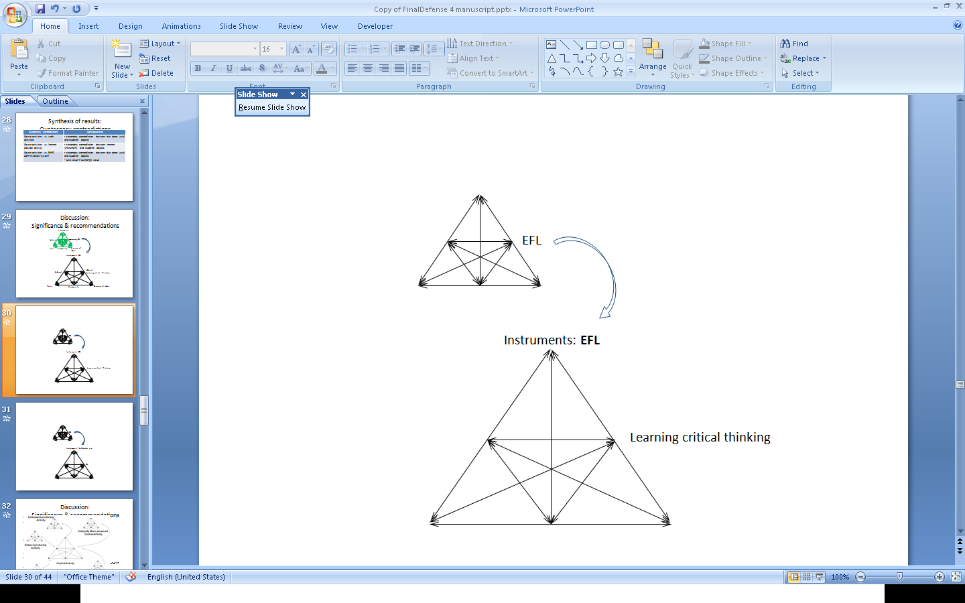

##### *Figure 7*. A course design where English occupies an instrument position in the student’s activity system, such as sheltered or adjunct model of CBLI.

Figure 7 illustrates a sheltered or adjunct model of CBLI (Brinton, Snow & Wesche, 2003). This course design (i.e. activity shell) encourages students to form an activity system motivated by an object of learning a non-English-related subject matter. English in this activity shell inevitably occupies a mediating position as an instrument. In Figure 8, the course design encourages students to transform their object of English learning. In this model, mediating instruments may include a course textbook, instruments of writing and recording, and technological instruments.

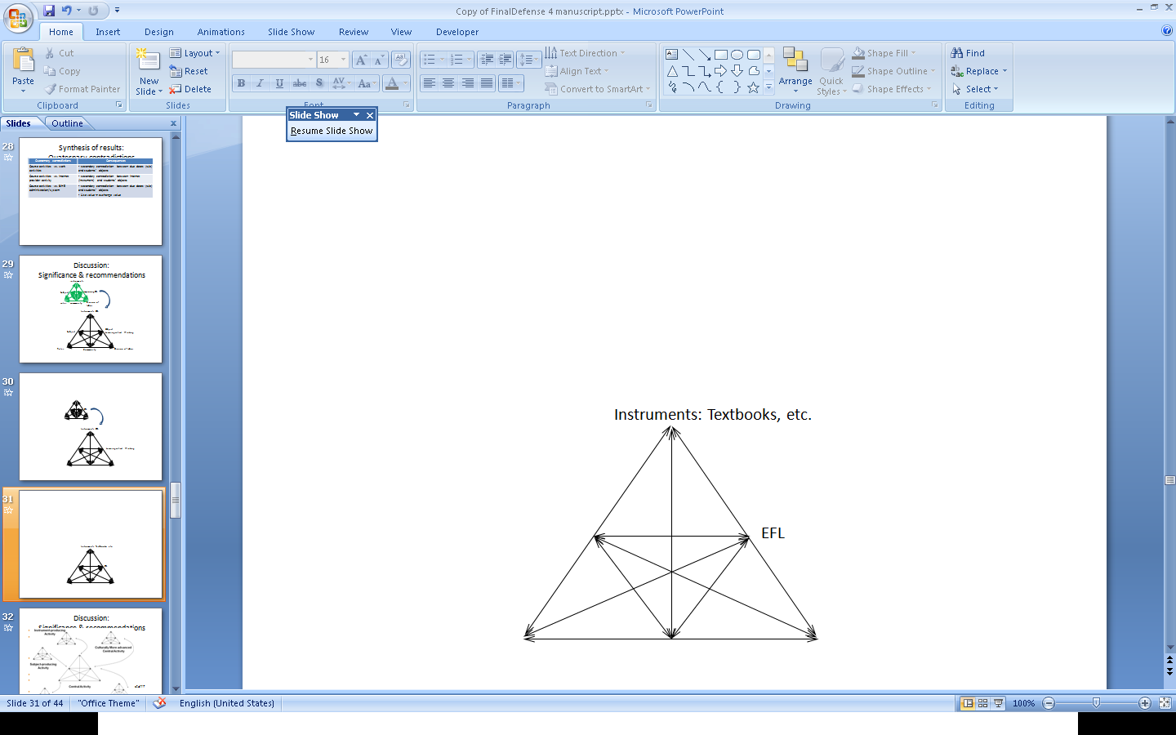

##### *Figure 8*. Course design where English occupies an object position in the student’s activity system, such as any English as a foreign or second language course.

Engeström (1987) suggests that modern schooling is losing credibility in the eyes of young learners because it encourages them to form activity systems where text (i.e. knowledge and facts obtained from textbooks and lectures) acts as the object of learning. He argues that text should belong in the node position of learners’ activity systems, while objects should be real-life problems. The findings of this study do not necessarily lead us to claim that we should use the target foreign/second language solely as instrument in course activity shells. However, they do suggest that a CBLI type of course design resembles a natural process of learning and development that occurs in real life: whenever an instrument of an activity system is inadequate, it calls for improvement in order to further transform the object. According to Vygotsky (1982a; 1982b), this is how human physical, cognitive, and social capacities have been evolving at the phylogentic (development of human species), sociocultural historical (development of man throughout human history), ontogenetic (lifelong development of an individual person), and microgenetic (short-term development of an individual person) levels.

There is yet another possible avenue for investigation based on the above. This study demonstrated that along with a content-oriented object, some students had an object of improving EFL, and some did not. The data show that regardless whether students had the EFL object or not, they exhibited active engagement in EFL-related actions, such as use of a dictionary, translating key words or parts of the text into Farsi, re-reading the text for better comprehension, and seeking help from other people. The question remains whether the presence of an EFL activity system affects language acquisition in a content-based course. This question may be key to understanding the processes of language acquisition of adults engaged in CBLI courses. According to Leont‘ev (1978), children do not have motives *per se* unlike adults; yet they successfully acquire languages via human interaction. Language, as a mediating instrument, becomes transformed without a conscious effort of a child. The findings of this kind of research may provide promising insights for language pedagogy.

There were many disturbances in the student participants’ actions that were manifestations of the secondary contradiction between inadequate EFL as a mediating instrument and their objects. However, the proposed methodology and the research questions were able to capture only regulative behaviors as resolutions to disturbances, some of which became consistent and were introduced into the activity systems as mediating instruments. The students’ papers did grow more complex, at least in lexical terms presumably due to the repeated use of certain concepts such as *perspectives, implications, purpose, information*, and the like. Some participants also started integrating hedging techniques, such as *seems to be, probably*, and *perhaps* in their papers closer to the end of the semester. However, it was impossible to identify whether and how these regulative behaviors and the feedback from the instructors affected their second language acquisition (SLA). A more in-depth analysis of these textual and discourse features would certainly shed more light on this phenomenon. Activity theoretical constructs could be enlightening in this kind of research because they contextualize participants’ SLA within the framework of their motives and contradictions. For example, the nature of instructor feedback as a facilitating versus inhibiting disturbance may have a differing consequence on SLA.

The results of the study also corroborate many previous findings. For example, despite the level of student English proficiency, lack of the content background creates unbearable challenges for students in CBLI courses. The importance of linguistic support when dealing with abstract subject matter is another theme to be highlighted in this regard. This oversight on the part of the team that developed the critical thinking course caused many disturbances for students with lower English proficiency. Along these lines, because lower level students tended to rely more on their first language as a scaffolding device in grasping the new content, perhaps this can be integrated as an optional mediating instrument for some students.

Finally, instructor feedback had a crucial role in the study. As was mentioned earlier, the feedback that emerged in this study could be categorized as either a facilitating disturbance or an inhibiting disturbance. The findings demonstrated that the former elicited more use value-oriented actions, while the latter tended to be exchange value-oriented. The nature of feedback as a disturbance in students’ actions implies a two-way endeavor. The student needs to have the right object, and the instructor should provide feedback conducive to the transformation of the object.

### References

Barab, S. A., Barnett, M., Yamagata-Lynch, L., Squire, K., & Keating. T. (2002). Using activity theory to understand the systemic tensions characterizing a technology-rich introductory astronomy course. *Mind, Culture, and Activity, 9*(2), 76-107.

Brinton, D. M., Snow, A. M., & Wesche, M. B. (2003). *Content-based second language instructi*on. Ann Arbor, MI: University of Michigan Press.

Burger, S., Wesche, M., & Migneron, M. (1997). “Late, late immersion”: Discipline-based second language teaching at the University of Ottawa. In R. K. Johnson & M. Swain ( Eds.). *Immersion education: International perspectives* (pp. 65-84). New York, NY, U.S.A.: Cambridge University Press.

Chadran, J. & Esarey, G. (1997). Content-based instruction: An Indonesian example. In S. B. Stryker & B. L. Leaver (Eds.), *Content-based instruction in foreign language education: Models and methods* (pp. 223-236). Washington DC: Georgetown University Press.

Chappell, E. R., & de Courcy, M. C. (1993). Using immersion to train primary school teachers of French in Australia. *The Canadian Modern Language Review, 49*(2), 316-337.

Corin, A. (1997). A course to convert Czech Proficiency to proficiency in Serbian and Croatian. In S. B. Stryker & B. L. Leaver (Eds.), *Content-based instruction in foreign language education: Models and methods* (pp. 78-104). Washington DC: Georgetown University Press.

Day, E., & Shapson, S. M. (1993). French immersion teacher education: A study of two programs. *The Canadian Modern Language Review, 49*(3), 446-465.

Edwards, H., Wesche, M. B., Krashen, S., Clement, R., & Kruidenier, B. (1984). Second-language acquisition through subject-matter learning: A follow-up study at the University of Ottawa. *The Canadian Modern Language Review, 41*, 268-282.

Engeström, Y. (1987). *Learning by expanding: An activity – theoretical approach to developmental research.* Retrieved November 2, 2007, from <http://communication.ucsd.edu/MCA/Paper/Engeström/expanding/toc.htm>

Engeström, Y. (1999a). Activity theory and individual and social transformation. In Y. Engeström, R. Miettinen, & R. L. Punamäki, *Perspectives on activity theory* (pp. 19-38). New York: Cambridge University Press.

Engeström, Y. (1999b). Expansive visibilization of work: An activity-theoretical perspective. *Computer Supported Cooperative Work,* 8, 63–93.

Engeström, Y. (2001). Expansive learning at work: Toward an activity theoretical reconceptualization. *Journal of Education and Work, 14*(1), 133-156.

Guba, E. G., & Lincoln, Y. S. (2005). Paradigmatic controversies, contradictions, and emerging confluences. In N. Denzin & Y. Lincoln (Eds.), *The sage handbook of qualitative research (3rd ed.),* (pp. 191-215). Thousand Oaks, CA: Sage Publications.

Hauptman, P.C., Wesche, M. B., & Ready. D. (1988). Second-language acquisition through subject-matter learning: A follow-up study at the University of Ottawa. *Language Learning, 38*(3), 433-475.

International religious freedom report 2007: Iran. (2007) *U.S. Department of State.* Retrieved from <http://www.state.gov/j/drl/rls/irf/2007/90210.htm>

Kasper, L. F. (1997). The impact of content-based instruction programs on the academic progress of ESL students. *English for specific purposes, 16*(4), 309-320.

Kasper, L. F. (2000). The short story as a bridge to content in the lower level ESL course. In L. F. Kasper (Ed.). *Content-based college ESL instruction* (pp. 107-121). Mahwah, NJ: Lawrence Erlbaum.

Kerans, M. E. (2001). Simulating the give-and-take of academic lectures. *TESOL Journal, 10*(2-3), 13-17.

Klahn, N. (1997). Teaching for communicative and cultural competence: Spanish through contemporary Mexican topics. In S. B. Stryker & B. L. Leaver (Eds.). *Content-based instruction in foreign language education: Models and methods* (pp. 203-221). Washington DC: Georgetown University Press.

Klee, C. A. & Tedick, D. J. (1997). The undergraduate foreign language immersion program in Spanish at the University of Minnesota. In S. B. Stryker & B. L. Leaver (Eds.). *Content-based instruction in foreign language education: Models and methods* (pp. 141-173). Washington DC: Georgetown University Press.

Lantolf, J. P. & Thorne, S. L. (2006). *Sociocultural theory and the genesis of second language development*. Oxford: Oxford University Press.

Leaver, B. L. (1997). Content-based instruction in a basic Russian program. In S. B. Stryker & B. L. Leaver (Eds.). *Content-based instruction in foreign language education: Models and methods* (pp. 31-55). Washington DC: Georgetown University Press.

Leont’ev, A. N. (1975). *Deyatelnost. Soznanie. Lichnost.* [Activity, Consciousness, Personality]. Moscow: Politizdtat.

Leontyev, A. N. (1981). *Problems of the development of the mind*. Moscow: Progress Publishers.

Leont'ev, A. N. (1989). The problem of activity in the history of Soviet psychology. *Soviet psychology, 27*(1), 22-39.

Mwanza, D. 2002. ‘Towards an activity-oriented design method for HCI research and practice.’ Doctoral dissertation. Retrieved December 16, 2007, from The Open University, United Kingdom: <http://iet.open.ac.uk/pp/d.mwanza/Phd.htm>

Mwanza, D. (2002). Towards an activity-oriented design method for HCI research and practice. Doctoral dissertation. Retrieved December 16, 2007, from The Open University, United Kingdom: <http://iet.open.ac.uk/pp/d.mwanza/Phd.htm>.

Nardi, B. A. (Ed.). (1996a). *Context and consciousness activity theory and human-computer interaction*. London, England: MIT Press.

Nardi, B. A. (1996b). Studying context: A comparison of activity theory, situated action models, and distributed cognition. In B. A. Nardi (Ed.), *Context and consciousness: Activity Theory and human-computer interaction,* (pp. 69-102). Massachusetts: The MIT Press.

Opp-Beckman, L. (2002). Africa online: A web- and content-based English language teaching course. *TESOL Journal*, *11*(3), 4-8.

Ryding, K. & Stowasser, B. (1997). Text development for content-based instruction in Arabic. In S. B. Stryker & B. L. Leaver (Eds.). *Content-based instruction in foreign language education: Models and methods* (pp. 107-118). Washington DC: Georgetown University Press.

Shaw, P. (1997). With one stone: Models of instruction and their curricular implications in an advanced content-based foreign language program. In S. B. Stryker & B. L. Leaver (Eds.). *Content-based instruction in foreign language education: Models and methods* (pp. 261-282). Washington DC: Georgetown University Press.

Sternfeld, S. R. (1997). Caterpillars into Butterflies: Content-based instruction in a first year Italian course. In S. B. Stryker & B. L. Leaver (Eds.). *Content-based instruction in foreign language education: Models and methods* (pp. 56-77). Washington DC: Georgetown University Press.

Straight, H.S. (1997). Language-Based Content Instruction. In S. B. Stryker & B. L. Leaver (Eds.). *Content-based instruction in foreign language education: Models and methods* (pp. 239-260). Washington DC: Georgetown University Press.

Stryker, S. B. (1997). The Mexico experiment at the Foreign Service Institute. In S. B. Stryker & B. L. Leaver (Eds.), *Content-based instruction in foreign language education: Models and methods* (pp. 174-202). Washington DC: Georgetown University Press.

Vines, L. (1997). Content-based instruction in French for journalism students at Ohio university. In S. B. Stryker & B. L. Leaver ( Eds.). *Content-based instruction in foreign language education: Models and methods* (pp. 119-140). Washington DC: Georgetown University Press.

Vygotsky, L. S. (1982a). *Voprosy teorii i istorii psikhologii.* [Problems of the theory and history of psychology].Moscow: Pedagogika.

Vygotsky, L. S. (1982b). *Problemy obshei psikhologii*. [Problems of general psychology]. Moscow: Pedagogika.

### About the Author

**Irshat Madyarov** is an assistant professor at the Department of English Programs, American University of Armenia. He is also an adjunct distance faculty member at the Baha’i Institute of Higher Education in Iran. He received his MA in TESOL at West Virginia University, WV and his Ph.D. in Second Language Acquisition and Instructional Technology at University of South Florida, FL. He has taught English as a second and foreign language, and a number of courses in applied linguistics at the graduate and undergraduate levels. He has presented and published internationally. His interests include digital technologies in TESOL, distance education, language program assessment, bilingual preschool education.

Email: [imadyaro@aua.am](mailto:imadyaro@aua.am)

Return to Table of Contents

**Editor’s Note**: This study uses data collected during design and implementation of a course to determine the effectiveness of component strategies and practices. Some of these outcomes may be teacher specific and related to the content of the course, so results might be different for other teachers and courses. Never-the-less, this is useful data for discussion and planning.

# An Action Research on Online Teaching Design Strategies and Practices

##### Shuyan Wang

##### China & USA

### Abstract:

This action research paper discusses the strategies and practices of designing, developing, and delivering a technology-enriched online course based on ASSURE model. Instructional materials, course activities, course assignments, and communications have been used to illustrate how technologies are integrated into online teaching and learning. Issues/concerns when delivering the online class are also discussed. This paper intends to demonstrate how to create an effective online learning environment and teach online courses efficiently.

**Keyword**s: pedagogical design, design strategy, online teaching, online learning environment, pre-service teachers, in-service teachers, ASSURE model, online course design, communication tools, and online collaboration.

### Background

Web-based education is quickly changing the foundation of higher education by impacting current university practices and policies. According to Allen and Seaman (2011), over 6.1 million students, which is nearly 31 percent of higher education students, were taking at least one online course during the fall 2010. This is a ten percent growth rate for online enrollment that far exceeds the less than one percent growth of the total higher education student population. The Market data study predicts that 37 percent of all post-secondary enrollments will be in online programs by 2015(Goldman, 2011)*.* As of August 2011, the U.S. Internet population includes 78 percent of adults and 95 percent of teenagers (Zickuhr & Smith, 2011). This trend is reflected at the university where the study has been conducted. The university has pushed transferring traditional face-to-face courses and programs to an online environment. Currently, it offers seven undergraduate online programs, 15 graduate online programs, and seven hybrid graduate programs, in addition to over 600 online courses offered each term. However, issues of online teaching and learning have merged as more students take online courses. First, not all instructors are trained to teach online. Second, not all students are suited to take online courses because of their learning styles. Therefore, a number of dropouts from online classes occur every term. Finally, even though most students complete the online courses, they might miss the effectiveness of interaction and communication found in traditional face-to-face classrooms.

After the WebCT course management system was upgraded to Blackboard 9.1 (Bb 9.1) course management system, more tools were made available for instructors and students for improved communication and interaction. As a result, educators faced new challenges to effectively use these tools. With the current functions in Bb 9.1, students enjoyed the flexibility in gaining knowledge and skills by stepping outside the tradition of isolated classrooms and adopting more interdisciplinary approaches via applying technologies. However, the communication tools operated differently due to the particular context of each activity the learner was involved with, the different purposes and expectations, the varying personal and professional backgrounds and concerns, and the level of familiarity with the technologies. Hence, further studies on these aspects needs to be conducted.

### Purposes and significance of this study

The purposes of this study include (a) investigating how current course design and course activities help pre-service and in-service teachers understand the importance of successfully integrating technologies into the classroom, (b) examining experiences, thoughts, and perspectives that pre-service and in-service teachers acquire as they finish course work and develop their blogfolios, and (c) studying how students think about the current course design in promoting their learning. Research questions included:

1. Whether the course activities helped pre-service and in-service teachers master the technology skills needed in classroom?
2. Whether the course activities helped students understand the methods of integrating technologies into teaching?
3. Whether current course design helped students learn how to integrate technology into teaching?

This study is significant to provide first-hand and detailed information on the experiences, perceptions, and reflections of the students who learned technology skills through a technology-enhanced learning environment and applied these skills directly to their own classroom. The results of this study can be used by online teachers to determine what teaching strategies and communication tools to use, and how to use them properly to motivate students’ collaboration and engagement. This study will also provide empirical evidence for future research that can be beneficial for online teachers, curriculum developers, and instructional designers in their efforts to target collaborative online learning environment.

### Methodology

Action research forms the methodological framework of this study. Action research is directly relevant to classroom instruction and learning and provides the means for teachers to enhance their teaching and improve student learning (Stringer, 2008). Action research “provides teachers with a philosophy and practice that allow them to systematically study the effects of their teaching on student learning” (Mills, 2007, p4). This study gathered information about how the author taught a graduate online class and how well her students learned to gain insight, develop reflective practice, effect positive changes in online teaching in general, and improve student outcomes and the lives of those involved (Mills, 2007). In addition, this study helps the author critically examine her teaching in order to improve and enhance instruction.

#### Identify an area of study

The research setting was an online graduate class entitled, *Computers in Education,* which was designed according to the ASSURE model. The ASSURE model is a constructivist approach to training design and is an instructional model for designing courses using different kinds of media. This model incorporates external resources and technology into the course materials and is especially helpful for instructors designing online courses. Smaldino, Lowther, and Russell (2008) had a detailed explanation about the ASSURE model in their book, *Instructional Technology and Media for Learning*. ASSURE is an acronym from the key verb of the six steps for planning and delivering instruction.

***Step 1 – Analyze learners*.** Students enrolled in spring 2010 were 20 masters or doctoral students and most of them were in-service teachers. These students were majoring or minoring in instructional technology (IT). This meant that they have had taken quite a few IT courses already and were experienced with basic technology applications and familiar with most tools such as most popular communication tools and authoring applications. These students had different learning styles. Most of them claimed as being visual, verbal, or aural/verbal learners. A few students stated that they were physical or logical, or solitary learners. Only one student mentioned that he was a social learner. Most students were K-12 classroom teachers and some of them had been using some technologies in their teaching.

***Step 2 – State Standards and objectives***. As most students were in-service teachers, this course used NETS for teachers’ standards as a guide of learning objectives. The online course, *Computers in Education,* not only provided students with theories of teaching and learning with technology, but also created a technology-enhanced learning environment where they experienced how these technologies helped their learning. The objectives included learning emerging technologies and integrating them into the curriculum. Technology skills learned from this class covered every stage a classroom teacher would use in class such as word processing, presentation, grade management, communication, website design, video and audio editing, and blog reflections.

***Step 3 – Select strategies, technology, media, and materials*.** Based on students’ learning style, this course used an E-book, *Teaching and Learning with Technology,* (3rd ed.) written by Lever-Duffy & McDonald and published by Allyn and Bacon in 2008. This book was chosen because there were podcasts and video clips with each chapter. A supplement Website, Mylabschool.com, also came with the book. In this site, students could access online hardware and software skill-builder tutorials if they did not have a solid foundation in basic technology skills for educational settings. These instructional materials in different formats help students learn and understand theories and skills effectively. In addition, the professor created video and word-processed tutorials to demonstrate skills needed for every hands-on project. PowerPoint slide shows and audio lectures related to special topics were also created and uploaded to the course site. The arrangement of this class met the needs of students with different learning styles.

***Step 4 – Utilize technology, media and materials***. In order to get to know the theories, students have read book chapters, view video clips, and listen to the podcasting provided for that chapter. The PowerPoint slides for each chapter were also provided to students as a guideline. Students would then participate in threaded discussions related to the content of the chapter. To apply what they learned to practice, students were asked to create nine hands-on projects based on this scenario: you were assigned to teach a 6th grade math class (or any subject/grade you want to teach) for this semester. All projects should be focused on the same project you chose to teach. You decided to integrate current Web 2.0 tools into your teaching to encourage students’ collaborations and integration. Students would then use all technologies discussed in class in their own classroom scenario.

***Step 5 – Require learner participation***. This course used blog, live classroom, voice board, discussion board, and emails for students to collaborate with their peers and professor. According to John Dewey (1963), students do not learn from their experiences, but learn from reflecting upon their experiences. Reflection was an important learning tool in this class. Students were asked to reflect upon their understanding of each topic in their personal blogs every week after they read the assigned chapter, viewed relevant video clips, and listened to the podcast. They were also asked to reflect on their learning experiences each time when they finished a hands-on project. Students were divided into groups of three at the start of the term. Each group member was required to read and comment on two other members’ blog reflections concerning book chapters and learning experiences in creating the projects, which would help them learn from each other. This did not require a heavy reading load compared with larger groups or read the posts from the entire class.

***Step 6 – Evaluate and revise***. The evaluation of the efficiency of the course design depends on how well students performed in the course. Student learning outcomes were evaluated through following course assignments: (a) Online journal – each student kept a blog and post reflections each time when finishing a project or reading book chapters, which indicated how well they understood the textbook; (b) Hands-on projects – each student set a scenario of the class he/she would teach and created instructional materials such as flyer, grade chart, quiz, rubric, worksheet, puzzle, Web site evaluation, online bookmarks, movie story, course site, and listserv with free tools for the subject he/she chose to teach, which indicated how well they mastered technology skills; and (c) Electronic portfolio (blogfolio) - includes all reflections posted in the whole term with the related projects linked at the end of each reflection with self-intro as the first post and course reflection as the last entry. Students received assignments and rubrics at the start of the term so that they were clear about the expectations and evaluation criteria. Students were allowed to revise their projects to earn a higher grade. The professor believed that practice led to progress, which was very true with hands-on projects. The more time students devoted to their projects, the more they would learn from this experience. The professor adjusted her course content each term according to student’s feedback and technology development.

The course was delivered within the Blackboard Learning Management System. The following screen-capture images display the layout and structure of the discussed course. Figure 1 is the homepage of the course where students could access the Welcome page, Course Materials page, and communication tools. If they click on the Course Materials icon, students could access course syllabus, assignments, reflection questions, and schedule as shown in figure 2. All related materials are linked in the schedule (refer to figure 3).

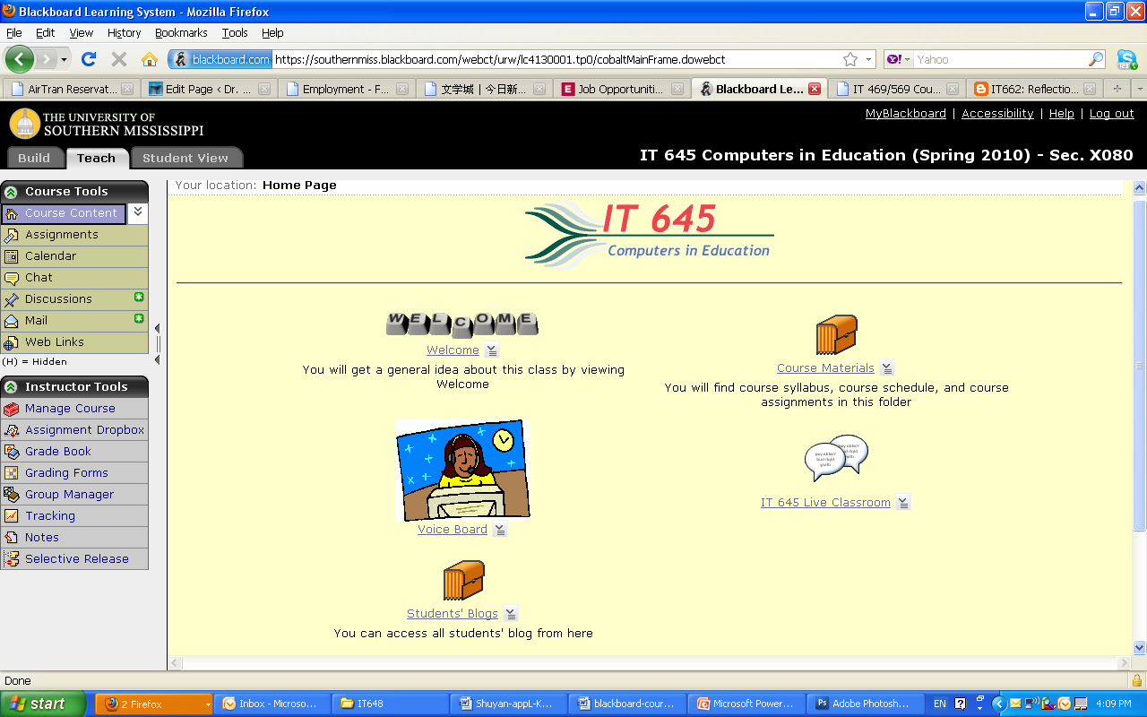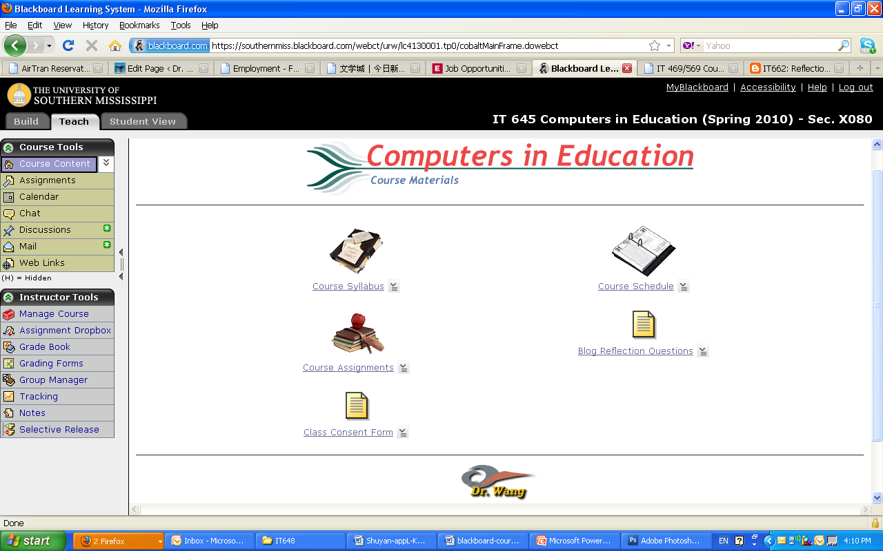

##### *Figure 1*: Home Page of the online course *Figure 2*: Course Materials page

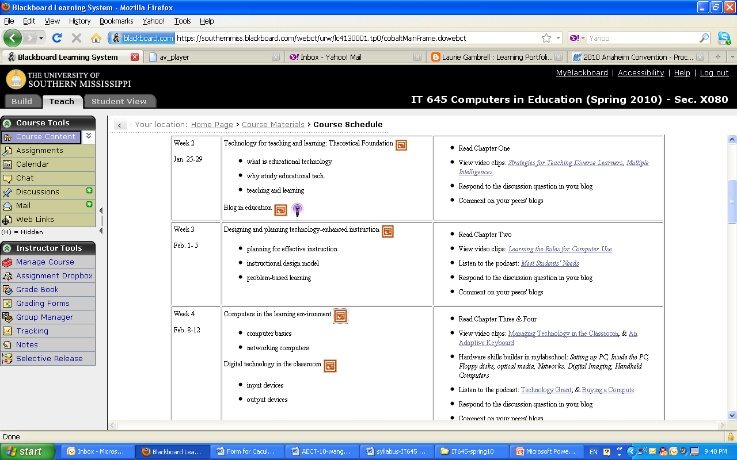

### *Figure 3*: Part of Course Schedule page

#### Collecting and Analyzing Data

Data were collected during the 2010 spring term that included open-ended survey questions, participant observations of student online activities, and documentations of the course to ensure triangulation of the data. At the end of the term, students finished a questionnaire (refer to Appendix) regarding their background information, experiences, and perspectives of course design, instructional materials, course activities, communications, and technology integration. As the professor of the online course, the researcher had the opportunity to observe students’ participation in all course activities as well as students’ struggles when they encountered problems. The observations reflected what students said in the reflections. Documentation in this study included blog reflections after each project, comments on the reflections, weekly announcements, and the tracking records of student activity in Blackboard. Documentation analysis provided deeper understanding of student’s reflections and instructor’s observation.

Data analysis procedures for this study included organizing the data, generating categories, themes and patterns, and writing the final report. The researcher put together documents, archival records, participants’ reflections, and the instructor’s journal in order to organize what she experienced, heard, saw, and read. The various data sources allowed the researcher to triangulate her observations and interpretations of the participants’ learning experience.

### Findings and discussions

Findings from this study showed that students were satisfied with the overall course design, required activities conducted in the course, and online communications between peers and with the instructor. All participants indicated that this course was extremely informative and activities helped them learn about the course content and technology skills. They especially expressed their positive interaction and collaboration in these online courses. Findings will be discussed in the topic of course design, instructional materials, course activities, and communication/interaction.

#### Course design

Findings from data analysis showed that 55 percent students strongly agree and 45 percent agreed that the course layout (refer to the first three figures) was easy to navigate. Sixty-five percent of the students strongly agreed and 35 percent agreed that the Welcome page helped them obtain a general idea of the requirements and structure of the course. Eighty-eight percent of the students strongly agreed and 12 percent agreed that the Schedule page with all readings, tutorials, and examples linked in each week gave them a clear idea of what to do and how to complete activities

##### *Figure 4*: Students’ perspectives on the course design

Half of the students strongly agreed and another half agreed that the Assignment document, which included all of the assignments, helped them schedule their time and keep up with the course assignments easily. Figure 4 shows student’s perspective on the course design.

#### Instructional materials

Findings from this study indicate that more than half of the students were not fond of e-book because of technical problems and the limited accessibility (only a six month online access). About half of the students thought the podcastings related to each chapter helped them understand the book and integrated the knowledge into their own classrooms.

In contrast, all students felt the video clips that accompanied the book chapters helped their understanding of the book material and examples. As one student stated, “The clips let me see how the concepts in the book work in real life. This is so important for teachers. It was very convenient to click right on those videos from the course schedule.” Because most students enrolled in this class had strong technology backgrounds, only about 40 percent felt the hardware and software skill-builder tutorials in mylabschool.com were helpful. However, most students (58 percent strongly agree and 30 percent agree) said that the video tutorials for each project created by the professor helped them a lot in working with hands-on projects.

Students liked the word-processed format tutorials created by the professor even more (70 percent strongly agree and 30 percent agree) than the video tutorials. Reason was that they could follow the word document tutorials more easily as video tutorials went too fast as they worked on their own projects. Although they could click pause and/or playback the video, they felt it was not as convenient as the word document tutorials, which was clearly illustrated with images and steps.

Over 90 percent of students agreed or strongly agreed that examples for hands-on projects helped them in working with their projects. Through the examples, they were clear about the professor’s expectation. Figure 5 shows student’s perspectives on instructional materials used in this course.

##### *Figure 5*: Students’ Perspectives on Instructional Materials

#### Course Activities

Findings from this study demonstrated that hands-on projects assisted students to learn the skills and gave them an idea of how to integrate these skills into their own classrooms. As one of the student stated in her blogfolio:

I was pleasantly surprised at how much I was able to retain from the course. I thought I would learn it well enough to do the assignments and then forget it. However, I have used almost everything I have learned in my own classroom already. I really enjoyed the class.

Another student stated:

The great part is that some of the projects are “small” enough that I can integrate them with minimal equipment and software…it gives me the tools to integrate, and freedom to come up with ways to use them.

Findings indicated that blog reflections on the hands-on projects helped students rethink what they learned in creating the project. As one student stated in the survey,

The reflections were helpful because the act of writing them made me evaluate the technology in terms of how valuable it was, how likely I would be to use it, and whether the preparation of the technology was worth the value it brings. If I did not have to write about it, I would have just checked it off the list as “assignment completed” without thinking much about it. I do think students need to understand what is expected in a well-written reflection and receive feedback so they can improve their writing.

Compared with other course activities, more students (about 35 percent) check neutral for the reflection on the book chapters even though over 60 percent felt that this activity helped them understand the content of the text book. In this activity, the professor asked three questions related to the chapter, each group member would choose one question to answer, and then they would read and comment on their group members’ answers to another two questions, which ensured that they understood the entire chapter. However, some students only read the chapter related to the question he/she needed to answer. This student’s comment represented what the students, who checked neutral, thought:

The reason I put neutral on this is because there was so much content of the book, and we only did reflections on certain parts of the chapters. So, on those parts, the blog reflections did help me understand. I had to read the book with understanding in order to synthesize my answer to the question. I always tried to bring in my own experiences as they relate to the subject because that is a strategy for comprehending the material. However, it would be impossible for students to answer their blog question without reading the entire chapter, and I’m sure that happens. …This book just had a huge amount of content.

Findings showed that most students felt that reading and commenting on peer’s blog postings gave them an opportunity to learn other’s understanding and their experiences with technology. They admitted that projects on Google functions provided them with the opportunities to cooperate with their peers. They thought creating a movie story helped them understand how to prepare multimedia components and how to integrate digital storytelling into their own teaching. Most students indicated that this was the first time they created a Website for the class they teach or will teach, which helped them understand the process of design and develop a course site. Through creating instructional materials with free online tools, students gained experiences of how to use Web 2.0 tools and integrating them into classroom.

##### *Figure 6*: Students’ Perspectives on Assignments

All students thought that the Web site evaluation activity gave them an idea ofwhat to look for while evaluating a Web site.

Findings showed that blogfolio was a great way to self-assess their projects, rethink what they learned, and think how to integrate technologies into their own classrooms. Student felt very pleased when they looked back at their blogfolios and saw everything they accomplished. Figure 6 demonstrated the level of satisfaction students have for every activity in the class based upon their value and significance in learning new tools and ideas.

#### Course Communications

Findings from this study indicated that giving a weekly announcement is necessary and helpful, which aided students to keep up with the schedule. Students stated that communication between students and the professor was effective and adequate. Among the communication tools used in the class, email was the most effective one. During the entire term, the professor received 256 emails and sent 222 emails through Blackboard excluding email exchanges with regular email system. There was one student who sent 58 emails and read 160 emails, which was doubled compared to the average emails read by other students. This was because this student struggled more than other students in working through the course activities. Other communication tools such as Live Classroom, Voice Board, and Discussion Board within Blackboard were seldom used during this term; therefore, students did not show much interest in those tools.

Figure 7 illustrated student’s perspectives on the value of different communication tools used in this class.

##### *Figure 7*: Students’ Perspectives on Communications

Based on the students’ course reflections, they were satisfied with the communication modes among their peers and with the instructor. Students indicated a positive experience of the interaction and collaboration in these online courses. They felt closely connected with their peers and the instructor. They were comfortable asking questions and communicating with other students. Most students stated that the interaction with peers provided them the opportunity to learn from other resources; they learned a lot from others through interaction. They also mentioned that interacting and communicating with peers required a large amount of self-motivation. By using these communication tools, they mastered the technology skills needed in classroom and gained teaching methods in integrating technology into their own classroom.

Finally, from this online class setting, they learned how to integrate technology into their curriculum. All students indicated that they would integrate what they learned from this class into their own classrooms. Figure 8 illustrated student’s perspectives on technology integration.

##### *Figure 8*: Students’ Perspectives on Technology Integration

#### Challenges and Issues

Findings from this study also indicated some challenges and issues in online learning. The first issue was Web accessibility. According to the Pew Internet August 2011 Report conducted by Zickuhr and Smith (2011), of 27 percent of American adults that have disabilities, 54 percent of them use Internet (16,5 @ of total) wheras 81 percent of adults without a disability use online. In the same survey, they found that only 62 percent American adults have high-speed Internet access. Therefore, this professor paid special attention to the file format, file size, and color theme of the design to make sure every student was able to access the materials.

The second issue was to use technologies, not just teach technologies. This professor tried her best to integrate technology skills learned in this class into the actual class activities so students would understand the usage from practice.

The third issue was regarding the blog reflections. Although students admitted that they learned most from reflections, there were complaints that some of their group members did not post their reflections on time which delayed other students to read and comment on the reflections. Students also mentioned that some reflections were not thoughtful or not thorough as requested, so there were not benefit from reading the reflections. At the same time, they also complained that some comments provided by their group members were not valuable as expected. Findings from this study also showed that reflections at the start of the term were more complete and thoughtful than the reflections posted at the end of the term, which led to the last issue: the quantity of readings and projects students had to finish within the term. Was it too much or were students overloaded?

As one student stated, “Being a full-time worker/student/mother, I didn’t have time to …” and another student said, “The class was really fun – just wished I had more time to devote to it.” Compared with traditional face-to-face classes, online courses required double or even triple time for both teachers and students to finish the same tasks required in the traditional classroom. Therefore, online teachers should reconsider the quantity of materials to be covered to ensure that students are not overloaded with class activities.

### Conclusion

This action research study demonstrated that current course design helped students learn how to integrate technology into teaching, and the course activities not only helped pre-service and in-service teachers master the technology skills needed in classroom, but also helped them to understand the methods of integrating technologies into teaching. This study proved that efficient communication and interaction were key factors to ensure the success of online courses and multimedia instructional materials promoted students with different learning styles and learning interests. Blogfolio used in the course not only increased students’ motivation of learning, but also promoted their critical thinking. Blogfolio was proved as a good learning tool. Findings from this study proved that course design was appropriate for the targeted students and class activities. Overall, the learning environment helped students achieve the course objectives.

### References

Allen, E., & Seaman, J. (2011). *Going the Distance: online education in the United States, 2011*. Needham, MA: Sloan-C. Retrieved from <http://www.onlinelearningsurvey.com/reports/goingthedistance.pdf>

Dewey, J. (1963). *Experience and education*. New York: Macmillan.

Goldman, J. (August 31, 2011). *Report: 30 percent of all college students take courses online*, <http://www.schools.com/news/30-percent-of-university-students-take-courses-online.html>

Mills, G. E. (2007). *Action research: A guide for the teacher researcher* (3rd Ed.). Pearson Education, Inc., Upper Saddle River, New Jersey.

Smaldino, S. E.; Lowther, D. L.; & Russell, J. D. (2008). *Instructional Technology and Media for Learning* (9th Ed.). Pearson Education, Inc., Upper Saddle River, New Jersey.

Stringer, E. (2008). *Action research in Education* (2nd Ed.). Pearson Education, Inc., Upper Saddle River, New Jersey.

Zickuhr, K. & Smith, A. (August, 2011). *Digital differences*. Pew Research Center’s Internet & American Life Project. Retrieved from <http://pewinternet.org/~/media/Files/Reports/2012/PIP_Digital_differences_041312.pdf>

##### Appendix: Questionnaire

Dear Students,

At the end of this term, I would like to know whether the course design is appropriate to you and if the technology used in this course helped you gain the knowledge of how to integrate technology into classroom. Your answer will help me to make sure this course design is efficient for a pure online class.

Your response to the following questions should reflect your experience in this course. Please be assured that your responses will be strictly confidential and won’t influence your final grade. But you will earn 5 bonus points for completing this survey. It may take you about 10 minutes to complete this survey. Your time is appreciated, and your participation is of importance to this research.

**Part I: Your background information**

Please check the best answer that describes you or your situation to each statement. Some questions may have more than one answer.

* + Your gender: ____ female  
     _____ male
  + Your age rank: _____20 – 29,   
     _____30 –39,   
     _____40 –49,

_____50 or above

* + Your current educational status: ____masters student,   
     _____doctoral student,   
     _____non-degree seeker
  + Your online learning experience: _____this is my first online course,  
     _____this is my second online course,  
     ____I have taken more than two online courses
  + Your current job: _____ K-12 teacher,   
     _____ secondary school teacher,   
     _____ others: explain
  + You technology background: _____I always feel scared with technologies.

_____I am very confident with technologies.  
 _**__**__I use some technology in my classroom.

_____I have been using almost every available technology   
 into my classroom.

* + Your learning style:

_____Visual (spatial): You prefer using pictures, images, and spatial understanding.

_____Aural (auditory-musical): You prefer using sound and music.

____Verbal (linguistic): You prefer using words, both in speech and writing.

_____Physical (kinesthetic): You prefer using your body, hands and sense of touch.

____Logical (mathematical): You prefer using logic, reasoning and systems.

_____Social (interpersonal): You prefer to learn in groups or with other people.

_____Solitary (intrapersonal): You prefer to work alone and use self-study.

**Part II. Your opinion on the tools and activities used in the class**

Please highlight your choice and type your comments after “More comments” if you feel something which was not mentioned in the statement. Any kind of comments are helpful and welcome. Notes: 1 - Strongly Agree, 2- Agree, 3 – Neutral, 4 – Disagree, 5 - Strongly Disagree

|  |  |
| --- | --- |
| **Course Design** |  |
| 1. Welcome page helps me to get a general idea ofthe requirements and layout of the course**.** | 1 ___, 2 ___, 3 ___, 4 ___, 5 ___  More comments: |
| 1. Assignment document helps me understand the course assignments easily**.** | 1 ___, 2 ___, 3 ___, 4 ___, 5 ___  More comments: |
| 1. Schedule page with all readings, tutorials, and examples linked under each week gives me a clear idea of what to do and how to do it. | 1 ___, 2 ___, 3 ___, 4 ___, 5 ___  More comments: |
| 1. The course layout is easy to navigate. | 1 ___, 2 ___, 3 ___, 4 ___, 5 ___  More comments: |
| **Instructional Materials** |  |
| 1. E-book is more convenient than hard copies. | 1 ___, 2 ___, 3 ___, 4 ___, 5 ___  More comments: |
| 1. Podcastings (Audio files accompanied with the book) related to each chapter help me understand the book and integrate the knowledge into my classroom. | 1 ___, 2 ___, 3 ___, 4 ___, 5 ___  More comments: |
| 1. Video clips accompanied with book chapters help me understand the book and integrate the knowledge into my classroom. | 1 ___, 2 ___, 3 ___, 4 ___, 5 ___  More comments: |
| 1. Hardware and software skill builder tutorials in mylabschool.com help me review/learn the basic skills. | 1 ___, 2 ___, 3 ___, 4 ___, 5 ___  More comments: |
| 1. Video tutorials for each project created by the professor help me a lot in working with my projects. | 1 ___, 2 ___, 3 ___, 4 ___, 5 ___  More comments: |
| 1. Word format tutorials created by the professor help me a lot in working with my projects. | 1 ___, 2 ___, 3 ___, 4 ___, 5 ___  More comments: |
| 1. Examples for hands-on projects help me a lot in working with my projects. | 1 ___, 2 ___, 3 ___, 4 ___, 5 ___  More comments: |
| **Course activities** |  |
| 1. Hands-on projects help me learn the skills and give me an idea of how to integrate this skill into my classroom. | 1 ___, 2 ___, 3 ___, 4 ___, 5 ___  More comments: |
| 1. Blog reflections on the hands-on projects help me rethink what I learned in creating the project. | 1 ___, 2 ___, 3 ___, 4 ___, 5 ___  More comments: |
| 1. Blog reflections on the book chapters help me understand the content of the text book. | 1 ___, 2 ___, 3 ___, 4 ___, 5 ___  More comments: |
| 1. Comments on peers’ blog postings give me opportunity to learn others’ understanding and their experience with technology. | 1 ___, 2 ___, 3 ___, 4 ___, 5 ___  More comments: |
| 1. Project on Google functions provided me with the opportunities to cooperate with my peers. | 1 ___, 2 ___, 3 ___, 4 ___, 5 ___  More comments: |
| 1. Project on Movie creating helps me understand how to prepare multimedia components and how to integrate story telling into my classroom. | 1 ___, 2 ___, 3 ___, 4 ___, 5 ___  More comments: |
| 1. Project on Web site design helps me understand the process of design and the structure of a course site. | 1 ___, 2 ___, 3 ___, 4 ___, 5 ___  More comments: |
| 1. Project on Web Tools provided me with opportunities to use different free online tools to create instructional materials. | 1 ___, 2 ___, 3 ___, 4 ___, 5 ___  More comments: |
| 1. Project on Web site evaluation gave me an idea ofwhat to look for while evaluating a Web site. | 1 ___, 2 ___, 3 ___, 4 ___, 5 ___  More comments: |
| 1. Blogfolio is a great way to self-assess my projects, rethink what I learned, and think how to integrate technologies into my own classroom. | 1 ___, 2 ___, 3 ___, 4 ___, 5 ___  More comments: |
| **Communications** |  |
| 1. Weekly announcements are informative and useful. | 1 ___, 2 ___, 3 ___, 4 ___, 5 ___  More comments: |
| 1. The communication between me and the professor is effective and adequate. | 1 ___, 2 ___, 3 ___, 4 ___, 5 ___  More comments: |
| 1. Live classroom is a great way to communicate with peers and professor. | 1 ___, 2 ___, 3 ___, 4 ___, 5 ___  More comments: |
| 1. Voice board is a useful tool because I can record voice message and send it to my friend through email. | 1 ___, 2 ___, 3 ___, 4 ___, 5 ___  More comments: |
| 1. Discussion board is efficient in threaded discussion. | 1 ___, 2 ___, 3 ___, 4 ___, 5 ___  More comments: |
| 1. Emailing is the most frequent~~ly~~ way I communicate with peers and professor. | 1 ___, 2 ___, 3 ___, 4 ___, 5 ___  More comments: |
| **Technology and Integration** |  |
| 1. IT 645 helps me learn the emerging technology in educational settings. | 1 ___, 2 ___, 3 ___, 4 ___, 5 ___  More comments: |
| 1. IT 645 helps me understand how to integrate technology into classroom. | 1 ___, 2 ___, 3 ___, 4 ___, 5 ___  More comments: |
| 1. I will integrate what I learned in IT 645 into my own teaching | 1 ___, 2 ___, 3 ___, 4 ___, 5 ___  More comments: |
| Other comments on IT 645: | |

Thank you for your participation.

### About the Author

|  |  |
| --- | --- |
|  | **Dr. Shuyan Wang** (Ph.D., Ohio University, 2004) is an Associate Professor in the Department of Curriculum, Instruction and Special Education at The University of Southern Mississippi, USA and an honorable professor at Linyi University, China. Her research interests include technology integration into teaching and learning, technology integration into EFL classroom, distance learning, assessment, and electronic portfolios.  Dr. Wang has large number of publications in the format of books, book chapters, research articles, and over 60 local, national, and international conference presentations. Her recent edited books include,*Learning Experiences in Developing Electronic Portfolios: A Case Study*, *Cases on E-Learning Management: Development and Implementation*, *Cases on Formal and Informal E-Learning Environments: Opportunities and Practices*, *Cases on Online Learning Communities and Beyond: Investigations and Applications*, *and Technology Integration and Foundations for Effective Technology Leadership.*  Dr, Wang have actively involved in several national and international academic associations as a member and/or a board member. She was the vice president and the president of Society of International Chinese in Educational Technology (SICET). She has been the managing editor of *Journal of Educational Technology Development and Exchange* sponsored by SICET since 2008.  Email: [shuyan.wang@usm.edu](mailto:shuyan.wang@usm.edu) |

Return to Table of Contents

**Editor’s Note**: In online learning, several feedback options are available. This study seeks to identify the relevance of each option to support learning, and how these options influence attitudes related to student satisfaction.

# Student Access to Online Interaction Technologies: The Impact on Grade Delta Variance and Student Satisfaction

##### Mark Ciampa and Mark Revels

##### USA

### Abstract

Online learning has significantly changed the educational landscape in recent years, offering advantages to both schools as well as students. Despite the fact that some faculty members are not supportive of online learning, researchers have demonstrated that the quality of online learning to be as effective as classroom learning. It has been stated by researchers that there is a need to use metrics to assess the value achieved through the use of online learning. This study measured the impact that student access to interactive technologies (discussion boards, e-mail, chats, videoconferencing, etc.) played in an online course. By restricting these technologies would they have an impact on grade delta variance and the student’s perceived satisfaction? The results of this study seem to indicate that in an online course student access to a variety of student-to-student collaborative technologies had no impact on five of the seven given student survey questions or on grade delta variance. In fact, lack of access to the interactive technologies only had an impact on two survey questions, namely “I have learned a lot in this course” and “My instructor treats me fairly.” Students in the restricted class had a significantly higher score on these two questions.

**Keywords**: Online learning, metrics to assess online learning, grade delta variance, students’ perceived satisfaction, access to online interaction technologies, constructivism, collaborative learning

### Literature Review

#### Definition of Online Learning

Advances in technology and the Internet have changed the way in which individuals access and use information. This advanced technology can enhance education delivery and knowledge acquisition in the form of online learning where learners and faculty members are at a distance from one another but are connected through the Internet by technological media and a learning management system (LMS) like Blackboard or WebCT (Sava, 2005). Educational institutions across the world now offer classroom instruction through LMS (Dorado, Hernandez, Sani, Griffin, & Barnette, 2009). And this online learning is increasing at a rapid pace: a 2010 higher education study revealed that over 4.6 million students were taking at least one online course during the 2008-2009 Fall semesters, which reflected a 17 percent increase from the previous year. This growth far exceeded the 1.2 percent increase of the overall higher education student population (Allen & Seaman, 2010). Chawdhry, Paullet and Benjamin state that an increasing number of students are enrolling in online learning to complete their degrees, compete in today’s job market, and advance in their careers (2011).

#### Advantages of Online Learning

Online learning offers advantages to both schools as well as students. For schools online courses offer higher education institutions innovative ways to target adult learners wanting to continue their education but are constrained (Coppola, Hiltz, & Roxanne, 2002). Lessen and Sorensen identify these constraints as work schedule, family and time (2006). Additional constraints such as distance, cost, time, job requirements, and family demands, can preclude students from attending traditional classes. Online courses enable students to balance the demands of their daily lives by setting their own schedule for learning (Chawdhry, Paullet, & Benjamin, 2011). Due to the flexibility in online learning most schools are able to reach a larger student population, thus increasing their enrollments in times of decreasing financial support from external entities. One population segment that benefits from online learning is the adult learners who can engage in just-in-time skill acquisition without time and location constraints (Zhang, 2004).

Online learning also offers significant advantages to students. First, as previously noted, online courses provide opportunities for individuals who would otherwise not have opportunities for learning (Deal, 2002). One study indicated that students prefer online learning because this delivery mechanism allows them to balance their life demands while at the same time going to school. Almost 88 percent of students chose online learning because they had other commitments that prevented them from attending courses on campus in classrooms (Hannay & Newvine, 2006).

Second, students perceive online learning and its associated technology as a strategic advantage to them. Several researchers have reviewed an entire body of literature that reflects the importance students place on the Internet to their academic careers (Budden, Anthony, Budden, & Jones, 2007). Almost 72 percent of students reported a preference for interacting online instead of face-to-face (F2F) with admission counselors (Hayes, Ruschman, & Walker, 2009). The importance of technology, particularly social networking, is especially important to graduate students, who recognize the benefits to their career development (Benson, Filipaios, & Morgan, 2010).

Third, students view online courses as convenient and beneficial. An exploratory study of factors that influence a student’s decisions to take online courses was conducted in 2009 by examining four key elements: convenience, level of difficulty, effectiveness, and social interaction. Convenience and effectiveness were both perceived by students as a positive influence in their decision to take online courses. Level of difficulty and social interaction were perceived by students as negative influences in their decision to take online courses. The study revealed that convenience was the major factor that influenced a student to take online courses (Dorado, Hernandez, Sani, Griffin, & Barnette, 2009). Another study indicated that 59 percent of students surveyed reported that their grades were higher in online courses than in traditional courses, and overall 70 percent of students indicated that they preferred online courses. One interesting finding of this study was that 90 percent of students said that they read the textbooks associated with their online courses while only 60 percent of students in traditional classes read the textbooks (Hannay & Newvine, 2006).

Fourth, online courses are seen as enhancements to communications and interactions. A 2008 study of student perceptions of various components of the Blackboard LMS found an increased level of communications and interactions in online classrooms. Over 63 percent of students indicated increased learner-to-instructor interactions, almost 62 percent agreed that there was a significant increase in the overall volume of communications in the online classroom, and 52 percent said that the LMS fostered a sense of community in the course. The respondents also found online learning to be effective and accessible: 68 percent stated that the online discussions helped them to understand and assimilate the course content and while almost 80 percent preferred submitting assignments online. Students also liked the functionality of the online learning: almost 81 percent agreed that the LMS make the classroom handouts readily available and accessible (Buzzetto-More, 2008).

#### Is Online Learning Viable?

Although many faculty members are supportive of online learning, some faculty members believe technology cannot improve teaching and learning (Cheng & Miller, 2009). In addition, they believe that online courses are inferior to classroom courses in terms of quality and learning outcomes (Anstine & Skidmore, 2005). Some faculty members have stated noted that the benefits of online learning may be outweighed by the disadvantages, such as the lack of peer interaction and less dynamic modes of instruction (Welsch, Wanberg, Brown, & Simmering, 2006).

Yet researchers demonstrate that the quality of online learning to be as effective as F2F learning (Neuhauser, 2002). An analysis by the Department of Defense's Advanced Distributed Learning Initiative and the University of Tulsa found learning effectiveness of online courses comparable to that of classroom instruction (Sitzmann, Kraiger, Stewart, & Wisher, 2006).

There may be several reasons why some faculty members are resistant to online learning. The implementation of online courses should be done only through careful analysis of online learning environments and an analysis of the online student’s characteristics (Singleton, Hill, & Koh, 2004). Without this analysis online courses can change the traditional student-teacher relationship from personalized attention to “just another number”, with the result being that the efficiency of online instruction is be less effective than the traditional classroom (Bressler, Bressler, & Bressler, 2011). Online instructors should understand that adults prefer to be actively engaged and involved in the learning process and come ready to learn what they need to know in order to cope effectively with their real-life situations (Knowles, 1980)

### Constructivism and Collaborative Learning

One approach to online learning that is currently being promoted is called “constructivism”. Carlson says that constructivism has gained a foothold in education, including traditional higher education, within the past fifteen years (2001). Constructivism says that for learning to occur it is necessary for learners to construct their own understandings of the world in which they live (Brooks & Brooks, 1993). Individuals “construct” new learning based on their past experiences, motives, and intentions. In short, learning is inherently personal, built sequentially upon a scaffold of experiences, and deepening in complexity as learners develop and gain new information and understandings. Education becomes a conceptual change, not just the acquisition of information (Biggs, 1999). Constructivism encourages faculty members to cultivate a learning environment by infusing students with a desire to engage in self-directed, self-reflective, interactive, collaborative learning experiences. This self-paced and autonomous learning, which are key principles of constructivism, are enhanced in an online learning environment where students can engage in learning anytime, anywhere, and at their own pace (Bellefeuille, 2006).

Faculty members can incorporate technology to elevate a student’s cognitive level with modeling, support and fading. Modeling provides students with adequate learning structures, leading students to the desired learning behavior. Supporting provides students with feedback so that students can independently perform tasks or assignments. Fading reduces the amount of support over time so that students can become confident and self-reliant (Bellefeuille, 2006). Using constructivism online learning, the faculty members then reposition themselves as facilitators whose collaborative presence invites peer interaction and participation among learners in a virtual learning environment (Conrad, 2002). In addition, online faculty members foster a supportive collegial, collaborative and interactive learning environment to enhance the sense of community by providing students with material and technology resources (De Simone, 2006).

Another approach to online learning is collaborative learning, which is a relationship among learners that requires response interdependence (a sense of sink or swim together), individual accountability (everyone has to contribute and learn), interpersonal skills (communication, trust, leadership, decision making, and conflict resolution), face-to-face promotive interaction, and processing (reflecting on how well the team is functioning and how to function even better) (Srinivas, 2010). Collaborative learning is different than cooperative learning, which states that people who help each other and who join forces to achieve a common goal will generally grow to feel more positively about each other and will be willing and able to interact constructively when performing a collective task‖ (Sharan, 1985). Collaborative learning develops higher level thinking skills, promotes learners-leader interaction and familiarity, builds self-esteem in learners, and promotes a positive attitude toward the subject matter (Srinivas, 2010). Collaborative learning helps to maximize student achievement through personalized learning and assessment while adhering to compliance and government regulations (Ogunlade, 2011).

### Metrics To Assess Online Learning

Koch notes that it is important to use metrics such as student learning, reduced cost, user satisfaction, and other similar measurements to assess the value achieved through the use of online learning (2006). There is extensive research that attempts to understand and measure what influences student satisfaction, attention and retention in an academic environment (Li, Finley, Pitts, & Guo, 2011). Studies have indicated that student engagement in college activities outside the classroom and interactions with other students and faculty tends to have a substantial impact in terms of student retention, academic performance, and overall satisfaction (Astin, 1999). Kuh found that participation in college activities, living on campus, and conversing frequently with other students and faculty positively influenced students’ learning and personal development (1995).

The most common forms of communication used by faculty to facilitate interaction with students include the use of asynchronous (e.g., email and online discussion boards) and synchronous communication (e.g., chat or instant messaging) (Li, Finley, Pitts, & Guo, 2011). The majority of research related to the use of asynchronous communication in higher education has focused on online learning that utilize Web-based communication technologies to deliver course content virtually and involves extensive student-instructor communications (Dezhi, Bieber, & Hilz, 2009).

### Study

Following Koch’s statement regarding the need to use metrics to assess the value achieved through the use of online learning, this study measures the impact that student access to interactive technologies plays in an online course. Specifically the study looks at two metrics: grade delta variance and the student’s perceived satisfaction of the course and instructor. In many online courses students use a variety of online interactive technologies to collaborate with other students. By restricting these technologies would they have an impact on grade delta variance and the student’s perceived satisfaction?

The primary research hypothesis is as follows:

H0 – No significant difference exists between grade delta variance and satisfaction regarding the use of online interaction technologies.

H1 – Students who used interaction technologies demonstrated a higher grade delta variance and satisfaction.

Student participants in the study were undergraduate students at a mid-South public university enrolled in two separate online courses, “Database Systems II” and “Telecommunications II”, over two consecutive semesters. Thus the study looked at students enrolled in a total of four classes. In the first semester students enrolled in these two courses had full access to a variety of student-to-student collaborative technologies through which they could interactive with all other students on both a scheduled as well as ad-hoc basis. For example, multiple discussion boards were available for students to post personal information about them as well as ask questions and receive answers from other students. In addition, students had full access to e-mail, chat, and videoconferencing tools. These were called the “Open” sections. In the second semester students who enrolled in these two courses had no access to student-to-student collaborative technologies. All other activities were the same. These were called the “Closed” sections.

In each of the four courses students took a pre-assessment test at the beginning of the course and a final exam at the end of the course. These were used to measure grade delta variance. In addition, students completed a seven-question satisfaction survey of the course and instructor at the end of the course. Using a 5-point Lickert scale the survey examined student perceptions regarding the following seven statements:

1. My instructor displays a clear understanding of course topics
2. My instructor is well prepared for class
3. Performance measures (exams, assignments, etc.) are well constructed
4. My instructor provides helpful feedback
5. Overall, my instructor is effective
6. I have learned a lot in this course
7. My instructor treats me fairly

The purpose of this study was to measure the grade delta variance for final grades and student satisfaction responses comparing “Open” (full access to student-to-student collaborative technologies) and “Closed” (no access) courses.

### Results

Initially, a series of descriptive statistics were conducted on these data. The same variables included in the independent-samples *t*-tests were included in these initial analyses, and consisted of delta grade (change in grade from the preassessment test to the final grade, using the final grade range), and survey questions 1 through 7. The Table 1 presents the results of these initial descriptive statistics, which consist of the valid and missing sample sizes for each measure, as well as the mean, median, standard deviation, and minimum and maximum scores.

##### Table 1

##### Descriptive Statistics

|  |  |  |  |  |  |  |  |  |  |
| --- | --- | --- | --- | --- | --- | --- | --- | --- | --- |
| Measure | | Delta Grade | Q1 | Q2 | Q3 | Q4 | Q5 | Q6 | Q7 |
| **N** | Valid | 59 | 46 | 46 | 46 | 46 | 46 | 46 | 46 |
| Missing | 0 | 13 | 13 | 13 | 13 | 13 | 13 | 13 |
| Mean | | 0.310 | 4.70 | 4.70 | 4.26 | 4.52 | 4.50 | 4.30 | 4.72 |
| Median | | 0.335 | 5.00 | 5.00 | 4.00 | 5.00 | 5.00 | 5.00 | 5.00 |
| Std. Deviation | | 0.192 | 0.591 | 0.662 | 0.929 | 0.752 | 0.782 | 0.940 | 0.584 |
| Minimum | | - 0.48 | 3 | 2 | 1 | 1 | 2 | 1 | 3 |
| Maximum | | 0.69 | 5 | 5 | 5 | 5 | 5 | 5 | 5 |

Next, a series of tests were conducted in order to determine the extent of normality associated with these measures. While larger sample sizes do not require a perfectly normal distribution with regard to the *t*-test, and in fact, markedly non-normal data can be used without producing invalid results, it is ideal to initially determine the extent of the normality of any measures analyzed. The following table presents the results of a series of one-sample Kolmogorov-Smirnov tests of normality conducted on these data. This test of normality, when statistically significant, indicates significant non-normality, while a non-significant result indicates a normal distribution. As indicated in Table 2, change in grade was not found to achieve statistical significance, indicating normality. However, the remaining measures (i.e., all seven survey questions) were found to be significantly non-normal on the basis of this analysis.

##### Table 2

##### Tests of Normality: One-Sample Kolmogorov-Smirnov Tests

*Measure Test Statistic p*

Delta Grade .972 .301

Survey: Q1 3.103 <.001

Survey: Q2 3.118 <.001

Survey: Q3 1.798 .003

Survey: Q4 2.495 <.001

Survey: Q5 2.357 <.001

Survey: Q6 2.129 <.001

Survey: Q7 3.178 <.001

Additionally, Table 3 table presents the results of measures of skewness and kurtosis calculated in order to further explore the normality of these measures. Measures of skewness or kurtosis divided by their respective standard errors which are above the absolute value of 3 is generally accepted as indicating substantial skewness or kurtosis. As indicated in the following table, these measures are found to have substantial negative skewness as well as substantial positive kurtosis.

##### Table 3

##### Tests of Normality: Skewness and Kurtosis

*Measure Delta Q1 Q2 Q3 Q4 Q5 Q6 Q7 Grade*

N (Valid) 59 46 46 46 46 46 46 46

N (Missing) 0 13 13 13 13 13 13 13

Skewness -1.939 -1.834 -2.453 -1.599 -1.877 -2.334 -1.500 -1.983

Std. Error of Skewness 0.311 0.350 0.350 0.350 0.350 0.350 0.350 0.350

Skewness/SE -6.235 -5.240 -7.009 -4.569 -5.363 -6.669 -4.286 -5.666

Kurtosis 6.501 2.389 6.197 2.900 3.823 7.864 2.349 2.959

Std. Error of Kurtosis 0.613 0.688 0.688 0.688 0.688 0.688 0.688 0.688

Kurtosis/SE 10.605 3.472 9.007 4.215 5.557 11.430 3.414 4.301

Furthermore, a series of histograms were also constructed in order to visually illustrate the distribution of these measures. These histograms are included in the appendix. Table 4 presents a series of descriptive statistics associated with the independent-samples *t*-tests conducted. As presented in the table, the sample size, mean, standard deviation, and standard error of the mean are reported for each of these measures separately on the basis of class. Change in grade was found to be lower with regard to the closed class, while scores on the seven survey questions were found to be higher in all cases with regard to the closed class as compared with the open class.

##### Table 4

##### Independent-Samples t-Tests: Descriptive Statistics

*Measure Class N Mean Std. Dev. S.E. Mean*

Delta Grade Open 28 .34 .244 .046

Closed 31 .29 .130 .023

Survey: Q1 Open 18 4.56 .705 .166

Closed 28 4.79 .499 .094

Survey: Q2 Open 18 4.50 .924 .218

Closed 28 4.82 .390 .074

Survey: Q3 Open 18 4.17 1.150 .271

Closed 28 4.32 .772 .146

Survey: Q4 Open 18 4.39 1.037 .244

Closed 28 4.61 .497 .094

Survey: Q5 Open 18 4.39 1.037 .244

Closed 28 4.57 .573 .108

Survey: Q6 Open 18 3.94 1.211 .286

Closed 28 4.54 .637 .120

Survey: Q7 Open 18 4.50 .786 .185

Closed 28 4.86 .356 .067

Finally, Table 5 presents the results of the independent-samples *t*-tests conducted. The results presented in this table consist of the results of Levene's test for the equality of variance, the independent-samples *t*-test, the mean difference and standard error of the difference between groups, as well as the 95% lower and upper confidence levels.

##### Table 5

##### Independent-Samples *t*-Tests

*Levene’s Test t-Test .*

*Measure Equal Variances F p t df p Mean Std. E. LCL UCL*

*Diff. Diff.*

Delta Grade EV assumed 1.094 .300 .976 57 .333 .049 .050 -.051 .149

EV not assumed .948 40.199 .349 .049 .052 -.055 .153

Survey: Q1 EV assumed 5.197 .028 -1.298 44 .201 -.230 .177 -.588 .127

EV not assumed -1.205 27.885 .238 -.230 .191 -.621 .161

Survey: Q2 EV assumed 13.023 .001 -1.636 44 .109 -.321 .196 -.717 .075

EV not assumed -1.399 20.948 .177 -.321 .230 -.799 .157

Survey: Q3 EV assumed 1.328 .255 -.547 44 .587 -.155 .283 -.725 .416

EV not assumed -.503 26.859 .619 -.155 .308 -.787 .477

Survey: Q4 EV assumed 8.291 .006 -.959 44 .343 -.218 .228 -.677 .240

EV not assumed -.834 22.096 .413 -.218 .262 -.761 .325

Survey: Q5 EV assumed 2.601 .114 -.769 44 .446 -.183 .237 -.661 .296

EV not assumed -.683 23.748 .501 -.183 .267 -.735 .369

Survey: Q6 EV assumed 7.445 .009 -2.166 44 .036 -.591 .273 -1.141 -.041

EV not assumed -1.908 23.126 .069 -.591 .310 -1.232 .050

Survey: Q7 EV assumed 20.182 .000 -2.101 44 .041 -.357 .170 -.700 -.015

EV not assumed -1.812 21.554 .084 -.357 .197 -.766 .052

Levene's test, if found to be statistically significant, would indicate that the results of the *t*-test in which equal variances was not assumed should be utilized, as this indicates that the assumption of the equality of variance has been violated. With regard to these analyses, significant differences between classes were found to be significant at the .10 alpha level with regard to survey questions 6 and 7. In both of these cases, the closed class had a significantly higher score on these measures as compared with the open class. None of the remaining independent-samples *t*-tests were found to achieve statistical significance.

In conclusion, the results of these analyses indicated that the closed class had a significantly higher score on survey questions 6 and 7 as compared with the open class. However, no other significant results were found. This indicates that with regard to the majority of the survey questions, as well as with regard to the change in grade from pretest and posttest scores, no significant differences were indicated between open and closed classes. Levene’s test was found to be significant in many cases, indicating significant differences between classes with regard to the variation in scores on a number of the survey questions.

### Conclusion and Future Study

The results from this study indicate that in an online course student access to a variety of student-to-student collaborative technologies—such as multiple discussion boards for students to post personal information about themselves as well as ask questions and receive answers from other students, e-mail, chat, and videoconferencing tools—had no impact on five of the seven survey questions or on grade delta variance. In fact, lack of access to the interactive technologies only had an impact on two survey questions, namely “I have learned a lot in this course” and “My instructor treats me fairly.” Students in the closed class had a significantly higher score on these two questions. It is difficult to surmise precisely why students in the closed section had a higher score on these questions than students in the open section. To the casual observer it may be supposed that students in the open class, who had access to other students, would have indicated a higher score on learning since they had access to interaction with other students; however, that was not the case.

Further study in this area needed to examine why students in a closed section scored higher on the two survey questions than in the open section.

### References

Allen, E., & Seaman, J. (2010). *Publications.* Retrieved June 13, 2012, from Sloan Learning On Demand: http://sloanconsortium.org/publications/survey/pdf/learningondemand.pdf

Anstine, J., & Skidmore, M. (2005, Spring). A small sample study of traditional and online courses with sample selection adjustment. *Journal of Economic Education, 36*(2), 107-127.

Astin, A. (1999). Student involvement: A developmental theory for higher education. *Journal of College Student Development, 40*(5), 518-529.

Bellefeuille, G. (2006). Rethinking reflective practice education in social work education: A blended constructivist and objectivist instructional design strategy for a web-based child welfare practice course. *Journal of Social Word Education, 42*(1), 85-103.

Benson, V., Filipaios, F., & Morgan, S. (2010). Online social networks: Changing the face of business education and career planning. *International Journal of e-Business Management, 4*(1), 20-33.

Biggs, J. (1999). *Teaching for Quality Learning at University.* Buckingham, England: The Society for Research into Higher Education and Open University Press.

Bressler, L., Bressler, M., & Bressler, M. (2011, September). Demographic and psychographic variables and the effect on online student success. *Journal of Technology Research, 2*, 1-16.

Brooks, G., & Brooks, J. (1993). *In Search of Understanding: The Case for Constructivist Classrooms.* Alexandria, VA: Association for Supervision and Curriculum .

Budden, C., Anthony, J., Budden, M., & Jones, M. (2007). Managing the evolution of a revolution: Marketing implications of Internet media usage among college students. *College Teaching Methods and Styles Journal, 3*(1), 5-10.

Buzzetto-More, N. (2008). Student perceptions of various e-learning components. *Interdisciplinary Journal of Knowledge and Learning Objects, 4*, 113-135.

Carlson, A. (2001, June). “Did I learn anything?” The use of self-assessment to evaluate authentic learning competencies of wwu freshman interest group seminar students. *Thesis* . Washington, USA.

Chawdhry, A., Paullet, K., & Benjamin, D. (2011, September). Assessing Blackboard: Improving online instructional delivery. *Information Systems Education Journal, 9*(4), 20-26.

Cheng, J., & Miller, L. (2009). A correlation study: The effect of online quality on student learning outcomes and attrition. *Association of Business Information Systems*, (pp. 21-31).

Conrad, D. (2002). Engagement, excitement, anxiety, and fear: Learner's experiences of starting an online course. *The American Journal of Distance Education, 16*(4), 205-226.

Coppola, N., Hiltz, S., & Roxanne, R. (2002, Spring). Becoming a virtual professor: Pedagogical roles and asynchronous learning networks. *Journal of Management Information Systems, 18*(4), 169-189.

De Simone, C. (2006). Preparing our teachers for distance education. *College Teaching, 54*(1), 183-184.

Deal, W. (2002). Distance learning: Teaching technology online resources in technology. *Technology Teacher, 61*(8), 21-26.

Dezhi, W., Bieber, M., & Hilz, S. (2009). Engaging students with constructivist participatory examinations in asynchronous learning networks. *Journal of Information Systems, 19*(3), 321-330.

Dorado, C., Hernandez, J., Sani, B., Griffin, C., & Barnette, W. (2009). An exploratory analysis of factors influencing student decisions to take online courses. *Issues in Information Systems, 10*(1).

Hannay, M., & Newvine, T. (2006). Distance learning: A comparison of online and traditional learning. *Merlot Journal of Online Learning and Teaching, 2*(1), 1-11.

Hayes, T., Ruschman, D., & Walker, M. (2009). Social networking as an admission tool: A case study in success. *Journal of Marketing for Higher Education, 19*, 109-124.

Knowles, M. (1980). *The modern practice of adult education: From pedagogy to andragogy.* New York: Cambridge Books.

Koch, J. (2006). Public investment in university distance learning programs: Some performance- based evidence. *Atlantic Economic Journal, 34*, 23-32.

Kuh, G. (1995). *Student Learning Outside the Classroom: Transcending Artificial Boundaries.* San Francisco: Jossey-Bass, Inc.

Lessen, E., & Sorensen, C. (2006). Integrating technology in schools, colleges, and departments of education: A primer for deans. *Change, 38*(2), 45-49.

Li, L., Finley, J., Pitts, J., & Guo, R. (2011, September). Which is a better choice for student-faculty ineraction: synchronous or asynchronous communication? *Journal of Technology Research, 2*, 1-12.

Neuhauser, C. (2002). Learning style and effectiveness of online and face-to-face instruction. *The American Journal of Distance Education, 16*(2), 99-113.

Ogunlade, J. (2011). Collaborative learning. *Association of Business Information Systems*, (pp. 17-19).

Sava, F. (2005). Critical issues in distance education: A report from the United States. *Distances Education, 26*(2), 255-272.

Sharan, S. (1985). Cooperative Learning and the multiethnic classroo. In R. Slavin, *Learning to Cooperating, Cooperating to Learn* (p. 255). New York: Plenum Press.

Singleton, E., Hill, J., & Koh, M. (2004). Imporving online learning: Students perceptions of useful and challenging characteristics. *The Internet and Higher Education, 7*(1), 59-70.

Sitzmann, T., Kraiger, K., Stewart, D., & Wisher, R. (2006). The comparative effectiveness of web-based classroom instruction: A meta-analysis. *Personnel Psychology, 59*(3), 623-664.

Srinivas, H. (2010, September 17). *Learning*. Retrieved from The Global Development Research Center: http://www.gdrc.org/kmgmt/c-learn/index.html

Welsch, L., Wanberg, C., Brown, K., & Simmering, M. (2006). The comparative effectiveness of web-based and classroom instruction: A meta-analysis. *Personnel Psychology, 59*(3), 623-644.

Zhang, D. (2004). Virtual Mentor and the Lab system-toward building an interactive, personalized, and intelligent e-learning environment. *Computer Information Systems, 44*(3), 35-43.

### About the Authors

|  |  |
| --- | --- |
|  | **Mark Ciampa** is an Assistant Professor of Computer Information Systems at Western Kentucky University in Bowling Green, Kentucky and holds a PhD in Digital Communication Systems from Indiana State University. Prior to this he was an Associate Professor and served as the Director of Academic Computing at Volunteer State Community College in Gallatin, Tennessee for 20 years. Mark has worked in the IT industry as a computer consultant for the U.S. Postal Service, the Tennessee Municipal Technical Advisory Service, and the University of Tennessee. He is also the author of over 20 technology textbooks, including *Security+ Guide to Network Security Fundamentals 4ed*, *CWNA Guide to Wireless LANs 2ed, Guide to Wireless Communications, Security Awareness: Applying Practical Security In Your World,* and *Networking BASICS*.  e-Mail: [mark.ciampa@wku.edu](mailto:mark.ciampa@wku.edu)) |
|  | **Mark Revels** is an Assistant Professor of Computer Information Systems at Western Kentucky University in Bowling Green, Ky. He is a technology educator, researcher, and professional with 30 years of progressive experience including biomedical and hospital physical plant systems management; development and management of decision support, inventory control, and logistics systems; and development and management of core manufacturing systems for multiple international manufacturers. He holds a Ph.D. in Technology Management from Indiana State University. In addition, he also holds three industry certifications: biomedical equipment management (Association for the Advancement of Medical Instrumentation), information systems (Institute for the Certification of Computing Professionals), and manufacturing and operations management (The Association for Operations Management).  e-Mail: [mark.revels@wku.edu](mailto:mark.revels@wku.edu) |

##### Appendix

# Histograms

|  |  |
| --- | --- |
|  |  |
|  |  |
|  |  |

|  |  |
| --- | --- |
|  |  |

Return to Table of Contents

**Editor’s Note**: Computer Assisted Instruction can include interactive components and multiple media options. In the early days of programed instruction, it was assumed that interactive multimedia could provide feedback for the frequently asked questions so that teachers could provide diagnostic-prescriptive assistance to student who needed additional support. This study was an attempt to measure the importance of teacher feedback.

# What Does the Teacher Do when the Computer does all of the Work?

##### Examining the Impact of Teacher-Generated Feedback in Online Secondary Self-Paced Courses that Use Computer-Assisted Instruction

##### Rebecca Hoey

##### USA

### Abstract

Teacher interaction and feedback are factors that contribute to success in online courses, but courses designed for computer-assisted instruction (CAI) require less communication between a teacher and student. This experimental research examined the impact of one type of communication-- teacher feedback--in online secondary self-paced math courses where CAI was embedded to assess its impact on the outcomes of student achievement and retention. Teachers in this study were instructed to provide standards-based, instructional, positive and timely feedback on formative and summative assessments to treatment group students, in addition to the immediate feedback provided to both groups by the CAI. It was found that achievement and retention were not significantly different between the treatment and control group, but those results may have been influenced by the marked lack of feedback provided by the teachers. The disconnect between the teachers’ perception of their feedback and the actual feedback provided was substantial. Evidence from the data suggests the need for future research on frequency and content of student-teacher interactions specific to self-paced online math courses.

*Keywords*: computer-assisted instruction, feedback, self-paced, online math, CAI, computer-aided instruction, secondary, online, retention, achievement

### Introduction

Software developed as computer-assisted instruction (CAI) offers the means for a student to engage with a computer for instruction, practice, and assessment. The software presents information, provides some way for the student to respond and delivers immediate feedback on the student’s response that minimizes the likelihood of future incorrect responses. More sophisticated CAI software adapts online to the student based on the student’s responses to improve individual learning.

In 2011, the prek-12 academic sector spent an estimated $4.9 billion on self-paced computer-assisted instruction (CAI) software, a growth of over 16% from the previous year (Nagel, 2011). This surge was driven by the rapid expansion of online learning at the elementary and secondary levels and state budget cuts.

The significant appeal of CAI to academic institutions is its potential to reduce the cost of education. Providing individualized instruction necessitates a low teacher-to-student ratio. Many institutions cannot afford the cost of hiring additional instructors. In their detailed cost-benefit analysis, Barrow, Markman and Rouse (2007) determined that the cost of using CAI is less than or equal to the cost of reducing class sizes. Courses with embedded CAI allow larger numbers of learners but instruction is more individualized. As well, using digital curriculum is a cost efficient method of aggregating and disaggregating instructional content (Means, Toyama, Murphy, Bakia & Jones, 2009).

Because CAI software marks students’ work and provides them immediate feedback, teachers see a reduction in their workload (Hannafin & Foshay, 2008). Providing detailed feedback is time consuming, particularly when formative assessment is used often, and particularly when the class size is large. Teachers may simply not have time to provide the type of feedback students need.

Many students enjoy engaging with computer-assisted instruction because it can create an individualized learning experience. With the use of an intuitive CAI, students are provided instruction based on their current ability level; students who need practice are provided it, while students who have demonstrated mastery move onto advanced topics without useless repetition. The feedback received from CAI on accuracy of responses is immediate and allows the student to quickly gauge their progress.

Computer-assisted instruction in online K-12 courses may bring into question the necessity of a teacher, but the significant importance of interaction with a teacher on achievement, retention and satisfaction has been emphasized in numerous studies. Roblyer, Davis, Mills, Marshall and Pape (2008) reported that retention was improved when there was a high level of interaction between the teacher and students and when the instructor took advantage of the technological tools available in the distance environment. Fredrickson, Pickett, Shea, Pelz and Swan (2000) discovered the most significant predictor of students’ perceived learning was the level of interaction they had with their online teacher. Studies by Weiner (2003) and Dennen, Darabi and Smith (2007) noted students desired extensive interaction with their teacher and quality feedback on their work or they felt ignored and alone within their online course. Studies by Bocchi, Eastman and Smith (2004), Means et al. (2009), Muilenburg and Berge (2005), and Watson and NCREL (2005) produced identical results—increased teacher interaction produced improved student outcomes. Despite the known benefits of computer-assisted instruction, the teacher’s role in an online course cannot be overlooked.

It has been well established in the literature that one specific type of interaction, a teacher’s feedback, is crucial. In his list of influences on student achievement, Hattie (2003) rated feedback as one of the most critical, with an effect size of 1.3--above students’ prior cognitive ability, direct instruction and mastery learning. Travers and Sheckley (2000) found that showing students the correct answer to a missed problem on formative assessment explained 15% of variance on post-test gains, but corrective feedback—the type that elaborates beyond the correct answer—explained 32% of variance in post-test gains. While feedback from a CAI can provide correct/incorrect feedback and solutions, it cannot yet explain patterns of errors to students or coach them through problem solving to determine areas of misunderstanding. When feedback is corrective, feedback and instruction become intertwined until feedback itself becomes an instructional and individualized teaching tool (Hattie & Timperley, 2007).

Feedback and monitoring of student learning are closely connected. The International Association for Online K-12 Learning (iNACOL, 2007) noted that teachers must use student data to monitor students’ use of time, monitor learning progress, develop interventions for struggling learners, and then provide timely and constructive feedback. Numerous studies reinforce that feedback and monitoring of progress is something both desired and expected by online students (Dennen et al., 2007; Gaytan & McEwen, 2007; Oliver, Osborne & Brady, 2009; Weiner, 2003). Perhaps more importantly, immediate, frequent and regular feedback and monitoring of individual performance can significantly decrease attrition of students in online courses (Chyung, Winieki & Fenner, 1998).

One of the most significant concerns about distance education is that the potential lack of interaction within the online environment may be harmful to students, particularly those who are not adult learners (Rice, 2006). An unfortunate drawback of computer-assisted instruction is that the teacher can become somewhat detached from the instruction, assessment and feedback process; teachers are not forced to become as intimately involved with each student’s work as they would were they grading and providing feedback themselves.

Computer-assisted instruction has untapped potential in distance education, but the inherent design of courses that rely on CAI may limit the imperative interaction between a teacher and student necessary for K-12 student success in the online environment. Additionally, if grading and feedback of formative assessments are left exclusively to the computer, a teacher’s critical involvement in monitoring student learning may be diminished. There is a lack of research about effective pedagogical practices in secondary online courses where CAI is used for instruction and assessment—particularly when those courses are self-paced. The purpose of this study was to contribute to the research by examining the impact of teacher feedback on student achievement and retention in online secondary self-paced math courses where computer-assisted instruction was embedded.

### Methodology

#### Participants

This study utilized an experimental design. The population examined was secondary students in online self-paced math courses where embedded CAI software provided instruction and assessment of student work. Students in the research sample were those taking an online math course from a small online high school program in the Midwest.

The fifty-two students in the research sample were randomly assigned into a treatment and control group. All students within both the treatment and control group were enrolled in an online math course that utilized standardized math curriculum presented and assessed by CAI software. All courses examined in this study were self-paced with no set start date, but had to be completed within four months of the start date.

Within each course students completed 5 to 7 units of study. Each unit contained a pretest, numerous pieces of formative assessment, and a posttest. Students were required to earn a 70% on each formative assessment in order to advance on to the next lesson. Though not all students in this study took the same math course, all content and assessments were the same within each course.

Four math teachers worked with students in the research sample. The teachers were required to complete asynchronous online training developed by the researcher on effective teacher-generated feedback, including instruction in how to formulate and write feedback according to the effective feedback model developed by the researcher. The effective feedback model laid out four critical characteristics required of all feedback sent to students: standards-based, instructional, positive and timely. Examples of feedback were provided, demonstrating the four characteristics of the effective feedback model. The teachers were required to complete an assessment to ensure they understood the model and the expectations of feedback for the study.

The four teachers agreed to review every assessment for each treatment-group student, identifying the patterns from missed responses in order to formulate effective teacher-generated feedback on each assessment. The feedback was provided to treatment-group students in addition to the immediate feedback provided by the CAI. Teachers were asked to provide feedback within 48 hours for formative assessment and 7 days for summative assessment. Students within the control group received immediate feedback from the CAI, but no teacher-generated feedback on formative or summative assessments.

#### Instruments

To control for the quality of feedback teachers provided to students in the treatment group, all four teachers included the researcher as a blind carbon copy on each email where feedback was sent to students in the treatment group. Feedback provided to students from the second unit in their courses was evaluated for fidelity to the effective teacher-generated feedback model using the Feedback Quality Rubric (Appendix B). Teachers were aware the feedback would be evaluated, but were not informed of which unit would be used.

The Feedback Quality Rubric (FQR) was derived from the Evidence of Instructor Engagement element of Roblyer and Wiencke’s Rubric for Assessing Interactive Qualities in Distance Courses (RAIQ) (2004), though it was modified to evaluate only feedback. The rubric was used to evaluate the following criteria of effective teacher-generated feedback: standards-based, instructional, positive, supports self-efficacy, and timely. Five levels of performance were assigned to each criteria: missing, minimum, moderate, above average and high level. Content validation was established for each criteria and level of performance.

Upon completion of the study, the teachers were asked to complete a Fidelity of Use Survey (Appendix A) regarding their fidelity to the effective teacher-generated feedback model. The teachers were asked to rate their feedback on a Likert scale of one through five, with one representing “rarely used” and five representing “always used”, for each of the four characteristics of effective teacher-generated feedback. Following the Likert scale questions, the survey asked open ended, free response questions regarding the teachers’ use of feedback. The results of the Fidelity of Use survey were compared with the ratings data from the Feedback Quality Rubric for each teacher to assess whether there was a disconnect between actual and perceived feedback shared with students.

#### Design.

To identify whether there was an effect from teacher-generated feedback on student outcomes, two variables were examined: student achievement and retention. To measure the variable of student achievement, a 2-factor mixed-mode factorial design was selected. Using this design, all students in the research sample were instructed to take a pretest and posttest for each unit of instruction within the CAI, creating a within-subjects factor with two levels, pretest and posttest. Students were separated into the treatment and control group, creating a between-groups factor with two levels, treatment and control.

To assess whether there was a significant difference in the variable of student retention from the variable of teacher-generated feedback, students who completed the course or remained within the treatment and control group for the four-month period were labeled as complete, whereas those students who did not successfully complete the course by the end of the four-month period were labeled as not complete. Rate of retention was then compared between groups using a chi-square.

### Data Analysis

#### Actual and Perceived Quality of Feedback

**Feedback Quantity.** Though the four teachers agreed to provide qualitative feedback to treatment-group students on every formative and summative assessment, it was discovered that no teacher provided feedback on more than 40% of assessments taken by their treatment-group students for unit two. Table 1 (below) demonstrates the total number of pieces of feedback expected from each teacher for all treatment-group students, the actual number of pieces of feedback provided, and the percentage of assessments that received feedback.

##### Table 1

##### *Percentage of Unit 2 Assessments that Received Feedback*

|  |  |  |  |
| --- | --- | --- | --- |
| Teacher | Total number of Pieces of Feedback Provided to Treatment Students on Assessments from Unit 2 | Number of Pieces of Feedback Needed  for All Treatment Students in Unit 2 | Percentage of Assessments in  Unit 2 that  Received Feedback |
| Teacher 1 | 5 | 72 | 7% |
| Teacher 2 | 17 | 82 | 21% |
| Teacher 3 | 20 | 50 | 40% |
| Teacher 4 | 6 | 47 | 13% |

Teacher 1 provided feedback on only 7% of formative and summative assessments for his treatment group students. Teacher 2 provided feedback on 21% of assessments, Teacher 3 provided feedback on 40% of assessments, and Teacher 4 provided feedback on 13% of assessments.

**Feedback Quality.** To determine if students received the same quality of feedback regardless of teacher, one-way between-S ANOVA was performed to compare mean scores for each teacher on each characteristic evaluated in the Feedback Quality Rubric, as well as the mean of their overall scores. Teachers were labeled as teacher 1, teacher 2, teacher 3 and teacher 4 for reporting. Mean scores were compared to determine if there were significant differences in the quality of feedback provided to treatment-group students that might influence the students’ achievement or retention.

Based on the raters’ scores, there were statistically significant differences in the quality of feedback provided by the four different teachers in the characteristics of standards-based, instructional, positive, self-efficacy, timely and overall score (see Table 2).

##### Table 2

##### *Differences in Quality of Feedback Based on Ratings from the Feedback Quality Rubric*

|  |  |
| --- | --- |
| Standards-Based | $F\left(3, 59\right)= 24.616, p<.001$, $η^{2}=.56$ |
| Instructional | $F\left(3, 59\right)=31.350, p<.001$, $η^{2}=.61$ |
| Positive | $F\left(3, 59\right)=6.568, p=.001$, $η^{2}=.25$ |
| Timely | $F\left(3, 59\right)=12.804, p<.001$, $η^{2}=.39$ |
| Overall | $F\left(3, 59\right)=21.08, p<.001$, $η^{2}=.52$ |

To evaluate specific differences between teachers, all possible pairwise comparisons were made using the Tukey HSD test. Using a level of significance of p < 0.05, it was found that there were significant differences when comparing teachers and the evaluated characteristics of feedback.

With respect to the feedback characteristic of standards-based, teachers 3 ($M=2.33$) and 4 ($M=2.60$) provided feedback significantly more focused on standards than teachers 1 $(M=.5)$ and 2 $(M=.38)$. Teachers 3 $(M=2.80)$ and 4 $(M=1.93)$ also provided feedback with significantly more instruction than teachers 1 $(M=.75)$ and 2 $(M=.43)$, though teacher 3 provided the most instructional feedback, significantly more than any of the others. Teacher 3 $(M=2.53)$ provided feedback that was significantly more positive than teacher 1 $(M=.83)$ or 2 $(M=1.52)$. Teacher 3 $(M=1.47)$ provided feedback that was significantly more timely than any other teacher. Teacher 3 $(M=11.40)$ had an overall score significantly higher than any other teacher, while teacher 4 $(M=7.20)$ had an overall score significantly higher than teacher 1 or 2.

Due to the apparent differences in quality of feedback provided to the treatment-group students, the researcher attempted to statistically control for these differences when analyzing data on student achievement and retention.

**Fidelity of Use Surveys**. Following the conclusion of the study, each of the four teachers completed a Fidelity of Use survey (Appendix A). The researcher compared the teachers’ perceptions of the quality of their feedback with the actual quality of the feedback as rated by external observers from the Feedback Quality Rubrics. There was a significant discrepancy between the teachers’ perceptions of quality and what was actually provided to students.

##### Figure 1. Comparison of FQR Rating and Fidelity of Use Rating for Teacher 1.

Teacher 1 commented that the most significant barrier to adhering to the effective feedback model was lack of time, particularly given that working for the online high school is a part-time job in addition to teaching full-time at a site-based high school. The teacher felt his feedback was most beneficial for students who were self-motivated, but also indicated that students who were high achievers needed less instructional feedback. With respect to students who struggled, the teacher indicated communication with those students became more about encouraging the student to meet deadlines and complete the course as opposed to feedback about the students’ actual math.

Always   
Used

Often   
Used

Moderately Used

Minimally Used

Rarely   
Used

Standards-based Instructional Positive Timely

##### Figure 2. Comparison of FQR Rating and Fidelity of Use Rating for Teacher 2.

Teacher 2 indicated his most significant barrier to adhering to the effective feedback model was that he had treatment and control group students in his online classes who attended the same site-based high school. The teacher reported that he sent all of those students feedback—treatment and control students—because he was concerned those students would discuss their online class and the control students would find the lack of feedback unfair. Because both treatment and control group students received feedback from this teacher, the overall results of the study may not represent the actual effect of teacher-generated feedback on student achievement and retention.

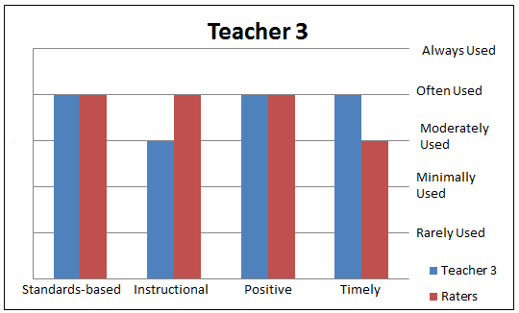

##### Figure 3. Comparison of FQR Rating and Fidelity of Use Rating for Teacher 3.

Teacher 3 received the highest ratings on the Feedback Quality Rubric, and his self-evaluation from the Fidelity of Use survey most closely aligned with the raters’ assessments. Similar to teacher 1, teacher 3 commented that he found himself providing more encouragement to adhere to due dates and finish the class than actual feedback on the students’ math.

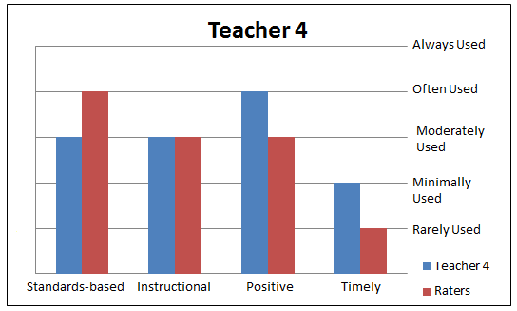

##### Figure 4. Comparison of FQR Rating and Fidelity of Use Rating for Teacher 4.

Similar to teacher 1, teacher 4 noted that his work with the online high school was not his primary job which resulted in it taking a secondary place with his time. He felt providing this type of feedback would be more realistic from teachers whose primary job was to work with online students.

#### Student Achievement

Students were instructed to complete the pretest for each unit prior to beginning the unit, though completion of the pretest was not required within the software or by the online high school. Since students were not prevented from beginning the unit without completing the pretest, some students forgot or skipped the pretest and seven students chose to skip all pretests. At the conclusion of each unit of study, students were to complete the posttest for the unit. Completion of the posttest was required for completion of the course.

Students who enrolled in a course but did not complete at least the first posttest were removed from the research sample. Six of the 52 students in the research sample were not included in analysis of the data for that reason. Five of those students had been assigned to the treatment group, and one to the control group.

Using student’s pre- and posttest scores, a mean pretest and posttest score was calculated for each student. Pretest and posttest mean scores were analyzed to confirm both variables had normal distribution around the mean. A scatter plot revealed pretest and posttest mean scores had a bivariate normal distribution and were linearly related.

Thirty-nine cases $(n=39)$ were identified, 21 from the control group and 18 from the treatment group. The rounded mean pretest score of the treatment group was $(M=54, SD=21)$ and the rounded mean pretest score of the control group was $(M=58, SD=24)$. The rounded mean posttest score of the treatment group was $(M=78, SD=10)$, and the rounded mean posttest score of the control group was $(M=79, SD=13)$.

A test of within-subjects effects produced the expected outcome that there was a significant difference between all students’ pretest and posttest scores, $F\left(1,37\right)=70.84, p<.001$.. The effect size, $η^{2}=.657,$ was large. Students’ scores improved between the pretest and posttest for each unit in their online courses. However, no significant interaction was detected with respect to group assignment and pre- and posttest scores, $F\left(1,37\right)=.56, p=.46.$ An analysis of between-subjects effects revealed that assignment to the treatment and control group had no significant effect on pre- and posttest scores, $F\left(1,37\right)=.19, p=.67$. Students who received teacher-generated feedback on formative and summative assessments, in addition to the immediate feedback provided by the CAI, had no more significant gains between their pretest and posttest scores than students who received no feedback from their instructor.

Given the significant difference in the quality of feedback provided to treatment group students, a second between-subjects variable of teacher was added to the general linear model-repeated measures model to determine whether there were significant effects or interactions between the variables of student achievement, group placement, and teacher.

A within-subjects review confirmed the previously reported significant effect of pretest and posttest, $F\left(1, 34\right)=67.38, p<.001, η^{2}=.63,$ and the lack of significant interaction between test and group assignment, $F\left(1, 34\right)=.39, p=.54$. This review revealed no significant interaction between teacher and test performance, $F\left(1, 3\right)=1.96, p=.14.$

#### Student Retention

Each student who remained in their online course, as evidenced by completion of all posttests for all required units, was labeled as ‘complete.’ Each student who dropped their online course without completing all posttests was labeled as “not complete” Six students in the study completed the first pretest but dropped before taking the first posttest and were removed from this analysis. Therefore, a sample size of $n=46$ was used, composed of 21 treatment group students and 25 control group students.

A chi square test was performed using the variables of treatment/control and complete/not complete to determine if there was a relationship between group placement and completion. The confidence interval of 95% was used to determine significance for results.

Of the 21 treatment group students, 15 completed their online course and 6 did not. Of the 25 control group students, 17 completed their online course and 8 did not. There was no statistically significant association between group membership and completion of the online math course, $χ^{2}\left(1\right)=.063, p=.801$. A phi coefficient confirmed the lack strength of the relationship $=-.037$.

Teacher 2 self-reported that he provided feedback to at least some of the control group students. To determine whether the three teachers who provided only feedback to treatment students had a different relationship between group membership and completion, cases from teacher 2 were selected out and cases from the other three teachers were compared using a chi square test resulting in a sample size of $n=29$. Of the 14 treatment group students, 8 completed their course and 6 did not. Of the 15 control group students, 8 completed their course and 7 did not. There was no statistically significant association between group membership and completion of the online math course when reviewing only cases of the three teachers who provided feedback to treatment group students exclusively, $χ^{2}\left(1\right)=.042, p=.837$.

Adherence to the effective feedback model varied between teachers for this research. The researcher sought to determine whether students’ completion of an online course could be predicted by characteristics of effective feedback. Binary logistic regression was selected to analyze the data.

The dichotomous variable selected for the regression was completion, and the predictor variables were the teachers’ mean scores for each feedback characteristic from the Feedback Quality Rubric. All treatment group students and some control group students received feedback from their teachers in this study, and therefore all students’ data were analyzed with the exception of the six students who dropped their online course prior to taking the first pretest. The sample size was $n=46$.

The Wald ratio for the coefficient of standards was not statistically significant, $χ^{2}\left(1\right)=.202, p=.653$. The Wald ratio for the coefficient of instruction was not statistically significant, $χ^{2}\left(1\right)=.803, p=.37$. The Wald ratio for the coefficient of positive was not statistically significant, $χ^{2}\left(1\right)=..619, p=.431$. No characteristic of feedback evaluated in this study made a statistically significant difference in student completion of their online self-paced math course.

### Discussion

#### Perceived and actual feedback

Students desire feedback, and online instructors believe feedback is important. Despite that, feedback in online courses is often sparse (Bransford, Brown & Cocking, 2001). Research suggests that teachers often believe they are providing students with effective feedback, while students do not believe they are receiving it (Gaytan & McEwen, 2007; Oliver et al., 2009). Lack of feedback remains a concern of online students as reported in the National Student Satisfaction Survey (Gill & Greenhow, 2008).

The results of the Fidelity of Use surveys support current research; the four teachers felt they provided students with feedback that was standards-based, instructional and positive at a noticeably higher level than the raters’ evaluations suggested. It was also apparent that none of the teachers provided feedback for every formative assessment within each unit. Discouragingly, teacher 1 provided feedback on only 7% of his students’ assessments, teacher 2 provided feedback on 21%, teacher 3 provided feedback on 40%, and teacher 4 provided feedback on 13% of student assessments. Those results are particularly concerning because the four teachers agreed to take part in the research and were aware that their feedback would be evaluated.

One possible explanation for the disconnect between perceived and actual feedback is that the teachers may not have separated their communication on pacing and encouragement from their feedback on assessments when considering their responses on the Fidelity of Use survey. Several teachers commented that many of their communications to students became ones of encouragement to stay on pace, as opposed to actual feedback on their work. Communication unrelated to feedback would have earned poor scores on the Feedback Quality Rubric, though those communications may have influenced achievement and retention.

One barrier to providing feedback noted by several of the teachers was that their work with the online students was not their primary job; their full-time positions were at site-based high schools. They found balancing a full-time job, a family and other responsibilities resulted in less time available to write the type of feedback requested, with the frequency it was requested. One teacher suggested effective feedback might come most consistently from a teacher who worked exclusively with online students.

#### Student Achievement

Analysis of the data indicated that teacher feedback made no significant difference between the achievement of students who received teacher feedback and those who did not. One possible explanation for that result is that students’ engagement with the CAI software was sufficient in improving their understanding of the mathematical concepts. Recent studies by Hannafin and Foshay (2008), Barrow et al. (2007), and Clardy (2009) have substantiated the effectiveness of CAI with respect to student achievement in math. The practice of providing additional feedback did not appear to improve that effectiveness.

An alternative explanation for the lack of difference in achievement between groups is that the feedback provided to treatment group students was not frequent or timely enough to influence achievement. Students may not have received enough feedback on formative assessments to improve their understanding in order to perform better on posttests. As well, given that teachers did not consistently provide feedback in a timely fashion, the feedback may not have been received close enough in time to the assessment to impact their posttest performance.

#### Student Retention

Incidence of non-completion of online courses has been well documented in the literature, with some reports indicating dropout rates as high as 40-70% (Roblyer et al., 2008). It may be unsurprising that courses based on students’ ability to self-pace often have a higher incidence of dropout than those that are paced by the teacher (Hannum et al., 2008). Separated by group, 32% of control group students dropped their course and 29% of treatment group students dropped their course. Those attrition rates are consistent with current research. There was no significant difference between the completion rate of the treatment group compared to the control group.

Retention did not appear related to the degree to which the four teachers adhered to the effective feedback model. Teacher 3, who most closely adhered, did not have a higher incidence of students who were retained than any other teacher. In fact, the teacher who adhered least closely to the feedback model had a higher rate of completion than did the teacher who adhered the most closely.

One possible explanation for these results is that treatment group students received limited teacher-generated feedback on their work, with some students receiving feedback on as few as 7% of assessments and no student receiving feedback on more than 40% of assessments. The treatment of feedback may not have been applied with enough frequency or substance to influence student retention.

### Implications and Directions for Future Research

Based on the findings of this research, several areas of study have been brought to light. First and foremost, this research should be replicated to support or refute the findings, with teachers who strictly adhere to the effective feedback model and provide feedback on all formative and summative assessments. Until that time, no conclusions should be drawn regarding the effectiveness of teacher-generated feedback in online secondary courses where computer-assisted instruction is embedded.

Feedback communication from the four teachers in this study often included comments that attempted to assist students with pacing. For example, “I see you’ve hit a rough spot of logging in and completing activities….please, please try to set 45-60 minutes PER DAY aside to work on the Alg. II material in order to be successful in learning it AND finishing on time (22 of December, less than a month away).” (Teacher 3, personal communication, November 29, 2011). This type of communication lets the student know the teacher is aware of his progress, and may prompt students to stay on track for completion. Additional research regarding teacher communication and pacing may lead to pedagogical strategies that improve retention.

This research explored feedback communication, with a focus on using specific characteristics of feedback within the communication. Current research suggests that increased communication between the teacher and student results in improved achievement and retention. Specific types of communication should be examined to determine if one type of communication leads to improved outcomes over types of communications.

The teachers in this study reported that their work with the online high school was a supplement to their full-time positions, and that they did not have enough time to devote to providing feedback to their online students. Future research should explore teacher performance factors between teachers whose primary position is teaching online for the institution and teachers who are teaching part-time with adjunct status. Teachers whose sole responsibility is with online students may provide feedback more frequently and with greater substance, which may influence students’ achievement and retention.

### Conclusion

What is the teacher’s role in online self-paced classes that use CAI? How should a teacher’s time be spent in those classes to produce the best student outcomes? This research attempted to contribute evidence to answer those questions. Unfortunately the research only served to confirm that many teachers overestimate both the quality and quantity of feedback that they provide to their online students. Given the minimal amount of feedback students received on formative and summative assessments, it is unsurprising that there was no significant difference in outcomes of achievement or retention. Further research must continue to define pedagogical strategies, including that of providing teacher-generated feedback, that result in improved student outcomes in online secondary self-paced courses that use computer-assisted instruction.

### References

Barrow, L., Markman, L., Rouse, C., & Federal Reserve Bank of Chicago (2007). Technology's edge: The educational benefits of computer-aided instruction. WP 2007-17. *Federal Reserve Bank of Chicago*

Bocchi, J., Eastman, J., & Swift, C. (2004). Retaining the online learner: profile of students in an online MBA program and implications for teaching them. *Journal of Education for Business*, *79*(4), 245-253.

Bransford, J., Brown, A., & Cocking, R. (Eds.). (2001). *How people learn: Brain, mind,* *experience, and school*. Washington, DC: National Research Council

Cavanaugh, C., Gillan, K., Bosnick, J., Hess, M., & Scott, H. (2008). Effectiveness of interactive online algebra learning tools. *Journal of Educational Computing Research*, *38*(1), 67-95.

Chyung, Y., Winiecki, D., & Fenner, J. (1998). A case study: Increase enrollment by reducing dropout rates in adult distance education. Proceedings of the Annual Conference on Distance Teaching & Learning, Madison, WI.

Clardy, A. (2009). Distant, on-line education: Effects, principles and practices. Retrieved from ERIC database. (ED506182)

Dennen, V., Darabi, A., & Smith, L.. (2007). Instructor-learner interaction in online courses: The relative perceived importance of particular instructor actions on performance and satisfaction. *Distance Education, 28*(1), 65-79.

Fredrickson, E., Pickett, A., Shea, P., Pelz, W., & Swan, K. (2000). Student satisfaction and perceived learning with on-line courses: Principles and examples for the SUNY Learning Network. *Journal of Asynchronous Learning Networks, 4*(2).

Gaytan, J. &  McEwen, B.. (2007). Effective online instructional and assessment strategies. *The American Journal of Distance Education, 21*(3), 117-132.

Gill, M., & Greenhow, M. (2008). How effective is feedback in computer-aided assessments?. *Learning, Media and Technology*, *33*(3), 207-220.

Hannafin, R., & Foshay, W. (2008). Computer-based instruction's (CBI) rediscovered role in K-12: An evaluation case study of one high school's use of CBI to improve pass rates on high-stakes tests. *Educational Technology Research and Development*, *56*(2), 147-160.

Hannum, W., Irvin, M. Lei, P., & Farmer, T. (2008). Effectiveness of using learner-centered principles on student retention in distance education courses in rural schools. *Distance Education*, *29*(3), 211-229.

Hattie, J. (2003). Distinguishing expert teachers from novice and experienced teachers. Australian Council for Educational Research. Retrieved from <http://www.acer.edu.au/documents/Hattie_TeachersMakeADifference.pdf>

Hattie, J., & Timperley, H. (2007, January 1). The power of feedback. *Review of Educational Research*, *77*(1), 81-112. Retrieved from http://rer.sagepub.com/content/77/1/81.full.pdf+html.

International Association for K-12 Online Learning. (2007). *National standards for quality online teaching*. Retrieved from <http://www.inacol.org/research/nationalstandards/NACOL%20Standards%20Quality%20Online%20Teaching.pdf>

Means, B., Toyama, Y., Murphy, R., Bakia, M., Jones, K., Department of Education (ED), et al. (2009). Evaluation of evidence-based practices in online learning: A meta-analysis and review of online learning studies. *US Department of Education*, Retrieved from ERIC database.

Muilenburg, L., & Berge, Z. (2005). Student barriers to online learning: A factor analytic study. *Distance Education*, *26*(1), 29-48.

Nagel, D. (2011, January 20). Prek-12 dominates growth in e-learning. *THE Journal*. Retrieved from http://thejournal.com/articles/2011/01/20/prek12-dominates-growth-in-e-learning.aspx

Oliver, K., Osborne, J., & Brady, K.. (2009). What are secondary students' expectations for teachers in virtual school environments? Distance Education, 30(1), 23-45.

Picciano, A., & Seaman, J. (2009, January). *K-12 online learning: A 2008 follow-up of the survey of U.S. school district administrators*. Retrieved from The Sloan Consortium website: <http://www.sloanconsortium.org/publications/survey/pdf/k-12_online_learning_2008.pdf>

Project Tomorrow. (2009). Learning in the 21st century: 2009 trends update. Retrieved from <http://www.blackboard.com/resources/k12/Bb_K12_09_TrendsUpdate.pdf>

Rice, K. (2006). A comprehensive look at distance education in the K-12 context. *Journal of Research on Technology in Education*, *38*(4), 425-448.

Roblyer, M., Davis, L., Mills, S., Marshall, J., & Pape, L. (2008). Toward practical procedures for predicting and promoting success in virtual school students. *American Journal of Distance Education*, *22*(2), 90-109.

Roblyer, M. & Wiencke, W. (2004). Exploring the interaction equation: Validating a rubric to assess and encourage interaction in distance courses. Journal of Asynchronous Learning Networks,8(4), 25-36.

Travers, Nan L., and Barry G. Sheckley. 2000. Changes in students' self-regulation based on different teaching methodologies. Journal of College Student Retention, 2(4), 295-311.

U.S. Department of Education, (2004). Toward a new golden age in american education: How the internet, the law, and today's students are revolutionizing expectations. *US Department of Education*.

Watson, J., & North Central Regional Educational Lab., N. (2005). Keeping pace with K-12 online learning: A review of state-level policy and practice. *Learning Point Associates / North Central Regional Educational Laboratory (NCREL)*, Retrieved from http://www.eric.ed.gov/PDFS/ED489514.pdf

Weiner, C. (2003). Key ingredients to online learning: Adolescent students study in cyberspace-the nature of the study. International Journal on E-Learning, 2(3) 44-50.

##### Appendix A

# Fidelity of Use Survey

Please answer the following questions honestly. Your responses will not be used in any evaluation of your teaching or performance. Rate your consistent use of the following characteristics of effective feedback. Select a 1 if you never wrote feedback that included a characteristic, to a 5 if you always wrote feedback that included a characteristic.

Teacher Identification Number: _____

Feedback was standards-based. Feedback indicated to students their progress toward the learning outcomes for the lesson or unit.

1 2 3 4 5   
Never used Always used

Feedback was instructional. Feedback provided to students some form of instruction in the areas students demonstrated as weakness.

1 2 3 4 5   
Never used Always used

Feedback was positive. Feedback was phrased in an encouraging manner, offering motivation to students. Positive feedback specifically identified areas of students’ strength, while avoiding false and general praise.

1 2 3 4 5   
Never used Always used

Feedback was timely. Feedback on formative assessment was provided to students within 48 hours of submission, and feedback on summative assessment was provided to students within 7 days of submission.

1 2 3 4 5   
Never used Always used

Please respond to the following three short answer questions.

1. If you were unable to strictly adhere to the effective teacher-generated feedback model, what prevented you from doing so?

1. Did the quality of your feedback change from the beginning of a class to the end of a class? Why or why not?

1. Please share any other comments you would like about your use of effective feedback.

Return to Table of Contents

##### Appendix B

# Feedback Quality Rubric

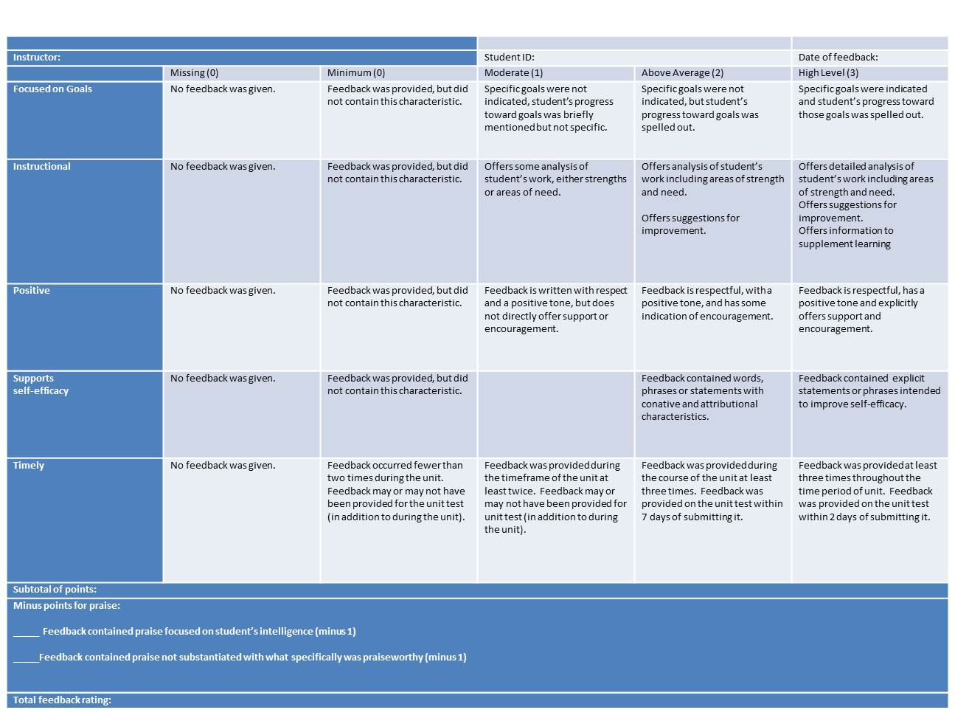

About the Author

|  |  |
| --- | --- |
|  | **Rebecca Hoey** Ed.D. is the Director of Online Learning at Northwestern College, Iowa. Her research interests are teacher effectiveness in online learning, pedagogical practices specific to the success of different types of online learners, and mentoring and coaching strategies to support new online teachers.  [rebecca.hoey@nwciowa.edu](mailto:rebecca.hoey@nwciowa.edu) |

Return to Table of Contents

**Editor’s Note**: This is a thoughtful study to initiate the dialog about which tools to use, their intended purpose and value, how they are perceived by faculty and students, and their relative value in different learning situations.

# Understanding the Pedagogies of Blogs, Wikis and Discussion Boards

##### Hani A. Weshah

##### Jordan

### Abstract

The purpose of this research is twofold. The first was to describe the researcher’s and students’ experience of accessing and using new technologies as educational tools blended with face-to-face contact to teach a class in a teacher education program at the University of Jordan. The second was to consider the ideas and insights instigated from this research, pertinent literature, learning theories and educational policy to better understand the pedagogies of these tools for integrating them in the K-12 education. The findings highlight the fact that the researcher found these tools to be useful for reflection and knowledge sharing and construction, whereas students perceived this approach effectively in terms of learning and teaching practice. The implications of the findings and the literature on Web 2.0 technologies offer support for the potential use in K-12 Education. However, their successful implementation needs to consider other factors that are discussed.

**Keywords**: Web 2.0 technology, blogs, wikis, discussion boards, e-learning, higher education, policy and practice.

### Introduction

Using online technology to support teaching and learning has undergone significant change in the last two decades. Farmer., Yue, & Brooks, (2008); Blanchard & Marshall, (2004); Crane (2009); Adams and McCrindle, (2008); O’Reilly (2007) indicated that developments in Information Communication Technology (ICT) have provided educational practitioners with a wide range of new technologies that can be used to enhance teaching and learning practices. There are many to choose from. However, this research has focused on the blogs, wikis and discussion boards; henceforth (Db).

According to (Achterman, 2006; Godwin-Jones, 2003; Ray, 2006), these new technologies have the potential to be used as a communication means, collaborative tools, and instructional resources in educational environments (Farmer, Yue and Brooks, 2008; Tekinarslan, 2008). It is claimed that the access and use of these new technologies is a useful practice for the development of higher order thinking skills, learner centered pedagogy, active and authentic learning, associative thinking, and interactive learning communities (O'Donnell, 2006; Farmer, Yue and Brooks, 2008).

As social software technologies, the popularization of wikis, blogs, and Dbs has led to the idea of e-learning. To define the term, e-learning was proposed to represent the use of the Internet as a platform for communication, collaboration and knowledge sharing and construction rather than the distribution of content (Downes, 2005; Robertson, 2008). This promotion has generally supported the notion of constructivism as a preferred learning approach (Bonk & Dennen, 2007; Juwah, 2006; Richardson, 2009).

Drawing on the social constructivist learning theories of Vygotski, Ferdig and Trammell (2004) usefully explicates the four central pedagogic benefits of blogging for students:

1. Assisting students to become subject matter experts through a process of regular scouring, filtering and posting.
2. Increasing student interest and ownership in learning.
3. Giving students legitimate chances for participation and enculturation them into a community of practice.
4. Providing learning opportunities for diverse perspectives   
   (Farmer, Yue, & Brooks, 2008, pp. 123-124).

The term web-log, or blog, was coined by Jorn Barger in 1997. It refers to a website powered by a software that simplifies publishing, organizing, and syndicating a web containing regular entries of commentary, descriptions of events, or other material such as graphics, videos or links, called posts. Entries are commonly displayed in a reverse chronological order (Doctorow et al., 2002; Crane, 2009). A weblog is frequently updated with new information about a particular subject or a range of subjects. It is all about engaging with the content and with the authors of what they have read reflecting, criticizing, questioning, and reacting (Crane 2009; Godwin-Jones, 2003; Guenther, 2005; Barlow, 2007; Winer, 2003; Oravec, 2003; Blood; 2000; Herring et al, 2005; Papacharissi, 2006).

According to Leuf and Cunningham (2001), creators of the original wiki concept, “a wiki is a freely expandable collection of interlinked webpages, a hypertext system for storing and modifying information – a database, where each page is easily edited by any user with a forms-capable Web browser client” (p. 14). It is possible to incorporate the text, audio, images, video and hyperlinks to other web pages (Robertson, 2008).

The difference between a wiki and a blog is that while members of the blog can comment on a post, no one is able to change a comment or post made by another. Blogs are a good forum for individuals to express their own opinions. Wikis, on the other hand, have a more open structure and allow others to change what one person has written. In fact, group consensus may override the individual opinion. Students can use wikis to create a set of documents that reflect the shared knowledge of the learning group, and gain insights. Wikis can also be used to facilitate the dissemination of information and group interaction, and enable the exchange of ideas.

Dbs, discussion forums, bulletin boards, and message boards typically refer to the same type of system. A discussion board is an asynchronous communication tool that allows one individual to post an idea, comment or question online. Other individuals who are members of the same discussion board may read that idea, comment, question, and respond with their own remarks over time. For example, if one individual posts a question, and three others post answers to that question, these four "posts" comprise what is known as a "thread" of conversation. The phrase, "threaded discussion board" is common, referring to threads of conversation, each focused on a particular topic; for instance: How student learn?. (Connell, 2005)

### Literature review

The literature on higher education indicates that collaborative learning is considered as an effectivelearning technique in both undergraduate and graduate levels. According to Barkley, Cross and Major (2005), for example, research findings demonstrate that collaboration promotes and improves learning (Tekinarslan, 2008; Robertson, 2008; Elgort et al, 2008; Farmer et al, 2008), and is an important role in academic achievement, personal development and student satisfaction (Fuchs-Kittowski & Kohler, 2002).

Blogs, wikis and Dbs technologies are considered as a medium to support collaborative learning by making it possible for individuals to contribute towards joint assessed outcomes (Elgort et al, 2008). The potential of wikis to support collaborative learning is often received with a high level of optimism. For example, ‘wikis are an excellent tool for collaboration in an online environment’ (Augar et al., 2004, abstract), ‘the efficacy of wikis is self evident (Choy & Ng, 2007, p.209), and ‘we now have access to an enabling suite of tools to support greater learner choice and self direction’ (McLoughlin & Lee, 2007, p.710). However, this potential has not been realized yet (Schwartz, Clark, Cossarin, & Rudolph, 2004)

In preparing this report, a search was conducted of major educational databases using the terms: web 2.0 technology, blogs, wikis, discussion boards, e-learning, higher education, policy, and practice. The researcher came across publications, which broadly fall into the categories of promotion, description, technical matters and declarations about the future use of wikis (Robertson, 2008). Other concerns were associated with the implementation of wikis, blogs, and Dbs technologies as a supplement to support a distance learning programs (Choy & Ng, 2007).

Given the rapidly changing nature of the use of technology in education, a search of publication in international peer reviewed journals has provided indication that little empirical research from the learners' perspective have been conducted. This paucity of refereed literature is also found in the case of blogs and Dbs as well (Williams & Jacobs, 2004; Connell, 2005; Kennedy et al., 2008; Robertson, 2008).

Connell (2004) indicated that a search in the literature on the social software shows that it is a technological development in its formative years which is promising for education and the community. Nevertheless, it is difficult to keep track of the available technologies due to the fact that they develop rapidly. What is important for the implementation of these technologies in education is to choose the appropriate one which fits the educational context and can be best used (Longhurst & Sandage, 2004)

However, "determining what is appropriate can be a daunting task" (Connell, 2004. p. 1).

Several researchers indicated that using new technologies; wikis, blogs and Dbs by educators for publishing course descriptions and syllabi on the Internet, for building professional development communities and sharing student work is not as yet widespread. They pointed out that weblogs can be used for enhancing students’ critical thinking, literacy skills, and ability to use the Internet for research purposes. New technologies allow for instant publishing, sharing, and collaboration among multiple students in a format that can be used in a variety of situations and subjects. Educators have also found a variety of creative applications for the wiki format based on a constructivist foundation including: quick informational website publishing, collaborative website posting, student assignments with peer review capabilities, problem solving, focused discussions, interdisciplinary projects, community building among students, and collaboration practice (Connell, 2005; Kennedy, 2003; Oravec, 2003; Weller, 2003).

Although the use of the wikis, blogs and Dbs has become widely recognized worldwide, the adoption of these tools in Jordan has not been supported. Moreover, these tools are not widely understood by educators. Additionally, the progress in using them has been moving at a slower pace due to budget, understanding, and intellectual property questions, (Gurak & Duin, 2004) as well as human factors like the lack of time or motivation to learn about new software (Wrede, 2003).

### Rationale

The origins, benefits and advantages of problem-based learning (Savin-Baden & Howell Major, 2004; Uden & Beaumont, 2006) and group based learning (Palloff & Pratt, 2005; A. Rogers, 2002) have been extensively considered by others. The research reported here was conducted in the context of a blended learning approach that incorporates blogs, wikis, and Dbs technology and face to face contact to teach small-cohort of graduate students ina curriculum planning course at the University of Jordan.

The analysis of the researcher’s and students’ experiences of the access to and the use of new technologies in teaching practice are also reported. However, the primary focus of the present study is on the possibility and requirements of the potential implementation of these tools in K-12 education taking into consideration that all of the participants were school teachers and that facilitated having the full picture of what really goes on in our schools and how this potential use might develop our teaching practices.

Additionally, this paper supports the argument related to the educational use of blogging in order to add knowledge, fill the research gap of the pedagogies of new technologies, and encourage using blogs in K-12 education.

Several researchers (e.g. Achterman, 2006; Godwin-Jones, 2003; Williams & Jacobs, 2004; Ray, 2006) assured that web-logs tools have a considerable potential for educational purposes. Besides, Bower et al. (2006) also underscored the importance of the collaborative and authentic learning of tasks.

Research that addresses pedagogical benefits from using new technologies to share and construct knowledge collaboratively, however, is still rather limited. The present research aims to further contribute to the body of evidence on the potential use of Web 2.0 technologies in K-12 classrooms.

### Context of the study

Weblogs experiences of the researcher and his group of graduate students were investigated in a 3 credit hour course named Curriculum Planning. The course was given during 2011 second semester in the Faculty of Education at the University of Jordan. Students were taught by using Web 2.0 technologies including blogs, wikis and Dbs blended with face-to-face contact during the course.

Curriculum planning Course is an obligatory course on the Master's of Education program; a graduate professional educational qualification that is usually taken on full time basis. The course is taught in a blended face-to-face teaching on campus; students meet for three hours per week. This course is designed to meet the needs of participants from all sectors of education and training including primary, secondary, and university educators. The course provides an opportunity for participants to examine curriculum theories, models, assumptions, concepts and issues and their application in curriculum planning. It is hoped that this course will lead to provoking thinking in creative resolutions for the issues discussed.

The class usually meets as a seminar in which students were active participants in the presentation and discussion of course materials. This course was based on the belief that learning takes place both singly and in concert with others, while much of what we know was learned from our own reading, writing, and reflection. Knowledge is also gained from observing and talking with others. Accordingly, students’ final grades depend on the satisfactory preparing for and participating in face-to-face in and outside (online) class discussions. Therefore, at the end of the course, students are expected to be able to demonstrate the following objectives:

1. Critically understand major theories of curriculum planning and their application in a range of contexts.
2. Select, apply and review a range of curriculum planning principles to suit the needs of learners of a range of contexts.
3. Select, apply and review a range of planning principles to suit the needs of the workplace.
4. Actively engage in contemporary discussions about curriculum planning in a range of contexts.
5. Develop, edit, and report their own content for their blogs, wikis and discussion board through the University of Jordan online resources. In order to achieve the course objectives, students were given assignments and expected to engage in the following types of assessment practices:

**Face-to-face class participation (10%).** Student participation in class discussion was evaluated by three criteria: 1) contributions to other students' learning, 2) clarity and originality of the student's contributions, and 3) willingness to assume responsibility for making class discussions work. Each student gets 1% towards his/her grade for each week s/he attends class and contributes in both small and large group scenarios.

**Reflective journals/blogs (10%).** Students were responsible for writing weekly reflective journals of the assigned readings and internet resources, and upload a blog in Blackboard by using the University of Jordan Website system. These journals (300- 500 words or 1-2 pages equivalent) should explore the central themes of the literature including: the structure, context, research questions, and the development of the work. They should also carefully examine the methods, analyses, interpretations, and compositions, paying close attention to both the theoretical and practical dimensions of the themes, issues and models. These weekly Journals must be uploaded and monitored by the lecturer as evidence of reflective thinking outside of class. Students will use the weekly journal as a part of small group discussion. A student receives 1% for evidence each of the 10 weeks that a journal or blog is brought to class.

**Class interaction-remote-electronic: Wikis and discussion boards (10%).** Each student was required to participate (to respond to or to add wiki and discussion board a minimum of one entry per week) outside the class to develop new knowledge pertinent to course topics. (10%) wasdetermined by academic discussion and the constructive contribution s/he made to group learning in a flexible environment throwing knowledge questions for brain storming, thinking/provoking around theoretical concepts, models or issues and sharing others’ knowledge by using Wikis and Discussion Boards. Student participation evaluated by the same criteria of face-to-face class participation. Assessment has been based on the quality of discussion and learning outcomes. Adding posts shows that the student is proactive and has thought about the literature and is keen on getting other students involved in discussion as well as stimulating learning among group members.

**Adding to Existing Knowledge (10%).**  5% is for adding posts and content of posts (contributing new knowledge and construction of to the discussion); 5% is for responding to students post and the quality of content (adding to existing knowledge); (academic referencing and critical analysis)

#### Assessment 1 (15%)

**Outcome**: Students demonstrate personal application of knowledge in the workplace and in his or her professional life. This does not only mean to summarize what they read, but also aimed at showing what changes out of their readings they can make in their workplace via the implementation of knowledge. (APA) standard is the adopted referencing style. This could lead to the identification of needs and hence ownership of how to further development of knowledge and skills. 15% is devoted for critical analysis; what is their own interpretation, opinion, or definitions of the theories, strategies of data collection and analysis of how to adapt to workplace.

#### Assessment 2 (15%)

**Outcome:** after three weeks, each student should handle an approximately 1500-word essay which includes an introduction , a body, and a conclusion. The topic of the essay has been discussed in the previous three weeks. The essay should highlight the application of knowledge in the workplace, the description of the issues expressed in the read studies, the way students deal with these issues that they have learned through the readings. The 15% is devoted for documentation using (APA) standard and for the active application of knowledge to produce qualitative outcomes via the implementation of curriculum planning theories in their institutions.

#### Assessment 3: Workplace Essay (30%).

Students have had the choice either to individually write a 2500-word assignment or a 4500-word group assignment; each group consisting of two or three. The assignment should be a case study demonstrating a thorough understanding of the theories learnt throughout the semester. It also should provide an example of an issue that exists in their workplace and how to deal with it using various theories learnt in the course. This should demonstrate that students have taken the theories and learnt and demonstrated the ability to practically apply them in a real life scenario as change agents.

Students were also asked to write one-page proposal to be submitted and to be matched up with students who have similar interests. The paper should include a wide variety of primary and secondary sources.

The paper was given a grade based on the clarity of writing, the degree to which it demonstrates an understanding of the topic and its context, and the way in which it synthesizes insights from inside and outside class. The students who have been matched with acted as peer reviewers to discuss the topic with.

Assessment 4: class presentation (10%): ***each individual or group was expected to provide a*** formal presentation to the class using a PowerPoint presentation. Individual presentations lasted for 10 minutes and group presentations for 15 minutes. Presentations were run over the final two weeks of the semester. The presentations were expected to cover: the understanding of theories, identification of issues in the workplace, suggested resolutions, the expected outcomes or benefits for the organization from the resolutions and motivation to take the theories and bring them to life in their real world situations.

### Methodology

A case study approach was implemented to gain an in-depth understanding of the pedagogies of new technologies including blogs, wikis and Dbs blended with face-to-face classroom approach. Qualitative methods were used to collect data from observation of students' activities when working on new technologies, analyses of students' documents on the blogs, in addition to students’ course experience survey (Denzin, 1989).

#### Participants

In this research, the participants were 18 graduate students (i.e. 12 female and 6 male) doing their Masters in education at the university of Jordan. All of them took the obligatory curriculum planning course.

#### Data collection

A case study formed the methodological framework of this investigation (Yin, 2009). This approach incorporated a number of data gathering techniques including the participant's observation to analyze the experience of a researcher and School of Education students with Web 2.0 technologies, documents analysis and students’ course experience survey. In addition, the researcher was able to write anecdotal segments of the collaborative process involved in the construction of the blogs, Wikis, Dbs and face-to-face class meetings at its various stages, using the history feature of the tools. In this course students were also required to keep online reflective journals as blogs on the blackboard, which provided an insight into their perceptions of the collaborative processes.

#### Participants' observation

The researcher was the instructor for the course in which graduate students were taught by using educational applications of Web 2.0 technologies including blogs, Wikis and Dbs. Students learned how to use the IT system to create and examine various applications on the website. They were required to build up their own blogs, Wikis, and Dbs with course content. The researcher recorded formative notes about students' activities both while the students were face-to-face in class and working on their assignments as well.

#### Document analysis

The documents analysis, which were created by students, comprised blogs, Wikis and Dbs. Students communicated with the instructor about the contents through e-mail and assignments' contents were based on predetermined criteria.

#### Course Experience Survey

The course experience survey is designed to capture the feedback about student learning experience within the higher education courses. The survey is anonymous, electronically administered by the researcher to students at the end of the course, so that no individual responses are identified. Students’ responses to survey statements and the written comments are returned to researcher for feedback. The survey consists of two sections: the first one includes 21 statements questioning about thestudent experience in this course; 2 are about learning objectives, 4 are about the learning resources, 3 are about computer-based teaching, 3 areabout linking theory into practice, 5 are about teaching behavior, 2 are about learning environment, 1 is about assessment tasks, and 1 is about the overall quality of teaching and learning in this class. The second section includes two open ended questions to elicit students’ perceptions of course experience about the best aspects of the course and the aspects of the course that needs improvement.

The feedback includes written notes on submitted work; general comment on the standard of work of the whole group studying this course; personal communication with teaching staff and student performance, or activities assessed in classes.

Web-based (online) materials are information that student access using the University of Jordan network or the internet. It includes lecture notes, tutorial guides and learning aids like text, diagrams, animation and feedback documents. Computer-based teaching materials include learning aids such as specialized software, or CD-ROM computer simulation used at home or in a computer laboratory. Triangulation of data from the above sources (participant observation, document analysis and course experience survey was applied to gain reliability and better results (Yin, 2009).

#### Data analysis procedures

The data were analyzed during 2011 second semester. Initially, the researcher printed out the collected data including blogs, Wikis and Dbs documents, class participation, and course experience survey responses and assigned pseudonyms to the participants. Then, a category construction approach comprising organization of the data sources, reduction of the text, and generation of conceptual categories by coding units of the data was applied in order to analyze the printed data (Bogdan & Biklen, 1992). Specifically, when reading the data, the researcher assigned coding categories as codes (e.g. researcher observations, students’ course experiences survey and literature review pertinent to new technologies) to the units of data. Unrelated data were eliminated during the coding process. After that, the coded data were placed in folders under the appropriate categories (Yin, 2009). The findings were reported based on the categories generated during the analysis of data.

### Implementation

Curriculum planning Course is an obligatory course on the Master's of Education program; a graduate professional educational qualification that is usually taken on full time basis.

The course is taught in a blended face-to-face teaching on campus; students meet for three hours per week. The researcher assigned readings from the field of curriculum planning, such as curriculum theories, concepts, models and issues. The instructional material was produced from a variety of academic resources pertinent to course content and uploaded in a blackboard for students.

Students were asked to post blogs regularly-reflective journal once a week-with at least 300-500 words -from the assigned readings and to interact with other students’ through Wikis and Dbs in the subject benefiting from the internet resources (e.g. books, electronic journals, websites, etc.) and the University of Jordan library resources as well to enrich the content of their reflective journals, class and online participation throughout the second semester 2011 with appropriate citations and references. Students can work together outside the class and during face-to-face teaching hours in a supportive environment.

Guidelines and a set of criteria were determined for marking these learning activities, they included frequency and consistency of activity; reference and demonstrated knowledge of course content; active engagement with the ideas of other students; and, appropriate use of supportive and/or illustrative material.

The scheduled face-to-face sessions were primarily to meet in class, discuss and make progress on theories, models and issues in curriculum planning. Contributions of Blogs, Wikis and Dbs should be completed outside the scheduled class time, students are instructed to consider and identify further information that is required on a weekly basis to provide the additional information that they require.

The above mentioned activities were designed to assist learners to conceptualize and articulate the principles that underpin workplace learning, engage in relevant issues in curriculum planning, and to provide a set of practical strategies to engage in workplace teaching and learning. The first ten sessions were conducted as lecture and group based learning. They aimed to provide exposure to a range of theories, models and discussions about workplace learning. This part of the course is assessed using an individual written assignment which forms 60% of the total mark for the course including blogs, wikis, discussion boards, assessment 1 & 2, and face-to-face meetings. The remaining 2 sessions involve individual and/or group presentations focused on case examples designed to represent the complexity of workplace learning environments. Given the knowledge of workplace learning that students bring to the course and understandings developed in the first few sessions, each student is required to develop an essay 30% and presentation 10%. These assignments form 40% of the total mark for the course.

Although students taking this course have basic skills of ICT through previous courses, a one hour briefing session was conducted with the whole student cohort to preview the software and to outline the overall objectives and expected learner outcomes of the course. This was followed by additional information sessions in tutorial class to provide students with a briefing on how to access and use the blogs, wikis and Dbs technologies conducted at the commencement of the semester through IT services.

To offer guidance to students, the researcher actively engaged with student blogs, wikis and Dbs through the system's comments function. Periodic online feedback during the face-to-face sessions was offered weekly tutorials to overcome any issues or problems that arose for students in their use of the blogging system

The assignments were marked using the University of Jordan platform as well as demonstrating knowledge, and for the quality of synthesizing the materials sourced from academic resources. It was important that the blogs, wiki and Dbs were designed as one cohesive site, and that it showed evidence of collaboration*,* rather than appearing to be the work of separate individuals. Reflective journals marked individually, but wikis and Dbs, one mark were awarded to anyone of the group members who contribute only.

On completion the submitted reports, an individual and/or group marks were calculated on the basis of quality content and presentation and modified according to individual contributions and awarded a final grade based on the following scale:

A= 80 - 100, B+ = 70 - 79, B= 60 - 69, Pass = 50 – 59, and Fail = 0 – 49.

Because the blogging activity was assessable, students were informed that Wikis, blogs and Dbs using the university's Learning Management System, Blackboard as a support tool for working collaboratively on a group and individual assignments and to ensure maximum security, so that only group members and the researcher can comment and or edit the students’ assignments.

While students have little knowledge and control over the way their course websites are configured in a Blackboard course website, full compatibility with the University’s IT services, and optimal administrative flexibility. For example, the page history features of the blogs, wikis and Dbs environment that details individual student contributions.

### Findings

#### Researcher’s experience with blogs, wikis and discussion boards

Consistent with the case study approach advocated by Yin (2009), a range of evaluation methods have been used to monitor and reflect upon the learning effects and outcomes of the blended approach Web 2.0 applications with face-to-face content. The blogs, Wikis and Dbs were displayed on the blackboard to be viewed and edited by the researcher online frequently through the administrative function tools of the University of Jordan Web-based system. The researcher and students have taken the advantages of these tools to upload, find and respond to group members as well as to search and find less frequently viewed or updated blogs, wikis and Dbs. The system was set up to only allow users to log in to upload, read and comment on blogs, Wikis and Dbs. Given these capabilities, findings were sorted by each of the following themes:

Class interaction (face-to-face)

Online observation and reflective comments maintained by the researcher.

Content analysis of online blogs, wiki, and Dbs.

#### Course experience survey feedback.

The data collection methods have included: statistical calculation of averages number of frequencies of using blogs, wikis, and Dbs as offered by the University of Jordan blogging software. The following provides findings as sourced through the above combination of data collection methods.

Over the 10-week period, students were expected to make one entry of blog contribution per week. 2% per week was awarded to those students who attended classes, participated and brought evidence of their learning at home by means of a blog. (2% = 1% is for evidence – blog/journal and 1% is for group discussion and contribution) 10 weeks= 20%

88% of the enrolled students attended classes and 84% of the enrolled students wrote at least 7 reflective journals. However, 85% of the students blogged with sufficient consistency and/or quality to meet the assessment criteria. The average number of journals was 8 out of 10 with the highest number of comments for students 52 comments. The lowest number of blogs was 4

Over the 10-week period, students were required to respond to or add a wiki and discussion board entry per week (minimum of one entry per week)

Assessment – 10% and was determined by academic discussion and the constructive contribution he/she has made to group learning in a flexible learning environment.

Adding posts (show that they were proactive and have thought about the literature and were keen on getting other students involved in discussion as well as stimulating learning among group members)

10% = 5% is for adding posts and content of posts (contributing new knowledge and construction of to the discussion); 5% is for responding to students post and the quality of content (adding to existing knowledge); academic referencing and critical analysis: 83% of students contributed at least with one wiki and Dbs. 47% the average mean of contributions; entries and responses. And 41% of students poorly visited Dbs; less than 5 contributions.

#### Student-student interaction

This interaction was a goal of the wikis and Dbs activities. Commenting on other student’s entries was a requirement for assessment. The number and quality of comments of the wikis and Dbs entries seems to be a greater readiness to respond to each other (reactive) rather than to make entries (proactive).

Students were formally rewarded for the number of comments on their blogs, wikis and Dbs even if there were quality differences. Observation reveals changing patterns of communication over time as students interact with each other.

Most students developed their blogs, and citing the online and written resources in accordance with APA citation style.

Students, who reflected on blogs features, were found to be friendly program user, and convenience for submitting assignments electronically through the University of Jordan website templates. This process does not take so much time. Students also did not have any significant difficulties when learning how to create their blogs, Wikis and Dbs on the website.

The students reflected that writing in blog environments positively contributed to their writing skills in terms of preparing and referencing or citation (n=18). Their skills in searching the related online literature for preparing blogs content also enhanced and encouraged to take greater responsibility for preparing better assignments. A few received feedback and proper examples from the instructor.

The researcher found that using blogs, wikis and Dbsmotivating students to work on their assignment. Another advantage of using them is that it also had a detailed audit trail which was very helpful in marking the assessment. It provides useful concrete evidence of individual student contributions and also to get an overview of the proportion of work done by each student on the whole wiki and Db sites.

From the researcher’s point of view, the use of blogs, wikis, Dbs helped students in achieving the course objectives, and there was little discernable difference in their success in achieving the course objectives. One of the indicators of the effectiveness of the new technologies used in the course was that the average marks for the group on assessment 1 and 2 (blogs outcomes), 3 Workplace Essay and 4 class presentation

#### Assessment 1.

Allof the enrolled students submitted their essays. The average of students marks was 87%

#### Assessment 2.

Allof the enrolled students submitted their essays. The average of students’ marks was 79%

#### Assessment 3 Workplace Essay.

Allof the enrolled students submitted their essays. The average of students marks was 76%. Out of 30, the range of students’ marks was 18 – 25

#### Assessmen 4 class presentation.

Allof the enrolled students presented their case studies individually and in groups. Out of 10, the range of students’ marks was 7 – 8; 75%

#### Final grades (Results of students achievement)

On completion the submitted reports, an individual and/or group marks were calculated on the basis of quality content and presentation and modified according to individual contributions and awarded a final grade based on the following scale:

(A) 80 – 100 8 students 45%,

(B+) 70 – 79 6 students 33%

(B) 60 - 69, 4 students 22%

Pass 50 – 59 None

Fail 0 – 49 None

This was also reflected in the comments of students’ course experience survey.

The researcher believes that using blogs, wikis and Dbs had an advantage by having students concentrated on the course objectives rather than on the technical issues of blogs, wikis and Dbs. Although using these tools not require technical knowledge,Wiki software was easy to access, use and update. On the other hand,students reported that blogging regularly motivated them to study the assigned readings, reflect connect and apply into workplace, understand the course content, and to make connections. Having access to and using blogs, wikis and Dbs where previous edits can be tracked, and replaced, students found that also an advantage.

The role of the instructor in supporting the implementation of the blogs, wikis and Dbs is central to recommendations that there is a need to introduce supportive instructions of the use of these technologies. Further, that greater assistance should be provided with how to use them to better support collaboration and learning. However, the researcher noticed that wikis and Dbs were poorly visited during the semester as it was obvious from the low number of contributions.

Regarding the new technology, some students felt that the wiki and Db worked well for sharing knowledge, resources and insightful, and was judged easy to use. 70% of the students commented positively on the ability of group members involved in commenting and engaging, they were able to check on the progress that other group members made.

Some students view that a wiki was not an appropriate for an academic assignment, others reported that the access and use of the wikis are difficult. There were also things students considered problematic. For example, some students pointed out negative comments were about the limited formatting features and the slow speed of the wiki. Students also mentioned a number of technical issues. In such a case, the researcher encouraged students to maintain maximum activity with their peers**.** In a non-linear document like a wiki, it could be difficult for a student to find and uneasy to follow all comments relating to their individual and group work, resulting in students missing out on feedback. Therefore in order to encourage students to engage critically with the materials and sources they use in their wiki and Db based work.

#### Face-to-face contact observations

Attendance at the University of Jordan is obligatory. A large proportion of the students (88%) did participate in all face-to-face meetings. Using new technologies encouraged better face-to-face class participation. Students indicated that the course assignment provided them with a valuable learning experience and this was reflected in the quality of their class discussion. Students also worked well together in the face-to-face with a slight preference for small group work; indeed, knowledge sharing was most effectively done in face-to-face meetings mode and considered more productive, convenient and conducted in a supportive learning environment. The researcher considered this blended approach is a challenge to many of the realities of teaching practice.

Face-to-face class meeting was conducted in the manner in which students were able toexpress their own opinions, interact with each other, discuss ideas and connect what they learnt with their workplace situations. blogs, wikis and Dbs were excellent tool for putting theory into practice. Most valuable: systematic comment, progressive learning. It was obvious that those tools support the face-to-face discussions, and help students to gain insight and knowledge, usefulness and latest updated.Moreover, new technologies enrich the quality of completed assignments and students engagement.

#### Documents analysis of blogs, wikis and Dbs

Students were given guidelines on what and how to write about and the content of the assignments. The subject was concerned with curriculum theories, concepts, models and issues. Students were able to reflect on assigned readings creatively and critically about their engagement with content issues in relation to their workplace**.** However, during the first few sessions, few students just summarized from the readings. Those students asked for more detailed descriptive guidelines and asked for models of typical blog posts. The researcher’s support, guidance and pedagogic scaffolding have helped students to improve their reflective journals and critically transformative. More explicit guidelines about what constitutes ‘reflection’ have helped the students how to reflect on their academic and workplace activities in a precise and concise manner. This reinforced the students to articulate analytical analysis and to apply such knowledge and integrating it as part of their intellectual growth within their daily lives in workplace.

This cohort of students who come from different disciplines; scientific, human and social specializations, actively engaged in different writing styles, point of views, mental and visual representations of knowledge and discussions which reflected in their journals.

#### Students’ responses to Course Experience Survey

Out of the 18 students who took the course, 16 students responded to an anonymous student course experience survey, which was delivered to the students by the researcher resulting in the response rate of 89% of all enrolled students. This response rate was fairly high. A clear majority of the students were demonstrating confident computer users (83%).

Positive comments about using the blended approach were made in the course feedback, with the students enjoying the experience of working with new technologies including blogs, wikis and Dbs. Students thought that these tools were useful to collect, organize information for the assignments, to build new knowledge and to encourage better individual participation in course activities.

Students’ responses to the open ended question: what are the best aspects of the course? To assess their view of the level of engagement in using the online resources and the intellectual processes, these responses were categorized into the following aspects: course objectives, instructor support, connecting theory into practice, and using specialized materials.

Regarding course objectives, few students responded saying I liked the whole class. Its objectives were achieved well through this approach. The objectives were clear, organized and the expectations as well. The instructor also was supportive and makes real efforts to understand difficulties that students have and to make the course interesting.

As for connecting theory into practice, most students indicated one of the most valuable aspects of the course was that it enabled them to connect what they have learned with their workplace and reflection skills. For example, those who felt those tools were very positive added comments.

Using specialized software: students gave constructive and insightful feedback about the value of the blogging tools. they indicate that these tools were effective in facilitating learning. All statements that are relevant to web-based materials including specialized software were rated as positive. For example, a number of students gave a response that strongly agreed with the educational value of new technologies conceded the experience of course was positive.*" very positively to the whole experience saying: basically I found it quite useful, constructive and fair".*

Overall, students were very positive about the contribution of the course assignment to their learning. They agreed that course assignments provided them with a valuable learning experience. They also thought that they worked together well, in both face-to-face and online. The students commented positively on other people's ideas as work progressed. Finally, students' support continued use the blended approach in other courses.

### Discussion

The analysis of findings used to describe the researcher’s and the students’ experience of access to and use of new technologies in teaching practice is undertaken with consideration to functionality, potentiality and the pedagogy of successful implementation of blogs, wikis and discussion boards.

The participants in this study and the researcher found blogs, wikis and Dbs are relatively friendly user tools to access and use to share their knowledge with others, and content development and editing. These findings are consistent with the proposition that innovations are more likely to be adopted if they are useful and easy to use (Hernndez-Ramos, 2004; Williams & Jacobs, 2004; Tekinarslan, 2008; Robertson, 2008), Blogs, wikis and Dbs with easy use features were quite helpful in getting the students to concentrate on information searching, literature review and writing activities rather than on technical aspects of web publishing. However, many students sought feedback about their writing activities. Thus, their skills have been improved when trained and required to use search engines for submitting essay type assignments for their reflective journals. The findings of this study suggest that blogs, wikis and Dbs can be used to help students build knowledge, skills and disposition towards using them in their workplace. Recommendations for improvement to Dbs of existing design were proposed. These finding are similar to the findings of studies conducted by (Williams & Jacobs, 2004; Embrey, 2002Johnson, 2004; Huffaker, 2005; Hernandez-Ramos 2004).

The consistency between the findings of this study and prior literature suggests that use of blogs in educational environments has common advantages for students. The examination of the blogs, wikis and Dbs produced by the students and their responses to the students experience survey of whether knowledge sharing was enhanced by using new technologies appear to indicate that when students used these tools for team work they were more likely to engage in activities associated with the application and possibly synthesis of knowledge into workplace. This finding also documented in (Elgort, 2008).

Using new technologies to do the course assignments gave a good insight into how the group process had worked. This demonstrates that the success of new technologies in group based activities depends on the success of. group work and dynamics. However, scaffolding is required to help students prepare for group assignment. These findings are consistent with the recognition that the role of the instructor is central to the success of blogs, wikis and Dbs implementation. Some respondents recommend more effective induction into the use of the db in a productive manner. That is, the role of the teacher should be clear (Choy & Ng, 2007), adequate technical and pedagogic support must be provided. However, if problem based learning is to be learner centered and constructivist, there is a need to ensure that teacher disposition ought to be positive (Elgort, 2007).

With specific concern for factors that promote the adoption of online technology in K-12 education. Robertson (2006b) described that disposition as a factor that acts as a backdrop against adoption of innovation. Teachers need to be aware of the potential of the technology in their practice, and, identify an authentic and meaningful opportunity for implementation in the face of perceived adequate support. Awareness may be developed through a short information session, longer professional development activities or as a result of transfer from personal use of the technology.

There is a need for human, physical, technical and financial support (Robertson, 2006b).

Rogers (1995) describes the process of the adoption of innovation in five steps: knowledge, persuasion, decision, implementation and confirmation. In order to adopt an innovation people must be aware of its existence and be provided with enough information to develop an interest in its use. Once an interest is developed people evaluate the usefulness of the innovation in terms of relative advantage compared with existing practices, compatibility with existing values and needs, and the level of complexity of the innovation. The findings of this study show that the use of the new technologies in facilitating learning in the workplace has provided students with the opportunity to develop an awareness of the potential implementation in K-12 education.

Whilst the sample is small, it is reasonable to propose that in the process of using these tools as part of group based activity, the participants have been able to observe its benefit (Rogers, 1995), However, when implementing new technologies, it is important that instructors chose appropriate technology that meets pedagogical goals, how to best to use them even for the most willing participant, and the most fitting contexts for use (Longhurst and Sandage, 2004)

This discussion concludes that blogs, wikis and Dbs embed a set of characteristics that are consistent with adoption by teachers in K-12 education. They lack complexity, they are flexible enough to be compatible with a range of teaching strategies, can be trialed easily and the results can be observed easily. Given that, the role of professional development is generally identified as a critical factor in supporting the implementation of technologies. A recent review of teacher professional development finds that activities that aim to change practice should use content that is relevant to the participants, provide examples of new pedagogy in action, provide support and time for changes in teacher’s understanding and commitment to new practices, recognize the influence of established expectations and norms, and establish an environment where participants feel safe to share ideas and examples of work (Harlen & Doubler, 2007). The activity examined in this paper, that is, the use of blogs, wikis and Dbs in a teacher preparation, embeds a number of the factors for professional development proposed by Harlen & Doubler (2007). The use of the blogs, wikis and Dbs based on a case example that is authentic in nature, relevant to participants who are interested in workplace based learning, and models new teaching and learning practice.

As it has already been shown, Rogers (1995) considers teacher’s disposition towards the adoption of technology in teaching is fundamental. There is a strong body of literature to support the contention that teacher’s belief of what constitutes good teaching are critical in shaping teacher’s practice (Borko & Putnam, 1995; Errington, 2004; Pajares, 1992; Schoenfeld, 1998) (Marland, 1997, 1998). It is also generally recognized that teachers bring values and beliefs about teaching to practice from their experience as learners. These are often developed while they were at school and are difficult to change (Pajares, 1992). Whilst general pedagogic knowledge can be described as generic and largely procedural knowledge (Turner-Bisset, 2001), pedagogical content knowledge, which differentiates novice from expert teachers (Shulman, 1987), is underpinned by values and beliefs about what constitutes good teaching practice and is largely developed on the profession, when teachers work in different contexts over a period of time (Gudmundsdottir, 1995). Therefore, if professional development of teachers is to fundamentally change teacher’s practice there is a need to move beyond simply providing technical level skills in the use of a technology and strategies for using the technology in an educational setting to address teacher’s beliefs about what constitutes good teaching practice (Errington, 2001; 2004; Marland, 1997; 1998; Palloff, & Pratt, 2005). Such an approach to professional development requires practitioners to engage ‘in dialogue about personal practical theories of learning and teaching’ (Errington, 2004, p.43) in order to ‘subject their theories to review and revision’ (Marland, 1998, p.18) so that sustainable changes in teaching practice can occur.

### In conclusion

Based on a small scale study of graduate learners in a teacher education program who have used blogs, wikis and Dbs to support group based learning in a blended learning approach, the researcher argues that the design and functionality of these tools is consistent with characteristics that promote adoption. Few students have recommendations for improvement of discussion board rather than being critical of what currently exists. They also make recommendations about the role of the teacher that have the potential to improve student learning. Using research on factors that support the adoption of new technology tools in K-12 Education, it is concluded that the use of theblogs, wiki and Dbs in facilitating learning in the workplace is consistent with promoting awareness, providing participants with an opportunity to assess the technology for further use, and to be able to make a decision about potential use on their own practice as teachers.

79.3% of students contributed to new knowledge and construction of to the class discussion and all students submitted their assignments. The average of students’ marks was 80.7%. This finding is discussed in respect to individual disposition towards the use of technology and factors that support the adoption of technology for teaching. When this and other factors are considered in respect to professional development programs that aim to promote sustainable and meaningful change in teaching practice,it is concluded that, in addition to technical and instructional concerns, professional development should also address the values and beliefs that underpin a teacher’s practice. Other factors instigated from pertinent literature, such as education, technology and learning policy, organizational culture, politics and decision making practices, human resources, gender, student outcomes and school leadership are considered key to the successful implementation and use of new technologies in our schools.

### References

Achterman, D. (2006). Making connections with blogs and wikis. California School Library Association Journal, 30, 1, 29-31.

Adams, A. and McCrindle, R. (2008) Pandora’s Box: Social and professional issues of the information age. Chichester: John Wiley and Sons.

Augar, N., Raitman, R. & Zhou, W. (2004). Teaching and learning online with wikis. In Beyond the comfort zone. Proceedings 21st ascilite conference (95-104). Perth, 5-8 December.

Barkley, E., Cross, K. & Major, C. (2005). Collaborative learning techniques: A handbook for college faculty. San Francisco; Jossey-Bass Publishers.

Barlow, A. (2007). The rise of the blogosphere. Westport, Conn: Praeger.

Blanchard, J & Marshall, J. (2004). Web-Based learning in K–12 classrooms: opportunities and Challenges. Edited book. The Haworth Press, Inc. USA.

Blood, R. (2000). Weblogs: A history and perspective. Available at: <http://www.rebeccablood.net/essays/weblog_history.html> (Accessed: 15 August 2012).

Blood, R. (2002). The weblog handbook: Practical advice on creating and maintaining your blog. Cambridge, Mass.: Perseus Publishing

Bogdan, R. & Biklen, S. (1992). Qualitative research for education (2nd. Ed.). Needham Heights, MA: Allyn and Bacon.

Bonk, C. & Dennen, V. (2007). Frameworks for design and instruction. In M. G. Moore (Ed.), Handbook of distance education (2nd ed., pp. 233-246). Pennsylvania: Lawrence Erlbaum.

Borko, H. & Putnam, R. (1995). Expanding teacher's knowledge base. A cognitive psychology perspective on professional development. In T. Guskey & M. Huberman (Eds.), Professional development in education. New paradigms and practices (pp. 35-66). Colombia University: Teachers College Press.

Bower, M., Woo, K., Roberts, M. & Watters, P. (2006). Wiki pedagogy - A tale of two wikis. Paper presented at the 7th International Conference on Information Technology Based Higher Education and Training (ITHET 06), Sydney, Australia.

Choy, S. & Ng, K. (2007). Implementing wiki software for supplementing online learning. Australian Journal of Educational Technology, 23, 2, 209-226.

Churchill, D. (2009). Educational applications of web 2.0: Using blogs to support teaching and learning. British Journal of Educational Technology, 40, 1, 179-183.

Connell S. (2005). Comparing blogs, wikis, and discussion boards as collaborative Learning Tools. San Diego State University. USA.

Connell, S. (2004). Uses for social software in education: A literature review. Retrieved August 12, 2012, from http://soozzone.com/690review.htm

Crane, B. (2009). Using web 2.0 tools in the K-12 classroom. Neal-Schuman Publishers, Inc. USA

Denzin, N. (1989). The research act: A theoretical introduction to sociological methods (3rd. Ed). Englewood Cliffs, NJ: Prentice Hall, Inc.

Doctorow, C., Dornfest, R., Johnson, S., Powers, S., [Trott, B & Trott](http://shop.oreilly.com/product/9780596003883.do#tab_04), M. (2002). Essential Blogging: Selecting and using weblog tools. O'Reilly Media.

Downes, S. (2004). Educational Blogging. Educause Review, 39, 5, 14-26.

Ebersbach, A., Glaser, M. & Heigl, R. (2006). Wiki: Web collaboration. Berlin Heidelberg. Springer-Verlag.

Elgort, I; Smith, A and Toland, J. (2008). Is wiki an effective platform for group course work?. Australian Journal of Educational Technology, 24, 2, 195-210.

Elgort, I. (2007). Using wikis as a learning tool in higher education. In ICT: Providing choices for learners and learning. Proceedings ascilite 2007. Singapore

Elgort, I., Marshall, S. & Pauleen, D. (2003). NESB student attitudes to an ICT-supported team project. In interact, integrate, impact: Proceedings ascilite 2003. Adelaide, Australia.

Embrey, T, (2002). You blog, we blog: A guide to how teacher librarians can use weblogs to build communication and research skills. Teacher Librarian, 30, 2, 7-9.

Engstrom, M. & Jewett, D. (2005). Collaborative learning the wiki way. TechTrends, 49, 6, 12-15.

Errington, E. (2001). The influence of teacher beliefs on flexible learning innovation in traditional university settings. In F. Lockwood & A. Gooley (Eds.), Innovation in open and distance learning: Successful development of online and web-based learning (pp. 27-37). London: Kogan Page Ltd.

Errington, E. (2004). The impact of teacher beliefs on flexible learning innovation: Some practices and possibilities for academic developers. Innovations in Education and Teaching International, 41, 1, 39-47.

Farmer, B. Yue, A. and Brooks, C. (2008). Using blogging for higher order learning in large-cohort university teaching: A case study. Australian Journal of Educational Technology, 24, 2,123-136.

Farmer, J. & Bartlett-Bragg, A. (2005). Blogs @ anywhere: High fidelity on-line communication. Paper presented at the 22nd ascilite. Brisbane, Australia.

Ferdig, R. & Trammell, K. (2004). Content Delivery in the Blogosphere. T H E Journal, 31, 7 , 12-20

Fuchs-Kittowski, F. & Kohler, A. (2002). Knowledge creating communities in the context of work processes. SIGGROUP Bulletin, 23, 3, 8-13.

Godwin-Jones, R. (2003). Emerging technologies. Blogs and wikis: Environments for on-line collaboration. Language Learning & Technology, 7, 2, 12-16.

Gudmundsdottir, S. (1995). The narrative nature of pedagogic content knowledge. In H. McEwen & K. Egan (Eds.), Narrative in teaching, learning and research (pp. 24-38). New York: Teachers College.

Guenther, K. (2005). Socializing your web site with wikis, twikis, and blogs. Online, 29, 6, p. 51

Gurak, L. & Duin, A. (2004). The impact of the internet and digital technologies on teaching and research in technical communication. Technical Communication Quarterly, 13, 2, 187-198.

Harlen, W. & Doubler, S. (2007). Researching the impact of online professional development of teachers. In R. Andrews & C. Haythornthwaite (Eds.), The Sage handbook of e-learning research (466-486). Los Angeles: Sage.

Hernandez-Ramos, P. (2004). Web logs and online discussions as tools to promote reflective practice. The Journal of Interactive Online Learning, 3, 1. 1-16.

Herring, S., Scheidt, L., Wright, E. and Bonus, S. (2005). Weblogs as a bridging genre. Information Technology & People 18, 2, 142–171.

Jenson, J.; Rose, C. & Brian Lewis, B. (2007). Policy unplugged: Dis/connections between technology policy and practices in Canadian Schools. McGill-Queens University Press. CA.

Johnson, A. (2004). Creating a writing course utilizing class and student blogs. The Internet TESL Journal, 10, 8, 10 – 10

Juwah, C. (Ed.) (2006). Interactions in online education. Implications for theory and practice. London: Routledge.

Kennedy, K. (2003). Writing with Web logs. Technology & Learning, 23, 7, 3-11

Kennedy, G. E., Judd, T. S., Churchward, A., Gray, K. & Krause, K.-L. (2008). First year students' experiences with technology: Are they really digital natives? Australasian Journal of Educational Technology, 24(1), 108-122.

Leuf, B. & Cunningham, W. (2001). The Wiki Way: Quick collaboration on the web. Boston: Addison Wesley.

Longhurst, J. & Sandage, S. (2004). Appropriate technology and journal writing: Structured dialogues that enhance learning. College Teaching, 52, 2, 69-75.

Marland, P. (1997). Towards more effective open and distance teaching. London: Kogan Page Limited.

Marland, P. (1998). Teacher’s practical theories: Implications for teacher development.. Asia-Pacific Journal of Teacher Education and Development, 1, 2, 15-39

McLaughlin, C. & Lee, M. (2007) Social software and participatory learning: Pedagogical choices with technology affordances in the Web 2.0 era. In ICT: Providing choices for learners and learning*.* Proceedings ascilite Singapore 2007

Molyneaux, T. & Brumley, J. (2007). The use of wikis as a management tool to facilitate group project work. In Proceedings AAEE: 18th Annual Conference of the Australian Association for Engineering Education, Melbourne, 9-13 December 2007.

O’Donnell, M. (2006). Blogging as pedagogic practice: Artifact and ecology, Asia Pacific Media Educator,1, 17, 5-19.

Oravec, J. (2003). Blending by blogging: weblogs in blended learning initiatives. Journal of Educational Media, 28, Nos. 2–3, 225-233

O’Reilly, T. (2007). What Is Web 2.0: Design patterns and business models for the next generation of software?. Communication & Strategies, 65, 1st quarter, 17-37.

Pajares, F. (1992). Teachers' beliefs and educational research: Cleaning up a messy construct. Review of Educational Research, 62, 3, 307-332.

Palloff, R. & Pratt, K. (2005). Collaborating online: Learning together in community. San Francisco: Jossey-Bass.

Papacharissi, Z. (2006). Audiences as media producers: content analysis of 260 blogs. In M. Tremayne (Ed.), Blogging, citizenship, and the future of media (pp. 21-38). New York: Routledge.

Ray, J. (2006) ‘Blogosphere: The Educational Use of Blogs (aka Edublogs)’ Kappa Delta Pi Record, 42, 4, 175-177.

Richardson, W. (2009). Blogs, wikis, podcasts, and other powerful web tools for classrooms. (2nd . Ed). Crown Press, CA. USA.

Robertson, I. (2008). Learners’ attitudes to wiki technology in problem based, blended learning for vocational teacher education. Australian Journal of Educational Technology, 24, 4, 425-441

Robertson, I. (2006b). Teachers integrating online technology in TAFE. Unpublished Doctor of Education thesis, Monash University, Melbourne.

Rogers, A. (2002). Teaching adults (3rd. Ed.). Buckingham: Open University Press.

Rogers, E. (1995). Diffusion of innovations (4rd ed.). New York: The Free Press.

Savin-Baden, M. & Howell Major, C. (2004). Foundations of problem-based learning. Maidenhead: Open University Press.

Schoenfeld, A. (1998). Toward a theory of teaching-in-context. Issues in Education, 4, 1, 1-94.

Schwartz, L., Clark, S., Cossarin, M. & Rudolph, J. (2004). Educational Wikis: features and selection criteria: Technical Evaluation Report. Athabasca University - Canada's Open University

Shulman, L. (1987). Knowledge and teaching: Foundations of the new reform. Harvard Educational Review, 57, 1, 1-22.

Tekinarslan, E. (2008). Blogs: A qualitative investigation into an instructor and undergraduate students' experiences. Australasian Journal of Educational Technology, 24(4), 402-412.

Uden, L. & Beaumont, C. (2006). Technology and problem-based learning. Hershey, PA: Information Science Publishing.

Vygotsky, L. (1978). Mind in society. Cambridge, MA: Harvard University Press.

Weller, M. (2007). Virtual learning environments: using, choosing and developing your VLE. Routledge. USA.

Weller, G. (2003). Using weblogs in the classroom. English Journal, 92, 5, 73-75.

Williams, J. & Jacobs, J. (2004). Exploring the use of blogs as learning spaces in the higher education sector. Australian Journal of Educational Technology, 20, 2, 232-247.

Wortham, J. (2007). After 10 Years of Blogs, the Future's Brighter Than Ever. <http://www.wired.com/entertainment/theweb/news/2007/12/blog_anniversary>. Retrieved 15 August 2012.

Wrede, O. (2003). Weblogs and discourse**: Weblogs as a transformational technology for higher education and academic research. Paper presented to** Blogtalk Conference, Vienna, May 23rd-24th 2003

Yin, R. (2009). Case study research: design and methods. (4th. Ed.). Thousand Oaks, CA: Sage Publications.

### About the Author

Hani A. Weshah Ph.D., Associate Professor, Department of Curriculum & Instruction, Faculty of Educational Sciences, University of Jordan, Amman, Jordan.

Email: [weshah@ju.edu.jo](mailto:weshah@ju.edu.jo)

Return to Table of Contents