InternAtional
Journal

of

Instructional Technology
and
Distance Learning

February 2016
Volume 13 Number 2
Editorial Board
Donald G. Perrin Ph.D.
Executive Editor
Elizabeth Perrin Ph.D.
Editor-in-Chief
Brent Muirhead Ph.D.
Senior Editor
Muhammad Betz, Ph.D.
Editor
ISSN 1550-6908

PUBLISHER'S DECLARATION
Research and innovation in teaching and learning are prime topics for the Journal of Instructional Technology and Distance Learning (ISSN 1550-6908). The Journal was initiated in January 2004 to facilitate communication and collaboration among researchers, innovators, practitioners, and administrators of education and training involving innovative technologies and/or distance learning.
The Journal is monthly, refereed, and global. Intellectual property rights are retained by the author(s) and a Creative Commons Copyright permits replication of articles and eBooks for education related purposes. Publication is managed by DonEl Learning Inc. supported by a host of volunteer editors, referees and production staff that cross national boundaries.
IJITDL is committed to publish significant writings of high academic stature for worldwide distribution to stakeholders in distance learning and technology.
In its first twelve years, the Journal logged over twelve million page views and more than two million downloads of Acrobat files of monthly journals and eBooks.
Donald G. Perrin, Executive Editor
Elizabeth Perrin, Editor in Chief
Brent Muirhead, Senior Editor
Muhammad Betz, Editor

Vol. 13. No. 2.
ISSN 1550-6908

Table of Contents – February 2016
 | Page
Editorial: Shakeup in Publishing Industry | 1
Donald G. Perrin
An evaluation of online resources and e-learning implementation (OREI) framework using SWOT analysis: case of Tanzania | 3
Patrick .D. Kihoza, Khamisi Kalegele, Irina Zlotnikova
Survey of 11th and 12th grade students who have completed  online courses | 23
M.O. Thirunarayanan and Argelio Estrada
A model of critical peer feedback to facilitate EFL writing  in online context | 33
Gao Xianwei, Moses Samuel and Adelina Asmawi

Return to Table of Contents

Editorial

Shakeup in the publishing industry

Donald G. Perrin
Most educators are dependent on the publishing industry to provide textbooks, reference books, testing materials, and a great variety of supporting tools to teach and evaluate their classes and students. Textbooks have embedded curriculum to serve the requirements of state and private learning institutions and regional accreditation agencies. Publishers compete with each other by offering an impressive array of media, services, web pages, and participation tools for teachers and learners. Their business models are dependent on representatives who visit individual schools and teachers, professional meetings and conventions, school districts and state and federal departments of education. Their customers range in size from an individual classroom to entire schools, school districts, regional and state school systems, and state departments of education. Once adopted, these texts may be used for several years.
Giant web marketers like Amazon have cut into profits and even eliminated many booksellers in the private sector, while educational publishers have either diversified their products or merged into larger economic units. They rely on copyright protection under the Digital Millennium Copyright Act [1] to combat piracy and unlicensed use of their products. Threats made by the film and music industries, and enforced by federal police and courts, have made teachers fearful of using or copying materials for use in their classrooms. This has had a crippling effect on public education because teachers and learners either do not have access, are not funded, or cannot afford to purchase or pay license fees. The only exception seems to be for school plays and libraries, which are often funded by outside donations. Music publishers have even (unsuccessfully) demanded license fees for songs around the campfire or in school concerts.
However, there are storm clouds on the horizon. Technology is making it easier and less expensive to copy any media of communication, with a potentially disastrous impact on media producers and publishers.
In 2012, Encyclopedia Britannica published its last printed Encyclopedia [2], due in part to the success of Wikipedia, an open source web publication. In 2015, the courts revoked the exclusive rights of publishers to publish federally funded medical research, saying all publically funded research must be open and accessible to the public after one year. Academics are protesting privatization of their works because it limits access and negatively impacts the growth of knowledge:
Imagine you’ve spent the last few years writing a manuscript. You submit it to a publisher, and they make you an offer. They’ll print it, but once it is published, they own your work. They’ll sell it to people who want to read it, but you won’t see any of the profits. Alternatively, if you pay the publisher to print your work, they’ll release it to the public on the web for free. [3]
Many professional associations publish research, and the cost of access is annual membership in the association, usually in the hundreds of dollars. It is difficult for academics to devote time to properly referee these articles, and they are not skilled as publisher even on websites. To achieve high academic standards, hundreds of professional organizations have subcontracted publication to Elsevier, Sage and other major educational publishers.
Storms are brewing even within these organizations that may require changes in their business models. Publishers are no longer the sole owners of federally published research [4]. To improve quality, publishers need to pay referees who currently work for free [5]. Publishers face growing opposition from authors, researchers, teachers and students against privatization of knowledge [6] and abuses of the DMCA Takedown process [7]. The negative impacts of privatization and the Digital Millennium Copyright Act on research, education, and economic growth are increasingly visible. The public is riling over extreme measures used to enforce the existing laws, and the courts and law makers are increasingly involved in settling differences.
Publishers are looking for new sources of revenue to stay in business, and their customers, based on the plethora of free information resources on the web, are seeking higher quality, lower cost, and free access for research and education. Publishers have also gained substantial cost savings and quality improvements through computer and web technologies. Encyclopedia Britannica was not put out of business by Wikipedia, but it was forced to change its business model.
[1a] http://www.copyright.gov/legislation/dmca.pdf
[1b] https://www.eff.org/issues/dmca
[2] http://www.britannica.com/topic/Encyclopaedia-Britannica-print-encyclopaedia
[3 ]http://www.theatlantic.com/science/archive/2016/01/elsevier-academic-publishing-petition/427059/
[4] http://grants.nih.gov/grants/NIH-Public-Access-Plan.pdf
[5] http://academia.stackexchange.com/questions/68191/why-dont-researchers-request-payment-for-refereeing
[6] https://archive.org/details/GuerillaOpenAccessManifesto
[7] https://www.eff.org/deeplinks/2015/02/absurd-automated-notices-illustrate-abuse-dmca-takedown-process

Return to Table of Contents
Editor’s note: This is a comprehensive study to support successful planning, implementation and management of elearning resources in Tanzania.

An evaluation of online resources and e-learning implementation (OREI) framework using SWOT analysis: case of Tanzania

Patrick .D. Kihoza, Khamisi Kalegele, Irina Zlotnikova

Tanzania and Botswana

Abstract
In Tanzania, there is a research gap report on the individual and organization factors that enhance, and those hinder the sustainability of e-learning initiatives. In this study, online resources and e-learning implementation (OREI) framework which proposed planning, implementation, and monitoring and evaluation of ICT in education initiatives as potential attributes, was evaluated using SWOT(Strengths, Weaknesses, Opportunities, and Threats) analysis. The framework is assessed using data collected from policy makers, teachers, tutors, teacher trainees and school students, and the findings reported. Finally, implications for research and framework practice are presented. This study makes two contributions. First, prior research on e-contents and e-learning are synthesized by identifying related empirical literatures. In doing so, adoptability of the empirical findings of prior researches in e-learning success is stressed. Second, the study offers theoretical evidence that may account for the use of the designed OREI framework by specifying the simultaneous role played by both internal and external factors. Results explored external environment for online resources and e-learning implementation together with strong internal drivers towards e-learning that would in general lead to a sustainable planning for feasible e-learning model useful for secondary education.
Keywords: E-learning, SWOT analysis, E-learning implementation, ICD4E, Tanzania, Secondary education

Introduction
In recent years, the move towards ICT use in education in developing countries has increased adjacent to the dominantly traditional approaches. Current digital native learners’ environment is expected to include technology; the past never included laptops, projectors, interactive whiteboards, and mobile devices but had books, pencils, chalkboards, and erasers (Warger, Dobbin, Initiative, & others, 2009). However computers do not increase students’ performance, they are still more important to any level of the education system (OECD, 2015). Among the key technology use trends reported by Johnson et al.(2013) and Nagel (2013) that have obstructed the education system are (1) increased shift toward blended learning (a model of e-learning), online-learning, and technology-driven collaborative learning, (2) the growth in the potential of social networks, (3) the value of openness in educational resources and technology and, (4) the challenges educators’ face as resources become more accessible on the Internet. The success of education system and students achievements principally are based on how students learn through interactions with people (teachers and peers) and instructional resources (textbooks, workbooks, instructional software, web-based content, homework, projects, quizzes, and tests) (Chingos & Whitehurst, 2012; Robertson, 2003).
The gap for technology use, the support framework needs to fulfill and the core curriculum technology relevance for secondary education needs to be identified and harmonized (Hooker, Mwiyeria, & Verma, 2011, p. 20; Olson et al., 2011, p. iii). In order to have effective classroom technology use, many aspects must overlap, among them being ICTs strategic plan, teaching and learning methods, flexible curriculum, and building human capacity and commitment (Baker, Bliss, Chung, & Reynolds, 2013; Niemi, Kynäslahti, & Vahtivuori-Hänninen, 2013; Olson et al., 2011). When teachers and teacher trainees characteristics, or qualities, are leveraged technology resources and meaningful application becomes positive (Ertmer & Ottenbreit-Leftwich, 2010; Midoro, 2013; So, Choi, Lim, & Xiong, 2012). A number of internal and external factors that drives this study have positive or negative effects on the ICT in education enhancement. The ability to identify strengths, weaknesses, opportunities, and challenges of ICT use in education brings forth the baseline for online resources and e-learning implementation framework linked to this study.
In the Internal-External Model presented by Zhang & Goel (2011), internal factors are referred to as individual’s knowledge and skills to use ICTs, general attitude towards information technology, personal innovativeness with information technology, and prior experience with using online resources for teaching and learning. External factors are ease of use of technology, organization support, and the government support. In Tanzania, the education sector face lack of power supply in schools, lack of resources (hardware, software, internet connections), teachers lack of technology classroom use competences and shortage of localized e-contents (Andersson, Nfuka, Sumra, Uimonen, & Pain, 2014; Farrell & Isaacs, 2007; Tanzania Institute of Education (TIE), 2009; United Republic of Tanzania (URT), 2008, 2013).
Planning and deciding on the level of e-learning model should focus on utilising existing opportunities while working on challenges (Cavus, 2013; Conde et al., 2014; Ismail, 2001; Varlamis & Apostolakis, 2006). The current development of e-learning in Tanzania draws on the rapid procurement of ICT resources (hardware and software) in education heavily supported by the ICT policy in basic education as a leading policy and funded by the government through the Ministry of education and Vocational Training.
This study intended to assess online resources and e-learning implementation framework using a SWOT (strengths, weaknesses, opportunities, and threats) analysis based on ICT use in secondary education in Tanzania. The SWOT analysis as an analytical method was used to identify and categorize significant internal factors (i.e. Strengths and weaknesses) and external factors (i.e. opportunities and threats) that could permit the success of OREI framework in the ICT in education initiatives in Tanzania.

Background

Online educational resources
There are libraries of online educational resources that could be stored and shared as learning objects. A digital content repository is a space where digital content can be stored, accessed, and shared amongst a group of people (O’Carroll et al., 2013). On the Internet, for example, digital contents can be copied, edited, uploaded, published, downloaded, and transmitted in different formats. However, true digital content involves more than simply replicating the format of a print textbook online (Baker, 2011). Online resources are not a printout or an ad hoc collection of links to Web pages, but they are true digital content restructures the text and images from print, and then adds video, rich media and interactive activities in a way that is optimized for learning. They can be acquired as in-house built or designed, subscribed, mixed or modified and or accessed as open educational resources freely available online (Watson et al.,2013).
The Project Tomorrow (2013) reported a list of online classroom educational resources that are mostly used by teachers as animations, games, e-books, real-time data, self-created videos, videos found online and virtual field trips. Among the first steps for enhancing technology use in education should be availability and accessibility (Norris, Sullivan, Poirot, & Soloway, 2003).

E-learning implementation
E-learning (or eLearning, or elearning) is a learning approach in which the interactions between learners and teachers are online and depend of the internet connection. E-learning is an instruction delivered using a personal computer or mobile device, Internet, or intranet that use media elements such as words, pictures and videos for building knowledge and skills linked to individual learning goals or an education system (Clark & Mayer, 2011, p. 27). There are two time-based modes of e-learning: synchronous and asynchronous.
In asynchronous online Instructors provide materials, lectures, tests, and assignments that can be accessed at any time with students given a timeframe-during which they need to connect at least once or twice and they are free to contribute (Hrastinski, 2008). The synchronous e-learning is referred to as virtual classrooms, Web conferences, Webinars, and online presentations; in common they all use of Web conferencing software to support live, interactive (more or less) learning events delivered on the World Wide Web (Hyder, Kwinn, Miazga, & Murray, 2007, p. 9). Synchronous requires students and instructors to be online at the same time where lectures, discussions, and presentations should occur at a specific hour with participating online at that specific hour (Beyth-Marom, Saporta, & Caspi, 2005).
Implementing e-learning should be approached as a strategic plan that involves developing projects, tasks, activities, dependencies, resources, and timelines for moving forward (Moore, 2007, p. 22). E-learning is free from limitations of space and time, while reaching learners in a global context (Kidd, 2010, p. 5). According to Kaplan & Zhu (2011, p. 238), four major components enhance positive ICT use: the student, the instructor, the course content, and relevant technology tools. The Content Management Systems (CMS), Learning Management Systems (LMS), and Learning Content Management Systems (LCMS) often compete for managing e-learning resources (Grant, 2010; Greenberg, 2002; Mijatovic, Cudanov, Jednak, & Kadijevich, 2013).
Institutions planning for e-learning implementation should carry out a SWOC (strengths, weakness, opportunities and challenges ) analysis to specify business or service requirements before making decision on the relevant e-learning systems (Naik & Shivalingaiah, 2009; Ryan, Toye, Charron, & Park, 2012; Smart & Meyer, 2005). Each of the three applications have considerable and specific strengths and facilities that may complement each other, but no one often is the best fit for the particular organization (Ninoriya, Chawan, & Meshram, 2011; Varlamis & Apostolakis, 2006).

SWOT framework
The SWOT framework is a strategic analysis tool used to identify and evaluate the strengths, weaknesses, opportunities and threats of a project (Zhang & Goel, 2011). It is a business tool for planning purposes intended to yield strategic insights (Helms & Nixon, 2010; Valentin, 2001). A central idea in SWOT analysis is identifying a primary objective, or desired end state of the project widely used as a preliminary step in planning processes in many types of organisation (Miles, Keenan, & Kaivo-Oja, 2003, p. 75; Nisheva, Gourova, Ruskov, Todorova, & Antonova, 2008). For most institutions that undertake e-learning initiatives, the desired outcome for SWOT analysis would result into successful adoption of e-learning (Zhang & Goel, 2011). The SWOT analysis combines analysis of external drivers and of internal resources of organizations for determining to what extent the actual strategy is suitable and appropriate to meet the challenges and changes in the organizations’ internal and external environment (Nisheva et al., 2008; Sambuu, 2005; Valentin, 2001).
There are many ICTs used in education frameworks, but not all can be accepted in all situations. Using SWOT analysis can enhance the localisation of a framework with reasonable information for the existing strengths, opportunities, weaknesses and challenges (Robertson, Webb, & Fluck, 2007, p. 24). For any investment to be made in technology use in schools or teacher training institution, focus should not only be on materials and resources, but users’ readiness and the teaching and learning environment should also be adjusted (Roy Barton & Haydn, 2006).

Research questions
Two research questions were used in this study.
RQ1: What are the individual users’ characteristics that are considered as inputs to the design of online resources and eLearning implementation framework?
RQ2: What are the strengths, weaknesses, opportunities, and threats (SWOT) Tanzania have regarding the use of ICT in secondary education?

Research method

Research design and procedure
This study applied mixed-methods approach to make use of qualitative and quantitative data that have the advantages of complementing each other and providing deeper understanding of the issues under the study. This research was carried in the secondary education domain as a case study. The study collected data from four secondary schools, teachers’ training college (TTC), one University, Ministry of Education and vocational Training and the Tanzania Institute of education. The study targeted to identify participants’ perceptions about ICT use in teaching and learning, the use of online resources and e-learning, challenges faced, opportunities etc. During the study, teachers first completed a short survey about the status of classroom ICT use, e-contents accessibility and availability, perceived readiness, and their own knowledge, skills and experience in ICT use for teaching. After completing the questionnaire, teachers and tutors focus group discussions took place (separately). The participants were asked to discuss how they perceive the SWOT of integrating and implementing online educational resources in classrooms, their perceived benefits and limitations and the skills. To solicit the attitudes of teachers, tutors, curriculum development experts and MoEVT officers; they filled out a questionnaire and later participated in a focus group interviews of roughly 15 minutes on the factors that influence ICT use in secondary education. The research team recorded and took notes during the focus group interviews. Data from the survey (including the open questions) and the questionnaires were analyzed. The case study was carried out on individuals with influence on the government’s decision to use ICT in education and those considered as principle beneficiaries supposed to have relevant competences, knowledge, skills, and readiness to support e-learning implementation in schools. The practices and actions of participated individuals could lead to factors affecting the present and future state of online educational resources and eLearning implementation in public schools. The study evaluated participants’ abilities, knowledge, skills, attitudes, and digital contents practices in the OREI framework dimensions based on SWOT analysis.

Participants
Data for the present study came from 542 participants. The study collected data from four secondary schools (from both teachers and students in year two and three of study), teachers’ training college (TTC) (tutors and teacher trainees in Science and Mathematics), University students (specialized in education), Ministry of Education and vocational Training officers (secondary education unit, teacher training unit, commissioner’s office and inspection unit) and the Tanzania Institute of education (curriculum developer experts). To avoid any personal conversations or topics outside the study at hand, researchers tried to stick to issues related to teaching practices with pedagogical ICTs and e-contents knowledge that could enhance e-learning implementation. The research used questionnaires and interviews as the primary instruments for data collection. Students’ participation was organized with approximately 35 students from each year of study selected randomly. All Science and Mathematics teachers who were available participated. In addition, approximately 50 Science and Mathematics teacher trainees from each year of study participated. All tutors in science and mathematics were available were freely allowed to participate in the study.

Table 1

Description of study participants
Research participants | N | Percent
Teachers(Schools) | 24 | 4.5
TTC Tutors | 12 | 2.2
School Students | 295 | 54.4
Teacher Trainees (University Bachelor in Education students) | 36 | 6.6
Teacher Trainees (TTC) | 158 | 29.2
Tanzania Institute of Education (TIE) | 10 | 1.8
Schools inspectors | 4 | 0.7
MoEVT (Teacher training unit, Commissioners’ office and Secondary Education Unit) | 3 | 0.6
Total | 542 | 100

Students participated were second year 160 (54.2%) and third year 135 (45.2%) with age range of 12-17 years. Schools were presented by 69 (23.4%) from Mongola, 70 (23.7%) from Kipera, 73 (24.7%) from Kilakala and 83 (28.1%) from Lupanga. Teachers were 6 (25.0%) from Mongola, 5 (20.8%) Kipera, 9 (37.5%) Kilakala, and 4 (16.7%) Lupanga. The questionnaires to the Tanzania Institute of Education were distributed by the director of human resources and collected after two weeks to allow them fill out the questionnaire without pressure because of their tight work schedules, the MoEVT officials participated were from secondary department, commissioner’s office and teacher education department. Tutors and teacher trainees were given freedom to participate, except that must come from science and mathematics specializations. School heads invited teachers who participated and the teachers on duty invited students.

Instrument
The survey comprised questions for teachers, tutors, students, schools’ inspectors and Tanzania Institute of Education officers on own experiences with online resources, their attitudes, self-perceived ICT use knowledge, skills, and the availability of ICT infrastructures that could enhance blended learning as a preferred model of e-learning. For the structured questions, a Likert scale of 1–5 was used. The demographic information of the participants (age, gender, year of study, subject of teaching, and years in the field of teaching) was solicited. The focus group interviews and guiding questions prompted the group to remain focused.

The OREI framework core domains and influences
The OREI framework provides a roadmap for planning, implementation and Monitoring and evaluation of ICT in education projects in developing countries taking Tanzania as a case. Understanding of key participants in the success of the OREI framework mainly focused on examining contribution of dimensional requirements into interactions and dependencies that define a framework dimensions. The OREI framework was designed with seven components of government support, stakeholder’s involvements, training, and recruitment of key users, infrastructures, technology and the monitoring and evaluation that work interactively to deliver the guiding principles.
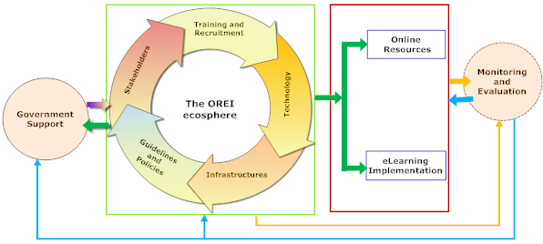

Figure 1. The OREI Core Domains conceptual presentation
The OREI framework focused on inventing a shared vision and technology integration plan that stands on the knowledge, attitudes, beliefs, and positive ICT use practices for all responsible parties. As part of an on-going study, this paper evaluated principle beneficiaries (teachers and students) and government agencies (MoEVT and TIE) required for supporting the enhancement of the ICT in secondary education.
For the project to succeed, consideration of users’ characteristics in the early stages is necessary to determine training and recruitment needs and avoid wastage of limited resources such as time and money. The government support should ensure the availability of funding, plan for the technology level and the training and recruitment. A best use of technology allow teachers and students, in a user friendly manner to interact online using a well-designed and localised technology and have constant access to the most curriculum relevant digital contents. The contribution of research and training institutions should be valued. Teachers should become creators of learning artifacts and interact with the technology effectively.
Training institutions should support teacher training programmes that emphasize on the use of pedagogical ICT resources. Research institutions should support improve the technology through research, development of new tools and positive suggestions for things that needs change-over. Schools infrastructures (Hardware and software) should support teachers and students sustainable access to the relevant ICT resources. The contribution of contents and teaching should balance to make use of all possible resources and contents available. The measure of SWOT analysis on the framework should sick to meet what the framework intents to achieve.

Data analysis
The survey data were analyzed using SPSS ver.21 and the focus group interview results reported qualitatively. The data collected through the survey were presented in stacked bar charts, radar with markers and pie charts showing percentages of respondents on each matter presented. The reliability analysis of scales was conducted and was confirmed with Cronbach’s alpha higher than 0.70. Participants’ responses to open questions in the questionnaires were qualitatively analyzed.

Results and discussion

Curriculum development experts perceived factors leading to ICT use in education
It was vital for this study to solicit information from curriculum developers and experts on the reasons for ICT use in education. The knowledge and readiness of curriculum development experts on ICT use in education have influence on the government’s decision to invest in ICTs in education. The question asked was “Why would you recommend ICTs to be used for teaching/learning in Tanzania secondary education?”). Results are in Figure 2 below.
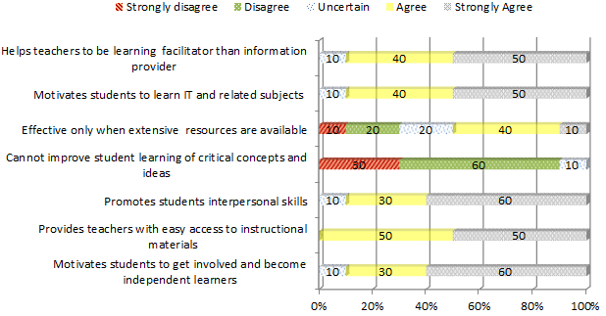

Figure 2. Perception of curriculum developer experts on the use ICTs in education
Results in Figure 2 above show that, majority (60%) agree on the ability of ICT use to motivate students become independent learners, (50%) agree that ICT provides teachers with easy access to instructional materials, (60%) agree that ICT promotes learners interpersonal skills, (50%) agree that the use of ICT motivates students to learn IT and other related subjects and (50%) agree that ICT helps teachers to become learning facilitator than being information providers only. However, it was recently reported that investing heavily in computers and classroom technology in schools does not improve performance; the use of technology increases teachers efficiency and learners collaboration and access to more diverse learning materials in a timely and flexible schedule (OECD, 2015).

Teacher trainee knowledge, skills and classroom ICTs practices
The study examined the abilities, belief, and skills of teacher trainees by focusing on their pedagogical ICT knowledge and skills. Their responses were assessed using Very Strong (VS), Strong (S), Adequate (AD), Weak (W), and Very Weak (VW). Results presented in Figure 3 show that, most of respondents reported Very Strong (VS), Strong (S), and Adequate (AD). Between 25% and 30% reported Very Strong (VS) on using productivity software (Word, Power point and Spreadsheet), Using Internet for general searching, learning new piece of software, and locating learning opportunities that advances technology skills. Between 25 % and 35 % of respondents reported, Strong (S) on using technology to support curriculum standards, teaching, or sharing technology use in a classroom, designing activities that use technology and searching for online content related to a particular subject. Majority who reported Adequate (AD) at 35% nominated searching for content specific of particular subject and at 25% integrating technology into lessons. This means that teacher trainees perceived themselves as having good pedagogical ICTs knowledge.
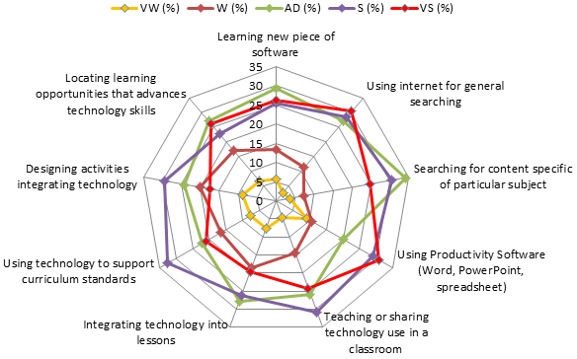

Figure 3. Teacher trainees knowledge, skills and pedagogical ICTs practices
Teachers’ ICT knowledge and skills are important attributes that could have positive influence on technology use in education (Ertmer & Ottenbreit-Leftwich, 2010). Majority of teacher trainees (20%) reported as Weak (W) on the ability to design classroom activities that involve technology. Teachers general ICT use knowledge do not always mean effective skills and ability to design classroom activities that use technology (So et al., 2012). Enhancing teacher trainees on basic ICT skills and knowledge helps them to become innovative for the improvement of the educational environment, development of technological literacy, and creation of deeper knowledge (Midoro, 2013).

School teachers’ classroom ICTs practices
School Teachers were assessed to find out how often have they practically considered the use of pedagogical ICT tools as teaching and learning resources/ aid. Results are in in Figure 4.
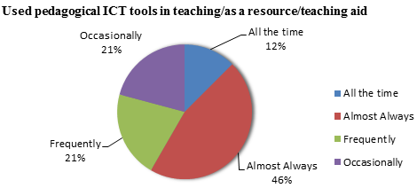

Figure 4. Teachers frequencies of pedagogical ICT tools they have used
As in Figure 4 above, the number of teachers who have considered using pedagogical ICT tools all the time, frequently and almost always combined is high (79.0%), with only 21.0% admitted to have used occasionally. No one reported “Not at all”. This means teacher’s readiness to use pedagogical ICT is high, even when they still face a lot of challenges. The success of ICT integration into real educational classes will depend on the ability of teachers to restructure the educational environment with the purpose of combining of new technologies and new pedagogics (Midoro, 2013).

Perception of students on experiences with the use of ICTs
In this study, we examined students’ experiences with pedagogical ICT that could have resulted from teachers’ abilities to use and present ICT tools in the classrooms. All tools assessed were not based on the experience to use but knowledge of the tools. The knowledge students have, is potential attribute in the SWOT analysis as an internal personal factors. Statistical results are in Figure 5 below.
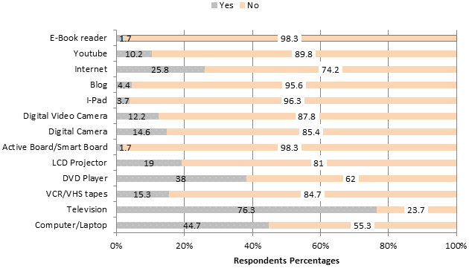

Figure 5. Pedagogical ICT tools students have practiced
Results in Figure 5 above show that, majority of students have not been exposed to the relevant pedagogical ICTs, they lack knowledge, skills and competence in the use of digital contents. The most tools that are knowledgeable to students are television ( 76.3 %) , computer/laptops (44.7%) and DVD player (38.0%) and the internet (25.8%).The rest reported ‘yes’ by less than 20%. This means most school students perceived themselves to have low knowledge on basic ICT tools that support e-learning models. A successful use of pedagogical ICTs in secondary education must affect both teachers and students through purposive use and access to relevant technologies. A stud by Norris, Sullivan, Poirot, & Soloway (2003) reported that, technology cannot have impact on learners when they have no opportunity to access and use the technology. Having minimum number of ICT tools in schools can lead to significant students’ knowledge, skills and awareness that are import for OREI efficient practices. The development of competencies among students follows into three stages of technology literacy (promoting opportunities to use ICTs for more effective knowledge acquisition within the learning process), knowledge deepening (application of technology for concepts deepening using real-world tasks) and knowledge creation (create new knowledge based on the available technology) (Midoro, 2013).

Tutors’ (TTC) knowledge and ICT tools practices
In this study, we assessed tutors readiness to use pedagogical ICTs to measure the level of teacher trainees’ exposure to relevant ICTs. The tools assessed are important for determining the level of technology, user knowledge and the need for training when OREI framework is enhanced. The knowledge of tutors’ on ICT tools, positively or negatively affects teacher trainees knowledge and abilities to adopt ICT use in education. Results are in Figure 6 below.

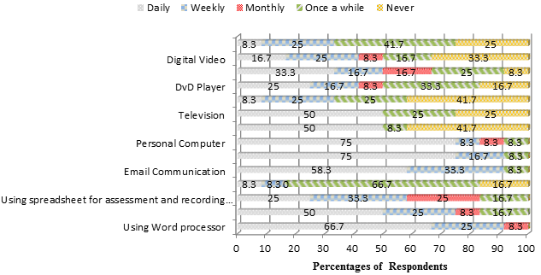

Figure 6. Respondents frequencies of pedagogical ICT tools practices
Results in Figure 6 above, revealed that majority of tutors have daily used word processor (66.7%), Power point presentation (50%), email communication (58.3%), internet search engine (75%), Ipad/android Phone/A tablet (50%), Television (50%), personal computer (75%) and projector (33.3%). In addition, tutors reported to have on a weekly basis used Spreadsheet application (33.3%), digital video (25%) and digital camera (25%). Those who nominated once a while majority reported using the DVD Player (33.3% ), College Website (66.7%) and the VCR/VHS tapes was reported never being used by 41.7%. They are able to search and access online educational resources that are more relevant to what e-learning needs. The more knowledge, belief and skills tutors have on ICTs use in classrooms; the more motivation and experiences teacher trainees gain. In particular, study by Barton & Haydn (2006) found that teacher trainees ICT use is portrayed by the experiences, knowledge and skills of their tutors. Application of new technologies in education assumes a new role of the teacher, new pedagogical techniques, and new approaches to teacher education (Midoro, 2013).

Government readiness to support ICT use in secondary education
Based on the conducted interviews, officials from the Ministry of Education and Vocational Training (MoEVT) had varied positive responses. The interview focused on existence of policies and guidelines, present and past ICT use in secondary education enhancement projects and personal knowledge and readiness to advice the govern on investing in ICT use in secondary education. It was found that the ICT policy for basic education exist, however no implementation guidelines such as strategic plan and investment framework. One officer stated: “We have an ICT policy for basic education, however it lacks harmonized implementation plan”. An officer from the Tanzania Institute of education when asked about the curriculum and directly support on ICT tools application, stated: “Majority of schools have no ICT infrastructures like computers, internet access, and electricity, therefore it is not realistic to implement ICT in secondary education”. The MoEVT officers when asked on present and previous ICT related projects, they listed three major recently carried out projects. Results are summarized in Table 2 below.

Table 2

Government readiness for educational ICT usage
Project Name | Project Sponsor/Coordinator | Project Objectives
(a) National Programme for ICT for Secondary school Teachers, 2005 to 2008 | MoEVT-Secondary Education Unit, World bank | -Targeted to eradicate ICT illiteracy among teachers and enhance its use in teaching.  -To its completion, the project supported 50 secondary schools and all 34 government teachers’ colleges with ICT infrastructures and e-contents
(b) SME (Science, Mathematics, and English) ICT project-2011-2013. | MoEVT-Teacher education Department and Global E-Schools and Communities Initiative (GESCI). | -Baseline study on e- resources gaps in secondary education and teacher training colleges.  -Install computer systems, internet, and equipment in 35 schools.  -Train Science, Mathematics, and English teachers in in ICT basic skills.
(c) Strengthening Innovation and Practice in Secondary Education (SIPSE) Project - June 2013 - May 2015 | MoEVT-Teacher education Department and funded by Master Card Foundation. | -Equipping teachers to provide a student-centered, participative and ICT- based approach to curriculum delivery in Science Technology, English, and Mathematics (STEM).
Government readiness should be known as the most important factors for public education system that have influence on many other factors. Among the factors that depends on government influence and have not sufficiently supported technology use in schools are ICT focused teacher preparation, insufficient number of computers and unreliable internet connections that stand as obstacles for the preparation of student-teachers to teach ICT and use ICT in their teaching (Andersson et al., 2014, p. 88). Investment in e-learning is not an alternative to investment in education generally; the two are seen as being complementary entities for promoting and transforming education for a better (Olson et al., 2011).

School Inspectors pedagogical ICT tools knowledge and support
The knowledge and support school inspectors have on the benefits of pedagogical ICT tools have influence on teachers’ technology adoption. It should be noted that, all school inspectors are teachers by professional; they are part of the MoEVT advising body on issues related to education improvement. When asked to mention any pedagogical ICT tools that could be recommended as teaching/learning resources, they listed numerous tools. Results are in Table 3 below.

Table 3

Interview results on school Inspectors pedagogical ICT tools
knowledge and support
Question: List some few examples of the pedagogical ICT tools that you could suggest to be included in the curriculum as teaching/learning resources/aid.
School Inspector (SPn) |  | School Inspector (SPn) response | Significance
Sp1 | Multimedia (scanners, digital cameras and video cameras), Electronic mail and the internet, Presentation software, Expansive software |  |  | Yes to all
Sp2 | Communicative application, interactive whiteboard software, simulation/animations applications, spreadsheets. |  |  | Yes to all
Sp3 | DvD player, Video, TV, Radio, Radio tapes, Content specific applications, presentation software e.g. power point, internet resources |  |  | Yes to all
Sp4 | Analytical/programing tools, content specific applications, presentation software. |  |  | Yes to all
Results in Table 3 above show that, inspection officers are knowledgeable about pedagogical ICT tools, but these results could not suggest if inspectors are good technology users or not. Their knowledge and skills about pedagogical ICTs have influence on what teachers practice in classroom. Schools’ inspectors have influence in the current and future use of ICTs in education (Robertson, 2003). Inspectors are part of policy makers, their knowledge and beliefs about technology have great influences on government’s decision to invest in ICT in secondary education.

Tanzania ICT use in education SWOT analysis
E-learning is built on the availability of ICT resources ranging from hardware, software and relevant educational materials that are well planned and accessible to learners and teachers. The SWOT analysis is viewed from two perspectives of external factors and internal factors as in Figure 7 below.
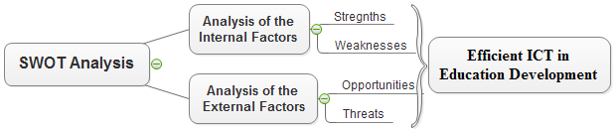

Figure 7. SWOT analysis process for ICT use in education.
The SWOT analysis helps to focus on strengths, minimize threats, and take the greatest possible advantage of opportunities available when taking any strategic action.

Table 4

ICT use in Tanzania Secondary Education SWOT analysis
Internal Factors
Strengths | Weaknesses
Government readiness as indicated by the past and ongoing ICT in education projects.  Availability of ICT policy for basic education used as base for ICT use and planning.  Presence of key decision makers who see ICT use in education as important.  Recognition and readiness of principle users on the importance and needs of ICT education  Training institution are increasing ICT teacher supply  Existence of private organizations ready to support and fund the ICT use in education projects.  Existence of the fiber backbone as an ongoing effort to link all education institutions and public secondary schools to the fiber optic for enhancing connectivity  Internet connectivity and Access growth and awareness among many citizens.  Growing and penetration of mobile devices country wide.  Low connectivity charges per bandwidth and flexibility  Possibilities of having local in-house content developers with ability to localise contents relevant to curriculum and guidelines  Availability of experienced staffs in delivering e-learning in the field of secondary education. | Lack of ICT policy for basic education strategic implementation plan and the framework.  Lack of technical infrastructure issues i.e. IT equipment not fit for education purpose  Physiological barrier of teachers and schools management  Principle users have weak English language that do support most of technology use terminologies  No universal standard of computer software and hardware specifications for secondary education  Lack of sustainable funding  Earlier, emphasis was given to information technology as a subject rather than pedagogical ICTs applications.  Due to lack of computers and professional teachers the skills and knowledge transferred to learners do not meet the minimum standards of ICT use in education  Lack of supportive infrastructures (inadequate computers, internet access, like internet , hardware and software, e-contents, unreliable internet connection and insufficient bandwidth)  Too many disadvantaged families (many families cannot afford to invest in technologies for their children)  Limited number of supporting experts (ICT users lack support).  Resistance to change (teachers unwillingness to adopt new technology use)  Lack of motivations and incentives to use e-contents in education (Teacher who use ICT are not recognized).  Tutors and Teachers have limited technology usage capabilities (pedagogical technology use, inability to search, design, edit and construct e-contents )  Lack of standardized and quality e-learning training materials.  Learners’ lack knowledge, skills and readiness to use ICT tools for learning.

External Factors
Opportunities | Threats
Possibility of enhancing availability of online collaboration tools.  Existence of unexplored external funding sources.  Opportunities for blending of existing traditional teaching methods with technology  New advancement in technology for our generation (Surrounded by graphical web browsers, laptops, cell phones, instant messenger services, broadband, wireless, video games, video conferencing, and crowd/cloud computing )  Could enhance development of ICT curriculum on international level.  Foster active cooperation of government, public and private sectors and international and donor organizations in ICT use in education.  Can motivate creativity and contribution in advancement of educational technology | Financial constraints (limited external funding sources)  Lack of sustainable power supply for running technological devices  Technology changes (new technologies can discourage users who are not eager to learning )  Lack of secondary school curriculum related e-books and e-contents.  Bandwidth and connectivity issues  E-learning being seen as not cost effective.  Lacking allocation of specific amount of fund in the government budget for the ICT in secondary education initiatives  There is misunderstanding that ICT education is just a computer literacy or knowledge of widely used applications  Consequences of inadequate computer hardware and software supply  If the government does not resolve issues related to preparation and education of teacher trainees in ICT use, few years later the nation will face lack of ICT qualified teaching staff.

Conclusion
Frameworks that help us organize learning with, though, or about ICT are useful, as are frameworks that guide us to a new level of technology use. The OREI framework and SWOT analysis prompted identification of favorable factors (strengths and opportunities) and unfavorable factors (weakness and threats) intended to yield strategic insights for the OERI framework practices. Without this information, framework implementation may miss feasible inputs (Valentin, 2001). However, there is also the warning that a framework that is reasonable and coherent in its own right may not be reasonable and coherent in certain situations (Robertson et al., 2007, p. 23). Hence, Tanzania education system needs a stable localized framework to be used a roadmap for ICT use in education planning and implementation.
The successful use of online educational resources and e-learning implementation (OREI) framework as a roadmap for the ICT in education planning in Tanzania secondary education depends much on several critical factors. The planning and deciding on the levels of ICT integration in secondary education settings should be interpreted in ways that are realistic and sustainable for improving educational outcomes. The favorable factors (strengths and opportunities) and the unfavorable factors (weakness and threats) presented in this study are grounded in practical solutions to problems and issues identified in the planning process, schools’ environments, principle users characteristics and the levels of stakeholders involvement in the process of designing a working solution.
This study promotes a roadmap for sustainable ICT use planning steps that enables education policy makers, research institutions, instructional designers, and teachers training institutions to construct and reconstruct their own understandings of their lived experience in relation to the use of ICT, its possibilities for continuation, the opportunities for improvement and change and the constraints currently limiting initiatives. The OREI framework will improve access, equity, and quality in the delivery of e-contents through integration and harmonization of curriculum relevant e-contents that can be used in teaching and learning. There has been an uncovered gap for identifying relevant and core technology for secondary education ICT use enhancement (Hooker et al., 2011, p. 20). Specifically, the OREI creates a cohesive ICT framework that enhance the planning and implementation of suitable ICTs in secondary education, provide and improve investment of ICT infrastructure that directly support teaching and learning. In addition, provide guidance for capacity building, transform basic education curriculum for e-delivery modes, develop guidelines for online resources design and access, integrate ICT in educational management functions, and enhance the contribution of stakeholders in ICT research and development. Redefining the Tanzania education in terms of e-learning models and implementation is an important step to be made in the 21st century (Baker et al., 2013, p. 8).

Recommendations and further studies
This study recommends for the government to invest in the availability of a centralized learning content management system that would lead, motivate and allow the creation, storage, sharing, and collaboration between users. To overcome barriers of ICT use in education we recommend for a shared vision and technology integration plan and changing attitudes and beliefs for all users. The basic question that needs to be addressed by proceeding studies is how integrated the e-learning models and approaches that cope with the societal and technological changes should be designed to lead the direction of seizing the available complex learning resources, enhance multilevel students’ flexibility, and empower teachers to work effectively in the school environments with high growing number of students. The proposed e-learning approach should first, take pedagogical, technical, and organizational aspects into account; second, take a systems design approach that might be necessary to mix online educational resources with face-to-face instruction and other media in order to maximize the effectiveness and efficiency of the e-learning model of choice. And third, it should be student centred to conspire the education policy and implementation plans that address collaboration of diverse, widely distributed set of learners who need to learn and transfer skills to an increasingly varied set of real-world contexts and settings.

References
Andersson, B., Nfuka, E. N., Sumra, S., Uimonen, P., & Pain, A. (2014). Evaluation of Implementation of ICT in Teachers’ Colleges Project in Tanzania (Final Evaluation Report No. Sida61745en Urn: nbn: se: sida-61745en). Stockholm, Sweden: Swedish International Development Cooperation Agency (Sida). Retrieved from http:/ sidapublications.citat.se/ interface/ stream/ stream.asp
Baker, D., Bliss, A., Chung, R., & Reynolds, C. (2013). E‐Learning for Teacher training in Tanzania : Policy, Players, Models, and Recommendations for the Asante Africa Foundation (Introduction to Policy Analysis No. PP200). Berkeley, California: University of California. Retrieved from http://www.asanteafrica.org/wp-content/uploads/2015/06/E-Learning.-TZ-Teachers.2013.pdf
Baker, R. (2011). Pedagogies and Digital Content in the Australian School Sector. The Learning Federati on, Education Services Australia. Retrieved from http://www.ndlrn.edu.au/verve/_resources/
ESA_Pedagogies_and_Digital_Content_in_the_Australian_School_Sector.pdf
Barton, R., & Haydn, T. (2006). Trainee teachers’ views on what helps them to use information and communication technology effectively in their subject teaching. Journal of Computer Assisted Learning, 22(4), 257–272. http://doi.org/10.1111/j.1365-2729.2006.00175.x
Beyth-Marom, R., Saporta, K., & Caspi, A. (2005). Synchronous vs. Asynchronous Tutorials. Journal of Research on Technology in Education, 37(3), 245–262. http://doi.org/10.1080/15391523.200 5.10782436
Cavus, N. (2013). Selecting a learning management system (LMS) in developing countries: instructors’ evaluation. Interactive Learning Environments, 21(5), 419–437. http://doi.org/10.1080/10494 820.2011.584321
Chingos, M. M., & Whitehurst, G. J. (2012). Choosing Blindly: Instructional Materials, Teacher Effectiveness, and the Common Core (Policy Document). Washington DC: Brown Center on Education Policy. Retrieved from http://www.brookings.edu/~/media/research/files/reports/ 2012/4/10%20curriculum%20chingos%20whitehurst/0410_curriculum_chingos_whitehurst.pdf
Clark, R. C., & Mayer, R. E. (2011). E-Learning and the Science of Instruction: Proven Guidelines for Consumers and Designers of Multimedia Learning. (R. Taff, Ed.) (3rd ed). San Francisco, CA,USA: John Wiley & Sons, Inc.
Conde, M. Á., García-Peñalvo, F. J., Rodríguez-Conde, M. J., Alier, M., Casany, M. J., & Piguillem, J. (2014). An evolving Learning Management System for new educational environments using 2.0 tools. Interactive Learning Environments, 22(2), 188–204. http://doi.org/10.1080/10494820. 2012.745433
Ertmer, P. A., & Ottenbreit-Leftwich, A. T. (2010). Teacher Technology Change: How Knowledge, Confidence, Beliefs, and Culture Intersect. Journal of Research on Technology in Education, 42(3), 255–284. http://doi.org/10.1080/15391523.2010.10782551
Farrell, G., & Isaacs, S. (2007). Survey of ICT and Education in Africa: A Summary Report, Based on 53 Country Surveys. (Country Reports No. Volume 2 : 53) (p. 74). Washington, DC,USA: infoDev / World Bank. Retrieved from http://www.infodev.org/en/Publication.353.html
Grant, M. M. (2010, February). CMS, LMS and LCMS. Presentation slides presented at the Education and Technology, University of South Carolina. Retrieved from http://www.slideshare.net/msquareg /cms-lms-lcms
Greenberg, L. (2002). LMS and LCMS: What’s the Difference? Teaching Circuits, 31(2). Retrieved from http://scripts.cac.psu.edu/staff/g/m/gms/fa07/IST-440W/LMS%20and%20LCMS_%20What’s% 20the%20Difference.pdf
Helms, M. M., & Nixon, J. (2010). Exploring SWOT analysis – where are we now?: A review of academic research from the last decade. Journal of Strategy and Management, 3(3), 215–251. http://doi. org/10.1108/17554251011064837
Hooker, M., Mwiyeria, E., & Verma, A. (2011). ICT Competency Framework for Teachers (ICT-CFT) :Contextualization and Piloting in Nigeria and Tanzania (World Bank and GESCI Initiative Synthesis report No. Draft). Dar-es-Salaam, Tanzania: Ministry of Education and Vocational Training (MoEVT), Tanzania. Retrieved from http://www.gesci.org/assets/files/Tanzania_Needs_ Assessment_Report_Draft_Final_230911%20_3.pdf
Hrastinski, S. (2008, November 17). Asynchronous and Synchronous E-Learning. EDUCAUSE, 31(4). Retrieved from http://www.educause.edu/ero/article/asynchronous-and-synchronous-e-learning
Hyder, K., Kwinn, A., Miazga, R., & Murray, M. (2007). Synchronous e-Learning : How to design, produce, lead, and promote successful learning events, live and online. (Bill Brandon, Ed.). The eLearning Guild. Retrieved from http://theelearningcoach.com/wp-content/uploads/downloads/2010/06/ synchbook.pdf
Ismail, J. (2001). The design of an e-learning system: Beyond the hype. The Internet and Higher Education, 4(3), 329–336.
Johnson, L., Malcolm, C., Samantha, A. B., Victoria, E., Alex, F., & Holly, L. (2013). NMC Horizon Report 2013 K-12 (K-12 series). Austin, Texas USA: The New Media Consortium. Retrieved from http://www.nmc.org/pdf/2013-horizon-report-k12.pdf
Kaplan, M., & Zhu, E. (2011). Teaching with Technology. In M. Svinivki, W. J. McKeachie, & L. Schreiber-Ganster (Eds.), Teaching with Technology (Thirteenth Edition, pp. 235–266). Calfornia, USA: Wadsworth, Cengage Learning.
Kidd, T. T. (2010). A Brief History of eLearning. (M. Khosrow-Pour, S. Clarke, M. E. Jennex, A. Becker, & A.-V. Anttiroiko, Eds.) (Vol. Vol.1). Hershey, New York, USA: Information Science Reference (an imprint of IGI Global).
Midoro, V. (2013). Guidelines on adaptation of the UNESCO ICT Competency Framework for Teachers (Methodological approach on localization of the UNESCOICT-CFT No. UDK 37). Moscow, Russia: UNESCO Institute for Information Technologies in Education. Retrieved from http://iite.unesco. org/pics/publications/en/files/3214726.pdf
Mijatovic, I., Cudanov, M., Jednak, S., & Kadijevich, D. M. (2013). How the usage of learning management systems influences student achievement. Teaching in Higher Education, 18(5), 506–517. http://doi.org/10.1080/13562517.2012.753049
Miles, I., Keenan, M., & Kaivo-Oja, J. (2003). Handbook of Knowledge Society Foresight (No. EF/03/50/EN). Dublin, Ireland: European Foundation for the Improvement of Living and Working Conditions. Retrieved from http://edz.bib.uni-mannheim.de/www-edz/pdf/ef/03/ef0350en.pdf
Moore, K. (2007). The E-Learning Strategy. (B. Brandon, Ed.). The eLearning Guild. Retrieved from http://theelearningcoach.com/wp-content/uploads/downloads/2010/06/strategy_ebook.pdf
Nagel, D. (2013, April 6). Six Technology Challenges Facing Education [Ed Tech Trends and News]. Retrieved May 9, 2015, from http://thejournal.com/Articles/2013/06/04/6-Technology-Challenges-Facing-Education.aspx?Page=1&p=1
Naik, U., & Shivalingaiah, D. (2009). Open Source Software for Content Management System. In 7th International CALIBER-2009 (pp. 225–239). Ahmedabad: INFLIBNET Centre. Retrieved from http://ir.inflibnet.ac.in/bitstream/1944/1028/1/29.pdf
Niemi, H., Kynäslahti, H., & Vahtivuori-Hänninen, S. (2013). Towards ICT in everyday life in Finnish schools: seeking conditions for good practices. Learning, Media and Technology, 38(1), 57–71. http://doi.org/10.1080/17439884.2011.651473
Ninoriya, S., Chawan, P., & Meshram, B. B. (2011). CMS, LMS and LCMS for elearning. IJCSI International Journal of Computer Science, 8(2), 644–647.
Nisheva, M., Gourova, E., Ruskov, P., Todorova, Y., & Antonova, A. (2008). Strategic framework for IT education and research at Sofia University. International Journal of Education and Information Technologies, 4(2), 213–225.
Norris, C., Sullivan, T., Poirot, J., & Soloway, E. (2003). No Access, No Use, No Impact. Journal of Research on Technology in Education, 36(1), 15–27. http://doi.org/10.1080/15391523.2003. 10782400
O’Carroll , A, Collins, S, Gallagher, D, Tang, J, & Webb, S. (2013). Caring for Digital Content: Mapping International Approaches (Research Report No. 2). Dublin, Ireland: Maynooth: NUI Maynooth; Dublin: Trinity College Dublin; Dublin: Royal Irish Academy.DOI: 10.3318/DRI.2013.1. Retrieved from http://dri.ie/caring-for-digital-content-2013.pdf
OECD. (2015). Students, Computers and Learning. Paris: OECD Publishing. Retrieved from http://www.oecd-ilibrary.org/education/students-computers-and-learning_9789264239555-en
Olson, J., Codde, J., deMaagd, K., Tarkelson, E., Sinclair, J., Yook, S., & Egidio, R. (2011). An Analysis of e-Learning Impacts & Best Practices in Developing Countries: With Reference to Secondary School Education in Tanzania (Information & Communication Technology for Development). Michigan, USA: Michigan State University. Retrieved from http://cas.msu.edu/wp-content/uploads/2013/ 09/E-Learning-White-Paper_oct-2011.pdf
Project Tomorrow. (2013). New Digital Learning Playbook:The Digital Content Story. Speak Up 2013 National Research Project. Retrieved from www.tomorrow.org/speakup/
Robertson, J. W. (2003). Stepping Out of the Box: Rethinking the Failure of ICT to Transform Schools. Journal of Educational Change, 4(4), 323–344. http://doi.org/10.1023/B:JEDU.0000006047. 67433.c5
Robertson, M., Webb, I., & Fluck, A. (2007). Seven steps to ICT integration. Camberwell, Victoria, Australia: ACER Press.
Ryan, T. G., Toye, M., Charron, K., & Park, G. (2012). Learning management system migration: An analysis of stakeholder perspectives. The International Review of Research in Open and Distributed Learning, 13(1), 220–237.
Sambuu, U. (2005). The usage of ICT for secondary education in Mongolia. International Journal of Education and Development Using ICT, 1(4), 101–118.
Smart, K. A., & Meyer, K. A. (2005). Changing Course Management Systems: Lessons Learned. EDUCAUSE Quarterly, (2), 68–70.
So, H.-J., Choi, H., Lim, W. Y., & Xiong, Y. (2012). Little experience with ICT: Are they really the Net Generation student-teachers? Computers & Education, 59(4), 1234–1245. http://doi.org/ 10.1016/j.compedu.2012.05.008
Tanzania Institute of Education (TIE). (2009). Curriculum for Advanced Secondary Education in Tanzania (2013th ed.). Dar-es-Salaam, Tanzania: Tanzania Instituite of Education. Retrieved from http:// www.moe.go.tz/index.php?option=com_docman&task=doc_download&gid=226&Itemid=619
United Republic of Tanzania (URT). (2008, August). Education Sector Development Programme-ESDP (2008-2017). The United Republic of Tanzania. Retrieved from http://planipolis.iiep.unesco.org/upload/Tanzania%20UR/Tanzania-ESDP-2008-2017.pdf
United Republic of Tanzania (URT). (2013). Basic Education Statistics in Tanzania (BEST). (National Data 2008-2012). Dar-es-Salaam: Ministry of Education and Vocational Training (MoEVT). Retrieved from http://www.moe.go.tz/index.php?option=com_docman&task=doc_download&gid=226& Itemid=619
Valentin, E. K. (2001). Swot Analysis from a Resource-Based View. Journal of Marketing Theory and Practice, 9(2), 54–69.
Varlamis, I., & Apostolakis, I. (2006). The Present and Future of Standards for E-Learning Technologies. Interdisciplinary Journal of E-Learning and Learning Objects, 2(1), 59–76.
Warger, T., Dobbin, G., Initiative, E. L., & others. (2009, October). Learning environments: where space, technology, and culture converge. EDUCAUSE Learning Initiative (ELI). Retrieved from https://net.educause.edu/ir/library/pdf/ELI3021.pdf
Watson, J., Murin, A., Vashaw, L., Gemin, B., & Rapp, C. (2013). Keeping Pace with K-12 Online and Blended learning: An annual Review of Policy and Practice (10th annual Keeping Pace report). Evergreen Education Group. Retrieved from http://www.kpk12.com/wp-content/uploads/EEG _KP2013-lr.pdf
Zhang, P., & Goel, L. (2011). Is e-learning for everyone? An internal-external framework of e-learning initiatives. MERLOT Journal of Online Learning and Teaching, 7(2), 193–205.

About the authors
Patrick D.Kihoza is a PhD student at the Nelson Mandela African Institution of sciences and Technology, Arusha, Tanzania. He is majoring in Information and Communications Sciences Engineering (ICSE) in the School of Computational and Communication Sciences and Engineering. He graduated in 2012 with a MSc. Computer Science (International CBU Master’s Programme in ICT)-University of Eastern Finland, Joensuu. He has a BSc.in Information and Communication Technology with Management (BSc.ICTM) from Mzumbe University, Tanzania.
Email: kihozap@nm-aist.ac.tz
Irina Zlotnikova is a full professor and Interim HOD Computer Science and Software in College of ICT, Botswana International University of Science and Technology. She has a PhD in Theory and Methodology of Computer Science Education (Doctor of Pedagogical Sciences, Moscow, Russia).In addition she has a PhD in Solid-State Electronics, Nano- and Microelectronics (Candidate of Technical Sciences, Voronezh, Russia) and an Engineer Degree in Radiophysics and Electronics (Voronezh, Russia).
E-mail: zlotnikovai@biust.ac.bw
Khamisi Kalegele is a lecturer at the Nelson Mandela African Institution of Science and Technology, Arusha, Tanzania; School of Computational and Communication Sciences and Engineering. He received a PhD in information sciences-Tohoku University, Japan. Currently, he is undertaking R&D activities related to ICT for development in health, education, and agriculture sectors.
E-mail: khamisi.kalegele@nm-aist.ac.tz

Return to Table of Contents

Return to Table of Contents
Editor’s note: The student perspective is an important factor in successful introduction and growth of quality distance learning programs. There are many reasons for adoption of distance learning programs, but at the end of the day they must fulfill the educational objectives and students must be satisfied. This is more than market research. It provides a pool of data to show where the system can be improved for the benefit of learners and educational providers.

Survey of 11th and 12th grade students who have completed online courses

M.O. Thirunarayanan and Argelio Estrada

USA

Abstract
A survey was conducted to determine eleventh and twelfth grade students’ experiences in and thoughts about online courses that they completed. Ninety-one eleventh and two hundred and thirty-one twelfth grade students participated in the study. The study participants were enrolled in a charter middle/high school in a diverse metropolitan city in the US. The survey contained items that were designed to determine study participants’ likings and preferences for taking online versus face-to-face courses, their thoughts about academic misconduct in online courses, and thoughts about communication and interaction with online teachers / facilitators. The study participants were also asked whether it was easier to pass in online or face-to-face courses and also the course delivery format in which they learn more. Findings indicate that study participants think it is easier to cheat in online courses and that they like and prefer to take courses face-to-face. Study participants also reported that online course teachers / facilitators communicated and interacted with them and were available to help them when they needed help. A majority of the study participants think it is easier to pass an online course and that they learn more in a face-to-face course.

Need for and purpose of the study
Online education is becoming more common at the K-12 level. The rapid growth of virtual education in the US at the K-12 level has been acknowledged by some authors (Barth, Hull, and St. Andrie, 2012; and Watson, 2007). According to Glass and Welner (2011): “Virtual or online schooling is a growing phenomenon” and “In just a decade, such virtual education has grown from a novelty to a movement.”
Some authors think that there is insufficient research regarding K-12 virtual schools (Barbour, 2010; Barbour, 2014; and Molnar, 2013). However, because online K-12 education is a growing phenomenon, some research has been conducted in different areas related to virtual education. Cavanaugh et al. (2009), who conducted a review of the literature in this area noted:
Our analysis of the open access literature indicated that a majority of that literature focused on statewide and consortium/multi-district virtual schools, the roles of teachers and administrators, the promise of virtual schooling and its initial rationale for implementation, administrative challenges, the technology utilized, and interaction with students.
A conclusion that can be drawn from the above statement is that while research has been conducted regarding various aspects of K-12 online or virtual education, not much research has been conducted regarding K-12 students’ thoughts about, and experiences in online courses. Such a conclusion is confirmed by Rice (2006) who stated: “a paucity of research exists when examining high school students enrolled in virtual schools, and the research base is smaller still when the population of students is furthered narrowed to the elementary grades.”
The purpose of this study is to determine eleventh and twelfth grade students’ experiences in and their opinions about online courses.

The study
Students who were enrolled in the eleventh and twelfth grades in a middle / high charter academy or school in a large and diverse city in the southeastern part of the United States participated in the study. The researchers obtained Institutional Review Board (IRB) approval from a university and permission from the administrator of an academy to survey students in the eleventh and twelfth-grades. Students in the eleventh and twelfth grades were targeted for the study because they were more likely to have completed an online course than students in lower grades. Following IRB requirements, only students below the age of 18 years who signed assent forms and whose parents signed consent forms were allowed to participate in the study. Students who were 18 years of age or older were allowed to participate in the study if they signed consent forms.
A survey was designed to elicit students’ responses to questions about their experiences in and thoughts about online courses. The questions and items in the survey were related to the following topical areas:
Students liking and preferences for taking courses
Academic misconduct in online and face-to-face courses
The Rigor of online courses
Communication with teachers in online courses
Interaction in online versus face-to-face courses
Do students think they learn more in online or face-to-face courses?
No questions were asked in the survey regarding the race or ethnicity of the students because more than ninety percent of the people in the city where the school is located are of Hispanic heritage. Ninety-one eleventh-graders and two hundred and thirty-one twelfth graders completed a thirty-item survey. Fifty-four (59.3%) of the eleventh graders who participated in the study were females while thirty-seven (40.7%) were males. One hundred and thirty-nine (60.2%) of the twelfth grade participants were females and ninety-two (39.8%) were males.
At the eleventh grade level, 52 (57.1%) of the students had completed one online course, twenty-eight (30.8%) had completed two online courses and eight (8.8%) had completed three online courses. At the twelfth grade level, one hundred and seventy-one (74%) had completed one online course, forty-eight (20.2%) had completed two online courses and eight (3.5%) had completed 3 online courses. Only very small numbers and percentages of students at both grade levels had completed four, five and more than five courses.

Study findings

Students’ likings and preferences for taking courses
An overwhelming majority of students at both grade levels indicated that they not only like, but also prefer to take class face-to-face. Nearly identical percentages of eleventh [n=80 (87.9%)] and twelfth grade [n=202 (87.4%)] students indicated that they like taking courses face-to-face. The percentages of students who responded that they prefer to take classes face-to-face were exactly the same at the eleventh [n=78 (85.7%)] and twelfth [n= 198 (85.7%)] grade levels. Figures 1 and 2 provide a side-by-side comparison of the percentages of students in the eleventh and twelfth grades who indicated that they like to take courses face-to-face or online.
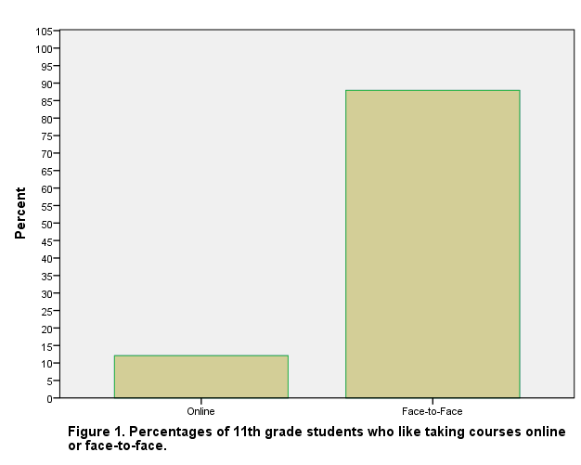 | 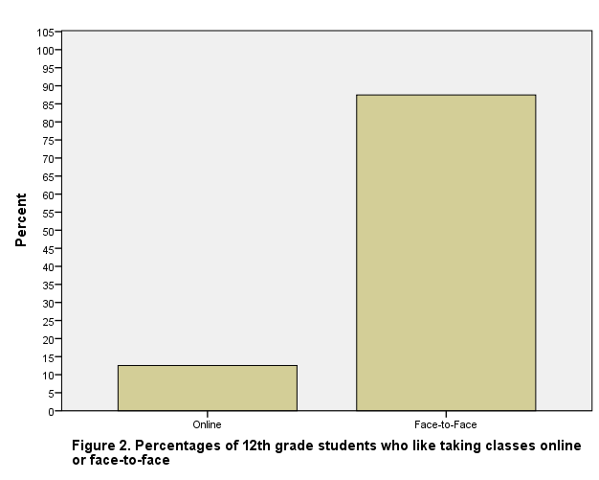
A question that comes to mind is why do some states in the US require students to take at least one course online prior to graduation when students do not seem to like taking courses online?
In response to the survey item I wish I could take all my courses online, a greater percentage of 11th grade students [n=82 (90.1%)] disagreed or strongly disagreed than did students in the twelfth grade [n=190 (82.3%). Figures 3 and 4 display comparative data for students at the two grade levels.
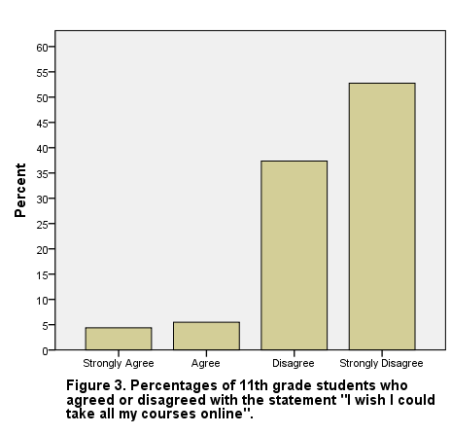 | 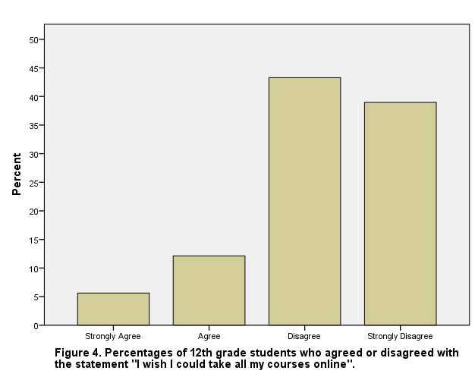
Students in both grades differed somewhat in their responses to the survey item I hate online courses. At the eleventh grade level, forty-six (50.5%) of the students strongly agreed or agreed with the statement. At the twelfth grade level, a smaller percentage [n=99 (42.9%)] of students either strongly agreed or agreed with the statement.

Academic misconduct in online courses
A study by Grijalva, Nowell, and Kerkvliet (2006) based on a study of a single online course concluded that academic dishonesty in online courses is really not that different from similar misconduct in face-to-face classrooms. The research findings in this area is inconclusive. Some researchers (Stuber-McEwen, Wiseley, and Hoggatt, 2009; and Watson and Sottile, 2010) have found that cheating behavior is higher in face-to-face classrooms based courses while others (Harmon, Lambrinos, and Buffolino, 2008) have identified more cheating risk of cheating in online courses. However, as online technologies continue to evolve, more opportunities may become available for students in online courses to cheat. For example, Moten et al (2013) have suggest that there are many more ways to cheat in online courses when compared to similar behavior in face-to-face courses. When asked to choose in response to the survey item I think it is easier to cheat in . . ., overwhelming percentages of both eleventh [n=86 (94.5%)] and twelfth grade [n= 217 (93.9%)] students selected online coursework. This shows that students at both eleventh and twelfth grade levels (see Figures 5 and 6) think that it is easier to cheat in online courses. Similar findings have been reported by Kennedy et al (2000) and King, Guyette, and Piotrowski (2009).
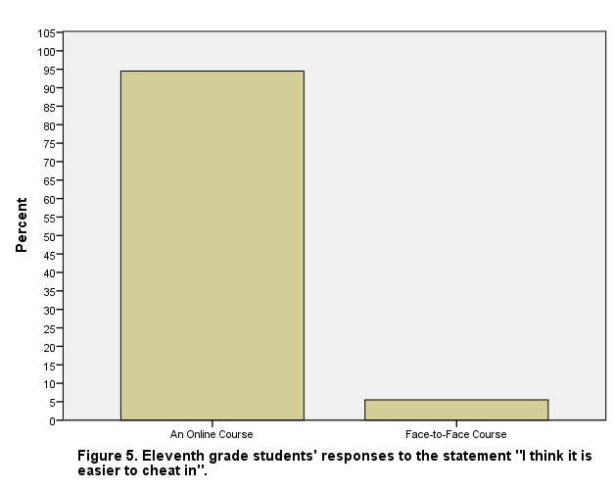 | 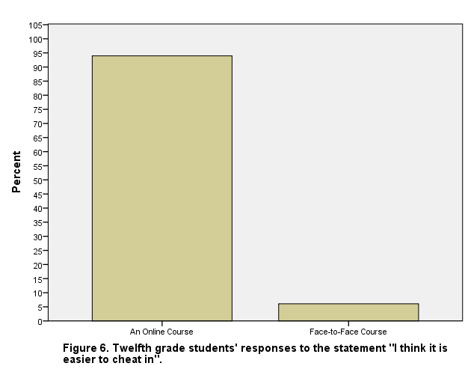
So what if large percentages of students think that it is easier to cheat in online courses? Do they actually know some who has cheated in online courses? Sixty-two (68.1%) eleventh graders and one hundred and thirty (56.3%) twelfth graders either strongly agreed or agreed in response to the survey item I know at least one person who cheated on tests and exams in an online course. These findings indicate that cheating appears to be prevalent in online courses at the high school level.
Fifty-three (58.2%) students in the eleventh grade strongly agreed or agreed with the survey item It is easy to have someone else do the work for you in an online course, and one hundred and fifty-five (67.1%) twelfth grade students responded to this item in a similar manner. However, only thirty-three (36.3%) eleventh grade and eighty-five (36.8%) twelfth grade students strongly agreed or agreed with the statement I know at least one person who completed an online course for another person.

The rigor of online courses
Which type of coursework do students think is more rigorous? According to responses from both eleventh [n=66 (72.5%)] and twelfth grade [n=169 (73.1%)] students either disagreed or strongly disagreed on the survey item that stated: Online courses are more demanding than face-to-face courses. These results are portrayed in Figure 7 and Figure 8.
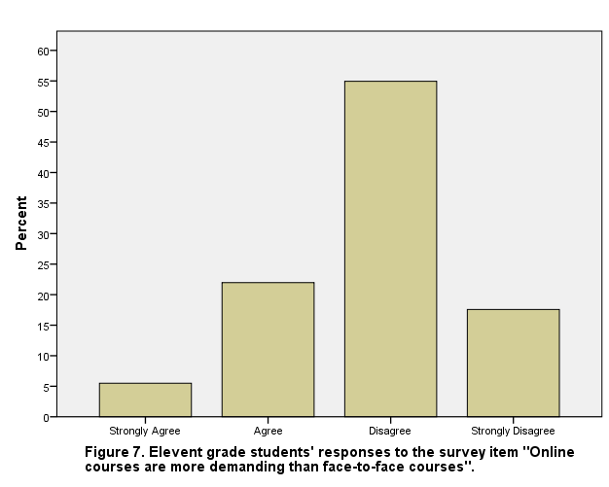 | 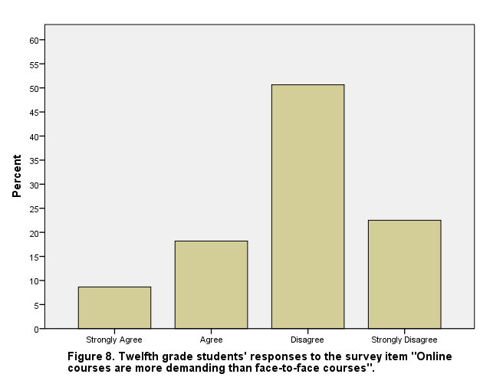
One of the survey items that participants responded to was: Taking a course online was an easy way to pass a required course. Seventy-five (82.4%) eleventh and one hundred and ninety seven (85.3%) twelfth grade students strongly agreed or agreed with the statement, as shown in Figures 9 and 10.
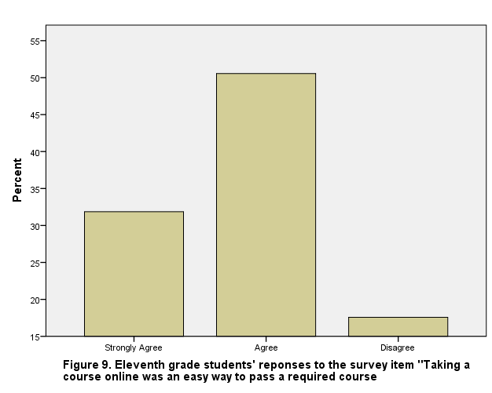 | 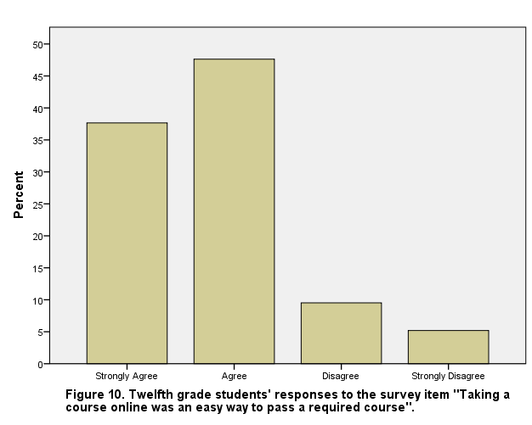
Another survey item regarding the rigor of coursework stated: I did not have to put much effort to pass the online course(s) that I took. Greater percentages of eleventh [n=52 (57.1%)] and twelfth grade students [n=126 (54.5%)] either strongly agreed or disagreed with the statement (see Figure 11 and Figure 12).
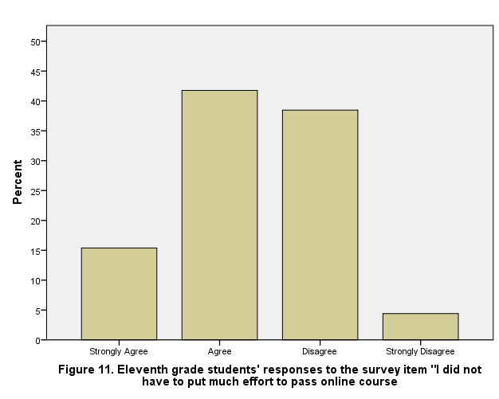 | 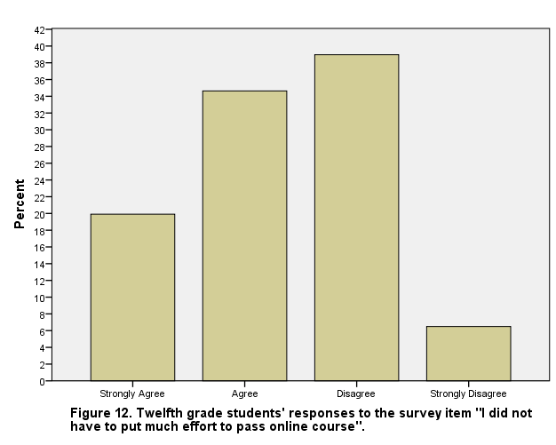
Is it easier to pass an online or face-to-face course? On the survey item that asked respondents to choose between face-to-face and online course formats, fifty-six (61.5%) eleventh grade and one hundred and seventy-one (74%) twelfth grade students indicated that it is easier to pass an online course (see Figure 13 and Figure 14).
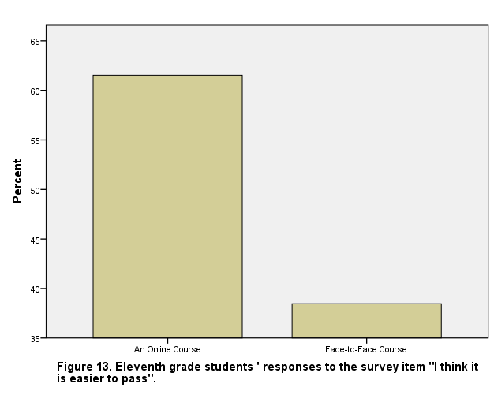 | 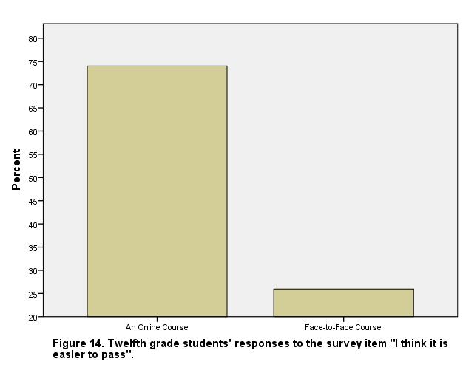
There was also a statistically significant difference between eleventh and twelfth grade students who indicated that was easier to pass an online course. The Person Chi-Square value of 4.895 was significant at the .027 level.
An item on the survey was about proctoring: The exams and tests in the online course(s) that I took were proctored. Forty-four eleventh grade (48.4%) and one hundred and thirty-five (58.4%) twelfth grade students chose never as their response. These findings suggest that there may be a need for proctoring exams and test in online courses at the high school level.

Communication with teachers in online courses
Seventy-eight (85.7%) eleventh grade and one hundred and eighty-four (79.7%) twelfth grade students indicated that they were able to communicate with an online teacher or facilitator either every day or at least once a week. The survey item that they were responding to was: In the online course(s) that I completed I was able to communicate with a teacher / facilitator.
Did the online teacher or facilitator communicate with the students? Sixty-four eleventh grade (74.7%) and one hundred and seventy-eight (77.1%) twelfth grade students indicated that such communication took place either every day or once a week in response to the survey item: My online course teachers / facilitator communicated with me.
A surprising finding is that seventy-four (81.3%) of the eleventh grade and one hundred and ninety-three (83.5%) twelfth grade students indicated that two way video was never used to facilitate communication between students and their online teachers or facilitators.
Both groups of eleventh [n=81 (89%)] and twelfth grade [n=201 (87%)] students indicated that a teacher or facilitator was available every day or once a week to help them when they needed help in connection with the online courses in which they were enrolled.
Sixty-three (69.2%) eleventh grade and one hundred and seventy (73.6%) twelfth grade students chose either always or sometimes in response to the following survey item: If I did not submit my online course assignments in a timely manner, a teacher / facilitator contacted me immediately.

Interaction in online versus face-to-face courses
When asked to choose between online and face-to-face courses on the survey item I think there is less interaction with the teacher / facilitator in . . ., eighty-seven eleventh (95.6%) and two hundred and fifteen (93.1%) twelfth grade students selected online courses. A survey item about interaction with other students was: I think there is more interaction with other students in . . . . Eighty-nine (97.8%) eleventh and two hundred and nineteen (94.8%) twelfth grade students chose face-to-face courses.

Do students think they learn more in online or face-to-face courses?
Did the study participants think they learn more in face-to-face or online courses? Eighty-six (94.5%) eleventh grade and two hundred and two (87.4%) twelfth grade students responded to the survey item I learn more in . . . by selecting face-to-face as their choice. This finding concurs with the findings of earlier research. Means et al (2010) found that K-12 students who completed online courses did not learn as much as students at the undergraduate and higher levels. This is not surprising since students have been known to experience difficulties in online environments (Barbour et al, 2012).

Discussion of findings
The findings of the study show that the eleventh and twelfth grade students who participated in this study overwhelmingly prefer and also like taking face-to-face courses. These findings suggest that online education may not be appropriate for all high school students. As Wood (2005) pointed out: “An online class requires discipline and motivation. Some students simply aren’t up to it, even if they excel in a traditional classroom setting” (p. 37). Barbour and Reeves (2009) also noted: “the only students typically successful in online learning environments are those who have independent orientations towards learning, highly motivated by intrinsic sources, and have strong time management, literacy, and technology skills. These characteristics are typically associated with adult learners” (p. 402). Students at the K-12 level could be encouraged to take mini-courses online before they decide if such courses are suitable for them. Only students who find out that they like online courses and have also demonstrated that they can do well in such courses should be allowed to enroll in online courses to earn credits that are required for graduation. Policy makers should take such information into account before mandating that all high school students should complete a certain number of courses online in order to satisfy requirements for graduating from high school.
High schools who participated in this study also consider face-to-face courses as being more demanding than online courses. They also think that it is easier to pass online courses. Responses from participating students also indicated that they did not put much effort to pass online courses. The data collected for this study appears to suggest that students do not consider online courses to be as rigorous as face-to-face courses. This is something policy makers need to address.
The potential for academic misconduct is certainly there in online coursework. Large proportions of study participants indicated that they knew someone who had either cheated in online courses. The data also shows that students in both eleventh and twelfth grades thought that is was easier to cheat in online courses as opposed to face-to-face courses. Study participants also indicated that they thought it is easy to get someone else to complete online coursework. Policies should be put in place to ensure that all online courses are proctored. Such proctoring will not only go a long way to minimize or even eliminate concerns about academic misconduct, but also help improve the rigor of online courses.
Based on responses provided by students, it appears that students who were enrolled in online courses and their facilitators / teachers communicated with each other on a frequent basis. Such interaction with faculty has been found to be important (Arbaugh and Benbunan-Fich, 2007; and Swan, 2003)) in online learning environments. However, the data does show there was a lack of two-way video-based communication between students and the facilitator or teacher. This could be because the technology to communicate using two-way video did not exist. If this is the case, policymakers can remedy this situation by recommending that funding be provided for upgrading the communications technologies that are used in online courses. As Martin (2005) noted that videoconferencing: “can provide, in a cost-effective, time-effective, and inclusive way, enriching and enjoyable distance learning experiences to people of all ages and abilities regardless of where they live” (p. 404).
Responses from study participants also indicated that online teachers or facilitators were there to help students when the students needed such help. The data collected for this study shows that teachers or facilitators of online courses are indeed communicating and interacting with and helping students with coursework.
When asked whether there was more interaction with teachers and other students in face-to-face or online courses, overwhelming percentages of students chose face-to-face courses. This is probably because students in high school spend more time together with each other and with their teachers in face-t-face classrooms.
Do students learn more in face-to-face or online courses? According to responses provided by students, they reportedly learn more in face-to-face courses than in online courses. This again brings up the question whether online courses are appropriate for students of all ages.

Suggestions for future research
Similar studies should be conducted suing a larger and more diverse sample of participants. The participants in this study were predominantly of Hispanic heritage. Similar studies involving participants from other racial ethnic as well as socio-economic groups should be conducted to determine their experiences and performances in and preferences for online courses. Studies could also be conducted to determine if high school students’ thoughts about online courses change after they complete more online courses.

Conclusion
As noted earlier in this paper, not much research has been conducted regarding the experiences and thoughts of high school students who have completed at least one online course. This study provides preliminary findings in this important area. The importance of the findings of this study stems from the fact that quite a few states have developed policies for online education without any information about what the beneficiaries of such policies, the students, think about taking courses online. Policy makers will now have some data to guide the development of policies related to online learning.

References
Arbaugh, J.B., and Benbunan-Fich. (2007). The importance of participant interactions in online environments. Decision Support Systems, 43(3): 853-865. Retrieved from http://www.sciencedirect.com/science/article/pii/S0167923607000073#
Barbour, Michael K. (2010). Researching K-12 online learning: What do we know and what should we examine? Distance Learning, 7(2): 7-12. Retrieved from http://digitalcommons.sacredheart.edu/cgi/viewcontent.cgi?article=1149&context=ced_fac
Barbour, Michael K. (2014). Virtual schools in the U.S. 2014: Politics, Performance, Policy, and Research Evidence – Section II: The Disconnect Between Policy and Research: Examining the Research into Virtual Schooling. Boulder, CO: National Education Policy Center, School of Education, University of Colorado Boulder. Retrieved from http://nepc.colorado.edu/files/virtual-2014-2-research-final.pdf
Barbour, Michael, Siko, Jason, Sumara, JaCinda, and Simuel-Everage, Kaye. (2012). Narratives from the online frontier: A K-12 student’s experience in an online learning environment. The Qualitative Report, 17:1-19.
Barbour, Michael K., and Reeves, Thomas C. (2009). The reality of virtual schools: A review of the literature. Computers & Education, 52: 402-416. Retrieved from http://ltc-ead.nutes.ufrj.br/constructore/objetos/The%20reality%20of%20virtual%20schools_A%20review.pdf
Barth, Patte, Hull, Jim, and St. Andrie, Rebecca. Searching for the Reality of Virtual Schools. Center for Public Education, National School Boards Association. Retrieved from http://www.centerforpubliceducation.org/Main-Menu/Organizing-a-school/Searching-for-the-reality-of-virtual-schools-at-a-glance/Searching-for-the-reality-of-virtual-schools-full-report.pdf
Cavanaugh, Cathy S., Barbour, Michael K., and Clark, Tom. (2009). Research and Practice in K-12 Online Learning: A Review of Open Access Literature. The International Review of Research in Open and Distance Learning, 10(1). Retrieved from http://www.irrodl.org/index.php/irrodl/article/view/607/1182
Glass, Gene V., and Welner, Kevin G. (2011). Online K-12 schooling in the U.S.: Uncertain private ventures in need of public regulation. School of Education, University of Colorado Boulder, Boulder, CO: National Education Policy Center. Retrieved from http://files.eric.ed.gov/fulltext/ED526345.pdf
Grijalva, Therese C., Nowell, Clifford, and Kerkvliet, Joe. (2006). Academic Honesty and Online Courses. College Student Journal, 40(1): 180-185.
Harmon, Oskar, Lambrinos, James, and Buffolino, Judy. (2008). Is the Cheating Risk Always Higher in Online Instruction Compared to Face-to-Face Instruction? University of Connecticut. Economics Working Papers. Paper 200814. http://digitalcommons.uconn.edu/econ_wpapers/200814
King, Chula G., Guyette, Jr., Roger W., and Piotrowski, Chris. Online exams and cheating: An empirical analysis of business students’ views. The Journal of Educators Online, 6(1). Retrieved from http://files.eric.ed.gov/fulltext/EJ904058.pdf
Kennedy, Kristen, Novak, Sheri, Raghuraman, Renuka, Thomas, Jennifer, and Davis, Stephen F. (2000). College Student Journal, 34(2): 309-314.
Martin, Marie. (2005). Seeing is believing: the role of videoconferencing in distance learning. British Journal of Educational Technology, 36(3), 397-405. Retrieved from http://onlinelibrary.wiley.com/doi/10.1111/j.1467-8535.2005.00471.x/pdf
Means, Barbara, Toyoma, Yukie, Murphy, Robert, Bakia, Marianne, and Jones, Karla. (2010). Evidence-Based Practices in Online Learning: A Meta-Analysis and Review of Online Learning Studies. Washington, DC: Center for Technology in Learning, U.S. Department of Education, Office of Planning, Evaluation, and Policy Development. Retrieved from https://www2.ed.gov/rschstat/eval/tech/evidence-based-practices/finalreport.pdf
Molnar, Alex. (2013). Virtual Schools in the U.S. 2013: Politics, Performance, Policy and Research Evidence. Boulder, CO: National Education Policy Center. Retrieved from http://nepc.colorado.edu/files/nepc-virtual-2013.pdf
Moten, James Jr., Fitterer, Alex, Brazier, Alex, Leonard, Jonathan, and Brown, Avis. Examining Online Cyber Cheating Methods and Prevention Measures. Electronic Journal of e-Learning, 11(2). Retrieved from www.ejel.org/issue/download.html?idArticle=241
Rice, Kerry Lynn. (2006) A Comprehensive Look at Distance Education in the K–12 Context. Journal of Research on Technology in Education, 38(4), 425-448, DOI: 10.1080/15391523.2006.10782468
Stuber-McEwen, Donna, Wiseley, Phillip, and Hoggat, Susan. (2009). Point, Click, and Cheat: Frequency and Type of Academic Dishonesty in the Virtual Classroom. Online Journal of Distance Learning Administration, XII(III). Retrieved from http://www.westga.edu/~distance/ojdla/fall123/stuber123.html
Swan, K. (2003). Learning effectiveness: what the research tells us. In J. Bourne & J. C. Moore (Eds.). Elements of Quality Online Education, Practice and Direction. Needham, MA: Sloan Center for Online Education, 13-45. Retrieved from http://ltc-ead.nutes.ufrj.br/constructore/objetos/learning%2520effectiveness4.pdf
Watson, John F. (2007). A National Primer on K-12 Online Learning. North American Council for Online Learning. Retrieved from http://files.eric.ed.gov/fulltext/ED509633.pdf
Watson, George, and Sottile, James. (2010). Cheating in the Digital Age: Do Students Cheat More in Online Courses? Online Journal of Distance Learning Administration, XIII(I). Retrieved from http://www.westga.edu/~distance/ojdla/spring131/watson131.html
Wood, Christina. (2005). HIGHSCHOOL.COM: All over the country, secondary school students are going online for classes. Will the virtual classroom redefine what it means to be a student–or a teacher? EDUTOPIA: 31, 32, 34, 36-37. Retrieved from http://files.eric.ed.gov/fulltext/ED484798.pdf

About the authors
M.O. Thirunarayanan is an associate professor of learning technologies in the College of Education at Florida International University in Miami, Florida.
Email: thiru@fiu.edu

Argelio Estrada is a teacher and coach at the Mater Academy Charter Middle / High School in Hialeah, Florida. He was a graduate student in the College of education at Florida International University when the study, based on which this paper is written, was conducted. He has since graduated with a master’s degree in curriculum and instruction with a specialization in learning technologies.

No external funding was sought or received for this research study.
The authors hereby declare that there are no conflicts of interests.

Return to Table of Contents
Editor’s note: In language learning, feedback can come from instructors, fellow students, and interactive learning resources. Peer feedback is a readily available source of reinforcement and it has both cognitive and affective value. This study is based on a model of critical peer feedback.

A model of critical peer feedback to facilitate
EFL writing in online context

Gao Xianwei, Moses Samuel and Adelina Asmawi

Malaysia

Abstract
Peer feedback in EFL writing has been regarded as time-consuming, and inefficient. An approach is to study the mental process of feedback to improve its quality. It is believed that higher-order thinking can produce high-order peer feedback in higher-level writing. In this study, “critical thinking” is explored to facilitate peer feedback and writing with higher-order thinking skills. “Critical peer feedback” is conceptualized with integration of critical thinking and feedback in order to improve the quality of feedback. This study aims to study the process of critical peer feedback through blogs and discussion. A qualitative case study is conducted with six junior students majoring Business English in a Chinese university. Three models of critical thinking are transferred to the participants in workshops. Three kinds of data including semi-structured interviews, six writing assignments and artifacts of critical peer feedback, are analyzed by Nivivo 10. The finding reveals that the Revised Bloom’s Taxonomy is more acceptable for the beginners of critical peer feedback which provides a six-step model of critical thinking. The conclusion of the critical peer feedback model in an online context may be significant for further implementation in various courses.
Keywords: critical peer feedback, critical thinking, online feedback, blog

Introduction
Feedback needs to be specific, appropriate, high quality, timely, accurate, constructive, outcome-focused, encouraging, positive, understandable and focused on what is done correctly and what needs to improve (Konold & Miller, 2005). Peer feedback is referred under different names such as peer response, peer review, peer editing, and peer evaluation (Bijami, 2013). Peer feedback emphasizes the activity of peers or students involvement in learning. Peer interaction is cardinal to the improvement of students’ learning, because it allows students to construct knowledge through social sharing and interaction (Lin et al., 2001).
There are arguments on the positive and negative effects of peer feedback. Mory (2003) discusses four perspectives on how feedback supports learning: 1) an incentive for increasing response rate and/or accuracy; 2) a reinforcer that automatically connects responses to prior stimuli (focused on correct responses); 3) Feedback can be considered as information that learners can use to validate or change a previous response; 4) Feedback can be regarded as the provision of scaffold to help students construct internal schemata and analyze their learning processes. Peer feedback can generate more comments on the content, organization, and vocabulary (Paulus, 1999). In addition, peer feedback has advantages such as developing critical thinking, learner autonomy and social interaction among students (Yang, Badger & Yu, 2006). The practice of peer feedback allows students to receive more individual comments as well as giving reviewers the opportunity to practice and develop different language skills (Lundstrom & Baker, 2009). Lange (2011) believes that students are allowed to give feedback without constraints, and exploring their ideas without fear or criticism from the teacher. In details, Nicol and Macfarlane-Dick (2006) articulate that peer feedback enhanced the students’ sense of self-control over their learning.
The major criticism of peer feedback is that although students express positive attitudes toward the usage of peer feedback, they tend to significantly favor feedback by the teachers (Yang, Badger & Yu, 2006; Zhang, 1995). Saito and Fujita (2004) find that a number of studies indicate that there are a number of biases associated with peer feedback including friendship, reference, purpose (development vs. grading), feedback (effects of negative feedback on future performance), and collusive (lack of differentiation) bias. Another issue is that most peer responses focus on products rather than the processes of writing, and many students in L2 contexts focus on sentence-level errors rather than the content and ideas (Storch, 2005).
The main purpose of peer feedback is to improve writing with high quality feedback. A basic research question is how to produce high quality peer feedback in writing and what is the strategy to produce high order peer feedback. One of the research gap is how to improve the quality of peer feedback and improve their ability of writing. In this study, critical thinking skills will be conducted in peer feedback to produce higher-quality peer feedback.

Writing, critical thinking and peer feedback
The writing skills develop in line with the other basic language skills such as the individual’s common sense, vocabulary, orthographic knowledge and social knowledge, etc. The ability to produce texts, language awareness, vocabulary knowledge and the thinking skill are the major components of writing (Bayat, 2014). The thinking skill is particularly important among these components. Among the thinking skills, critical thinking plays a significant role in enabling the writing put forward by the writer in the text to be well-grounded.
Critical thinking aims to evaluate the clarity of opposing situations or ideas as distinct from the other kinds of thinking. Critical thinking acts as a result of a combination of knowledge, skills and attitudes, recognizing the problem, finding evidence for the arguments, and acquiring knowledge regarding the accuracy of evidence, turning this process into an attitude and using it comprise the content of critical thinking (Bayat, 2014). Critical thinking is divided into five dimensions as inference, recognition of assumptions, deduction, interpretation, and evaluation of arguments (Watson & Glaser, 1964). Writing is also a process of critical thinking and creating.
After the study of the previous literature, many scholars mention the use of “critical thinking” to facilitate the quality of feedback from the perspective of constructivism and cognition in education. According to the empirical study of peer feedback, many students note that, if they develop the capacity of feedback for critical thinking, this will help them to make more helpful reviews to their peer’s writing and more objective judgment on their won work (Nicol, Thomson & Breslin, 2014).
However, the critical thinking study in peer feedback is limited without a list of scientific studies on the disciplines and skills. According to the literature review, Li (2007) mentions the critical features of formative peer feedback, but she does not further explore the content of “the critical features”. Ruggiero (2012) studies the strategy of critical reading and critical listening, but he also does not study how to be “critical”. Yu, Wu, Nie and Yuan (2015) argue to use critical thinking to increase the cognitive ability of peer feedback, but their research focuses on the quantitative research on the predictive effect of online peer feedback. Krueger (2010) articulates stressing levels of critical thinking and using writing as a mechanism to develop writing qualification.
Feedback is a post-response of analyzing and evaluating to the writers’ writing. Critical thinking also has close relationship with feedback. Many researchers believe that feedback and critical thinking have the similar thinking process in analyzing and evaluating. In education, feedback can improve the ability of critical thinking (Duron, Limbach & Waugh, 2006; Ertmer et al, 2007). While critical thinking can offer the mechanism of mental process in feedback. However, there is limited study on the critical thinking and feedback in education.

Critical peer feedback and writing
According to the previous literature, Pearlman (2007), based on the critical pedagogy, studies to transcend peer feedback through critical collaborative assessment, and articulated the importance of critical peer collaborative learning process. Li (2007) realizes the “effects of critical assessment training on quality of peer feedback and quality of students’ final projects in peer assessment”, but “critical assessment” is not further discussed. Cox et al. (2013) review the “ideal preceptor qualities” in peer assessment, one of which is to encourage critical thinking and problem solving. Ruggiero (2012) makes an empirical study of critical reading and critical writing, but he does not define what is “critical” in reading and writing. Forster (2007) studies using critical feedback to improve research writing. However, he does not further even define “critical feedback” and the mechanism of “critical feedback”. “Critical feedback” is still a vague definition in his writing. Therefore, there are few researchers definitely defining “critical” and “critical feedback” in education.
Most of the studies concerning with “critical” are based on the individual experiences - the perspective of empiricism. Zhao (1996) studies “the effects of anonymity on critical feedback in computer-mediated collaborative learning” and gave a definition of “critical feedback” based on the foundation of “evolutionary epistemology”. He defines critical feedback as “an essential mechanism in the process of learning, which helps the learner to realize the inadequacies of his present knowledge” (Zhao, 1996, p. 13). This is the rarely definite definition of critical feedback, which emphasizes the mechanism is essential to knowledge growth, and the existed knowledge needs reconsideration to construct better theories. Zhao (1996) emphasizes the construction process of knowledge growth and individual role in learning, and anonymous assessment to reduce the influenced factors of peer feedback in computer-mediated platform.
In summary, critical feedback is different from the term “feedback” in “critical”. “Critical” refers to a deep and comprehensive judgment which comes from the concept of “critical thinking” in education. Based on the previous explanation of critical thinking in education, critical feedback is constructed as a constructive learning method, based on the purposes of: 1) emphasize the constructive process of language acquisition; 2) highlight the individual mental and psychometrical development in higher education; 3) summarize the effectiveness study of peer feedback and advocate a systematical and comprehensive process of feedback; 4) explore the effective methods to improve the quality of peer feedback.

Research question
The two research questions addressed in this study are:
- What is the process of critical peer feedback to facilitate EFL writing through blogs?
- What is the model of critical peer feedback to facilitate EFL writing through blogs?

Research methodology

Research design
This study is carried out in two phases. The first phase focused on the two workshops about the introduction of critical peer feedback and Qzone weblog for online peer feedback in Business English writing. Three kinds of critical thinking model are introduced to the participants including Paul-Elder Model (2012), Reichenbach’s Six-step Model ((Reichenbach, 2001), and the Revised Bloom’s Taxonomy of critical thinking (Forehand, 2005). The Qzone weblog is explored to the participants to conduct online feedback and comments. The objective of the two workshop is made the participants grasp the knowledge and skills of critical peer feedback and the online peer feedback on Qzone weblog. The second phase focused on the collection of data, and the data analysis. Each of the workshops was conducted for two times with three hours.This study is conducted for one semester duration at the first semester of 2015-2016.

Participants
A large class of 42 students is selected for the research population who are divided into 7 groups for online critical peer feedback in their Business English Writing course in a Chinese university. Business English is a discipline in this university for 15 years. A group of 6 students is chosen as the case group. The six case participants (CP) are coded as CP1 to CP6 for anonymous online peer feedback. They have no knowledge of critical thinking and critical peer feedback in English learning. This is their first time to have the course of Business English writing based on the syllabus. The lecturer will conduct the course and critical peer feedback among groups on Qzone weblog, and the researcher is only the observer.

Table 1
Participants | Code name |  | Gender | Major | Grade degree | Work experience related to BEW
Li |  | CP1 | Male | Business English | Junior | 1 month
Lu |  | CP2 | Male | Business English | Junior | 2 month
Wan |  | CP3 | Female | Business English | Junior | No
Sun |  | CP4 | Female | Business English | Junior | No
Shen |  | CP5 | Female | Business English | Junior | No
Yu |  | CP6 | Female | Business English | Junior | 2 month

Demographic Information of the participants and their code names

Data collection and data analysis
During the second phase, the semi-structured interviews were conducted three times among the six case participants, which were based on the interview protocols. Each of the interviews was lasted for 30 to 45 minutes. The six Business English writing assignments were written by the case participants based on the syllabus and uploaded on their Qzone for critical peer feedback. The three times of interviews for each case participants were recorded and transcribed. Three kinds of data are collected including semi-structured interviews, artifacts of Business English writing, and artifacts of critical peer feedback. These qualitative data are analyzed by QSR Nvivo 10 with free nodes, tree nodes, and the models.

Findings
1) CP1 From the interview transcripts of CP1, he presents that for critical peer feedback, he chooses the Revised Bloom’s Taxonomy Model of critical thinking to “analyze” and “evaluate” his peers’ writings and then gave some suggestions on “creating”. He argues when he gives a critical peer feedback, he will read the writing for two or three times, think comprehensively about the writing, analyze the language and writing tasks, give his assessment, try to find some suggestion for “creating”, and then persuade to rewrite it. When he gives a written critical peer feedback on Qzone, he will firstly praise the writing, make error correction, and then analyze the writing in the view of comprehensive way, and finally give suggestions on creativity to make it more attractive to the readers and more logical.
I will praise his writing firstly [...]. Then I will give my analysis, evaluation and suggestion of creating[...]. I try to give my special views and comments. I will try to reanalyze it and recompose it. I pay much attention on creativity and try to study whether it can reach the writing purposes and can generate business profit. (Cited from Interview Transcript/CP1/23 Oct., 2015)
2) CP2 From the interview transcript of CP2, he insists that he applies the three step of “analyzing, evaluating and creating” which is based on the Revised Bloom’s Taxonomy of critical thinking skills. At the first interview, he insists his critical peer feedback ability is still developing and at a low level of applying and analyzing. He cannot reach a higher level at the beginning stage of the study.
I adopt the six steps of Bloom’s model. As my understanding, critical peer feedback has a step-by-step process. My critical peer feedback is at the low level from “remembering, understanding and applying”. I still cannot reach the higher level of “analyzing, evaluating and creating”. (Cited from Interview Transcript/CP2/23 Oct., 2015)
At the second interview, CP2 presents that he follows the three steps of Revised Bloom’s Taxonomy for critical thinking. First, he will read the Business English writing for several times. Second, he will assess the grammar and sentence errors. Third step is to study the relationship between writing themes and logic to figure out whether there are logic problems, whether the writing content fulfills the requirement of writing tasks, and to study the logic of sentences, the expressiveness of the sentences.
I will read a writing several times before feedback. The basic is to assess its errors on grammar and sentences. Then I will check his writing theme and its logic, to study whether there are logic problems which means the logic of writing tasks and writing content. At last, I will give a comprehensive study, to study the logic of sentences, the expressiveness of the sentences. It is my general steps of critical peer feedback. At first, I focus on the grammar error, and then attempt to reach a higher level. (Cited from Interview Transcript/CP2/08 Dec., 2015)
At the third interview, CP2 insists that he will comment the “strength” of the writing and then point out the “weakness”. However, he used to directly point out the “weakness” without comments of the “strength” (a praise). He argues that they are the adult learners and do not need the praise of compliment. He used to read the writing by smart phone as soon as he got the synchronous notice of writing upload, and then think about it. After he comes back to his dorm, he will open his computer and make his feedback. He also hopes that he can get reply for his feedback whether it is negative or positive, which is helpful for his further feedback and writing.
I will talk about his “strength”, and then his “weakness”. But now, I will directly go to his “weakness”[...]. About the steps, I use my phone, read one time and think about it when I go back my dorm after opening my computer. Then I will make a comment on the computer[...]. I give my feedback, I wish to get reply whether is negative or positive. (Cited from Interview Transcript/CP2/04 Jan., 2016)
3) CP3 Based on the interview transcripts of CP3, she adopts the Revised Bloom’s Taxonomy of critical thinking skills. At the first interview, she conducts her peer feedback in the aspect of error correction on grammar, stylistics and rhetoric features. She does not grasp the skills of critical peer feedback by critical thinking.
When I get an article, I will first check the grammar problems, second the style, and third the wording and rhetoric features like parallelism, and to evaluate whether they are your special features, or your own writing but no the pattern sentences. (Cited from Interview Transcript/CP3/09 Oct., 2015)
At the second interview, CP3 has grasp the steps of critical peer feedback from the three aspects of “analyzing, evaluating and creating”. She argues that she will try to find out the errors firstly, then study the cohesion, finally the creation of the writing. She pays much attention on the creation, the difference with other peers’ writings. In the time of giving critical peer feedback, she will write “first, second...” and “I think you’d better...”. If other peers have make a feedback on an aspect, she will try not to make feedback on that aspect again.
First, I will check if there are errors, second is the cohesion, and third is creation whether there is some special writing. The simple way is to check the grammar errors [...]. You need to analyze, evaluate comprehensively, and to create something [...]. In written Language logic, I used “First, second”, or “I think you’d better...”. [...] I tried to assess on a whole, cohesion, expressiveness, and the attractive points, the special writing. If all the writings are similarly, I will not read anymore, read the different points. (Cited from Interview Transcript/CP3/08 Dec., 2015)
4) CP4 Based on the interview transcripts, CP4 has a simple cognition on critical peer feedback while pays much attention to the creation. Most of her understanding of critical peer feedback is to check the errors and to find the creation parts of the writing. She argues to assess the content of the writing, the sentence patterns, the structure and the language uses, however, she does not present how to assess and what parts shall be assessed in details.
I will have a comprehensive check of the structure; then to study the content, which this is main aspect; finally, it is the sentences [...]. I pay much attention to “creating” [...]. I am not sure. Maybe, I will notice the weakness of the article, and the attractiveness of the every aspects, the feeling of freshness. I think there shall be a feeling of authenticity if the language is concise and understandable. (Cited from Interview Transcript/CP4/09 Oct., 2015)
CP4 furthers that she will read the writing carefully, assess the sentences line by line, and try to give some suggestions on creating.
I will read the article, have a look at the structure, and then check the sentences. I will check the sentences line by line and try to study whether there is a better way to write. (Cited from Interview Transcript/CP4/08 Dec., 2015)
According to the data analysis from CP4, she acquires the concept of critical thinking and critical peer feedback in a manner of slow way. She can not conceptualize critical thinking and critical peer feedback clearly with her own language in the first interview. She has the difficulty to conduct critical peer feedback. In her point of view, critical peer feedback is to read the peer’s writing carefully and feedback concretely. However, at the second interview, she accepts the Revised Bloom’s Taxonomy Model of critical thinking for critical peer feedback.
5) CP5 Based on the interview transcripts of CP5, she adopts the Revised Bloom’s Taxonomy of critical thinking skills to conduct the critical peer feedback. She emphasized the “creative” parts of the writing. However, she still pays much attention to the error correction in her process of peer feedback. The primitive cognition of error correction is deeply rooted at her process of peer feedback.
Sometimes I will read once, then I check the basic knowledge such as grammar and cohesion. After I checked the basics, I would check the expressions, and their affection. I will read other peers’ feedback. I will try to find some omits from others’ feedback. (Cited from Interview Transcript/CP5/23 Oct., 2015)
In this example, CP5 directs her process of critical peer feedback as checking the errors, then the cohesion and affection of writing. She would like to read others’ feedback firstly, then try to find some omits from others’ feedback.
I will say something good, either one sentence of compliment or directly say all of the weakness- piles of “weakness”. The praise is only few words, except that there are no errors. The first is grammar errors, the affection, and then from the affection to check whether it has completed all of the writing tasks. I found that there was no creation. All of us have a similar writing. (Cited from Interview Transcript/CP5/05 Dec., 2015)
CP5 indicates that she will praise the peer writing firstly before coming to the “weakness” of the writing. She will comment the errors, affection, and check the writing tasks, and finally try to give some suggestion on creation.
6) CP6 According to the interview data of CP6, she adopts the Revised Bloom’s Taxonomy of critical thinking skills for critical peer feedback. She has grasped the skills of critical peer feedback and applied it at her peer feedback. She also offers the error correction as the first cognition of the peer feedback. She pays attention to the logic of writing structure, the creation of expressions and language communication skills. She attempts to reason the logic among the sentences and the article structure. She argues that Business English writing has many pattern expressions and model structures which will constrain the students’ creation in writing practice.
I will not only assess the grammar errors, but the article logic like whether there are repetitions, and whether the writing task had been completed. However, the creation is not enough. There are so many constrain in Business writing. If the sentences are concrete and precise, I will follow the writing thread of thought to give my feedback. But it is difficult to give feedback about creation. (Cited from Interview Transcript/CP6/23 Oct., 2015)
Sometimes I read others’ feedback. After carefully thinking, I will try to comment their advantages and disadvantages, and then integrate the two parts. (Cited from Interview Transcript/CP6/11 Dec., 2015)
CP6 indicates that she will feedback on the grammar errors firstly, then come to the logic of the writing, the creation, the concreteness and precision of the sentences. In the second example, she indicates that she likes to learn from other peers’ feedback, and then make an integrated comment on the advantages and disadvantages of the writing.

Conclusion and discussion
Based on the data analysis of interviews and CPF artifacts, it could be concluded that the case participants have adopted the Revised Bloom’s Taxonomy as their skills of critical peer feedback. They follow the model to conduct their critical peer feedback. The mental process of critical peer feedback is more complicated. Based on the data analysis and the input and output hypothesis in second language acquisition, the mental process of critical peer feedback can be categorized as the following four steps.
First, when they begin to read a peer’s writing artifacts, they will intake the peers’ writings of the writing tasks, language, and organization, etc. This is the lower-order thinking stage (LOTs) in Revised Bloom’s Taxonomy of “remembering, understanding, and applying” in Business English writing. At the “intake” stage of critical peer feedback, these three activities are not a linear way of thinking. “Intake” refers to the actual internal understanding of the input by an individual in second language leaning (Rast, 2008; Pawlak, 2011). In this study, the peer’s “intake” in critical peer feedback refers to the actual ability of understanding and applying Business English writing. They maybe intake in one aspect, two aspects, or three aspects together. They may be leaping to or from one to another.
Second, after the “intake” stage, it comes to the stage of critical thinking with the activities of “analyzing”, “evaluating” and “creating”. The case participants adopt the three-step model of critical thinking which has the advantage of concrete, clear and easy to understand and grasp. These three steps are not always whole conducted during their critical peer feedback. However, they all highlighted the importance of “creating” in Business English writing.
The third stage of critical peer feedback is the stage of output. The peers will based on their “intake” of knowledge to assess their peers’ writing with critical thinking, and then “output” their feedback. “Output” refers to the language produced by a language learner (Zhang, 2009). In this study of critical peer feedback, the “output” refers to the written feedback language by peers for their peer writings. This stage will be expressed as their artifacts of critical peer feedback in this study.
Based on the codes of critical peer feedback process in Nvivo 10, the output of critical peer feedback usually includes the following five processes: praising, error correcting, analyzing the writing tasks (WT), evaluating and creating. The five parts may not be all presented at each time, which is depended on the peers’ performance.
During the step of “CPF Output”, the first step of “praising” refers to the compliments that the peers will give some praising languages to compliment the writer and try to obtain the agreement and acceptance, and diminish the embarrassment for the further criticism. Praise is regarded as an important function in motivating, rewarding and enhancing self-esteem in feedback (Askew, 2000, p.7). The next step is to correct errors which is not very important for higher-level Business English writing, but it is a meta-cognitive habit for the Chinese students. The third step is to analyze the Business English writing tasks and requirements, and to check the items of each writing requirement. The forth step is to evaluate and assess the fulfillment of the writing tasks, and conciseness and completeness of the syntax, pragmatic and rhetorical features, etc. The last is to study the creativity of the writing which is not only on the writing of wording, sentence patterns, and discourse; but also the attraction for a successful business communication such as affective languages, logic and rhetoric, etc. The five steps are the basic mental process of critical peer feedback. However, they may be presented partly in a process of critical peer feedback.
According to data analysis, the case participants insist that it is necessary for the writers to re-edit their writing after proof-reading and self-reflection. This activity shall be conducted depending on the writer’s self-reflection and judgment. The activities of proofreading and re-editing are also activity of rewriting The case participants argue that rewriting is advisable for the improvement of Business English writing. For further critical peer feedback, the case participants believe that it is necessary to upload their rewritten writings to their Qzone weblog. These activities will not be ceased until they believe that their writing is more acceptable as an efficient and qualified business writing. After re-uploading the rewriting assignment, the other turn of critical peer feedback can be started among the peer to give their critical peer feedback again. In this way, the cycling of critical peer feedback is a new turn of facilitating and improving Business English writing, which may reach an even higher level of critical peer feedback.

Figure 1. Model of critical peer feedback for EFL writing in online context
CPF OUTPUT
INTAKE
Remembering
Understanding
Applying
Praising
Analyzing WT
Evaluating
Creating
Error Correcting
Proof-reading
Rewriting
Re-uploading
Re-editing
POST-OUTPUT
CRITICAL THINKING
Analyzing
Evaluating
Creating

Self-reflecting

Recommendation
The models of peer feedback in EFL writing shall be furthered. According to the literature, Nelson and Schunn (2009) discuss the five feedback features in a proposed model of peer feedback. The five features are divided into two parts: 1) cognitive feature including summarization, specificity, explanation, and scope; and 2) affective feature with affective languages such as praise, and criticism. Timms et al.(2015) study the feedback model at the intelligent learning environment, which represents how learners notice, process, and understand feedback in the processing of feedback from cognitive psychology and neuroscience perspective.
In this study of critical peer feedback in EFL writing, critical skills are explored in the process of peer feedback. The Revised Bloom’s Taxonomy is accepted in critical peer feedback, which emphasizes the six steps of critical thinking. The critical peer feedback model is concluded as the five steps including “intake”, “critical thinking”, “critical peer feedback output” and the “post-output”. Although this model is concluded in this qualitative case study and not for generalization. It is meaningful for the further study of critical peer feedback. The model is suitable for large class instruction and online peer feedback environment. In the further study, this “critical peer feedback model” can be conducted in the practice of peer feedback to assess its efficiency. More critical thinking models could be explored in peer feedback. The researchers could also study their model of critical peer feedback in other cases.

References
Askew, S. (2000). Feedback for Learning. New York: Routeldge Falmer.
Bijami, M. (2013). Peer feedback in learning English writing: Advantages and disadvantages. Journal of Studies in Education, 3 (4), 91-98.
Bayat, N. (2014). The relationship between prospective teacher’s levels of critical thinking and their success in academic writing. Education and Science, 39(173), 155-170.
Cox, C. D., Peeters, M. J., Stanford, B. L., & Seifert, C. F. (2013). Pilot of peer assessment within experiential teaching and learning. Currents in Pharmacy Teaching and Learning, 5, 311-320.
Duron, R., Limbach, B., & Waugh, W. (2006). Critical thinking framework for any discipline. International Journal of Teaching and Learning in Higher Education, 17 (2), 160-166.
Ertmer, P. A., Richardson, J. C., Belland, B., Camin, D., Connolly, P., Coulthard, G., Mong, C. (2007). Using peer feedback to enhance the quality of student online postings: An exploratory study. Journal of Computer‐Mediated Communication, 12(2), 412-433.
Forehand, M. (2005). Bloom’s taxonomy: Original and revised. In M. Orey (Ed.), Emerging perspectives on learning, teaching, and technology. Create Space Independent Publishing Platform.
Foster, P. (2007). Working with critical feedback to improve research writing. In P. C. Taylor and J. Wallance (eds.), Contemporary qualitative research: Exemplars for science, mathematics educators, (pp. 15-22). Springer.
Krathwohl, D. R. (Eds.), Anderson, L. W. (Eds.), Airasian, P. W., Cruikshank, K. A., Mayer, R. E., Pintrich, P. R., Raths, J., & Wittrock, M. C. (2001). A taxonomy for learning, teaching, and assessing: A revision of Bloom’s taxonomy of educational objectives (Complete edition). New York: Longman.
Krueger, R. A. (2010). Using stories in evaluation. In J. Wholey, H. Hatry, & K. Newcomer (eds.), Handbook of practical program evaluation (3rd ed.), (pp. 404-423). San Francisco, CA: Jossey-Bass.
Konold, C., & Miller, C. D. (2005). TinkerPlots: Dynamic data exploration. Emeryville, CA: Key Curriculum Press.
Lange, K. (2011). Scientific explanations of peer feedback or teacher feedback. (Unpublished master’s thesis). Arizona State University, USA.
Li, L. (2007). Effects of critical assessment training on quality of peer feedback and quality of students’ final projects in peer assessment. (Unpublished doctoral dissertation). University of Nebraska, USA.
Lin, S. S. J., Liu, E. Z. F., & Yusan, S. M. (2001). Web-based peer assessment: feedback for students with various thinking-styles. Journal of Computer Assisted Learning, 17(4), 420-432.
Lundstrom, K., & Baker, W. (2009). To give is better than to receive: The benefits of peer review to the reviewer’s own writing. Journal of Second Language Writing, 18, 30–43.
Paul, R. W., & Elder, L. (2012). The miniature guide to critical thinking: Concepts and tools. Tomales, CA: Foundation for Critical Thinking Press.
Reichenbach, B. R. (2001). An introduction to critical thinking. McGraw Hill Higher Education.
Ruggiero, V. R. (2012). The art of thinking: A guide to critical and creative thought (10th ed.). Pearson.
Mory, E. H. (2003). Feedback research revisited. In D. H. Jonassen (Eds.), Handbook of Research for educational communications and technology (pp. 745-783). New York: Macmillan.
Paulus, T. M. (1999). The effect of peer and teacher feedback on student writing. Journal of Second Language Writing, 8(3), 265–289.
Storch, N. (2005). Collaborative writing: Product, process, and students’ reflections. Journal of Second Language Writing, 14(3), 153–173.
Nelson, M. M., & Schunn, C. D. (2009). The nature of feedback: How different types of peer feedback affect writing performance. Instructional Science,37(4), 375-401.
Nicol, D., Thomson, A., & Breslin, C. (2014). Rethinking feedback practices in higher education: A peer review perspective. Assessment and Evaluation in Higher Education, 1(39), 102-122.
Nicol, D. J., & Macfarlane-Dick, D. (2006). Formative assessment and self-regulated learning: A model and seven principles of good feedback practice. Studies in Higher Education, 31(2), 199-218.
Pawlak, M. (2011). Second Language Learning and Teaching. German: Springer.
Pearlman, S. J. (2007). Beyond Response: Transcending peer feedback through critical collaborative assessment. (Unpublished doctoral dissertation). Indiana University of Pennsylvania, USA.
Rast, R. (2008). Foreign Language Input: Initial Processing. United Kingdom: Cromwell Press Limited.
Saito, H., & Fuita, T. (2004). Characteristics and user acceptance of peer rating in EFL writing classroom. Language Teaching Research, 8(1), 31-54.
Timms, M., DeVelle, S., Schwantner, U., & Lay, D. (2015). Towards a Model of How Learners Process Feedback. Artificial Intelligence in Education, 9(112), 794-799.
Watson, G., & Glaser, E. M. (1964). Watson-Glaser critical thinking appraisal manual. New York: Harcourt, Brace, and World.
Yang, M., Badger, R., & Yu, Z. (2006). A comparative study of peer and teacher feedback in a Chinese EFL writing class. Journal of Second Language Writing, 15, 179–200.
Yu, S. Y., Wang, G. H., Nie, S. X. & Yuan, M. X. (2015). Critical thinking to improve learning by an online learning model. E-education Research, 7(267), 35-41.
Zhang, S. (2009). The role of input, interaction and output in the development of oral fluency. English Language Teaching, 2(4), 91-99.
Zhang, S. (1995). Re-examining the affective advantages of peer feedback in the ESL writing class. Journal of Second Language Writing, 4, 209–222.

About the authors
Gao Xianwei (PhD student) is now learning at Faculty of Education, University of Malaya. He is a lecturer at School of Foreign Languages, Xuchang University in China. He has published articles in many scholarly journals and presented academic papers in international conferences. His research interests include TESL, Business English Study and English for Specific Purposes.
E-mail:gaoxw2013@gmail.com
Moses Samuel (Prof. Dr.) is a professor at Faculty of Education, University of Malaya. He has published articles in many scholarly journals and presented academic papers in international conferences. His research interests include TESL, instruction, L2 writing, discourse analysis, and collaborative learning.
E-mail: mosess@um.edu.my
Adelina Asmawi (PhD) is a lecturer and deputy dean at Faculty of Education, University of Malaya. She has published articles in many scholarly journals and presented academic papers in international conferences. Her research interests include TESL, instruction, education technology, and second language acquisition.
E-mail: adelina@um.edu.my
Return to Table of Contents

