InternAtional
Journal

of

Instructional Technology
and
Distance Learning

August 2016
Volume 13 Number 8
Editorial Board
Donald G. Perrin Ph.D.
Executive Editor
Elizabeth Perrin Ph.D.
Editor-in-Chief
Brent Muirhead Ph.D.
Senior Editor
Muhammad Betz, Ph.D.
Editor
ISSN 1550-6908

PUBLISHER'S DECLARATION
Research and innovation in teaching and learning are prime topics for the Journal of Instructional Technology and Distance Learning (ISSN 1550-6908). The Journal was initiated in January 2004 to facilitate communication and collaboration among researchers, innovators, practitioners, and administrators of education and training involving innovative technologies and/or distance learning.
The Journal is monthly, refereed, and global. Intellectual property rights are retained by the author(s) and a Creative Commons Copyright permits replication of articles and eBooks for education related purposes. Publication is managed by DonEl Learning Inc. supported by a host of volunteer editors, referees and production staff that cross national boundaries.
IJITDL is committed to publish significant writings of high academic stature for worldwide distribution to stakeholders in distance learning and technology.
In its first twelve years, the Journal logged over twelve million page views and more than two million downloads of Acrobat files of monthly journals and eBooks.
Donald G. Perrin, Executive Editor
Elizabeth Perrin, Editor in Chief
Brent Muirhead, Senior Editor
Muhammad Betz, Editor

Vol. 13. No. 8.
ISSN 1550-6908

Table of Contents – August 2016
 | Page
I couldn’t have said it better | 1

Donald G. Perrin
Content of critical peer feedback in Business English writing using Qzone weblogs among Chinese undergraduates | 3

Gao Xianwei, Moses Samuel and Adelina Asmawi

Social Network sites integration and effectiveness through EFL/ESL teachers’ viewpoints | 13

Sulaiman A. Alnujaidi

Using Wordle in qualitative research: a supplemental tool for case studies | 23

Syntia Santos Dietz

Comparative-effectiveness research of two types of smart bilingual subtitles | 37

Lili Zhang, Yue Liu, Hong Tang

Internet of things: wireless issues in using Mobile Communication Network | 49

Karan Verma

Cultivating leaders in the distance learning classroom | 57

Marianne Raley

A research study about: Computer-Assisted Reading instruction | 61

Rabia Zouaghi

Return to Table of Contents

Editorial

I couldn’t have said it better

Donald G. Perrin

Indeed, I could not have said it so well. Ken Robinson’s book Creative Schools: The Grassroots Revolution that’s Transforming Education, is a must read for anyone interested in improving teaching and learning. Ken Robinson takes the best ideas from the past half century and adds a ton of his own to clarify our misconceptions and refine the purpose of education for the 21st century.
Ken has a nice way of telling us how to do better. By careful analysis, sound reasoning and well-chosen analogies and examples, he shows how specific changes can make education more relevant and more effective in this dynamically changing world. He shows how testing, standards and even curriculum has been used in a way that is not productive for our students or for the end goals of education. He features programs and people who have made significant changes within the system, even in the face of policies and regulations that would dictate otherwise. He provides statistics to support his ideas for change and the need for change. By working from the grass roots upward, Ken shows how each of us can make a difference in way that does not occur with the top-down approach. And when we put together the results of thousands of small differences, we can achieve transformational change. The successive chapters of his book develop step-by-step to give us a new image of our personal role in education, teaching and learning.
Articles and editorials in this journal and elsewhere reflect many of Ken Robinson’s ideas, but he takes them further. He integrates the elements across all disciplines, all methods of teaching and learning; all stakeholders including students, teachers, administrators, parents, politicians and philanthropists; all levels of society; and all cultures and languages. He enables us to see the big picture in increasing levels of detail as he puts them together in a coherent progression chapter by chapter. He shows that we don’t have to wait for an act of government of change in policy by a school board for change to begin. The transformation is already taking place.
As we face a very uncertain future, the answer is not to do better than we’ve done before. We have to do something else. The challenge is not to fix this system but to change it; not to reform it but to transform it. The great irony of the current malaise in education is that we actually know what works. We just don’t do it on a wide enough scale. We are in a position as never before to use our creative and technological resources to change that. We now have limitless opportunities to engage young people’s imaginations and to provide forms of teaching and learning that are highly customized to them.
If you have not experienced Ken Robinson’s 2006 TED.com talk Do Schools Kill Creativity? click on the link. At the time of publishing this editorial, Ken’s 19 minute presentation had received over forty-one million total views. It is available with subtitles and transcript in 59 languages.
In 2016, Creative Schools: The Grassroots Revolution that’s Transforming Education, by Ken Robinson and Lou Aronica, was published in paperback by Penguin Books and as a Kindle eBook.

Return to Table of Contents

Return to Table of Contents
Editor’s Note: Feedback is a crucial part of the communication processes to reinforce accurate or desired responses and to correct errors. Peer feedback plays an important role for a number of reasons. There is only one instructor for a large number of students. The instructor may have learned that content long ago while peers share the same learning experiences in the same timeframe. For this reason they may be more effective in assisting other learners. Critical feedback goes beyond content, form and correcting errors.

Content of critical peer feedback in Business English writing using Qzone weblogs
among Chinese undergraduates

Gao Xianwei, Moses Samuel and Adelina Asmawi

Malaysia
Abstract
Peer feedback in writing focuses on the content, form and error correction. Peer feedback in writing has been regarded as time-consuming and inefficient. The study gap is how to improve the quality of peer feedback in higher-level writing such as Business English writing. In this study, higher-order thinking is applied to the peer feedback, defined as “critical peer feedback”, in higher-level writing, which aims to study how critical peer feedback improve the content of peer feedback in Business English Writing. A qualitative case study is conducted with six junior students majoring Business English in a Chinese university. Three kinds of data, including semi-structured interviews, six writing assignments and the artifacts of critical peer feedback, are analyzed by Nvivo 10. The finding reveals that the quality of peer feedback has been improved by critical peer feedback; the content of peer feedback becomes more detailed and various, and the content of peer feedback focuses on the seven aspects including errors, discourse analysis, pragmatic functions, rhetorical features, affection, style and syntax.
Keywords: Critical peer feedback; content; higher-order thinking; Business English Writing; critical thinking
Introduction
Feedback is a post-response of analyzing and evaluating to the writers’ writing. Critical thinking also has close relationship with feedback. Many researchers believe that feedback and critical thinking involve similar thinking processes in analyzing and evaluating. In education, feedback can improve the ability of critical thinking (Duran, Limbach & Waugh, 2006; Ertmer et al, 2007). Critical thinking can offer the mechanism of mental process in feedback. However, there is limited study on the critical thinking and feedback in education. It is believed that higher-level writings need higher-order thinking skills in peer feedback (Strijbos, Narciss, & Dunnebier, 2010; Gielen & Waver, 2015).
In this study, critical thinking is applied in peer feedback in order to improve the quality of peer feedback. The concept “critical peer feedback” integrates “critical thinking” and “peer feedback”, to study peer feedback on performance of critical thinking skills by clearly and intelligently analyzing, evaluating and creating responses. It refers to a kind of higher-order assessment of writing with critical thinking skills of analysis and evaluation to critique a peers’ work by application of cognition, foundation of writing knowledge and writing task comprehension and their application. It aims to scaffold peers for their writing and at the same time construct self-cognition of writing ability.
Feedback needs to be specific, appropriate, high quality, timely, accurate, constructive, outcome-focused, encouraging, positive, understandable and focused on what is done correctly and what needs to improve (Konold & Miller, 2005). Peer feedback is referred under different names such as peer response, peer review, peer editing and peer evaluation (Bijami, 2013). Peer feedback emphasizes the activity of peers or students involvement in learning and the content of peer feedback.
There is a lot of research about the content of peer feedback. Caulk (1994) concluded there are six categories such as form, reorganization, more information, write less, clarity and style. Olson and Raffeld (1987) categorize three types of feedback as surface level, clarification level, or content level. Nelson and Schunn (2009) studied the nature of feedback including summarization, specificity, explanations, scope, affective language, and their influence on writing performance.
The most peer feedback focus on products rather than the processes of writing, and many students in L2 contexts focus on sentence-level errors rather than the content and ideas (Storch, 2005). Studies claim that feedback on error to L2 students is discouraging and generally fails to produce any improvements in their subsequent writing (Fazio, 2001; Hyland & Hyland, 2006). However, what is the content of critical peer feedback in English writing? Can the content of critical peer feedback facilitate the quality of writing? These two research questions lead to this study.
Business English is a discipline in Chinese university from 2007, which is authorized by Embassy of Chinese Education (Zhang, 2008, P.37). Business English is a cross-discipline including English Language and literature and International Trade. Business English Writing is one of the compulsory courses in Business English. Business English Writing is regarded as a vocational writing and higher-level writing. Peer feedback in Business English Writing still focuses on the error corrections in China (Zhang, 1995; Wang, 2007). However, the researchers believe that higher-level writing shall be “error-free” (Ferris, 2004, 2006). Error correction is the content of lower-level peer feedback in L2 writing. Therefore, it is significant to study the content of critical peer feedback in Business English Writing.

Research question
The research questions addressed in this study are:
- What is the content of critical peer feedback in Business English Writing among Chinese undergraduates?
- Can the content of critical peer feedback facilitate higher quality in Business English Writing?

Research methodology

Research design
This study is carried out in two phases. The first phase focused on the two workshops about the introduction of critical peer feedback and Qzone weblog for online peer feedback in Business English writing. Three kinds of critical thinking model are introduced to the participants including Paul-Elder Model (2012), Reichenbach’s Six-step Model (Reichenbach, 2001), and the Revised Bloom’s Taxonomy of critical thinking (Forehand, 2005). The Qzone weblog provides a structure for participant’s online feedback and comments. The objective of the two workshops is to enable participants to grasp the knowledge and skills of critical peer feedback and the online peer feedback using Qzone weblogs. The second phase focused on the collection of data and data analysis. Each of the workshops was conducted in two three-hour sessions. This study was conducted for one semester, the first semester of 2015-2016.

Participants
A large class of 42 students was selected for the research population. They were divided into 7 groups for online critical peer feedback in their Business English Writing course in a Chinese university. Business English is a discipline in this university. Business English writing is one of the required courses in Business English. A group of 6 students is chosen as the case group. The six case participants (CP) are coded as CP1 to CP6 for anonymous online peer feedback. They have no knowledge of critical thinking and critical peer feedback in English learning. This is their first time to have the course of Business English writing based on the syllabus. The lecturer will conduct the course and critical peer feedback among groups on Qzone weblog. The researcher is the only observer.

Table 1

Demographic Information of the Participants and their Code Names
Participants | Code Name | Gender | Major | Grade/ Degree
Li | CP1 | Male | Business English | Junior
Lu | CP2 | Male | Business English | Junior
Wan | CP3 | Female | Business English | Junior
Sun | CP4 | Female | Business English | Junior
Shen | CP5 | Female | Business English | Junior
Yu | CP6 | Female | Business English | Junior

Data collection and data analysis
During the second phase, the semi-structured interviews were conducted three times among the six case participants, which were based on the interview protocols. Each of the interviews lasted for 30 to 45 minutes. The six Business English writing assignments were written by the case participants based on the syllabus and uploaded on their Qzone for critical peer feedback. The three times of interviews for each case participants were recorded and transcribed. Three kinds of data were collected including semi-structured interviews, artifacts of Business English writing, and artifacts of critical peer feedback. These qualitative data were analyzed by QSR Nvivo 10 with free nodes, tree nodes, and models (see Figure 1).

Findings
Based on the data analysis of interview transcriptions and artifacts of critical peer feedback by QSR Nvivo 10, the content of critical peer feedback that was presented at their interviews and illustrated as their artifacts, was coded into free nodes including the following seven parts- error correction, discourse analysis, pragmatic functions, rhetorical features, affection, style and syntax. The seven parts are presented clearly in the tree nodes.

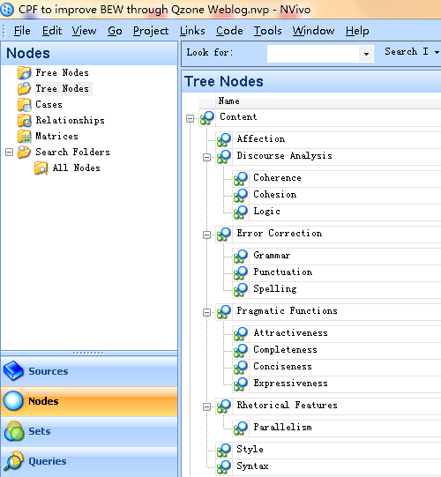
Figure 1: Tree nodes of content of critical peer feedback in Nvivo 10
The detailed seven nodes and their “children” nodes are modeled in Figure 2.
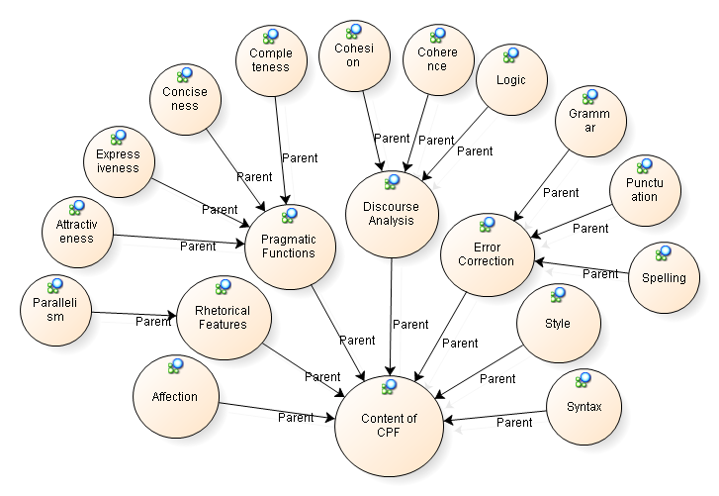

Figure 2: Nodes of the content of critical peer feedback in QSR Nvivo 10

Error correction
The case participants point out that their first action in critical peer feedback is to correct errors on grammar, punctuation and spelling. Error correction cannot be neglected in critical peer feedback on Business English writing. Although they believe that their Business English writing is a vantage or higher-level English writing and errors should not appear. In this study of data, the fact is that there are still many errors in their Business English writings. The case participants can find many errors on grammar, punctuation and spelling. Error correction is still a major part of critical peer feedback in Business English writing.
Generally, when I evaluate a writing, the first viewed in my eyes is grammar errors, the second is style, and the third is wording, and then rhetoric like parallelism, the affective languages. The last is special feature which can attract me.
(Cited from Interview Transcript/ CP3/ 09 Oct., 2015)
You can comment the basic grammar errors, and then the sentences cohesion. You should find something basic, and then have a look on the affective expressions.
(Cited from Interview Transcript/ CP5/ 23 Oct., 2015)
From the interview transcripts of CP3 and CP4, their first action of assessing a writing is to correct the grammar errors. However, in their artifacts of critical peer feedback, there are also many grammar, spelling and punctuation error, which has become a very serious problem in their critical peer feedback.
CP5: 2015-12-23 13:07:30
in my opinion, we, several did not have a better understanding to the 'definition of the report' or how to organise a report, and i think [...].
CP4: 2015-12-23 14:26:11
about the finding ,it's too long,and not very clear.
CP6: 2015-12-29 12:02:25
i think the finding has som problems.the imformation is not specific and correct.
(Cited from CPF Artifacts-CP3/CP3/A6)
In the artifact of CP3, the three case participants of CP4, CP5, and CP6 provide their critical peer feedback on her writing. However, there are many errors in the feedback language such as grammar error of capitalization in the initial word, spelling error of “organise” instead of “organize”, “som” instead of “some”, “imformation” instead of “information”, and punctuation errors like comma, ‘single quotation’ instead of “double quotation”. These errors and mistakes in writing and critical peer feedback artifacts shall be concerned by the teachers in their practice of critical peer feedback. It is necessary to enhance the supervision in proofreading and editing to eliminate these errors in Business English writing.

Discourse analysis
Discourse refers to the “text” or the “sequence of sentences”, and discourse analysis refers to the study of the structure of sentences (Tannen, Hamilton, & Schiffrin, 2015, pp. 11-16). In the study of discourse analysis, there are many critical parts such as register, genre, cohesion, coherence and logic, etc.
In the process of critical peer feedback, the case participants realize the importance of cohesion, coherence and logic of sentences in Business English writing. In their critical peer feedback, they give their feedback on three main aspects for a general discourse analysis. In the following example, CP2 directs that he not only pays attention to the error correction, but also the sentence logic, cohesion and coherence. His feedback is also concerned with clearness and accuracy of expression in Business English writing.
At the beginning of this study, I pay much attention to the grammar errors, and not check the sentence logic. But now, I prefer to study its sentence logic, the cohesion and coherence. Whether or not they are clear, is very important to the writing.
(Cited from Interview Transcript/ CP2/ 23 Oct., 2015)

Pragmatic functions
Business English writing is vocational English writing with specific objectives. The writing objectives are purposeful with clear purposes, application fields, targeted audience, and special language. In order to fulfill these purposes, the pragmatic functions need to be highlighted such as “clearness, conciseness and courtesy” (Chen, 2005), and “accuracy, clarity and simplicity” (Gartside, 1976).
Based on the QSR Nvivo 10 data analysis of interview transcripts and feedback artifacts, the case participants recognized the importance of understanding pragmatic functions in Business English writing I will have a comprehensive study of the writing about grammar errors, the completeness of the writing tasks, cohesion, coherence, and some points which can attract me for further reading. Most of our writings are similar, so I’d like to read the special one, the difference with others. (Cited from Interview Transcript/ CP2/ 23 Oct., 2015)
I have a look whether their writing is completed in sentence structure, and writing tasks. I’d like to check the attractiveness. Are there some attractive, amazing parts in the writing? Are there something new and creative? I think the language should be simple, clear and concise. This can give us a feeling of reality and authenticity. (Cited from Interview Transcript/ CP4/ 09 Oct., 2015).
They mentioned pragmatic functions in the data sources in four parts: completeness, conciseness, expressiveness, and attractiveness. “Completeness” refers to meeting requirements of the writing tasks and the correctness of the sentences. “Conciseness” refers to the clarity, accuracy, and clearness of the writing sentences and structures. “Expressiveness” refers to the smoothness and readability of the writing. “Attractiveness” refers to a writing quality which can elicit interest or desire in the readers for a successful business.
In these two examples of interview transcripts, CP2 and CP4 mention the pragmatic functions of completeness, conciseness and attractiveness in Business English writing. They have recognized these pragmatic functions to use as rubrics to assess a writing.

Rhetoric feature
Rhetorical features in writing refers to a vast array of rhetorical figures such as repetition, parallelism, hyperbole, overstatement and understatement, etc. Business English writing pursues conciseness, clarity, simplification and persuasiveness for the successful business communication. However, rhetorical features are also needed to enhance the expressiveness and affection at some styles.
If I give a writing now, I will check first the grammar, second the style, third the rhetorical feature like parallelism, and the affective languages. Is there something I can improve like rhetoric? (Cited from Interview Transcript/CP3/09 Oct., 2015)
In the example, the rhetorical features are mentioned by CP3 as one part for critical peer feedback. CP3 argues that the rhetorical feature of parallelism cannot be neglected in Business English writing. Other types of rhetorical features shall be recognized and improved in Business English writing.

Affection
Affection refers to the affective languages to persuade and express some kinds of emotions in Business English writing. The readers are the potential customers of the writers in business activities. The readers are emotional figures who need the affective languages in business communications such as greeting, expressions of sorry and pardon, expressions of forgiveness, and expressions of complaint, etc. Affective languages are widely used in the business letter writing.
The case participants argue the importance of affective languages in Business English writing. They insist that affective expressions are very important for a successful business writing. However, the affective expressions must cater for the situation of the business writing with proper emotional expressions. The abused affection in business writing may become an obstacle to a successful business negotiation.
If I give a writing now, I will check first the grammar, second the style, third the rhetorical features like parallelism, and the affective languages. Is there something I can improve like rhetoric? (Cited from Interview Transcript/CP3/09 Oct., 2015)
CP3: 2015-10-19 12:46:20
First, maybe you can praise or appreciate the school using thankful languages in this congratulation letter. I think it will be better.
Second, if it is possible, you can encourage him to study continually, as far as I am concerned.
CP1: 2015-10-19 10:45:07
Your language in this congratulation letter is oral language which may make the reader feel that you are a close friend of her, very intimate and comfortable. By the way, you should pay attention to your style of letter.
(Cited from CPF-Artifacts-CP4/CP4/A3)
At the example, CP3 mentions that she likes to assess the affective languages whether it is suitable for the different situations. At example 44, CP3 indicates the usage of affective languages in CP4’s writing and CP1 encourages the use of oral English and affective languages in congratulation writing.

Style
According to the syllabus of Business English Writing, they are many kinds of Business English writing styles such as business letter, e-mail, memo, notice, business report, product description writing and academic writing, etc. Each kind of business writing has a special style which is different from others. The corrective style is a basic requirement in business writing, which is not only concerned with a successful writing but also the impression and professionalization of the company.
The case participants argue the importance of styles in business English writing. The correction of style is a main part of critical peer feedback, which is a meta-cognition of Business English writing.
The style is also very important. If your style is not right, your writing may be not good. That’s to say that you don’t grasp the basic knowledge of business writing. Although there are few style errors, it still could be found more or less. (Cited from Interview Transcript/CP5/23 Oct., 2015)
First, you should pay attention to your style. It is messed up totally. You need make them align on the left. I think you shall put your e-mail and phone number at the end of the writing. Finally, you need make your resume more attractive, to attract their eyes on your capability. (Cited from CPF-Artifacts-CP1/CP1/A1)
In the first example, CP5 implies the importance of style for Business English writing which represents not only a writing but also your business experiences. In the second example, CP1 makes his critical peer feedback on the style of resume writing in Business English writing.

Syntax
Syntax is the study of how sentences are organized and constructed with the principles and processes (Chomsky, 2002, pp. 11). At the study of Business English writing, sentence writing is a difficult point because of the particular sentence patterns and native language transfer. English sentence structure is different with Chinese sentence structure. The Chinese sentence structure will impact the cognition of English sentence structure in not only a positive way but a negative aspect.
Therefore, there are always many uncompleted sentences or disordered sentences in Business English writing by the negative transfer of Chinese language. The case participants have realized this phenomenon in their writing activities. During their critical peer feedback, they will assess the completeness of sentences, and then offer their critical peer feedback on syntax.
The most basic is to check his sentences, to find out what the problems exit in his sentences. Then, I will go to the writing task and logic, to study the problems on whether he has finished the writing tasks and whether the writing is logical. (Cited from Interview Transcript/CP2/23 Oct., 2015)
CP5: 2015-11-19 14:33:41
The body is simple but you express the general idea. I think it is good, but I wonder if the subject can be expressed in this way.
CP2: 2015-11-20 12:36:25
Simple and clear expression, it's good. But I think it’s better to use Imperative Sentence in the end.
(Cited from CPF-Artifacts-CP4/CP4/A4)
In the first example, CP2 emphasizes that he will assess the sentence structure firstly. The correctness of sentence structure and syntax is the basic for Business English writing. In the second example, CP5 and CP2 offer their critical peer feedback on the sentences and try to give some suggestions to improve the sentence writing.
However, they are many sentence modules in Business English writing. In other words, these fixed sentence modules and expressions are widely used in Business English writing. It is necessary to assess the corrective usages of these sentence modules which is helpful for the efficiency and formality of Business English writing.

Conclusion
Before this study, the case participants insisted their content at a peer feedback would be to find errors and correct errors. Their only activity in peer feedback is error correction on grammar, spelling and punctuation. With the study of critical peer feedback, they have realized that there are other aspects to be assessed except errors. They believe that Business English writing is a vocational and LSP higher-level writing with particular features on syntax, style, pragmatic functions and affection. These particular features in Business English writing need to be improved during critical peer feedback.
Based on the data analysis, these seven parts are highlighted by the case participants in their peer feedback including error correction, discourse analysis, pragmatic functions, rhetoric features, affection, style, and syntax (see Table 2). And the mentioned aspects of the seven parts of content in critical peer feedback are listed in the following table.

Table 2

The content of critical peer feedback in Business English writing
Error Correction | Grammar  Spelling  Punctuation | Rhetoric Features | Parallelism
Discourse Analysis | Cohesion  Coherence  Logic | Affection | Thanks  Congratulation
Pragmatic Functions | Completeness  Conciseness  Expressiveness  Attractiveness | Style | E-mail  Resume  Business Card  Memo  Business Letter  Business Report
Syntax | Cohesion  Coherence
However, the case participants can not conclude all the content of each parts in the practice of their critical peer feedback, which are only parts of it. The content of critical peer feedback includes not only the error correction of language, but also the every aspects of Business English writing, in addition to the consideration of successful business communication.

References
Bijami, M. (2013). Peer feedback in learning English writing: Advantages and disadvantages. Journal of Studies in Education, 3 (4), 91-98.
Chen J. P. (2005). Language characters and its translation in business contract English. Chinese Translators Journal, 7, 23-28.
Chomsky, N. (2002). Syntactic Structure. Mouton de Gruyter, Berlin & New York.
Duron, R., Limbach, B., & Waugh, W. (2006). Critical thinking framework for any discipline. International Journal of Teaching and Learning in Higher Education, 17 (2), 160-166.
Ertmer, P. A., Richardson, J. C., Belland, B., Camin, D., Connolly, P., Coulthard, G., Mong, C. (2007). Using peer feedback to enhance the quality of student online postings: An exploratory study. Journal of Computer‐Mediated Communication, 12(2), 412-433.
Fazio, L. (2001). The effect of corrections and commentaries on the journal writing accuracy of minority-and-majority language students. Journal of Second Language Writing, 10(4), 235-249.
Ferris, D. (2004). The “grammar correction” debate in L2 writing: Where are we, and where do we go from here? (and what do we do in the meantime...?). Journal of Second Language Writing, 13(1), 49-62.
Ferris, D. (2006). Does error feedback help student writers? New evidence on the short-and long-term effects of written error correction. In K. Hyland & F. Hyland (eds.), 81-104.
Forehand, M. (2005). Bloom’s taxonomy: Original and revised. In M. Orey (Ed.), Emerging perspectives on learning, teaching, and technology. Create Space Independent Publishing Platform.
Gartside, L. (1976). Modern business correspondence (3rd Ed.). Macdonald & Evans.
Gielen, M., & De Waver, B. (2015). Structuring peer assessment: Comparing the impact of the degree of structure on peer feedback content. Computers in Human Behavior, 52, 315-325. doi: 10.1016/j.chb.2015.06.019.
Hyland, K & Hyland, F. (2006). Feedback on second language students’ writing. Language Teaching, 39, pp 83-101 doi:10.1017/S0261444806003399.
Konold, C., & Miller, C. D. (2005). TinkerPlots: Dynamic data exploration. Emeryville, CA: Key Curriculum Press.
Nelson, M. M., & Schunn, C. D. (2009). The nature of feedback: How different types of peer feedback affect writing performance. Instructional Science, 37(4), 375-401.
Olson, M. W., & Raffeld, P. (1987). The effects of written comments on the quality of student compositions and the learning of content. Reading Psychology, 8, 273 - 293.
Paul, R. W., & Elder, L. (2012). The miniature guide to critical thinking: Concepts and tools. Tomales, CA: Foundation for Critical Thinking Press.
Reichenbach, B. R. (2001). An introduction to critical thinking. McGraw Hill Higher Education.
Strijbos, J., Narciss, S., & Dunnebier, K. (2010). Peer feedback content and sender’s competence level in academic writing revision tasks: Are they critical for feedback perceptions and efficiency? Learning and Instruction, 20, 291-303.
Storch, N. (2005). Collaborative writing: Product, process, and students’ reflections. Journal of Second Language Writing, 14(3), 153-173.
Tannen, D., Hamilton H. E., & Schiffrin, D. (2015). The handbook of discourse analysis (2nd). Wiley-Blackwell.
Zhang, S. (1995). Re-examining the affective advantages of peer feedback in the ESL writing class. Journal of Second Language Writing, 4, 209-222.
Zhang, Z. C. (2008). Business English: Theories and practice. Beijing: University of International Business and Economics Press.

About the authors
Gao Xianwei (PhD student) is now learning at Faculty of Education, University of Malaya. He is a lecturer at School of Foreign Languages, Xuchang University in China. He has published articles in many scholarly journals and presented academic papers in international conferences. His research interests include TESL, Business English Study and English for Specific Purposes.
E-mail:gaoxw2013@gmail.com
Moses Samuel (Prof. Dr.) is a professor at Faculty of Education, University of Malaya. He has published articles in many scholarly journals and presented academic papers in international conferences. His research interests include TESL, instruction, L2 writing, discourse analysis, and collaborative learning.
E-mail:mosess@um.edu.my
Adelina Asmawi (PhD) is a lecturer and deputy dean at Faculty of Education, University of Malaya. She has published articles in many scholarly journals and presented academic papers in international conferences. Her research interests include TESL, instruction, education technology, and second language acquisition.
E-mail: adelina@um.edu.my

Return to Table of Contents
Editor’s Note: According to the author, “the main contribution of this paper is investigation of teachers’ attitudes, perceptions, experience, and expectation on integration of social network sites into the ESL/EFL instructional setting. It explores in what manner this integration supports and enhances students’ language learning experiences, specifically in Middle Eastern languages. This contribution is theoretically and practically relevant because social networking has become an integral part of modern society. Teachers as practitioners need to be updated and upgraded with the knowledge and skills to cater to these emerging technologies and user applications in their daily instruction.” . . .

Social Network Sites Integration and Effectiveness through EFL/ESL Teachers’ Viewpoints

Sulaiman A. Alnujaidi

Saudi Arabia

Abstract
This study investigated the relationship between ESL/EFL teachers’ experiences, attitudes, perceptions, and expectations toward the integration and effectiveness of Social Network Sites (SNS) in English instruction. A questionnaire-based survey of 107 participants from several higher education institutions in Saudi Arabia revealed the participants’ average SNS usage experience (m = 2.60, SD = 1.22), their overall positive attitude (m = 3.44, SD=1.8), positive perceptions (m = 3.87, SD = 0.92), and positive expectations (m= 3.7, SD=0.92). Furthermore, the correlations between experience and attitudes (r = .767, p = .000), and experience and perceptions (r = .861, p = .000) were statistically significant. Attitudes and perceptions significantly correlated at r = .796, p = .000, and attitudes and expectations significantly correlated at r = .350, p = .000. However, experience did not significantly correlate with expectations (r = .187, p = .053), nor did perceptions with expectations (r = .140, p = .149). A multiple regression analysis was performed to determine if the three-variable model (attitudes, perceptions, and expectations) predicts the SNS experience variable: The model was significant at 0.01, R2 = .759, adjusted R2 = .752, F (3, 103) = 108.043, p = .000. The significant predictors were attitudes and perceptions.
Keywords: Social Networking Sites (SNS), English as a Second Language (ESL), English as a Foreign Language (EFL), Teaching English as a Second Language (TESL), Teaching English as a Foreign Language (TEFL), Facebook, Twitter, YouTube, Instagram, MySpace

Introduction
Social Network Sites (SNS), such as Facebook, Twitter, YouTube, Instagram, and MySpace, have attracted millions of users, many of whom have integrated these sites into their daily practices and connect with other users based on shared interests, political views, or activities (Clarkson, 2013). Some SNS tools target diverse audiences, while others attract people based on shared linguistic, racial, sexual, religious, or nationality-based identities (Boyd & Ellison, 2007).
According to Boyd and Ellison (2007), SNS allow individuals to "(1) construct a public or semi-public profile within a bounded system, (2) articulate a list of other users with whom they share a connection, and (3) view and traverse their list of connections and those made by others within the system" (p. 1). Duffy (2011) identified five common features of SNS: "a user can (a) create a profile, (b) find peers online, (c) publicly erect or confirm peer connections, (d) collaborate to share content, and (e) form online communities" (p. 286).
Current views on language teaching emphasize the vital role of communicative and cultural competence in language learning. Canale and Swain (1980) listed four components of communicative competence: grammatical competence (words and rules), sociolinguistic competence (appropriateness), discourse competence (cohesion and coherence), and strategic competence (appropriate use of communication strategies). Cultural competence is the ability to interact effectively with people across different cultures. It has four components: an awareness of one’s own cultural worldview, positive attitude towards cultural differences, knowledge of different cultural practices and worldviews, cross-cultural communication skills (Fenner, 2008). Social network sites (SNS) have been proven to enhance both communicative and cultural competence (Borau et al., 2009).
This research study aims to investigate the relationship between ESL/EFL teachers' experiences, attitudes, perceptions, and expectations toward the integration and effectiveness of SNS in English language teaching.

Literature review
The vast popularity of SNS has created new opportunities for language learners and teachers to interact in authentic ways that were previously difficult to achieve (Chartrand, 2012). Current research on the use of Web 2.0 technologies in second language (L2) learning revealed that "second language learning/acquisition research has been experiencing a paradigm shift: It is moving from a cognitive orientation to a social orientation, from classroom contexts to naturalistic settings, from an acquisition metaphor to a participation metaphor, and from L2 learning to L2 use" (Wang & Vasquez, 2012, p. 413); therefore, the application of Web 2.0 technologies in many L2 learning contexts has transformed pedagogy, curriculum design, language learning conception, and even the research in this field (Wang & Vasquez, 2012). Ellison (2008) argued that SNS products and applications are rapidly evolving while universities are exploring new ways to implement SNS, and faculty members are experimenting with SNS to support learning. She also asserted that higher education institutions should understand students’ SNS practices because "they are fundamentally changing the social fabric of the university" (p. 19). SNS contribute in fostering positive relationships among students and providing many opportunities for them to interact with peers, instructors and native speakers (Blattner & Fiori, 2009).
A growing number of university professors use Twitter to connect with colleagues around the country as well as in the classroom to retain student engagement and encourage dialogue (The Faculty Focus, 2009). The potential educational uses of Twitter stem from its ability to create a classroom community, promote collaborative writing, foster editing skills, develop literacy skills, provide reader response, offer students opportunities to discuss issues in formal and informal settings, provide collaboration across institutions and borders, enhance group-project management, assess opinion and examine consensus, foster interaction about a given topic, and finally enhance metacognition (Grosseck & Holotescu, 2008). Manca and Ranieri (2016) examined how higher education scholars are using social media for personal, teaching, and professional purposes. Their study showed that social media use is still limited and restricted, that is, the frequency of personal use is mostly associated with the frequency of professional use, and prior experience with e-learning is greatly associated with social media use. By incorporating Twitter in the classroom, students and the faculty “were able to engage in sharing, collaboration, brainstorming, problem solving, and creating moment-to-moment experiences” (Dunlap & Lowenthal, 2009, p.47).
SNS integration into ESL teaching was found to "broaden students’ knowledge, increase their motivation, and build confidence in learning ESL writing" (Yunus, Salehi, & Chenzi, 2012, p. 16). Both teachers and students should have relevant technical skills to maximize on SNS potentials (Yunus et al., 2012). SNS has also been proven to facilitate dynamic communication inside and outside classrooms, create a sense of community and belonging, provide authentic exposure to English, and stimulate motivation to learn English in an authentic fashion (Kikuchi & Otsuka, 2008). Not only could SNS assist in the acquisition of lower thinking skills (e.g., basic vocabulary), but it could also offer language learners opportunities to acquire higher proficiency skills with more complex structures that involve conceptual learning (Alm, 2006). Furthermore, Ho-Abdullah, Hashim, Jaludin, and Ismail (2011) examined how web-based social networking can be used to provide ESL students with the opportunity to use English and to reflect on and improve ESL teachers’ practices. They found that web-based social networking encouraged students’ English language use in informal settings. Many EFL writing, listening, vocabulary, and research activities can be initiated and incorporated through Twitter because “Twitter not only provides an alternative medium through which to improve students’ written communication skills, but also their analytical, collaborative, and social networking skills” (Mork, 2009, p. 51).
The present ESL/EFL teachers are faced with many technological advances that present challenges as well as opportunities to their profession. This concern was clearly expressed by an EFL teacher who stated that “EFL teachers are dealing with technologically savvy students and often competing for their students’ attention with the latest gadgetry. Even the most dynamic EFL teacher is going to be operating at a loss when it comes to YouTube and Twitter being secretly watched and talked about beneath desks and behind folded books” (Morris, 2011, p. 1).
Although there is much enthusiasm about SNS’ potential, there remains insufficient evidence-based research on SNS use as instructional tools for L2 learners, or whether teachers and students would perceive SNS to be useful in teaching ESL/EFL in Saudi Arabia. As experiences, attitudes, perceptions, and expectations can influence the stakeholders’ use of SNS, it is critically important to understand carefully and study the experiences, attitudes, perceptions, and expectations of ESL/EFL teachers toward the integration and effectiveness of SNS in the ESL/EFL instructional process in Saudi Arabia.

Purpose of the study
There remains insufficient research on the relationship between ESL/EFL teachers’ experiences, attitudes, perceptions, and expectations toward the integration and effectiveness of SNS in English language instruction. Given the scarcity of research on this topic, this study will address the following research questions:
- What are the experiences of ESL/EFL teachers in SNS?
- What are the attitudes of ESL/EFL teachers toward the integration and effectiveness of SNS in English language teaching?
- What are the perceptions of ESL/EFL teachers toward the integration and effectiveness of SNS in English language teaching?
- What are the expectations of ESL/EFL teachers toward the integration and effectiveness of SNS in English language teaching?
- Is there a statistically significant relationship between ESL/EFL teachers' experiences, attitudes, perceptions, and expectations toward the integration and effectiveness of SNS in English language teaching?

Study methods
To investigate this study's research questions, a descriptive-correlational research design was employed “to learn about the relationship among variables and to make predictions based on an understanding of the relationship” (Johnson & Christensen, 2000, p. 26) and to “determine relationships among two or more variables without necessarily inferring causality” (Swanson & Holton, 1997, p. 70).
Data was collected from a sample of ESL/EFL teachers (N=107) in several Saudi higher education institutions that included male, female, Saudi, and non-Saudi ESL/EFL teachers holding different academic positions (i.e., teachers, lecturers, assistant professors, associate professors, and professors). The data collection instrument was a survey questionnaire to obtain information about perceptions, feelings, thoughts, and beliefs (Johnson & Christensen, 2000). This study used the “Information and Communication Technology (ICT) Use in English Teaching” adapted from the University of Warwick: ICT was replaced with SNS to fit this study’s scope. The questionnaire comprised five parts with 63 items. The first part consisted of five items on the participants’ demographics. The second part consisted of 10 items to identify the participants’ SNS experiences. The third and fourth parts comprised 10 Likert-scale items designed to identify participants’ attitudes and 20 Likert-scale items to identify participants’ perceptions toward SNS, respectively. The fifth part consisted of 18 Likert-scale items designed to identify the participants’ SNS expectations.

Validity and reliability
This study utilized the “ICT Use in English Teaching” from the University of Warwick. This instrument has been widely used in several studies on technology adoption and integration in instruction; however, ICT was replaced with SNS for this study. The Cronbach’s alpha reliability coefficients of the instrument indicated a high level of internal consistency.

Study results

Participants' demographics
Gender and age. The descriptive analysis of the participants' gender and age (Appendix A) showed that 51.4% of the participants were males, and 48.6% were females. The majority 38.3% of participants were between 22-30 years old. Additionally, results revealed that the majority of male participants (17.8%) were between 31-39 years old while the majority of female participants (27.1%) were between 22-30 years old.
Academic rank. The descriptive analysis in Appendix B showed that the majority (45.8%) were lecturers, while the least number (2.8%) were professors. Among male participants, 29.0% were lecturers, while the majority of female participants were both lecturers (16.8%) and teachers (16.8%).
Nationality. The descriptive analysis in Appendix A revealed that 57.9% of participants were non-Saudi: Among the non-Saudi participants, 32.7% were males while the majority of Saudi participants (23.4%) were females.
Major. The descriptive analysis of participants' major (Appendix B) showed that the majority of participants (33.6%) majored in Linguistics while the least participants (8.4%) majored in Translation. The 21.5% majority of male participants were Linguistics majors whereas the 16.8% majority of female participants were TESL/TEFL majors.

What are the experiences of ESL/EFL teachers in SNS?
For this research question, 10 items were administered to identify participants’ experiences in some of the popular SNS tools. The statistical analysis in figure 1 showed that participants' overall experience in SNS was average (m = 2.60, SD = 1.22) but recorded very good experience with YouTube (4.28) and good experience with Facebook (3.78). However, they rated average experience with Twitter (3.15), Google Plus (2.72), Instagram (2.55), Academia (2.26), and Classmate (1.97); conversely, participants rated poor experience with Flickr (1.79), English Baby (1.79), and MySpace (1.77).

Figure 1. Descriptive Statistics for Participants' Experiences in SNS Tools.
Note: For mean scores above 4, the experience level is deemed very high.

What are the attitudes of ESL/EFL teachers toward the integration and effectiveness of SNS in English language teaching?
For this research question, participants were asked 10 Likert-scale items to identify their attitudes toward SNS integration and effectiveness in ESL/EFL instruction. The statistical analysis in figure 2 showed that participants had an overall positive attitude toward SNS (m = 3.44, SD =1.8) particularly for chatting with others and for teaching purposes including English teaching matters.

Figure 2. Descriptive Statistics for Participants' Attitudes toward SNS.
Note: Mean score >3= Positive Attitude, <3= Neutral Attitude

What are the perceptions of ESL/EFL teachers toward the integration and effectiveness of SNS in English language teaching?
To answer this research question, participants responded to 20 Likert-scale items to identify their perceptions toward SNS integration and effectiveness in ESL/EFL instruction. In figure 3, statistical analysis indicated that participants had overall positive perceptions toward SNS (m = 3.87, SD = 0.92). Among all the items, most of the participants strongly agreed that SNS could enable students to create an international network and present an authentic platform for the practice and use of communicative English. Furthermore, they believed strongly in use of SNS to enhance English teaching. However, there appears to be a low agreement in teachers changing their traditional methods of teaching and reverting to the use of SNS as their main teaching tool.

Figure 3. Descriptive Statistics for Participants' Perceptions toward SNS.
Note: All participants were in agreement except for items indicated by * to mean strong agreement
and ** for disagreement.

What are the expectations of ESL/EFL teachers toward the integration and effectiveness of SNS in English language teaching?
For this research question, 20 Likert-scale items were administered to identify participants’ expectations toward SNS integration and effectiveness in ESL/EFL instruction. The analysis in figure 4 showed that participants had overall positive expectations toward SNS (m = 3.7, SD = 0.92). Most of the participants agreed that SNS use could provide more interactive activities for students and avenues for more practical English knowledge. However, participants were neutral toward increasing SNS use and SNS-related materials in English instruction.

Figure 4. Descriptive Statistics for Participants' Expectations toward SNS.
Note: All participants were in agreement except in items
marked with * to mean a neutral expectation.

Is there a statistically significant relationship between ESL/EFL teachers' experiences, attitudes, perceptions, and expectations toward the integration and effectiveness of SNS in English language teaching?
To answer this research question, Pearson Correlation Coefficients were employed and the data analysis (see Table 1) revealed that the correlations between experiences and attitudes (r = .767,
p = .000) and experiences and perceptions (r = .861, p = .000) were statistically significant. The data analysis also showed that the correlations between attitudes and perceptions (r = .796, p = .000) and attitudes and expectations (r = .350, p = .000) were statistically significant. However, the results showed that experiences did not significantly correlate with expectations (r = .187, p = .053), and perceptions did not significantly correlate with expectations (r = .140, p = .149).

Table 1

Correlation Coefficients Analysis for Participants' Variables
 |  | Experience | Attitudes | Perceptions | Expectations
Experience | Pearson Correlation |  | .767** | .861** | .187
 | Sig. (2-tailed) | - | .000 | .000 | .053
 | N |  | 107 | 107 | 107
Attitudes | Pearson Correlation | .767** |  | .796** | .350**
 | Sig. (2-tailed) | .000 | - | .000 | .000
 | N | 107 |  | 107 | 107
Perceptions | Pearson Correlation | .861** | .796** |  | .140
 | Sig. (2-tailed) | .000 | .000 | - | .149
 | N | 107 | 107 |  | 107
Expectations | Pearson Correlation | .187 | .350** | .140
 | Sig. (2-tailed) | .053 | .000 | .149 | -
 | N | 107 | 107 | 107
** Correlation is significant at the 0.01 level (2-tailed)

Study discussion and conclusions
The findings revealed that the majority of participants were in the age category between 22-30 years old, held MA degrees (lecturers), were non-Saudi, and majored in Linguistics. The findings showed that the participants had overall average experiences in SNS, and they were most experienced with YouTube, Facebook, and Twitter.
The findings also indicated that participants had overall positive attitudes, perceptions, and expectations toward SNS. The results revealed that the correlations between experience and attitudes and experience and perceptions were statistically significant. Results also showed that the correlations between attitudes and perceptions and attitudes and expectations were statistically significant. However, the data analysis revealed that experience did not significantly correlate with expectations, and perceptions did not significantly correlate with expectations. The findings also indicated that the model of the three variables (attitudes, perceptions, and expectations toward SNS) predicting the variable (experiences in SNS) was statistically significant with attitudes and perceptions as the significant predictors.

The findings of this study indicated that ESL/EFL teachers in the Saudi higher education institutions have average but positive experiences, and positive attitudes and perceptions toward SNS. Higher education institutions in Saudi Arabia have invested substantially on establishing the infrastructure of their campuses. However, for a successful SNS implementation in English instruction, focus should be given to the instructional process, professional development, and SNS integration in ESL/EFL teaching. ESL/EFL teachers should be provided with opportunities for professional development on SNS integration through workshops, seminars, and conferences. They need continuous training on effective strategies for SNS integration in their teaching methodologies to improve their instructional performance and empower their students' learning experiences. Teachers need to learn the best practices associated with SNS integration to apply effectually its use as a fundamental component of their ESL/EFL teaching process. They should also be supported technically to enhance their SNS adoption and integration and manage any technical difficulties that may surface before and during the integration process. Incentives
(e.g., financial rewards and awards) should also be granted to the teachers that have effectively integrated SNS in their instruction. The learning environment should also be equipped with all necessary equipment so that ESL/EFL teachers would become motivated to adopt and integrate SNS in their teaching process. Finally, higher education institutions in Saudi Arabia need to encourage more collaboration among the ESL/EFL teachers by providing opportunities for the teachers to demonstrate to and share with their colleagues the benefits derived from SNS integration in their teaching process and toward their students' achievement.

Implications for future research
The results of this study suggest that further research studies could be conducted in order to better address the SNS issue in ESL/EFL teaching. The following recommendations may be considered for further investigation:
- This study examined ESL/EFL teachers’ experiences, attitudes, perceptions, and expectations toward SNS in English language teaching. Future research should also examine students’ learning styles, social status, and cultural competence.
- This study employed ICT as a theoretical framework. Future research should employ other models that address SNS integration in educational settings.
- This study was limited to ESL/EFL teachers’ experiences, attitudes, perceptions, and expectations toward SNS. Future research should include other fields where SNS adoption and integration have become the general integral part of the teaching process.
- This study used a quantitative approach to investigate ESL/EFL teachers’ experiences, attitudes, perceptions, and expectations toward SNS. Future research should employ a qualitative approach as well for a detailed examination on this issue.
- Future studies may address the personal, technical, and institutional challenges faced by teachers while using SNS such as the lack of clear policies on SNS use in instruction and the clear distinction between educational and personal social networking in classroom settings.

References
Alm, A. (2006). CALL for autonomy, competence, and relatedness: Motivating language learning environments in Web 2.0. The JALT CALL Journal, 2(3), 29-38.
Boyd, D.M., & Ellison, N.B. (2007). Social network sites: Definition, history, and scholarship. Journal of Computer-Mediated Communication, 13(1), 11.
Blattner, G., & Fiori, M. (2009). Facebook in the language classroom: Promises and possibilities. International Journal of Instructional Technology, 6(1), 17-28.
Borau, K., Ullrich, C., Feng, J., & Shen, R. (2009). Microblogging for language learning: Using Twitter to train communicative and cultural competence. Advances in web learning–ICWL, Lecture Notes in Computer Science, 5686, 78-87.
Canale, M., & Swain, M. (1980). Theoretical bases of communicative approaches to second language teaching and testing. Applied Linguistics, 1, 1-47.
Chartrand, R. (2012). Social networking for language learners: Creating meaningful output with Web 2.0 tools. Knowledge Management & E-Learning: An International Journal, 4(1), 97-101.
Clarkson, K. (2013). Usage of Social Network Sites amongst University Students. Munich, Germany: Grin Verlag.
Duffy, P. (2011). Facebook or faceblock: Cautionary tales exploring the rise of social networking within tertiary education. In C. McLoughlin & M. Lee (Eds.), Web 2.0-based E-learning: Applying social informatics for tertiary teaching (pp. 284-300). Hershey, PA: Information Science.
Dunlap, J., & Lowenthal, P.R. (2009). Instructional uses of Twitter. In P. R. Lowenthal, D. Thomas, A. Thai, & B. Yuhnke (Eds.), The CU Online Handbook: Teach Differently: Create and collaborate (pp. 46-52). Raleigh, NC: Lulu Enterprises.
Ellison, N.B. (2008). Introduction: Reshaping campus communication and community through social network sites. The ECAR Study of Undergraduate Students and Information Technology, 8, 19-32.
Fenner, A.B. (2008). Cultural awareness in the foreign language classroom. In J. Cenoz & N. H. Hornberger (Eds.) Encyclopedia of Language and Education, (pp. 273-285). New York: Springer Science + Business Media LLC.
Grosseck, G., & Holotescu, C. (2008). Can we use Twitter for educational activities?, presented at the 4th International Scientific Conference, eLearning and Software for Education, Bucharest, Romania, April 2008.
Ho-Abdullah, I., Hashim, R. S., Jaludin, A., & Ismail, R. (2011). Enhancing opportunities for language use through web-based social networking. International Conference on Social Science and Humanity, 5, 136-139.
Johnson, B., & Christensen, L. (2000). Educational research: Quantitative & qualitative approaches. Boston, MA: Allyn & Bacon.
Kikuchi, K., & Otsuka, T. (2008). Investigating the use of social networking services in Japanese EFL classrooms. The JALT CALL Journal, 4(1), 40-52.
Manca, S. & Ranieri, M. (2016). “Yes for sharing, no for teaching!”: Social media in academic practices. The Internet and Higher Education, 29, 63-74.
Mork, C. (2009). Using Twitter in EFL Education. The JALT CALL Journal, 5(3). 41-56.
Morris, N.O. (2011). Using Technology in the EFL Classroom in Saudi Arabia. MA TESOL Collection. Paper 511. Retrieved from http://digitalcollections.sit.edu/cgi/viewcontent.cgi?article=1514&context=ipp_collection
Swanson, R. A., & Holton, E. F. (1997). Human resource development research handbook: Linking research and practice. San Francisco, CA: Berrett-Koehler Publishers, Inc.
The Faculty Focus. (2009). Twitter in higher education 2009: Usage habits and trends of today’s college faculty. Retrieved from http://www.facultyfocus.com/free-reports/twitter-in-higher-education-usage-habits-and-trends-of-todays-college-faculty
Wang, S., & Vasquez, C. (2012). Web 2.0 and second language learning: What does the research tell us? The CALICO Journal, 29(3), 412-430.
Yunus, M., Salehi, H., & Chenzi, C. (2012). Integrating social networking tools into ESL writing classroom: Strengths and weaknesses. English Language Teaching, 5(8), 42-48.

Appendix A

Frequency Statistics for Participants' Age and Nationality
Gender |  | Age |  |  |  |  | Nationality
 |  | 22-30 | 31-39 | 40-48 | > 48 | Total | Saudi | Non- Saudi | Total
Male | Count | 12 | 19 | 14 | 10 | 55 | 20 | 35 | 55
 | % of Total | 11.2% | 17.8% | 13.1% | 9.3% | 51.4% | 18.7% | 32.7% | 51.4%
Female | Count | 29 | 13 | 6 | 4 | 52 | 25 | 27 | 52
 | % of Total | 27.1% | 12.1% | 5.6% | 3.7% | 48.6% | 23.4% | 25.2% | 48.6%
Total | Count | 41 | 32 | 20 | 14 | 107 | 45 | 62 | 107
 | % of Total | 38.3% | 29.9% | 18.7% | 13.1% | 100.0% | 42.1% | 57.9% | 100.0%

Appendix B

Frequency Statistics for Participants' Academic Rank and Major
Gender |  | Academic Rank |  |  |  |  |  |  |  | Major
 |  | 1 | 2 | 3 | 4 | 5 | 6 | 7 | Total | A | B | C | D | E | Total
Male | Count | 2 | 3 | 9 | 31 | 7 | 0 | 3 | 55 | 16 | 23 | 7 | 3 | 6 | 55
 | % of Total | 1.9% | 2.8% | 8.4% | 29.0% | 6.5% | 0.0% | 2.8% | 51.4% | 15.0% | 21.5% | 6.5% | 2.8% | 5.6% | 51.4%
Female | Count | 1 | 1 | 4 | 18 | 18 | 8 | 2 | 52 | 18 | 13 | 7 | 6 | 8 | 52
 | % of Total | 0.9% | 0.9% | 3.7% | 16.8% | 16.8% | 7.5% | 1.9% | 48.6% | 16.8% | 12.1% | 6.5% | 5.6% | 7.5% | 48.6%
Total | Count | 3 | 4 | 13 | 49 | 25 | 8 | 5 | 107 | 34 | 36 | 14 | 9 | 14 | 107
 | % of Total | 2.8% | 3.7% | 12.1% | 45.8% | 23.4% | 7.5% | 4.7% | 100.0% | 31.8% | 33.6% | 13.1% | 8.4% | 13.1% | 100.0%
Note: 1: Professor, 2: Associate Professor, 3: Assistant Professor, 4: Lecturer, 5: Teacher, 6: Teaching Assistant, 7: Other
A: TESL/TEFL, B: Linguistics, C: Literature, D: Translation, E: Other

About the author
Sulaiman A. Alnujaidi, received his PhD in TESL/TEFL from the University of Kansas, US. He is currently working as an assistant professor, College of Language and Translation, at the English Department, Imam Muhammad Ibn Saud University, Saudi Arabia. His major interests are Computer-Assisted Language Learning (CALL), Web-Assisted Language Learning (WALL), E-Learning, Language Acquisition, and Language Strategies.
Email address: sulaiman_alnujaidi@yahoo.com

Return to Table of Contents
Editor’s Note: A visual representation of the importance of words and verbal concepts can sometimes be useful in interpretation of data. This paper illustrates how word clouds created with Wordle may povicde supportive data.

Using Wordle in qualitative research:
a supplemental tool for case studies

Syntia Santos Dietz

USA

Abstract
Wordle is a creative word visualization tool that can be used on a variety of areas including research. This paper provides an example of how this innovative software can serve as a supplementary tool in qualitative research. Wordle was used on a qualitative case study exploring the study abroad experience of counselor education students. Wordle provided a visually rich way to acquire a basic understanding of the data and quickly visualize initial patterns in the text. Use and limitations of Wordle, findings produced through the software on the case study and are discussed along with implications for future research.
Keywords: Wordle, research tool, case study, qualitative research, word clouds, study abroad, counselor education, data visualization, novice researchers, data analysis, validation, instructional technology.

Introduction
Data visualization, the visual communication of data, has been used in various forms for hundreds and maybe even thousands of years. Popular methods that are still in use such as the line, bar, and pie chart, originated in the eighteenth century. The advancements in technology and cultural shifts have advanced data visualization as a field of study in the search towards greater transparency and accessibility of data. Even though the need to communicate data in effective ways will only increase, as a field data visualization is still in its early stages of diffusion and maturity (Kirk, 2012). This article aims to offer an insight of the use of Wordle, a data visualization tool, in qualitative research. The researcher will present the results drawn by Wordle as part of a case study exploring the study abroad experience of counselor education students. The use and limitations of Wordle, and its implications for research are discussed.

Data visualization
Data visualization serves as a way to communicate information through visual representation. It has been utilized in multiple disciplines for its ability to summarize and present data more clearly and effectively (Baralt, Pennestri, & Selvandin, 2011). Kirk (2012) defines data visualization as “the representation and presentation of data that exploit our visual perception abilities in order to amplify cognition,” with the representation of data refers to the transformation of raw material into a physical form that best portrays its attributes, and the presentation of data relates to the integration of the data representation and the overall communicated work (e.g. choice of colors, annotations, and interactive features). Kirk (2012) further describes that the ultimate goal of data visualization is to help the reader to become better informed about the subject under study.
Data visualization is a tool that may be used to support data analysis and the communication of study results. It helps to grab readers’ attention and become engaged with the data, resulting in a better understanding of the topic on hand (Azzam & Evergreen, 2013). Data visualization has increased in the past few years in academia and other contexts facilitating the understanding of complex events and phenomena by presenting data in a multimodal way. Data visualization tools have incorporated visual, textual, phonological and even animated input to help analyze raw data (Baralt, et al., 2011). According to Aparacio and Costa (2014), data visualization “changes the way people experience information.” They also stated that the subject of data analysis is fashionable and its major trends include infographics, mobility, social media, globalization, and science communication, among others.
Word clouds are one of the most popular forms of data visualization and are used to accentuate the main points of texted-based information. They present the most frequently used words, from the text under study, in the shape of a cloud. The size of the words represents the frequency of use. In other words, the more that a word is used in the text the bigger it appears in the cloud (Baralt, et al., 2011). A number of programs have been created to generate these word clouds, such as TagCrowd, MakeCloud, ToCloud, Tagxedo, Tagul, and wordsift (Baralt, et al., 2011; McNaught & Lam, 2010); however, the most popular word cloud generator is Wordle (Baralt, et al., 2011).
Word clouds have been proven useful as a supplementary research tool for preliminary analysis and validation of previous findings (McNaught & Lam, 2010); however, literature on the use of word clouds in qualitative research, and Wordle specifically, remains limited (Williams, Parkes, & Davies, 2013). This article aims to contribute to the understanding of the use of Wordle in qualitative research. Wordle was chosen for its visual impact, accessibility, simplicity, and versatility (Williams, et al., 2013; McNaught & Lam, 2010; Baralt, et al., 2011).

Wordle
Created in 2008 by IBM developer Jonathan Feinberg, Wordle was first described as “a toy” to generate word clouds (Hayes, 2008; Baralt, et al., 2011). Since then, Wordle has increased in popularity and proven to be a versatile, valuable, and user-friendly tool. Wordle has been used in different fields including educational research (McNaught & Lam, 2010), management education (Williams, et al., 2013), library science (Mallon, 2015), legal writing (Martin, 2012), and foreign language writing, (Baralta, et al., 2011). The use of data visualization has become more accessible through tools like Wordle. Users can easily create visualizations without requiring vast technical knowledge and training (Baralt, et al., 2011).
Wordle (www.wordle.net) is a free open access tool that generates word clouds of large amounts of written data, highlighting the words that most frequently appear in the text. The more frequently a word is used in the text, the larger that word will appear in the resulting cloud (Martin, 2012; Baralt, et al., 2011; Foote, 2009). To use it, the researcher simply clicks “create” and pastes the data under study in the text box. The program immediately generates a Wordle, a graphic representation of the content in the shape of a cloud. The researcher can then change the layouts, fonts, and color scheme of the image, remove unwanted words, and view the total word frequency count. The number of words to be displayed can also be limited by the investigator. The final image can be printed, saved as a pdf, posted in the Wordle gallery, or embed in a web site or blog (Martin, 2012; Foote, 2009; Hayes, 2008; Baralt, et al., 2011).
McNaught and Lam (2010) describe Wordle’s limitations and recommend its use as a supplementary tool rather than as a stand-alone research tool. They argue that since Wordle is a frequency based tool, it works best when analyzing text in which the full responses of the informants have been preserved (eg. speeches, transcripts, and raw writing responses) in order to obtain more meaningful results. Other limitations to consider when working with Wordle are that the words are retrieved out of context and that it is not possible to trace the codes back to the original text. Words are treated as isolated units, making the process fast, but at the cost of dismissing contextual elements such as the semantics of the words, and the phrases or sentences the words were a part of. Therefore, their recommendation is using Wordle as a supplemental tool in research. The following case study illustrates the use of Wordle as a supplementary tool for data analysis.

Case study
Case studies have been commonly used across several disciplines, including social sciences, to better understand complex real life experiences (Creswel, 2013; Noor, 2008). Case study research has been defined as “a qualitative approach in which the investigator explores a real life, contemporary bounded system (a case) or multiple bounded systems (cases) over time, through detailed, in depth data collection involving multiple sources of information” (Creswell, 2013, p. 97). Needless to say qualitative research in general, and particularly case studies, often deal with a variety of sources of information, different types of data, and large amounts of text. The study that will be discussed in this article was conducted to acquire an in-depth understanding of the study abroad experience from a sample of counselor education students (Author, 2014). The phenomenon of interest in this single case study was cultural competence development through study abroad programs. A short term faculty lead program conducted in 2012 was the case under study (Casey & Houghton, 2010; Merriam, 2009).
The study abroad program included one orientation session, 13 days on site, and one debriefing session upon return to the United States. While in Honduras, students were able to engage in several teaching, research, and service activities with the purpose of learning about the culture and the counseling profession in the host country. Students also partook in reflective tasks such as group debriefing sessions and individual daily journals. The group was also able to travel to different cities to gain exposure to cultural differences within the country. The group had ongoing interactions with locals, including counseling faculty and students from the host university.
Eight of the ten counselor education students who were enrolled in the 2012 study abroad program to Honduras agreed to participate in the study. Three sources of information were analyzed to obtain detailed and rich descriptions of the case (Lichtman, 2013): extant documentation about the program, extant journal entries, and a follow up survey. Journal entry prompts were developed as part of the study abroad program based on a detailed review of the literature, the professional experience of the leaders, the developmental process of the group, and the on-site daily activities. Survey items were aligned with the purpose and research questions of the study, the theoretical framework, available literature, and previous research. Each data source was coded and analyzed independently, identifying emerging themes, and then again collectively and guided by the research questions of the study, providing a more comprehensive description of the case. The emerging themes were validated by the participants. For the purpose of this article we will focused on the data that were imported to Wordle for analysis that included journals and a follow up survey.

Using Wordle
Wordle was chosen for this particular case study as a supplementary research tool. According to McNaught and Lam (2010) the produced images or word clouds when using Wordle can be useful tools in educational research. Word clouds aid the researcher in quickly visualizing initial patters in the text and account for word frequency. The closeness of the researcher to the data and the large amount of text made Wordle an ideal option to allow for some distance between the researcher and the data. In qualitative research, the researcher is the main instrument of data collection and analysis. The researcher decides what information to gather, and all information is filtered through and influenced by his or her knowledge, experience, and skills (Litchman, 2013). Due to the on-site data collection process, involvement in the organizational processes, and the active role of the researcher, the case study approach is particularly characterized by considerable personal involvement of the researcher (Spath & Pine, 2004).
In the present case study, the researcher was fully involved with the development, implementation, and evaluation of the study abroad program, and fully conducted the case study. The 2012 study abroad program was initiated by a personal interest of the researcher in developing a relationship between the American University and the host institution in Honduras. Conversations with all the stakeholders lead to the organization of the first study abroad program for counselor education students at that particular institution. The researcher was born and raised in Honduras and at the time was an international student at the visiting institution. She took the role of teaching assistant throughout the program, helping organize, conduct, and evaluate every stage of the study abroad experience including traveling with the group.

Data collection
Participants were asked to write journal entries throughout the study abroad experience. They were given daily prompts to help guide their reflection process. Participants submitted their entries by email or by directly uploading the file to a Moodle project site designed specifically for the program. Only the program leaders had access to the files and they provided feedback to the students in order to enhance the reflection process. The prompts were developed based on a literature review, the professional experiences of the leaders, and the program’s objectives and itinerary.
Journal reflections have been widely used on study abroad programs in the mental health field. Journals entries responded to the nature and purpose of the study as well as to the daily activities of the program (Alexander, Krucsek, & Ponterotto, 2005; Jaoko, 2010; Jurgens, & McAuliffe, 2004; West-Olatunji, Goodman, Mehta, & Templeton, 2011). Entries were also designed to reflect on cultural components and to help the processing of personal reactions to the lived experiences of the participants (Alexander, et al., 2005). Four of the journal entries written by each participant were selected to be part of the case study. These four entries were pre-determined and designed to capture the developmental process of the participants and as part of the program evaluation. These entries referred to the expectations, first impressions, self-reflections, and final reflections of the participants, resulting in 32 journal entries.
In addition to the extant journal entries, the researcher created a follow up survey specific to the case study in order to assess long term program impact. The survey was sent electronically to all the students who participated in program approximately 17 months upon return to the U.S. Students received a formal invitation and the link to the survey. After reading the informed consent and agreeing to participate in the study the students received access to the survey questions. The survey included five open ended questions and no space or time limitation were given to complete it.

Data analysis working with Wordle
Text data collected from the chosen journal entries and the open ended questions of the follow up survey were cleaned by removing all identifying information and preparing it to be entered into the word-visualization tool, Wordle (www.wordle.net). Data were entered in Wordle as plain text without titles and with a standard format of Times New Roman font, 12 on size, and single space. As previously described, Wordle is an open access free tool that generates word clouds of large amounts of written data, highlighting the words that more frequently appear in the text entered. In this case study, data were entered separate for each journal and follow up survey first and then together for an overall view of the data.

Findings through word clouds
Five word clouds were created related to the data sources in this case study and were titled after each source of information: expectations, first impressions, letter to yourself, final reflection, and follow up survey. Data were entered in Wordle before initiating the coding process of the data analysis. The resulting word clouds were an objective count of word frequency in the text. When comparing the highlighted words in the clouds with the resulting themes and codes from the data, similarities of information can be seen.
Expectations cloud. The first cloud (See figure 1) emerged from the first journal entry that the students were asked to complete. This first entry was requested prior to travel to Honduras as part of the pre-departure orientation process. Literature regarding study abroad programs emphasize the importance of orientation and reflection for the success of the program (Alexander et al., 2005; Cordero & Negroni Rodriguez, 2009; Fairchild, Pillai, & Noble, 2012; Jaoko, 2010; Jurgens, & McAuliffe, 2004; McDowell, Goessling, & Melendez, 2012; West-Olatunji, et al., 2011). Students were presented with the following guidelines to help them reflect on their expectations, and goals for their study abroad experience: “Reflect about your expectations and goals for this experience. How do you expect this experience to be, how are you preparing for it and what do you plan to achieve?”
Out of 3,071 words uploaded to Wordle for this journal entry, the most frequent words used were: Honduras, experience, excited, culture, Spanish, goals, personal, professional, expectations, study, and abroad. After further analysis of the data, the case study findings resulted on the following themes for this journal entry: expectations, goals, preparation for travel, feelings, and first time experiences.
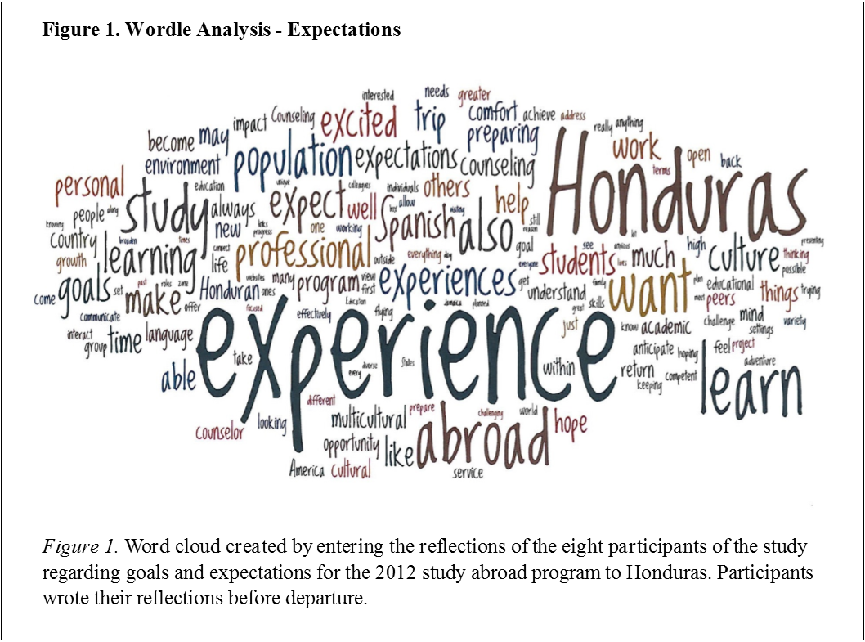

Figure 1. Wordle analysis- Expectations
First impressions. The second entry was written upon arrival to Honduras to capture the students’ first impressions of their study abroad experience. The pre-arrival journal and the first impressions journal serve as a base line to explore the transformation of the participants throughout the experience (Kottler, 2012). The prompt for this entry was as follows: “Take your time to reflect on all your experiences in this first day of our adventure. Talk about your emotions, thoughts and cultural differences in your journey, and describe your first impressions of Honduras.”
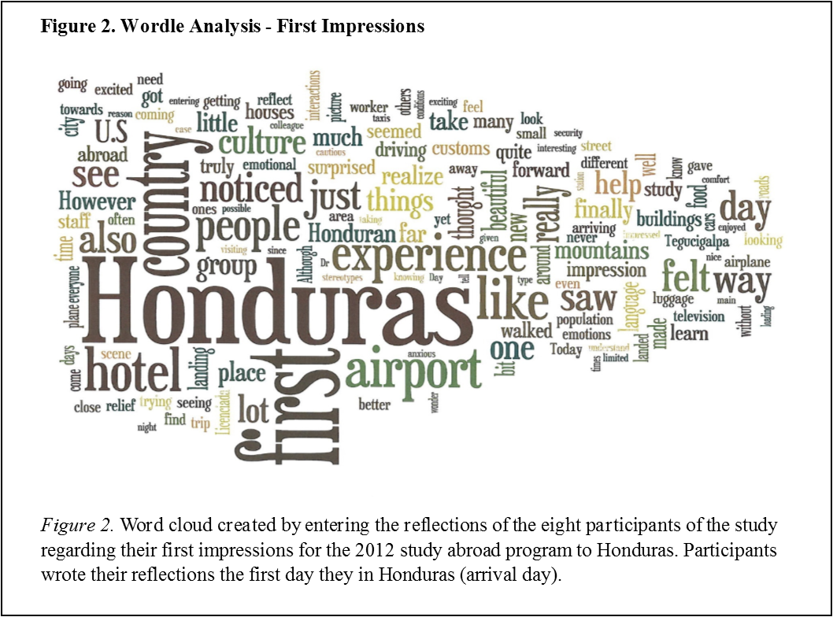
Figure 2 – Wordle analysis – First impressions
For the first impressions cloud, with 3,023 words entered to Wordle (See figure 2), the most repeated words were the following: Honduras, first, hotel, country, experience, people, airport, see, noticed, felt, impressions, things, realized, surprised, culture, group, far, beautiful, new, help, different, buildings, language, and learn. The resulting themes of the case study for this section included: feelings, differences between Honduras and the U.S., personal reflections, first thoughts about Honduras, and expectations for the program which included the codes learn, experience, and growth.
Letter to Self. The third journal entry included in this study was requested on the seventh day of the 13-days trip to Honduras. This journal entry prompt was designed to give participants the opportunity to reflect exactly half way through the program. The prompt is particularly related to the impact of study abroad programs in the self-awareness and self-confidence of the participants mentioned in the literature (Jaoko, 2010). The prompt was: “We have experienced a lot in a very short time. Please write yourself a letter overviewing (in as much detail as might be helpful to you and in your own style) the experiences we've had/your personal experiences. What have some of your highlights been? What are some key things you have learned about yourself? What are some impacts on your personal and/or professional development?”
The letter to yourself cloud (See figure 3), with 4,759 words, emphasized: people, experience, Honduras, able, know, life, learning, work, different, want, time, knowledge, proud, hope, continue, help, counselor, culture, opportunity, professional, home, remember, others, first, life, and see. The themes emerged on the case study for this section included: highlights with codes such as people, events, and experience; reflections with codes poverty, culture, life lessons, differences between the countries, about Honduras and about the study abroad experience; personal impact with codes related to personal change, new view of the world, deep emotions, first time experiences, taking things for granted, and learned about self; professional impact on social justice, cultural competence, and able to relate the experience to the U.S.; and personal goals and messages of self-encouragement.
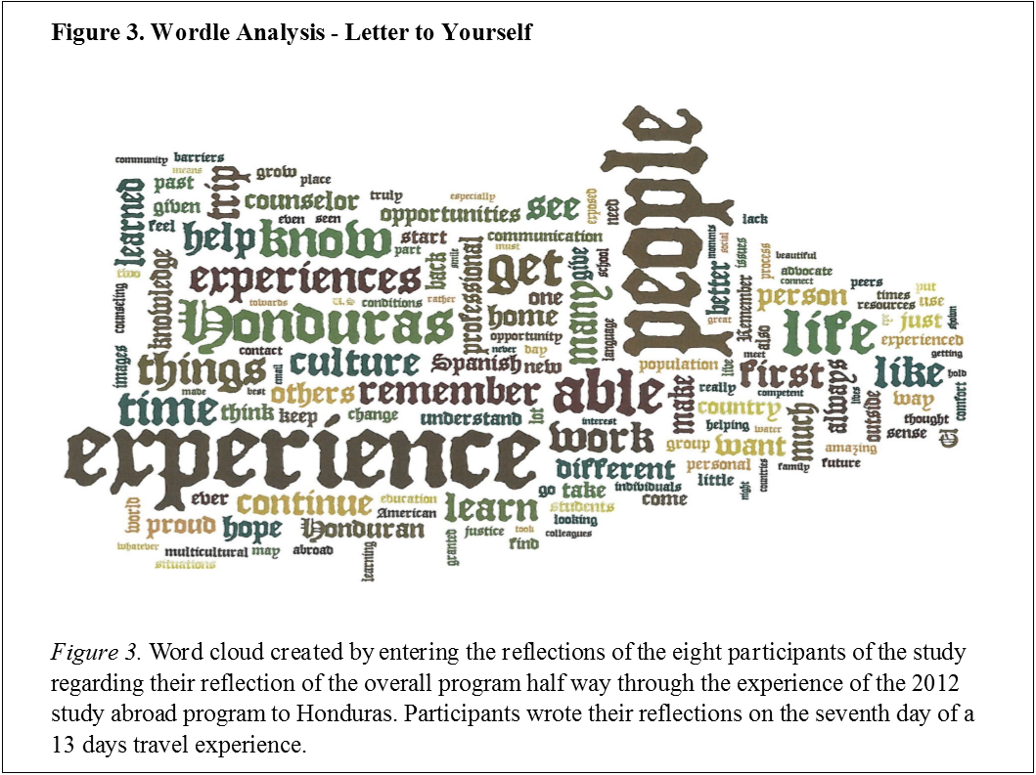

Figure 3. Wordle analysis – Letter to yourself
Final reflection. The fourth entry was requested in the form of a final reflection written upon return to the U.S. It was important to give the students opportunity to reflect on the program upon completion and capture their impressions. Jaoko (2010) affirmed that study abroad programs, when well-designed, may influence cultural competence. This journal aimed to capture the experience and development of the participants after the program was completed. Prompts for the final reflection had more indications as it served as a final paper for the study abroad program: “Reflect upon your experience addressing your multicultural awareness, knowledge, and how these will improve your multicultural competence (how will this awareness and knowledge influence your skills, what will you do to build on your knowledge in practice). Keep your response to a maximum of 5 pages in length (double space), adhere to APA, 6th ed., and limit grammatical and spelling errors.”
For the final reflection (See figure 4), with 6,821 words, the most used words included: Honduras, experience, multicultural, people, culture, able, time, learned, students, like, work, see, first, professional, America, world, understand, life, counselor, think, knowledge, different, find, better, important, and program. Themes from the case study for this section included impressions of the overall experience, cultural competence, social justice, events, self-reflections, reflective comparison, and relevance of the program.
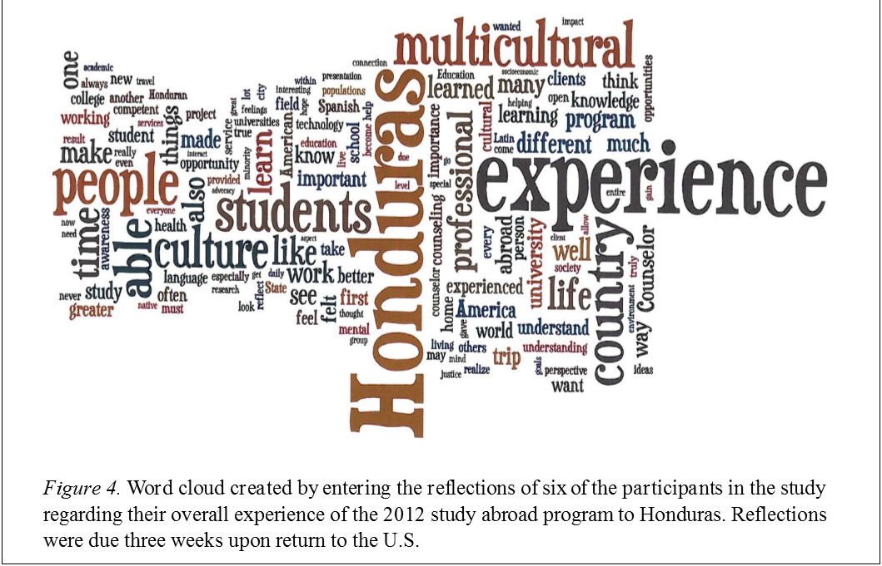

Figure 4. Wordle analysis – Final reflection
Follow up survey. After the analysis of the journal entry data, a follow up survey was sent to the participants. The survey items were aligned with the purpose and research questions of the study, based on the available literature and previous research, and responded to the theoretical framework of the study on cultural competence development. The open ended questions of the survey were as follow:
- What are the most powerful learning experiences that you remember from your study abroad program to Honduras?
- Please share the story of what has happened since you came back from Honduras?
- How did the study abroad program to Honduras influence what you think about the world and about yourself?
- Please describe any impact that the study abroad experience in Honduras has had on your life (personally and professionally)?
- Anything else about your study abroad experience you would like to add?
The responses of the participants to the question above were entered to Wordle without titles and without the actual questions. The most used words, out of 2,908, for the follow up survey (See figure 5) included: Honduras, experience, study, powerful, abroad, people, trip, work, world, different, life, opportunity, see, learning, great, value, different, cultures, feel, learned, and country. Main themes for the case study regarding the follow up survey were divided by question. For question one these included: overall impressions of the program, learned experiences, people, self-reflections, language barriers, immersion, and ability to relate to the Hispanic population in the United States. For question two: studies and work, opportunities to share the experience with others, perceived improvement of cultural competence, people and interactions, and desire to continue traveling. For question three: awareness, perception of the world, social justice, and perception of self. Question four themes were personal experiences and professional experiences. For question five the themes included: overall experience, suggestions and challenges, and recommendations.

Figure 5. Wordle analysis – Follow-up survey

Overall data. Figure 6 presents the word cloud resulting from entering the entire data set to Wordle. From a total of 20,582 words, the three most frequently used words were Honduras, experience, and people.
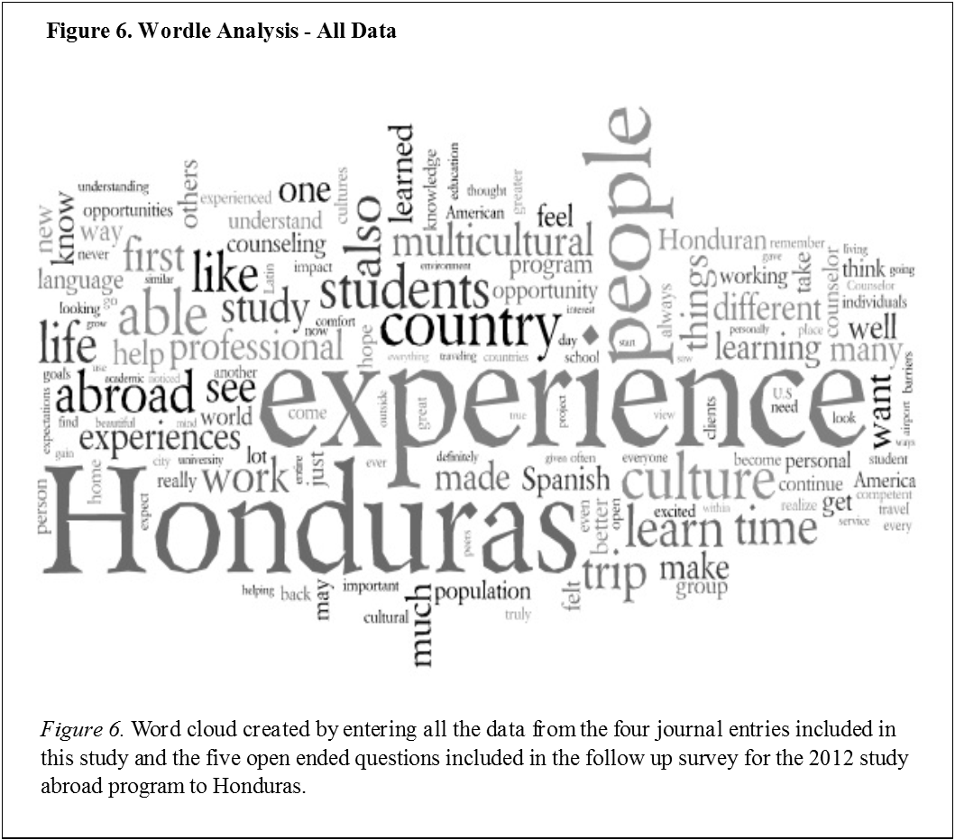

Figure 6. Wordle analysis – All data

Trustworthiness
Wordle has also been found useful in the process of validating findings (McNaught & Lam, 2010). Utilizing Word clouds may be used to support the trustworthiness of the study. According to Merriam (2009), trustworthiness in qualitative research refers to credibility, consistency, and transferability. Credibility deals with the congruency between findings and reality. Consistency denotes the dependability of the results in relation to the collected data. And transferability signifies the learning driven from the analysis and the transferability of that acquired knowledge to different situations. In the discussed case study, utilizing Wordle provided an additional level of analysis, separation of the researcher from the data, and an additional set of findings to enriched the description of the study adding to the rest of the strategies utilized to account for the trustworthiness of the case study (Merriam, 2009).

Discussion
The five word clouds provided the first visualization of the data for the case study and an objective count of the most-used words. The visualizations also helped in the initial reading of the data, providing the first view to initial patters from the data. When compared to the rest of the data analysis of the case study, the words highlighted in the word clouds seemed to align with the overall findings. Patterns that the researcher was able to see through Wordle reflected the aspects that students emphasized throughout the data as a whole including: the country, the culture, the experiences, the people, and the profession. Students also highlighted their feelings, knowledge, impressions, and personal and professional impact of the study abroad experience. Wordle served as a supplementary research tool in the presented case study helping with preliminary analysis and validation of findings (McNaught & Lam, 2010). As a first view of the data, the word clouds provided an avenue for the investigator to reflect on the data and start visualizing potential codes and patterns.
As mentioned in previous studies, the use of the program itself was simple and provided visual support to the study (Williams, et al., 2013; McNaught & Lam, 2010; Baralt, et al., 2011). Simplicity, accessibility and low cost make of Wordle an appealing supplementary tool for data analysis and validation. It may be particularly useful for novice researchers as a basic tool to initiate the exploration of data. It provides a non-threatening opportunity to explore and present data more creatively for both researcher and audience. Wordle also allows researchers to separate themselves from the data as the text is entered in the program as the participants provided, and without any modifications or interpretations. Consequently, it gives researchers an opportunity to view the data from an alternative perspective and it provides an additional set of information for validating findings and accounting for the trustworthiness of the study. (McNaught and Lam, 2010; Merriam, 2009).
It is important to mention that the text was enter to Wordle in its entirety, and no words were remove to obtain a more realistic picture of the data. According to McNaught and Lam (2010), Wordle works best when the full responses of the informants have been preserved. This was especially important in this case study since data was collected at different times of the journey. Wordle provided an opportunity to visualize the differences and similarities of the words used by the participants through their experience. However, entering text without modifications also made some of Wordle’s limitations evident. According to McNaught and Lam (2010) the words are retrieved out of context and it is not possible to trace the codes back to the original text. Words are treated as isolated units, making the process fast, but at the cost of dismissing elements such as the semantics of the words, and the phrases or sentences the words are part of. This can be easily seen in the word clouds as they separated synonyms that in regular analysis would have been coded equally, and included words that are not relevant to research.
Further research is needed to assess the impact of using Wordle as a supplementary tool for different types of research and fields. More studies specifically designed to evaluate the use of Wordle as either a data analysis or validation tool will be valuable. The differentiation between using Wordle in qualitative and quantitative research may also be of interest. Future research may also include assessing the usefulness of the tool for novice researchers in regards to self-efficacy, exploration of data, data analysis, and validation of result. In addition, research regarding the utilization of Wordle as a tool for teaching and training may be explored. Finally, more studies regarding the use of different data visualization tools and word cloud programs in research and training are needed.

References
Author (2014). Cultural competence development through study abroad initiatives: Case study Honduras (Doctoral dissertation). Retrieved from: http://www.lib.ncsu.edu/resolver/1840.16/9287.
Aparicio, M., & Costa, C. J. (2014). Data visualization. Communication Design Quarterly, 3, 7-11. doi: 10.1145/2721882.2721883.
Alexander, C. M., Krucsek, T., & Ponterotto, J. (2005). Building multicultural competencies in school counselor trainees: An international immersion experience. Counselor Education and Supervision, 44, 255-266. doi: 10.1002/j.1556-6978.2005.tb01754.x.
Azzam, T., & Evergreen, S. (eds). (2013). J-B PE single issue (Program) evaluation: Data visualization, Part 2, Volume 2. New Directions for Evaluation, 140(1). Somerset, US: Jossey-Bass. Retrieved from http://www.ebrary.com.
Baralt, M., Pennestri, S., & Selvandin, M. (2011). Action research: Using wordles to teach foreign language writing. Language Learning & Technology, 15(2), 12-22.
Cassey, D., & Houghton, C. (2010). Clarifying case study research: Examples from practice. Nurse Researcher, 17(3), 41-51.
Cordero, A., & Negroni Rodríguez, L. (2009). Fostering cross-cultural learning and advocacy for social justice through an immersion experience in Puerto Rico. Journal of Teaching in Social Work, 29, 134-152. doi: 10.1080/08841230802238195.
Creswell, J. W. (2013). Qualitative inquiry & research design: Choosing among five approaches (3rd ed.). Thousand Oaks, California: Sage Publications, Inc.
Fairchild, S. R., Pillai, V. K., & Noble, C. (2012). The impact of social work study abroad program to Australia on multicultural learning. International Social Work, 49, 390-401. doi. 10.11.77/0020872806063413.
Foote, C. (2009). It’s a mad mad Wordle. School Library Journal, 55(7), 32-34.
Hayes, S. (2008). Technology toolkit: Wordle students words. Voices from the Middle, 16(2), 66-68.
Jaoko, J. (12/01/2010). Study abroad: Enhanced learning experience in cultural diversity. College Quarterly, 13(4).
Retrieved from http://www.collegequarterly.ca/2010-vol13-num04-fall/jaoko.html
Jurgens, J. C., & McAuliffe, G. (2004). Short-term study-abroad experience in Ireland: An exercise in cross-cultural counseling. International Journal for the Advancement of Counseling, 26, 147-161. doi: 10.1023/B:ADCO.0000027427.76422.1f.
Kirk, A. (2012). Data visualization: A successful design process. Birmingham, UK: Packt Publishing Ltd.
Kottler, J. A. (2003). Transformative travel: International counselling in action. International Journal for the Advancement of Counseling, 24, 207-210. doi: 10.1023/A:1023364628260.
Litchtman, M. (2013). Qualitative research in education: A user’s guide (3rd ed.). Thousand Oaks, California: Sage Publications, Inc.
Mallon, M. (2015). Data visualization. Public Services Quarterly,11(3), 183-192. doi: 10.1080/15228959.2015.1060147.
Martin, A. (2012). A picture is worth a thousand words: How Wordle can help legal writers. Legal Communication & Rhetoric: Journal of the Association of Legal Writing Directors, 9, 139-147.
McDowell, T., Goessling, K., & Melendez, T. (2012). Transformative learning through international immersion: Building multicultural competence in family therapy and counseling. Journal of Marital and Family Therapy, 38, 365-379. doi: 10.1111/j.1752-0606.2010.00209.x.
McNaught, C., & Lam, P. (2010). Using Wordle as a supplementary research tool. The Qualitative Report, 15(3), 630-643.
Merriam, S. B. (2009). Qualitative research: A guide to design and implementation. San Francisco, California: John Wiley & Sons, Inc.
Noor, K. B. M. (2008). Case study: A strategic research methodology. American Journal of Applied Sciences, 5(11), 1602-1604. doi: 10.3844/ajassp.2008.1602.1604
Spath, R., & Pine, B. (2004). Using the case study approach for improved program evaluations. Child and Family Social Work, 9, 57-63. doi: 10.1111/j.1365-2206.2004.00310.x.
Williams, W., Parkes, E. L., & Davies, P. (2013). Wordle: A method for analyzing MBA student induction experience. The International Journal of Management Education, 11(1), 44-53. doi:10.1016/j.ijme.2012.10.002
West-Olatunji, C., Goodman, R. D., Mehta, S., & Templeton, L. (2011). Creating cultural competence: An outreach immersion experience in southern Africa. International Journal for the Advancement of Counselling, 33, 335–346. doi. 10.1007/s10447-011-9138-0.

About the author
Dr. Syntia Santos Dietz obtained her Ph.D. in Counseling and Counselor Education at North Carolina State University (NCSU) in 2014 and her M.Ed. in School Counseling at the State University of New York at Buffalo (UB) in 2006 as a Fulbright scholar. She worked as professor and program coordinator in her home country Honduras, in their school counseling program at the Universidad Pedagógica Nacional Francisco Morazán (UPNFM).
Dr. Santos is a National Certified Counselor (NCC) and a License School Counselor in the state of North Carolina. Dr. Santos is currently working as assistant professor at East Carolina University (ECU). Her areas of interest include cultural competence development, international counseling, international education, counselor education, and school counseling. In addition, Dr. Santos serves as an editorial board member for the Professional Counselor journal (TPC) and she is also a steering committee member for the International Registry of Counselor Education Programs (IRCEP).
Correspondence concerning this article should be addressed to Syntia Santos Dietz, Department of Interdisciplinary Professions, East Carolina University, Greenville, NC 27858. Email: santosfigueroas14@ecu.edu

Return to Table of Contents

Return to Table of Contents
Editor’s Note: This paper presents two types of smart bilingual subtitles and explores which subtitle types can be effective in language acquisition and video comprehension.

Comparative-effectiveness research of two types of smart bilingual subtitles

Lili Zhang, Yue Liu, Hong Tang

China

Abstract
Many studies substantiated the effect of subtitles on language learning. This paper presents two types of smart bilingual subtitles and tries to explore the best subtitle type that could be both effective in language acquisition and video comprehension. This paper conducted experiment with 119 clinical-medicine-major undergraduates enrolled in Qiandongnan National Polytechnic, China. The study materials are video clips taken from the movie Atonement. Each clip is provided with two types of smart subtitles made by the author. According to the results, both subtitles have effect on vocabulary learning; based on native subtitles, adding target foreign words (new word) below might be an effective measure to learn foreign vocabulary with no apparent interference on watching experience. Chinese subtitles with new-English-word- below is more effective for vocabulary learning than English subtitles with Chinese paraphrase of new English words in bracket; Chinese subtitles with new-English-word- below is more effective for phrase-learning than English subtitles with Chinese paraphrase of new English words in bracket. The more words highlighted a subtitle contains, regardless of native language or foreign language, the less effective vocabulary learning would be. English subtitles with Chinese paraphrase of new English words in bracket is slightly better than Chinese subtitles with new-English-word- below in video comprehension.

Background
In digital age, television and film became people’s major entertainment. In light of the acceleration of the development of globalization, the international film industry welcomes a rapid expansion. More video products have been sold worldwide. Meanwhile, due to the flourish of internet, especially those video websites, people are provided more accesses to foreign video products. In China, an increasing amount of people accustomed to watching original English, Japanese or Korea film and TV programs with Chinese subtitles, rather than Chinese dubbed movies or dramas.
Subtitles are vital components of videos of foreign language. Subtitles are derived from either a transcript or screenplay of the dialog or commentary in films, television programs, usually displayed at the bottom of the screen. They can either be a form of written translation of a dialog in a foreign language, or a written rendering of the dialog in the same language, with or without added information to help viewers who are deaf and hard of hearing to follow the dialog, or people who cannot understand the spoken dialogue or who have accent recognition problems.
Many studies have proved that watching foreign videos with subtitles could help audience to acquire foreign language. Guillory (1998) found that using keywords subtitles was better than using no subtitle to understand the content and keywords subtitles was helpful to lessen learners’ attention distracting. From previous research, subtitle preference is more or less obligatory and unaffected by contextual factors such as sound of video, familiarity of subtitle, or visual image. De Bruycker 和 d’Ydewalle （2003）的研究发现，在不熟悉视频语言的情况下，被试对母语字幕注视时间要长于外语字幕。当语言发音为外语或与母语十分远时，被试对母语字幕的加工时间要长于外语字幕. Li Tianyi and Xin Tongchuan (2013) proves that dual English-Chinese subtitles creates better effects than only English subtitles. Geza Kovacsand and Robert C. Miller designed Smart Subtitles, interactive subtitles tailored towards vocabulary learning. In their study participants correctly defined over twice as many new words in a post-viewing vocabulary test when they used Smart Subtitles, compared to dual Chinese-English subtitles.
In summary, above studies substantiated the effect of subtitles on language learning.

Research question
Based on all the studies above, in order to lessen learners’ attention distracting while learning vocabulary, this paper presents two types of smart bilingual subtitles and tries to explore the best subtitle type that could be both effective in language acquisition and video comprehension. In concrete terms, some of our research questions are as followed: Based on all the studies above, in order to lessen learners’ attention distracting while learning vocabulary, this paper presents two types of smart bilingual subtitles and tries to explore the best subtitle type that could be both effective in language acquisition
- Which type of smart subtitles could help students learn more English vocabularies?
- Which type of smart subtitles is more effective for vocabulary learning?
- Which type of smart subtitles is more effective for video comprehension?
- What subtitle would most participants’ prefer?

User study

Participants
Our study participants were 119 clinical-medicine-major undergraduates enrolled in two second-semester English classes of Qiandongnan National Polytechnic. 80 of our participants were male, and 39 were female. The two classes were taught by the same English teacher. None of the participants were from English-speaking backgrounds. As there’s no placement test after their entrance, we referred their initial English proficiencies to the National College Entrance Examination, which demonstrated a basic command of English of basic education stage.

Materials
We used two video clips taken from the movie Atonement. In our pre-test survey, students from other class acknowledged that this movie was interesting and intriguing. They could understand the plot to a large extent, but were not certain about most of the vocabularies.
One clip is the first 6 minutes of the movie, while the second clip is the next 7 minutes of the movie. Each clip is provided with two types of SRT files, Subtitle A and Subtitle B.

Table 1

Examples of Subtitle A and Subtitle B
Subtitle A | Chinese with new English word below
Example | 利昂说他很有魅力  Charming
Subtitle B | English with Chinese paraphrase of new English word in bracket subtitles after
Example | Stupendous(不可思议). It's stupendous, darling. Your first play.

Technically, the two types of Smart Subtitles are manually made by Excel, Word, Java Code rather than using a software like Smart subtitle. Our steps are as followed:
- Trim video of Atonement into clip 1 (6 mins) and Clip 2 (7 mins).
- Transform SRT files into TXT format.
- Trim and Analyze English subtitles of Atonement through Microsoft Word and Excel.
- Identify “new” English word by filtering out vocabulary that students had already learnt from original English subtitle.
- For Subtitle A, based on Chinese subtitles, add each New English word below its Chinese definition with the help of Jave Code.
- For Subtitle B, based on English subtitles, add Chinese definitions or paraphrases after each New English word (in bracket) with the help of Jave Code.
Of the first clip, there are all together 538 English words, 240 of which are non-repeated. There are 205 English words, 128 non-repeated words in the second clip. Of all the words, 26 were assumed “new” to the students, filtered based on the English vocabulary of basic education.

Procedure
The first class (58 students) saw the first clip with Subtitle A and the second with Subtitle B, while class 2 (61 students) saw the first clip with Subtitle B and the second with Subtitle A.

Table 2

Procedures and arrangement of video watching
Video  Class | Clip 1 (6-minutes) | Clip 2 (7-minutes)
Class 1 | Subtitle A | Subtitle B
Class 2 | Subtitle B | Subtitle A
Before students started watching each clip, we informed them that they would be given a post-test afterwards, and that they should attempt to learn vocabulary in the clips as well as understand the story while watching the video. Students should watch the clips straight-through without any pauses.

Posttest
After all the students finished watching the two clips, we asked them to finish a posttest within 20 minutes, including a comprehension quiz, a vocabulary quiz and a questionnaire.

Comprehension Quiz
We firstly evaluated their comprehension and understanding of video and observation of details via 5 true-or-false questions.
Example: Briony does not want to play the part of Arabella. ( )

Vocabulary Quiz
We evaluated vocabulary learning via a 20-question free-response vocabulary quiz, with two types of questions. One type of question provided a word that had appeared in the video clip and asked students to provide a Chinese definition for the word.
Example: What does the word amenable mean? __________________
The other type of question provided a word that had appeared in the video clip and the context it had been used in, and asked students to provide a Chinese definition for the underlined word.
Example: I'm worried about the play. I'm sure it's a masterpiece. __________________
For both types of questions, as Wesche and Paribakht (1996) recommended, we additionally asked the student to self-report whether they had known the meaning of the word before watching the video, so that we could determine whether it was a new word or one they had previously learned from some external source.

Questionnaire
After students completed the Comprehension Quiz and Vocabulary Quiz, we asked them to complete a questionnaire where they rated the following questions on a 5-point Likert scale (Strongly disagree, Disagree, Neither agree nor disagree, Agree, Strongly agree):
- Do you think smart subtitles will help you to understand the video?
- Do you think smart subtitles will interfere with your understanding of the video?
- Do you think smart subtitles will help you learn vocabulary better?
- How enjoyable did you find the experience of watching this video with smart subtitles?
And there would also be other questions regarding their previous vide-watching experience, preference of subtitles etc. such as:
- Do you usually keep notes or consult the dictionary while watching English video?
Finally, we asked them to provide free-form feedbacks, questions or suggestions.

RESULTS
According to the univariate analysis, interaction between questions and subtitles are significant (F (1, 461) =6.550, P<.05, η2=0.014).

Table 3

Estimated marginal means of accuracy rate between
question types and subtitles types
Dependent Variable: Accuracy Rate
Subtitles | Question Types | Mean | Std. Error | 95% Confidence Interval
 |  |  |  | Lower Bound | Upper Bound
Subtitle B | Vocabulary Quiz | 0.17 | 0.025 | 0.121 | 0.219
 | Comprehension Quiz | 0.556 | 0.025 | 0.506 | 0.606
Subtitle A | Vocabulary Quiz | 0.244 | 0.025 | 0.195 | 0.293
 | Comprehension Quiz | 0.501 | 0.026 | 0.451 | 0.552

Figure 1. Estimated marginal means of accuracy rate between
question types and subtitles types

We found the following results from our study:
- Both types of smart subtitles could benefit students’ vocabulary acquisition.
- Subtitle A is more effective for vocabulary learning than Subtitle B.
- Subtitle A is more effective for phrase learning than Subtitle B.
- The more words highlighted a subtitle contains, regardless of native language or foreign language, the less effective vocabulary learning would be.
- Most students did not have particular preference towards the two types of smart subtitles.
- Students’ comprehension did not differ significantly between two subtitles. Subtitle B is slightly better than Subtitle A in video comprehension.

Vocabulary Learning
We measured the number of new words learned as the number of correctly defined words. Figure below shows the numbers of students who correctly define each of the 20 new words. According to the research, both types of smart subtitles could benefit students’ vocabulary acquisition. For Question 9, there were 10 results marked as previously known.
Then we made comparison between Subtitle A and Subtitle B based on the percentage of students who correctly defined words, excluding words that students had marked as previously known. As shown in Figure 2, thus, we assume that subtitle A is more effective for vocabulary learning.

Figure 2 Numbers of students who correctly defined the 20 new words
Next, according to the Nonparametric Tests, the main effect of the number of words contained in the questions on the accuracy rate of students was marginally significant (sig=0.057), the questions contained two or more words had generally higher accuracy rate than those contained only one word.

Figure 3 Percentage of students who correctly defined the words (%)
The first four questions that most of the students failed to answer were Question 1 (0.86%), Question 16 (5.04%), Question 20 (5.08%) and Question 18 (5.88%) of Vocabulary Quiz.

Table 4

First four questions that most of the students failed to answer
Question 1 | I hope you're not gonna be getting under our feet today, Miss Briony. ________
Subtitle A | 我希望今天你不要挡我们道儿 布莱欧妮小姐  getting under our feet
Subtitle B | I hope you're not gonna be getting under our feet (挡我们道儿) today, Miss Briony.
Question 16 | What does the word rumour mean? _________________
Subtitle A | 利昂今天回来 你知道吗? 我听见这么传  heard a rumour
Subtitle B | Leon(利昂)'s coming down today, did you know I heard a rumour(传闻/谣言).
Question 20 | What does the word evanesce mean? _________________
Subtitle A | 从家乡消失 去往伊斯特本(英 港口)  evanesce Eastbourne
Subtitle B | evanesce(消失) from her home to go to Eastbourne(伊斯特本).
Question 18 | What does the word grieve mean? _________________
Subtitle A | 留下伤心的父母 看着他们的长女  grieved firstborn
Subtitle B | It grieve(使伤心)d her parents to see their firstborn(长子)
As shown above, each of the four questions belongs to two situations: 1) contains a phrase or 2) contains more than one English words highlighted or paraphrased (not necessary new word, any word that is presented has effect to some extent). In this case, we could come to a conclusion that smart subtitles were less effective if the sentence contains a phrase or more than one new word. To be more specific, effectiveness of smart subtitles regarding different numbers of words contained is in descending order from single word, more than one word and phrase.

Figure 4 Percentage of students who correctly defined the words (%) of Subtitles
that contain two or more English words
We further examined the differences between Subtitle A and Subtitle B based on subtitles that contain two or more words. Nonparametric Tests shows that for the questions contained two or more words, the accuracy rates of students watched subtitle A was significantly higher than those of students watched subtitle B (sig=0.036). In another word, Subtitle A shows an obvious advantages than Subtitle B. Three vocabulary questions that lead to the most obvious differences of results are Question 5 (31.03%), Question 9 (29.34%) and Question 19 (34.82%).

Table 5

Three vocabulary questions that lead to the most obvious differences of results
Question 5 | You'll be in this play or you'll get a clout. __________________
Subtitle A | 戏剧就是瞎显摆 好好排戏要不我就敲你们的脑袋  get a clout.
Subtitle B | It's just showing off. You'll be in this play or you'll get a clout(敲脑袋).
Question 9 | I'm sure a half-hour break would do us all good. __________________
Subtitle A | 我看休息半小时对我们都好  do us all good
Subtitle B | I'm sure a half-hour break would do us all good(对我们都好).
Question 19 | What does the word firstborn mean? _________________
Subtitle A | 留下伤心的父母 看着他们的长女  grieved firstborn
Subtitle B | "It grieve(使伤心)d her parents to see their firstborn(长女)
As shown in the table above, Question 5 and Question 9 share the similarity that each subtitle contains a phrase. In this case, the effectiveness of Subtitle A could be ascribed to its consistent alignment with Chinese subtitles above, which might make it easier for students to relate English spelling to its Chinese definition. Subtitle B did not provide a word-to-word alignment which would increase difficulty in understanding the meaning of the phrase. However, no convincing evidence could comprehensively explicate why the results of Question 19 differ significantly.

Video comprehension
For video comprehension, as shown below, there’s no obvious differences between results of students who watch Clip 1 with different types of subtitle. The accuracy rate of students who watch Clip 2 with subtitle B is higher than that of subtitle A. To sum up, English subtitles with Chinese paraphrase of new English words in bracket is slightly better than Chinese subtitles with new-English-word- below in video comprehension.

Figure 5 Accuracy rate of Comprehension Quiz of Clip 1 and Clip 2

Figure 6 Numbers of students who choose the right answer of questions of Comprehension Quiz

Questionnaire
According to the questionnaire, most students think smart subtitle could benefit them with both vocabulary learning and video comprehension. More than half students agree that smart subtitles would not disturb their watching experience. Some students also mentioned in the feedback section that as they find it possible to learn English words via smart subtitles, they thought this experience was interesting and they felt good about themselves.

Figure 7 Questionnaire results
However, when ask about which kind of subtitles do students prefer next time when they watch foreign video, 80% students recommend bilingual subtitles rather than smart subtitles. Many students explain their reasons in the free-form feedback sections: smart subtitles, especially English subtitles with Chinese paraphrase of new English words in bracket (Subtitle B), might be too difficult for students who have a weak foundation in English. They found it hard to understand the video unless they have known the grammar or syntax better.

Figure 8 what type of subtitles do students prefer next time
when they watch foreign video

Conclusion
Though our study has a lot of deficiencies, the results prospect a very useful approach towards language learning via smart subtitles. Based on native subtitles, adding foreign word below might be an effective measure to learn foreign vocabulary with no apparent interference on watching experience.
- Chinese subtitles with new-English-word- below is more effective for vocabulary learning than English subtitles with Chinese paraphrase of new English words in bracket.
- Chinese subtitles with new-English-word- below is more effective for phrase-learning than English subtitles with Chinese paraphrase of new English words in bracket.
- The more words highlighted a subtitle contains, regardless of native language or foreign language, the less effective vocabulary learning would be.
- English subtitles with Chinese paraphrase of new English words in bracket is slightly better than Chinese subtitles with new-English-word- below in video comprehension.

Future work
In the future, besides vocabulary acquisition and content comprehension, the research objects could range from listening, spelling, pronunciation, gramma, syntax etc.
In addition, a more comprehensive research could be conducted to investigate the best forms of smart subtitles in light of the diversities of participants’ foreign language proficiencies, as well as for different stages of foreign language learning. Wang Fuxing et al. (2012) found that although the movie was local language and easy to process and understand, participants also preferred to pay much attention on subtitle. The subtitle preference was influenced by subtitle familiarity. Therefore, further study could focus on the comparison between only-key-words smart subtitle and other forms of subtitles.
Meanwhile, a smart-subtitle-making tool could be developed later to increase the efficiency in designing and implementing smart subtitles. With the help from IT program or specialist, or collaboration with video websites such as YouTube and Netflix and dictionary software, ordinary people might soon greet an interesting self-study experience. If possible, an adaptive subtitle-tool could be designed to automatically update subtitles based on individualized learning, such as the enlargement of students’ vocabulary storage.
Last but not least, as what language learning benefits most from foreign videos with subtitles is the engagement and motivation it inhabits with, in our perspective, the watching experience should not yield to the excessive pursuit of high efficiency, such as the quantity of vocabulary learnt. Therefore designers, teachers and researchers should spend efforts keeping the balance between flow experience, understanding and learning.

References – see footnotes

About the authors
Lili Zhang is an instructional designer and research assistant in Sichuan Institute of Education Sciences. Zhang has received her bachelor degree of English for Economics and Trade from Southwestern University of Finance and Economics. She has received her master degree of Instructional Design, Development and Evaluation from Syracuse University. Her concentrations include instructional design, Gamification, distance education, multi-media. She has designed several instructional software with Eastedu and participated in some distance education programs.
eMail: omoiii@vip.qq.com, lilizhang.isitestar.cn
Yue Liu is an assistant professor in Sichuan Institute of Education Sciences. Liu has received her bachelor and master degrees from Beijing Normal University, department of Psychology, and majored in Education measurement. Liu’s research concerns multidimensional item response theory, test equating, testlet model and so on. Liu has published several papers in some CSSCI journals. She was also invited to be a reviewer for Psychological Science, one of the CSSCI journals in China. eMail: helena701@126.com
Hong Tang is an Associate professor in QianDongnan National Polytechnic. Tang has received her master degree from Guizhou Normal University, majored in Education Management. Tang engaged in College English Teaching for many years. Tang’s major research direction includes Second Language Learning and Education Management.
eMail: Kailisugar@126.com

Return to Table of Contents

Return to Table of Contents
Editor’s Note: Interactive multimedia, learning objects and learning management systems provide abundant data to monitor learning, measure student progress, determine how students learn and optimize learning strategies and curriculum. The Internet of Things provides yet another avenue to recognize and collect data beyond what was initially recognized as important. Using the cloud and big data techniques, it can conduct research not possible with traditional small samples.

Internet of Things: wireless issues in using
mobile communication network

Karan Verma

India

Abstract
Internet of Things (IoT) is an emerging technology that effectively collects data from billions of connected things using sensors and devices, derives intelligence, builds context and helps transform the way businesses, as well as our society, are run. IoT enables new use cases due to real time information from things. IoT uses various communication networks to send information from sensors and devices to the server in the cloud for analysis. One of the popular networks is the Mobile Communication Network. Mobile Communication is ideal for connecting things on the move and things outside premises. For example, it is used heavily in transport and logistics industries for real time location of vehicles on the move using GPS technology. This paper discusses various issues that arise in using mobile communication networks for IoT device-server connectivity and suggests possible solutions as well.
Keywords: Internet of Things, Mobile Communications, transport & logistics, fleet management, vehicle tracking.

Introduction
Internet of Things (IoT) is an environment in which objects, living things are provided with unique identifiers and the ability to transfer data over a network without requiring human-to-human or human-to-computer interaction.
IoT helps derive intelligence from multitude of these connected things, builds context and use them to transform the way businesse, as well as our society, are run today. IOT enables new use cases due to real time information from the sensor devices.
Mobile Communication Networks (MCN) play an import role in IoT connecting things outside premises and/or on the move to servers on the cloud. The advantages of MCN are 1) there is no need for investment on the network infrastructure, 2) theycover a large percentage of land area in the world.
While there are good reasons to use MCN in IoT for things-server connectivity, there are issues one needs to be aware when using MCN for IoT solutions. This paper discusses the issues likely to be faced by IoT solution developer and possible solutions available.
Section 2 of this paper highlights the importance of MCN in IoT through few solution examples.
Section 3 describes IoT solution components in brief and introduces necessary IoT terminologies to understand the subsequent sections.
Section 4 discusses issues that may be faced during IoT solution development/deployment that uses MCN.

Components of IoT
Figure 1 below depicts a typical IoT solution and its components.
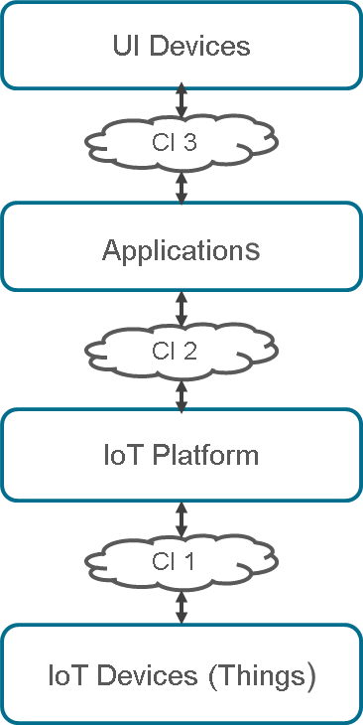

Fig 1: Typical IoT Solution

IoT devices (things)
IoT is all about device intelligence. Power of IoT application depends on the rich set of devices connected to it.
IoT devices can be broadly categorized into sensor devices and actuator devices.
Devices typically connect to IoT platform over IP protocol. Devices that do not support IP protocol connect to IoT platform through a Gateway (GW) device, which converts non-IP protocols to IP protocol. Examples for devices that require a GW are Zigbee devices, Bluetooth devices, and MODBUS devices.

IoT platform
IoT platform is either hosted on local data centres or on the cloud. The main purpose of an IoT platform is to enable applications to use intelligence and context information from sensor devices and control Actuator devices without the application are required to know:
- how to connect to things from different vendors, different protocols, different functionalities
- what information is available in which devices and
- how to manage a large number of devices

IoT application
IoT applications are of two types; 1) IoT enabled legacy applications and 2) New IoT applications.
IoT enabled legacy applications are legacy applications connected with device intelligence. With device intelligence they bring efficiency in operations, convenience to users, better decision making, etc. This is necessary to protect investments made in the existing applications.
New IoT applications use combined intelligence from different kinds of devices and implement new kinds of use cases that are not possible with legacy applications.

UI device
The UI device could be a PC, laptop, mobile or a tablet that has the ability to display and to give commands.

Communication infrastructure
As shown in Figure 1, an IoT solution requires a multiple communication infrastructure: CI1 to CI3.
CI1 connects IoT devices to IoT platform and this traffic primarily goes over internet. The options include broadband connectivity, mobile internet connectivity over MCN and dial-up network.
CI2 connects IoT platform and the application. Local Area Network (LAN) infrastructure is used in case of co-located IoT platform and application. If they are in different locations, Virtual Private Network (VPN) over an internet connection or over a leased line is preferred.
CI2 connects end-users to IoT applications. This access is primarily over internet. Mobile Internet and other forms of internet connections are used.
CI1 and CI2 are for machine to machine communication and CI3 is for machine to human communication. This paper only discusses the issues in machine to machine communication over MCN, i.e., CI1 over MCN.

Importance of MCN in IoT
Let us consider a vehicle tracking application where trucks plying all over a country needs to be tracked to get current location, distance travelled, route taken, time taken, stops, speed at different locations, fuel consumption, etc. This requires wireless data communication and the wireless network should cover the entire country.
Creating such a countrywide network requires huge investment and a few years of time. Fortunately, two wireless networks exist today meeting the above requirements. They are satellite Communication and MCN. Satellite networks cover the entire world including sea and polar regions, but the cost of service is very high. On the other hand MCN covers most of human inhabited places and highways. Most important aspect is that the cost of Mobile data service is a fraction of the satellite data service. Low cost of MCN data service makes vehicle tracking applications commercially viable.
There are many applications, similar to vehicle tracking, which can leverage the MCN. Fleet management tries to address several issues such as fuel costs, maintenance expenses, and passenger and driver safety among others. Fleet Management encompasses several use cases such as optimization of vehicle routes, vehicle diagnostics such as fuel usage, tyre pressure and driving patterns and instant proof of delivery of goods.
Wearable’s using GPS and mobile communications are being used for woman and child safety applications as well as remote monitoring of dementia patients. Other applications defining wearable landscape include fitness & wellness, healthcare and infotainment.
Remote monitoring of vending machines, toll collection on highways and container tracking are other popular IoT applications that use Mobile Communications.
Any IoT application that requires operation over longer distances can take advantage of GSM/3G/4G Mobile communication capabilities. While MCN is clearly capable of sending high quantities of data, especially for 4G, the expense and also power consumption will be too high for many applications, but it can be ideal for sensor-based low bandwidth-data projects that will send very low amounts of data over the Internet.

Issues in using MCN for IoT

Disruption in communication
Here disruption means both disconnection of existing communication session or not being able to establish a new communication session temporarily. Disruption in communication can happen due to multiple reasons in MCN network:
- Outside network coverage area: While on the move things can go from coverage area to non-coverage area. This results in abrupt failure of existing communication sessions and may not be able to set up a new communication session as long as it is in the non-coverage area.
- Network Shadow regions: These are small patch of area, within the network coverage, where signal is too weak for connection. This can happen under a tunnel, basement parking area, or due to poor MCN network deployment.
- Can’t connect due to Network congestion: Network congestion is the condition where there are too many users trying to use the network than the network can support. Due to this IoT devices may not be able to connect to the server.
One of the key reasons identified is spectrum availability. This impacts the number of installed telecom towers or Base Transceiver Stations. As per Deloitte and Touche, there are over 400,000 towers in India while the real need is over 600,000. By 2020, the number of towers are expected to cross 500,000 mark.
Another key reason for this problem is that the service providers have not scaled up their telecom network infrastructure in proportion to the increased network usage. The latter is a direct consequence of the increased number of subscribers and increased number of calls made by these subscribers.
The basis of competition in this industry in India is pricing and not QoS. This allows the service providers to try and increase their subscriber base as much as possible without investing enough in network infrastructure.
- Communication session drops due to network congestion: When an IoT device attempts handoff to another BTS due to poor signal or moving towards another BTS, and if radio resources are not available for handoff, existing session may get dropped.
All the above issues result into IoT devices not able to send data/events to IoT server. This problem is circumvented by equipping the IoT device with additional memory. The event data is stored in the memory with location and timestamp details and transmitted to the server whenever the communication with the tower is restored.
Many GPS based tracking devices today come equipped with extra memory to store data.

SMS notifications
A lot of real time IOT applications rely on SMS to notify alerts and events to the decision making authorities. In many cases, the customer prefers SMS to a mobile application. However, SMS uses store and forward mechanism for delivery. The delivery of SMS depends on the receiving mobile on the network as well as the network load. SMS may get lost if the network load is high.

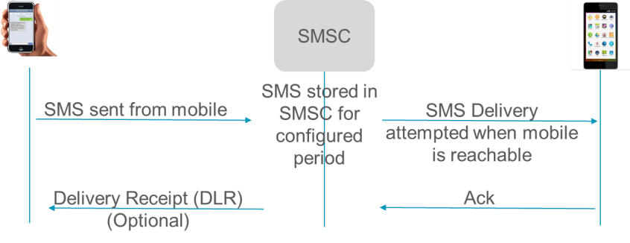
Fig 2: Simple illustration of an SMS Protocol

Network latency issues
Network Latency refers to the delay experienced by packets in the network. Before sending packets over the network, a radio network connection has to be established. The table below provides latency and radio connection setup time for different MCN technologies. Network latency is inherent to communication protocol and network design and hence cannot be reduced. However knowing the network latency will help IoT solution designers to choose the right communication network for the application.

Table 1

Radio connection set up & latency in MCN
MCN  Technology | Latency (msec) | Radio Connection setup time (msec)
2G Data | 300-1000
3G | 100-500 | 200-2500
4G | <100 | 50-100

Both network latency and connection establishment time impact the response time of interactive IoT applications. Timeout values used to identify issues such as “no response”, Packet losses, etc. should consider latency.
Response time includes the following:
- Radio Connection setup: Before sending any data over MCN network, radio connection needs to be setup. As seen from the table above, the values are significant compared to latency. Though this is one time, if the design is such that radio connection is established for every interaction, then one needs to consider the connection setup time too in the response time calculation.
- Transport Session setup: After the radio connection setup, transport connection needs to be setup. If TCP is used as a transport protocol, TCP session setup should be considered. If UDP is required, there is no session and hence there is no session setup overhead. TCP session setup time will be 3 times the network latency as minimum three messages have to be exchanged to set up a session.
- Transaction overhead: After the session setup, actual message transaction will take place to complete the specified use case. Number of transactions depends on the use case. The time taken for this is equal to the number of transactions multiplied by the network latency.
Let us take a use case to understand how latency and connection setup time impact the response time.
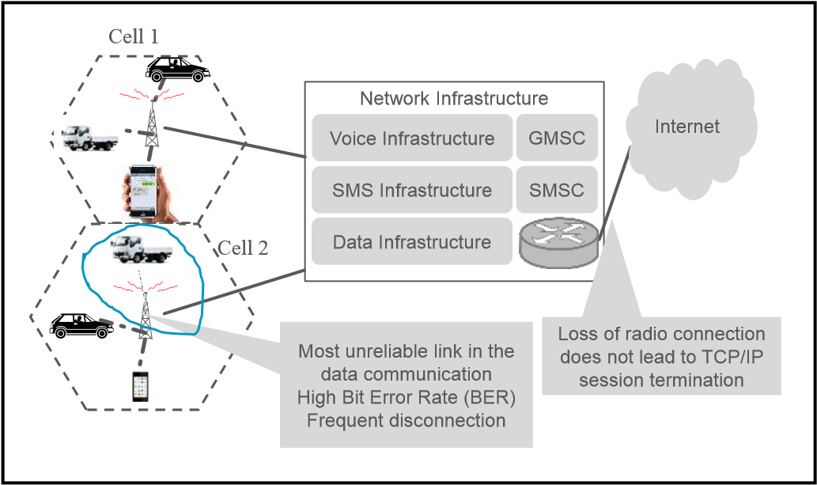

Fig 3: MCN challenges
In home automation applications, a user touching an icon on the mobile phone screen would be like a light bulb turning ON/OFF and the icon getting updated with current status within a second. Anything longer is not acceptable as we are used to mechanical switches which have a response time of <100msec.
In the above example, there are four transactions:
- Request from the mobile application to IoT platform,
- Request from IoT platform to the IoT device for turning ON light,
- Response from the IoT device to IoT platform and
- Response from IoT platform to the mobile application.
These are the minimum transactions required; there may be more depending on how applications are developed.
In home automation applications, the session between devices and IoT server is usually designed for a fast response. Hence, the Radio connection setup time and TCP session setup time can be ignored. The only parameter that impacts the response time is network latency. In the above example, the response time is 4 times the network latency as it involves 4 transactions.
If a 2G data network is used, then the response time could be from 1.2 sec to 4 sec. This may not be acceptable for a home automation application; a 4G network will be suitable for home automation applications as the maximum response time is < 400 mSec.

IoT server cannot initiate communication with devices
IoT devices primarily use data services of MCN for connecting to the IoT platform. IoT devices accessing the data services are allocated with NAT-ed IP address.
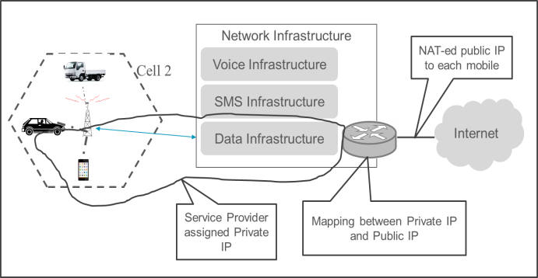

Fig 4: NAT-ing Issue in MCN
Each device with mobile data connection will have two IP addresses: A local IP address assigned from the Service Provider’s local IP pool and a NAT-ed Public IP Address. Both the IP addresses can change every time a data connection is made. Since the devices are behind
NAT-ing router, IoT platforms cannot initiate a connection to mobile devices.
This is acceptable where only IoT devices initiate connection to IoT platform. As an example, sensor only devices wakeup at programmed intervals, collects data from sensor, connect to platform, push the data to platform and go back to sleep.
However, there are many occasions in IOT where in the server/Cloud needs to initiate communication with the device e.g., to reconfigure a mobile device, to query status of the device or to request the device to upgrade the firmware.
Providing a public IP address for each mobile device is one solution. While this is technically possible, it is not practical due to shortage of IPv4 addresses.
This issue can be addressed in many ways:

Maintain communication session. Communication is initiated from the mobile device and the session is maintained without closing. IoT server will be able to communicate with that device on the same session. This method is used where real-time access is required from IoT application. However, this is an expensive solution as this utilizes more resources in the network and as well as in the platform.

Session extension. When the device connects to server for posting the data or for Keep Alive, the session is extended by the IoT server to carry out the intended device access. This technique can be used where the device communicates periodically and a delay in access can be tolerated. This technique can be suitable for device configuration, software upgrade and status query.

SMS notification. Server sends SMS to the mobile device indicating the device to initiate connection to the server. When the connection is initiated, server can complete the device access. However, one should be aware that SMS delivery is best effort only and the delivery time is variable.

Higher power consumption
Power consumption of a GSM device for every transmit or receive varies from 13mA (average idle mode) to 2A (transmission bursts), with typical being 300mA. The battery life of a typical GSM/GPRS module with 1500mAh battery varies from 1 to 2 months depending on the transmit interval and sleep configuration. However, the expected battery life of an IoT device ranges from 18 months to 30 months.
Hence, use of MCN network for IoT applications is limited to outdoor applications that require communication over long distances and tracking things that are on the move such as vehicles or goods being transported.
Today, in most cases, devices that use MCN for communication are powered by the vehicle battery. Container tracking devices often use 2 or 3 powerful batteries that last up to 6 months with a transmit interval configured for 60 to 120 minutes.

Conclusion
MCN is the preferred communication technology today for IoT communication for connecting things that are moving and/or placed outdoors. Ubiquity, coverage and well established government policies are the main advantages of MCN.
However there are issues such as NAT-ed IP and disruptions in communication sessions for which solution providers have found workarounds. Power consumption is an issue which one needs to live with for now.
New wireless technologies, such as Low Power Wide Area Network (LPWAN), are in various stages of development for creating long range, low power, very low cost wireless, with a low bit rate for IoT/machine-to-machine communication. Deployment of such wireless networks may address some of the issues not addressed by MCN in the future.

References
- Ilya Gregorik, “High Performance Browser Networking”, O-Reilly, USA, 1st Edition, Sep 2013.
- Tim Hatt, Kenechi Okeleke, Mike Meloan, Closing the Coverage Gap – a view from Asia, GSMA Intelligence, Jun 2015.
- 'India's Mobile Towers to Number More Than 500,000 by 2020', Press Trust of India, 17 Jun, 2015.

About the author
Mr. Karan Verma is a web developer and an Engineering student in the Department of Computer Science and Engineering at D A V Institute of Engineering and Technology
(I.K.Gujral Punjab Technical University ), Jalandhar, Punjab, India. He is actively involved in several projects. He is selected as a Dell Campassador from among 2500+ students(2016-2017). He is an engineer by profession but an artist by choice. . He is curious about different forms of art and obssessed with all unique things and innovations and trends in different areas.
Email : karanvrm19@gmail.com

Return to Table of Contents
Editor’s note: While other studies are determining how to create more self-directed learners, a necessary aptitude for success in distance learning, this study recognizes that those who have the aptitudes, discipline and skills to be successful in distance learning are potential leaders. Success in distance learning may be a valuable means to select candidates for leadership programs.

Cultivating leaders in the distance learning classroom

Marianne Raley

USA
Keywords: distance learning, education, leadership, adult learner, identity, distance education, continuing education, higher learning, college instruction, e-learning, virtual classrooms, educational strategies

Introduction
Distance learners face unique challenges in order to obtain their college degrees (Rothweiler, 2012). They must possess superior time management, facility with diverse technologies, personal drive, and excellent organization to complete their discussion postings, individual assignments, and team projects by deadline (Hannay & Venne, 2012). Many distance learners are non-traditional students who work full time, care for families, and experience additional stresses adjusting to the college coursework (Eriksen, 2006). Though this provides added time constraints, successful distance learners use astute strategies to prioritize needs, delegate tasks, and maximize work opportunities to meet their demanding personal, professional, and academic obligations (Ying, Huamao, Ronghuai, Yanhua, & Jingjing, 2008). Students who successfully manage the complex challenges associated with distance learning are demonstrating leadership abilities and are ideal candidates for targeted leadership instruction that will maximize their professional and academic success.
Leadership skills generally include problem solving, delegating tasks, successful collaboration in diverse teams, communication abilities, and information management and implementation (Stein, 2013). Distributive Leadership models in higher education focus on the importance of collaborative work where, “knowledge, skills and information” are freely shared (Keppell, O'Dwyer, Lyon, & Childs, 2011, p. 10). Identifying and fostering leadership skills in proven candidates, such as successful online students, will build the student’s self-esteem and lay a foundation for future success in the academic and professional worlds. Leadership skills that are practiced in a safe space like an online classroom, or indeed, any supportive class environment, allow the student to polish those abilities and feel comfortable transferring them to the professional sphere (Shanty & Gropelli, 2014).
Building active engagement strategies into the class will allow students to practice leadership skills that can readily translate to the world outside of the classroom (Fulford, 2013; Stein, 2013). Whether it is integrating social media, podcasting, videocasting, blogging, or other current digital trends, instructors can capitalize on the wide range of interactive content creation opportunities to further engage the distance learner and ensure that they are effectively reahing the course objectives. Today’s distance learners face many obstacles to their commitment to the work of each class. Whether it is stress from their jobs, families, or personal challenges, distance learners are busy adults with full schedules. To get the most out of each class, they must see clear application to their personal and professional lives. As Fulford (2013) states, “adult learning theory clearly indicates that we learn the most by doing” (p. 82). Team based exercises, hands on projects, and other active engagement strategies can help, not only keep the attention of the adult learner, but also to create opportunities for meaningful absorption and acquisition of knowledge and skills. Using interesting and challenging exercises, like assigning a team book review to distance learners, offers students a chance to practice their team building and communication skills within a familiar framework while building the community of the classroom (Moore, 2008).
Technology and diverse media offer a wide range of learning and leadership opportunities for distance learners. Rather than being disadvantaged by working online for their classes, these students can be on the leading edge of digital capabilities and demonstrate a sound, working knowledge of software and learning platforms to create, collaborate, and present or submit their assignments. Popular digital platforms like Facebook, Youtube, podcasts, and blogging sites are generally accessible and free or low cost. These can support leadership learning by promoting collaboration, brand building experience, and the overall enhanced learning of objectives with user-generated content opportunities (Phelps, 2012).
Though younger students may already be familiar with many social media opportunities, there still may be areas of unease or unfamiliarity with using such platforms in an academic environment. Understanding potential limitations of student knowledge and experience can better prepare the instructor to foster success with diverse learning strategies that may make use of interactive technologies (Phelps, 2012). Adult students, in particular, may experience stress when presented with tasks and technologies that are outside their areas of expertise (Eriksen, 2006). Starting with technology that is familiar to students, like assignments that include watching a carefully selected movie that promotes the goals of the class, can help to clearly demonstrate concepts, especially with leadership skills (Hannay & Venne, 2012). Incorporating innovative digital strategies for leadership learning online requires a consideration of the student population to ensure that the assignments “support and not detract from the overall objectives, goals, and missions of leadership education” (Phelps, 2012, p. 67).
Distance learners may also be geographically diverse and can enjoy the benefits of working with other students and instructors from all over the country and around the world (Motteram & Forrester, 2005). Students who may not otherwise have an opportunity to pursue higher education at a campus nearby are able to pursue degrees with online courses. The diverse backgrounds and geographic locations of distance learners can help to replicate the professional challenges of communicating over long distances or with varied groups of employees. While this diversity may offer advantages in leadership training, it can also contribute to difficulties with regular computer or Internet access, time, and individual progress with the work (Phelps, 2012). When deciding to implement digital learning and leadership opportunities in an online classroom, consideration should be given to accessibility for any assignment.
Since the demographics of undergraduate distance learning students are similar to community colleges, students may be above traditional age and have extensive workplace experience and personal obligations that influence their success in the classroom (Kimmel, Gaylor, Grubbs, & Hayes, 2012). Instructors must be sensitive to both the skills that students bring to the classroom as well as the skills with which they have not yet gained an adequate facility (Tinberg & Weisberger, 1998). While acquiring new skills may aid personal and professional transitions, it may be challenging for students to stay engaged and motivated without meaningful support from the faculty (Rothweiler, 2012). In distance learning courses, there is usually no face-to-face component or brick-and-mortar classroom that ensures students make attendance or make progress on the class work. Instructors must overcome these challenges by clearly linking the tasks in the classroom to specific uses in the professional world. This can help keep adult students with professional experience engaged and motivated to absorb the new skills (Kim, 2009).
Though distance learners are steeped in the digital innovation which may enhance the flexibility and ease with which they can attend class, they must also confront a myriad of personal challenges which may include full time employment, family obligations, and other anxieties associated with non-traditional age, returning to or beginning an online college education, and the higher proportion of first generation college attendance that may impact their confidence and feelings of ease with their own, demonstrated abilities (Nordstrom, Goguen, & Hiester, 2014). With distance learning, there is no hiding out in the back of a classroom, avoiding making contributions to the class conversation, or just texting while the professor is lecturing. Each student must participate fully from the beginning of the course or risk damaging their scores. Students may also have had negative experiences with formal education in the past that inhibit their ability to see themselves as the successful college students and leaders-in-training that they are. These challenges may impede the adoption of new identities associated with higher learning and leadership. When managing the challenges of college and the development of new leadership skills, distance learning classrooms can offer a safe space to explore new abilities in the presence of others who help connect the new and old aspects of their identities (Felfe & Schyns, 2014).
As a liminal space, the online classroom offers students that opportunity to explore new leadership skills and management strategies while transitioning their identities as leaders (Felfe & Schyns, 2014). Students who are just starting out on their college journeys may wish to transform themselves and make a fresh start, but are hesitant to claim a new identity without sufficient practice. When students try on new identities in the classroom, they are able to experiment and play with them until they feel confident enough to claim those identities outside the classroom. “With repeated interaction and revision, a more coherent identity develops, one that reinforces the role of the claimed identity within the self-concept (that the student has adopted)” (Ibarra & Petriglieri, 2010, p. 17). A student who may not have felt like a dynamic, educated leader outside the classroom is able to gradually explore and identify with the new skills and abilities that they have cultivated.

Conclusion
The online learning environment offers unique benefits and challenges to students and instructors (Hannay & Venne, 2012). Distance learners who are able to successfully navigate the significant obstacles to their education can be ideal candidates for leadership training. Preparing these dynamic, hardworking, and resourceful students with targeted leadership skills can help students more confidently and successfully use leadership skills to achieve their academic and professional goals. The digital classroom can offer a unique environment where adult learners can obtain hands-on, technically savvy, and professionally applicable instruction. The cultivation of these leadership skills in a dynamic and relevant manner ensures that they are able to learn course objectives alongside key leadership strategies like collaboration, team building, prioritization, communication, and problem solving. The online college class can also provide a flexible space to exercise new leadership roles and identities which allows students to develop the confidence they need to act as leaders in their professional, academic, and local communities.

References
Eriksen K. (2006). The constructive developmental theory of Robert Kegan. Family Journal,
14 (3) , pp. 290-298.
Felfe, J. & Schyns, B., (2014),"Romance of leadership and motivation to lead", Journal of Managerial Psychology, Vol. 29 Iss 7 pp. 850 - 865 Permanent link to this document: http://dx.doi.org/10.1108/JMP-03-2012-0076
Fulford, M. D. (2013). Practice what you preach: Using an experiential learning approach to teach leadership. Journal of Leadership, Accountability and Ethics, 10(2), 81-86. Retrieved from http://search.proquest.com/docview/1459143629?accountid=458
Hannay, M., & Venne, R. (2012). It's showtime: Using movies to teach leadership in online courses. Journal of Online Learning and Teaching, 8(3), 238. Retrieved from http://search.proquest.com/docview/1500359815?accountid=458
Ibarra, H., Petriglieri, J.L., (2010), "Identity work and play", Journal of Organizational Change Management, Vol. 23 Iss 1 pp. 10 - 25 Permanent link to this document: http://dx.doi.org/10.1108/09534811011017180
Keppell, M., O'Dwyer, C., Lyon, B., & Childs, M. (2011). Transforming Distance Education Curricula Through Distributive Leadership. Journal Of Asynchronous Learning Networks, 15(4), 9-21.
Kim, K. (2009). Motivational challenges of adult learners in self-directed E-learning. Journal of Interactive Learning Research, 20(3), 317-335. Retrieved from http://search.proquest.com/docview/211247847?accountid=458
Kimmel, S. B., Gaylor, K. P., Grubbs, M. R., & Hayes, J. B. (2012). Good Times to Hard Times: An Examination of Adult Learners' Enrollment From 2004-2010. Journal of Behavioral and Applied Management, 14(1), 18-38. Retrieved from http://search.proquest.com/docview/1082324507?accountid=458
Moore, L. (2008). Killing Two Birds with One Stone: Using Book Reviews to Teach Leadership and Foster Community. Journal of Leadership Education Volume 7, Issue 2 - Fall 2008: Special Issue
Motteram, G., & Forrester, G. (2005). Becoming an Online Distance Learner: What can be learned from students' experiences of induction to distance programmes? Distance Education, 26(3), 281-298. Retrieved from http://search.proquest.com/docview/217779788?accountid=458
Nordstrom, A. H., Goguen, L. S., & Hiester, M. (2014). The Effect of Social Anxiety and Self-Esteem on College Adjustment, Academics, and Retention. Journal of College Counseling,17(1), 48-63.
Phelps, K. (2012). Leadership Online: Expanding the Horizon. New Directions for Student Services, 2012(140), 65-75. doi:10.1002/ss.20032
Rothweiler, B. M. (2012). Factors related to successful course completion in an online program for returning high school dropouts(Order No. 3527249). Available from ProQuest Dissertations & Theses Full Text. (1082007589). Retrieved from http://search.proquest.com/docview/1082007589?accountid=458
Shanty, J. A., & Gropelli, T. (2014). Using active engagement to teach leadership. The Journal of Continuing Education in Nursing, 45(12), 533-534.
doi:http://dx.doi.org/10.3928/00220124-20141121-14
Stein, L. (2013).Schools Need Leaders - Not Managers: It's Time for a Paradigm Shift. Journal of Leadership Education. Volume 15 Issue 2 . DOI: 1012806/V15/I2/I3
Tinberg, H., Weisberger, R. (1998). In Over Our Heads: Applying Kegan's Theory of Development to Community College Students. Community College Review, 26 (2), pp. 43-56.
Ying, W., Huamao, P., Ronghuai, H., Yanhua, H., & Jingjing, W. (2008). Characteristics of Distance Learners: Research on Relationships of Learning Motivation, Learning strategy, Self-efficacy, Attribution and Learning results. Open Learning, 23(1), 17-28.

About the author:
Marianne Raley holds a B.A. in English from Florida State University and an M.A. in English from the University of North Florida. Her teaching and research focus on the needs of adult distance learners. She is particularly interested in the intersections of identity, leadership, and mental health needs in distance learning communities. eMail: Marianne.Raley@phoenix.edu

Return to Table of Contents
Editor’s Note: 2229 words

A research study about:

Computer-Assisted Reading instruction

Rabia Zouaghi

USA

Abstract
Reading is considered as an essential skill in a modern society is a crucial skill for academic achievement and success for all students. Consequently, the teaching of reading has become one of the primary objectives for schools and teachers all over the world. An enormous amount of work has been done to assist learners who struggle with their reading skills. A tool that has been considered is the use of information technologies; namely computers. Research has been conducted to examine the impact of computers, across elementary, secondary, and college curricula in order to improve student`s reading comprehension. This paper reviews a body of literature that synthesizes the effects of computer-assisted reading instruction to enhance reading comprehension of students. It also addresses research that investigates the impact on comprehension when students are presented with computerized versus printed reading material. Findings suggest that computer assisted-instruction hold a great promise as an instructional tool, suggesting that the conductive learning environment provided by computer-assisted instruction should be used effectively.
Keywords: technological tools, reading comprehension, computer-assisted reading instruction.

Computer-assisted reading
Computer software programs have been developed and used to facilitate multiple, complex tasks in almost every field. This is simply because such programs are accessible to use in education. Researchers have demonstrated interest in using computers to enhance learning since 1960s (Rupley & Chevrette, 1983; Thompson, 1980, as cited in Singhal, 1998). The Stanford Computer Assisted Instruction (CAI) was the first project designed to develop computer programs for learning to read (Singhal, 1998, p.3) since learning to read is “highly valued and important for social and economic advancement (Snow, Burns, & Griffin, 1998). CAI is considered as one of the highly recommended strategies that could assist students to improve their reading comprehension skills. CAI generally contains many elements including; drills and practice, tasks, instructional games, and other material that can be used along with lecturing, a traditional instruction method, to improve student`s achievement.
Frequent attempts were made to use the computer as tool to teaching reading skills in classrooms. One of the first documented attempts was the Stanford project, conducted by Richard C. Atkinson. Atkinson & Hansen (1966) drew a comprehensive computer-based system for teaching initial reading, a system that was completely monitored and minimized the role of the reading teacher. Computer based instruction is believed to be “more interactive than traditional classroom lectures” (Najjar, 1996. p.2). The results of the project were published several years later on an evaluation of Stanford CAI program in initial reading, indicating that CAI students achieved higher scores when compared with students instructed by teachers (Fletcher & Atkison, 1972, as cited in Singhal, 1993, p.3).
There are three reasons why students in computer assisted instruction reading programs usually have better achievement in reading comparing to tradition methods in teaching reading skills: The first reason is the care and skill with which the programs are designed for individualized instruction. Second, motivational feature offered by immediate feedback in computer-assisted instruction. Third, the students are actively involved in the learning assignment (Rupley & Chevrette, 1983, as cited in Singhal, 1998).
Krasilnikov (1989) gave a description for a course that was developed in Russia using computer assisted instruction in order to develop second language learners reading skills (as cited in Singhal, 1998, p.3). Nine computer programs along with learning modules were developed in which low level learners in second language literacy could practice “word recognition and word comprehension, recognition of word boundaries and sentence structures, recognition of the devices used to create textual cohesion, sentence completion, vocabulary development, skimming skills, scanning, and practice in reading for global understanding, and reading for total comprehension” (Sinhal, 1998, p.4). Singhal (1998) pointed out that those computer programs were solely described specific reading skills; the impact of program as such was not described in detail, even though provided “practice in both top-down and bottom-up reading comprehension strategies” (p.4).
In addition to the studies described above, more recent studies in the area of computers and reading have examined the effects of implementing multimedia reading software on reading comprehension for students. Lomicka`s (1997) explored how multimedia impact the level of reading comprehension through having students think aloud during the reading of text on the computer screen (as cited in Singhal, 1993, p.6), using a tracker to record the amount of glossing type and time length that each was consulted. The results showed that computerized reading with full glossing enhances the level of reading comprehension.
Chaika (1999), Cotton (2001), & Chang (2000) asserted that CAI promotes learning by integrating technology into the classroom (as cited in Tillman, 2004), indicating that improves achievement if students were motivated, including learners with learning abilities (Kim & Kamil, 2001, as cited in Tillman, 2004). A software association also reported positive achievements of CAI to students with special needs. Likewise, Najjar (1996) reviewed many studies that show that multimedia can assist in learning more information more quickly compared to traditional classroom lecture, concluding that computer-based instruction is instrumental in this regard, especially if “the computer-based multimedia instruction is interactive and learner paced” (p. 10).
Furthermore, Soe, Koki and Chang (2000) highlighted the impact of CAI on reading achievement (as cited in Tillman, 2004). Mioduser, Tur-Kaspa, and Leitner (2000) explored particular features of computer technology related to reading children`s acquisition of early reading skills. Mioduser et al. (2000) used a software program that allows specific manipulation of letters and word components in activities and games involving the decomposition, and creating of words. Findings show that children who received the reading intervention program with computer significantly improved “their phonological awareness, word recognition, and letter naming skills” in comparison to their peers who received a reading intervention program with only printed materials and those who received no formal reading intervention program (p. 58). Butler-Pascoe & Wiburg (2003) stated that “technology resources motivate readers” by achieving different reading objectives, and that the Internet provides readers with “immediate access to extensive and up-dated information” (as cited in Kim, 2007, p.31).
Other studies (Son, 2003; Jasper, 2003) testing the use of three different reading text formats: paper-based format (PF), computer-based non-hypertext format (NHF), and computer-based hypertext format (HF), found that using hyperlinks was instrumental to improve students’ reading skills in their second language (as cited in Kim, 2007, p.32). A plenty of educational technologies are available today to help and assist student and enhance the reading skills including, audiobooks, electronic books and online texts, electronic talking books, and programmed reading instruction. Beers (1998) states that such technologies act as a “scaffold” that helps students who are “struggling, reluctant, or second-language learners” to read above their actual reading level (p. 33). In addition, using audiobooks in combination with written texts does assist in improving the student`s reading skills since they listen to the audio version of the book and follow along with the printed version (Beers, 1998, p. 33).
Online texts are those that area available on the World Wide Web. With access to an Internetconnected computer, students can locate a wide variety of free online materials, including books, plays, short stories, magazines, and references material online. Also, in a study by Wise, Ring & Olson (2000) involving elementary students who were struggling with reading two CAI programs were compared for enhancing reading skills, such as “identifying sounds in non-words and manipulating sound/letter patterns, and accurate –reading-in-context” (as cited in Macaruso & Walker, 2008, p.269) which focused on learning strategies for reading comprehension. Findings indicated that “phonological analysis” delivered greater assistance in “untimed word reading than accurate-reading in context, “especially for low level beginner reader children (as cited in Macaruso & Walker, 2008, p.269).

Discussion
After conducting such a research in implementing CAI in teaching reading subject in classrooms, it seems that this topic took a critical spot in research field many years ago and many studies attempted to explore and prove their hypotheses that, which provided a large body of work about impact of using computer in improving the reading instruction. In fact, many studies proved the benefits of Computer Assisted Instruction (CAI) in improving reading comprehension. Some researchers claimed that CAI improves the phonological sensitivity skills of children who are at risk as main reason to use such a tool in reading instruction. Others indicated that, there is a need for a follow-up assessment, in order to explore the effectiveness of the use of the computer as an instructional tool in reading comprehension. Moreover, another research indicates that CAI can offer an effective educational tool to help poor readers more than print especially when CAI is applied in an interactive instructional environment. In addition, many researchers called for the use of CAI in instruction since it provides a positive motivation toward learning.
However, it looks like that there is still a need to accumulate more research about computer assisted reading instruction that provides evidence confirming that poor readers using CAI can improve their reading skills. Tillman (2004) points out to the existence of an enormous body of work linked to CAI, yet he argued that there is a much smaller amount of research has been devoted to the impact of CAI on reading instruction (Tillman, 2004).
Also, during this research it was found that most of previous studies that focused on affects of CAI in instruction, has been done on very young students where there was no a clear map or plan provided to educators that focuses on how reading on the computer can actually take place and the factors that contribute to the process of reading comprehension using CAI. Furthermore, more applicable technology resources such as web readings tasks ought to be developed to examine the effects of computer-assisted reading. Even though a lot of reviewed and published research report a positive effect of using CAI in reading instruction, Paterson, Henry, O’Quin, Ceprano, and Blue (2003) collected and used data to examine the differences between a treatment and control group of student, concluding no differences (Paterson et al., 2003, as cited in Macaruso & Walker, 2008, p.269). Sponder (1993) stressed that the computers and multimedia play a significant role in supporting learning; however, he argued that the educational role of information technologies should not be presumed (p. 2).

Conclusion
To conclude, there is almost consensus by researchers that the computer as a technological tool is instrumental in improving reading instruction. It has been found more effective in achieving reading comprehension than tradition methods, such as printed literary texts. Research supported the fact that students using CAI achieves better than who are instructed by teachers; some researchers, indeed, attributed it to the fact that computer- based instruction is more interactive than traditional classroom lectures. Computer-based instruction has been a motivational tool besides being instructionally instrumental as it seamlessly engages students in learning process.
Technology, particularly CAI, has been trend in the literature for the improvement of reading subject but no solid conclusion could be drawn from the available literature about the effectiveness of CAI in reading instruction; however this review does provide considerable evidence that CAI enhance reading instruction to support increased achievement and hold a great promise for becoming formidable instructional tools that increase student`s engagement in reading and enhance reading comprehension. CAI has been an instrumental instructional tool that assists teachers in designing individualized reading programs, taking into consideration the level of student proficiency.
It is also important to mention that computer is not meant to substitute the teacher role in the learning process, but rather improves and enhances classroom reading instruction. That reading instruction using the computer is a great method to engage students in the reading process improves the student capabilities to meet their varying needs. It’s worth mentioning that suggestions of this literature review are frequent and research studies that report that certain technology increases students’ skills and achievement are often conducted by the publishers of the technology and software industries; however, only positive findings about the use of their educational software are noted in their reports and studies.

References
Atkinson, R. C., & Hansen, D. N. (1966). Computer-assisted instruction in initial reading: The Stanford project. Institute for Mathematical Studies in the Social Science, Stanford University. Retrieved from http://suppes-corpus.stanford.edu/techreports/IMSSS_93.pdf
Beers, K. (1998). Listen while you read: Struggling readers and audiobooks. School Library Journal, 44(4), 30-35. Retrieved from http://interactivereadalouds.pbworks.com/f/Listen+While+You+Read.pdf
Kim, Hea-Suk (2007). The effects of computer-assisted reading instruction on reading skills and vocabulary learning. Multimedia-Assisted Language Learning, 10 (3), 27-50. Retrieved from http://kmjournal.bada.cc/wp-content/uploads/2013/05/10-3-2Kim.pdf
Macaruso, P., & Walker, A. (2008). The efficacy of computer-assisted instruction for advancing literacy skills in kindergarten children. Reading Psychology, 29 266-287. Retrieved from http://stu.westga.edu/~ssynan1/literacy/Macaruso.pdf
Mioduser, D., Tur-Kaspa, H., & Leitner, I. (2000). The learning value of computer-based Instruction of early reading skills. Journal of Computer Assisted Learning, 16, 54- 63. Retrieved from http://muse.tau.ac.il/publications/66.pdf
Najjar, L. J. (1996). Multimedia information and learning. Journal of Educational Multimedia and Hypermedia, 5, 129-150. Retrieved from http://www.medvet.umontreal.ca/techno/eta6785/articles/multimedia_and_learning.pdf
Singhal, M (1998). Using computers as reading instructional tools: Applications and implications. ERIC ED, 3(2). Retrieved from http://files.eric.ed.gov/fulltext/ED419225.pdf
Snow, C.E., Burns, M.S., & Griffin, P. (1998). Preventing reading difficulties in young children. Washington, DC: National Academy Press. Retrieved from http://files.eric.ed.gov/fulltext/ED416465.pdf
Sponder, B. (1993). Computer assisted reading instruction: New tools for new experiences. ERIC ED, 15(1), 1-7. Retrieved from http://files.eric.ed.gov/fulltext/ED372749.pdf
Tillman, P. S. (2004). Computer-Assisted instruction (CAI) and reading acquisition: A Synthesis of the Literature. Retrieved from http://chiron.valdosta.edu/are/TillmanPLRFinal.pdf

About the author
Rabia Zouaghi is a student at Nazareth College, Pittdfordf, NY
Email rzouagh2@mail.naz.edu

Return to Table of Contents

Subtitle Retrieved June 7, 2016 from http://en.wikipedia.org/wiki/Subtitle,2016-7
Guillory, H. G. (1998). The effects of keyword captions to authentic French video on learner comprehension. CALICO Journal, 15, 89-108.
De Bruycker, W., & d'Ydewalle, G. (2003). Reading native and foreign language television subtitles in children and adults. In J. Hyona, R. Radach & H. Deubel (Eds.) , The mind's eye: Cognitive and applied aspects of eye movement research (pp. 671-684): North-Holland.
Li, T., & Xin, T. (2013). The Influence of Movies with Different Subtitles on Receptive and Productive Vocabulary. Journal of Guangdong University of Foreign Studies, 7, 105-108
Geza, K., & Robert, C. M. (2014) Smart subtitles for vocabulary learning. In Proceedings of the SIGCHI Conference on Human Factors in Computing Systems (CHI '14). ACM, New York, NY, USA, 853-862. DOI=http://dx.doi.org/10.1145/2556288.2557256,
Wesche, M., & Paribakht, T. S. (1996) Assessing Second Language Vocabulary Knowledge: Depth Versus Breadth. Canadian Modern Language Review, 53, 13–40.
Wang, F., Zhou, Z., Zhao, X., Bai, X. & Yan, G. (2012). Subtitle Preference While Viewing Native Language Movie: The Effect of Subtitle Familiarity [J] Studies of Psychology and Behavior, 10, 50-57

