InternAtional
Journal

of

Instructional Technology
and
Distance Learning

August 2015
Volume 12 Number 8

Editorial Board
Donald G. Perrin Ph.D.
Executive Editor
Elizabeth Perrin Ph.D.
Editor-in-Chief
Brent Muirhead Ph.D.
Senior Editor
Muhammad Betz, Ph.D.
Editor

ISSN 1550-6908

PUBLISHER'S DECLARATION
Research and innovation in teaching and learning are prime topics for the Journal of Instructional Technology and Distance Learning (ISSN 1550-6908). The Journal was initiated in January 2004 to facilitate communication and collaboration among researchers, innovators, practitioners, and administrators of education and training involving innovative technologies and/or distance learning.
The Journal is monthly, refereed, and global. Intellectual property rights are retained by the author(s) and a Creative Commons Copyright permits replication of articles and eBooks for education related purposes. Publication is managed by DonEl Learning Inc. supported by a host of volunteer editors, referees and production staff that cross national boundaries.
IJITDL is committed to publish significant writings of high academic stature for worldwide distribution to stakeholders in distance learning and technology.
In its first decade, the Journal published more than 600 articles; 7,500 pages of research and theory by over 1,000 authors. It logged over ten million page views and more than a million downloads of Acrobat files of monthly journals and eBooks. Many authors benefited from refereed publication for retention, promotion, tenure, and advancement in their profession
Donald G. Perrin, Executive Editor
Elizabeth Perrin, Editor in Chief
Brent Muirhead, Senior Editor
Muhammad Betz, Editor

Vol. 12. No. 8.
ISSN 1550-6908

Table of Contents – August 2015
 | Page
Editorial: see note | 1
Impact of elearning on primary school children and teachers: A study of the One Laptop Per Child Pilot project in Fiji | 3
Raturi, Shikha and Kedrayate, Akanisi
Online program development as a growth strategy across diverse academic programs | 25
Chera LaForge, Young You, Ross Alexander, Neil Sabine
Online Discussion Self-Grading Innovation Using the Quizzing Tool | 41
Laura M. Schwarz and Nancyruth Leibold
The advantages and disadvantages of distance learning in higher education | 51
Phyllis A. Witt
Teacher educators’ awareness towards quality assurance in teacher educational institutions (teis) in Tamil Nadu | 59
G.Esther Jeba Selvi & A.S.Arul Lawrence

Return to Table of Contents

Editorial

Donald G. Perrin
The editorial will be added later so that publication will not be further delayed for the authors in this issue

Return to Table of Contents

Return to Table of Contents
Editor’s Note: This is a carefully crafted research program to determine the effectiveness of the One Laptop per Child project in Fiji. It seeks information on teacher and student preferences within the range of activities involved in this program and effectiveness of these different options. In the process it tries to fill gaps in research findings for similar programs.

Impact of elearning on primary school children and teachers:
A study of the One Laptop per Child Pilot project in Fiji

Raturi, Shikha and Kedrayate, Akanisi

Fiji

Abstract
The current trend of integrating technology in learning at all levels of education system has also impacted Fiji primary schools. The effort to integrate elearning in primary school began with the launch of ‘One Laptop per Child’ project in three primary schools whereby each school received fifty XO laptops. The impact of this intervention was investigated after 1.5 years of project implementation. The study reports learners’ and teachers’ generally positive perception of elearning and highlights some challenges. The impact on learners’ social, behavioural and cognitive skills holds promise. The need for continuous professional development and elearning policy to ensure support for teachers is one of the major implications of this study.
Keywords: elearning; Information Communication Technologies; One Laptop per Child, OLPC

Introduction
In the current climate of Information Communication Technologies (ICTs) integration in school systems across the globe, Pacific Island Countries school systems have also been impacted albeit slightly. The changing pedagogies attempt to equip young students with 21st century learning skills. The University of the South Pacific has been instrumental in fulfilling its commitment towards elearning which is evident by the incremental development to acquire state-of-the-art ICT facilities together with its move towards online learning. Furthermore, inclusion of ICTs as one of its seven priority areas in USP’s Strategic Plan (2013-2018) indicates USP’s firm commitment to ICT development in the region. It is, therefore, imperative that the school system provides opportunities to experience ICT integrated pedagogies. Schooling systems run by various Ministries of Education (MoEs) will ensure students’ smooth transition to ICT enabled learning environments that exist in tertiary institutions.
The One Laptop per Child (OLPC) initiative was started by Nicholas Negroponte and his team at the MIT Media lab in 2002 and sugar component worked on by Walter Bender and his team. Negroponte was careful about ‘technology’ getting the attention and labeled it as an ‘education project’. However, critics point out that because of the focus on providing technology such as XO laptop to children instead on the educational content and logistics of usage of technology, the project is a laptop project and not education project (Volta, 2007). Uruguay was the first country to achieve One Laptop per Child in 2009. Since then, intervention with XO laptop has been carried out in different parts of the world and resulted in varying degree of success.
The launching of OLPC pilot project in three schools (Draiba Primary, Nabua Sanatan and Navesi Primary) in 2013 by the Government of Fiji (Ministry of Education) is thus considered a timely intervention. A Memorandum of Understanding (MoU) signed between USP and MoE ensured partnership between these two bodies and their commitment towards elearning. Thus, USP assisted MoE with setting up the pilot project in the three schools and provided teacher training and technical assistance with servers. Bhatta (2008) highlights the importance of project evaluation of the test and pilot phases and the lessons that can be learned from the test and pilot to assist with the scaling up as well as to monitor the progress of the project. The thrust for the present research is primarily from the point of action research/formative evaluation as highlighted by Urrea and Bender (2012) to inform USP and MOE on the need for modification to the approach, if any, for future projects. The main aim of the OLPC Fiji Pilot research project is to provide important lessons for the next phase of the project.
The OLPC initiative is based on five core principles (OLPC, 2008):
- Child Ownership. The child is the custodian of the laptop, it is theirs to use at school and at home.
- Low Ages: XO is designed specifically for children aged 6 to 12.
- Saturation. XO should be deployed on the basis of One Laptop for EVERY child in a class or school.
- Connection. Anything the child does on the XO can be done together with others, as a learning experience.
- Free and Open Source. Students and educators can share learning materials in a spirit of free and open collaboration.
The initiative ‘One Laptop per Child’ in Fiji was launched by distributing 50 XO laptops to each of the three pilot schools namely, Draiba Primary, Nabua Sanatan and Navesi Primary school in 2012. Each of the three pilot schools were required to work on setting-up a room that would be equipped with the XO laptops and a server and air-conditioning system. The XO lab was rostered for all classes in each of the schools to use; Navesi Primary allowed teachers to take XO laptop and children out in the field sometimes. It must be noted that core principle 1 and 3 is no longer applicable in this initiative. Therefore, the conceptual understanding is drawn from the three of the five principles mentioned above that is 2, 4 and 5 and a body of literature on integration of technology in classrooms.
The implementation of the OLPC project in Pacific Island Countries (PICs) is much different from its counterparts in the rest of the world in its approach of providing 50 laptops per school instead of saturating each school. This approach more or less remains the same in PICs. Therefore, the research findings from this project will inform not only Fiji but PICs too.
It must be noted that PICs are now embracing integration of Information Communication and Technologies (ICTs) into the education system and seeking alternate devices and approaches. It will, therefore, also inform such interventions that make use of disruptive technology innovations in learning and teaching.
More importantly, a lack of rigorous research in the area of ICT intervention in schools around the world has led to numerous speculations relating to the failure of ICT in education projects, it is therefore pertinent that this research study is carried out to fill the gaps in the existing literature in ICT intervention in school systems.

Research questions
There are four research questions pertinent to this investigation:
Q1. What is the digital status of students, teachers and parents in the three pilot schools?
Q2. What is the students’, teachers’ and parents’ perception of using XO laptop in learning and teaching?
Q3. What kind of impact does XO intervention have on students’ cognitive, social and behavioural skills?
Q4. What are the implications of XO intervention for policy makers and educators?

Theoretical Orientation
The theoretical underpinning the OLPC initiative is constructionism (Papert, 1993a, 1993b) and it is one of the underlying assumptions for implementing this project in PICs too. The researchers believe that the activities with the XO laptop provide learners with ample opportunities to construct their knowledge and build their understandings. Lohr (2008) reports, “It’s an approach that builds on the conceptual work of Jean Piaget, the Swiss philosopher and developmental theorist, and the practical research of his intellectual descendants like Seymour Papert, the M.I.T. computer scientist, educator and inventor of the Logo programming language, designed for education”.
Papert (1980) believed that children in the future would use a computer in place of a pencil and viewed the computer as a powerful learning tool that would enable children to construct and learn. His vision of ubiquitous computer culture and learning principles are underpinned by his theory of constructionism (1993b). Thus, the OLPC initiative is based on Papert’s constructionism that focuses on the student as the ‘subject’ rather than the ‘object’ and engages in ‘learning by making’. Papert, as cited in Hooker (2008), contrasted constructionism with instructionism highlighting the indispensible role played by electronic digital dynamic media; the potential of the XO laptop in its ability to act as the tool and provide the right learning environment for the learner to learn by constructing knowledge themselves.
The researchers believe that Vygotsky’s theory of social constructivism (1978) comes to life in these classrooms. Learners learn with computers/laptops that not only provide them an opportunity to reach their next level of proximal development, but also learn by collaborating with peers where laptops are interconnected by means of a wifi and a server. Digital technologies are bridging the digital gap through ubiquitous internet and many different devices. OLPC is considered as an important contributor that can help connect learners (Ebner, Dorfinger & Neuper, 2011). Connectivism (Siemens, 2005) is considered instrumental in joining the dots to form the knowledge and make meaning and the presence of web together with OLPC initiative makes it a feasible proposition. Siemens remarks, “amplification of learning, knowledge and understanding through the extension of a personal network is the epitome of connectivism” (p. 6, 2005).

Literature review
The conceptual understanding for this study is drawn from a assortment of literature about ICT integration in education from various OLPC studies. An understanding of digital skills and perception of intervention helps understand the premise of learners’ and teachers’ position with respect to such intervention. The impact of the intervention on cognitive, social and behavioural skills helps evaluate the intervention in the light of participants’ digital skills and perceptions.
The belief that ICT intervention provides affordances that enable learners’ learning journey is at the heart of OLPC project (Papert, 1980), (Bebbel & Kay, 2010; Drayton, Falk, Stroud, Hobbs & Hammerman, 2010). However, as Bhatta (2008) points out, media invariably focused “far more on (XO) laptop itself and not enough on than how it can be used to enhance quality education” (p.12). He goes on to point out the need to treat the XO laptop as a tool which will only be useful as it delivers the education content and if the user is able to use that content. Nepal is one of the first countries that looked at implementing OLPC project in a systematic manner, which is going from test phase to pilot phase and ensuring teacher preparation, network and power infrastructure development, and government capacity building forms an integral part of the project lifecycle (Bhatta, 2008)
Urrea and Bender (2012) worked through an aggregated review of evaluations studies by OLPCA and summarised the common indicators that indicate social and learning impact are at the heart of project and a measure of its evaluation. This study will also address some of these indicators as highlighted in the study by Urrea and Bender.
Hirji, Barry, Fadel and Gavin (2010) reported that impact of OLPC become even more prominent when the content and language is localized, quoting examples from Haiti, Ethiopia, Cambodia and many more. They added ‘teacher involvement and participation’ is key to the project’s success and that it was equally important to provide holistic training and professional development for teachers. A lack of local training program is evident in nearly all OLPC projects. The role of management in implementation of a technology intervention in any educational institution has been highlighted by many researchers. (Bebbel et al 2010; Drayton et al 2010; Whatley, 2011). Whatley (2011) pointed to the important role played by the headmaster of the school and the need for the headmaster’s clear understanding and perceptions of the OLPC program in order to make it a success. She highlighted that headmaster’s motivation helps her to implement creative and constructive initiatives in their school be it teacher training, technical support and overall management.
Hirji et al (2010) listed 4 major impacts on students as a result of OLPC intervention:
- An increase in attendance and access
- An increase in confidence and motivation
- Bridging socio economic inequality
- Need and subsequent redefining of children’s social support networks and connectivity at large with the global community
It must be noted that bridging social inequality was only achieved in the cases where complete saturation was one of the OLPC core principles (OLPC, 2008); this happened only in Uruguay.
In the PICs, Solomon Islands is the only country so far which has produced an evaluation of their OLPC project. It must be noted that involvement of Australian Council for Educational Research (ACER) from the beginning helped with the process of evaluation. The Ministry of Education and Human Resources Development (MEHRD) developed its own evaluation framework which served later as the basis for ACER’s evaluation (Australian Council for Educational Research report, 2010). According to ACER’s report (2010), despite a number of glitches (as listed in Appendix 1 of ACER report), “the response to the rollouts of the laptops in the three pilot schools has been very positive” (p. 27) and there is a general notion that laptop will assist in improving students’ learning. Similarly, a randomised evaluation after 15 months of implementation in 319 schools in rural Peru reports an increase in access to computers (ratio of computers per students from 0.12 to 1.18 in treatment schools), some positive results in general cognitive skills but no effects on enrollment and test scores in Math and Language (Cristia, Ibarraran, Cueto, Santiago and Severin, 2012).
On the other hand, the OLPC experiences in European classroom reveal that the usefulness of the project can be enhanced by transferring the experiences to developing countries in a bottoms-up approach as well as supporting community building at local and international levels (Ebner, Dorfinger and Neuper 2011).
Despite Negroponte’s assertion on OLPC being an ‘education’ and not a ‘laptop’ project, much heat has surrounded the project and much remains to be desired for. A lack of rigorous research has resulted in confusion and skepticism surrounding the educational value of the OLPC concept.
Bhatta (2005) highlights the misconceptions that arise in the environment of lack of research in this critical area.

Research methodology and design
The OLPC program has been reported to make use of empirical analysis, data collection, focus groups and general qualitative analysis for evaluation studies ((Hirji, Barry, Fadel and Gavin, 2010). It must be noted that in OLPC Solomon Islands program, Ministry of Education and Human Resources Development (MEHRD) was involved in implementation and some of MEHRD officials were also interviewers, the issue of respondents providing “expected” responses to please the interviewers was circumvented by asking same/similar questions to a variety of respondents/groups to allow data triangulation (Australian Council for Educational Research report, 2010). A similar approach has been taken in this research study considering USP’s dual role and involvement in the training and then this research study.
The ethical considerations were treated with utmost care and the USP Research protocol together with MOE research protocol was followed. Permission from the Faculty of Arts, Law and Education (FALE) Research Office and research permit from MOE to carry out research was taken prior to conducting research in the pilot schools. Three questionnaires for students, teachers and parents were designed to carry out the survey. A team of experts were asked to read the questions to assist with the process of reliability and content validity of the instruments. Four undergraduate education students were employed as research interns for one and a half day each. Three student interns who had the permits to enter school carried out administering of the instrument. One student intern performed data entry assisted by the three student interns for each school. The interns were briefed on the research process, which provided a comfortable environment for participants during the survey. Student interns were also reminded of research ethics. The administration of each school advised students, teachers and parents about the research and made arrangements for a student to conduct the survey which comprised of both open and closed ended questions. It is mainly qualitative in nature with basic descriptive statistics employed to investigate demographic and correlations if any; SPSS 21 was utilized.
A total of 240 students (80 students from each school and 10 from each class from class 1 to 8; stratified randomly picked), 28 teachers and 29 parents participated in the study from the three pilot schools.

Results and discussions

Demographic, digital access and experience
Some basic descriptive statistics on demographic and access to and experience with Information and Communication Technologies (ICTs) for the sample is illustrated in the following bar charts (Figure 1 to 12) and Tables 1-2.
Students:
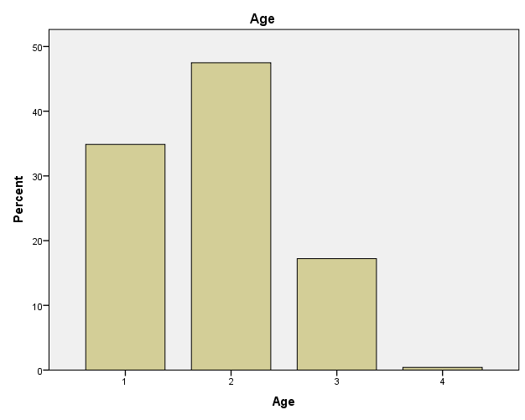

Fig 1. Age
(Key: 1 = 5-8 yrs; 2=9-12 yrs; 3=13-15yrs; 4=Over 15 yrs)
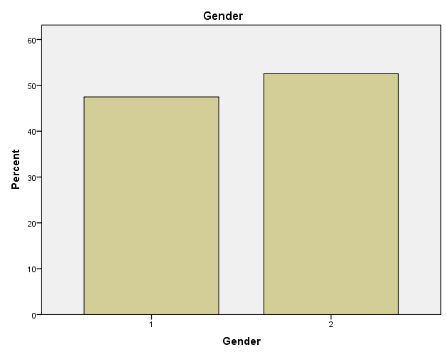 | 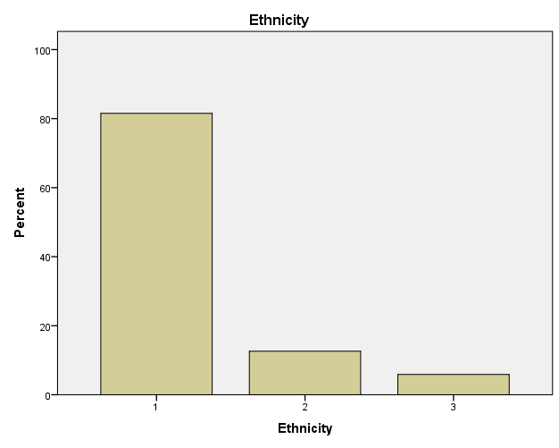
Fig 2. Gender  1 = Male; 2=Female | Fig 3. Ethnicity  1 = iTaukei; 2=Indo-Fijian; 3=Others

Slightly less than half the students (113 out of 240) in the survey fall in the age group 9-12years, with near gender balance (female slighter higher than male students) and 81% iTaukei (N=119) students in the sample. The term i-Taukei refers to indigenous Fijians and ‘others’ comprise all others except i-Taukei and Indo-Fijian but including Chinese-Fijians, Rotuman, Banabans and other Pacific Islander. The migration of students from one location to another is evident from figure 4 considering the number of students who indicated less than twelve months exposure with the XO laptop.
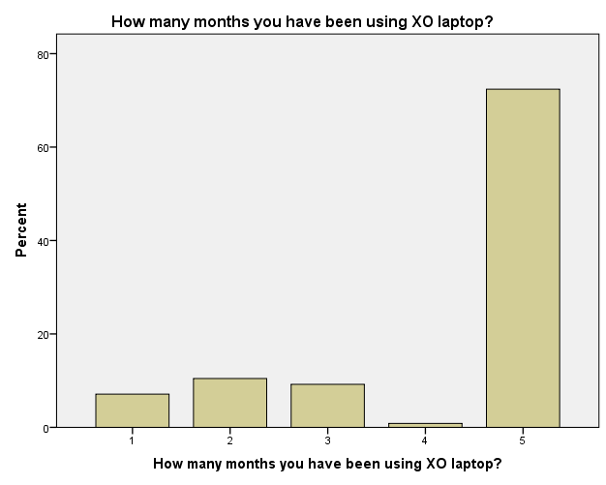

Fig 4. Exposure to XO laptop
1 = 1-3 months; 2=3-6 months; 3=9-12months; 4=Over 12months
Nearly 72 percent (173 students out of 239; 1 did not respond to the question) had experienced using the XO laptop for more than 12 months and 17 students indicate less than 3 months exposure, it is expected that this statistics would have implication on the overall responses obtained for other questions as well as teachers responses.
Further responses on exposure and experience with Information Communication Technologies (ICTs) indicated that learners are not ‘digital natives’. These included students’ access and experience with computer and internet.
Teachers
The teachers’ gender, ethnicity, qualification, teaching experience, position and age were deemed necessary to understand their perceptions towards integration of technology in learning and teaching and its correlation (Figures 5 to 10).
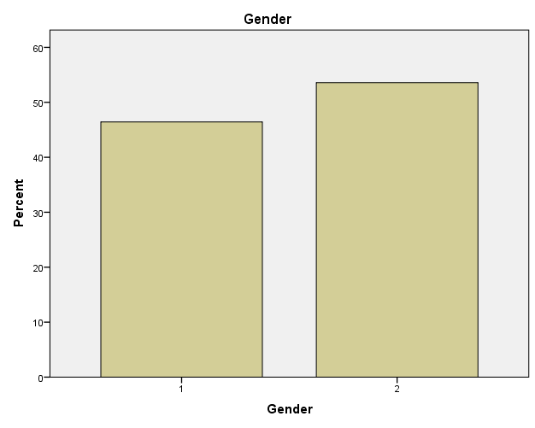 | 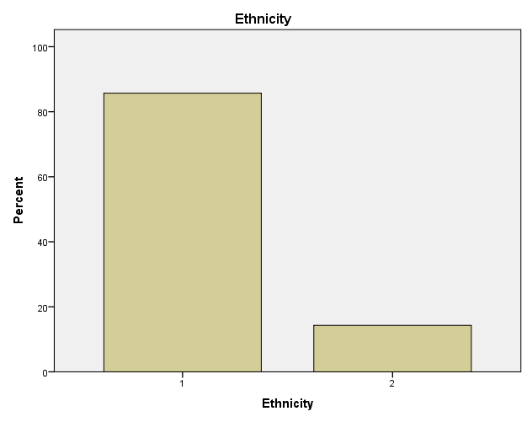
Fig 5. Gender  Gender (Key: 1 = Male; 2=Female) | Fig.6. Ethnicity  1 = iTaukei; 2=Indo-Fijian; 3=Others
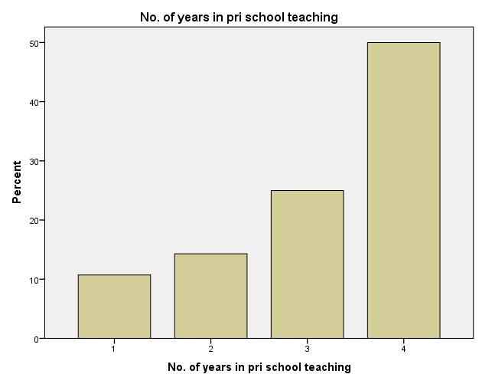 |  | 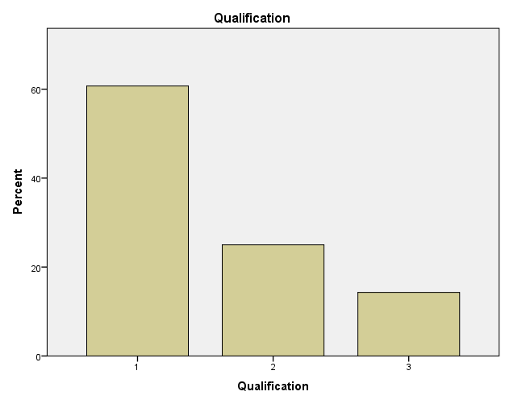
Fig 7. Teaching experience  1 = < 2yrs; 2 = 2-5 yrs; 3 = 5-10yrs; 4 = > 10yrs |  | Fig.8. Qualification  1 = Certs; 2 = Dip; 3 = Bachelors; 4 = Masters

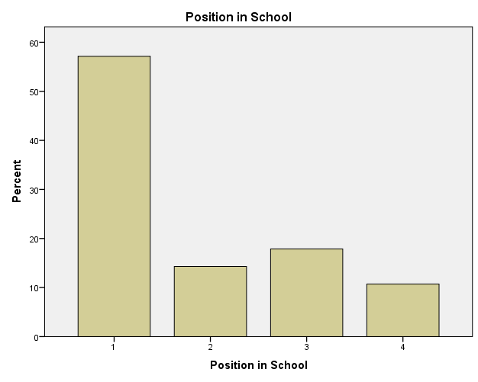 | 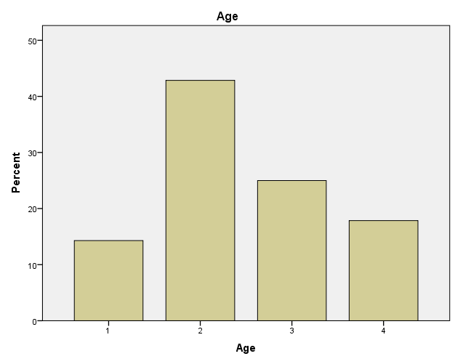
Fig 9. Position in School  1=Asst.Teacher; 2=Teacher; 3=Snr.Teacher; 4=Head | Fig.10. Age  1=18-25yrs;2=26-35yrs;3=36-45yrs;4=>46yrs

The figures illustrate slightly higher number of females (15 out of 28) and a greater number of iTaukei (24 out of 28) teachers in this sample.
Further responses on exposure and experience with Information Communication Technologies (ICTs) indicated that teachers are ‘digital immigrant/adapter’ evident from the small numbers with less than 2 years of computer (N=3) and internet experience (N=4) and the rest with experience over 2 years as illustrated in Figures 11-12.
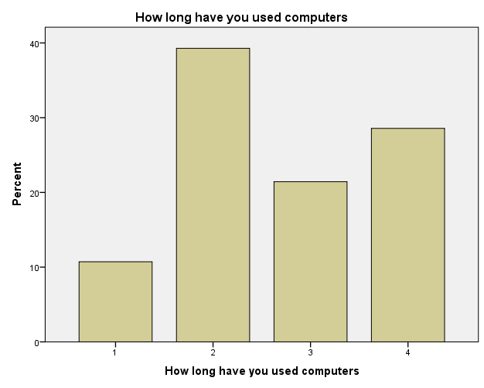 | 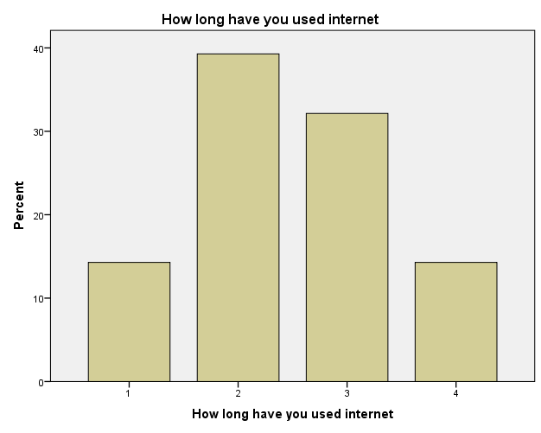
Fig 11. Computer experience  1 = < 2yrs; 2 = 2-5yrs; 3 = 5-10yrs; 4 = > 10yrs | Fig.12. Internet experience  1 = < 2yrs; 2 = 2-5yrs; 3 = 5-10yrs; 4 = > 10yrs

The access to a mobile phone, computer and internet (on both mobile and computer) is given in Table 2.

Table 2

Access to ICTs
 | Personal computer | Internet at home | Mobile | Internet on mobile
Yes | 25 | 20 | 26 | 19
No | 3 | 8 | 2 | 9
Total | 28 | 28 | 28 | 28
It is thus obvious that teachers are well equipped with ICTs and the fact that 19 out of 28 teachers have internet on their mobile indicates their preference for technology and connectedness. The computer and internet access and experience should have some influence over teachers’ preferences in the use of XO laptop in learning and teaching.
Parents
Out of 29 parents surveyed, 28 parents were iTaukei and 1 Indo-Fijian. The access to a mobile phone (both for child and parent), computer and internet (on both mobile and computer) is given in Table 3.

Table 3

Access to ICTs
 | Personal computer | Internet at home | Child/ren has/have a mobile | Parent has a mobile | Internet on mobile
Yes | 19 | 20 | 1 | 27 | 14
No | 9 | 9 | 28 | 2 | 15
Total | 29 | 29 | 29 | 29 | 29
Table 3 illustrates that parents consider technology as part of commodity at home and more than half of the children have access to computer and internet at home. The socio-cultural environment of the child plays a role in their cognitive development. The findings so far indicate that household in Fiji too would contribute towards the impact of OLPC project; the access and experience of children and teacher with ICTs must be kept under consideration.

Perception of using XO laptop
Preference for activities and reasons
It was considered important that activities on XO laptop (Appendix 1) were evaluated by learners and teachers in order to understand their perceptions. Thus a question on their top ten favourite activities was asked and reasons for best and least liked activity were also investigated. Refer to Appendix 1 for various activities indicated in Figures 13-16.

Students
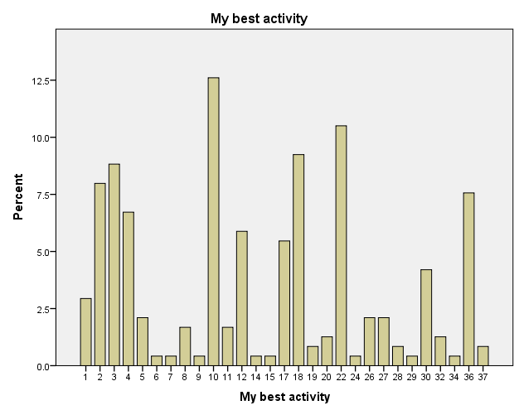
Fig.13. Students’ favourite activity on XO laptop;
x-axis indicates various activities on XO
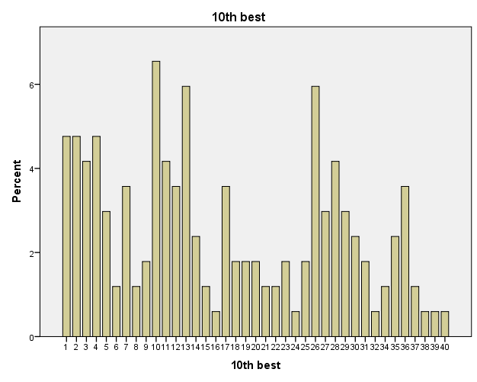
Fig.14. Students’ least favourite in their top-ten list of activity on XO;
x-axis indicates various activities on XO
It was remarkable to note that 29 activities out of the 40 activities found a place in at least one student’s “best of top ten activities”, which is evident from Figure 14. This highlights more than half of the activities manage to retain children’s attention. The ‘Speak Activity’ emerged as the most (N=30) liked activity when asked to pick their top ten activity followed by ‘Tux Math’ (N=25), ‘Write Activity’ (N=22), ‘Maze Activity’ (N=21), ‘Browse Activity’ (N=19) and ‘Chat’ (N=18). Other trends that emerge from this statistics together with their reason for preference are:
- Activities that are ‘fun’, ‘simple’ and ‘interactive’ made them popular amongst children.
- Children were quick in linking the value of activity to improving the literacy and numeracy skills in some cases.
- Activities that help with literacy can be grouped such as ‘Speak’, ‘Write’, ‘Chat’, ‘Typing Turtle’, ‘Word’ and ‘Get Book’ most preferred by 83 students.
- Activities that help with ‘numeracy’ can be grouped such as ‘Tux Math’, ‘Clock’, ‘Calculate’, ‘Measure’ and ‘Ruler’ most preferred by 39 students.
- Game based learning aspect of these activities came up as the reason for its preference such as ‘Tux Math’, ‘Maze’ and ‘Etoys’.
On the other hand, least preferred in the top ten were spread out throughout all the forty activities pointing out that the 11 activities which did not make it to the top (in the top-10 list) found a place in the bottom of the top ten. The least preferred activities were ‘Speak’ (N=11), ‘TamTamJam’ (N=10) and ‘Clock’ (N=10). The reasons that emerged most were ‘difficult to do/hard’, ‘boring’, ‘too many steps to follow’ and ‘lack of practice’. There is a possibility that with time students may like a particular activity as they get to practice with it further.
Teachers
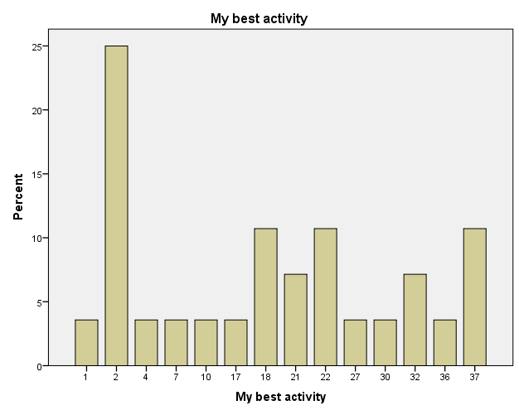
Fig.15. Teachers’ favourite activity on XO;
x-axis indicates various activities on XO
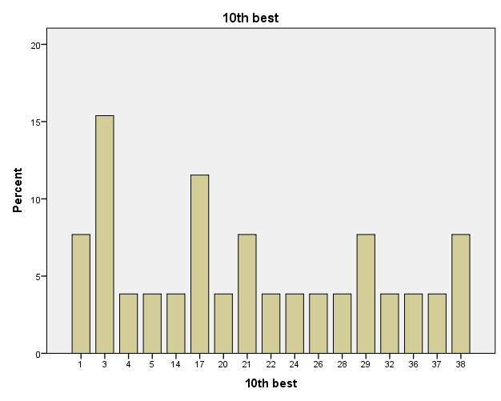

Fig.16. Teachers’ least favourite in their top-ten list of activity on XO;
x-axis indicates various activities on XO
It is interesting to note that 14 activities out of 40 made it to the top of the top-10 list of teachers favourites where ‘Browse’ was the most popular (N=7) followed by ‘Write’, ‘Tux Math’ and ‘Wikipedia’ (N=3 for each). Both ‘Browse’ and ‘Wikipedia’ were seen to enable ‘research options’, ‘access to information’, ‘interesting and educational’, ‘share new information with colleagues’ and ‘enhances learning and teaching’.
The ‘Maze Activity’ (N=4), ‘Typing Turtle’ and ‘Abacus Activity’ ((N=3 for each) emerged as the least preferred of the top-ten activities. These activities were perceived as ‘difficult/complicated’, ‘time consuming’, ‘unfamiliar activity’ and finally ‘lack of practice’ too came up as a reason.
Once again if similar activities are grouped together, teachers mostly preferred activities that gave them access to resources and information or targeted numeracy and literacy skills. However, ‘practice’ with an activity plays an important role. For both students and teachers.
XO use and perceptions
Since it is a common belief that use of XO brings about changes in perception of use of technology in the classroom, therefore XO use and perception of stakeholders were investigated.
XO and enjoyment
In general when students were asked if use of XO made learning enjoyable, except for six students and five no responses, the remainer (N=229) perceived learning with XO as ‘enjoyable’. Some of the most popular reasons for considering it enjoyable was mainly owing to its ‘Game based learning’ aspect’, ‘independent learning’ option with opportunity for ‘research and seek information’ and ‘self-assessment’. The students like its ability to give them prompt feedback of their success/failure so that they could progress further.
While students found XO enjoyable, it did not make a difference to 33 students whether there was a lesson incorporating XO, some of these students added that they liked coming to school regardless of XO. Three students did not give a response. However, 203 students indicated that they looked forward to coming to schools if they had XO lesson in the time-table. The students again equated XO to ‘enjoyment’, ‘motivation’, ‘helpful’, ‘fun’, ‘change’, ‘greater access to information’ and ‘excitement’. While those who could not care for XO in the timetable equated it to being ‘hard’ and ‘boring’.
On the other hand, all teachers indicated that they would prefer to use XO for a lesson, when asked if they would integrate it in their learning and teaching. The reasons give were that it helped grab children’s ‘attention’, made the classroom ‘lively’, helped student’s improve ‘research skills’ and ‘motivated students easily’.
Out of 29 parents, majority (N=22) agreed that their child/ren enjoyed using XO, five did not give any response and two did not agree. The reason for enjoyment was attributed to XO providing their child/ren access to more resources and information, and adding ‘excitement’ and ‘novelty’ in their learning process. The fact that students discussed what they did in class using XO with parents as they returned home made parents believe that their child/ren must be enjoying using XO in the classroom.
When asked if their child/ren looked forward to coming to school, six responded negatively, three failed to give a response and 20 responded positively. The parents generally seemed happy about their child/ren using technology in their learning process and equated XO with ‘enjoyment and excitement’, ‘thinking out of the box’, ‘learning enhancement tool’ and good for improving their ‘reading and writing skills’.
XO and ease of learning
When asked if including XO activity made learning easier or harder, 217 students considered easier while 21 commented on it as making the lesson harder and 2 failed to respond. The reasons for XO perceived as harder was due to the ‘lack of practice’ and ‘lack of support’; these were mainly new students in the school as highlighted by the students. The ‘simple lay out’, ‘game based learning’ and ‘fun interface’ made it easier to use for some learners.
All the teachers agreed that it helped make classroom teaching easier with XO illustrating the reasons as:
“Personally, I am still finding out how and which lessons I can integrate with my classroom learning but I am positive that this will be accomplished in due time”
or
“Time management from my classroom to the lab [is difficult] and not enough laptop for the children”
While those who agreed attributed the ease to the fact that it enables ‘self-learning/independent learning’, ‘fun with learning’ , ‘motivation in children’ and targets a number of ‘learning styles’ thus making it easier for teachers.
XO and its impact on ICT skills and learning and teaching
The students and teachers were asked to evaluate changes in their ICT skills as a result of OLPC programme. The students reported ‘fair’ changes in word processing (M = 3.00, N = 240) and Paint and Publisher (M = 3.05, N = 239) skills whereas ‘a little change’ in use of search engines (M = 2.39, N = 227). There was very minute effect on spreadsheet skills though. A lot of application in XO resemble Office apps and other information processing skills which can help improve ICT skills.
Similarly, teachers reported a change in ICT skills as illustrated in Table 4.

Table 4

Change in ICT skills of teacher since OLPC training
ICT Skills | N | M | SD
Word processing | 26 | 3.58 | 1.391
Spreadsheet | 26 | 2.62 | 1.061
Paint, Publisher etc | 26 | 2.77 | 1.070
Email etc. | 27 | 3.59 | 1.366
Moodle skills | 26 | 2.27 | 1.218
Internet Search Engines | 27 | 3.81 | 1.272
Online services | 27 | 2.56 | 1.396
Social Media | 27 | 3.81 | 1.495
VoIP services/ Audio-Video conferencing | 27 | 3.07 | 1.482
Blogs, wiki etc | 27 | 2.63 | 1.182
There were a number of opportunities for teachers to practice ICT skills as they began their OLPC training and clearly it had an impact on their ICT skills with social media (there is an OLPC Facebook page), search engines, emails, word processing and VoIP/audio-video conferencing skills being the most conspicuous.
Teachers were asked to evaluate the impact of use of XO on their learning and teaching practices. Prior to this, three questions were targeted to seek their satisfaction with OLPC project, training and support (Figures 17-19).
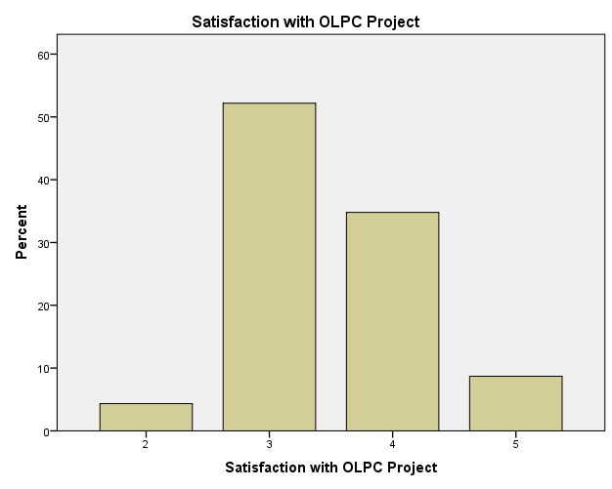

Fig.17. Satisfaction with OLPC Project
(Key: 1 = Least; 2 = Fair; 3 = Good; 4 = Very Good; 5 = Excellent)
Out of 28 teachers, five did not respond and 23 responded. 12 teachers rated their satisfaction with OLPC project as ‘good’ whereas eight rated it ‘very good’, not a single teacher rated it ‘least’. The mean for satisfaction rating with OLPC project is 3.48 (N=23).
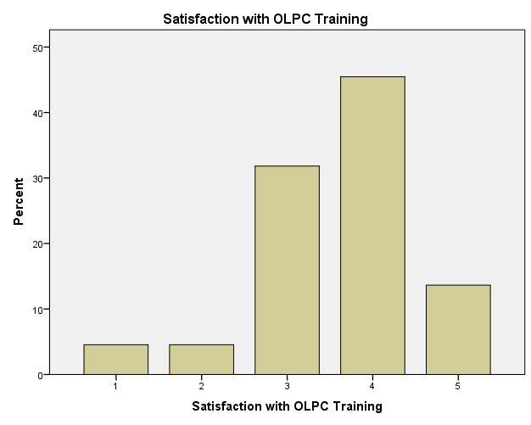

Fig.18. Satisfaction with OLPC Training
(Key: 1 = Least; 2 = Fair; 3 = Good; 4 = Very Good; 5 = Excellent)
Out of 28 teachers, five did not respond and 22 responded. The satisfaction was recorded ‘least’ by one teacher whereas seven rated it ‘good’ and ten rated it ‘very good’. The mean for satisfaction rating with OLPC training is 3.59 (N=22).
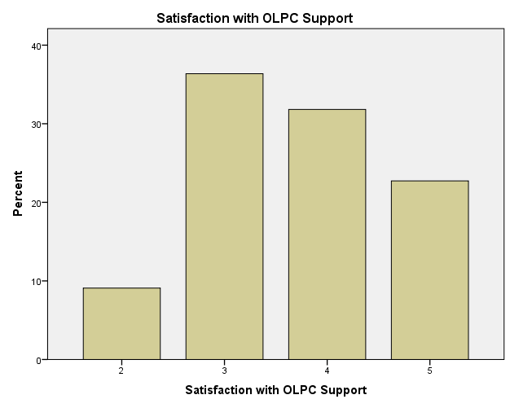
Fig.19. Satisfaction with OLPC Support
(Key: 1 = Least; 2 = Fair; 3 = Good; 4 = Very Good; 5 = Excellent)

Out of 28 teachers, six did not respond and 22 responded. The satisfaction was recorded ‘good’ by eight teachers whereas seven rated it ‘very good’ and five rated it ‘excellent’. The mean for satisfaction rating with OLPC support is 3.68 (N=22).
Relationship between satisfaction with OLPC training and OLPC project (ρ = .436 at p=.01 level, N = 22) as well as OLPC support (ρ = .538 at p=..05 level, N = 22) revealed weakly moderate positive relationship. This indicates that the impact of satisfaction with training influences satisfaction with overall project and project support. Therefore, the importance of teacher training cannot be underestimated and this must be carefully thought through.
All teachers agreed that OLPC project has impacted them as a teacher indicating the ICT intervention effort as a success. They commented on ‘improved ICT skills’ which reaffirmed their earlier responses in table 3. Some teachers gave other impacts such as ‘enhanced ability to think outside the box’, ‘improved interaction skills’, ‘increased self-confidence’, ‘worthwhile professional development’ and ‘ability to design a variety of lessons with various activities from XO’. Teachers believed that their own researching skills had improved tremendously due to the inclusion of XO in the classrooms. XO was viewed as a useful teaching tool/aid that assisted their learning and teaching practices and made their life easier. However, the teachers were quick in acknowledging the need for more time to enable better use of XO since it is not linked to the curriculum yet.

XO intervention: its impact on students’ cognitive, social and behavioural skills
The parents and teachers contributed to help reveal impact of XO intervention on students’ cognitive, social and behavioural skills.
Out of 29 parents, three failed to respond to this issue, four responded negatively and rest (N = 22) responded positively. The reasons given by parents were mostly on improved ICT skills of their child/ren and some commented on their improved research and information processing skills and their ability to extract information from around the world. It seemed to parents that their child/ren had enhanced learning desire after the inclusion of XO in the school.
Except for one teacher, all agreed that there was an improvement in students’ general behaviour. Issues of attendance were reported to have improved. The teachers commented on student’s ability to be more attentive and focused, eager to learn/increased motivation and improved classroom behavior during XO lesson were quite conspicuous. Improved collaboration skills during the XO lesson was also highlighted by a teacher. One teacher commented,
“Wednesday is our OLPC day and this is when they are on their best behavior”
It seemed easier to handle behavioural issues in the classroom as teacher would use ‘XO’ as an incentive tool. Improved ‘self-confidence’, ‘independent learning skills’,‘interaction and collaboration skills’ among students were highlighted by the teachers.
Teachers attributed activities such as ‘TuxMath’, ‘Speak’ ‘Read’ and Write to contribute towards improved literacy and numeracy skills, however, this needs to be investigated in a more systematic and focused manner. Observations such as these remain anecdotal.

Conclusion
It is evident that the deployment of particular technologies will not necessarily result in improved learning outcomes unless teachers are given opportunities and support to evaluate and experiment with it and make informed choices as reported by others (Drayton, Falk, Stroud, Hobbs & Hammerman, 2010). It is crucial that PICs do not end up in a situation of ‘high resources, low value’ as faced elsewhere (Cuban, 2001, 2006; Cuban, Kirkpatrick & Peck, 2001), therefore, every measure must be taken to ensure the pivotal role played by teachers is scoped and supported and strategic measures put in place. Some researchers blame low use of technology owing to the computer to student ratio not having achieved a ubiquitous environment (Papert & Harel, 1991; Cuban, 2006), however this does not matter in the context of PICs as higher computer to student ratio encourages collaborative learning which is preferred by many Pacific Island learners (Raturi, 2015).
The students’ perceptions indicate their inclination towards a highly interactive learning environment that provides opportunities for self-directed/independent learning to in turn develop creative skills. It is obvious that students in this study prefer constructionism. The extent of moving from instructionism to constructionism must be fully realised not just by teachers but all stakeholders as majority of the education system across the globe still follows instructionism as opposed to constructionism. It takes a lot of courage, effort and planning to transform pedagogical philosophy of any institution especially when it is the so called ‘radical constructionism’.
This pilot study indicates students, teachers and parents acceptance to embrace OLPC project, however, student and teacher migration creates some problems. There is a clear need to address the cases of student and teacher migration from non-OLPC school to OLPC school during the school year so that they can be trained in the use of XO and brought to the same level of competency as the other students and teachers in an OLPC school.
The digital access and experience of teachers from the three pilot school gives them the status of ‘digital migrants/adapters’ whereas the students do not fit in the ‘digital native’ category.
The most important finding of this study is the popularity of “game based learning” activities and how this feeds into improved numeracy and literacy skills. Also, improved ICT skills of students and more importantly teachers since the OLPC training for teachers and XO intervention in the schools for students is more prominent in case of teachers than students. This emphasizes two-pronged effect of use of XO in classroom that is improved learning and ICT skills. The importance of teacher training and support post-training comes out clearly as lack of practice has been noted to influence use of XO and the various activities in it.
Another very important point on linking XO activities to curriculum which was vaguely highlighted needs careful consideration and deliberation such that XO activities are incorporated in lesson plan by the curriculum development unit itself. It indicates that curriculum revision in light of XO activities should have been the first stage of the OLPC project and should have happened prior to teacher training and project implementation in schools.
The impact of XO intervention on students’ social and behavioural skills is evident from the teachers and parents comments on improved attendance, motivation and attitude towards learning in the three pilot schools. An improvement in collaboration, interaction, independent learning skills and creativity highlights the impact of using XO activities. These improved social and behavioural skills are similar to one reported by Hirji et al (2010).
The enthusiasm and support by all stakeholders is extremely important and so is their presence during the various stages of OLPC implementation process considering the ‘lack of understanding and familiarity’ amongst people (Bhatta, 2008).
The fact that all sugar activities can be downloaded, an indication of favourite activities in this study enables all stakeholders to consider should there be a need to replace XO laptop in the primary schools in future roll out. Bhatta (2008) remarked the competition OLPC must be prepared to face in near future as competitively priced inexpensive and powerful laptops enter the market; this is the current scenario as the market is flooded with a number of options in PICs. Efforts must be made to look into relatively cheaper, localised and sturdier technical solutions.

Implication of XO intervention for policy makers and educators
The XO intervention has several implications for policy makers and educators in light of the fact that school education system is moving towards integration of technology in learning and teaching.
- The Ministry of Education/governing school body needs to ensure that students and teachers transferred from a non-OLPC (or non-computing device school) to OLPC school (computing device installed school) have an orientation and training program in place for their smooth transition.
- There is a need for Curriculum Development Unit to urgently look into the available activities on XO laptop or any other computing device and link it to the existing curriculum to improve its integration in learning and teaching practices in the primary classrooms.
- The educators need to understand the power of ‘game based learning’ which must be harnessed and efforts be made to develop applications of this nature in future.
- The activities preferred by students and teachers provide an indication of what future application development for the region may look like. It would be imperative that educators and policy makers jointly look into this such that localization of application development is closely linked with curriculum; a point that is currently missing.
- Teachers need to be given opportunities for enough continuous professional development support in order to gain efficacy with use of ICT based activities in a computing device. This needs to be embedded in elearning policy for the country.
- Considering the current OLPC initiative status around the world, alternative computing devices and learning application/activities based on this research needs to looked into for such future projects in PICs

Acknowledgements
MOE Fiji and FALE and SOE Research office is thanked
for their cooperation and facilitation of research permit documents.
FALE office funds for hiring student interns are also appreciated.

References
Australian Council for Educational Development report (2010). “Evaluation of One Laptop Per Child (OLPC) Trial project in the Solomon Islands” ACER Final Report on the evaluation of the OLPC program for Ministry of Education and Human Resources Development (MEHRD), March 2010. Retrieved from http://wiki.laptop.org/images/0/0b/SolomonIslandsOLPCTrialsEvaluationByACER2010.pdf
Bebell, D. & Kay, R. (2010). One to One Computing: A Summary of the Quantitative Results from the Berkshire Wireless Learning Initiative Journal of Technology, Learning, and Assessment, 9(2). Retrieved from http://www.jtla.org
Bhatta, S.D. (2008). Tackling the problems of quality and disparity in Nepal’s school education: The OLPC model. Studies in Nepali History and Society 13(1): 17-48. © Mandala Book Point. Retrieved from http://wiki.laptop.org/images/2/26/SDBhatta.pdf
Cristia, J.P., Ibarraran, P., Cueto, S., Santiago, A. and Severin, E. (2012). Technology and Child Development: Evidence from the One Laptop per Child Program. IDB Working Paper Series No. IDB-WP-304. Retrieved from http://publications.iadb.org/bitstream/handle/11319/3919/Technology%20and%20Child%20Development%3a%20Evidence%20from%20the%20One%20Laptop%20per%20Child%20Program.pdf;jsessionid=C86F39A555FFCFD7275D71A2C7A16EBF?sequence=1
Cuban, L. (2001). Oversold and underused: Computers in the classrooms. Cambridge, MA: Harvard University Press. Retrieved from http://www.urosario.edu.co/CGTIC/Documentos/Cuban_article_oversold.pdf
Cuban, L. (2006). The laptop revolution has no clothes. Education Week. Retrieved from http://www.edweek.org/ew/articles/2006/10/18/08cuban.h26.html
Cuban, L., Kirkpatrick, H. and Peck, C. (2001). High Access and Low Use of Technologies in High School Classrooms: Explaining an Apparent Paradox. American Educational Research Journal, 38(4), 813.
Drayton, B., Falk, J.K., Stroud, R., Hobbs, K., & Hammerman, J. (2010). After Installation:
Ubiquitous Computing and High School Science in Three Experienced, High-Technology Schools. Journal of Technology, Learning, and Assessment, 9(3). Retrieved from http://www.jtla.org .
Ebner, M., Dorfinger, J. and Neuper, W (2011):First Experiences woth OLPC in European Classrooms. International Journal on E-Learning, 10 (4), pgs. 343-364. Chesapeake, VA: AACE.
Hirji, Z., Barry, B., Fadel, R. and Gavin, S. (2010). Assessment Overview of One Laptop Per Child Projects. One Laptop Per Child Foundation Learning Group. Retrieved from http://wiki.laptop.org/images/2/24/OLPCF_M%26E_Publication.pdf
Hooker, M. (2008). 1:1 Technologies/Computing in the Developing World: Challenging the Digital Divide. Global e-Schools and Communities Initiative. Retrieved from http://wiki.laptop.org/go/OLPC_research#1:1_Technologies.2FComputing_in_the_Developing_World:_Challenging_the_Digital_Divide_.282008.29
Lohr, S. (2008). Why Walter Bender Left One Laptop Per Child. The New York Times Blog. Retrieved from http://bits.blogs.nytimes.com/2008/05/27/why-walter-bender-left-one-laptop-per-child-edited-hold-for-wed-am/
Papert, S. (1980). Mindstorms: Children, computers, and powerful ideas. New York: Basic Books.
Papert, S. (1993a). Mindstorms: Children, computers, and powerful ideas. New York: Basic Books.
Papert, S. (1993b). The children's machine: Rethinking school in the age of the computer. New York: Basic Books.
Papert, S. and Harel, I. (1991). Situating Constructionism. Constructionism: Research reports and essays, 1985-1990. Norwood, NJ: Ablex Publishing Corporation. Retrieved from http://www.papert.org/articles/SituatingConstructionism.html
Raturi (2015). An evaluation of the elearning Continuum in Higher Education: A Study at the University of the South Pacific. Unpublished PhD Thesis, University of the South Pacific.
Siemens, G. (2005). Siemens, G. (2005). Connectivism: A Learning Theory for the Digital Age. International Journal of Instructional Technology and Distance Learning. 2 (1). ISSN 1550-6908. Retrieved on 20th Jan. 2013 from http://itdl.org/journal/jan_05/article01.htm
Urrea, C. and Bender, W. (2012). Innovation in Evaluation. Retrieved from http://wiki.laptop.org/images/5/5a/InnovationinEvaluation-Report.pdf
Volta, Wayan (2007). The Real OLPC Debate: Laptop Project vs. Education Project. Retrieved from http://www.olpcnews.com/commentary/press/debate_laptop_education.html
Vygotsky, L. (1978). Mind in Society. The development of higher psychological processes. Cambridge, MA: Harvard University Press.
Whatley, C. (2011). The role of Headmasters in the successful implementation of One Laptop per Child: A case study in Rwanda. Retrieved from http://wiki.laptop.org/images/c/c0/Ceri_Whatley_Conference_Paper.pdf

Appendix 1.
Activities and codes given in the research data for top ten activities as indicated in Figures 13-16
Activity CODE | Activity | Activity CODE | Activity
1 | Record | 21 | Abacus Activity
2 | Browse Activity | 22 | Tuxmath
3 | Maze Activity | 23 | Numbers Activity
4 | Paint Activity | 24 | Ruler Activity
5 | Physics Activity | 25 | Distance Activity
6 | Pippy Activity | 26 | Clock
7 | Get Books | 27 | Calculate Activity
8 | Turtle Art | 28 | Implode Activity
9 | Etoys | 29 | Moon Activity
10 | Speak Activity | 30 | Memorize Activity
11 | Tam Tam Edit | 31 | JAMedia
12 | Tam Tam Mini Activity | 32 | Foto Toon
13 | Tam Tam Jam | 33 | Portfolio
14 | Poll Activity | 34 | Scratch Activity
15 | Help Activity | 35 | Jigsaw Puzzle
16 | Finance Activity | 36 | Chat Activity
17 | Typing Turtle | 37 | WikipediaEN
18 | Write Activity | 38 | StopWatch
19 | Words Activity | 39 | Labyrinth Activity
20 | Measure Activity | 40 | InfoSlicer

About the authors
Dr. Shikha Raturi is an academic in the area of elearning and also co-manages Teachers Educational Resource and Elearning Centre (TEREC) at the University of the South Pacific, Fiji. She worked as a researcher and teacher integrating technology in Senior High School (A-level/IB/ACT and others) and Undergraduate Chemistry interacting with learners from diverse backgrounds from Africa to Pacific Island Countries (PICs) for nearly 20 years. She made a transition to elearning/education field 6 years back, studying and researching the learning environments and use of technology/elearning in Higher Education. Her work through TEREC involves working on elearning issues with ministries of education across PICs which included elearning workshop for Fiji, Vanuatu, Samoa and Tuvalu, elearning policy stakeholders consultation for Vanuatu and the most recent one was Open Educational Resources policy development and its consultative process facilitated by Fiji Higher Education Commission. She is a certified online instructor with specialization in online pedagogy and administration.
Email ids: raturi_s@usp.ac.fj or shikhanr@gmail.com

Dr. Akanisi Kedrayate is the Dean of Faculty of Arts, Law and Education in the University of the South Pacific. Her professional and research interests are in Community Education, Non-formal and Adult Education, Leadership, Gender and Education, Curriculum Issues and Development. She has conducted training workshops for trainers in the Solomon Islands, Tonga, Vanuatu, Cook Islands and Fiji. In collaboration with ILO and Tuvalu Government, she has conducted a national workshop for women on income generation within the context of community development and Evaluation of the Married Couple's Course at the Marist Training Centre in Tutu, Taveuni-Fiji. She has also worked with the University of PNG to facilitate a national workshop for the formulation of curriculum for non-formal/adult and community education. Dr Kedrayate has collaborated with the Asian-South Pacific Cooperative Centre in Sydney in conducting training in community development skills for co-operative and fisheries officers from the Pacific Region. Dr Kedrayate's consultancy work has included working with the Fiji Government in the training of social workers on community development skills in the Pacific Island Countries. She has also collaborated with various international organization such as ILO, University of PNG, Asian-South Pacific Cooperative Centre in Sydney, Asian Development Bank and AusAid. Email id: kedrayate_a@usp.ac.fj

Return to Table of Contents

Return to Table of Contents
Editor’s Note: This is an excellent example of how online courses and programs can grow and strengthen institutional programs where there is attention to faculty and student needs and enhancements to improve the quality of the learning experience

Online program development as a growth strategy across diverse academic programs

Chera LaForge, Young You, Ross Alexander, Neil Sabine

USA

Abstract
Many colleges and universities are pursuing online program development as a means to increase enrollment and ensure financial viability. However, to use online program development as a growth strategy requires thoughtful planning, a commitment to professional development and infrastructure for faculty, and high quality and innovative course design. This case study explores the growth of two disparate online programs in Political Science and Mathematics at a Mid-western regional comprehensive university. Enrollment data and student demographics were examined to show the changing face of online programs and challenges inherent in developing and growing an online completion degree. Recommendations for best practices in curriculum development, course scheduling, program marketing, and instructional design are also included.
Keywords: distance education administration, curriculum design, political science, mathematics, instructional design, course scheduling, online program development, program planning,
distance education marketing.

Introduction
Founded in 1971, Indiana University East is a regional campus of Indiana University (IU) with an enrollment of approximately 4,600 students. As a regional campus, its mission is to offer educational opportunities to students in its service region who would typically not have access to an Indiana University degree. IU East is one of five Indiana University regional campuses, each of which has a defined service region throughout the state. IU East’s service region is the nine county area of eastern Indiana with a combined population of approximately 321,000. In addition, IU East has a reciprocity agreement with several counties in southwestern Ohio. Unlike the other regional campuses of Indiana University, IU East’s service region lacks a metropolitan area, which presents unique challenges with regard to attracting students, marketing, and program development. A commuter campus, IU East does not have dorms. Demographically, the IU East service region is shrinking in population and number of high school graduates, similar to many other communities and regions throughout the Midwest. This presents difficult enrollment management and growth challenges.
As a teaching-centered, comprehensive, Master’s-level institution, IU East offers baccalaureate and master’s degrees in a variety of disciplines. Graduate education at IU East is a relatively new phenomenon, with six programs in total. Beginning in 2007, largely out of necessity, IU East became heavily involved in online programming and education, which spearheaded a period of intense enrollment and program growth. Indiana University, as a whole, has been relatively slow to adopt online learning and programs. As such, IU East established itself and remains the leader in online education within Indiana University. This investment in online education was the primary variable in the doubling of student enrollment at the institution between 2007 and 2014.
Today, IU East boasts 12 online degree programs (11 undergraduate). Approximately 55% of all IU East students take at least one online course per semester (a 23% increase since 2012) and approximately 42% of all credit hours generated on campus are online (a 10% increase since 2012). As of the fall 2014 semester, students from 39 states, plus Washington, D.C., and 16 foreign countries were enrolled in IU East online programs, which include, but are not limited to: Business Administration, Communication Studies, Criminal Justice, Political Science, Mathematics, Nursing, Psychology, and Natural Sciences. Online programs in History and Spanish will be added soon. Additionally, the institution offers online classes in nearly all academic disciplines, including foreign language and several lab sciences.
To contend that the future success of Indiana University East as an institution depends upon the maintenance and continued growth and development of online education is an understatement. Due to the demographic challenges mentioned above and increased competition from other universities, the faculty, staff, and administration are committed to the delivery of high quality online programs that best serve the needs of students. These offer multiple options for educational services, while maintaining the quality of the Indiana University brand. This can be a difficult challenge (Bonvillian & Singer, 2013). Over the past several years, through targeted faculty and staff hiring practices; training and development in best-practices in online teaching and learning; and a commitment to resource allocation for online program development, IU East has positioned itself well to remain the leader for online education within Indiana University and beyond.
To best illustrate the strategies IU East is employing to remain competitive and even increase its position in the increasingly-competitive world of online education (Bonvillian & Singer, 2013), this essay will highlight the practices of two academic units—the School of Humanities and Social Sciences (HSS) and the School of Natural Sciences and Mathematics (NSM). More specifically, it will use the growth and development of two particular programs—Political Science in HSS and Mathematics in NSM—to demonstrate how seemingly disparate academic disciplines can produce high quality online courses and programs.

Online programs in the School of Humanities and Social Sciences (HSS)
The School of Humanities and Social Sciences (HSS) at Indiana University East is the largest academic unit on campus, with six academic departments, approximately 45 full-time faculty members (over 40% of all full-time IU East faculty), over 110 part-time faculty members, and more than 1100 majors in over a dozen degree programs. Within HSS, there are six online degree programs at the baccalaureate level—Communication Studies, English (Technical and Professional Writing), General Studies, Criminal Justice, Political Science, and Psychology. Programs in History and Spanish have been approved locally and are in various stages of the approval process within Indiana University and the State of Indiana. Additionally, HSS offers a robust online graduate degree in Composition Studies. The existing M.A. in English, which is a traditional program with several online courses, has been proposed and is in the approval process to be added as an online degree program. As of the fall 2014 semester, 44% of all credit hours generated in HSS are from online programs and courses. The largest online degree programs are in the disciplines of Psychology, Criminal Justice, Communication Studies, and General Studies.
HSS administration and faculty have been proactive in ensuring the quality and consistency of its online courses and programs, from both faculty and student perspectives (Pearcy, 2014), based on the notion that professional development opportunities for faculty in the arena of online education is integral to the success of the unit and the institution overall, a sentiment re-enforced by academy-wide best-practices and the literature on the subject (Baran & Correia, 2014; Herman, 2014; Holt, Palmer, Gosper, Sankey, & Allen, 2014). Herman (2014) notes, although faculty incentives for online course delivery, development, and instruction are varied, they are important to developing and sustaining overall institutional efforts in online education.
First, IU East has adopted the Quality Matters (QM) rubric and program to vet, review, and approve its online courses. Because HSS houses the majority of online programs at IU East, HSS faculty have been among the first trained and certified in QM, including peer-reviewers (Level 2 QM certification). It is the goal that all full-time faculty members and as many part-time faculty members as possible be at least QM Level 1 certified by the end 2015. In the future, faculty members will be required to complete this level of certification to teach an online HSS course. Second, Indiana University has adopted Canvas as the Learning Management System (LMS) for all its campuses. Indiana University East, and particularly HSS, has proactively and strategically decided to utilize Canvas for all its courses well in advance of the university-prescribed deadline for conversion. Faculty strongly feel adopting Canvas as soon as possible will result in a more consistent student experience.
Finally, HSS has implemented a Lead Faculty in Online Programs initiative to ensure the quality and consistency of its online programs, from both faculty and student perspectives. Lead Faculty members in each discipline will serve as mentors and guides to full and part-time faculty members teaching courses across that particular discipline and will have duties that include: obtaining Level 2 QM certification; training full and part-time faculty members on best practices in online education and teaching; developing course “shells” of high-enrollment, introductory, and select major-level courses that utilize large numbers of adjunct faculty that will require very little customization, ensuring the consistency and quality of every section of that particular course; liaising with the Center for Teaching and Learning (CTL) regarding trainings and development opportunities; and attending online teaching and learning conferences, meetings, and seminars to remain apprised of best practices and techniques in online teaching and learning; among other duties (Herman, 2014; Holt et al., 2014).
IU East, including HSS, relies heavily upon well-qualified adjunct faculty members to deliver a large percentage of its courses, including online courses. To ensure the quality and consistency of online courses across HSS, Lead Faculty and full-time disciplinary faculty ensure adjunct faculty members do not necessarily have to create or develop most courses to which they are assigned; just teach them. With regard to program structure, course delivery, faculty workload, and student experience, the ultimate goal within HSS is to provide consistency, clarity, and replicability; foster innovation and adhere to academy-wide best practices (Barran & Correia, 2014; Herman, 2014; Holt et al., 2014; Pearcy, 2014). Detailed in the next section is the development of one of HSS’s newest online degree programs, the BS in Political Science, which has enjoyed tremendous growth in student enrollment in a very short time.

Development of the online Political Science program
The Political Science program offers one online degree completion major and one face-to-face major, both Bachelors of Science in Political Science. Prior to fall 2011, no Political Science program existed; rather, students pursued a Bachelor of Science in Behavioral and Social Sciences (BSS) with a concentration in Political Science. Transition to a standalone major and an online completion program happened in rapid succession, which led to a number of unique challenges. The following section outlines those challenges, growth of the online degree completion program, attempts at targeted marketing of the program, and innovative teaching styles employed in the online classroom.
From 2009 to 2011, the Political Science program enrolled no more than 14 majors in any semester. When it transitioned away from the BSS, the number of majors temporarily increased before declining. Seeing a need for more students, the program sought approval for an online completion degree and began to offer it in the fall of 2012. At that time, only one student was enrolled in the online cohort. As of the fall of 2014, two years later, the total number of online students stands at 28. The total number of majors in both the online and face-to-face program has increased from 23 in the fall of 2011 to 49 in the fall of 2014, more than 200 percent growth.
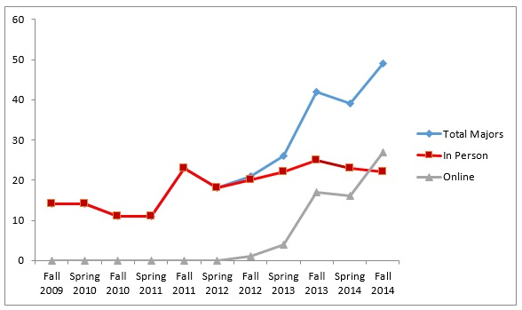

Graph 1: Growth in the political science online completion degree program
Major growth has been rapid, but pales in comparison to the growth in total credit hours delivered. Prior to the advent of the online completion program, most upper-level courses in the program, outside of those required by Criminal Justice, registered no more than 10 to 15 students. Lower level courses saw moderate enrollments of 20 to 30 due to their popularity as general education courses. During the 2011-2012 academic year, the program offered no online electives. In the fall of 2012, it offered two for a total enrollment of 52 students. A semester later, online enrollments surpassed seated enrollments by 14, a trend that continues today. Of the 186 Indiana University East students enrolled in political science courses in the fall 2014 semester, 80 percent were taking a course online. Most online courses now enroll between 25 to 40 students with select high-enrollment courses reaching 90.
Some of this growth has occurred due to Political Science’s service to other programs on campus. IU East offers a Bachelor of General Studies (BGS), which allows students to opt for a concentration in Social and Behavioral Sciences. Students enrolling in the BGS program frequently choose upper-level political science electives. Furthermore, both Psychology and Criminal Justice students are encouraged to register for select Political Science courses to fulfill diversity requirements and an additional course fulfills requirements for the Women and Gender Studies minor and certificate.
The numbers in Graph 2 significantly underestimate the total number of students served by political science faculty due to the program’s participation in the Indiana University Online Course Connect (OCC) program. An initiative of IU Online, Indiana University's centralized online programming office, the OCC allows students at any IU branch campus to enroll in online courses without permission or paperwork. In the pilot of the program in spring 2014, one Political Science course was added with a total enrollment of 89 students, 72 of which were at other IU branch campuses. The program increased their participation in the fall 2014 semester, adding six of their courses to the initiative, resulting in 240 students enrolled from other campuses. The program allowed Political Science to market to students who would have been outside our recruitment areas. Many students were repeat enrollees in the OCC or participated in intercampus transfer to take online Political Science courses that were not included in the program. The dip that appears in Graph 2 for fall 2014 actually disappears when the additional 240 enrollees are added to the enrollment headcount.
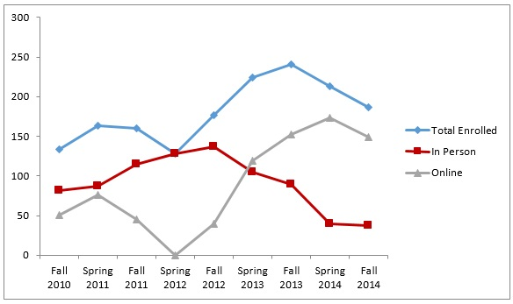

Graph 2: Enrollment Growth in Political Science Courses
Overall, the program has seen substantial growth in just a short time, both in the number of majors and credit hours delivered. Much of this growth has come from non-traditional students. In fall 2009, when the online program was not in existence, the average age of a Political Science major was approximately 24 years old. In fall 2014, the average age had grown to approximately 28 years old. As seen in Graph 3, an increasing proportion of students are also completing their degrees part-time. This change in both enrollment status and age has implications for how courses are structured, students are likely to be balancing family and work on top of school, and may only participate and access the course in the evenings or on the weekends. Students enrolling in online courses highlight the need for flexibility and convenience as one of the most important factors in enrolling in online courses and instruction design must reflect that flexibility (Stanford-Bowers, 2008).
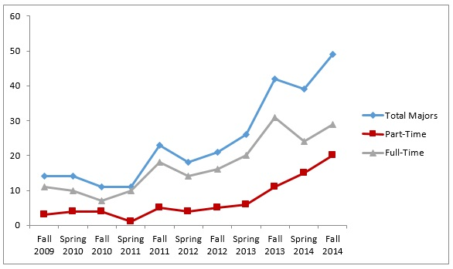

Graph 3: Political Science Majors by Enrollment Status
While the number of students and credit hours provided has grown, faculty hiring has not. The Political Science program currently has two full-time faculty and a small number of adjunct faculty. The department size has introduced unique challenges when it comes to enrollment management and course rotation. The online degree completion program begins on the premise students will have completed a minimum of 60 credit hours, including their general education requirements and their introductory level political science courses. Students are therefore expected to complete a required 30 hours at the 200-level or higher at IU East, with 15 of those hours in Political Science. In reality, however, most students enter with unfulfilled requirements and the need to complete at least one introductory course in the program introducing issues regarding course scheduling. This is compounded by the fact the program still maintains a sizeable number of traditional, on campus students, who prefer, if given the choice, to take seated courses.
One of the first changes made after the online completion program began in fall 2012 was the alteration of major requirements to alleviate these challenges. The prior degree requirements allowed almost no flexibility in course selection, students were required to take a prescribed set of courses, regardless of whether they were completing the major online or in person. Given limited faculty resources and minimum enrollment requirements, students had difficulty scheduling the courses they needed, in the format they wanted, in time for graduation, requiring faculty and advisors to process frequent degree requirement waivers.

Table 1

Political Science Major requirements
Category | Old Requirements | Updated Requirements
Major Core Requirements | Introduction to American Politics  Introduction to Political Theory  Introduction to Comparative Government | Introduction to American Politics  Introduction to Political Theory  Introduction to Comparative Government or Introduction to International Relations
Advanced Core Requirements | Making Democracy Work  Indiana State Government and Politics  One Political Science Elective | 3 hours of American Politics  3 Hours of Comparative Politics/International Relations  3 hours of Political Theory  Additional 12 hours of electives at 200-level+.
Quantitative Requirements | Analyzing Politics  Public Opinion and Political Participation | Analyzing Politics
Additional Requirements | Ethical Reasoning (from two courses)  Diversity (from two courses)  Capstone experience | At least 18 hours of advanced core at 300-level or higher.  Capstone experience
Total Hours | 30 hours | 36 hours
The new major requirements, as shown in Table 1, require more total credit hours (36 compared to 30), but speeds time to graduation by increasing flexibility. Students are now required to take 15 credit hours of major core requirements and an additional 21 upper level hours within three prescribed tracks. The new structure allows the program to offer both seated and online sections of introductory courses, which meet course enrollment minimums on a consistent basis and a robust selection of upper-level electives both in person and online. Many students eligible to remain under the old major requirements have opted for the new major requirements, despite the need to take more courses.
Political Science has also made an effort to ensure online students feel connected to the campus and the program through outreach efforts. Both existing research and student feedback indicates online students want to feel like they belong on the campus, even though they may never set foot in the state or country (Brinthaupt, Fisher, Gardner, Raffo, & Woodward, 2011). Building rapport and maintaining instructor presence is an important component of all courses, but the program also maintains a blog and Instagram account profiling activities on campus and resources specifically for online students. Special guest presentations are frequently streamed or recorded for online viewing and some instructors have recorded in class lectures for online students to access. Furthermore, quality online advising and mentoring have been a stated goal of the program for the past two years, as existing research has found “advising is viewed as a way to connect students to the campus and help them feel that someone is looking out for them” (Kuh, Kinzie, Schuh, & Associates, 2005). Existing research by Waldner, McDaniel, and Widener (2011) has found e-advising can improve persistence, advising quality, and benefit on-campus students. Between fall 2013 and spring 2014, the program retained 71.43 percent of its majors and 59.52 percent of its majors from fall 2013 to fall 2014.
The program, in conjunction with Criminal Justice, is also seeking to aggressively market the online degree completion program. Using Census data from 2012, the Lumina Foundation (2014) reported 737,448 Indiana residents had some college credit, but had not completed a degree. The same report found a total of 1,329,396 Ohio residents in the same position. The programs believe tapping into this pool of individuals can help grow both programs exponentially. The programs worked collaboratively with the university’s marketing department to create brochures profiling the completion programs and successful graduates. The intention is mailers will be sent to all municipal, county, and state government offices, as well as all law enforcement agencies, in both states.
Efforts at connecting online students to the campus and marketing campaigns would be for naught without high quality online courses for students to enroll in. As discussed above, Political Science is part of the Lead Online Faculty program within HSS and is working to standardize its curriculum at the introductory level to ensure quality, persistence, and retention. Faculty in the program have pursued and have been awarded course development grants, high impact professional development grants, and have been named as Faculty Fellows through the Center for Teaching and Learning. Additionally, all full-time faculty, and many adjunct faculty, have completed additional training in online education--including certification as Quality Matters Peer Reviewers. Continuous improvement, assessment, and reflection upon online courses are essential for the continued success of the program.
Political Science faculty also remain committed to course development based upon best practices in teaching, both online and face-to-face. As discussed above, social presence of the instructor is especially important for student persistence and satisfaction and most instructors use recorded video lectures and frequent communication with learners to ensure their presence is felt in the classroom (Richardson & Swan, 2003). All courses employ multiple modalities to ensure student learning and comprehension. Using Canvas modules (and Oncourse Lessons and Modules before that), courses are organized to foster student engagement and ensure students walk through course requirements and feature text-based materials, instructor created and professional videos, quizzes, and writing assignments (Bain, 2004; Brinthaupt et al., 2011). Instructors have also employed third party tools, including Tumblr and wikis, to encourage students to present their research and assignments visually. An increasingly large component of online courses in the program is based upon active learning. Most classes employ asynchronous group work, as group work has been found to contribute to increased student retention and persistence (Astin, 1997) and reflects the professional skills students will need after college (Mannix & Neale, 2005). The majority of online instructors also employ online office hours, using Adobe Connect, which allows students to interact with the instructor through chat, video, or audio means.
While most disciplines face challenges in conveying course materials to students online, political science requires discussing and debating potentially controversial topics. In an age of increasing incivility in politics, the program offers courses in policy-making, gender and politics, African American politics, and the psychology and politics of hate online, all courses rife with the potential for sensitive discussions. Best practices culled from teaching these types of courses has been presented at both regional and national conferences on pedagogy and published in SoTL journals (see for instance Osborne, Kriese, Tobey, & Johnson, 2009).

Online programs in the School of Natural Sciences and Mathematics (NSM)
The School of Natural Sciences and Mathematics (NSM) at IU East has 16 full-time faculty members and approximately 20 part-time faculty members offering a dozen undergraduate degree programs and two graduate degree programs to approximately 200 majors. Over the past several years, NSM has enjoyed significant growth in credit hours generated, number of courses and sections offered, new programs, and number of majors. Its largest degree programs are in Biology, Mathematics, Natural Sciences and Mathematics (with several concentrations), and Chemistry. Recently, it added a MAT in Mathematics and a graduate certificate in Mathematics. NSM faculty and administrators have invested heavily in online education with 38% of all credit hours generated during the fall 2014 semester from online courses (up from 28% in fall 2012) and in total number of course sections—17% in fall 2012 and 30% in fall 2014. Most notably, the online BS in Mathematics had 15 students in 2011 versus over 100 today. Suffice it to say, the future growth potential of NSM programs depends largely on online program and course delivery, a reality understood and embraced by its faculty (Mandernach, Mason, Forrest, & Hackathorn, 2012; Totaro, Tanner, Noser, Fitzgerald, & Birch, 2005).
The success of many degree programs within NSM depends largely on the quality and success of its online courses and programs. For example, upper-division courses in Mathematics rarely, if ever, have enough students to “make” in face-to-face sections. Conversely, online Mathematics courses routinely boast between 24-40 students (or more). Therefore, NSM has put the entire BS in Mathematics online; not only to best serve student demand, but to also produce a viable, sustainable academic program that would not be possible in the traditional delivery model.
Interestingly, faculty members in NSM were early-adopters and long-time practitioners of teaching lab science and Mathematics courses online in myriad and diverse disciplines, including: Biology, Chemistry, Biochemistry, Physics, and Geology. Using concept-based online simulations, home kits, case studies, and data sets, NSM students are able to apply concepts and ideas learned in the online classroom using both online labs and physical, tangible tools. While some within academia would continue to question the validity of utilizing online labs, the faculty of NSM has found it to be a useful, appropriate, and beneficial means of engaging students in a meaningful manner. Courses in mental illness and addictions have been offered online since 1996. Zoology was taught utilizing many online components beginning in 2000 and became an exclusively online course in 2005. Since 2005, NSM leadership has incentivized faculty to develop and teach online courses, in addition to hiring new faculty with online teaching experience, to strategically meet the school’s mission with regard to course delivery and program development.
With regard to graduate education, the MAT in Mathematic was launched in 2013 as a hybrid program, with several online Mathematics courses. The School is presently requesting approval for the program to be delivered exclusively online. In addition, NSM leadership and science faculty are proposing an online MAT in Science. Current and potential students throughout IU East’s service region and beyond overwhelmingly need and prefer online programs in Science and Mathematics. Overall, the success of NSM depends largely on the quality design and delivery of online courses. Accordingly, program development, faculty hiring practices, and courses scheduling reflect that reality and need. Detailed below is an accounting of NSM’s most successful online degree program, the BS in Mathematics.

Development of the online Mathematics Program
The Department of Mathematics at IU East offers two online degree completion programs, a Bachelor of Arts in Natural Science and Mathematics with a concentration in Mathematics and a Bachelor of Science in Mathematics. This section highlights the successful and rapid growth of these degree completion programs through enrollment data, addresses program structure, and explains pedagogical methods and technologies employed within Mathematics courses at the University.
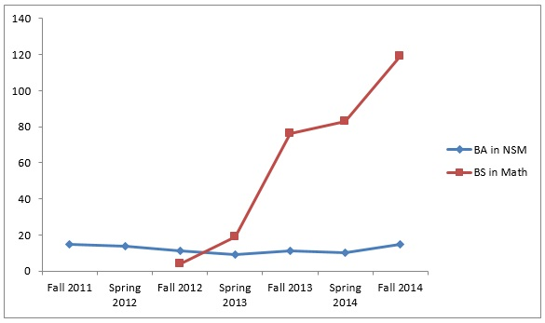

Graph 4: Growth in the NSM Online Completion Degree Programs
Graph 4 presents the rapid growth in online NSM programs, especially the BS in Mathematics. Prior to 2010, the BA in NSM with a Mathematics concentration never enrolled more than a handful of students. The online completion program launched with four students in spring 2011 and grew to 15 in fall 2011. Based upon the success of the NSM degree completion program, the department implemented a second degree, the Bachelor of Science in Mathematics, in fall 2012. As shown in the above graph, while student enrollments in the BA in NSM have stayed near 15, enrollments in the BS in Mathematics have sharply increase. Beginning with only four students in fall 2012, the program currently enrolls 119.

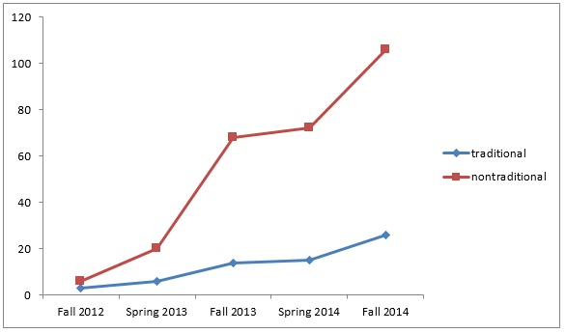

Graph 5: Traditional to Non-Traditional Students in the BS in Mathematics
Furthermore, the student demographic has changed as evidenced in Graph 5. Enrollment of both traditional (18-23) and non-traditional (older than 24) students has increased, but the data shows the majority of currently enrolled students are non-traditional. In fall 2014, 80.3 % in the program was older than 24 years old. More students are also completing the program part-time, as evidenced in Graph 6.
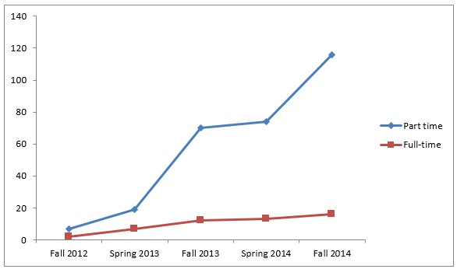

Graph 6: Part-Time to Full-Time Students in the BS in Mathematics
The number of full-time students has slowly increased; however, the majority of the increase in enrollments is from part-time students. The current fall 2014 data shows part-time students occupy 87.8% in the program. In summary, while traditional full time student enrollments are gradually increasing, the more significant increase is from the part-time and non-traditional student populations. This introduces unique instructional needs for that group of students.
Like the Political Science program, both NSM online completion programs presume students will have already completed 60 credit hours before enrolling. This includes completion of the general education requirements and required program pre-requisites. The BA in NSM with a Mathematic concentration is intended to be a liberal arts degree and requires completion of 33 credit hours of Mathematics, beginning with Calculus I. The BS in Mathematics requires more content knowledge of Mathematics and requires the completion of at least 45 credit hours beyond Calculus I. The 45 credit hours consist of 30 credit hours of required Mathematics courses and 15 credit hours of elective Mathematics courses. As shown in Table 2 below, the BS in Mathematics program covers proof-based courses, as well as computational mathematics courses. The majority of the BA in NSM with a Mathematics concentration is focused on computational mathematics. Students must also earn at least 30 credit hours at Indiana University East.

Table 2

Sample of Mathematics courses
 | BA in NSM with Math. Conc. | BS in Mathematics
Core | M 215-Calculus I  M 216-Calculus II  M 311-Calculus III  M 303-Linear Algebra  M 313-Elementray Differential Equations  M 380-Histroy of Mathematics  M 393-Bridge to Abstract Mathematics  M 499-Capstone in Mathematics | M 215-Calculus I  M 216-Calculus II  M 311-Calculus III  M 303-Linear Algebra  M 393-Bridge to Abstract Algebra I  M 403-Intro. to Analysis I  M 447-Mathematical Modeling I  M 499-Senior Seminar in Mathematics
Elective | M 405 – Number Theory  K 300- Statistical Techniques | M 313-Elementary Differential Equation  M 371-Elementary Computational Methods  M 405-Number Theory  M 421-Introduction to Topology  M 463-Introduction to Probability Theory
With increased demand for online courses, there is a need for considerate and systemized course design (Olson & Werhan, 2005). As a framework in online education, Garrison and Vaughn (2008) proposed social presence, cognitive presence, and teaching presence. Social presence is described as feeling intimacy or togetherness (Shin, 2002). Cognitive presence is described as the degree of inquiry and critical thinking beyond social presence (Bair & Bair, 2014) and Anderson, Rourke, Garrison and Archer (2001) found “teaching presence begins before the course commences as the teacher, acting as instructional designer, plans and prepares the course of studies, and it continues during the course, as the instructor facilitates the discourse and provides direct instruction when required.”
Prior to creating a course, instructors are asked to identify the targeted student body to achieve a design that is tailored to their needs. As noted above, most students in the program are part-time, non-traditional, working students and this has been reflected in the course design. Courses frequently include Instructor-Generated Video (IGV) and virtual office hours to increase engagement and upper-level electives use a variety of tools including modules, forums, and wikis. In particular, faculty report Instructor-Generated Videos (IGV) has a strong impact on student and faculty interaction.
IGVs have also been shown to have a positive influence on student satisfaction and engagement (Draus, Curran, & Trempus, 2014; Pan, Sen, Starret, Bonk, Rodgers, Tikoo, & Powell, 2012). Furthermore, Borup, West, and Graham (2012) conclude IGVs improves social and teaching presence. In general, IGVs contributes to narrowing the distance between students and an instructor. Before creating IGVs for upper level mathematics course, such as Linear Algebra or Differential Equation, the foremost consideration is the level of difficulty of the required course content and the students’ educational background. Courses frequently contain narrated PowerPoint presentations on required course content. Instructors also noticed many students had not recently taken a math class and wanted to review the prerequisite Mathematics content. In order to reduce gaps between the current content and the prerequisite, many courses also contain a review of select concepts.
To create IGVs, instructors have adopted three technologies: Adobe Connect, Microsoft Word, and a tablet computer with a digitizer pen. Adobe Connect is a web conferencing tool that can be used to record lectures for online learning. Lectures use a combination of these tools and Word documents with unexplained problems and questions and include simultaneous handwriting and verbal explanation of the concepts being covered. This relates the mathematical content to the students like a traditional lecture delivery. Instructors have found IGVs of less than 15 minutes are most successful at holding the student’s concentration. Furthermore, Adobe Connect has the ability to record the instructor computer screen itself to show direct demonstration of course related applications such as Excel and Virtual Graphing Calculators. This enables students to practice at their own pace. Instructors assign homework problem similar to the example in the IGVs, raising course engagement and content understanding.
The level of interaction is the most dramatic difference between online and face-to-face education. In a traditional course, students have direct interaction with an instructor or colleague. That is not the case for online education. In all online education, the popular form of interaction is the use of asynchronous threaded discussion boards (Hewitt, 2005). The strengths of such an asynchronous interaction method are highlighted in many articles (Cavana, 2009; Gold, 2001; Morse, 2003), but the form of interaction varies greatly depending on course topics. In upper-level Mathematics courses, interaction includes both asynchronous and synchronous methods of delivery.
To facilitate student to student interaction, like a study group, instructors divide the class into groups with six or seven members and use discussion boards as the main asynchronous interaction method. The discussion boards are subcategorized into general and off topic discussion boards, review discussion boards, and weekly group discussion boards. General and off topic discussion boards are open to all students in a class to discuss any topic. Review discussion boards are open to all students in a class to discuss relevant prerequisite content. Weekly group discussion board are open to only the assigned group to discuss course content as assigned by the course instructor. Group project discussion boards are open to only the assigned group, where they work together on a small project assigned by the course instructor
Requiring students to introduce themselves in the general and off topic discussion forums prior to the first week of the semester can increase student engagement. Many non-traditional students are able to bring diverse perspectives from their social and life experience through the general and off topic board. Through both review and weekly group discussion boards, students discuss course content and assignments. Specifically, each weekly group discussion forum is only accessible to the group members, which makes it possible to discuss course content intensively in a small group environment, improving cognitive presence.
It is important that the instructor monitor and participate in all of these activities. In particular, one of the most important instructor roles is to post leading questions at the beginning of the week. Observation reveals students respond more to the instructor’s leading question than other postings. Group project discussion boards, on the other hand, are purely for student to student interaction. In these group assignments, students frequently exchange personal contact information, like phone numbers, for better interpersonal communication, increasing their social interaction.
While asynchronous interaction is a popular and useful method to enhance online education, stronger student to instructor interaction is also possible to raise the teaching presence and increase the intimacy between student and instructor. Instructors also hold synchronous, biweekly virtual online office hours with the help of Adobe Connect. Technology has made it possible for the instructor and students to share computer screens and communicate with each other in diverse formats. Students can ask questions through a chat window, while viewing the instructor’s shared computer screen, and listening to the instructor’s verbal explanation. If the instructor allows students to speak verbally, it causes some confusion because there are many students trying to ask questions. Thus, the chat window can be considered the best means for student involvement. One disadvantage, however, is that students cannot type mathematic notations in the chat window. To resolve this problem, instructors request students send questions by email prior to virtual office hour.
Given the demographics of most online students, the Mathematics faculty believes it is important to select one daytime and one evening office hours and experience has shown most students attend the evening hour. Each office hour session is recorded and uploaded into the LMS. Overall, student participation was low without obligatory action. To resolve this problem, instructors now assign an attendance score that requires students to attend four times per semester. This change has resulted in a sharp increase in participation. However, required online office hours reduce the flexibility and the spirit of an all online education. Some students complain of the difficulty of attending due to time zone issues or overlap with working hours. In these cases, instructors have suggested alternative options to replace the attendance, such as a phone interview or a required summary of the recorded virtual online hours. The following student evaluation comment shows why real time virtual office hours improve social and teaching presence: “the online office hours, combined with the online lectures, pushes this online course to a near on-campus level”.

Conclusion
This research demonstrates how one institution that is highly-invested in online education has successfully developed and grown diverse academic programs across academic disciplines and units, using Political Science and Mathematics as examples. While every institution is different, this essay demonstrates how a commitment to effective, efficient, and consistent course and curricular design; investment in faculty development; and an emphasis on quality are important factors which contribute to the success of any institution involved in online education. While further research needs to be conducted, faculty members, course designers, and administrators can perhaps utilize some of the lessons and best practices described here.

References
Anderson, T., Rourke, L., Garrison, D. R., and Archer, W. (2001). Assessing teaching presence in a computer conferencing context. Journal of Asynchronous Learning Networks, 5(2), 1-17.
Astin, A. (1997). Liberal education and democracy: The case for pragmatism. In R. Orrill (Ed.), Education and democracy: Re-imagining liberal learning in America (pp. 207-224). New York: The College Board.
Bain, K. (2004). What the best college teachers do. Cambridge, MA: Harvard University Press.
Bair, David E. and Bair, Mary A. Ph.D. (2011). Paradoxes of online teaching. International Journal for the Scholarship of Teaching and Learning: 5(2), Article 10.
Baran, E. & Correia, A. (2014). A professional development framework for online teaching. TechTrends, 58(5), 96-102. http://dx.doi.org/10.1007/s11528-014-0791-0
Bonvillian, W.B. & Singer, S. (2013). The online challenge to higher education. Issues in Science and Technology, Summer, 23-30.
Borup, J., West, R.E., & Graham, C.R. (2012). Improving online social presence through asynchronous video. The Internet and Higher Education, 15(3), 195-203. http://dx.doi.org/10.1016/j.iheduc.2011.11.001
Brinthaupt, T.M., Fisher, L.S., Gardner, J.G., Raffo, D.M., & Woodward, J.B. (2011). What the best online teachers should do. Journal of Online Learning and Teaching, 7(4), 515-524. http://jolt.merlot.org/vol7no4/brinthaupt_1211.htm
Cavana, M.L.P. (2009). Closing the circle: From Dewey to Web 2.0. In C. R. Payne (Ed.), Information technology and constructivism in higher education: Progressive learning frameworks (pp. 1-13). Hershey, PA. http://dx.doi.org/10.4018/978-1-60566-654-9.ch001
Draus, P.J., Curran, M.J. & Trempus, M.S. (2014). The influence of instructor-generated video content on student satisfaction with and engagement in asynchronous online classes. Journal of Online Learning and Teaching: 10(2), 240-254. http://jolt.merlot.org/vol10no2/draus_0614.pdf
Garrison, D.R., & Vaughn, N.D (2008). Blended learning in higher education. Framework, principles, and guidelines. San Francisco, CA: Jossey-Bass Publishers.
Gold, S. (2001). A constructivist approach to online training for online teachers. Journal of Asynchronous Learning Networks, 5(1), 35-37.
Herman, J.H. (2014). Faculty incentives for online course design, delivery, and professional development. Innovative Higher Education, 38, 397-410. http://dx.doi.org/10.1007/s10755-012-9248-6
Hewitt, J. (2005). Toward an understanding of how threads die in asynchronous computer conferences. The Journal of the Learning Sciences, 14(4), 567-589. http://dx.doi.org/10.1207/s15327809jls1404_4
Holt, D., Palmer, S., Gosper, M., Sankey, M. & Allen, G. (2014). Framing and enhancing distributed leadership in the quality management of online learning environments in higher education. Distance Education, 35(3), 382-399. http://dx.doi.org/10.1080/01587919.2015.955261
Kuh, G.D., Kinzie, J. Schuh, J.H. and Associates. (2005). Student success in college: Creating conditions that matter. San Francisco: Jossey-Bass.
Mandernach, B.J., Mason, T., Forrest, K.D. & Hackathorn, J. (2012). Faculty views on the appropriateness of teaching undergraduate psychology courses online. Teaching of Psychology 39(3), 203-208. http://dx.doi.org/10.1177/0098628312450437
Mannix, E. and Neal, M.A. (2005). What differences make a difference? The promise and reality of diverse teams in organizations. Psychological Science in the Public Interest 6(2), 31-55. http://dx.doi.org/10.1111/j.1529-1006.2005.00022.x
Matthews, D. (2014). A Stronger Nation Through Higher Education: An Annual Report from Lumina foundation. Retrieved from http://www.luminafoundation.org/resources/a-stronger-nation-through-higher-education.
Morse, K. (2003). Does one size fit all? Exploring asynchronous learning in a multicultural environment. Journal of Asynchronous Learning Networks, 7(1), 37-55.
Olson, S.J., & Werhan, C. (2005). Teaching preparation online: A growing alternative for many. Action in Teacher Education, 27(3), 76-84. http://dx.doi.org/10.1080/01626620.2005.10463392
Osborne, R.E., Kriese, P., Tobey, H., & Johnson, E. (2009). Putting it all together: Incorporating “SoTL practices” for teaching interpersonal and critical thinking skills in an online course. Insight: A Journal of Scholarly Teaching, 4, 45-55. http://www.insightjournal.net/Volume4/IncorporatingSoTLTeachingInterpersonalCriticalThinkingSkillsOnlineCourse.pdf
Pan, G., Sen, S., Starret, D.A., Bonk, C.J., Rodgers, M.L., Tikoo, M., and Powell, D.V. (2012) Instructor-made videos as a learner scaffolding tool. Journal of Online Learning and Teaching 8(4). http://jolt.merlot.org/vol8no4/pan_1212.htm
Pearcy, M. (2014). Student, teacher, professor: Three perspectives on online education. The History Teacher, 47(2), 169-184.
Richardson, J.C. and Swan, K. (2003). Examining social presence in online courses in relation to students’ perceived learning and satisfaction. Journal of Asynchronous Learning Networks, 7(1), 68-88.
Shin, N. (2002). Beyond interaction: The relational construct of transactional presence. Open Learning, 17(2), 121-137. http://dx.doi.org/10.1080/02680510220146887
Stanford-Bowers, D.E. (2008). Persistence in online classes: A study of perceptions among community college stakeholders. Journal of Online Learning and Teaching 4(1), 37-50. http://jolt.merlot.org/vol4no1/stanford-bowers0308.htm
Totaro, M.W., Tanner, J.R., Noser, J., Fitzgerald, J.F. & Birch, R. (2005). Faculty perceptions of distance education courses: A survey. Journal of College Teaching & Learning 2(7), 13-20.
Waldner, L., McDaniel, D., & Widener, M. (2011). E-Advising excellence: The new frontier in faculty advising. Journal of Online Learning and Teaching 7(4), 551-561. http://jolt.merlot.org/vol7no4/waldner_1211.htm

About the authors
Chera LaForge is an Assistant Professor of Political Science at Indiana University East. calaforg@iue.edu
Young You is an Assistant Professor of Mathematics at Indiana University East.
youy@iue.edu
Ross Alexander is the Dean of School of Humanities and Social Sciences and Professor of Political Science at Indiana University East. roscalex@iue.edu
Neil Sabine is the Dean of School of Natural Science and Mathematics and Professor of Biology at Indiana University East. nsabine@iue.edu

Return to Table of Contents
Editor’s Note: This is a good starting point to apply self-grading to discussions. It is not a research study per se, but contains a wealth of information from a structured empirical application of self-grading that can reduce teacher load and enhance student performance.

Online Discussion Self-Grading Innovation Using the Quizzing Tool

Laura M. Schwarz and Nancyruth Leibold

USA

Abstract
Many educators find class size, time, volume of discussion posts, and other variables as obstacles to accurately grading every discussion post for every adult learner in the online classroom. Likewise, learners sometimes do not read educator feedback, or if they do, may not use the feedback to remediate their discussion postings. Further, learners sometimes do not read and apply instructions and grading rubrics for creating their online discussions. These factors can be frustrating and time consuming for the educator, and are often not developmentally stimulating for the adult learner. Adult learners’ engagement in self-grading speaks to Andragogy, the theory about how adults learn. Discussion self-grading is an innovative method faculty can employ to engage the adult learner in active reflection, introspection, and evaluation of their own performance. The goals of discussion self-grading in the online course room are ultimately improved discussion performance and enhanced learning. This article will examine discussion self-grading as a theoretically sound, innovative, yet simple grading method educators can employ to encourage adult learners to evaluate their own performance. Further, the article will explain methods for using the quizzing tool in conjunction with a discussion grading rubric to implement this innovation. Lastly, anecdotal evidence from employment of the discussion self-grading innovation in the online environment with over 300 learners is presented.
Keywords: Andragogy, reflection, self-grading, introspection, self-evaluation, self-assessment, self-reflection, innovation, online discussion, discussion self-grading, online education, higher education, adult learner, Knowles, online teaching, online learning

Introduction
The traditional method of educators grading adult learners’ online discussion performance has flaws and is often problematic for both parties. Many educators find that accurately and constructively grading online course discussion postings is difficult, painstaking, time consuming, tedious, and frequently, an unrewarding task. Educators naturally find it frustrating when they have laboriously created feedback, only to have the learners ignore it or not use it for remediation and growth. Learners sometimes do not read or apply instructions and grading rubrics, as the importance may not be readily apparent. Adult learners may also find it frustrating if they believe the instructor was not accurate in their appraisal. The traditional method of educators providing feedback for online discussion may not be developmentally stimulating or engaging, and perhaps is not a sound teaching/learning methodology for the adult learner. An innovative, learner-focused approach to assessment of online discussions using the andragogy theoretical framework, reflection, introspection and self-grading is the focus of this article.

Conceptual and theoretical frameworks
Self-grading is a practice that has been used and studied for decades. The application of self-grading in online learning specifically is new to the scene, but worthy of exploration and empirical study. Some educators may be leery of allowing students to take charge of grading their own work because they believe grading is their prevue only, and fear that learners may not be honest in their self-appraisal and over-inflate their grade. There is however, empirical evidence in the literature demonstrating that learners are capable of being on-par with the educator’s assessment, and may sometimes even assign a lower grade to themselves. Further, research indicates that participants in self-grading learned from their mistakes though the self-grading process (Davis & Rand, 1980; Wagner, Suh, & Cruz, 2011). Andragogy is the theoretical basis for this teaching practice innovation and supports self-grading. Recognizing learners as adults with previous experiences, knowledge, and motivation is a value of discussion self-grading. Reflection is a concept that is critical in the guidance of this innovation as well. The use of reflection and introspection is a necessary aspect of improving one’s work.

The concept of self-grading
The concept of self-grading is not a new one in the educational research literature. However, specific information about and study of online discussion self-grading is virtually absent from the literature, hence worthy of further discussion and investigation. Self-grading is defined as the process by which learners reflect upon their own learning and course work, including the assignment of a grade. In 1980, Davis and Rand published their study on adult learner self-grading versus educator grading of quizzes, midterm examinations, analysis papers, and the final paper, comparing the performance of two classes. The self-graded class assigned comparable grades to the instructor, except for the midterm examination where the instructor assigned a higher grade than the learners did. Similarly, Wagner, Suh, and Cruz (2011) reported student self-reported grades lower or comparable to grades assigned by faculty in the pharmacy student population.
Edwards (2007) examined student self-grading in social statistics at the college level and found favorable results. Eighty-six percent of students in Edwards’ study reported that self-grading was a favorable strategy. Students explained that they gained knowledge from their own mistakes, because when they self-graded, they saw what needed correction and learned from it. Some students reported that others may cheat or inflate their grade, but the study findings did not support this as an actual problem (Edwards, 2007). Conversely, Strong, Davis, and Hawks (2004) reported grade inflation of tests, quizzes, and projects by adult students in a large general education course that used self-grading. Cherepinsky (2011) studied self-reflective grading in applied calculus courses for engineers by having students correct their own tests. The instructor would mark the math questions as correct or incorrect, and then return the tests to the students, who would then work the incorrect problems to correct them. Students reported that they learned from their mistakes and that the self-reflective grading was a positive experience (Cherepinsky, 2011). Although evidence is available about self-grading, the topic of online discussion self-grading specifically warrants empirical study.

Andragogy
The student self-grading solution addresses Andragogy, a theory for how adults learn. Knowles (1970) describes andragogy as a learner-centered approach to teaching and learning that recognizes the unique learning conditions of the adult. Andragogy is in contrast to Pedagogy, a theory for how children learn. Pedagogy is teacher-directed and the learner is submissive to the teacher (Knowles, Holton & Swanson, 2015). The adult learner prefers self-directed, meaningful, goal-directed learning practices that build upon their previous experiences and knowledge (Knowles, Holton, & Swanson, 2015). Knowles, Holton, and Swanson (1998) explain the principles of Andragogy are that adult learners: 1) want to know why, what, and how; 2) want self-directed learning; 3) prefer building on prior learning; 4) learn best when ready and the timing is right; 5) learn best in a problem-centered environment; and 6) are motivated by a value or goal. These adult learning principles are congruent with discussion self-grading practice. Self-grading recognizes autonomy, as learners are able to direct their own self-grading and learn from their accomplishments as well as mistakes. Self-evaluation is a part the principle of self-directed learning (Knowles, Holton, & Swanson, 2015). In the case of discussion self-grading, the expectation is that the learner is self-directed. Self-direction and self-evaluation are both important life and career skills. Learners have busy lives, so a several-day window to complete self-grading allows each learner to find a time that works in their schedule to do so. This practice lends to both self-direction, and learning best when ready and the timing is right. Further, discussion self-grading addresses Andragogy because builds on prior learning by using reflection in a new context. The discussion self-grading strategy provides an environment rich in looking back at one’s work and determining what was done correctly, and where there are areas for improvement. The value of improving one’s work, successful course completion, and earning a desired grade are examples of motivating factors for the adult learner.

The concept of reflection
Since Knowles (1984) includes past experiences in his theory of andragogy, the concept of reflection plays a significant part in the self-grading of discussions by adult online learners. Reflection is defined as introspective examination and evaluation of experiences, beliefs, knowledge, oneself, and practices with the intent of improving the future (Dewey, 1933; Kember, McKay, Sinclair, & Wong, 2008). Bulman (2008) describes reflection as the use of critical analysis of an experience to make positive changes for the future.
Reflection is a valuable habit to develop to prepare for the skills essential for continuous quality self-improvement, not only in the classroom, but also beyond. Being reflective about one’s performance in situations, for example, writing, schoolwork, and workplace situations, can help individuals identify areas of strength and areas for improvement. Reflection is an important professional and life skill for all adults regardless of their career or life situation. Self-grading is an ideal opportunity for the adult learner to practice reflection. In the context of discussion self-grading, reflection is the use of reviewing one’s own discussion posting to assess what is correct, and what to improve upon for future discussion writing. When the adult learners grades their own discussions, they can reflect on their own performance and see the importance of the discussion grading rubric or instructions as they apply these in the process. Discussion self-grading helps to motivate the adult learner to improve performance and enhance learning in the online classroom discussion. The practice of reflection may also ultimately transcend from discussion self-grading into other facets of the adult learner’s life such as professional practice and personal relationships.
The thoughtful use of reflection is not new to higher education. For example, much research regarding the use of reflection has been conducted in the area of nursing education. This research is useful in demonstrating the value of reflection in educational and career endeavors alike. Bagay (2012) explains that nurses may use reflection in nursing practice when triggered by a work-related challenge or death of a patient. In addition, Bagay (2012) advocates for the lifelong use of reflection by nurses and encourages the use of reflection in nursing education to promote professional development and improve quality patient care. Langley and Brown (2010) investigated the perceptions of graduate students and faculty about the use of reflective journals in online education. The online reflective journal included four areas: professional development, personal growth, empowerment, and facilitation of the learning process (Langley & Brown, 2010). A majority of learners and faculty agreed that reflective journaling bolstered professional development and distinguished personal strengths and weaknesses. Additionally, learners and faculty agreed that the reflective journaling enabled meaning-making and furthered learning (Langley & Brown, 2010). The perceptions by post-registration learners and faculty are that reflection is a worthy practice for evaluation and to make meaning of situations (Bulman, Lathlean, & Gobbi, 2012). Bulman, Lathlean, and Gobbi (2012) described reflection as a way of being, instead of a way to think or do something. Horton-Deutsch, McNelis, and O’Haver Day developed an entire curriculum that is reflection-centered for a graduate psychiatric nursing program (2012). The faculty believes that curriculum and teaching/learning is best grounded in reflection – for example, a curriculum with case studies, clinical vignettes with classroom or online discussions, and reflective written assignments. The use of reflection in coursework for nurses has shown favorable learning benefits. Courses that include reflection opportunities such as self-grading of discussions provide learners with opportunities to cultivate their reflective beings.

A simple step-wise methodology for implementing discussion self-grading
The online discussion self-grading innovation is supported by empirical evidence of the accuracy and effectiveness of self-evaluation as well as by the theory of andragogy and concept of reflection. The why behind online discussion self-grading is evident, but it is also important for educators to consider how to do it. Employing discussion self-grading is not as simple as telling learners to “grade your own discussions.” A thoughtful, deliberate, and successful process should be utilized to facilitate both a straight-forward and user-friendly discussion of self-grading for learners and educators alike. As there is no evidence from the literature for how-to implement discussion self-grading, the authors will share the step-wise method they created and successfully used for more than three years. The authors developed and fine-tuned their method of implementing discussion self-grading over several semesters during a three-year period with successful anecdotal results that will be discussed later in this article. The simple steps to implementing discussion self-grading presented next include creating a rubric, creating a self- grading quiz, and informing the learners with instructions. This method should work in virtually all learning management systems (LMS) because all that is required for technology is an LMS quizzing tool, a feature inherent to an LMS.
Step 1: Create a rubric
The first step to implementing discussion self-grading is the creation of a discussion grading rubric. A rubric is “a document that articulates the expectations for an assignment by listing the criteria or what counts, and describing levels of quality from excellent to poor” (Reddy & Andrade, 2010, p. 435). There are three necessary components of a rubric: evaluation criteria, quality definitions, and a scoring strategy (Reddy & Andrade, 2010). Rubrics are useful in formative evaluation, can help mediate improved performance, assist learners in planning and carrying out work, and in self-assessment. Specific grading criteria for rubrics empower learners to assess their work and give an honest grade (Jackson, 2012). Using a well-developed rubric will help to ensure the accuracy of the self-grading. Combining a rubric with self-evaluation helps to improve the learners’ performance and the ability to self-assess (Panadero & Jonsson, 2013). The five criteria the authors used for the rubric they created for online discussion self-grading include: 1) spelling, grammar and sentence format; 2) discussion participation timeliness and interaction; 3) content of initial posting; 4) content of responses to others’ postings; and 5) APA format. See Figure 1 for the rubric in detail. The authors have allocated 5 points total for the rubric (one point per criterion), points can however be allocated per the educator’s discretion.

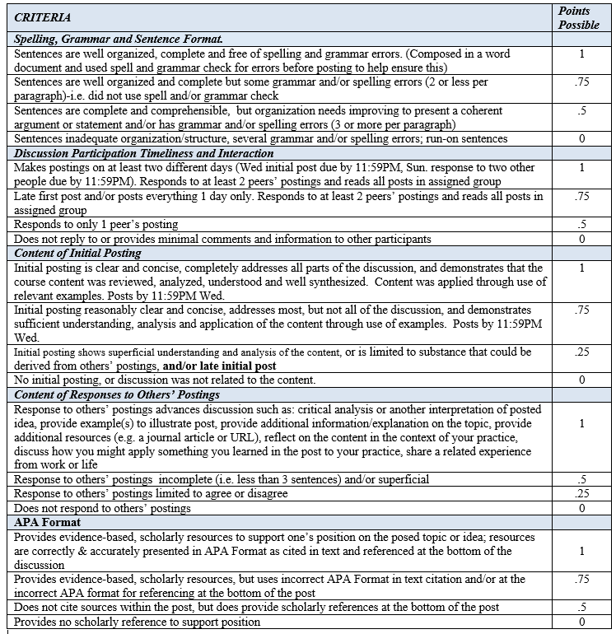
Figure 1. Discussion grading rubric created by Laura M. Schwarz, DNP, RN, CNE ©

Step 2: Create the discussion self-grading “quiz”
The LMS course quizzing tool can easily be utilized to create a discussion self-grading “quiz” the learners use to evaluate themselves. In this case, the quizzing tool is not used to test knowledge, rather serves as a conduit for the learner to grade their own performance. The quizzing tool provides an automated and convenient way for learners to grade their discussions, and an easy way for instructors to have the discussion self-grading scores automatically recorded. The educator can set the results to automatically populate to the grades area of the LMS, further streamlining grading. One quiz was created per discussion; that is one quiz for each unit or week. To create the quiz, one rubric criterion was used for each question. The criterion forms the stem of the question, and the description (definition) of each grading level forms options with points to correlate with each option. See Figure 2 for an example of a question using one of the rubric criterion created by the authors.

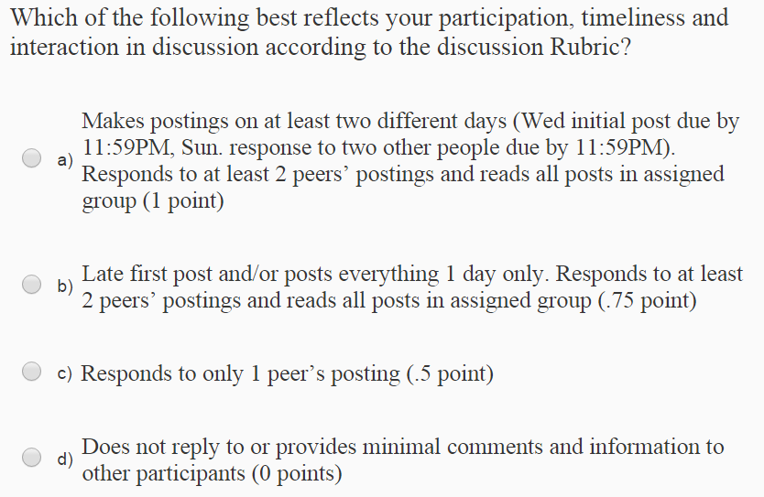

Figure 2. Example of a discussion self-grading quiz question using a rubric criterion.
The authors do not time the quiz because it is not necessary and felt it may put undue pressure on the learner or confuse them, as this is not a test of knowledge. The authors did allow more than one attempt in case the learner made a mistake in clicking the wrong option, or wished to change the grade they had given themselves upon further review of and reflection upon the discussion. The discussion self-grading quiz was linked to the grades area of the LMS so that the points populated there. By using the quiz population to grades feature, the learner is able to see immediate scoring in their gradebook and the educator benefits by this timesaving measure. Parameters were set so that the quiz started in the middle of the discussion timeframe, and so that the quiz ended a week later, a few days after the discussion had closed. This timeframe has shown to provide an ample period for learners to complete the self-grading quiz with all learners completing the quiz most weeks by the time it closed. Occasionally a learner would forget to complete the discussion self-grading within the allotted time. In most instances, the learner contacted their respective educator and a manual grade entry was done by the faculty member. If the learner did not take ownership of contacting the educator, then the grade was changed to a “zero.” The discretion of whether or not to contact the learner is of course up to the individual educator, however the authors believe that self-direction is part of adult learning as supported by Andragogy. Learners were held accountable for an honest self-appraisal by being informed that if they were found to have overly inflated their grade that it would be changed to a “zero”
Step 3: Inform learners with directions
The third step is to inform the learners about the discussion self-grading and give them some instructions for how to complete the associated quizzes. For example, each of the authors hosted a live synchronous orientation session via online video conferencing at the beginning of a course. This included verbal explanation of the purpose for self-grading, what was required, and how to do discussion self-grading. The authors have found it helpful to visually show the learners the discussion self-grading quiz in the synchronous meeting and demonstrate how to complete it. In addition to the live meeting orientation, written instructions and rationale for the discussion self-grading were included with the rubric, in the syllabus, and in the LMS. There are some assumptions educators make with regard to self-grading of discussions. These include that learners will: be honest; be self-motivated to study, understand and accurately apply the discussion grading rubric; will follow-through with grading each discussion after completion (self-direction); and will be motivated to improve their discussion performance. The authors communicated these assumptions to the learners in both the live synchronous session and the written instructions. The authors also notified the learners to contact their faculty member if they forgot to complete the discussion self-grading. The faculty members allowed one overdue discussion self-grading quiz during the semester, after which a late point penalty was enacted. Further, the authors notified learners that discussions were read and randomly audited by the faculty member. Moreover, they notified learners what the consequences were for significantly overinflating their grade so that the learners were compelled to be honest. The consequence was that the faculty member would change the grade to a “zero.” The authors did not need to use this penalty during the three years they trialed the discussion-self grading as no learners had significantly over-inflated their grade. The authors created a “practice” discussion self-grading quiz that did not count for a grade so that the learners had an idea of what the quizzes looked like and how they work before they completed the one for the first discussion. The authors have also found that learners benefited from having due dates and a reminder for each discussion self-grading quiz announced prior to when each “opened” and a reminder before it “closed” via the course room calendar.
Anecdotal results of authors trialing discussion self-grading
The two authors utilized the self-grading for approximately the past three years in each of their respective various upper-division courses in a 100% online Registered Nurse (RN) baccalaureate completion nursing program, and also in freshman-level writing courses. An enrollment of over 300 students were in the various courses that used discussion self-grading during the past three years. Though the information presented here is not from a formal study, the authors’ anecdotal findings of using the discussion self-grading quiz during these three years were overall positive from both the instructor and student vantages. The authors found that discussion quality improved over the traditional instructor grading, particularly after the first week’s discussion grading. The authors surmise that this finding is likely that learners’ actively using and applying the rubric criteria to grade themselves required a critical appraisal using rubric details to closely compare performance to the rubric standards. In doing so, learners may have noticed details of the rubric criteria that they did not initially identify prior to the first discussion, and hence strived to self-remediate with subsequent discussions. Further, learners may have been compelled to do well because they did not want to have to take points away from themselves.
The authors also found that the learners were usually reasonably accurate in self-appraisal. Surprisingly, no grade over-inflation was present, though there was a minority of learners who graded themselves more “harshly” than the faculty would have. Some learners for example deducted points for timeliness in the first week after adding the course late in the week. This was easily remedied by adding points to the learners’ scores, sending a note to them explaining the points added, and letting the learners know it was not necessary for them to dock points for lateness in this instance. Most learners completed the discussion self-grading before the quiz “closed,” but a few did not and asked the educator to re-open or post scores for them. Learners “forgetting” to complete the quiz was the biggest drawback because it took extra time on the educators’ part to re-open the quiz or to post the grade for the student. Setting “limits” by enforcing “a late-assignment” penalty with a point deduction is one way to encourage students to increase the importance of completing the quiz on time and hence help decrease the occurrence.
Learners noted the discussion self-grading was a positive experience. They commented that with the discussion self-grading, they did not feel the need to add extraneous verbiage to discussions to make them look longer, that discussion self-grading was a great way to learn, and that as a self-evaluation opportunity it was a positive. Additionally they commented that they found discussion self-grading was more beneficial than expected because it kept them accountable as they did not want to have to take points away from themselves. Lastly, learners had their feedback immediately from themselves and any changes or comments were received via email from the faculty within forty-eight hours.
From the educator vantage, the authors were at first skeptical to trial the online discussion self-grading. Upon initiation however, they appreciated that the learners’ discussions improved quickly, and that the learners were honest and reasonably accurate with their self-appraisal. There was also an absence of frustration the authors had previously felt when learners did not remediate and grow from detailed educator feedback. Further, the authors found that with not having to spend significant time on grading the discussions, that they had more time to provide valuable constructive feedback to learners on assignments and to work on developing course materials. The initiation of discussion self-grading in the online course environment has proven extremely worthwhile to the authors.

Conclusions
The theory of andragogy and incorporating the valuable skill of self-reflection support online discussion self-grading as does empirical evidence on the effectiveness of self-grading. Online discussion self-grading using the quizzing tool is an effective and efficient way for adult learners to reflect on their discussions and complete self-grading. Discussion quality improves with use of self-reflection as adult learners pay attention to the details of the rubric with direct employment to evaluate their own performance. Further, discussion self-grading is self-rewarding and reinforcing when to adult learners when they do well. The method of self-grading presented in this article provides immediate feedback to the learner because there is no need to wait for instructor to provide discussion feedback. There is some work involved on the educator’s part in that they should “spot-check” discussions/grading and sometimes need to remediate or re-open the discussion self-grading quiz. There are some important limitations to mention. The authors found few studies on the topic of discussion self-grading while reviewing the literature. The evidence specific to online discussion self-grading presented in this article is anecdotal. There is a need more formal qualitative and quantitative study of the effectiveness of student self-grading as an approach to adult learning. Andragogy, incorporating the valuable skill of reflection supports online discussion self-grading.

References
Bagay, J. M. (2012). Self-reflection in nursing. Journal of Professional Nursing, 28(2), 130-131. doi:10.1016/j.profnurs.2011.12.001
Bulman, C. (2008). Chapter 1: An introduction to reflection. In. Bulman & Schutz (Eds.), Reflective Practice in Nursing. (4th ed.). Oxford: Blackwell Scientific Publications.
Bulman, C., Lathlean, J., & Gobbi, M. (2012). The concept of reflection in nursing: Qualitative findings on student and teacher perspectives. Nurse Education Today, 32, e8-e13. doi:10.1016/j.nedt.2011.10.007
Cherepinsky, V. (2011). Self-reflective grading: Getting students to learn from their mistakes. Primus: Problems, Resources, and Issues in Mathematics Undergraduate Studies, 21(3), 294-301. doi: 10.1080/10511970903147861
Davis, J. K. & Rand, D. C. (1980). Self-grading versus instructor grading. Journal of Educational Research, 73(4), 207-211.
Dewey, J. (1933). How We Think. New York: D. C. Heath.
Edwards, N. M. (2007). Student self-grading in social statistics. College Teaching, 55(2), 72-76. doi: 10.3200/CTCH.55.2.72-76
Horton-Deutsch, S. McNelis, A. M., & Day, P. O. (2012). Developing a reflection-centered curriculum for graduate psychiatric nursing education. Archives of Psychiatric Nursing, 26(5), 341-349. doi:10.1016/j.apnu.2011.09.006
Jackson, N. M. (2012). Grading themselves. Instructor 1999, 121(6), 59-60.
Kember, D., McKay, J., Sinclair, K., & Wong, F. K. Y. (2008). A four-category scheme for coding and assessing the level of reflection in written work. Assessment & Evaluation in Higher Education, 33(4), 363-379. doi: 10.1080/02602930701293355
Knowles, M. S. (1984). Andragogy in action. San Francisco: Jossey-Bass.
Knowles, M. S., Holton, E. F., & Swanson, R. A. (1998). The adult learner: The definitive class in adult education and human resource development. (5th ed.). Woburn, MA: Butterworth-Heinemann.
Knowles, M. S., Holton, E. F., & Swanson, R. A. (2015). The adult learner: The definitive class in adult education and human resource development. (8th ed.). New York, NY: Routledge.
Langley, M. E., & Brown, S. T. (2010). Perceptions of the use of reflective learning journals in online graduate nursing education. Nursing Education Perspectives, 31(1), 12-17.
Panadero, E., & Jonsson. A. (2013). The use of scoring rubrics for formative assessment purposes revisited: A review. Educational Research Review, 9, 129-144.
doi: 10.1016/j.edurev.2013.01.002
Reddy, Y. M. & Andrade, H. (2010). A review of rubric use in higher education. Assessment & Evaluation in Higher Education, 35(4), 435-438.
doi: 10.1080/02602930902862859
Strong, B., Davis, M., & Hawks, V. (2004). Self-grading in large general education classes: A case study. College Teaching, 52(2), 52-57.
Wagner, M. L., Suh, D. C., & Cruz, S. (2011). Peer-and self-grading compared to faculty grading. American Journal of Pharmaceutical Education, 75(7), 130. doi: 10.5688/ajpe757130

About the authors’
Laura M. Schwarz is an Assistant Professor of Nursing at Minnesota State University, Mankato. Laura has been an RN for 24 years, a nurse educator for 19 years, and has over 10 years of experience teaching online. Research interests include distance education, teaching technology and innovations, incivility, mentoring, and family nursing. E-mail: laura.schwarz@mnsu.edu

Nancyruth Leibold’s nursing career has been a 35-year blend of clinical practice, education, and research. Nancyruth is an Assistant Professor of Nursing at Southwest Minnesota State University. Her scholarly interests are eTeaching and eLearning, virtual simulations, leadership, public health nursing, incivility, and conflict management.​ Email: nancyruth.leibold@smsu.edu

Return to Table of Contents
Editor’s Note: This student paper provides fuel for debate on the value of distance learning from the point of view of the institution, faculty, and learners. It emphasizes new strengths for higher levels of learning and makes us aware of areas that need to be addressed, particularly for learners that do not have access to adequate computers, networks and library resources.

The advantages and disadvantages of distance learning in higher education

Phyllis A. Witt

USA

Acknowledgement
Warmest thanks to Professor Kelly Paynter, Ed.D in the Department of Education at Liberty University
for all of her support. I deeply appreciate the great insight she offered to help make my research paper
a success. Thank you again for going the extra mile to help me achieve my goals.

Abstract
Technology-mediated distance learning has become a trend that is rapidly growing. The demand for non-traditional credit courses is overwhelming. Many colleges and universities are now offering credit courses in a traditional and non-traditional setting. This study investigates the effectiveness of distance learning and its usefulness for educating potential students who live in rural areas of the country and do not have easy access to a traditional classroom. This study also investigates the effectiveness of distance learning for non-U.S. students who are seeking a U.S. accredited degree, and Americans who are looking to further their education in a non-traditional fashion. The research articles used in this study draw from technology integration, education, and a mixed method of studies that conceptualize the advantages and disadvantages of distance learning in higher education. This study utilizes qualitative techniques to investigate the pros and cons of distance learning, while providing the reader with an in depth understanding of the advantages and disadvantages of learning in a traditional setting versus learning in a non-traditional format.
Keywords: distance education, distance learning, technology, disadvantages, advantages, traditional, non-traditional

The advantages and disadvantages of distance learning
Recent studies confirms that virtual and distance education is now a high priority among schools and jobs that are concerned with education and training. The nature and quality of distance education has vastly improved over time because facilitators and students are being trained and given the opportunity to experience the feeling of teaching and learning within a virtual community, while placing them in a more comfortable zone with the use of technology. However, all educational programs, such as distance learning comes with advantages and disadvantages that must be considered before making a decision.

Distance education at a glimpse
There are many advantages to distance education. However, this study seeks to validate the advantages and disadvantages of distance education because distance learning has piqued the interest of many (e.g., colleges/universities, organizations), especially foreign students who are in search of an accredited degree from the United States. Yet, many question the quality of distance education and wonder if distance learning is beneficial at all.

Advantages of distance education for students
Accessibility
The results of one study, Main and Dziekan (2012) indicated that the quality of learning was adequately maintained, and that more distant or rural students who would not have been able to participate otherwise were effectively served using integrated modalities. Online courses “can reach a much larger audience by drawing students from greater geographic regions than traditional classroom courses” (Lei & Gupta, 2010, p. 617). Distance education is without a doubt more accessible for students who live in rural areas of the country, parents who have young children at home and/or have overwhelming amounts of responsibilities, individuals with restricted mobility (e.g., handicapped, elderly), and students from a foreign country who want to acquire a U.S. degree. Learning for these students cannot take place in a traditional classroom setting. However, distance education provides a combination of learning modalities to address the specific needs of all students.
Flexibility
Many students are otherwise obligated with responsibilities, chores, work, travel, etc. Some students work an eight or twelve hour shift with breaks in between, and some work an overnight shift. One of the many benefits of distance education is that a person’s location and schedule does not matter, if they have access to a computer and the internet they are able to access the courses. They are not required to sign in at any given hour and courses are accessible 24 hours daily. Prior to all “technological advancements, education, in the form of ‘pure’ correspondence study, was created to give those students a chance to study who could not attend ordinary school or university due to social, medical, financial, or geographical reasons” (Lei & Gupta, 2010; Holmberg, 1977). With distance learning, you do not have to forego your responsibilities in order to get an education or be a facilitator of education.
Costs
One of the major advantages of distance education is there are less expenses. Foreign students avoid the cost and inconvenience of applying for a student visa to travel and study in the United States. Students do not have to worry about the cost of fuel charges and/or public transportation, daycare or aftercare for their young children or elderly family members, and/or the inconvenience of crowded highways and parking because courses can be completed from the comfort of their home. Travel to and from a traditional classroom can take anywhere from an hour to four hours round trip. Students can allot that time to completing assignments, which allows them to save on time and money.
Students may also benefit from cheaper courses. On-campus courses are more expensive and additional cost (e.g., meal plans, dorms) may apply. Distance learning significantly reduces the cost of materials. Students are able to access course materials such as lecture notes, syllabus, assignment sheets, and interactive demonstrations and more on-line (DeNeui & Dodge, 2006; Lei & Gupta, 2010).
Choice
Proponents of distance learning frequently refer to online learning and virtual schools as a “revolution” in education and as a critical tool for preparing students to be viable contributors to the knowledge economy of the new century (Scott, Leon, & Don, 2009; Spring, 2004). This means that students need to make life-changing choices. Many communities have very few colleges and/or universities and some communities do not have any. Students have the option of choosing from a wide variety of colleges and universities that are not available in their area. Distance education gives students access to a wide variety of colleges and universities of choice. Students will be able to find colleges or universities that specialize in a particular field of study that catches their interest. Distance education provides students with choices and learning and evaluation formats that will meet their personal needs.

Advantages of distance education for faculty
Faculty members also have demanding schedules and overwhelming obligations, but they experience the same flexibility in distance education as the students. Faculty members benefit from the joys of knowing that technology will maximize and facilitate a higher level of learning. Distance learning provides an opportunity for the students, instructors and peers to interact with each other, while using their critical thinking skills when responding to discussion boards. Haake and Pfister (2010) have expressed that distributed learning groups will acquire more knowledge and achieve a deeper understanding when supported by appropriate scripts (meaning to impose some kind of structure and a set of rules on the learning process in order to foster systematic and efficient communication, coordination, and collaboration among the members of a learning group). Collaborative discussion boards is an avenue that facilitators use to ensure that students are acquiring and sharing knowledge while building international communities.
Instructors also benefit from the personal dialogue they have with their students. Student participation is much higher in distance learning because students feel more relaxed and comfortable sharing their opinions and chatting with others in the distance community. Distance education provide students with a meaningful learning experience, while gaining knowledge of technology and preparing them to be competitive in the global information economy.

Advantages of distance education for institutions
Since distance learning has majorly transformed the delivery of instructions, it has positively changed the way students learn and the way educators teach. With distance education on the rise, colleges and universities are able to maximize their available resources to meet the needs of the students (Gould, 2003; Lei & Gupta, 2010). Distance education extends to a larger audience (foreign and American), which increases student enrollment. Distance learning allows for a reduction in classroom size, and it adheres to the demands of students who require classes during the peak hours of the day. Institutions also benefit from the cost reduction of materials (paper and photocopies), because course materials can be accessed online. As one can see, distance education has its advantages from an institutional perspective.

The effectiveness of distance education
Sheninger (2014) asserts that the educational technology utilized in distance learning increases “student engagement in learning, closes the digital divide by increasing technology literacy in all students, increases relevance and real-world application of academics, and builds 21st Century skills” (p.5). Distance learning contributes to the development of the 21st Century skills (Collaboration, Communication, Critical Thinking, and Creativity) in so many ways. Scott et al. (2009) found that distance learning fostered a sense of teamwork and collaborative learning on the part of the students involved, dispositions that employers find desirable in their employees. Distance education teaches students strategies (e.g., group self-evaluation, cooperative learning models) that are valuable to employers. Research (Ajunwa, 2010) revealed that group self-evaluation activities are a useful and valuable avenue in helping students promote personal and academic growth including developing their critical thinking skills in the evaluation process. Instructors utilize this strategy to stimulate learning causing lessons to be more student-centered. Instructors will then reach beyond the temporary restraints of the traditional model of learning and use of technology to facilitate cooperative learning. This is usually accomplished through discussion boards, blogs, and/or other interactive activities that promote interaction and social skills. Studies (Kupczynski, Mundy, & Goswami, 2012) revealed that cooperative learning benefit instructors as well as students participating in distance learning, as they reflect on and improve teaching and learning practices in a virtual classroom.
Kupczynski, et al. (2012) asserted that with the rapid increase of and demand for online education, it becomes imperative for virtual instructors to incorporate feasible instructional strategies and formats proven to be successful in traditional educational settings. It is imperative for distance and virtual instructors to continue professional development to continue implementing the best practices to promote higher achievement among students. Maheridou, Antoniou, Kourtessis, and Avgerinos (2011) note that for the continuing professional development of teachers, distance educations’ most significant advantage may be its reach and ability to provide teachers with learning resources. An advantage that is necessary for educators in order to continuously provide the best practices for maximizing learning.

The disadvantages of distance education
Distance education is on the rise, however, despite the many advantages for educating students through distance learning, there are unfortunately some drawbacks that must be considered as well.

Disadvantages of distance education for students
Despite the many advantages that comes along with distance learning for students there are some major drawbacks. Many instructors want to ensure that the distance learning community is very interactive so they require students to participate in group discussion board forums, blogs, chat rooms, etc. Unfortunately, Scott et al. (2009) adds that a significant number of students do not have the necessary access to compatible hardware, software and/or the internet connectivity needed to be involved in distance learning. This is common among minority students and students from low socio-economic levels, and it places them at a major disadvantage. These students are also faced with some additional unforeseen costs that present a major challenge such as registration and technology fees charged by higher education institutions, and the cost of textbooks. Textbooks are a requirement for distant education and they are very expensive. One book can run anywhere from 18 to 300 hundred dollars. Even though distance education eliminates the cost of traveling, in some instances students may be required to go to their local library or campus library. Some institutions have an online library, and others do not. It is difficult for instructors to facilitate and maximize student learning, because not all students have access to the required resources, and their community may not offer the available resources and technologies needed to be fully operational at nearby public libraries and Internet cafes (Scott et al. 2009). Students that come from low socio-economic households do not live in a community where cafes and libraries exist. Depending on the location of the library the trip can be costly, which can be very frustrating for less fortunate students.
Research found that less than 22% of children in homes with a household income of $20,000 or less had access to a home computer and computer usage was notably less than children in homes with annual incomes of $75,000 or more because households with lower incomes tend to lack connectivity to the Internet (Becker, 2000; Scott et al., 2009). Many students who are less fortunate tend to have internet connectivity that is less than par. This presents a major problem because unlike a traditional classroom setting, distance education lacks face-to-face interactions. When issues arise students must rely on e-mail to communicate with their instructors. With less than par internet connections, students will face technical difficulties due to slow internet speeds. In non-traditional courses, students are required to read and write more than the traditional classroom setting. These students will experience cognitive overload from the high levels of anxiety they will experience from the fear of missing assignments or important announcements due to slow internet, glitches, and frustrating lag time.
Another drawback for distance education for students is self-regulation. Many students have issues with motivation and procrastination, and they require frequent reminders or one-on-one attention from instructors. Instructors may not take this into consideration when structuring formats and may provide too much course work. The learning format in distance education require students to be self-disciplined, self-regulated, and self-motivated. If students are unable to function independently then distance education would not be an effective way of learning for them. This most commonly applies to students with special needs (e.g., ADHD, ADD, Autistic) or linguistic barriers. Unlike a traditional setting, distance education is not afforded the same resources, such as educators who prompt you when needed, directed assistance, and/or immediate feedback. Students may wait 24 to 48 hours before they receive feedback from instructors. Immediate feedback is important because students find adequacy when challenged.
Another critical drawback for distance learning is the lack of social interactions. Many students are in need of face-to-face interactions because it makes them feel personally connected, and it helps them observe the actions of others through social cues (e.g., body language, facial expressions, etc.). Some students are motivated to learn when they are able to clown around with peers, or share mutual concerns and/or suggestions. When this need is not met many students feel uninterested or bored with learning.

Disadvantages of distance education for faculty
Despite the many advantages of distance educations for faculty, there are quite a few drawbacks. Instructors are responsible for effectively delivering instruction to all students within a non-traditional setting. This is very challenging for instructors because students are no longer in a face-to-face environment so it may be difficult for them to grasp the concept of the message being delivered by the instructor, which decreases the students’ motivation. Finding avenues to motivate students in a traditional environment is very challenging, but motivating students from a distance is double the challenge. In order for instructors to be effective in educating students outside of the traditional classroom setting they must be willing and able to accept the additional challenge, while displaying a great deal of patience.
Web-based technology and instruction also present many new challenges. Instructors must learn how to use the appropriate software for distance-learning formats, and create curriculum and interactive coursework (e.g., discussion boards, chat rooms) to ensure that student are experiencing a higher level of learning. At the same time, institutions must consistently upgrade their software in order to keep up with the latest technology and meet the demands and needs of the students. Each time this occurs, instructors must learn how to use the software and restructure the learning formats. This is very frustrating, and often causes some instructors to become less motivated to teach in a distance learning environment.
Another drawback to distance learning for faculty is the means of communication. Instructors deliver instruction through visual presentations, written instructions, and a detailed syllabus. When students have questions regarding assignments, assessments, or grading, they want immediate feedback. Instructors generally supply students with their e-mail address and telephone number with a turnaround time for responses (generally 24 – 48 hours). Due to the absence of face-to-face contact, instructors may experience a high volume of e-mails and/or phone calls that they are expected to respond to within the turnaround time. Instructors are already overwhelmed with other obligations without the additional chore of responding to voicemails and/or e-mails.
As an end result, cognitive overload is one of the major drawbacks experienced by faculty. Technology-mediated distance-learning is very demanding and overwhelming. Often the tasks of instructors requires too much capacity in the working memory causing cognitive overload (Jong, 2010). How can instructors optimize the use of their working memory in order to avoid cognitive overload? This requires patience, a willingness to work under pressure for positive student outcomes, and continued professional development trainings.

Disadvantages of distance education for institutions
Distance education is a major advantage to institutions because it increases student enrollment, however, it challenges their budget and their ability to effectively meet the needs of their students. Higher education institutions are facing a crisis because physical resources are limited and they are having a hard time meeting the increasing technological demands of students and stakeholders (everyone involved). Lei and Gupta (2010) assessed that with the current state budget projections, significant federal funding would not be forthcoming, and therefore, individual institutions must look within for an immediate cure. Higher education institutions are responsible for supplying the appropriate hardware and software in order to contribute to the growth of distance education. Therefore, if the benefits of distance education cannot outweigh the cost it will not be effective in meeting the needs of the students.
Institutions also experience additional costs for maintenance, periodic upgrades to software, and repairs. Many students and faculty members will not be as accepting of this because it throws them out of their comfort zone, and many have difficulty adapting. Upgrades and changes to software may cause students to experience incompatibility technology issues which can be very frustrating. It is the job of the faculty member to avoid high extraneous loads in order to ensure that students feel comfortable using the system. Unfortunately this would be difficult for faculty members to do if they too are facing high levels of stress. Learning tasks for students will require too much capacity, and learning will be hampered. This puts a temporary damper on student and faculty motivation. In order for higher education institutions to avoid these types of pitfalls they will need to hire on-line technology experts to train their faculty members and this process is very time consuming and costly. In some cases, faculty and staff from different departments are sent to various conferences and professional development trainings, and the faculty need to be compensated for travel and training, but due to the strain on the budget, funds are limited. This is a major drawback that is often overlooked.

Conclusion
Distance learning in higher education is thriving throughout the nation. Technology-mediated innovations and advancements permit instructors to deliver information to students anywhere in the world. Distance education provide students with choices, and the flexibility needed to further their education without ditching major responsibilities. Colleges and universities have experienced a substantial increase in student enrollment due to the expansion of technology. Institutions are now able to meet the demands of the students. Instructors are comfortable with the instructional formats offered to students because it supports a higher level of learning. The collaborative and cooperative learning models offered also promote the academic and personal growth of the students. The levels of communication between students, peers, and the instructors have vastly improved. Students perform better in the distance learning community because it is self-paced and flexible. Despite the many obstacles faced by institutions, and students who are less fortunate, the future of distance education is very bright.

References
Ajunwa, O. (2010). Integrating group self-evaluation in open and distance learning system. Turkish Online Journal of Distance Education (TOJDE), 11(1), 76-83.
Haake, J., & Pfister, H. (2010). Scripting a distance-learning university course: Do students benefit from net-based scripted collaboration? International Journal of Computer-Supported Collaborative Learning, 5(2), 191-210. doi:10.1007/s11412-010-9083-7
Jong, T. (2010). Cognitive load theory, educational research, and instrumental design: Some food for thought. Instructional Science, 38(2), 105-134.
doi:10.1007/s11251-009-9110-0
Kupczynski, L., Mundy, M. A., Goswami, J., & Meling, V. (2012). Cooperative learning in distance learning: A mixed methods study. International Journal of Instruction, 5(2), 81-90.
Lei, S. A., & Gupta, R. K. (2010). College distance education courses: Evaluating benefits and costs from institutional, faculty and students' perspectives. Education, 130(4), 616-631.
Maheridou, M., Antoniou, P., Kourtessis, T., & Avgerinos, A. (2011). Blogs in distance education: An analysis of physical educators' perceptions of learning. Turkish Online Journal of Distance Education (TOJDE), 12(1), 95-107.
Main, D., & Dziekan, K. (2012). Distance education: Linking traditional classroom rehabilitation counseling students with their colleagues using hybrid learning models. Rehabilitation Research, Policy & Education (Elliott & Fitzpatrick, Inc.), 26(4), 315-320.
Scott, G., Leon, P., & Don, L. (2009). Distance learning and virtual schools: A journey towards the future. Journal of Technology Integration in the Classroom, 1(1), 29-41.
Sheninger, E. (2014). Digital leadership: Changing paradigms for changing times. Thousand Oaks, CA: Corwin

About the author
Phyllis A. Witt is a graduate student completing her M.Ed. in Leadership Teaching and Learning at Liberty University in Lynchburg, VA., and currently holds a B.S. in Special Education Interdisciplinary Studies. She is a substitute special educator and regular educator for grades K-12, and an educational surrogate for special need youth in foster care with the Division of Family Services.
E-mail: pawitt1018@gmail.com

Return to Table of Contents
Editor’s Note: Quality assurance enables teacher training institutions to achieve local and ultimately global standards for their educational programs. Underdeveloped countries have determined the need for quality education to support economic development and are striving to catch up with global trends in quality education.

Teacher educators’ awareness towards quality assurance in teacher educational institutions (TEIS) in Tamil Nadu

G.Esther Jeba Selvi & A.S.Arul Lawrence

India

Abstract
The present study aims to examine the awareness of teacher educators towards quality assurance in teacher educational institutions (TEIs) in Tamil Nadu. In this normative survey study, the investigators have selected 100 teacher educators as sample by simple random technique from Tuticorin, Madurai, Virudhunagar, Namakkal and Vellore districts of Tamil Nadu. The investigator used standardised self-made Quality Assurance Awareness Questionnaire with 28 items. To analyse the data, ‘t’-test, chi-square and ANOVA were the chosen statistical techniques. The findings show that (1) there is no significant difference in the awareness of teacher educators towards quality assurance in TEIs with respect to gender, (2) teacher educators with commerce master degrees are having more awareness than the teacher educators with science and arts, (3) teacher educators with B.Ed. degree are having more awareness than the teacher educators with M.Phil. and M.Ed., and (4) the level of awareness of teacher educators towards quality assurance in TEIs is moderate. Female teacher educators are slightly more aware than the male teacher educators towards quality assurance in TEIs.
Keywords: Awareness, Quality Assurance, Teacher Education

Introduction
Education is a systematic and deliberate influence exerted by mature persons upon the immature through instruction, discipline and harmonious development of physical, intellectual, aesthetic, social and spiritual powers of human being, according to individual social needs, directed towards the union of the learner with the educated. Education is a process of human enlightenment and empowerment for the achievement of better and higher quality of life. A sound and effective system of education results in the enfoldment of learners’ potentialities, enlargement of their competencies and transformation of interest, attitude and values. This is possible only through quality teacher education.

Role of NCTE in quality assurance
The National Council for Teacher Education (NCTE) is designed to ensure planned and coordinated development of teacher education and determination and maintenance of its standards. The Council lays down norms for specified categories of courses and guidelines. These are used to grant recognition to teacher educational institutions for offering TEPs. This process of granting recognition to teacher educational institution (TEI) is to ensure the minimum level of infrastructure, academic facilities and the human resources of requisite qualifications. For encouraging the TEIs to offer innovative programmes and courses in teacher education, NCTE has provided for necessary regulations to recognise such TEPs.
The NCTE became a statutory body by an act of Parliament in 1993. The main objective of the NCTE is to achieve planned and coordinated development of the teacher education system throughout the country. It is also involved in the regulations and proper maintenance of norms and standards in the teacher education system. NCTE has taken number of steps for raising the quality of teacher education system. It has formulated norms and standards for twelve teacher education courses in all at pre-primary, primary, secondary, senior secondary, physical and distance education courses. It is mandatory for the existing and new institutions to seek NCTE recognition after fulfilling the NCTE norms. Further, these recognized institutions have to submit the Performance Appraisal Report (PAR) annually. On the basis of the PAR, actions are taken to withdraw the recognition in case of violation of norms and standards.
In 2002, the Council also developed the ‘Curriculum Framework for Quality Teacher Education’ for upgrading the quality of teacher education programmes to par with international standards.

Role of NAAC in quality assurance
All over the world, since the 1980s the expansion of the system of higher education was coupled with mounting criticism about the quality of education. As a result of this, establishment of quality assurance agencies has become a common phenomenon worldwide. India joined this trend in 1994 by establishing the National Assessment and Accreditation Council (NAAC) on the recommendation of National Policy on Education 1986 report. The primary objectives of establishment of NAAC is to assess and accredit institutions of liberal arts, science and other disciplines in order to help these institutions to work continuously to improve the quality of education, through self-evaluation of performance of an institution and/or its units based on self-study and peer review through defined criteria. Accreditation is the certification given by NAAC, which is valid for a period of five years. The process of assessment followed by NAAC is in accordance with the internationally accepted practice with certain modification to suit the Indian context. For quality assurance of teacher educational institutions, the NAAC and the NCTE have entered into a memorandum of understanding (MOU) for executing the process of assessment and accreditations of TEIs coming under the provision of the NCTE (Sharma, 2013).

Need for the study
The quality assurance of higher education has become an important global trend. Nearly half of all countries worldwide have created quality assurance mechanisms, of one type or another, during the last decade or two. The following factors help explain this trend:
Due to the rapid expansion of higher education systems, there is now a more diverse range of providers of higher education, comprising public and private institutions, cross-border institutions and distance education organizations (Castillo, 2013).
Globalization has brought with it an increasing level of academic fraud, or fake credentials. This increases the demand for trustworthy organizations that can establish confidence using quality assurance methods.
The quality of public higher education institutions has suffered in many countries due to economic constraints and a shift in priorities from advanced levels to basic education.
There are strong expectations that quality assurance mechanisms will ensure continuous quality control and improvement. Quality assurance is linked to professional mobility, and a growing number of regional and international integration processes. This raises the need for more effective mechanisms for the professional recognition of higher education credentials (Gangwar et al, 2013).
In the above context, Quality teaching has become an issue of importance as the landscape of higher education has been facing continuous changes. The quality of teaching is decided in what ways learners get education and training. Teacher education has a vital role in deciding the quality of the nation. The investigator, being a research scholar of Teacher Education Programme, is interested in this area of research. After 2004, there was a mushroom growth of Teacher Educational Institutions across the nation as per the requirements quoted by Knowledge Commission. Tamil Nadu is not an exception to this. There are about 665 colleges of education in Tamil Nadu. Everyone accepts that the quantity has increased, but at the same time it is essential to verify whether the quality of Teacher Education is maintained in all teacher education institutionsThis investigator has studied the awareness of quality assurance in teacher educational institutions in Tamil Nadu.

Operational definition of the key terms
Teacher Educators are the teachers who teach and give training to the student-teachers or prospective teachers systematically by the teacher preparation programme. Here the investigators mean the teachers working in any one of the colleges of education of Tamil Nadu.
Awareness is the state or ability to perceive, to feel, or to be conscious of events, objects or sensory patterns. In this level of consciousness, sensory data can be confirmed by an observer without necessarily implying understanding. More broadly, it is the state or quality of being aware of something.
Quality Assurance (QA) is the planned and systematic activities implemented in a quality system so that quality requirements for a product or service will be fulfilled. It is the systematic measurement, comparison with a standard, monitoring of processes and an associated feedback loop that confers error prevention.
Teacher Educational Institutions (TEIs) refer to the institutions or colleges that adopt the policies and procedures designed to equip prospective teachers with the knowledge, attitudes, behaviors and skills they require to perform their tasks effectively in the classroom, school and wider community.

Objectives
To find out whether there is any difference in the awareness of teacher educators towards quality assurance in TEIs with respect to gender, educational qualification, and professional qualification.

Null hypotheses
- There is no significant difference in the awareness of teacher educators towards quality assurance in TEIs with respect to gender.
- There is no significant difference in the awareness of teacher educators towards quality assurance in TEIs with respect to educational qualification.
- There is no significant difference in the awareness of teacher educators towards quality assurance in TEIs with respect to professional qualification.
- There is no significant association between gender and the level of awareness of teacher educators towards quality assurance in TEIs.

Methodology
In this normative survey study, the investigators selected 100 teacher educators as the sample by simple random technique from Tuticorin, Madurai, Virudhunagar, Namakkal and Vellore districts of Tamil Nadu. The investigator used a standardised self-made Quality Assurance Awareness Questionnaire with 28 items. To analyse the data, ‘t’-test, chi-square and ANOVA were used as the statistical techniques.

Data analysis

Table-1

Distribution table of the sample with respect to gender
Gender | Number of Respondents | Percentage
Male | 28 | 28%
Female | 72 | 72%
Total | 100 | 100%
It is inferred for the above table that 28 % of male and 72% of female teacher educators were taken as sample for the research work.

Table-2

Distribution of the sample with respect to PG Degree
PG Degree | Number of Respondents | Percentage
M.A. | 38 | 38%
M.Sc. | 35 | 35%
M.Com. | 27 | 27%
Total | 100 | 100%
Among the research respondents, 38 %, 35 % and 27 % are M.A., M.Sc. and M.Com degree holders respectively in this study.

Table-3

Distribution of the sample with respect to professional qualifications
Professional Qualification | Number of Respondents | Percentage
B.Ed. | 12 | 12%
M.Ed. | 43 | 43%
M.Phil. | 45 | 45%
Total | 100 | 100%
Among the research respondents, 12%, 43% and 45% are qualified with B.Ed., M.Ed. and M.Phil., professional qualifications respectively in this study.

H₀1: There is no significant difference in the awareness of teacher educators towards quality assurance in TEIs with respect to gender.

Table-4

Difference in the awareness of teacher educators
towards quality assurance in TEIs with respect to gender
Gender | Sample Size | Mean | SD | ‘t’ Value | ‘P’ Value | LOS
Male | 28 | 25.75 | 2.914 | 1.191 | 0.236 | NS
Female | 72 | 24.9 | 3.294 | 1.257
Since the calculated ‘P’ value is greater than the table value at 5% level of significance, the null hypothesis is accepted. Hence, there is no significant difference in the awareness of teacher educators towards quality assurance in TEIs with respect to gender.

H₀2: There is no significant difference in the awareness of teacher educators towards quality assurance in TEIs with respect to educational qualification.

Table-5

Difference in the awareness of teacher educators
towards quality assurance in TEIs in terms of educational qualification
Educational Qualification | N | Mean | SD | ‘F’ Value | ‘P’ Value | LOS
M.A. | 38 | 24.50 | 2.586 | 1.377 | 0.257 | S
M.Sc. | 35 | 25.34 | 3.725
M.Com. | 27 | 25.78 | 3.203
Total | 100 | 25.14 | 3.2
Since the calculated ‘P’ value is greater than the table value at 5% level of significance, the null hypothesis is rejected. Hence, there is a significant difference in the awareness of teacher educators towards quality assurance in TEIs with respect to educational qualification.

H₀3: There is no significant difference in the awareness of teacher educators towards quality assurance in TEIs with respect to professional qualification.

Table-6
Difference in the awareness of teacher educators
towards quality assurance in TEIs in terms of professional qualification
Professional Qualification | N | Mean | SD | ‘F’ Value | ‘P’ Value | LOS
B.Ed. | 12 | 26.17 | 2.125 | 2.947 | 0.057 | S
M.Ed. | 43 | 24.28 | 3.127
M.Phil. | 45 | 25.69 | 3.356
Total | 100 | 25.14 | 3.2
Since the calculated ‘P’ value is greater than the table value at 5% level of significance, the null hypothesis is rejected. Hence, there is a significant difference in the awareness of teacher educators towards quality assurance in TEIs with respect to professional qualification.

H₀4: There is no significant association between ender and the level of awareness of teacher educators towards quality assurance in TEIs.

Table-7

Association between gender and level of awareness of teacher educators
towards quality assurance in TEIs
Gender | Level of Awareness of Teacher Educators towards Quality Assurance in TEIs |  |  | Total | Chi-square Value | ‘P’ Value | LOS
 | Low | Average | High
Male | 8.4  (30.00%) | 11.8  (42.14%) | 7.8  (27.86%) | 28 | 0.841 | 0.657 | S
Female | 21.6  (30.00%) | 30.2 (41.95%) | 20.2  (28.05%) | 72
Total | 30 | 42 | 28 | 100
It is inferred from the table that 30.00% of males have low, 42.14% of them have moderate, and 27.86% of them have high level awareness towards quality assurance in TEIs. 30.00% of females have low, 41.95% of the have moderate and 28.05% of them high level awareness towards quality assurance in TEIs.
Since the calculated Chi-square value is greater than the table value at 5% level of significance, the null hypothesis is rejected. Hence, there is a significant association between the gender and level of awareness of teacher educators towards quality assurance in TEIs.

Findings and interpretations
There is no significant difference in the awareness of teacher educators towards quality assurance in TEIs with respect to gender.
There is a significant difference in the awareness of teacher educators towards quality assurance in TEIs with respect to educational qualification. When comparing the mean scores, the teacher educators with commerce master degree (25.78) are having more awareness than the teacher educators with science (25.34) and arts (24.50). This may be due to the fact that the commerce teacher educators studied and applied the commercial tactics and techniques. Moreover, they have to complete their master degree before doing their bachelor degree in education. Therefore they are much more aware than their counterparts.
There is a significant difference in the awareness of teacher educators towards quality assurance in TEIs with respect to professional qualification. When comparing the mean scores, the teacher educators with B.Ed. degree (26.17) are having more awareness than the teacher educators with M.Phil. (25.69) and M.Ed. (24.28). This may be due to the fact that they may be interested in pursuing higher education to improve their qualification and so they have more awareness compared to others.
There is a significant association between the gender and level of awareness of teacher educators towards quality assurance in TEIs. The level of awareness of teacher educators towards quality assurance in TEIs is moderate. Female teacher educators are slightly more aware than the male teacher educators towards quality assurance in TEIs. It may be due to the fact that female teachers have to improve their knowledge to maintain their position. In teaching profession the number of female teachers is more than males. The percentage of female teachers in the TEIs of Tamil Nadu is about 80% when compared to males. This is also evident in the ratio of female and male teachers in the sample taken for this study.

References
Castillo, E. Ana Maria (2013). Quality assurance in higher education. Retrieved from http://deanships.jazanu.edu.sa
Definitions Dictionary, Retrieved from http://www.definitions.net/definition/Awareness
Gangwar, Sharda; Deshbhratar, Anita & Garg, Pragya (2013). Social media in quality enhancement in higher education. International Journal of Research and Development- A Management Review (IJRDMR), 2(1), 93-97. Retrieved from http://www.irdindia.in/journal_ijrdmr/pdf/vol2_iss1/16.pdf
Sharma, Savitri (2013). Quality assurance in teacher education. International Educational E-Journal, II (III), 157-161. Retrieved from http://www.oiirj.org

About the Authors
G.Esther Jeba Selvi is a Doctoral Research Scholar, Tamil Nadu Open University,
Chennai, India.
A.S.Arul Lawrence is a Research Supervisor, School of Education, Tamil Nadu Open University, Chennai, India.
http://arullawrence.hpage.com

Return to Table of Contents

